s Iz8
_{TAX CONNECT}

438th Issue: 21st January 2024-27th January 2024
12017

sssss

Knowledge Partner:



TAX CONNECT :

Mumbai : Unit No. 312, Omega Business Park, Near-Kaamgar Hospital, Road No. 33, Wagle Industrial Estate,
Thane (West), Maharashtra – 400604
Bengaluru : 951, 24th Main Road, J P Nagar, Bengaluru, Karnataka – 560078.
Delhi (NCR) : B-139, 2ndFloor, Transport Nagar, Noida-201301 (U.P)
Kolkata : 6, Netaji Subhas Road, 3rd Floor, Royal Exchange Building, Kolkata – 700001
- Room No. 119, 1stFloor, “Diamond Arcade” 1/72, Cal Jessore Road, Kolkata – 700055
- Tobacco House, 1, Old Court House St, Radha Bazar, Corner, Kolkata, West Bengal 700001
Dubai : Azizi Feirouz, 803, 8th Floor, AL Furjan, Opposite Discovery Pavillion, Dubai, UAE

Contact : +91 7003384915

Website : www.taxconnect.co.in
Email : info@taxconnect.co.in

Friends,
Taxpayers are now witnessing a new era where economic offenses are no more taken with an attitude of “Letting things be”. Tax Professionals should also change accordingly and ensure that tax compliances are in order. We have heard many cases under GST and Customs where prosecution proceedings have been initiated for suspected evasion of tax/duty. Now the Income Tax Authorities have also got into the Act by invoking Section 276C of The Income Tax Act. Even when an assessee failed to file its Return in time and to pay the tax due before the due date of filing the return of income, prosecution u/s 276CC and 276C (1) of the Income Tax Act was launched.

Section 278E gives a presumption to lay prosecution in case of non-filing of Return within the time limit and suppression of income in the Return filed, is with malafide intention to evade Tax. Hence, the Court held that it cannot by exercising its power under Section 482 of C.D.C.., quash the proceedings presuming the contrary. Let’s first understand Section 276CC, before moving further –

Failure to furnish returns of income.

276CC. If a person wilfully fails to furnish in due time the return of fringe benefits which he is required to furnish under sub-section (1) of section 115WD or by notice given under sub-section (2) of the said section or section 115WH or the return of income which he is required to furnish under subsection (1) of section 139 or by notice given under clause (i) of sub-section (1) of section 142] or section 148 or section 153A, he shall be punishable,-

(i) in a case where the amount of tax, which would have been evaded if the failure had not been discovered, exceeds twenty-five hundred thousand rupees, with rigorous imprisonment for a term which shall not be less than six months, but which may extend to seven years and with fine;

(ii) in any other case, with imprisonment for a term which shall not be less than three months, but which may extend to two years and with fine:

Provided that a person shall not be proceeded against under this section for failure to furnish in due time the return of fringe benefits under sub-section (1) of section 115WD or return of income under sub-section (1) of section 139-
(i) for any assessment year commencing prior to the 1st day of April, 1975; or

(ii) for any assessment year commencing on or after the 1st day of April 1975, if-

(a) the return is furnished by him before the expiry of the assessment year, or a return is furnished by him under sub-section (8A) of section 139 within the time provided in that subsection; or

(b) the tax payable by such person, not being a company, on the total income determined on regular assessment, as reduced by the advance tax or self-assessment tax, if any, paid before the expiry of the assessment year, and any tax deducted or collected at source, does not exceed ten thousand rupees.]

Generally, taxpayers who have been charged under Section 276CC may defend themselves by proving that they had a reasonable cause for the failure to disclose income or furnish accurate particulars of income, or that the failure was due to a bona fide mistake or error. Further, the authority has to prove that it is a “willful” non-compliance. In addition, if the taxpayer voluntarily and completely discloses the income before any notice is issued under Section 142(1)/ 153A of the Income Tax Act, they may be able to avoid penalty and prosecution. Atleast after the notice is received, the subsequent return filing will relax the rigours of the law to some extent.

However, in case there is a failure to file the return of income even after receipt of notice under Section 153A of the Act within period of 30 days from date of receipt of notice under Section 153A of the Act, then the department cannot be faulted in launching prosecution as was held in the case of P. ARULMUDI Vs THE ASSISTANT COMMISSIONER OF INCOME TAX, CHENNAI [2024-VIL-07-MAD-DT].

Just to reiterate that we remain available over telecom or e-mail.
Editor:
Vivek Jalan
Partner - Tax Connect Advisory Services LLP

Co-Editor:
Rohit Sharma
Director – Tax Connect Advisory Services LLP

S.NO. | TOPICS | PAGE NO.
1] | TAX CALENDER | 4
2] | INCOME TAX | 5
NOTIFICATION | CENTRAL GOVERNMENT AUTHORISES THE INQUIRING AUTHORITY
CASE LAW | VALIDITY OF REOPENING OF ASSESSMENT U/S 147 - ADMISSIBILITY OF DEDUCTION U/S 80-IA : BOMBAY HIGH COURT
3] | GST | 6-7
ADVISORY | ADVISORY ON PAYMENT THROUGH CREDIT CARD (CC)/DEBIT CARD (DC) AND UNIFIED PAYMENTS INTERFACE (UPI)
CASE LAW | GIFT VOUCHERS/GIFT CARDS ARE “ACTIONABLE CLAIMS” AND THEREFORE NOT LIABLE TO TAX AS THEY FALL WITHIN THE PURVIEW OF THE EXECUTION IN SECTION 7(2) OF THE RESPECTIVE GST ENACTMENTS READ WITH SCHEDULE III TO THE RESPECTIVE GST ENACTMENTS : MADRAS HIGH COURT
4] | FEMA | 8
CASE LAW | OFFENCE UNDER FEMA - ELIGIBLE CHARGE AGAINST PETITIONER IN SCN - NO PERMISSION WAS GIVEN FOR REPATRIATION OF SALE PROCEEDS TO PERSON RESIDENT OUTSIDE INDIA AND THAT ACQUISITION AND TRANSFER OF IMMOVABLE PROPERTY BY HER HEIRS RESIDING OUTSIDE INDIA WOULD BE COVERED : BOMBAY HIGH COURT
5] | CUSTOMS | 9-14
NOTIFICATION | SEEKS TO CONTINUE LEVY OF ANTI-DUMPING DUTY ON META PHENYLENE DIAMINE IMPORTED FROM CHIAN PR FOR 5 YEARS PURSUANT TO SUNSET REVIEW FINAL FINDINGS ISSUED BY DGTR
NOTIFICATION | FIXATION OF TARIFF VALUE OF EDIBLE OILS, BRASS SCRAP, ARECA NUT, GOLD AND SILVER
NOTIFICATION | SEEKS TO AMEND SECOND SCHEDULE TO THE CUSTOMS TARIFF ACT TO PRESCRIBE EXPORT DUTY OF 50% ON EXPORTS OF MOLASSES (HS 1703)
NOTIFICATION | SEEKS TO AMEND NOTIFICATION NOS. 48/2021 AND 49/2021 - CUSTOMS BOTH DATED 13.10.2021 IN ORDER TO EXTEND THE EXISTING CONCESSIONAL IMPORT DUTIES ON SPECIFIED EDIBLE OILS UP TO AND INCLUSIVE OF THE 31ST MARCH 2025
NOTIFICATION | AMENDMENT IN NOTIFICATION RELATING TO EXEMPTION OF DEPOSITS U/S 51A (4) OF THE CUSTOMS ACT, 1962 - CUSTOMS AUTOMATED SYSTEM IS NOT IN PLACE, WITH RESPECT TO ACCOMPANIED BAGGAGE AND OTHER THAN THOSE USED FOR MAKING [ELECTRONIC] PAYMENT
NOTIFICATION | AMENDMENT IN NOTIFICATION RELATING TO EXEMPTION OF DEPOSITS INTO ECL TILL 30TH JUNE, 2023 U/S 51A (4) OF CUSTOMS ACT, 1962
NOTIFICATION | RATE OF EXCHANGE OF ONE UNIT OF FOREIGN CURRENCY EQUIVALENT TO INDIAN RUPEES - SUPERSESSION NOTIFICATION NO. 01/2024-CUSTOMS(N.T.), DATED 4TH JANUARY, 2024
6] | DGFT | 15
NOTIFICATION | AMENDMENT IN POLICY CONDITION OF SILVER COVERED UNDER CHAPTER 71 OF SCHEDULE –I (IMPORT POLICY) OF ITC (HS) 2022
7] | TAX PLEADING AND PRACTICE JOURNAL | 16
8] | GST PLEADING AND PRACTICE: WITH SECTION-WISE GST CASES & GST NOTICES AND THEIR REPLIES | 17
9] | HANDBOOK ON GST 2022 | 18
10] | HOW TO HANDLE GST LITIGATION: ASSESSMENT, SCRUTINY, AUDIT & APPEAL | 19
11] | LET’S DISCUSS FURTHER | 20

Due Date | Form/Return/Challan | Reporting Period | Description
22nd January | GSTR-3B | Oct-Dec’2023 | Summary return for taxpayers who have opted for the QRMP scheme and are registered in category X states or UTs
24th January | GSTR-3B | Oct-Dec’2023 | Summary return for taxpayers who have opted for the QRMP scheme and are registered in category Y states or UTs

NOTIFICATION
Central Government authorises the inquiring authority
OUR COMMENTS: The Central Board of Direct Taxes vide Notification No. 13/2024 dated 19.01.2024 notified whereas, the Central Government is of the opinion that for the purpose of departmental inquiry relating to Shri Sailendra Mamidi, Principal Commissioner of Income Tax (Retd.) (Charged Officer), it is necessary to summon as witnesses, namely, (1) Sh.Vinod P S Shibu S/o P.K. Sreedharan, R/o Pezhuvelil home, Vadavathoor P.O., Kottayam, Pin- 686019; (2) Sh. Ajayan S/o Sh. A.N. Gopalan, R/o Valechria, Kumarakom P.O., Kottayam; (3)Y. Hari Kumar (Retd.) Addl. Sup. of Police, CBI/ACB, Bengaluru R/o Revathy house No. 209, Ward No. 4, Krishnapuram Village, Pullikkanakku, Kayamkulam Alappuzha, Pin-690573; (4) Sh. Satheesh Kumar M M, R/o Mannuserril house, Amalagiri P.O., Kottayam, Pin- 686561; (5) Sh. Bijumon M G, R/o Mundackal house, Cheruvandoor, Ettumanoor P.O., Kottayam, Pin- 686631; (6) Sh. Binesh Jacob Mathew, R/o Manamthadathil house, Pattithanam, P.O. Etturmannoor, Kottayam-686631; (7) Sh. Joy Thomas, Prop. M/s Powath Jewellers, R/o Powath House, Kumarakom P.O., Kottayam; (8) Sh. Manu M S, S/o Sh. Soman. K, R/o Mangala Mukidiyil, Mudiyoorkonam, P.O. Pandalam, Pathanamthitta; (9) Sh. Thomas Kurien, Finance and administrative, Manager and Cashier M/s Vellapally Brothers R/o Vattackattu house, Pakkil P.O., Kottayam, District- 686012, Kerala; and (10) Sh. Raju, S/o Sh. Appukkuttan Nair, R/o Kunnil Veedu, Manntodi, Veiloor, Murkkupuzha P.O., Thiruvananthapuram (Nityananda Madom, Chilambil, Sasthavattom P.O., Thiruvananthapuram).
Now, therefore, in exercise of the power conferred by sub-section(1) of section 4 of the Departmental Inquiries (Enforcement of Attendance of Witnesses and Production of Documents) Act, 1972, the Central Government hereby authorises the inquiring authority to exercise the powers specified in the section 5 of the said Act in respect of the summoning and enforcing the attendance of witnesses and examining them on oath in relation to witnesses, namely (1) Sh.Vinod P S Shibu; (2) Sh. Ajayan; (3) Sh. Y. Hari Kumar; (4) Sh. Satheesh Kumar M M; (5) Sh. Bijumon M G; (6) Sh. Binesh Jacob Mathew; (7) Sh. Joy Thomas; (8) Sh. Manu M S; (9) Sh. Thomas Kurien; and (10) Sh. Raju.
[For further details please refer the notification]
CASE LAW
Validity of reopening of assessment u/s 147 - admissibility of deduction u/s 80-IA : BOMBAY HIGH COURT
OUR COMMENTS: It was held that admittedly, the financial statements relating to the relevant AY mentions the amount received by Petitioner as compensation towards damages to its wharf. The reasons to believe escapement of income reveals that the reopening of assessment is based on the examination of financial statements furnished by Petitioner. There is nothing on record to indicate that Petitioner has failed to discharge its duty of disclosure. In fact, the reasons themselves are based on disclosure by Petitioner.
AO had within his possession all the primary facts and it was for him to make necessary inquiry and draw proper inferences. The AO has not discharged his duty and in fact has relied upon financial statements and other documents furnished by Petitioner itself for his reason to believe escapement of income. It cannot be said that income chargeable to tax for the AY under consideration has escaped assessment by reason of the omission or failure on the part of Petitioner to disclose fully and truly all material facts. Thus, it can safely be held that the reopening of assessment of income is clearly on the basis of change of opinion without availability of any tangible new information. Consequently, notice u/s 148 rejecting the objections of Petitioner to the reasons to believe notice and the draft assessment order are quashed. Petition allowed.

ADVISORY
ADVISORY ON PAYMENT THROUGH CREDIT CARD (CC)/DEBIT CARD (DC) AND UNIFIED PAYMENTS INTERFACE (UPI)
OUR COMMENTS: To facilitate the taxpayer registered under GST with more methods of payment, two new facilities of payment have now been provided under e-payment in addition to net-banking. The two new methods are Cards and Unified Payments Interface (UPI). Cards facility includes Credit Card (CC) and Debit Card (DC) namely Mastercard, Visa, RuPay, Diners(CC only) issued by any Indian bank.
Payment through CC/DC/UPI can be made through Kotak Mahindra Bank irrespective of CC/DC issued by any Indian bank. Other banks are in the process of integration. At present the facility is available in 10 states and remaining states are expected to join soon.
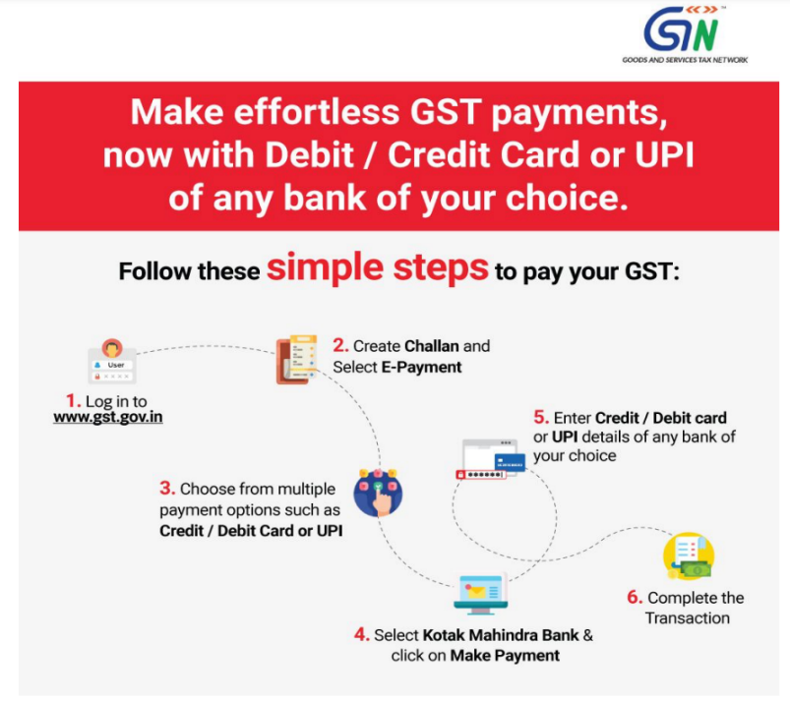
Quick Steps are as follows:
[For further details please refer the advisory]

CASE LAW
GIFT VOUCHERS/GIFT CARDS ARE “ACTIONABLE CLAIMS” AND THEREFORE NOT LIABLE TO TAX AS THEY FALL WITHIN THE PURVIEW OF THE EXECUTION IN SECTION 7(2) OF THE RESPECTIVE GST ENACTMENTS READ WITH SCHEDULE III TO THE RESPECTIVE GST ENACTMENTS : MADRAS HIGH COURT
OUR COMMENTS: It was held that “Gift Voucher/Card” issued by the petitioner is a “document” within the meaning of Section 3(18) of the General Clause Act, 1897 and thus an “instrument” within the meaning of Section 2(14) of the Indian Stamp Act, 1899 as a right/liability is created and is recorded. The amount specified in it is a debt - “Gift Voucher/Card” thus acknowledges debt. Thus, “Gift Voucher/Card” is nothing but a “debt instrument”. It can be redeemed on a future date on its presentation towards ‘sale consideration’ for purchase of the merchandise from any one of the petitioner’s retail outlets.
The “Gift Voucher/Card” is a debit card. It is like a frozen cash received in advance and thaws on its presentation at the retail outlet for being set off against the amount payable by a customer for purchase of merchandise sold by the petitioner or the amount specified therein is to be returned to the customer as per RBI’s Master Direction where a customer fails to utilize it within the period of its validity - “Gift Voucher/Card” is therefore an “actionable claim” within the meaning of Section 2(1) of the respective GST Enactments read with Section 3 of the Transfer of Property Act, 1882.
Since “Actionable claim” is specified in Sl.No.6 in the Schedule III, no tax is payable on it. “Gift voucher/Card” issued by the petitioner qualify as “actionable claim” within the meaning of the definition of “actionable claim” in Section 3 of the Transfer Act, 1882 as incorporated in Section 2(1) of the respective GST Enactments - the view in the impugned order that there is no need to determine whether “voucher” is an “actionable claim” to arrive at a conclusion that it is neither a supply of “goods” nor a supply “service” in a way is partly correct. However, the ultimate conclusion arrived is not correct.
The confusion and doubt surrounding the interpretation of Section 12(4) of the respective GST Enactments are partly on account of the fact that it is a new provision under the new regime under the respective GST Enactments as in force from 01.07.2017 - Neither, the definition of ‘Voucher’ as in Section 2(118) nor Section 12(4) of the respective GST Enactments were there in the Model GST Laws that were in circulation in 2016.
If the “Gift Vouchers/Cards” is for a specified item of jewellery of specified value, tax is payable at the time of its issuance, as there is supply (i.e transfer) within in the meaning of Section 7(1-A) of the respective GST Enactments read with Sl.No.1(c) to the II Schedule to the respective GST Enactments. Therefore, tax is payable in view of Section 12(4)(a) of the respective GST Enactments at the time of issuance of such “Gift Vouchers/Cards” - if there is no supply ie. no transfer within in the meaning of Section 7(1-A) of the respective GST Enactments read with Sl.No.1( c) to the II Schedule to the respective GST Enactments, time of supply will get postponed to the actual time of redemption of the “voucher” to a future date of sale of merchandise or such goods when such Gift Voucher/Card is presented by the customer at the Counter of the petitioner.
The petitioner will be liable to tax on the date of redemption under Section 12(4)(b) of the respective GST Enactments - the clarification in the impugned order is modified to that extent. The impugned order is quashed to that extent.
This writ petition is partly allowed.

CASE LAW
OFFENCE UNDER FEMA - ELIGIBLE CHARGE AGAINST PETITIONER IN SCN - NO PERMISSION WAS GIVEN FOR REPATRIATION OF SALE PROCEEDS TO PERSON RESIDENT OUTSIDE INDIA AND THAT ACQUISITION AND TRANSFER OF IMMOVABLE PROPERTY BY HER HEIRS RESIDING OUTSIDE INDIA WOULD BE COVERED : BOMBAY HIGH COURT
OUR COMMENTS: It was held that Issuance of a show cause notice is not an empty formality. Its purpose is to give a reasonable opportunity to the affected persons to contend that they have not committed any breach. Proper opportunity should be given to the person likely to be affected by the order proposed to be made a notice of the action intended to be taken, inform him about the materials on the basis of which the appropriate authority proposes to take action and give a fair and reasonable opportunity to such person to represent his case and to correct or controvert the material sought to be relied upon against him.
It is essential for a show cause notice to indicate the precise scope of the notice and also to indicate the points on which the recipient of the show cause notice give a reply.
In our view, there is nothing in the show cause notice to give any indication as to what are the allegations to which petitioner should furnish a statutory explanation. In paragraph 9 of the show cause notice, it is stated that without obtaining the prior permission of RBI, petitioner has repatriated the sale proceeds to M/s Salvation Army but the provisions relied upon in the show cause notice by respondent no.2 has nothing to do with repatriation of any sale proceeds. Further, Regulation 8 of the said Regulation only provides ‘save as otherwise provided in the act or regulations no person resident outside India shall transfer any immovable property in India’. It does not refer to any acquisition.
As could be seen from the show cause notice itself the admitted position is Mrs. Meerabai Dawson held immovable property in India, which she inherited from her parents, who were resident in India. The Executors of the Will of Mrs. Meerabai Dawson only disposed the immovable property that she had inherited from her parents who were residents in India, and repatriated the sale proceeds to the beneficiaries of her Will. The beneficiaries did not transfer any property in India from respondent no.2 to allege breach of Regulation 8. Moreover, petitioner was, admittedly, only the power of attorney holder and legal counsel of the Executor’s of the Will of Mrs. Meerabai Dawson and therefore, cannot be held liable in the facts of the present case.
We are inclined to exercise our jurisdiction under Article 226 of the Constitution of India and quash and set aside the impugned show cause notice.

NOTIFICATION
Seeks to continue levy of anti-dumping duty on Meta Phenylene Diamine imported from Chian PR for 5 years pursuant to Sunset Review Final Findings issued by DGTR
OUR COMMENTS: The Ministry of Finance, Department of Revenue vide notification no 01/2024-Customs(ADD) dated 15.01.2024 notified Whereas, the designated authority, vide notification number 7/06/2023-DGTR, dated the 30th June, 2023, published in the Gazette of India, Extraordinary, Part I, Section 1, dated the 30th June, 2023, had initiated the review in terms of sub-section (5) of section 9A of the Customs Tariff Act, 1975 (51 of 1975) (hereinafter referred to as the Customs Tariff Act), and read with rule 23 of the Customs Tariff (Identification, Assessment and Collection of Anti-dumping Duty on Dumped Articles and for Determination of Injury) Rules, 1995, in the matter of continuation of anti-dumping duty on imports of “Meta Phenylene Diamine” (hereinafter referred to as the subject goods) falling under tariff item(s) 2921 51 20 or 2921 51 90 of the First Schedule to the Customs Tariff Act, originating in or exported from China PR (hereinafter referred to as the subject country) imposed vide notification of the Government of India, Ministry of Finance (Department of Revenue), number 5/2019-Customs (ADD), dated the 24th January, 2019, published in the Gazette of India, Extraordinary, Part II, Section 3, Sub-section (i), vide number G.S.R. 46(E), dated the 24th January, 2019;
And whereas, in the matter of review of anti-dumping duty on imports of the subject goods, originating in or exported from the subject country, the designated authority in its final findings, published vide notification number 7/06/2023-DGTR, dated the 23rd October, 2023, published in the Gazette of India, Extraordinary, Part-I, Section 1, dated the 23rd October, 2023, has come to the conclusion that-
(i) the imports from the subject country have remained substantial in absolute terms as well as relative to the domestic industry’s production and in the Indian demand, even though the volume has declined slightly since the original investigation;
(ii) the production, sales, capacity utilization of the domestic industry is adversely impacted on account of dumped imports;
(iii) dumped imports from subject country are causing injury to the domestic industry;
(iv) there is likelihood of not only continuation but also intensification of dumping and consequent injury to the Indian industry in the event of cessation of the existing anti-dumping duties at this stage,
and has recommended continued imposition of the anti-dumping duty on imports of the subject goods, originating in or exported from the subject country, in order to remove injury to the domestic industry.
Now, therefore, in exercise of the powers conferred by sub-sections (1) and (5) of section 9A of the Customs Tariff Act, 1975 read with rules 18, 20 and 23 of the Customs Tariff (Identification, Assessment and Collection of Anti-dumping Duty on Dumped Articles and for Determination of Injury) Rules, 1995 and in supersession of the notification of the Government of India, Ministry of Finance (Department of Revenue), number 5/2019-Customs (ADD), dated the 24th January, 2019, published in the Gazette of India, Extraordinary, Part II, Section 3, Sub-section (i), vide number G.S.R. 46(E), dated the 24th January, 2019, the Central Government, after considering the aforesaid final findings of the designated authority, hereby imposes on the subject goods, the description of which is specified in column (3) of the Table below, falling under tariff item(s) of the First Schedule to the Customs Tariff Act as specified in the corresponding entry in column (2), originating in the country as specified in the corresponding entry in column (4), exported from the country as specified in the corresponding entry in column (5), produced by the producers as specified in the corresponding entry in column (6), an anti-dumping duty at the rate equal to the amount as indicated in the corresponding entry in column (7), in the currency as specified in the corresponding entry in column (8) and as per unit of measurement as specified in the corresponding entry in column (9) of the said Table, namely :-
TABLE
Sl.  No. | Tariff Item(s) | Description of goods | Country  of origin | Country  of export | Producer | Amo  unt | Curr-ency | Unit of  Measu-rement
(1) | (2) | (3) | (4) | (5) | (6) | (7) | (8) | (9)
1. | 29215120  or  29215190 | Meta  Phenylene  Diamine* | China PR | Any  country  including  China PR | Zhejiang Amino-  Chem Co., Ltd | 1.50 | USD | MT
2. | -do- | -do- | China PR | Any  country  including  China PR | Any producer  other than serial number  1 | 1.71 | USD | MT
3. | -do- | -do- | Any Country other than  China PR | China PR | Any | 1.71 | USD | MT
*Meta Phenylene Diamine , also known as m- Phenylene Diamine, 1,3- diaminobenzene, 1, 3- Benzenediamine, m- Aminoaniline, mBenzenediamine, m- Diaminobenzene, 1,3-Phenylenediamine, 3- Aminoaniline, mFenylendiamin, Phenylenediamine, and m-Aminoaline, Phenylenediamine meta.
2. The anti-dumping duty imposed under this notification shall be levied for a period of five years (unless revoked, superseded or amended earlier) from the date of publication of this notification in the Official Gazette and shall be payable in Indian currency.
Explanation.- For the purposes of this notification, rate of exchange applicable for the purpose of calculation of such anti-dumping duty shall be the rate which is specified in the notification of the Government of India, Ministry of Finance (Department of Revenue), issued from time to time, in exercise of the powers conferred by section 14 of the Customs Act, 1962 (52 of 1962), and the relevant date for the determination of the rate of exchange shall be the date of presentation of the bill of entry under section 46 of the said Customs Act.
[For further details please refer the notification]
NOTIFICATION
Fixation of Tariff Value of Edible Oils, Brass Scrap, Areca Nut, Gold and Silver
OUR COMMENTS: The Ministry of Finance, Department of Revenue vide notification no 02/2024-Customs(NT) dated 15.01.2024 notified In exercise of the powers conferred by sub-section (2) of section 14 of the Customs Act, 1962 (52 of 1962), the Central Board of Indirect Taxes & Customs, being satisfied that it is necessary and expedient to do so, hereby makes the following amendments in the notification of the Government of India in the Ministry of Finance (Department of Revenue), No. 36/2001-Customs (N.T.), dated the 3rd August, 2001, published in the Gazette of India, Extraordinary, Part-II, Section-3, Sub-section (ii), vide number S. O. 748 (E), dated the 3rd August, 2001, namely:-
In the said notification, for TABLE-1, TABLE-2, and TABLE-3 the following Tables shall be substituted, namely: -
“TABLE-1
Sl. No. | Chapter/ heading/ sub-heading/tariff item | Description of goods | Tariff value (US $Per Metric Tonne)
(1) | (2) | (3) | (4)
1 | 1511 10 00 | Crude Palm Oil | 869
2 | 1511 90 10 | RBD Palm Oil | 874
3 | 1511 90 90 | Others - Palm Oil | 872
4 | 1511 10 00 | Crude Palmolein | 877
5 | 1511 90 20 | RBD Palmolein | 880
6 | 1511 90 90 | Others - Palmolein | 879
7 | 1507 10 00 | Crude Soya bean Oil | 928
8 | 7404 00 22 | Brass Scrap (all grades) | 4862
TABLE-2
Sl. No. | Chapter/ heading/ sub-heading/tariff item | Description of goods | Tariff value (US $)
(1) | (2) | (3) | (4)
1. | 71 or 98 | Gold, in any form, in respect of which the benefit of entries at serial number 356 of the Notification No. 50/2017-Customs dated 30.06.2017 is availed | 662 per 10 grams
2. | 71 or 98 | Silver, in any form, in respect of which the benefit of entries at serial number 357 of the Notification No. 50/2017-Customs dated 30.06.2017 is availed | 747 per kilogram
3. | 71 | (i) Silver, in any form, other than medallions and silver coins having silver content not below 99.9% or semi- manufactured forms of silver falling under sub-heading 7106 92;  (ii) Medallions and silver coins having silver content not below 99.9% or semi- manufactured forms of silver falling under sub-heading 7106 92, other than imports of such goods through post, courier or baggage.  Explanation. - For the purposes of this entry, silver in any form shall not include foreign currency coins, jewellery made of silver or articles made of silver. | 747 per kilogram
4. | 71 | (i) Gold bars, other than tola bars, bearing manufacturer's or refiner's engraved serial number and weight expressed in metric units;  (ii) Gold coins having gold content not below 99.5% and gold findings, other than imports of such goods through post, courier or baggage.  Explanation. - For the purposes of this entry, "gold findings" means a small component such as hook, clasp, clamp, pin, catch, screw back used to hold the whole or a part of a piece of Jewellery in place. | 662 per 10 grams
TABLE-3
Sl. No. | Chapter/ heading/ sub-heading/tariff item | Description of goods | Tariff value (US $ Per Metric Ton)
(1) | (2) | (3) | (4)
1 | 080280 | Areca nuts | 8140 (i.e., no change)"
2. This notification shall come into force with effect from the 16th day of January, 2024.
[For further details please refer the notification]
NOTIFICATION
Seeks to amend Second Schedule to the Customs Tariff Act to prescribe export duty of 50% on exports of Molasses (HS 1703)
OUR COMMENTS: The Ministry of Finance, Department of Revenue vide notification no 01/2024-Customs dated 15.01.2024 notified whereas, the Central Government is satisfied that export duty should be levied on certain articles and that circumstances exist which render it necessary to take immediate action.
Now, therefore, in exercise of the powers conferred by sub-section (1) of section 8 of the Customs Tariff Act, 1975 (51 of 1975) (hereinafter referred to as the Customs Tariff Act), the Central Government, hereby directs that the Second Schedule to the Customs Tariff Act shall be amended in the following manner, namely: -
In the Second Schedule to the Customs Tariff Act, after S. No. 9A and the entries relating thereto, the following Sl. No. and entries relating thereto shall be inserted, namely: -
(1) | (2) | (3) | (4)
“9B. | 1703 | Molasses resulting from the extraction or refining of sugar | 50%”;
2. This notification shall come into force on the 18th of January, 2024.
[For further details please refer the notification]

NOTIFICATION
Seeks to amend notification Nos. 48/2021 and 49/2021 - Customs both dated 13.10.2021 in order to extend the existing concessional import duties on specified edible oils up to and inclusive of the 31st March 2025
OUR COMMENTS: The Ministry of Finance, Department of Revenue vide notification no 02/2024-Customs dated 15.01.2024 notified In exercise of the powers conferred by sub-section (1) of section 25 of the Customs Act, 1962 (52 of 1962) read with section 124 of the Finance Act, 2021 (13 of 2021), the Central Government, on being satisfied that it is necessary in the public interest so to do, hereby amends the following notifications of the Government of India in the Ministry of Finance (Department of Revenue), specified in column (2) of the Table below, to the extent specified in the corresponding entries in column (3) of the said Table, namely:-
TABLE
S. No. | Notification No. and Date | Amendments
(1) | (2) | (3)
1. | 48/2021-Customs, dated the 13th October, 2021, published in the Gazette of India, Extraordinary, Part II, Section 3, Sub-section (i), vide number G.S.R. 733(E)., dated the 13th October, 2021 | In the said notification, in paragraph 2, for the figures “2024”, the figures “2025” shall be substituted;
2. | 49/2021-Customs, dated the 13th October, 2021, published in the Gazette of India, Extraordinary, Part II, Section 3, Subsection (i), vide number G.S.R. 734(E)., dated the 13th October, 2021 | In the said notification, in paragraph 2, the words, figures, and letters “Provided that nothing contained in this notification shall apply to the goods specified against serial numbers 1, 2 and 3 of the Table above on or after the 1st day of April, 2024.” shall be omitted.

[For further details please refer the notification]

NOTIFICATION
AMENDMENT IN NOTIFICATION RELATING TO Exemption of deposits u/s 51A (4) of the Customs Act, 1962 - customs automated system is not in place, with respect to accompanied baggage and other than those used for making [electronic] payment

OUR COMMENTS: The Ministry of Finance, Department of Revenue vide notification no 06/2024-Customs(NT) dated 19.01.2024 notified In exercise of the powers conferred by sub-section (4) of section 51A of the Customs Act, 1962 (52 of 1962), the Central Board of Indirect Taxes and Customs, on being satisfied that it is necessary and expedient to do so, hereby makes the following further amendments to the Notification No.19/2022-Customs (N.T.) dated the 30th March, 2022, published in the Gazette of India, Extraordinary, Part II, Section 3, Sub-section (ii) vide S.O. 1512 (E), dated the 30th March, 2022, namely, -
In the said notification, in para 2, for the words, '20th January, 2024', the words ‘1st March, 2024’ shall be substituted.
[For further details please refer the notification]

NOTIFICATION
AMENDMENT IN NOTIFICATION RELATING TO Exemption of deposits into ECL till 30th June, 2023 u/s 51A (4) of Customs Act, 1962
OUR COMMENTS: The Ministry of Finance, Department of Revenue vide notification no 05/2024-Customs(NT) dated 19.01.2024 notified In exercise of the powers conferred by sub-section (4) of section 51A of the Customs Act, 1962 (52 of 1962), the Central Board of Indirect Taxes and Customs, on being satisfied that it is necessary and expedient to do so, hereby makes the following amendments to the notification No.18/2023-Customs (N.T.) dated the 30th March, 2023, published in the Gazette of India, Extraordinary, Part II, Section 3, Sub-section (ii) vide S.O. 1528 (E), dated the 30th March, 2023, namely, -
In the said notification, in para 2, for the words, ‘19th January, 2024’, the words ‘29th February, 2024' shall be substituted.
[For further details please refer the notification]

NOTIFICATION
RATE OF EXCHANGE OF ONE UNIT OF FOREIGN CURRENCY EQUIVALENT TO INDIAN RUPEES - SUPERSESSION NOTIFICATION NO. 01/2024-CUSTOMS(N.T.), DATED 4TH JANUARY, 2024
OUR COMMENTS: The Ministry of Finance, Department of Revenue vide notification no 04/2024-Customs(NT) dated 18.01.2024 notified In exercise of the powers conferred by section 14 of the Customs Act, 1962 (52 of 1962), and in supersession of the Notification No. 01/2024-Customs(N.T.), dated 4th January, 2024 except as respects things done or omitted to be done before such supersession, the Central Board of Indirect Taxes and Customs hereby determines that the rate of exchange of conversion of each of the foreign currencies specified in column (2) of each of Schedule I and Schedule II annexed hereto, into Indian currency or vice versa, shall, with effect from 19th January, 2024, be the rate mentioned against it in the corresponding entry in column (3) thereof, for the purpose of the said section, relating to imported and export goods.
SCHEDULE-I
Sl. No. | Foreign Currency | Rate of exchange of one unit of foreign currency equivalent to Indian rupees
(1) | (2) | (3)
 |  | (a) | (b)
 |  | (For Imported Goods) | (For Export Goods)
1. | Australian Dollar | 55.80 | 53.40
2. | Bahraini Dinar | 229.35 | 212.65
3. | Canadian Dollar | 62.70 | 60.70
4. | Chinese Yuan | 11.90 | 11.45
5. | Danish Kroner | 12.35 | 12.00
6. | EURO | 92.30 | 89.10
7. | Hong Kong Dollar | 10.80 | 10.50
8. | Kuwaiti Dinar | 279.15 | 261.8
9. | New Zealand Dollar | 52.15 | 49.80
10. | Norwegian Kroner | 8.05 | 7.80
11. | Pound Sterling | 107.35 | 103.85
12. | Qatari Riyal | 23.60 | 22.15
13. | Saudi Arabian Riyal | 22.90 | 21.50
14. | Singapore Dollar | 62.95 | 60.95
15. | South African Rand | 4.50 | 4.25
16. | Swedish Kroner | 8.10 | 7.85
17. | Swiss Franc | 98.20 | 94.50
18. | Turkish Lira | 2.85 | 2.70
19. | UAE Dirham | 23.35 | 22.00
20. | US Dollar | 84.10 | 82.35
SCHEDULE-II
Sl. No. | Foreign Currency | Rate of exchange of 100 units of foreign currency equivalent to Indian rupees
(1) | (2) | (3)
 |  | (a) | (b)
 |  | (For Imported Goods) | (For Export Goods)
1. | Japanese Yen | 57.10 | 55.35
2. | Korean Won | 6.40 | 6.00

[For further details please refer the notification]

NOTIFICATION
APPOINTMENT OF COMMON ADJUDICATING AUTHORITY FOR THE PURPOSE OF ADJUDICATION OF FINALIZATION OF PROVISIONAL ASSESSMENT IN SVB CASE W.R.T. M/S ECOCLEAN MACHINES PVT. LTD
OUR COMMENTS: The Ministry of Finance, Department of Revenue vide notification no 03/2024-Customs(NT) dated 16.01.2024 notified In exercise of the powers conferred by sub-section (1) of section 4, read with section 3 and sub-sections (1) and (1A) of section 5 of the Customs Act, 1962 (52 of 1962), the Central Board of Indirect Taxes and Customs, hereby appoints officer mentioned in column (4) of the Table below to exercise the powers and discharge duties conferred or imposed on officers mentioned in column (3) of the said Table in respect of Noticee mentioned in column (1) of the Table, for purpose of adjudication of show cause notices mentioned in column (2) therein, namely:-
Table
Name of the Noticee and Address | Show Cause Notice  Number and Date | Name of  Adjudicating  Authorities | Common  Adjudicating  Authority  appointed
(1) | (2) | (3) | (4)
M/s Ecoclean Machines Pvt. Ltd, Address: A 57/58, H block, Pimpri, MIDC, Pune-411018,Mahar ashtra. | (i) SCN No. CRC-07/RPB/  2020-21/ACC(I) dated  14.12.2020, DIN  No.202012790A000000D  D2 | (i) Assistant  Commissioner of  Customs, CRC-II,  Air Cargo  Complex, Sahar,  Andheri, Mumbai | Assistant/ Deputy Commissioner of  Customs , Air  Cargo Complex,  Sahar, Andheri,  Mumbai Customs  Zone-III
 | (ii) SCN No. 816/2020-21/  GR V/ NS-V/ JNCH issued  vide F. No. S/26-  Misc-2151/2020-21 Gr. V  dated 08.02.2021, DIN No.  2021027800000000F0A7 | (ii) Deputy  Commissioner of  Customs, Gr. V,  Jawaharlal Nehru  Custom House,  Maharashtra.
[For further details please refer the notification]

NOTIFICATION
Amendment in policy condition of silver covered under Chapter 71 of Schedule –I (Import Policy) of ITC (HS) 2022
OUR COMMENTS: The Ministry of Commerce and Industry vide public notice no. 57/2023 dated 15.01.2024 notified In exercise of powers conferred by Section 3 and Section 5 of Foreign Trade (Development & Regulation) Act, 1992, read with paragraph 1.02 and 2.01 of the Foreign Trade Policy 2023, as amended from time to time, the Central Government hereby makes the following amendments under Chapter 71 of Schedule-1(Import Policy) of ITC(HS) 2022:
1. Policy Condition no. 05 of the Chapter 71 is introduced as under:
i. Import of Semi-Manufactured Silver Paste, Sheets, Plates, Strips, Tubes, Electrodes, Wires, Silver Brazing Alloys(in any form), by Electrical, Electronics and Engineering industries including Glass and Solar Industries as input for their own manufacturing process on ‘Actual User’ Basis shall be ‘Free’.
ii. Import items mentioned at serial (i) above for Research & Development purposes by Government or Government Recognised Research Institutions shall also be ‘Free’.
iii. Import for other purposes is permitted through Nominated Agencies as notified by RBI (in case of banks) and DGFT (for other agencies).
2. The Import Policy condition for the following ITC(HS) Codes is amended as under:
ITC(HS) code & Description | Import Policy | Existing Policy Condition | Revised Policy Condition
71069210  - Other: --Semi-manufactured  ---  Sheets, plates, strips,  tubes and pipes | Restricted | Import is allowed only through nominated agencies as notified by RBI (in case of banks) and DGFT (for other agencies). | Subject to Policy condition no. 05 of this Chapter.
71069290  - Other: --Semi-manufactured  ---  Other | Restricted | Import is allowed only through nominated agencies as notified by RBI (in case of banks), DGFT (for other agencies) and by qualified jewellers as notified by the IFSCA for import through India International bullion Exchange (IIBX). | Subject to Policy condition no. 05 of this Chapter. Import for other purposes is also permitted through Qualified Jewellers as notified by the IFSCA for import through India International bullion Exchange (IIBX).
Effect of the notification: Import of Semi-Manufactured Silver Paste, Sheets, Plates, Strips, Tubes, Electrodes, Wires, Silver Brazing Alloys(in any form), by Electrical, Electronics and Engineering industries including Glass and Solar Industries as input for their own manufacturing process on ‘Actual User’ basis shall be ‘Free’. Import of given items for R&D purposes by Government or Government Recognised Institutions shall also be ‘Free’. Import for any other purposes shall be through specified agencies as per the earlier provisions.
This is issued with the approval of Minister of Commerce & Industry.
[For further details please refer the notiifcation]

:IN STANDS

TAX PLEADING AND PRACTICE JOURNAL
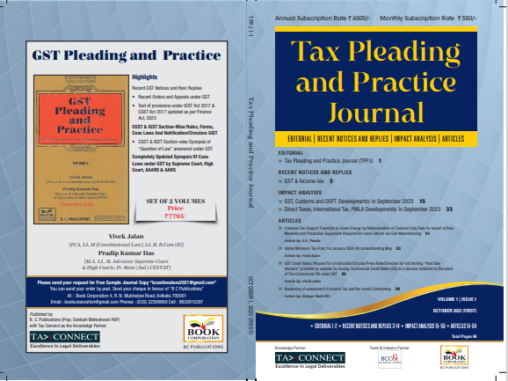

CONTENTS
- Recent Notices and replies on GST & Income Tax
- Impact Analysis on GST, Customs and DGFT Developments: In September 2023
- Impact Analysis on Direct Taxes, International Tax, PMLA Developments: In September 2023
- Articles

Author:
Vivek Jalan
[FCA, LL.M (Constitutional Law), LL.B, B.Com(H)]

S.K. Panda
[IRS-Retd.; Ex-Member CBIC & Special Secretary – GoI]

P.K. Das
[IRS-Retd.; Ex-Member CBDT & Special Secretary – GoI]

Published by: In Association With:
BOOK CORPORATION TAX CONNECT ACADEMY
4, R. N. Mukherjee Road 6, Netaji Subhas Road,
Kolkata 700001 Kolkata 700001
Phones: (033) 64547999 Cell: 7003384915
Cell: 9830010297, 9331018333 Order by email: info@taxconnect.co.in
Order by email:bookcorporation@gmail.com Website : www.taxconnect.co.in
Website :www.bookcorporation.com

:IN STANDS

GST PLEADING AND PRACTICE: With Section-wise GST Cases & GST Notices and their Replies
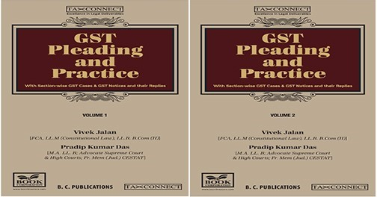

ABOUT THE BOOK: This publication includes:
- Recent GST Notices and their Replies
• Recent Orders and Appeals under GST
• Text of provisions under IGST Act 2017 & CGST Act 2017 updated as per Finance Act, 2023

- CGST & IGST Section-Wise Rules, Forms, Case Laws And Notification/Circulars GIST
• CGST & IGST Section-wise Synopsis of “Question of Law” answered under GST

- Completely Updated Synopsis Of Case Laws under GST by Supreme Court, High Court, AAARS & AARS

Authors:
Vivek Jalan
[FCA, LL.M (Constitutional Law), LL. B, B. Com(H)]

Pradip Kumar Das
[M.A. LL. B; Advocate Supreme Court & High Courts; Fr. Mem (Jud.) CESTAT]

Published by: In Association With:
BOOK CORPORATION TAX CONNECT ACADEMY
4, R. N. Mukherjee Road 6, Netaji Subhas Road,
Kolkata 700001 Kolkata 700001
Phones: (033) 64547999 Cell: 7003384915
Cell: 9830010297, 9331018333 Order by email: info@taxconnect.co.in
Order by email:bookcorporation@gmail.com Website : www.taxconnect.co.in
Website :www.bookcorporation.com
:IN STANDS

HANDBOOK ON GST 2022
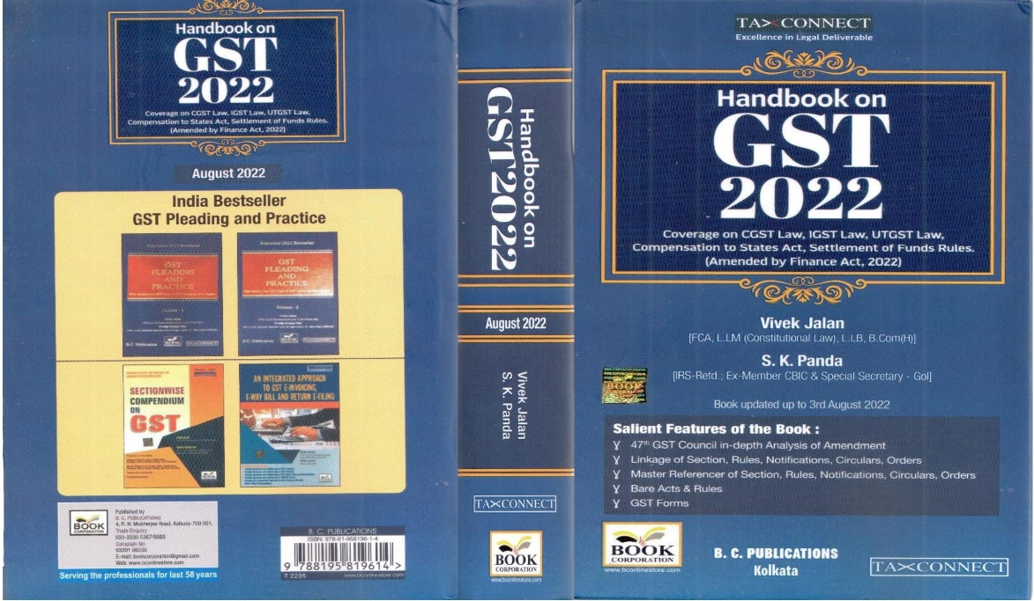

CONTENTS
- 47th GST Council in-depth Analysis of Amendment
- Linkage of Section, Rules, Notifications, Circulars, Orders
- Master Reference of Section, Rules, Notifications, Circulars, Orders
- Bare Acts & Rules
- GST Forms
Author:
Vivek Jalan
[FCA, LL.M (Constitutional Law), LL.B, B.Com(H)]

S.K. Panda
[IRS-Retd.; Ex-Member CBIC & Special Secretary – GoI]

Published by: In Association With:
BOOK CORPORATION TAX CONNECT ACADEMY
4, R. N. Mukherjee Road 6, Netaji Subhas Road,
Kolkata 700001 Kolkata 700001
Phones: (033) 64547999 Cell: 7003384915
Cell: 9830010297, 9331018333 Order by email: info@taxconnect.co.in
Order by email:bookcorporation@gmail.com Website : www.taxconnect.co.in
Website :www.bookcorporation.com

:IN STANDS

How to Handle GST LITIGATION: Assessment, Scrutiny, Audit & Appeal
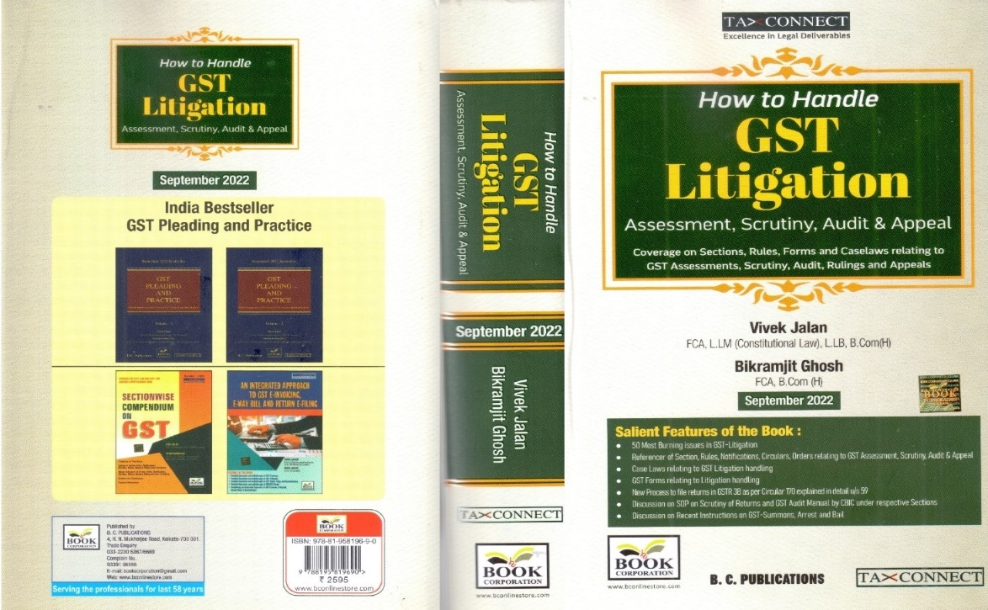

CONTENTS
1. 50 Most Burning issues in GST-Litigation
2. Reference of Section, Rules, Notifications, Circulars, Orders relating to GST Assessment, Scrutiny, Audit & Appeal
3. Case Laws relating to GST Litigation handling
4. GST Forms relating to Litigation handling
5. New process to file returns in GSTR 3B as per circular 170 explained in details u/s 59
6. Discussion on SOP on Scrutiny of Returns and GST Audit Manual by CBIC under respective Sections
7. Discussion on Recent Instruction on GST-Summons, Arrest and Bail

Authors:
Vivek Jalan
[FCA, LL.M (Constitutional Law), LL. B, B. Com(H)]

Bikramjit Ghosh
[FCA, B. Com(H)]

Published by: In Association With:
BOOK CORPORATION TAX CONNECT ACADEMY
4, R. N. Mukherjee Road 6, Netaji Subhas Road,
Kolkata 700001 Kolkata 700001
Phones: (033) 64547999 Cell: 7003384915
Cell: 9830010297, 9331018333 Order by email: info@taxconnect.co.in
Order by email:bookcorporation@gmail.com Website : www.taxconnect.co.in
Website :www.bookcorporation.com

LET’S DISCUSS FURTHER!



OUR OFFICES:
MUMBAI
Unit No. 312, Omega Business Park, Near Kaamgar Hospital, Road No. 33, Wagle Industrial Estate, Thane West,
Maharashtra- 400604

Contact Person: Priyanka Vishwakarma
Email:priyanka.vishwakarma@taxconnect.co.in
BENGALURU
951, 24th Main Road, J P Nagar, Bengaluru, Karnataka – 560078.

Contact Person: Anil Pal

Email:anil.pal@taxconnectdelhi.co.in

DELHI (NCR)
B-139, 2nd Floor, Transport Nagar,
Noida-201301 (U.P)

Contact Person: Poonam Khemka

Email:poonam.khemka@taxconnect.co.in



DUBAI
Azizi Feirouz, 803, 8th Floor, AL Furjan, Opposite Discovery Pavillion,
Dubai, UAE

Contact Person: Rohit Sharma

Email:rohit.sharma@taxconnect.co.in

KOLKATA
R No 119; 1st Floor; Diamond Arcade; 1/72, Cal Jessore Road,
Kolkata – 700055

Contact Person: Uttam Kumar Singh

Email:uttam.singh@taxconnect.co.in
KOLKATA
6, Netaji Subhas Road, 3rd Floor, Royal Exchange Building,
Kolkata - 700001

Contact Person: Tithly Roy

Email:tithly.roy@taxconnect.co.in

Disclaimer:
This e-bulletin is for private circulation only. Views expressed herein are of the editorial team and are based on the information, explanation and documents available on Government portal platforms. Tax Connect or any of its employees do not accept any liability whatsoever direct or indirect that may arise from the use of the information contained herein. No matter contained herein may be reproduced without prior consent of Tax Connect. While this e-article has been prepared on the basis of published/other publicly available information considered reliable, we do not accept any liability for the accuracy of its contents.
Tax Connect 2024. All rights reserved.

