s Iz8
_{TAX CONNECT}

437th Issue: 14th January 2024-20th January 2024
12017

sssss

Knowledge Partner:



TAX CONNECT :

Mumbai : Unit No. 312, Omega Business Park, Near-Kaamgar Hospital, Road No. 33, Wagle Industrial Estate,
Thane (West), Maharashtra – 400604
Bengaluru : 951, 24th Main Road, J P Nagar, Bengaluru, Karnataka – 560078.
Delhi (NCR) : B-139, 2ndFloor, Transport Nagar, Noida-201301 (U.P)
Kolkata : 6, Netaji Subhas Road, 3rd Floor, Royal Exchange Building, Kolkata – 700001
- Room No. 119, 1stFloor, “Diamond Arcade” 1/72, Cal Jessore Road, Kolkata – 700055
- Tobacco House, 1, Old Court House St, Radha Bazar, Corner, Kolkata, West Bengal 700001
Dubai : Azizi Feirouz, 803, 8th Floor, AL Furjan, Opposite Discovery Pavillion, Dubai, UAE

Contact : +91 7003384915

Website : www.taxconnect.co.in
Email : info@taxconnect.co.in

Friends,
A new Era has started in GST with the inception of DRC-01B and DRC-01C. The issuance of these notices blocks the taxpayers from further filing the GSTR-1/ 3B unless the perceived mismatches between GSTR-1/GSTR-3B/GSTR-2B are reconciled. Now, from 1st March 2024 there is one addition to the ab-initio blockages so to say – Taxpayers will not be able to generate B2B (Business to Business) or B2E (Business to Export) E-Waybills without E-Invoice details.

Let us guess the Government’s perspective. It is a fact that certain unscrupulous elements are trying to game the system and cause a loss to the exchequer. Consider that such an unscrupulous element has made an invoice (not E-Invoice) and generated an E-Waybill on the same. No E-Invoice is required to be generated for 30 days. Now, when the material reaches the consignee, then the E-Waybill is cancelled, and Invoice is also cancelled ab initio without reporting it at all. Hence the entire transaction may skip the GST net. To safeguard this, it is possible that this new restriction has been thought of.

Even if the background is true, the fact is that all taxpayers will be affected by this change. There are many facets to this blocking which we discuss as follows –

1. During e-Invoice generation, if the transportation details are sent, the e-Waybill (Part A & Part B) will be automatically generated.
2. During e-Invoice generation, if the transportation details are not sent, the e-Waybill (Only Part A) will be automatically generated.
3. E-Invoice generation can happen without generating the EWB, but it is better in case EInvoice and EWB are simultaneously generated.
4. In case E-Invoice and EWB are not simultaneously generated, IRN and E-Invoice details is required to be mentioned in EWB, without which EWB will not be generated
5. Once IRN is updated in EWB, the NIC Portal will auto-update E-Invoice details in the EWB.
6. This applies to the E-Waybill categories for B2B & B2E like Supply/Exports/SKD/CKD/Lots.
7. For SKD/CKD/Lots –

A. All DCs along with E-Invoice need to be generated before clearance of the 1st Consignment.

B. The EWB for the earlier consignments (which will be generated on the basis of Delivery Chalans) need not be generated on the basis of E-Invoice Details.

C. The EWB generated for the last consignment, in the basis of E-Invoice, need to have the E-Invoice details like IRN, etc.

8. No IRN (E-Invoice) details would be required for –

A. Transactions such as B2C, non-GST supplies, Job-work and other movements where EInvoice is not applicable.

B. Where Suppliers are not liable for e-Invoicing.

9. Where E-Way Bills are generated by transporter, similar check would be enforced on the Supplier GSTIN.
10. Other operations such as Part-B updating, transporter Id updating, etc. will continue as usual without any change.

Issues and Pointers –
1. The GSPs need to integrate the E-Invoice details with the EWB generation portal
2. Even though there is a time limit of 30 days for generation of E-Invoice, yet no movement can now happen without generation of E-Invoice.
3. For bill-to-ship-to transactions, let’s take a case where the shipping party is required to generate E-Invoice and the Biling party is not required to generate E-Invoice. In such a case, in case EWB is made from the Biling Party’s Invoice, then the EWB can still be made without E-Invoice details.

Just to reiterate that we remain available over telecom or e-mail.

Editor:
Vivek Jalan
Partner - Tax Connect Advisory Services LLP

Co-Editor:
Rohit Sharma
Director – Tax Connect Advisory Services LLP

S.NO. | TOPICS | PAGE NO.
1] | TAX CALENDER | 4
2] | INCOME TAX | 5
NOTIFICATION | EXEMPTION FROM SPECIFIED INCOME U/S 10(46) – 'PUNJAB STATE FACULTY OF AYURVEDIC AND UNANI SYSTEMS OF MEDICINE'
NOTIFICATION | EXEMPTION FROM SPECIFIED INCOME U/S 10(46) – 'CHENNAI METROPOLITAN WATER SUPPLY AND SEWERAGE BOARD', NOTIFIED
3] | GST | 6
CASE LAW | VALIDITY OF SHOW CAUSE NOTICE (SCN) FOR GST DEMAND - TRANSITIONAL CREDIT - INPUT TAX CREDIT AVAILED BY THE PETITIONER UNDER THE PRE-GOODS AND SERVICES TAX REGIME AND ROLLED OVER TO THE GOODS AND SERVICES TAX REGIME : JHARKHAND HIGH COURT
4] | FEMA | 7
CASE LAW | POWER OF SEARCH AND SEIZURE CONFERRED ON THE DIRECTORATE OF ENFORCEMENT AS PER FEMA - VALIDITY OF SEIZURE/CONFISCATION MADE BY THE RESPONDENTS - SEEKING A DIRECTION TO RETURN/RELEASE THE MONEY, CURRENCY ILLEGALLY CONFISCATED/SEIZED : RAJASTHAN HIGH COURT
5] | CUSTOMS | 8
INSTRUCTION | REQUIREMENT OF QUALITY CONTROL OR INSPECTION OR BOTH, PRIOR TO EXPORT AS PER MILK AND MILK PRODUCTS (QUALITY CONTROL, INSPECTION & MONITORING) RULES, 2020
6] | DGFT | 9
PUBLIC NOTICE | EXTENSION OF VALIDITY OF PRE-SHIPMENT INSPECTION AGENCIES (PSIAS)
PUBLIC NOTICE | ALLOCATION OF 8606 MTRV OF RAW CANE SUGAR TO USA UNDER TRQ SCHEME FOR US FISCAL YEAR 2024
7] | TAX PLEADING AND PRACTICE JOURNAL | 10
8] | GST PLEADING AND PRACTICE: WITH SECTION-WISE GST CASES & GST NOTICES AND THEIR REPLIES | 11
9] | HANDBOOK ON GST 2022 | 12
10] | HOW TO HANDLE GST LITIGATION: ASSESSMENT, SCRUTINY, AUDIT & APPEAL | 13
11] | LET’S DISCUSS FURTHER | 14

Due Date | Form/Return/Challan | Reporting Period | Description
14th January | Issue of TDS Certificate | November’2023 | Due date for issue of TDS Certificate for tax deducted under section 194-IA, 194-IB, 194M, 194S in the month of November, 2023
15th January | FORM 24G | December’2023 | Due date for furnishing of Form 24G by an office of the Government where TDS/TCS for the month of December, 2023 has been paid without the production of a challan
15th January | Statement of TCS | December’2023 | ​Quarterly statement of TCS for the quarter ending December 31, 2023
15th January | FORM 15CC | December’2023 | Quarterly statement in respect of foreign remittances (to be furnished by authorized dealers) in Form No. 15CC for quarter ending December, 2023
15th January | FORM 15G/15H | December’2023 | ​Due date for furnishing of Form 15G/15H declarations received during the quarter ending December, 2023
15th January | FORM 49BA | December’2023 | ​Furnishing of statement in Form No. 49BA under Rule 114AAB (by specified fund) for the quarter ending December 31, 2023
20th January | GSTR-3B | December’2023 | GST Filing of returns by a registered person with aggregate turnover exceeding INR 5 Crores during the preceding financial year.
20th January | GSTR-5A | December’2023 | Summary of outward taxable supplies and tax payable by a person supplying OIDAR services.

NOTIFICATION
Exemption from specified income U/s 10(46) – 'Punjab State Faculty of Ayurvedic and Unani Systems of Medicine'
OUR COMMENTS: The Central Board of Direct Taxes vide Notification No. 11/2024 dated 08.01.2024 notified In exercise of the powers conferred by clause (46) of section 10 of the Income-tax Act, 1961 (43 of 1961), the Central Government hereby notifies for the purposes of the said clause, ‘Punjab State Faculty of Ayurvedic and Unani Systems of Medicine’ (PAN: AAALT1669E), a body constituted by the Punjab Government, in respect of the following specified income arising to that body, namely:-
(a) Fees, by whatever name called;
(b) Maintenance Fund receipts; and
(c) Interest earned on bank deposits.
2. This notification shall be effective subject to the conditions that Punjab State Faculty of Ayurvedic and Unani Systems of Medicine, SAS Nagar, Punjab:-
(a) shall not engage in any commercial activity;
(b) activities and the nature of the specified income shall remain unchanged throughout the financial years; and
(c) shall file return of income in accordance with the provision of clause (g) of sub-section (4C) of section 139 of the Income-tax Act, 1961.
3. This notification shall be deemed to have been applied for assessment years 2020-2021, 2021-2022, 2022-2023 and 2023-2024 relevant to the financial years 2019-2020, 2020-2021, 2021-2022 and 2022-2023 respectively.
[For further details please refer the notification]
NOTIFICATION
Exemption from specified income U/s 10(46) – 'Chennai Metropolitan Water Supply and Sewerage Board', notified
OUR COMMENTS: The Central Board of Direct Taxes vide Notification No. 10/2024 dated 08.01.2024 In exercise of the powers conferred by clause (46) of section 10 of the Income-tax Act, 1961 (43 of 1961), the Central Government hereby notifies for the purposes of the said clause, ‘Chennai Metropolitan Water Supply and Sewerage Board’ (PAN: AAALM0037B), a Board constituted by the Government of Tamil Nadu, in respect of the following specified income arising to that Board, namely:
(a) Grant and subsidies received from Government;
(b) Centage receipts received from Municipalities, Local authority and Government;
(c) Receipts of taxes, charges, fees, fines, forfeitures, penalties, etc. by whatever name called;
(d) Income from sale of farm produce, rent from properties;
(e) Other miscellaneous income such as interest on deposits with TNEB, GPF/CPS investments, staff welfare investments, Debt Reserve Fund, Fixed Asset renewal fund, advance to staff and contractors, sale of assets/scrap; and
(f) Interest earned on bank deposits.
2. This notification shall be effective subject to the conditions that Chennai Metropolitan Water Supply and Sewerage Board:-
(a) shall not engage in any commercial activity;
(b) activities and the nature of the specified income shall remain unchanged throughout the financial years; and
(c) shall file return of income in accordance with the provision of clause (g) of sub-section (4C) of section 139 of the Income-tax Act, 1961.
3. This notification shall be deemed to have been applied for assessment years 2020-2021, 2021-2022, 2022-2023 and 2023-2024 relevant for the financial years 2019-2020, 2020-2021, 2021-2022 and 2022-23.
[For further details please refer the notification]

CASE LAW
VALIDITY OF SHOW CAUSE NOTICE (SCN) FOR GST DEMAND - TRANSITIONAL CREDIT - INPUT TAX CREDIT AVAILED BY THE PETITIONER UNDER THE PRE-GOODS AND SERVICES TAX REGIME AND ROLLED OVER TO THE GOODS AND SERVICES TAX REGIME : JHARKHAND HIGH COURT
OUR COMMENTS: It was held that the said issue is squarely covered by the decision of this Court rendered in the case of Usha Martin Limited being W.P.(T) No. 3055 of 2022 dated 10.11.2022 [2022 (11) TMI 1266 - JHARKHAND HIGH COURT], wherein this Court held that the repeal of the existing laws upon coming of the G.S.T. law regime did not leave a vacuum as to past transactions which were not closed. The repeal and saving clause (e) under Section 174(1) of the C.G.S.T. Act allowed such legal proceedings to be instituted in respect of inchoate rights except rights under transactions which were past and closed.
As a matter of fact, section 174 of the JGST Act deals with repeal and saving provision, wherein the JVAT Act, 2005, except in respect of goods included in Entry 54 of the State List of the Seventh Schedule of the Constitution, Jharkhand Entertainment Tax Act, 2012, Jharkhand Advertisement Tax Act, Jharkhand Entry Tax on consumption or use of goods Act, 2011 were repealed - However, section 174(2)(e), saves any investigation, inquiry, verification, assessment, adjudication and any other legal proceedings as if these Acts have not so amended or repealed. Thus, the GST authorities are incorrect in assuming jurisdiction and initiating a proceeding under the provision of the JGST Act alleging therein that the Input Tax Credit so transited from the pre-GST regime is inadmissible under the JVAT regime.
Validity of SCN - it is also alleged that SCN does not fulfill the ingredients of proper show cause notice and is issued in excess of its jurisdiction - HELD THAT:- The Respondent department without issuing any detailed Show Cause Notice has proceeded with the matter by merely issuing a “Summary of Show Cause Notice” being FORM GST DRC-01 dated 21.07.2018 (Annexure-2). Thus, the very initiation of the adjudication proceeding without issuance of detail Show Cause Notice is void ab initio and any consequential adjudication order passed thereto is non-est in the eyes of law.
In the case at hand, FORM GST DRC-01 (Annexure-2) in question has been issued without specifying any date of hearing nor the relevant provisions have been struck down for the reason that the Show Cause Notice has been issued u/s 73 & 74 both. The purpose of Section 73 and 74 of the JGST Act are entirely different from each other and the proceedings under either of the section can be initiated as the foundational facts do suggest. Thus, FORM GST DRC-01 being ‘Summary of Show Cause Notice” does not constitute a proper Show Cause Notice as the mandatory ingredients are absent. Thus, on this score alone, the impugned show-cause notice is fit to be quashed.
Setting aside DRC-07 dated 23.08.2018 issued by respondent No. 4 without passing of adjudication order and in violation of Principle of natural justice - HELD THAT:- In the present case no adjudication order has been passed by Respondent authority and they have straightaway proceeded to issue FORM GST DRC- 07 being ‘summary of order’ in utter disregard to the mandatory provisions of the GST Act and thus the entire proceeding is non-est in the eyes of law - The fact that no adjudication order has been passed in the present matter has duly been accepted by the Respondent authority in their Counter Affidavit at para 15. It is reiterated that no opportunity of hearing at any stage has ever been granted to the Petitioner being utter disregard to the section 75(4) of the JGST Act. Thus, the present case is also hit by violation of Principles of Natural Justice.
The impugned show cause notice being reference no. 1519 dated 21.07.2018 (Annexure-2) & the DRC- 07 dated 23.08.2018 (Annexure-3), is hereby quashed and set-aside - Application allowed.

CASE LAW
POWER OF SEARCH AND SEIZURE CONFERRED ON THE DIRECTORATE OF ENFORCEMENT AS PER FEMA - VALIDITY OF SEIZURE/CONFISCATION MADE BY THE RESPONDENTS - SEEKING A DIRECTION TO RETURN/RELEASE THE MONEY, CURRENCY ILLEGALLY CONFISCATED/SEIZED : RAJASTHAN HIGH COURT
OUR COMMENTS: It was held that the provisions of Section 132B of the Income Tax Act, 1961 inter alia provides for application of seized and requisitioned assets which provides that the assets seized may be dealt with in the manner provided therein, whereby, the amount of any existing liability and the amount of liability determined on completion of the assessment may be recovered out of such assets, however, such power is, thereafter, governed by two provisos
A bare look at the first proviso would reveal that on an application made for release of the assets while indicating the source of acquisition of such assets, after adjusting the liability, remaining portion of the assets has to be released. The second proviso indicates that such asset or any portion thereof shall be released within a period of 120 days from the date on which the last of the authorizations for search was executed.
The proviso are not without reason inasmuch as the same have been incorporated only with a view that to ensure that determination of liability has to take place expeditiously and in case the same does not take place the assets have to be released.
In the present case, search took place on 14/3/2019 and despite repeated representations made in the year 2019 and 2020, neither the assets have been released nor the representations have been rejected indicating any reason. Further, even when a show cause notice was issued on 16/10/2020 and a response was filed on 19/3/2021, despite passage of over 02 years and 09 months, no determination has taken place.
So far as the source of acquisition is concerned, as required by the first proviso (supra), a specific submission has been made that the books of account have been seized along with currency and everything is recorded therein and, therefore, the source is very much reflected and available with the respondents.
Thus plea raised by respondents pertaining to attempt to challenge the show cause notice is concerned, the adjudication/determination of the show cause notice is well within the powers of the respondents and none prevented them from determining the same expeditiously, however, the respondents have chosen not to make the determination and continue to sit over the various representations made for release of assets, which action cannot be countenanced.
Respondents despite release of the seized currency are free to make the determination of the show cause notice, qua which no relief has been claimed presently.
Action of the respondents in not releasing the seized assets of the petitioners is essentially in violation of Section 132B of the Act, 1961, which is applicable in terms of Section 37(3) of the FEMA, 1999 and, therefore, the inaction of the respondents in this regard cannot be sustained. Petition is partly allowed. The respondents are directed to pass appropriate orders for release of the seized assets pursuant to the search conducted on 14/3/2019 within a period of four weeks from today.

INSTRUCTION
Requirement of quality control or inspection or both, prior to export as per Milk and Milk Products (Quality Control, Inspection & Monitoring) Rules, 2020
OUR COMMENTS: The Ministry of Finance, Department of Revenue vide instruction no 01/2024-Customs dated 10.01.2024 instructed that The Board is in receipt of variation in the practices regarding the requirements of milk and milk products certificates during export in respect of Milk and Milk Products (Quality control, Inspection & Monitoring) Rules, 2020. The matter on the above subject has been examined in the Board in consultation with Dept. of Commerce (DoC) and Export Inspection Council (EIC).
2. It is to be mentioned that Milk and milk products has been defined in SO 4031 (E) as 'Milk" means the normal mammary secretion derived from complete milking of healthy milch animal, without either addition thereto or extraction therefrom, and it shall be free from colostrum; and "Milk Product' means a product obtained by processing of milk, which may contain food additives and other ingredients functionally necessary for the milk product.
3. As per Order dt. 09.11.2020 under Export (Quality Control and Inspection) Act, 1963 vide S.O 4031 (E) read with order dated 29.12.2023 (copy enclosed), it is stated that, milk and milk products shall be subjected to quality control or inspection or both prior to export. However, the Health certificate shall be required only in the case, where importing country has specific requirement for the same.
4. It is further mentioned that as per Rule 4. (1) of Export of Milk Products (Quality Control, Inspection and Monitoring) Rules, 2020
"An exporter intending to export milk or milk products shall
((a) apply for the approval of its establishment where the intended milk or milk product is prepared or processed as per Food Safety Management System based Inspection system specified under sub-rule (2), applicable for export to all countries; or
(b) follow the consignment-wise inspection specified under sub-rule (3), applicable for export to countries other than European Union subject to the requirements of the importing countries from time to time. "
5. Accordingly, in case of export of Milk and Milk products, Customs shall verify either:
a. The letter of approval issued by EIC for the plant and consequential certificate for Export issued by the approved establishment as mentioned in Annexure- XXI of Executive Instructions for Milk and Milk products by EIC (copy enclosed); or
b. The Certificate of Inspection issued by the Export Inspection Agency declaring such consignment is export worthy in the specified format as mentioned in the Annexure-XXX of Document No. EIC/MMP-Ex-Instruction/2022/Issue-2 (copy enclosed).
6. It is requested that necessary action may be taken to sensitize officers under your jurisdiction regarding the said matter.
7. The difficulties, if any, may be brought to the notice of the Board.
8. Hindi version follows
[For further details please refer the instruction]

PUBLIC NOTICE
Extension of validity of Pre-Shipment Inspection Agencies (PSIAs)
OUR COMMENTS: The Ministry of Commerce and Industry vide public notice no. 37/2023 dated 12.01.2024 notified In exercise of powers conferred under the paragraph 1.03 read with paragraph 2.04 of the Foreign Trade Policy, 2023, the Director General of Foreign Trade in relaxation of the provision as in Para 2.52 (c) of Handbook of Procedures, 2023 notifies as under:-
The validity of recognition of the Pre-Shipment Inspection Agency (PSIAs) included in Appendix 2G of Appendices and Aayat Niryal Forms (A & ANF) of Foreign Trade Policy 2023 which are completing their original tenure of three years as on 27.12.2023 is extended upto 31.03.2024.
2. Effects of this public notice: Validity of Pre-Shipment Inspection Agency (PSIAs) as listed in the Appendix 2G of A & ANF, has been extended from 27.12.2023 to 31.03.2024.S
[For further details please refer the public notice]
PUBLIC NOTICE
Allocation of 8606 MTRV of raw cane sugar to USA under TRQ scheme for US fiscal year 2024
OUR COMMENTS: The Ministry of Commerce and Industry vide Public Notice no. 36/2023-24 dated 03.01.2024 notified In exercise of the powers conferred under Paragraphs 2.04 of the Foreign Trade Policy, 2023, the Director General of Foreign Trade hereby allocates quantity of 8606 MTRV for export of raw cane sugar to USA under TRQ scheme for US fiscal year 2024.
2. As per Notification No. 3/2015-20 dated 20.04.2015, export of sugar (HS Code 17010000) to USA and EU under TRQ is 'Free' subject to the conditions notified in the 'Nature of Restrictions' in the above notification.
3. Certificate of Origin, if required, for preferential export of sugar to USA shall be issued by Additional Director General of Foreign Trade, Mumbai on recommendation of APEDA regarding entity and quantity for which eligible. Other certification requirement, if any, prescribed specifically for export of sugar to USA would continue to be followed.
4. The quota will be operated by Agriculture and Processed Food Products Export Development Authority (APEDA), New Delhi as the implementing agency for export of TRQ items to USA.
5. The reporting requirement as notified vide Notification No. 3/2015-2020 dated 20.04.2015 read with Notification No. 20 dated 07.09.2015 would be followed.
6. Effect of this Public Notice:
The quantity of 8606 MTRV raw cane sugar to be exported to USA under TRQ scheme from 01.10.2023 to 30.09.2024 has been notified.
[For further details please refer the public notice]

:IN STANDS

TAX PLEADING AND PRACTICE JOURNAL
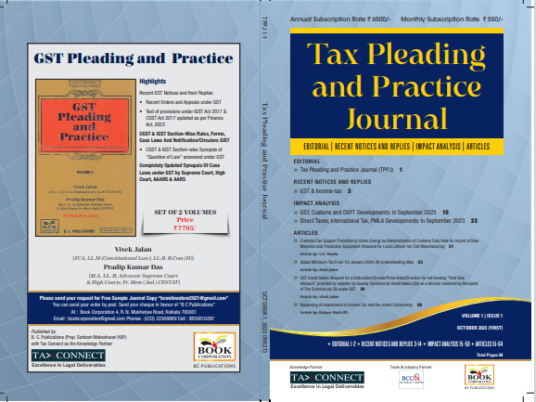

CONTENTS
- Recent Notices and replies on GST & Income Tax
- Impact Analysis on GST, Customs and DGFT Developments: In September 2023
- Impact Analysis on Direct Taxes, International Tax, PMLA Developments: In September 2023
- Articles

Author:
Vivek Jalan
[FCA, LL.M (Constitutional Law), LL.B, B.Com(H)]

S.K. Panda
[IRS-Retd.; Ex-Member CBIC & Special Secretary – GoI]

P.K. Das
[IRS-Retd.; Ex-Member CBDT & Special Secretary – GoI]

Published by: In Association With:
BOOK CORPORATION TAX CONNECT ACADEMY
4, R. N. Mukherjee Road 6, Netaji Subhas Road,
Kolkata 700001 Kolkata 700001
Phones: (033) 64547999 Cell: 7003384915
Cell: 9830010297, 9331018333 Order by email: info@taxconnect.co.in
Order by email:bookcorporation@gmail.com Website : www.taxconnect.co.in
Website :www.bookcorporation.com

:IN STANDS

GST PLEADING AND PRACTICE: With Section-wise GST Cases & GST Notices and their Replies
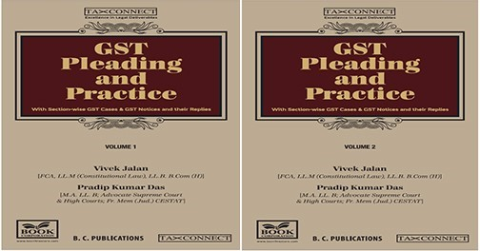

ABOUT THE BOOK: This publication includes:
- Recent GST Notices and their Replies
• Recent Orders and Appeals under GST
• Text of provisions under IGST Act 2017 & CGST Act 2017 updated as per Finance Act, 2023

- CGST & IGST Section-Wise Rules, Forms, Case Laws And Notification/Circulars GIST
• CGST & IGST Section-wise Synopsis of “Question of Law” answered under GST

- Completely Updated Synopsis Of Case Laws under GST by Supreme Court, High Court, AAARS & AARS

Authors:
Vivek Jalan
[FCA, LL.M (Constitutional Law), LL. B, B. Com(H)]

Pradip Kumar Das
[M.A. LL. B; Advocate Supreme Court & High Courts; Fr. Mem (Jud.) CESTAT]

Published by: In Association With:
BOOK CORPORATION TAX CONNECT ACADEMY
4, R. N. Mukherjee Road 6, Netaji Subhas Road,
Kolkata 700001 Kolkata 700001
Phones: (033) 64547999 Cell: 7003384915
Cell: 9830010297, 9331018333 Order by email: info@taxconnect.co.in
Order by email:bookcorporation@gmail.com Website : www.taxconnect.co.in
Website :www.bookcorporation.com
:IN STANDS

HANDBOOK ON GST 2022
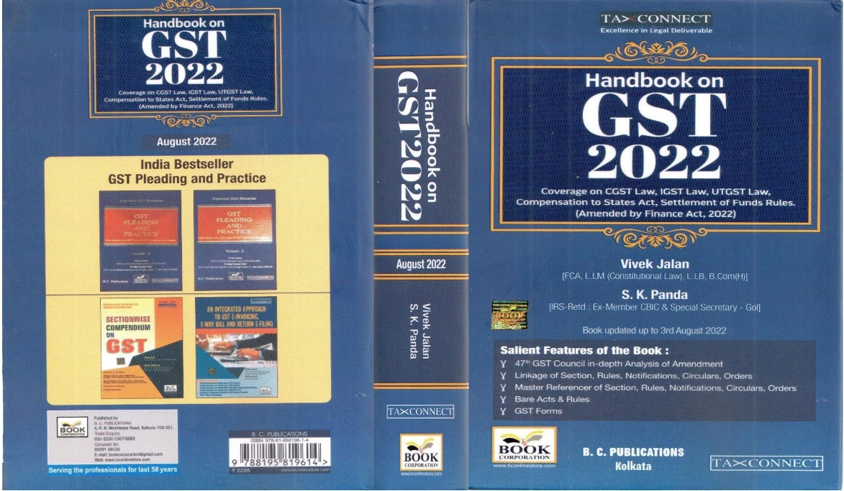

CONTENTS
- 47th GST Council in-depth Analysis of Amendment
- Linkage of Section, Rules, Notifications, Circulars, Orders
- Master Reference of Section, Rules, Notifications, Circulars, Orders
- Bare Acts & Rules
- GST Forms
Author:
Vivek Jalan
[FCA, LL.M (Constitutional Law), LL.B, B.Com(H)]

S.K. Panda
[IRS-Retd.; Ex-Member CBIC & Special Secretary – GoI]

Published by: In Association With:
BOOK CORPORATION TAX CONNECT ACADEMY
4, R. N. Mukherjee Road 6, Netaji Subhas Road,
Kolkata 700001 Kolkata 700001
Phones: (033) 64547999 Cell: 7003384915
Cell: 9830010297, 9331018333 Order by email: info@taxconnect.co.in
Order by email:bookcorporation@gmail.com Website : www.taxconnect.co.in
Website :www.bookcorporation.com

:IN STANDS

How to Handle GST LITIGATION: Assessment, Scrutiny, Audit & Appeal
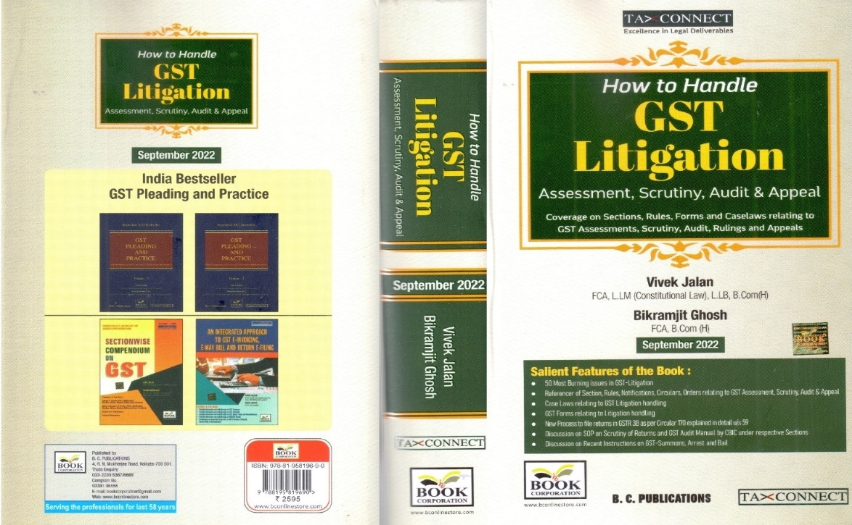

CONTENTS
1. 50 Most Burning issues in GST-Litigation
2. Reference of Section, Rules, Notifications, Circulars, Orders relating to GST Assessment, Scrutiny, Audit & Appeal
3. Case Laws relating to GST Litigation handling
4. GST Forms relating to Litigation handling
5. New process to file returns in GSTR 3B as per circular 170 explained in details u/s 59
6. Discussion on SOP on Scrutiny of Returns and GST Audit Manual by CBIC under respective Sections
7. Discussion on Recent Instruction on GST-Summons, Arrest and Bail

Authors:
Vivek Jalan
[FCA, LL.M (Constitutional Law), LL. B, B. Com(H)]

Bikramjit Ghosh
[FCA, B. Com(H)]

Published by: In Association With:
BOOK CORPORATION TAX CONNECT ACADEMY
4, R. N. Mukherjee Road 6, Netaji Subhas Road,
Kolkata 700001 Kolkata 700001
Phones: (033) 64547999 Cell: 7003384915
Cell: 9830010297, 9331018333 Order by email: info@taxconnect.co.in
Order by email:bookcorporation@gmail.com Website : www.taxconnect.co.in
Website :www.bookcorporation.com

LET’S DISCUSS FURTHER!



OUR OFFICES:
MUMBAI
Unit No. 312, Omega Business Park, Near Kaamgar Hospital, Road No. 33, Wagle Industrial Estate, Thane West,
Maharashtra- 400604

Contact Person: Priyanka Vishwakarma
Email:priyanka.vishwakarma@taxconnect.co.in
BENGALURU
951, 24th Main Road, J P Nagar, Bengaluru, Karnataka – 560078.

Contact Person: Anil Pal

Email:anil.pal@taxconnectdelhi.co.in

DELHI (NCR)
B-139, 2nd Floor, Transport Nagar,
Noida-201301 (U.P)

Contact Person: Poonam Khemka

Email:poonam.khemka@taxconnect.co.in



DUBAI
Azizi Feirouz, 803, 8th Floor, AL Furjan, Opposite Discovery Pavillion,
Dubai, UAE

Contact Person: Rohit Sharma

Email:rohit.sharma@taxconnect.co.in

KOLKATA
R No 119; 1st Floor; Diamond Arcade; 1/72, Cal Jessore Road,
Kolkata – 700055

Contact Person: Uttam Kumar Singh

Email:uttam.singh@taxconnect.co.in
KOLKATA
6, Netaji Subhas Road, 3rd Floor, Royal Exchange Building,
Kolkata - 700001

Contact Person: Tithly Roy

Email:tithly.roy@taxconnect.co.in

Disclaimer:
This e-bulletin is for private circulation only. Views expressed herein are of the editorial team and are based on the information, explanation and documents available on Government portal platforms. Tax Connect or any of its employees do not accept any liability whatsoever direct or indirect that may arise from the use of the information contained herein. No matter contained herein may be reproduced without prior consent of Tax Connect. While this e-article has been prepared on the basis of published/other publicly available information considered reliable, we do not accept any liability for the accuracy of its contents.
Tax Connect 2023. All rights reserved.

