s Iz8
_{TAX CONNECT}

432nd Issue: 10th December 2023-16th December 2023
12017

sssss

Knowledge Partner:



TAX CONNECT :

Mumbai : Unit No. 312, Omega Business Park, Near-Kaamgar Hospital, Road No. 33, Wagle Industrial Estate,
Thane (West), Maharashtra – 400604
Bengaluru : 951, 24th Main Road, J P Nagar, Bengaluru, Karnataka – 560078.
Delhi (NCR) : B-139, 2ndFloor, Transport Nagar, Noida-201301 (U.P)
Kolkata : 6, Netaji Subhas Road, 3rd Floor, Royal Exchange Building, Kolkata – 700001
- Room No. 119, 1stFloor, “Diamond Arcade” 1/72, Cal Jessore Road, Kolkata – 700055
- Tobacco House, 1, Old Court House St, Radha Bazar, Corner, Kolkata, West Bengal 700001
Dubai : Azizi Feirouz, 803, 8th Floor, AL Furjan, Opposite Discovery Pavillion, Dubai, UAE

Contact : +91 7003384915

Website : www.taxconnect.co.in
Email : info@taxconnect.co.in

Friends,
On and from AY 2017-18, Special provisos were added to Section 50C(1) of Income Tax Act, for full value of consideration in certain cases. The Section with the provisos hold that –

Where the consideration received or accruing as a result of the transfer by an assessee of a capital asset, being land or building or both, is less than the value adopted or assessed or assessable by any stamp valuation authority, the value so adopted for assessment shall be deemed to be the full value of the consideration received or accruing as a result of such transfer.

[Provided that where the date of the agreement fixing the amount of consideration and the date of registration for the transfer of the capital asset are not the same, the value adopted or assessed or assessable by the stamp valuation authority on the date of agreement may be taken for the purposes of computing full value of consideration for such transfer:

Provided further that the first proviso shall apply only in a case where the amount of consideration, or a part thereof, has been received by way of an account payee cheque or account payee bank draft or by use of electronic clearing system through a [bank account or through such other electronic mode as may be prescribed], on or before the date of the agreement for transfer.]

However, these provisos are applicable w.e.f. AY 2017-18. Earlier, the decision of Hon'ble Supreme Court in case of Seshasayee Steels (P.) Ltd. v. AIT reported in (2020) in this respect lays down that in order to attract provisions of section 53A of the Transfer of Property Act The transferee must, in part performance of the contract, have taken possession of the property or any part thereof. The transferee (developer) must have performed or be willing to perform his part of the agreement. Further, a registered deed must be executed. It should not be a mere a license to enter the property for the purpose of carrying out development. As per the decision of The Hon'ble Karnataka High Court in case of CIT vs. Dr. T.K. Dayalu reported in (2011) capital gains will arise in the year in which full control and possession of land in question is given.

Another issue raised many a times is that say in the above example, the entire consideration was paid by the buyer in Year 1 after deduction of TDS u/s 194IA, then would the proposition change and the Capital Gain or Capital Loss be assessed in Year 1 as it would be deemed that the transfer took place in year 1 itself. The answer still will not change as transaction shall be treated as transfer only when possession has been taken or retained by buyer. Since possession of property has been handed over to buyer in Year 3, transfer would be considered to have taken place in Year 3 only.

Now consider the case where the date of agreement fixing the amount of consideration and the date of registration of property is different, value adopted by stamp valuation authority on the date of agreement has to be taken for purposes of computing full value of consideration of such transfer in case the control/possession has been transferred as on the date of fixing the consideration as held in the case of SMT. NEELA REDDY MORAMREDDY GARU Vs INCOME TAX OFFICER [2023-VIL- 1551- ITAT-HYD]

To sum up, prior to AY 2017-18 the capital gains should be offered to tax in the year in which the following conditions are satisfied –

1. The year in which the transferee has taken physical possession of the property or any part thereof.

2. The year in which transferee has performed or is willing to perform his part of the agreement.

A mere a license to enter the property for the purpose of carrying out development work would not be sufficient. But, as per the decision of The Hon'ble Karnataka High Court in case of CIT vs. Dr. T.K. Dayalu reported in (2011) 14 taxmann.com 120, capital gains will arise in the year in which full control and possession of property in question is given.

Just to reiterate that we remain available over telecom or e-mail.

Editor:
Vivek Jalan
Partner - Tax Connect Advisory Services LLP

Co-Editor:
Rohit Sharma
Director – Tax Connect Advisory Services LLP

S.NO. | TOPICS | PAGE NO.
1] | TAX CALENDER | 4
2] | INCOME TAX | 5
NOTIFICATION | EXEMPTION FROM SPECIFIED INCOME U/S 10(46) – ‘GODAVARI RIVER MANAGEMENT BOARD, HYDERABAD’ NOTIFIED
CASE LAW | REOPENING OF ASSESSMENT U/S 147 - REASON TO BELIEVE - AS ALLEGED ACCOMMODATION ENTRY SAID TO HAVE BEEN RECEIVED BY THE PETITIONER FROM MR S.K. JAIN [ACCOMODATION ENTRY PROVIDER] : DELHI HIGH COURT
3] | GST | 6
CASE LAW | REFUND OF ACCUMULATED INPUT TAX CREDIT - INVERTED DUTY STRUCTURE - DENIAL ON THE GROUND THAT THE RATE OF TAX ON INPUT SUPPLY AND OUTPUT SUPPLY ARE THE SAME - WHETHER IN THE GIVEN FACTS REFUND OF ACCUMULATED ITC IS PROSCRIBED BY VIRTUE OF CLAUSE (II) OF THE PROVISO TO SECTION 54(3) OF THE CGST ACT? : DELHI HIGH COURT
4] | FEMA | 7
CASE LAW | TRANSACTION ENTERED INTO BY A FOREIGN CITIZEN OF “INDIAN ORIGIN”, TO DEAL WITH REAL ESTATE IN INDIA ON CERTAIN CONDITIONS - TRANSACTION (SPECIFIED IN SECTION 31 OF THE 1973 ACT) ENTERED INTO IN CONTRAVENTION OF THAT PROVISION IS VOID OR IS ONLY VOIDABLE AND IT CAN BE VOIDED AT WHOSE INSTANCE : SUPREME COURT
5] | CUSTOMS | 8-9
NOTIFICATION | RATE OF EXCHANGE OF ONE UNIT OF FOREIGN CURRENCY EQUIVALENT TO INDIAN RUPEES - SUPERSESSION NOTIFICATION NO. 84/2023-CUSTOMS(N.T.), DATED 16TH NOVEMBER, 2023
NOTIFICATION | SEEKS TO EXEMPT IMPORTS OF YELLOW PEAS [HS 0713 10 10] FROM APPLICABLE BCD AND AIDC UP TO 31.03.2024
6] | DGFT | 10-12
NOTIFICATION | AMENDMENT IN EXPORT POLICY OF DC-OILED RICE BRAN
NOTIFICATION | AMENDMENT OF IMPORT POLICY AND POLICY CONDITIONS FOR YELLOW PEAS UNDER ITC(HS) CODE 07131010 OF CHAPTER 07 OF ITC(HS), 2022, SCHEDULE-L (IMPORT POLICY)
NOTIFICATION | AMENDMENT IN EXPORT POLICY OF ONIONS
NOTIFICATION | EXPORT OF NON-BASMATI WHITE RICE (UNDER HS CODE 10063090) TO COMOROS, MADAGASCAR, EQUATORIAL GUINEA, EGYPT AND KENYA THROUGH NATIONAL COOPERATIVE EXPORTS LIMITED (NCEL)
NOTIFICATION | INCORPORATION OF POLICY CONDITION FOR EXPORT OF NON-BASMATI RICE UNDER HS CODE 10063090
7] | TAX PLEADING AND PRACTICE JOURNAL | 13
8] | GST PLEADING AND PRACTICE: WITH SECTION-WISE GST CASES & GST NOTICES AND THEIR REPLIES | 14
9] | HANDBOOK ON GST 2022 | 15
10] | HOW TO HANDLE GST LITIGATION: ASSESSMENT, SCRUTINY, AUDIT & APPEAL | 16
11] | LET’S DISCUSS FURTHER | 17

Due Date | Form/Return/Challan | Reporting Period | Description
10th December | GSTR-7 | November’23 | Monthly return filed by individuals who deduct tax at source or TDS under the Goods and Services Tax (GST)
10th December | GSTR-8 | November’23 | Monthly return to be filed by e-commerce operators registered under the GST.
11th December | GSTR-1 | November’23 | Monthly Statement of Outward Supplies to be furnished by all normal registered taxpayers making outward supplies of goods and services or both and contains details of outward supplies of goods and services.
13th December | GSTR-1(IFF) | November’23 | Details of B2B Supply of a registered person with turnover upto INR 5 Crores during the preceding year and who has opted for quarterly filing of return under QRMP.
13th December | GSTR-6 | November’23 | Details of Input Tax Credit (ITC) received and distributed by an Input Service Distributors (ISD).
13th December | GSTR-5 | November’23 | Summary of outward taxable supplies and tax payable by a non-resident taxable person.
15th December | FORM 24G | November’23 | ​Due date for furnishing of Form 24G by an office of the Government where TDS/TCS for the month of November, 2023 has been paid without the production of a challan
15th December | Advance Tax | AY 2024-25 | ​Third instalment of advance tax for the assessment year 2024-25​
15th December | TDS Certificate | October’23 | Due date for issue of TDS Certificate for tax deducted under section 194-IA, 194-IB, 194M & 194S in the month of October, 2023
15th December | FORM 3BB | November’23 | ​Due date for furnishing statement in Form no. 3BB by a stock exchange in respect of transactions in which client codes been modified after registering in the system for the month of November, 2023

NOTIFICATION
Exemption from specified income U/s 10(46) – ‘Godavari River Management Board, Hyderabad’ notified
OUR COMMENTS: The Central Board of Direct Taxes, Ministry of Finance vide Notification No. 102/2023 dated 05-12-2023 notified In exercise of the powers conferred by clause (46) of section 10 of the Income-tax Act, 1961 (43 of 1961), the Central Government hereby notifies for the purposes of the said clause, ‘Godavari River Management Board, Hyderabad’ (PAN AAAGG1473Q), a Board constituted by Central Government in pursuance of section 85 of the Andhra Pradesh Re-Organization Act, 2014, in respect of the following specified income arising to the said Authority, as follows:
(a) Grants/Subsidies received from Central Government;
(b) Grants/Subsidies received from State Governments of Andhra Pradesh and Telangana; and
(c) Interest from bank deposits, including savings account.
2. This notification shall be effective subject to the conditions that Godavari River Management Board, Hyderabad -
(a) shall not engage in any commercial activity;
(b) activities and the nature of the specified income shall remain unchanged throughout the financial years;
and
(c) shall file return of income in accordance with the provision of clause (g) of sub-section (4C) of section 139 of the Income-tax Act, 1961.
3. This notification shall be deemed to have been applied for assessment years 2020-21 to 2023-2024 relevant for the financial years 2019-20 to 2022-2023 respectively.
[For further details please refer the notification]

CASE LAW
Reopening of assessment u/s 147 - Reason to believe - as alleged accommodation entry said to have been received by the petitioner from Mr S.K. Jain [accomodation entry provider]:HON’BLE DELHI HIGH COURT
OUR COMMENTS: It was held that the notice issued to the petitioner was accompanied by two (2) sheets of paper, which, inter alia referred to the accommodation entries made available to the petitioner. The assessment order was thereafter framed in the first round, i.e., on 30.03.2015. Therefore, according to us, the material that was examined by the AO in the second round was no different from that which was examined when the assessment order dated 30.03.2015 was passed.
As indicated above, the allegation with regard to the source of the accommodation entry and the amount was also similar, both when the assessment order dated 30.03.2015 was passed and when the 2018 notice was issued. Therefore, according to us, it is a clear case of change of opinion.
Revenue’s submission that the assessment order did not deal with the query raised with regard to the accommodation entry and the material furnished, in our opinion, is misconceived, as the aspect concerning accommodation entries was the focus of the assessment order, which is evident upon perusal of the said assessment order itself.
AO adverts to the notices issued to the petitioner, to which we had made a reference above, and the material (i.e., two sheets of paper) which were alluded to the accommodation entry received by the petitioner.
It is well-established that an AO need not write a detailed order, as long as the assessment record is indicative of the fact that a query was raised and it was answered; if such an exercise has been undertaken, it would not be open to the AO to reopen the same, unless fresh material comes to light which was not available when the matter was examined in the first instance.
Thus principle that once a query is raised and answered, the AO would have formed an opinion, notwithstanding the fact that no reasons are recorded in the assessment order. In such circumstances, the reassessment proceedings, if initiated, would be construed as being invalid in law. This principle is founded on the rationale that the assessee has no control over the manner in which the AO chooses to frame the assessment order. One needs to remember that the AO wears two hats, that of an inquisitor and adjudicator. Decided in favour of assessee.

CASE LAW
REFUND OF ACCUMULATED INPUT TAX CREDIT - INVERTED DUTY STRUCTURE - DENIAL ON THE GROUND THAT THE RATE OF TAX ON INPUT SUPPLY AND OUTPUT SUPPLY ARE THE SAME - WHETHER IN THE GIVEN FACTS REFUND OF ACCUMULATED ITC IS PROSCRIBED BY VIRTUE OF CLAUSE (II) OF THE PROVISO TO SECTION 54(3) OF THE CGST ACT? : DELHI HIGH COURT
OUR COMMENTS: It was held that in terms of Section 54(1) of the CGST Act, any person claiming refund of tax and interest paid on such tax or any amount paid by him, is entitled to make an application for refund before expiry of two years from the relevant date, which is defined under Explanation (2) to Section 54 of the CGST Act. Sub-section (3) of Section 54 of the CGST Act provides that subject to provisions of Sub-section (10) of Section 54 of the CGST Act, a person may claim refund of unutilised ITC at the end of any tax period. However, the proviso to Sub-section (3) to Section 54 of the CGST Act restricts the entitlement to refund of unutilised ITC. It expressly provides that no refund of unutilised ITC would be allowed except in cases covered under Clauses (i) and (ii) of the proviso to Section 54(3) of the CGST Act. Under Clause (i) of the proviso to Section 54(3) of the CGST Act, refund of ITC is available in cases of zero rated supplies made without payment of tax. In terms of Clause (ii) of the proviso to Section 54(3) of the CGST Act, refund is admissible, where the credit is accumulated on account of rate of tax on inputs being higher than the rate of tax of output supplies.
The Supreme Court had considered the proviso to sub-section (3) to Section 54 in UNION OF INDIA & ORS. VERSUS VKC FOOTSTEPS INDIA PVT LTD. [2021 (9) TMI 626 - SUPREME COURT] had authoritatively held that the refund of unutilised ITC was confined to two categories as spelt out in Clauses (i) and (ii) of the proviso to Sub-section (3) of Section 54 of the CGST Act - petitioner’s claim for refund is founded on Clause (ii) of the proviso to Section 54(3) of the CGST Act. According to the petitioner, the rate of tax on certain inputs is higher than the tax paid on outputs (bottled LPG). Resultantly, the petitioner has been unable to fully utilise the ITC on its inputs.
It is also relevant to note that the Appellate Authority had, inter alia, found that the petitioner’s claim for refund would not be admissible by virtue of the Circular No. 135/05/2020 as in terms of the paragraph 3.2 of the said Circular refund of accumulated ITC was not available, where the input and output supplies were the same. It is implicit in the contentions advanced on behalf of the Revenue before us that, this ground stands virtually abandoned.
The concerned authority is directed to process the petitioner’s applications for refund along with applicable interest in accordance with law as expeditiously as possible and in any event, within a period of six weeks from date –
Petition allowed.

CASE LAW
Transaction entered into by a foreign citizen of “Indian origin”, to deal with real estate in India on certain conditions - transaction (specified in Section 31 of the 1973 Act) entered into in contravention of that provision is void or is only voidable and it can be voided at whose instance : SUPREME COURT
OUR COMMENTS: Mandation to get general or special permission of the RBI for transfer or disposal of immovable property situated in India by sale or mortgage by a person, who is not a citizen of India –
HELD THAT:- Foreigners should not be permitted/allowed to deal with real estate in India; the peremptory condition of seeking previous permission of the RBI before engaging in transactions specified in Section 31 of the 1973 Act and the consequences of penalty in case of contravention, the transfer of immovable property situated in India by a person, who is not a citizen of India, without previous permission of the RBI must be regarded as unenforceable and by implication a prohibited act. That can be avoided by the RBI and also by anyone who is affected directly or indirectly by such a transaction.
There is no reason to deny remedy to a person, who is directly or indirectly affected by such a transaction. He can set up challenge thereto by direct action or even by way of collateral or indirect challenge.
Until permission is accorded by the RBI, it would not be a lawful contract or agreement within the meaning of Section 10 read with Section 23 of the Contract Act. For, it remains a forbidden transaction unless permission is obtained from the RBI. The fact that the transaction can be taken forward after grant of permission by the RBI does not make the transaction any less forbidden at the time it is entered into. It would nevertheless be a case of transaction opposed to public policy and, thus, unlawful. In this view of the matter, the appellant must succeed and would be entitled for the reliefs claimed in O.S. No. 10079 of 1984 for declaration that the gift deed dated 11.03.1977 and supplementary deed dated 19.04.1980 in favour of respondent No.1 are invalid, unenforceable and not binding on the plaintiff.
A fortiori, the plaintiff is entitled for possession of the suit property from respondent no.1 and persons claiming through him, admeasuring 12,306 square feet and also mesne profits for the relevant period for which a separate inquiry needs to be initiated under Order 20 Rule 12 of the Code of Civil Procedure, 1908.
In the present case, the land was owned by a foreign citizen. For which reason, the rigours of Section 31 must apply with full force. Additionally, it must be kept in mind that the stated notification was issued in 1993, around which time a change in policy regarding the investment opportunities for non-resident Indians and foreigners had been crystallised, by opening up of economy in India. In the present case, we are dealing with the transaction effected close to the coming into force of the 1973 Act i.e., in the year 1977 when considerations were different and governed by different policy manifested in the form of enactment of Section 31 of the 1973 Act, spoken to by the then Finance Minister in the Lok Sabha, forbidding foreigners from dealing with real estate in India.
The condition predicated in Section 31 of the 1973 Act of obtaining “previous” general or special permission of the RBI for transfer or disposal of immovable property situated in India by sale or mortgage by a person, who is not a citizen of India, is mandatory. Until such permission is accorded, in law, the transfer cannot be given effect to; and for contravening with that requirement, the concerned person may be visited with penalty under Section 50 and other consequences provided for in the 1973 Act. Hence, the Trial Court as well as the High Court committed manifest error in dismissing the suit filed by the plaintiff for a declaration in respect of suit property admeasuring 12,306 square feet and for consequential reliefs referred to therein.
A priori, we conclude that the decisions of concerned High Courts taking the view that Section 31 of the 1973 Act is not mandatory and the transaction in contravention thereof is not void or unenforceable, is not a good law. However, transactions which have already become final including by virtue of the decision of the court of competent jurisdiction, need not be reopened or disturbed in any manner because of this pronouncement. This declaration/direction is being issued in exercise of our plenary power under Article 142 of the Constitution of India. For, there has been a paradigm shift in the general policy of investment by foreigners in India and more particularly, the 1973 Act itself stands repealed. Accordingly, we deem it appropriate to overrule the decisions of the High Courts, taking contrary view, albeit, prospectively.
The appeal is allowed. The impugned judgment and decree of the Trial Court, as confirmed by the High Court, is set aside.

NOTIFICATION
Rate of exchange of one unit of foreign currency equivalent to Indian rupees - Supersession Notification No. 84/2023-Customs(N.T.), dated 16th November, 2023
OUR COMMENTS: The Ministry of Finance, Department of Revenue vide notification no 90/2023-Customs(N.T) dated 07.12.2023 notified In exercise of the powers conferred by section 14 of the Customs Act, 1962 (52 of 1962), and in supersession of the Notification No. 84/2023-Customs(N.T.), dated 16th November, 2023 except as respects things done or omitted to be done before such supersession, the Central Board of Indirect Taxes and Customs hereby determines that the rate of exchange of conversion of each of the foreign currencies specified in column (2) of each of Schedule I and Schedule II annexed hereto, into Indian currency or vice versa, shall, with effect from 8th December, 2023, be the rate mentioned against it in the corresponding entry in column (3) thereof, for the purpose of the said section, relating to imported and export goods.
SCHEDULE-I
Sl.  No. | Foreign Currency | Rate of exchange of one unit of foreign currency equivalent to Indian rupees
(1) | (2) | (3)
 |  | (a) | (b)
 |  | (For Imported Goods) | (For Export Goods)
1. | Australian Dollar | 55.70 | 53.30
2. | Bahraini Dinar | 229.80 | 213.05
3. | Canadian Dollar | 62.30 | 60.35
4. | Chinese Yuan | 11.90 | 11.45
5. | Danish Kroner | 12.20 | 11.85
6. | EURO | 91.35 | 88.25
7. | Hong Kong Dollar | 10.80 | 10.55
8. | Kuwaiti Dinar | 279.10 | 261.75
9. | New Zealand Dollar | 52.20 | 49.90
10. | Norwegian Kroner | 7.70 | 7.50
11. | Pound Sterling | 106.45 | 103.00
12. | Qatari Riyal | 23.65 | 22.20
13. | Saudi Arabian Riyal | 22.95 | 21.55
14. | Singapore Dollar | 63.15 | 61.15
15. | South African Rand | 4.55 | 4.25
16. | Swedish Kroner | 8.05 | 7.85
17. | Swiss Franc | 97.15 | 93.50
18. | Turkish Lira | 2.95 | 2.80
19. | UAE Dirham | 23.40 | 22.05
20. | US Dollar | 84.30 | 82.55
SCHEDULE-II
Sl. No. | Foreign Currency | Rate of exchange of 100 units of foreign currency equivalent to Indian rupees
(1) | (2) | (3)
 |  | (a) | (b)
 |  | (For Imported Goods) | (For Export Goods)
1. | Japanese Yen | 57.65 | 55.90
2. | Korean Won | 6.50 | 6.10
[For further details please refer the notification]
NOTIFICATION
Seeks to exempt imports of Yellow Peas [HS 0713 10 10] from applicable BCD and AIDC up to 31.03.2024
OUR COMMENTS: The Ministry of Finance, Department of Revenue vide notification no 64/2023-Customs dated 07.12.2023 notified In exercise of the powers conferred by sub-section (1) of section 25 of the Customs Act, 1962 (52 of 1962) read with section 124 of the Finance Act, 2021 (13 of 2021), the Central Government, on being satisfied that it is necessary in the public interest so to do, hereby exempts the goods of the description specified in column (3) of the Table below, falling under the tariff item of the First Schedule to the Customs Tariff Act, 1975 (51 of 1975) (hereinafter referred to as the ‘Customs Tariff Act’), specified in the corresponding entry in column (2) of the said Table, when imported into India, from the whole of the duty of customs leviable thereon under the First Schedule to the Customs Tariff Act and from the whole of the Agriculture Infrastructure and Development Cess leviable thereon under the said section of the Finance Act, 2021 (13 of 2021), namely: -
Table
Sl. No. | Tariff item | Description of goods
(1) | (2) | (3)
1. | 0713 10 10 | Yellow Peas
2. This notification shall come into force with effect from the 8th day of December, 2023, and shall remain in force up to and inclusive of the 31st day of March, 2024.
[For further details please refer the notification]

NOTIFICATION
Amendment in Export policy of Dc-Oiled Rice Bran
OUR COMMENTS: The Ministry of Commerce and Industry vide notification no. 51/2023 dated 08.12.2023 notified In exercise of powers conferred by Section 3 read with section 5 of the Foreign Trade (Development & Regulation) Act, 1992 (No. 22 of 1992), as amended, read with Para 1.02 and 2.01 of the Foreign Trade Policy, 2023, the Central Government hereby, in slight modification of Notification No. 21/2023 dt. 28th July, 2023, makes following amendment in Chapter 23 of the Schedule -2 of ITC HS export policy related to export policy of Dc-Oiled Rice Bran:
Sl. No. | ITC HS code | Description | Present Policy | Policy Condition
94A | 2306 | OIL-CAKE AND OTHER SOLID RESIDUES, WHETHER OR NOT GROUND OR IN THE FORM OF PELLETS, RESULTING FROM THE EXTRACTION OF VEGETABLE OR MICROBIAL FATS OR OILS, OTHER THAN THOSE OF HEADING 2304 OR 2305 | Free | However, export of De-Oiled Rice Bran under ITC HS code 2306 and under any other HS code is prohibited till 31.03.2024.
2. Effect of the Notification:
Export prohibition of De-Oiled Rice Bran is extended till 31st March, 2024.
[For further details please refer the notification]
NOTIFICATION
Amendment of Import Policy and Policy Conditions for Yellow Peas under ITC(HS) Code 07131010 of Chapter 07 of ITC(HS), 2022, Schedule-l (Import Policy)
OUR COMMENTS: The Ministry of Commerce and Industry vide notification no. 50/2023 dated 08.12.2023 notified ln exercise of powers conferred by Section 3 and Section 5 of Foreign Trade (Development & Regulation) Act, 1992, read with paragraph 1.02 and 2.01 of the Foreign Trade Policy (FTP) 2023, as amended from time to time, the Central Government hereby amends Import Policy and Policy conditions for Yellow Peas under ITC(HS) Code 07131010 of Chapter 07 of ITC(HS), 2022, Schedule -l (Import Policy) as under—
HS Code &  Description | Existing  Import  Policy | Existing Policy Condition | Revised  Import  Policy | Revised Policy Condition
07131010- Yellow Peas | Restricted | Import of Peas shall be subject to an annual (fiscal year) quota Minimum Import Price (MIP) of Rs. 200/- and above CIF per kilogram and import is allowed through Kolkata Sea port only. This Restriction shall not apply to Governments import commitments under any Bilateral or Regional Agreement or Memorandum of Understanding. | Free | a) Import is 'Free' without the MIP condition and without Port Restriction, for the period up to 31st March 2024. Import consignments where Customs out-of-charge is issued after 31st March 2024 shall not be considered as ‘Free’  b) With effect from 1st April 2024, the 'Restricted' import policy and associated policy conditions as existing prior to this Notification shall come into force.  c) All import of Yellow Peas during this period up to 31st March 2024 shall be allowed subject to compulsory registration under the Import Monitoring System.
2. Procedures in regard to prior registration of Yellow Peas consignments under the Import Monitoring System shall be notified separately.
Effect of the Notification: Import of Yellow Peas under ITC(HS) Code 07131010 is "Free" subject to registration under the Import Monitoring system with immediate effect for the period up to 31st March 2024. MIP condition and Port Restriction shall also not be applicable to such Yellow Peas imports for the period up to 31st March 2024.
This is issued with the approval of the Minister of Commerce & Industry.
[For further details please refer the notification]
NOTIFICATION
Amendment in export policy of Onions
OUR COMMENTS: The Ministry of Commerce and Industry vide notification no. 49/2023 dated 07.12.2023 notified In exercise of powers conferred by Section 3 read with section 5 of the Foreign Trade (Development & Regulation) Act, 1992 (No. 22 of 1992), as amended, read with Para 1.02 and 2.01 of the Foreign Trade Policy, 2023, the Central Government hereby amends the Export Policy of Onions in Chapter 07 of Schedule 2 of the ITC (HS) Export Policy, as under:
Tariff item  HS Code | Unit | Item description | Export Policy | Policy condition | Revised Export Policy | Revised Policy condition
0703 10 19 | KG | Onions: | Free | Subject to a Minimum Export Price (MEP) of US $ 800 F.O.B. per Metric Ton (MT), till 31st December, 2023." | Prohibited till  31.03.2024. | --
2. The Notification will come into effect from 08.12.2023. The provisions as under Para 1.05 of the Foreign Trade Policy, 2023 regarding transitional arrangement shall not be applicable under this Notification. Further, consignments of onions will be allowed to be exported on fulfillment of any one of the following three conditions:
i. where loading of onions on the ship has commenced before this Notification;
ii. where the shipping bill is filed and vessels have already berthed or arrived and anchored in Indian ports for loading of onion and their rotation number has been allocated before this Notification; The approval of loading in such vessels will be issued only after confirmation by the concerned Port Authorities regarding anchoring/berthing of the ship for loading of onions prior to' the Notification; and
iii. where consignments of onions has been handed over to the Customs before this Notification and is registered in their system / where consignmentsonions has entered the Customs Station for exportation before this Notification and is registered in the electronic systems of the concerned Custodian of the Customs Station with verifiable evidence of date and time stamping of these commodities having entered the Customs Station prior to issuance of this Notification. "Ihe period of export shall be upto 5th January, 2024.
3. Export on onions will also be allowed on the basis of permission granted by the Government of India to other countries based on the request of their Government.
4. Effect of this Notification:
Export policy of onions under HS Code 0703 10 19 is amended from 'Free' to 'Prohibited, till 31.03.2024'.
[For further details please refer the notification]
NOTIFICATION
Export of Non-basmati White Rice (under HS Code 10063090) to Comoros, Madagascar, Equatorial Guinea, Egypt and Kenya through National Cooperative Exports Limited (NCEL)
OUR COMMENTS: The Ministry of Commerce and Industry vide notification no. 48/2023 dated 07.12.2023 notified In exercise of powers conferred by Section 3 read with section 5 of the Foreign Trade (Development & Regulation) Act, 1992 (No. 22 of 1992), as amended, read with Para 1.02 and 2.01 of the Foreign Trade Policy, 2023 and in accordance with the provision contained in Para 2 (iv) of Notification No. 20/2023 dated 20.07.2023, export of following quantity of Non-basmati White Rice (under HS Code 10063090) to Comoros, Madagascar. Equatorial Guinea, Egypt and Kenya is permitted through National Cooperative Exports Limited (NCEL):-
S. No. | Country Name | Quantity
1 | Comoros | 20,000 MT
2 | Madagascar | 50.000 MT
3 | Equatorial Guinea | 10,000 MT
4 | Egypt | 60,000 MT
5 | Kenya | 1,00,000 MT
Effect of the Notification:
Export of Non-Basmati White Rice (under ITC-HS Code 10063090) to Comoros, Madagascar, Equatorial Guinea, Egypt and Kenya through National Cooperative Exports Limited (NCEL) is notified.
[For further details please refer the notification]
NOTIFICATION
Incorporation of Policy Condition for export of Non-basmati rice under HS Code 10063090
OUR COMMENTS: The Ministry of Commerce and Industry vide notification no. 47/2023 dated 07.12.2023 notified The Central Government, in exercise of powers conferred by Section 3 read with section 5 of the Foreign Trade (Development & Regulation) Act, 1992 (No.22 of 1992), as amended, read with Para 1.02 and 2.01 of the Foreign Trade Policy, 2023, hereby incorporates the following Policy Condition for export of Non-basmati rice against ITC (HS) code 1006 30 90 of Chapter 10 of Schedule 2 of the ITC (HS) Export Policy, as under:
ITC HS Codes | Description | Export Policy | Policy condition
1006 30 90 | Non-basmati white rice (Semi-milled or wholly milled rice, whether or not polished or glazed: Other) | Prohibited | One time exemption from "Prohibition" is granted to Indian Rice Exporters Federation for export of 20 MT of Non-basmati white rice (Semi-milled or wholly milled rice, whether or not polished or glazed: Other) as donation to National Disaster Risk Reduction & Management Authority (NDRMA), Government of Nepal for the earthquake victims.
2. Effect of this Notification:
One time exemption from 'Prohibition' is granted to Indian Rice Exporters Federation for export of 20 MT of Non-basmati white rice (Semi-milled or wholly milled rice, whether or not polished or glazed: Other) under HS Code 1006 30 90 as donation to Nepal earthquake victims.
[For further details please refer the notification]

:IN STANDS

TAX PLEADING AND PRACTICE JOURNAL
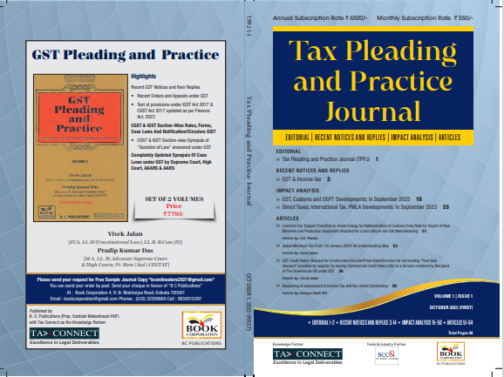

CONTENTS
- Recent Notices and replies on GST & Income Tax
- Impact Analysis on GST, Customs and DGFT Developments: In September 2023
- Impact Analysis on Direct Taxes, International Tax, PMLA Developments: In September 2023
- Articles

Author:
Vivek Jalan
[FCA, LL.M (Constitutional Law), LL.B, B.Com(H)]

S.K. Panda
[IRS-Retd.; Ex-Member CBIC & Special Secretary – GoI]

P.K. Das
[IRS-Retd.; Ex-Member CBDT & Special Secretary – GoI]

Published by: In Association With:
BOOK CORPORATION TAX CONNECT ACADEMY
4, R. N. Mukherjee Road 6, Netaji Subhas Road,
Kolkata 700001 Kolkata 700001
Phones: (033) 64547999 Cell: 7003384915 Cell: 9830010297, 9331018333 Order by email: info@taxconnect.co.in
Order by email:bookcorporation@gmail.com Website : www.taxconnect.co.in
Website :www.bookcorporation.com

:IN STANDS

GST PLEADING AND PRACTICE: With Section-wise GST Cases & GST Notices and their Replies
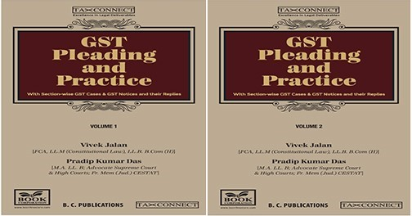

ABOUT THE BOOK: This publication includes:
- Recent GST Notices and their Replies
• Recent Orders and Appeals under GST
• Text of provisions under IGST Act 2017 & CGST Act 2017 updated as per Finance Act, 2023

- CGST & IGST Section-Wise Rules, Forms, Case Laws And Notification/Circulars GIST
• CGST & IGST Section-wise Synopsis of “Question of Law” answered under GST

- Completely Updated Synopsis Of Case Laws under GST by Supreme Court, High Court, AAARS & AARS

Authors:
Vivek Jalan
[FCA, LL.M (Constitutional Law), LL. B, B. Com(H)]

Pradip Kumar Das
[M.A. LL. B; Advocate Supreme Court & High Courts; Fr. Mem (Jud.) CESTAT]

Published by: In Association With:
BOOK CORPORATION TAX CONNECT ACADEMY
4, R. N. Mukherjee Road 6, Netaji Subhas Road,
Kolkata 700001 Kolkata 700001
Phones: (033) 64547999 Cell: 7003384915 Cell: 9830010297, 9331018333 Order by email: info@taxconnect.co.in
Order by email:bookcorporation@gmail.com Website : www.taxconnect.co.in
Website :www.bookcorporation.com
:IN STANDS

HANDBOOK ON GST 2022
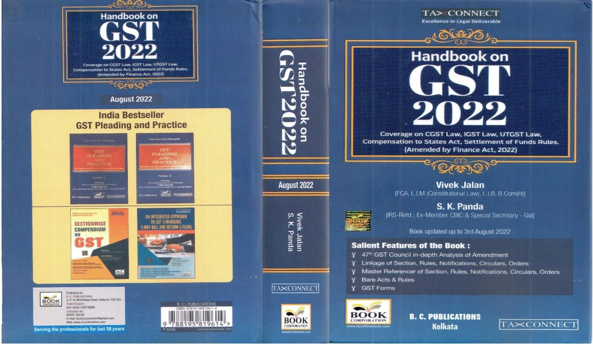

CONTENTS
- 47th GST Council in-depth Analysis of Amendment
- Linkage of Section, Rules, Notifications, Circulars, Orders
- Master Reference of Section, Rules, Notifications, Circulars, Orders
- Bare Acts & Rules
- GST Forms
Author:
Vivek Jalan
[FCA, LL.M (Constitutional Law), LL.B, B.Com(H)]

S.K. Panda
[IRS-Retd.; Ex-Member CBIC & Special Secretary – GoI]

Published by: In Association With:
BOOK CORPORATION TAX CONNECT ACADEMY
4, R. N. Mukherjee Road 6, Netaji Subhas Road,
Kolkata 700001 Kolkata 700001
Phones: (033) 64547999 Cell: 7003384915 Cell: 9830010297, 9331018333 Order by email: info@taxconnect.co.in
Order by email:bookcorporation@gmail.com Website : www.taxconnect.co.in
Website :www.bookcorporation.com

:IN STANDS

How to Handle GST LITIGATION: Assessment, Scrutiny, Audit & Appeal
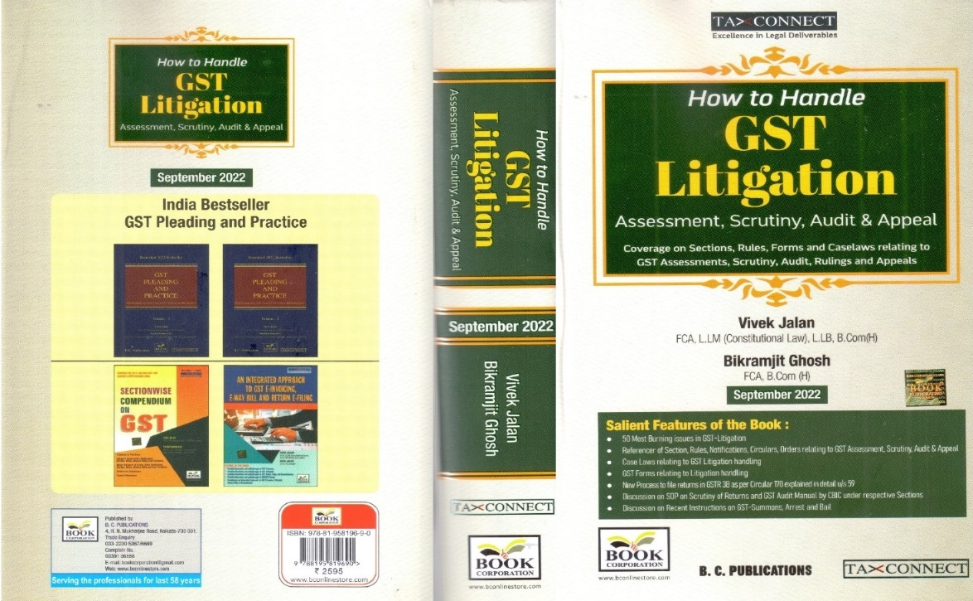

CONTENTS
1. 50 Most Burning issues in GST-Litigation
2. Reference of Section, Rules, Notifications, Circulars, Orders relating to GST Assessment, Scrutiny, Audit & Appeal
3. Case Laws relating to GST Litigation handling
4. GST Forms relating to Litigation handling
5. New process to file returns in GSTR 3B as per circular 170 explained in details u/s 59
6. Discussion on SOP on Scrutiny of Returns and GST Audit Manual by CBIC under respective Sections
7. Discussion on Recent Instruction on GST-Summons, Arrest and Bail

Authors:
Vivek Jalan
[FCA, LL.M (Constitutional Law), LL. B, B. Com(H)]

Bikramjit Ghosh
[FCA, B. Com(H)]

Published by: In Association With:
BOOK CORPORATION TAX CONNECT ACADEMY
4, R. N. Mukherjee Road 6, Netaji Subhas Road,
Kolkata 700001 Kolkata 700001
Phones: (033) 64547999 Cell: 7003384915 Cell: 9830010297, 9331018333 Order by email: info@taxconnect.co.in
Order by email:bookcorporation@gmail.com Website : www.taxconnect.co.in
Website :www.bookcorporation.com

LET’S DISCUSS FURTHER!



OUR OFFICES:
MUMBAI
Unit No. 312, Omega Business Park, Near Kaamgar Hospital, Road No. 33, Wagle Industrial Estate, Thane West,
Maharashtra- 400604

Contact Person: Priyanka Vishwakarma
Email:priyanka.vishwakarma@taxconnect.co.in
BENGALURU
951, 24th Main Road, J P Nagar, Bengaluru, Karnataka – 560078.

Contact Person: Anil Pal

Email:anil.pal@taxconnectdelhi.co.in

DELHI (NCR)
B-139, 2nd Floor, Transport Nagar,
Noida-201301 (U.P)

Contact Person: Poonam Khemka

Email:poonam.khemka@taxconnect.co.in



DUBAI
Azizi Feirouz, 803, 8th Floor, AL Furjan, Opposite Discovery Pavillion,
Dubai, UAE

Contact Person: Rohit Sharma

Email:rohit.sharma@taxconnect.co.in

KOLKATA
R No 119; 1st Floor; Diamond Arcade; 1/72, Cal Jessore Road,
Kolkata – 700055

Contact Person: Uttam Kumar Singh

Email:uttam.singh@taxconnect.co.in
KOLKATA
6, Netaji Subhas Road, 3rd Floor, Royal Exchange Building,
Kolkata - 700001

Contact Person: Tithly Roy

Email:tithly.roy@taxconnect.co.in

Disclaimer:
This e-bulletin is for private circulation only. Views expressed herein are of the editorial team and are based on the information, explanation and documents available on Government portal platforms. Tax Connect or any of its employees do not accept any liability whatsoever direct or indirect that may arise from the use of the information contained herein. No matter contained herein may be reproduced without prior consent of Tax Connect. While this e-article has been prepared on the basis of published/other publicly available information considered reliable, we do not accept any liability for the accuracy of its contents.
Tax Connect 2022. All rights reserved.

