s Iz8
_{TAX CONNECT}

431st Issue: 3rd December 2023-9th December 2023
12017

sssss

Knowledge Partner:



TAX CONNECT :

Mumbai : Unit No. 312, Omega Business Park, Near-Kaamgar Hospital, Road No. 33, Wagle Industrial Estate,
Thane (West), Maharashtra – 400604
Bengaluru : 951, 24th Main Road, J P Nagar, Bengaluru, Karnataka – 560078.
Delhi (NCR) : B-139, 2ndFloor, Transport Nagar, Noida-201301 (U.P)
Kolkata : 6, Netaji Subhas Road, 3rd Floor, Royal Exchange Building, Kolkata – 700001
- Room No. 119, 1stFloor, “Diamond Arcade” 1/72, Cal Jessore Road, Kolkata – 700055
- Tobacco House, 1, Old Court House St, Radha Bazar, Corner, Kolkata, West Bengal 700001
Dubai : Azizi Feirouz, 803, 8th Floor, AL Furjan, Opposite Discovery Pavillion, Dubai, UAE

Contact : +91 7003384915

Website : www.taxconnect.co.in
Email : info@taxconnect.co.in

Friends,
The ensuing one year or so is going to be a year of notices and Orders under GST as multiple years assessments gets time barred.

As per Section 169 of The CGST Act 2017, GST Notices under DRC-01 or Order in DRC-07 can be served by hand delivery, or by registered post, or by e-mail, or uploaded on the GST Portal or affixing in the last place of business. However, such Notices & Orders served on e-mail on many occasions go in junk mail and taxpayers cannot trace it. High Courts have also ruled that uploading the GST notice/Orders in the “View additional notices/orders” Tab instead of “View notices & Orders” Tab is also irregular services and so is the service of notice to a driver of vehicle. Service of notice to advocate with POA also sometimes gets lost or are not traceable. These matters on the one hand create hardship for taxpayers, on the other hand it makes it difficult for the Dept. to trace these and lastly also leads to unnecessary litigation.

To remove this hardship The CBIC has issued Instruction 04/2023 dated 23rd Nov. 2023 wherein it has held that under section 52, section 73, section 74, section 122, section 123, section 124, section 125, section 127, section 129 and section 130 of the CGST Act, a notice is required to be issued by the proper officer to a person for demand and recovery of any amount of tax not paid or short paid/ amount of input tax credit wrongly availed/ amount of refund erroneously made, for recovery of interest and/ or for imposition of any penalty or fine on the said person. However, as per Rule 142(1) of the CGST Rules a summary of such notice is also required to be served by the proper officer electronically on the portal in FORM GST DRC-01. Similarly as per Rule 142(5) of CGST Rules, where any order is issued by the proper officer under section 52 or section 62 or section 63 or section 64 or section 73 or section 74 or section 75 or section 76 or section 122 or section 123 or section 124 or section 125 or section 127 or section 129 or section 130 of CGST Act, summary of such order is also required to be uploaded electronically on the portal by the proper officer in FORM GST DRC-07, specifying the amount of tax, interest and penalty, as the case may be, payable by the person concerned.

However some of the field formations are serving such notices and orders manually only and are not serving the summary of the notices issued under section 52 or section 73 or section 74 or section 122 or section 123 or section 124 or section 125 or section 127 or section 129 or section 130 of CGST Act, electronically on the portal in FORM GST DRC-01, or are not uploading the summary of the order issued under section 52 or section 62 or section 63 or section 64 or section 73 or section 74 or section 75 or section 76 or section 122 or section 123 or section 124 or section 125 or section 127 or section 129 or section 130 of CGST Act electronically on the portal in FORM GST DRC-07.

Non-issuance of the summary of such notices/ orders electronically on the portal is in clear violation of the explicit provisions of CGST Rules.

Just to reiterate that we remain available over telecom or e-mail.

Editor:
Vivek Jalan
Partner - Tax Connect Advisory Services LLP

Co-Editor:
Rohit Sharma
Director – Tax Connect Advisory Services LLP

S.NO. | TOPICS | PAGE NO.
1] | TAX CALENDER | 4
2] | INCOME TAX | 5
CASE LAW | REVISION U/S 263 - NO ENQUIRY V/S INADEQUATE ENQUIRY – OFFICER FAILED TO ENQUIRE ABOUT THE “UNEXPLAINED CASH DEPOSIT” FOUND CREDITED IN THE RESPONDENT’S/ASSESSEE’S BANK ACCOUNT : DELH HIGH COURT
3] | GST | 6-7
ADVISORY | ADVISORY FOR PILOT PROJECT OF BIOMETRIC-BASED AADHAAR AUTHENTICATION AND DOCUMENT VERIFICATION FOR GST REGISTRATION APPLICANTS OF ANDHRA PRADESH
ADVISORY | ADVISORY: TWO-FACTOR AUTHENTICATION FOR TAXPAYERS
ADVISORY | ADVISORY FOR THE PROCEDURES AND PROVISIONS RELATED TO THE AMNESTY FOR TAXPAYERS WHO MISSED THE APPEAL FILING DEADLINE FOR THE ORDERS PASSED ON OR BEFORE MARCH 31, 2023
4] | FEMA | 8
CASE LAW | PROCEEDINGS INITIATED U/S 56 OF FERA - NON ISSUE OF SCN - VIOLATION OF PRINCIPLE OF NATURAL JUSTICE : DELHI HIGH COURT
5] | CUSTOMS | 9-12
NOTIFICATION | FIXATION OF TARIFF VALUE OF EDIBLE OILS, BRASS SCRAP, ARECA NUT, GOLD AND SILVER
NOTIFICATION | EXEMPTION OF DEPOSITS FROM THE PROVISIONS OF SECTION 51 OF CUSTOMS ACT, 1962
NOTIFICATION | NOTIFICATION TO EXEMPT DEPOSITS INTO ECL TILL 19TH JANUARY 2024
NOTIFICATION | FIXATION OF TARIFF VALUE OF EDIBLE OILS, BRASS SCRAP, ARECA NUT, GOLD AND SILVER
NOTIFICATION | SEEKS TO AMEND NOTIFICATION REGARDING THE FIRST TRANCHE OF INDIA UAE CEPA, DATED THE 30TH APRIL, 2022, IN ORDER TO ALIGN IT WITH CHANGES INTRODUCED VIDE NOTIFICATION NO. 72/2023-CUSTOMS (N.T.), DATED 30.09.2023
6] | DGFT | 13
NOTIFICATION | EXPORT OF FOOD COMMODITIES THROUGH NATIONAL COOPERATIVE EXPORTS LIMITED (NCEL)
7] | TAX PLEADING AND PRACTICE JOURNAL | 14
8] | GST PLEADING AND PRACTICE: WITH SECTION-WISE GST CASES & GST NOTICES AND THEIR REPLIES | 15
9] | HANDBOOK ON GST 2022 | 16
10] | HOW TO HANDLE GST LITIGATION: ASSESSMENT, SCRUTINY, AUDIT & APPEAL | 17
11] | LET’S DISCUSS FURTHER | 18

Due Date | Form/Return/Challan | Reporting Period | Description
7th December | Deposit of TDS/TCS | November’23 | ​Due date for deposit of Tax deducted/collected for the month of November, 2023. However, all sum deducted/collected by an office of the government shall be paid to the credit of the Central Government on the same day where tax is paid without production of an Income-tax Challan

CASE LAW
Revision u/s 263 - No enquiry v/s inadequate enquiry – OFFICER failed to enquire about the “unexplained cash deposit” found credited in the respondent’s/assessee’s bank account : DELH HIGH COURT
OUR COMMENTS: Principal Commissioner of Income Tax, in the instant case, while concluding that the cash sale transactions, according to him, had not been duly verified, chose not to carry out any enquiry on his own before cancelling the original assessment order and directing a fresh assessment to be made in the matter. The PCIT, in our view, wrongly equated a case of "no enquiry" with what he construed as "inadequate enquiry".
Assessee had offered an explanation with regard to cash deposits. In the course of the assessment proceedings, the AO had accepted the explanation given by the respondent/assessee that the source of the cash deposits was cash sales. Assessee had also explained why several invoices were issued on the same date bearing the same amount. It was the respondent/assessee's submission that since it was in the business of selling gold, the quantity sold often did not vary, and therefore, the amounts shown in the invoice were also similar.
This was a plausible explanation which found favour with the AO. The respondent/assessee, in support of the plea that the cash sales were the source of the deposits found credited in the subject bank account, had concededly submitted relevant material, which the AO examined in the course of the assessment proceedings. AO, having been satisfied with the explanation given, chose not to make any addition with regard to the cash deposit. PCIT on the other hand, without making any enquiry at his end, chose to cancel the assessment order with a direction to pass a fresh assessment order.
PCIT had to reach a conclusion in the fact situation obtaining in the instant case, that the assessment order was erroneous by conducting an enquiry before passing an order u/s 263.
PCIT, in our opinion, took the easy route by cancelling the impugned order and remanding the matter for a fresh assessment to the AO.
While exercising powers under Section 263 of the Act, the concerned officer is entitled to examine the entire record, which includes not only the assessment order but also the notices issued, queries raised, responses received, and the material/evidence placed on record by the assessee. In a nutshell, the record should disclose whether the AO had applied his mind to various facets that cropped up during the assessment proceedings. In other words, furnishing reasons in the assessment order is not the sine qua non of a sustainable assessment order. Courts have repeatedly stated that the AO is not required to give detailed reasons for accepting or not accepting a particular transaction. The record should reflect whether the AO applied his mind to the transaction in issue [See CIT v. Ashish Rajpal [2009 (5) TMI 18 - DELHI HIGH COURT]
Tribunal set aside the PCIT’s order correctly - Decided in favour of assessee.

ADVISORY
ADVISORY FOR PILOT PROJECT OF BIOMETRIC-BASED AADHAAR AUTHENTICATION AND DOCUMENT VERIFICATION FOR GST REGISTRATION APPLICANTS OF ANDHRA PRADESH
OUR COMMENTS: The GSTIN vide advisory dated 01.12.2023 advised that about recent developments concerning the application process for GST registration. It is advised to keep the following key points in mind during the registration process.
1. Rule 8 of the CGST Rules, 2017 has been amended to provide that an applicant can be identified on the common portal, based on data analysis and risk parameters for Biometric-based Aadhaar Authentication and taking photograph of the applicant along with the verification of the original copy of the documents uploaded with the application.
2. The above-said functionality has been developed by GSTN. It will be rolled out in Andhra Pradesh on 4th December, 2023.
3. The said functionality now also provides for the document verification and appointment booking process. After the submission of the application in Form GST REG-01, the applicant will receive either of the following links in the e-mail,
(a) A Link for OTP-based Aadhaar Authentication OR
(b) A link for booking an appointment with a message to visit a GST Suvidha Kendra (GSK) along with the details of the GSK and jurisdiction, for Biometric-based Aadhaar Authentication and document verification (the intimation e-mail)
4. If the applicant receives the link for OTP-based Aadhaar Authentication as mentioned in point 3(a), she/he can proceed with the application as per the existing process.
5. However, if the applicant receives the link as mentioned in point 3(b), she/he will be required to book the appointment to visit the designated GSK, using the link provided in the e-mail. Once the applicant gets the confirmation of appointment through e-mail (the appointment confirmation e-mail), she/he will be able to visit the designated GSK as per the chosen schedule.
6. At the time of the visit of GSK, the applicant is required to carry the following details.
(a) a copy (hard/soft) of the appointment confirmation e-mail
(b) the details of jurisdiction as mentioned in the intimation e-mail
(c) Aadhaar Number
(d) the original documents that were uploaded with the application, as communicated by the intimation e-mail.
7. The biometric authentication and document verification will be done at the GSK, for all the required individuals as per the GST application Form REG-01.
8. The applicant is required to choose an appointment for the biometric verification during the maximum permissible period for the application as indicated in the intimation e-mail. In such cases, ARNs will be generated once the Biometric-based Aadhaar Authentication process and document verification are completed.
9. The feature of booking an appointment to visit a designated GSK is currently available for the applicants of the Andhra Pradesh.
10. The operation days and hours of GSKs will be as per the guidelines provided by the administration in your respective state.
[For further details please refer the advisory]
ADVISORY
ADVISORY: TWO-FACTOR AUTHENTICATION FOR TAXPAYERS
OUR COMMENTS: The GSTIN vide advisory dated 01.12.2023 advised that
1. GSTN is introducing two-factor authentication (2FA) for taxpayers to strengthen the login security in GST portal. The pilot rollout has been done for a state of Haryana and working seamlessly. Currently, 2FA will be rolled out for Punjab, Chandigarh, Uttarakhand, Rajasthan and Delhi in 1st phase. In 2nd phase, it is planned to be rolled out all states across India.
2. Taxpayers would need to provide one-time password (OTP) post entering user id and password, the OTP will be delivered to their Primary Authorized Signatory “Mobile number and E-mail id”.
3. Tax-payers are requested to keep their email and mobile number of authorized signatory updated on the GST Portal for receiving the OTP communication. This OTP would only be asked, in case the tax-payer changes the system (desktop or laptop or browser) and location.
4. The solution would be rolled out from 1st of December’2023.
[For further details please refer the advisory]
ADVISORY
ADVISORY FOR THE PROCEDURES AND PROVISIONS RELATED TO THE AMNESTY FOR TAXPAYERS WHO MISSED THE APPEAL FILING DEADLINE FOR THE ORDERS PASSED ON OR BEFORE MARCH 31, 2023
OUR COMMENTS: The GSTIN vide advisory dated 28.11.2023 advised that
1. Amnesty for Taxpayers: The GST Council, in its 52nd meeting, recommended granting amnesty to taxpayers who could not file an appeal under section 107 of the CGST (Central Goods and Services Tax) Act, 2017, against the demand order under section 73 or 74 of the CGST Act, 2017, passed on or before March 31, 2023, or whose appeal against the said order was rejected due to not being filed within the specified time frame in sub-section (1) of section 107.
2. In compliance with the above GST Council recommendation, the government has issued Notification No. 53/2023 on November 2, 2023.
3. Taxpayers can now file an appeal in FORM GST APL-01 on the GST portal on or before January 31, 2024, for the order passed by the proper officer on or before March 31, 2023. It is further advised that the taxpayers should make payments for entertaining the appeal by the Appellate officer as per the provisions of Notification No. 53/2023. The GST Portal allows taxpayers to choose the mode of payment (electronic Credit/Cash ledger), and it is the responsibility of the taxpayer to select the appropriate ledgers and make the correct payments. Further, the office of the Appellate Authority shall check the correctness of the payment before entertaining the appeal and any appeal filed without proper payment may be dealt with as per the legal provisions.
4. If a taxpayer has already filed an appeal and wants it to be covered by the benefit of the amnesty scheme would need to make differential payments to comply with Notification No. 53/2023. The payment should be made against the demand order using the "Payment towards demand" facility available on the GST portal. The navigation step for making this payment is provided: Login >> Services >> Ledgers >> Payment towards Demand.
5. Taxpayers who have previously filed an appeal but it was rejected as time barred in APL-02 by the Appellate authority, then the taxpayer would be able to refile the appeal. However, in case, the taxpayers face any issue while re-filing APL-01, a ticket shall be raised on the Grievance redressal portal: https://selfservice.gstsystem.in. The taxpayer shall select the Category “Amnesty Scheme” and the sub-category “Amnesty scheme- Issue in appeal filing” while raising a ticket.
6. Furthermore, if the Appellate authority has issued a rejection order in APL-04 due to the appeal application being time-barred, then the taxpayer has to approach the respective Appellate authority office well in advance to comply with the dates in the said notification. The Appellate authority after checking the eligibility of the taxpayer for the amnesty scheme will forward the case to GSTN through the State Nodal officer.
7. Also, it is important to note that for the APL 04 issued cases no direct representations will be entertained by GSTN or through the Grievance redressal portal. APL 04-issued cases have to be compulsorily forwarded through the State Nodal officer.
8. Post receiving the case from the State nodal officer, GSTN will enable the taxpayer to file an appeal against the concerned order.
[For further details please refer the advisory]

CASE LAW
Proceedings initiated u/s 56 of FERA - non issue of SCN - Violation of principle of natural justice : DELHI HIGH COURT
OUR COMMENTS: It was held that no complaint can be filed unless the person accused of such offence has been given an opportunity of showing that he has such requisite permission. It is clear that from the facts of this case and also not disputed by Respondent that there is no such show cause notice which was issued and served on the fresh address of the petitioner at Gurugram. That apart, it is pertinent to note that though the notice issued under proviso to Clause (ii) of sub section (2) of Section 61 FERA was not served upon the petitioner, the demand notice dated 28.08.2020 was served upon the correct address. There is no explanation as to how and from where the ED obtained this correct address of the petitioner while issuing the demand notice.
So far as the judgments of State Bank of India [2023 (3) TMI 1205 - SUPREME COURT] and Oil and Natural Gas Corporation Limited [2014 (10) TMI 589 - SUPREME COURT] relied upon are concerned, they laid down the law in respect of what is trite by now that rule of Audi Alteram Partem is fundamental to the policy of Indian law and as such any order by any quasi-judicial authority or any administrative authority entailing drastic civil consequences cannot be sustained except after affording an opportunity to the person who would have to face such civil consequences. There is no doubt in the mind of this Court that there has been clear violation of principles of natural justice in the present case.
Since the respondent therein had failed to comply with the mandatory requirement of Section 61(2) of FERA, the Trial Court in that case clearly had erred in taking cognizance and on that basis, quashed and set aside the impugned order on charge.
This Court respectfully concurs with the observations and the ratio laid down in the case United India Airways Ltd. & Anr. [2018 (4) TMI 421 - DELHI HIGH COURT]
Proceedings being separate and not intertwined in respect of violation u/s 18(2) and (3) and Section 56 of the FERA - This Court is of the considered opinion that the substratum of violation of under Section 18(2) for becoming an offence u/s 56 has to be tested first by issuing show cause notice/opportunity notice so as to permit the petitioner to explain as to whether it got the requisite permission in accordance with law or not.
Since the show cause notice or opportunity notice was never served upon the petitioner, the consequent proceedings initiated u/s 56 FERA cannot be continued. It is for violation of Section 18(2) and Section 18(3) of the FERA that would entail action u/s 56 FERA, but the intervening threshold of issuance of show cause notice/opportunity notice and hearing the notice before passing the decision upon such mandatory application of principles of natural justice alone that the action u/s 56 could, at all, have been initiated. As such the submission of Respondent on that count are found to be untenable.
Present writ petition is allowed and as a consequence thereof, a writ of certiorari is issued quashing the exparte proceedings issued by the ED.

NOTIFICATION
Fixation of Tariff Value of Edible Oils, Brass Scrap, Areca Nut, Gold and Silver
OUR COMMENTS: The Ministry of Finance, Department of Revenue vide notification no 89/2023-Customs(N.T) dated 30.11.2023 notified In exercise of the powers conferred by sub-section (2) of section 14 of the Customs Act, 1962 (52 of 1962), the Central Board of Indirect Taxes & Customs, being satisfied that it is necessary and expedient to do so, hereby makes the following amendments in the notification of the Government of India in the Ministry of Finance (Department of Revenue), No. 36/2001-Customs (N.T.), dated the 3rd August, 2001, published in the Gazette of India, Extraordinary, Part-II, Section-3, Sub-section (ii), vide number S. O. 748 (E), dated the 3rd August, 2001, namely:-
In the said notification, for TABLE-1, TABLE-2, and TABLE-3 the following Tables shall be substituted, namely: -
“TABLE-1
Sl. No. | Chapter/ heading/ sub-heading/tariff item | Description of goods | Tariff value  (US $Per Metric Tonne)
(1) | (2) | (3) | (4)
1 | 1511 10 00 | Crude Palm Oil | 870
2 | 1511 90 10 | RBD Palm Oil | 878
3 | 1511 90 90 | Others – Palm Oil | 874
4 | 1511 10 00 | Crude Palmolein | 882
5 | 1511 90 20 | RBD Palmolein | 885
6 | 1511 90 90 | Others – Palmolein | 884
7 | 1507 10 00 | Crude Soya bean Oil | 1010
8 | 7404 00 22 | Brass Scrap (all grades) | 4688
TABLE-2
Sl. No. | Chapter/ heading/ sub-heading/tariff item | Description of goods | Tariff value  (US $)
(1) | (2) | (3) | (4)
1. | 71 or 98 | Gold, in any form, in respect of which the benefit of entries at serial number 356 of the Notification No. 50/2017-Customs dated 30.06.2017 is availed | 659 per 10 grams
2. | 71 or 98 | Silver, in any form, in respect of which the benefit of entries at serial number 357 of the Notification No. 50/2017-Customs dated 30.06.2017 is availed | 807 per kilogram
3. | 71 | (i) Silver, in any form, other than medallions and silver coins having silver content not below 99.9% or semi-manufactured forms of silver falling under sub-heading 7106 92;  (ii) Medallions and silver coins having silver content not below 99.9% or semi-manufactured forms of silver falling under sub-heading 7106 92, other than imports of such goods through post, courier or baggage.  Explanation. - For the purposes of this entry, silver in any form shall not include foreign currency coins, jewellery made of silver or articles made of silver. | 807 per kilogram
4. | 71 | (i) Gold bars, other than tola bars, bearing manufacturer’s or refiner’s engraved serial number and weight expressed in metric units;  (ii) Gold coins having gold content not below 99.5% and gold findings, other than imports of such goods through post, courier or baggage.  Explanation. - For the purposes of this entry, “gold findings” means a small component such as hook, clasp, clamp, pin, catch, screw back used to hold the whole or a part of a piece of Jewellery in place. | 659 per 10 grams
TABLE-3
Sl. No. | Chapter/ heading/ sub-heading/tariff item | Description of goods | Tariff value  (US $ Per Metric Ton)
(1) | (2) | (3) | (4)
1 | 080280 | Areca nuts | 8068(i.e., no change)”
2. This notification shall come into force with effect from the 01st day of December, 2023.
[For further details please refer the notification]
NOTIFICATION
Exemption of deposits from the provisions of Section 51 of Customs Act, 1962
OUR COMMENTS: The Ministry of Finance, Department of Revenue vide notification no 88/2023-Customs(N.T) dated 29.11.2023 notified In exercise of the powers conferred by sub-section (4) of section 51A of the Customs Act, 1962 (52 of 1962), the Central Board of Indirect Taxes and Customs, on being satisfied that it is necessary and expedient to do so, hereby makes the following further amendments to the Notification No.19/2022-Customs (N.T.) dated the 30th March, 2022, published in the Gazette of India, Extraordinary, Part II, Section 3, Sub-section (ii) vide S.O. 1512 (E), dated the 30th March, 2022, namely, -
In the said notification, in para 2, for the words, '1st December, 2023', the words '20th January, 2024' shall be substituted.
[For further details please refer the notification]
NOTIFICATION
Notification to exempt deposits into ECL till 19th January 2024
OUR COMMENTS: The Ministry of Finance, Department of Revenue vide notification no 87/2023-Customs(N.T) dated 29.11.2023 notified In exercise of the powers conferred by sub-section (4) of section 51A of the Customs Act, 1962 (52 of 1962), the Central Board of Indirect Taxes and Customs, on being satisfied that it is necessary and expedient to do so, hereby makes the following amendments to the notification No.18/2023-Customs (N.T.) dated the 30th March, 2023, published in the Gazette of India, Extraordinary, Part II, Section 3, Sub-section (ii) vide S.O. 1528 (E), dated the 30th March, 2023, namely, -
In the said notification, in para 2, for the words, '30th November, 2023', the words '19th January, 2024' shall be substituted.
[For further details please refer the notification]
NOTIFICATION
Fixation of Tariff Value of Edible Oils, Brass Scrap, Areca Nut, Gold and Silver
OUR COMMENTS: The Ministry of Finance, Department of Revenue vide notification no 86/2023-Customs(N.T) dated 28.11.2023 In exercise of the powers conferred by sub-section (2) of section 14 of the Customs Act, 1962 (52 of 1962), the Central Board of Indirect Taxes & Customs, being satisfied that it is necessary and expedient to do so, hereby makes the following amendments in the notification of the Government of India in the Ministry of Finance (Department of Revenue), No. 36/2001-Customs (N.T.), dated the 3rd August, 2001, published in the Gazette of India, Extraordinary, Part-II, Section-3, Sub-section (ii), vide number S. O. 748 (E), dated the 3rd August, 2001, namely:
In the said notification, for TABLE-1, TABLE-2, and TABLE-3 the following Tables shall be substituted, namely:
"TABLE-1
Sl. No. | Chapter/ heading/ sub-heading/tariff item | Description of goods | Tariff value (US $Per Metric Tonne)
(1) | (2) | (3) | (4)
1 | 1511 10 00 | Crude Palm Oil | 849(i.e., no change)
2 | 1511 90 10 | RBD Palm Oil | 861 (i.e., no change)
3 | 1511 90 90 | Others - Palm Oil | 855 (i.e., no change)
4 | 1511 10 00 | Crude Palmolein | 865 (i.e., no change)
5 | 1511 90 20 | RBD Palmolein | 868 (i.e., no change)
6 | 1511 90 90 | Others - Palmolein | 867 (i.e., no change)
7 | 1507 10 00 | Crude Soya bean Oil | 1001 (i.e., no change)
8 | 7404 00 22 | Brass Scrap (all grades) | 4633 (i.e., no change)
TABLE-2
Sl. No. | Chapter/ heading/ sub-heading/tariff item | Description of goods | Tariff value (US $)
(1) | (2) | (3) | (4)
1. | 71 or 98 | Gold, in any form, in respect of which the benefit of entries at serial number 356 of the Notification No. 50/2017-Customs dated 30.06.2017 is availed | 634 per 10 grams (i.e., no change)
2. | 71 or 98 | Silver, in any form, in respect of which the benefit of entries at serial number 357 of the Notification No. 50/2017-Customs dated 30.06.2017 is availed | 800 per kilogram
3. | 71 | (i) Silver, in any form, other than medallions and silver coins having silver content not below 99.9% or semi-manufactured forms of silver falling under sub-heading 7106 92;  (ii) Medallions and silver coins having silver content not below 99.9% or semi-manufactured forms of silver falling under sub-heading 7106 92, other than imports of such goods through post, courier or baggage.  Explanation. -For the purposes of this entry, silver in any form shall not include foreign currency coins, jewellery made of silver or articles made of silver. | 800 per kilogram
4. | 71 | (i) Gold bars, other than tola bars, bearing manufacturer's or refiner's engraved serial number and weight expressed in metric units;  (ii) Gold coins having gold content not below 99.5% and gold findings, other than imports of such goods through post, courier or baggage.  Explanation. -For the purposes of this entry, "gold findings" means a small component such as hook, clasp, clamp, pin, catch, screw back used to hold the whole or a part of a piece of Jewellery in place. | 634 per 10 grams (i.e., no change)
TABLE-3
Sl. No. | Chapter/ heading/ sub-heading/tariff item | Description of goods | Tariff value (USD Per Metric Tonne)
(1) | (2) | (3) | (4)
1 | 080280 | Areca nuts | 8068 (i.e., no change)"
2. This notification shall come into force with effect from the 29th day of November, 2023.
[For further details please refer the notification]
NOTIFICATION
Seeks to amend notification REGARDING the first tranche of India UAE CEPA, dated the 30th April, 2022, in order to align it with changes introduced vide notification No. 72/2023-Customs (N.T.), dated 30.09.2023
OUR COMMENTS: The Ministry of Finance, Department of Revenue vide notification no 63/2023-Customs dated 30.11.2023 notified In exercise of the powers conferred by sub-section (1) of section 25 of the Customs Act, 1962 (52 of 1962), the Central Government, on being satisfied that it is necessary in the public interest so to do, hereby makes the following further amendments in the notification of the Government of India in the Ministry of Finance (Department of Revenue), No. 22/2022-Customs, dated the 30th April, 2022, published in the Gazette of India, Extraordinary, Part II, Section 3, Sub-section (i), vide number G.S.R. 328(E), dated the 30th April, 2022, namely:-
In the said notification, in the TABLE I, after S. No. 1271 and the entries relating thereto, the following serial number and entries shall be inserted, namely:-
(1) | (2) | (3) | (4)
“1271A. | 2207 10 12 | All goods | 95”;
[For further details please refer the notification]

NOTIFICATION
Export of food commodities through National Cooperative Exports Limited (NCEL)
OUR COMMENTS: The Ministry of Commerce and Industry vide notification no. 46/2023 dated 30.11.2023 notified In exercise of powers conferred by Section 3 read with section 5 of the Foreign Trade (Development & Regulation) Act, 1992 (No. 22 of 1992), as amended, read with Para 1.02 and 2.01 of the Foreign Trade Policy, 2023, export of following food commodities are permitted through National Cooperative Exports Limited (NCEL) : -
Country Name | Commodity | Quantity
Bhutan | Wheat Grain | 14,184 MT
Bhutan | Wheat Flour Atta | 5326 MT
Bhutan | Maida/Semolina | 15,226 MT
Bhutan | Broken Rice | 48 804 MT
Mali | Broken Rice | 1 Lakh MT
Senegal | Broken Rice | 5 Lakh MT in six months' time
Gambia | Broken Rice | 50,000 MT in six months' time
Indonesia | Broken Rice | 2 Lakh MT
2. Consequent to this Notification, Trade Notice No. 08/2023 dated 20.06.2023, Trade Notice No. 17/2023 dated 28.07.2023 and Trade Notice No. 18/2023 dated 28.07.2023 are hereby rescinded.
Effect of the Notification:
Export of above-mentioned food commodities are permitted through National Cooperative Exports Limited (NCEL). This Notification rescinds Trade Notice No. 08/2023 dated 20.06.2023, Trade Notice No. 17/2023 dated 28.07.2023 and Trade Notice No. 18/2023 dated 28.07.2023
[For further details please refer the notification]

:IN STANDS

TAX PLEADING AND PRACTICE JOURNAL
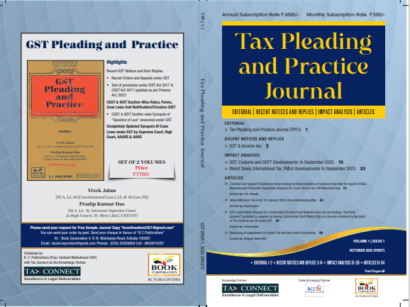

CONTENTS
- Recent Notices and replies on GST & Income Tax
- Impact Analysis on GST, Customs and DGFT Developments: In September 2023
- Impact Analysis on Direct Taxes, International Tax, PMLA Developments: In September 2023
- Articles

Author:
Vivek Jalan
[FCA, LL.M (Constitutional Law), LL.B, B.Com(H)]

S.K. Panda
[IRS-Retd.; Ex-Member CBIC & Special Secretary – GoI]

P.K. Das
[IRS-Retd.; Ex-Member CBDT & Special Secretary – GoI]

Published by: In Association With:
BOOK CORPORATION TAX CONNECT ACADEMY
4, R. N. Mukherjee Road 6, Netaji Subhas Road,
Kolkata 700001 Kolkata 700001
Phones: (033) 64547999 Cell: 7003384915 Cell: 9830010297, 9331018333 Order by email: info@taxconnect.co.in
Order by email:bookcorporation@gmail.com Website : www.taxconnect.co.in
Website :www.bookcorporation.com

:IN STANDS

GST PLEADING AND PRACTICE: With Section-wise GST Cases & GST Notices and their Replies
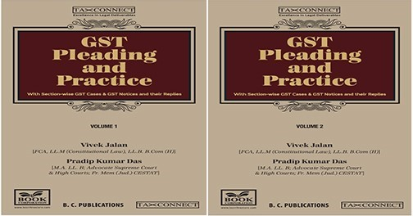

ABOUT THE BOOK: This publication includes:
- Recent GST Notices and their Replies
• Recent Orders and Appeals under GST
• Text of provisions under IGST Act 2017 & CGST Act 2017 updated as per Finance Act, 2023

- CGST & IGST Section-Wise Rules, Forms, Case Laws And Notification/Circulars GIST
• CGST & IGST Section-wise Synopsis of “Question of Law” answered under GST

- Completely Updated Synopsis Of Case Laws under GST by Supreme Court, High Court, AAARS & AARS

Authors:
Vivek Jalan
[FCA, LL.M (Constitutional Law), LL. B, B. Com(H)]

Pradip Kumar Das
[M.A. LL. B; Advocate Supreme Court & High Courts; Fr. Mem (Jud.) CESTAT]

Published by: In Association With:
BOOK CORPORATION TAX CONNECT ACADEMY
4, R. N. Mukherjee Road 6, Netaji Subhas Road,
Kolkata 700001 Kolkata 700001
Phones: (033) 64547999 Cell: 7003384915 Cell: 9830010297, 9331018333 Order by email: info@taxconnect.co.in
Order by email:bookcorporation@gmail.com Website : www.taxconnect.co.in
Website :www.bookcorporation.com
:IN STANDS

HANDBOOK ON GST 2022
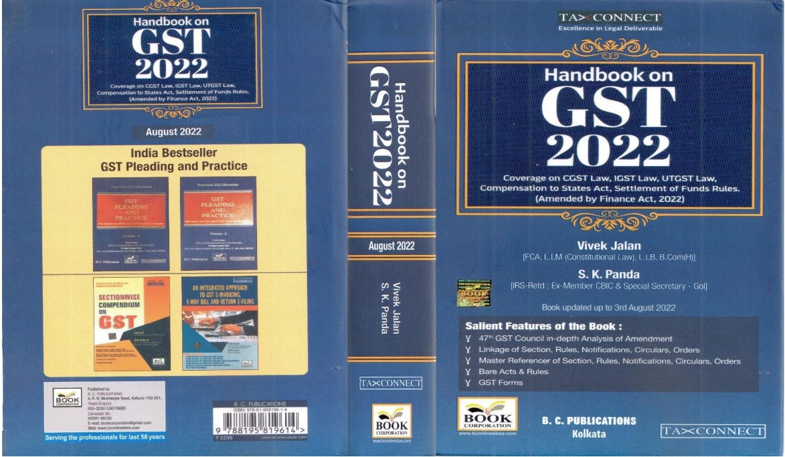

CONTENTS
- 47th GST Council in-depth Analysis of Amendment
- Linkage of Section, Rules, Notifications, Circulars, Orders
- Master Reference of Section, Rules, Notifications, Circulars, Orders
- Bare Acts & Rules
- GST Forms
Author:
Vivek Jalan
[FCA, LL.M (Constitutional Law), LL.B, B.Com(H)]

S.K. Panda
[IRS-Retd.; Ex-Member CBIC & Special Secretary – GoI]

Published by: In Association With:
BOOK CORPORATION TAX CONNECT ACADEMY
4, R. N. Mukherjee Road 6, Netaji Subhas Road,
Kolkata 700001 Kolkata 700001
Phones: (033) 64547999 Cell: 7003384915 Cell: 9830010297, 9331018333 Order by email: info@taxconnect.co.in
Order by email:bookcorporation@gmail.com Website : www.taxconnect.co.in
Website :www.bookcorporation.com

:IN STANDS

How to Handle GST LITIGATION: Assessment, Scrutiny, Audit & Appeal
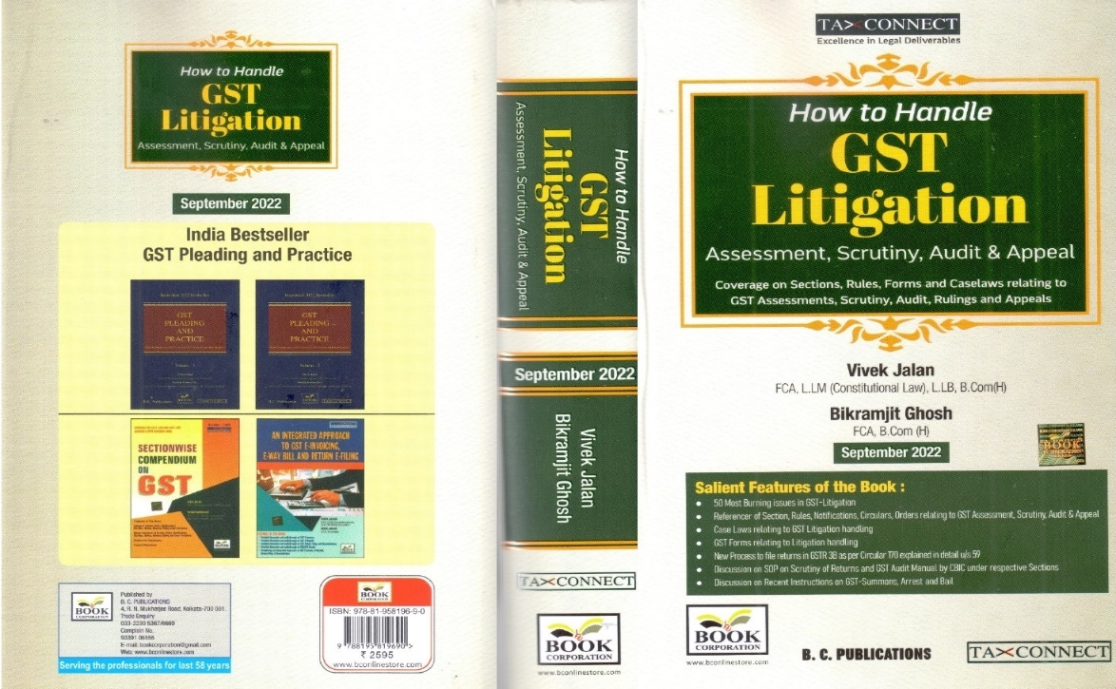

CONTENTS
1. 50 Most Burning issues in GST-Litigation
2. Reference of Section, Rules, Notifications, Circulars, Orders relating to GST Assessment, Scrutiny, Audit & Appeal
3. Case Laws relating to GST Litigation handling
4. GST Forms relating to Litigation handling
5. New process to file returns in GSTR 3B as per circular 170 explained in details u/s 59
6. Discussion on SOP on Scrutiny of Returns and GST Audit Manual by CBIC under respective Sections
7. Discussion on Recent Instruction on GST-Summons, Arrest and Bail

Authors:
Vivek Jalan
[FCA, LL.M (Constitutional Law), LL. B, B. Com(H)]

Bikramjit Ghosh
[FCA, B. Com(H)]

Published by: In Association With:
BOOK CORPORATION TAX CONNECT ACADEMY
4, R. N. Mukherjee Road 6, Netaji Subhas Road,
Kolkata 700001 Kolkata 700001
Phones: (033) 64547999 Cell: 7003384915 Cell: 9830010297, 9331018333 Order by email: info@taxconnect.co.in
Order by email:bookcorporation@gmail.com Website : www.taxconnect.co.in
Website :www.bookcorporation.com

LET’S DISCUSS FURTHER!



OUR OFFICES:
MUMBAI
Unit No. 312, Omega Business Park, Near Kaamgar Hospital, Road No. 33, Wagle Industrial Estate, Thane West,
Maharashtra- 400604

Contact Person: Priyanka Vishwakarma
Email:priyanka.vishwakarma@taxconnect.co.in
BENGALURU
951, 24th Main Road, J P Nagar, Bengaluru, Karnataka – 560078.

Contact Person: Anil Pal

Email:anil.pal@taxconnectdelhi.co.in

DELHI (NCR)
B-139, 2nd Floor, Transport Nagar,
Noida-201301 (U.P)

Contact Person: Poonam Khemka

Email:poonam.khemka@taxconnect.co.in



DUBAI
Azizi Feirouz, 803, 8th Floor, AL Furjan, Opposite Discovery Pavillion,
Dubai, UAE

Contact Person: Rohit Sharma

Email:rohit.sharma@taxconnect.co.in

KOLKATA
R No 119; 1st Floor; Diamond Arcade; 1/72, Cal Jessore Road,
Kolkata – 700055

Contact Person: Uttam Kumar Singh

Email:uttam.singh@taxconnect.co.in
KOLKATA
6, Netaji Subhas Road, 3rd Floor, Royal Exchange Building,
Kolkata - 700001

Contact Person: Tithly Roy

Email:tithly.roy@taxconnect.co.in

Disclaimer:
This e-bulletin is for private circulation only. Views expressed herein are of the editorial team and are based on the information, explanation and documents available on Government portal platforms. Tax Connect or any of its employees do not accept any liability whatsoever direct or indirect that may arise from the use of the information contained herein. No matter contained herein may be reproduced without prior consent of Tax Connect. While this e-article has been prepared on the basis of published/other publicly available information considered reliable, we do not accept any liability for the accuracy of its contents.
Tax Connect 2022. All rights reserved.

