Iz8
_{TAX CONNECT}

421st Issue: 24th September 2023-30th September 2023
12017

sssss

Knowledge Partner:



TAX CONNECT :

Mumbai : Unit No. 312, Omega Business Park, Near-Kaamgar Hospital, Road No. 33, Wagle Industrial Estate,
Thane (West), Maharashtra – 400604
Bengaluru : 951, 24th Main Road, J P Nagar, Bengaluru, Karnataka – 560078.
Delhi (NCR) : B-139, 2ndFloor, Transport Nagar, Noida-201301 (U.P)
Kolkata : 6, Netaji Subhas Road, 3rd Floor, Royal Exchange Building, Kolkata – 700001
- Room No. 119, 1stFloor, “Diamond Arcade” 1/72, Cal Jessore Road, Kolkata – 700055
- Tobacco House, 1, Old Court House St, Radha Bazar, Corner, Kolkata, West Bengal 700001
Dubai : Azizi Feirouz, 803, 8th Floor, AL Furjan, Opposite Discovery Pavillion, Dubai, UAE

Contact : +91 7003384915

Website : www.taxconnect.co.in
Email : info@taxconnect.co.in

Friends,
Rule 31B of The CGST Rules inserted vide Notification No 45/2023, provides for determining the Value of supply in case of online gaming including online money gaming. The same goes as follows:

Notwithstanding anything contained in this chapter, the value of supply of online gaming, including supply of actionable claims involved in online money gaming, shall be the total amount paid or payable to or deposited with the supplier by way of money or money’s worth, including virtual digital assets, by or on behalf of the player:

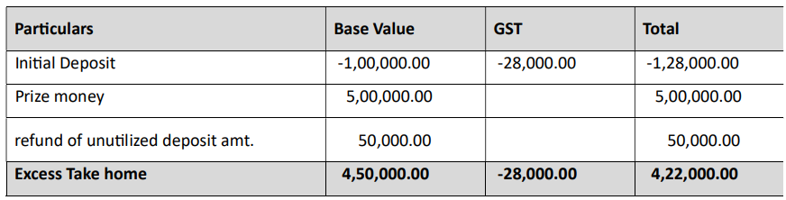
Provided that any amount returned or refunded by the supplier to the player for any reasons whatsoever, including player not using the amount paid or deposited with the supplier for participating in any event, shall not be deductible from the value of supply of online money gaming.

To explain with an example – Say a gamer deposits Rs. 1 Lakh before starting an online gaming session. He has to additionally pay Rs.28,000/- as GST. Thereafter he utilizes only Rs. 50,000 worth of his deposit, yet he will be refunded only Rs.50,000/- and not the proportionate GST of Rs.14,000/-.

Again, Rule 31C provides for Value of supply of actionable claims in case of casino as follows–

Notwithstanding anything contained in this chapter, the value of supply of actionable claims in casino shall be the total amount paid or payable by or on behalf of the player for –

(i) purchase of the tokens, chips, coins, or tickets, by whatever name called, for use in casino;
or
(ii) participating in any event, including game, scheme, competition or any other activity or process, in the casino, in cases where the token, chips, coins or tickets, by whatever name called, are not required:

Provided that any amount returned or refunded by the casino to the player on return of token, coins, chips, or tickets, as the case may be, or otherwise, shall not be deductible from the value of the supply of actionable claims in casino.

To explain with an example – Say a better deposits Rs. 1 Lakh before starting a betting session. He has to additionally pay Rs.28,000/- as GST. Thereafter he utilizes only Rs. 50,000 worth of his deposit, yet he will be refunded only Rs.50,000/- and not the proportionate GST of Rs.14,000/-.

The silver lining is in the explanation to 31B & 31C which provides as follows –

Explanation- For the purpose of rule 31B and rule 31C, any amount received by the player by winning any event, including game, scheme, competition or any other activity or process, which is used for playing by the said player in a further event without withdrawing, shall not be considered as the amount paid to or deposited with the supplier by or on behalf of the said player.”

To explain with an example – Say a better/gamer deposits Rs. 1 Lakh before starting a betting/gaming session. He has to additionally pay Rs.28,000/- as GST. Thereafter he utilizes only Rs. 50,000 worth of his deposit, but wins Rs.5,00,000/-, he will take home as follows –
Hence, the proviso to Rule 31B & 31C seems to change the taxable event from ‘supply’ to ‘expected supply’. Even though an actionable claim is a beneficial ownership in debt, yet when no supply is received at all, the non-reduction of the refunded amount from the value of supply seems to stretch the taxability. However, the explanation to the Rules makes it clear that the GST Authorities seek to control only the entry point and not post that and hence even the prize money is not taxable, just like in case of a lottery.

Just to reiterate that we remain available over telecom or e-mail.

Editor:
Vivek Jalan
Partner - Tax Connect Advisory Services LLP

Co-Editor:
Rohit Sharma
Director – Tax Connect Advisory Services LLP

S.NO. | TOPICS | PAGE NO.
1] | TAX CALENDER | 4
2] | INCOME TAX | 5-6
NOTIIFCATION | CENTRAL GOVERNMENT NOTIFIED NON-BANKING FINANCIAL COMPANIES (NBFCS U/S 43B (da) OF INCOME TAX ACT 1961
NOTIIFCATION | CENTRAL GOVERNMENT NOTIFIED NON-BANKING FINANCIAL COMPANIES (NBFCS) U/S 43D OF INCOME TAX ACT 1961
NOTIIFCATION | EXEMPTION FROM SPECIFIED INCOME U/S 10(46) – NOTIFIES ‘UTTAR PRADESH EXPRESSWAYS INDUSTRIAL DEVELOPMENT AUTHORITY’
CIRCULAR | EXTENSION OF TIMELINES FOR FILING OF FORM 10B/10BB AND FORM ITR-7 FOR THE ASSESSMENT YEAR 2023-24
3] | GST | 7
ADVISORY | GEOCODING FUNCTIONALITY FOR THE ADDITIONAL PLACE OF BUSINESS
NOTIIFCATION | APPOINTMENT OF GST ADJUCATING AUTHORITY
4] | FEMA | 8
CASE LAW | TRANSACTION ENTERED INTO BY A FOREIGN CITIZEN OF “INDIAN ORIGIN”, TO DEAL WITH REAL ESTATE IN INDIA ON CERTAIN CONDITIONS - TRANSACTION (SPECIFIED IN SECTION 31 OF THE 1973 ACT) ENTERED INTO IN CONTRAVENTION OF THAT PROVISION IS VOID OR IS ONLY VOIDABLE AND IT CAN BE VOIDED AT WHOSE INSTANCE : SUPREME COURT
5] | CUSTOMS | 9-10
NOTIFICATION | RATE OF EXCHANGE OF ONE UNIT OF FOREIGN CURRENCY EQUIVALENT TO INDIAN RUPEES
CIRCULAR | IMPLEMENTATION OF EX-BOND SHIPPING BILL IN ICES 1.5
6] | DGFT | 11
PUBLIC NOTICE | DE-LISTING OF AGENCIES AUTHORIZED TO ISSUE CERTIFICATES OF ORIGIN- (NON-PREFERENTIAL) FROM APPENDIX 2E OF FTP, 2023
7] | HANDBOOK ON GST 2022 | 12
8] | HOW TO HANDLE GST LITIGATION: ASSESSMENT, SCRUTINY, AUDIT & APPEAL | 13
9] | GST PLEADING AND PRACTICE: WITH SECTION-WISE GST CASES & GST NOTICES AND THEIR REPLIES | 14
10] | LET’S DISCUSS FURTHER | 15

Due Date | Form/Return/Challan | Reporting Period | Description
30th September | Challan-cum-Statement | Aug-23 | ​​Due date for furnishing of challan-cum-statement in respect of tax deducted under section 194-IA, 194-IB, 194M & 194S in the month of August, 2023
30th September | Audit report under section 44AB​ | AY 2023-24 | Due date for filing of audit report under section 44AB​ for the assessment year 2023-24 in the case of a corporate-assessee or non-corporate assessee (who is required to submit his/its return of income on October 31, 2023)​
30th September | Form 9A | FY 2023-24 | Application in Form 9A for exercising the option available under Explanation to section 11(1) to apply income of previous year in the next year or in future (if the assessee is required to submit return of income on November 30, 2023).
30th September | Form no. 10 | FY 2023-24 | ​​Statement in Form no. 10 to be furnished to accumulate income for future application under section 10(21) or section 11(1) (if the assessee is required to submit return of income on November 30, 2023).
30th September | Quarterly statement of TCS deposited | April-June 2023 | ​​​Quarterly statement of TCS deposited for the quarter ending June 30, 2023  Note: The due date of furnishing TCS statement has been extended from June 30, 2023 to September 30, 2023 vide Circular no. 9/2023, dated 28-06-2023
30th September | Quarterly statement of TDS deposited | April-June 2023 | ​​​​Quarterly statement of TDS deposited for the quarter ending June 30, 2023  Note: The due date of furnishing TDS statement has been extended from June 30, 2023 to September 30, 2023 vide Circular no. 9/2023, dated 28-06-2023
30th September | Form no. 10B/10BB | AY 2023-24 | ​​​​Furnishing of Audit report in Form no. 10B/10BB by a fund or trust or institution or any university or other educational institution or any hospital or other medical institution.  Note: the due date for furnishing the Audit report in Form no. 10B/10BB has been extended from September 30, 2023 to October 31, 2023 vide Circular no. 16/2023, dated 18-09-2023

NOTIFICATION
Central Government notifieD non-banking financial companies (NBFCs U/s 43B (da) of INCOME TAX Act 1961
OUR COMMENTS: The Central Board of Direct Taxes, Department of Revenue, Ministry of Finance, vide notification No. 80/2023 dated 22.09.2023 notified In exercise of the powers conferred by clause (da) of section 43B of the Income-tax Act, 1961 (43 of 1961), the Central Government hereby notifies the following classes of non-banking financial companies (NBFCs), for the purpose of the said clause, namely:–
(a) all NBFCs classified in the Top Layer;
(b) all NBFCs classified in the Upper Layer;
(c) all NBFCs classified in the Middle Layer.
Explanation.– The classification of NBFCs in the Top Layer, Upper Layer and Middle Layer shall be according to the Reserve Bank of India’s guidelines contained in Circular DOR.CRE.REC.No.60/03.10.001/2021-22 dated October 22, 2021.
2. This notification shall come into force from the date of its publication in the Official Gazette.
[For further details please refer the notification]ICATION
NOTIFICATION
Central Government notifieD non-banking financial companies (NBFCs) U/s 43D of INCOME TAX Act 1961
OUR COMMENTS: The Central Board of Direct Taxes, Department of Revenue, Ministry of Finance, vide notification No. 79/2023 dated 22.09.2023 notified In exercise of the powers conferred by section 43D of the Income-tax Act, 1961 (43 of 1961), the Central Government hereby notifies the following classes of non-banking financial companies (NBFCs), for the purpose of the said section, namely:–
(a) all NBFCs classified in the Top Layer;
(b) all NBFCs classified in the Upper Layer;
(c) all NBFCs classified in the Middle Layer.
Explanation.–he classification of NBFCs in the Top Layer, Upper Layer and Middle Layer shall be according to the Reserve Bank of India’s guidelines contained in Circular DOR.CRE.REC.No.60/03.10.001/2021-22 dated October 22, 2021.
2. This notification shall come into force from the date of its publication in the Official Gazette.NO
[For further details please refer the notification]
TIFICATION
NOTIFICATION
Exemption from specified income U/s 10(46) – Notifies ‘Uttar Pradesh Expressways Industrial Development Authority’
OUR COMMENTS: The Central Board of Direct Taxes, Department of Revenue, Ministry of Finance, vide notification No. 78/2023 dated 19.09.2023 notified In exercise of the powers conferred by clause (46) of section 10 of the Income-tax Act, 1961 (43 of 1961), the Central Government hereby notifies for the purposes of the said clause, ‘Uttar Pradesh Expressways Industrial Development Authority’ (PAN AAALU0121E), an Authority constituted by the State government of Uttar Pradesh, in respect of the following specified income arising to that Authority, namely:
(a) grants received from the state government;
(b) moneys received from the disposal of land, building and other properties, movable and immovable;
(c) moneys received by way of rent & fees or any other charges from the disposal of land, building and other properties, movable and immovable;
(d) Income earned from Tender Fees, Document Fees, License Fees; and
(e) Interest earned on funds deposited in the banks and on (a) to (d) above.
2. This notification shall be effective subject to Uttar Pradesh Expressways Industrial Development Authority:-
(a) shall not engage in any commercial activity;
(b) activities and the nature of the specified income shall remain unchanged throughout the financial years; and
(c) shall file return of income in accordance with the provision of clause (g) of sub-section (4C) of section 139 of the Income-tax Act, 1961.
3. This notification shall be deemed to have been applied for the assessment year 2023-2024 relevant for financial year 2022-2023.
[For further details please refer the notification]
CIRCULAR
Extension of timelines for filing of Form 10B/10BB and Form ITR-7 for the Assessment Year 2023-24
OUR COMMENTS: The Central Board of Direct Taxes, Department of Revenue, Ministry of Finance, vide Circular No. 16/2023 dated 18.09.2023 circulated that On consideration of difficulties reported by the taxpayers and other stakeholders, the Central Board of Direct Taxes (CBDT), in exercise of its powers under Section 119 of the Income-tax Act, 1961 (Act), provides relaxation in respect of following compliances:
1. The due date of furnishing Audit report under clause (b) of the tenth proviso to clause (23C) of section 10 and sub-clause (ii) of clause (b) of sub-section (1) of section 12A of the Income-tax Act, 1961, in the case of a fund or trust or institution or any university or other educational institution or any hospital or other medical institution in Form 10B/Form 10BB for the Previous Year 2022-23, which is 30th September, 2023, is here by extended to 31st October, 2023.
2. The due date of furnishing of Return of Income in Form ITR-7 for the Assessment Year 2023-24 in the case of assessees referred to in clause (a) of Explanation 2 to sub-section (1) of section 139 of the Act, which is 31st October, 2023, is hereby extended to 30th November, 2023.
[For further details please refer the circular]

ADVISORY
GEOCODING FUNCTIONALITY FOR THE ADDITIONAL PLACE OF BUSINESS
OUR COMMENTS: The GSTIN vide advisory dated 19.09.2023 instructed that
1.GSTN is pleased to inform that the geocoding functionality for the "Additional Place of Business" address is now active across all States and Union Territories. This builds upon the geocoding functionality earlier implemented for the principal place of business, operational since February 2023.
2.To date, over 2.05 crore addresses have been geocoded for both principal and additional places of business by GSTN. Moreover, since March 2022, all new addresses are geocoded at the point of registration, ensuring consistent accuracy and standardisation from the beginning.
3. Here is a brief guide on how to utilize this feature:
i.Access: Navigate to Services>>Registration>>Geocoding Business Addresses tab on the FO portal to find this functionality.
ii.Usage: The system will display a system-generated geocoded address. You have the option to accept this or modify it as needed. If a system-generated address is not available, you can input the geocoded address directly.
iii.Viewing: Saved geocoded address details can be found under the "Geocoded Places of Business" tab. After logging in, go to My Profile >> Geocoded Places of Business.
iv.One-time Submission: This is a one-time activity, and post-submission, address revisions are not permitted. Taxpayers who have already geocoded their addresses through new registration or core amendment would not be required to do this as on the GST portal their address will be shown as geocoded. Remember, changes to the address on your registration certificate can only be made through the core amendment process. This geocoding feature will not affect previously saved addresses.
v.Eligibility: This feature is accessible to normal, composition, SEZ units, SEZ developers, ISD and casual taxpayers whether they are active, cancelled, or suspended.
[For further details please refer the advisory]
NOTIFICATION
APPOINTMENT OF GST ADJUCATING AUTHORITY
OUR COMMENTS: The Central Board of Indirect Taxes and Customs vide notification no. 46/2023-Central Tax dated 18.09.2023 notified In exercise of the powers conferred by section 5 of the Central Goods and Services Tax Act, 2017 (12 of 2017) and section 3 of the Integrated Goods and Services Tax Act, 2017 (13 of 2017), the Board, hereby appoint officers mentioned in column (5) of the Table below to act as the Authority to exercise the powers and discharge the duties conferred or imposed on officers mentioned in column (4) of the said Table in respect of noticee mentioned in column (2) of the said Table for the purpose of adjudication of notice mentioned in column (3) of the said Table, namely:-
TABLE
Sl.  No. | Name of Noticee  and Address | Notice Number  and Date | Name of Adjudicating  Authority | Name of the Authority
(1) | (2) | (3) | (4) | (5)
1. | M/s Inkuat Infrasol Pvt. Ltd., 1st Floor, H.No. 2067/8, Flat No. 101, E-Wing, Roopkamal Plaza, opp. Rajlaxmi kalher Thane, Bhiwandi, Thane- 421302. | 39/PK/Inkuat/2021-22 dated 25.03.2022 | Joint or Additional Commissioner, CGST and Central Excise Bhiwandi Commissionerate. | Joint or Additional Commissioner, CGST and Central Excise Thane Commissionerate [holding the charge of adjudication of DGGI cases].
[For further details please refer the notification]

CASE LAW
Transaction entered into by a foreign citizen of “Indian origin”, to deal with real estate in India on certain conditions - transaction (specified in Section 31 of the 1973 Act) entered into in contravention of that provision is void or is only voidable and it can be voided at whose instance : SUPREME COURT
OUR COMMENTS: It was held that Foreigners should not be permitted/allowed to deal with real estate in India; the peremptory condition of seeking previous permission of the RBI before engaging in transactions specified in Section 31 of the 1973 Act and the consequences of penalty in case of contravention, the transfer of immovable property situated in India by a person, who is not a citizen of India, without previous permission of the RBI must be regarded as unenforceable and by implication a prohibited act. That can be avoided by the RBI and also by anyone who is affected directly or indirectly by such a transaction.
There is no reason to deny remedy to a person, who is directly or indirectly affected by such a transaction. He can set up challenge thereto by direct action or even by way of collateral or indirect challenge.
Until permission is accorded by the RBI, it would not be a lawful contract or agreement within the meaning of Section 10 read with Section 23 of the Contract Act. For, it remains a forbidden transaction unless permission is obtained from the RBI. The fact that the transaction can be taken forward after grant of permission by the RBI does not make the transaction any less forbidden at the time it is entered into. It would nevertheless be a case of transaction opposed to public policy and, thus, unlawful. In this view of the matter, the appellant must succeed and would be entitled for the reliefs claimed in O.S. No. 10079 of 1984 for declaration that the gift deed dated 11.03.1977 and supplementary deed dated 19.04.1980 in favour of respondent No.1 are invalid, unenforceable and not binding on the plaintiff.
A fortiori, the plaintiff is entitled for possession of the suit property from respondent no.1 and persons claiming through him, admeasuring 12,306 square feet and also mesne profits for the relevant period for which a separate inquiry needs to be initiated under Order 20 Rule 12 of the Code of Civil Procedure, 1908.
In the present case, the land was owned by a foreign citizen. For which reason, the rigours of Section 31 must apply with full force. Additionally, it must be kept in mind that the stated notification was issued in 1993, around which time a change in policy regarding the investment opportunities for non-resident Indians and foreigners had been crystallised, by opening up of economy in India. In the present case, we are dealing with the transaction effected close to the coming into force of the 1973 Act i.e., in the year 1977 when considerations were different and governed by different policy manifested in the form of enactment of Section 31 of the 1973 Act, spoken to by the then Finance Minister in the Lok Sabha, forbidding foreigners from dealing with real estate in India.
The condition predicated in Section 31 of the 1973 Act of obtaining “previous” general or special permission of the RBI for transfer or disposal of immovable property situated in India by sale or mortgage by a person, who is not a citizen of India, is mandatory. Until such permission is accorded, in law, the transfer cannot be given effect to; and for contravening with that requirement, the concerned person may be visited with penalty under Section 50 and other consequences provided for in the 1973 Act. Hence, the Trial Court as well as the High Court committed manifest error in dismissing the suit filed by the plaintiff for a declaration in respect of suit property admeasuring 12,306 square feet and for consequential reliefs referred to therein.
A priori, we conclude that the decisions of concerned High Courts taking the view that Section 31 of the 1973 Act is not mandatory and the transaction in contravention thereof is not void or unenforceable, is not a good law. However, transactions which have already become final including by virtue of the decision of the court of competent jurisdiction, need not be reopened or disturbed in any manner because of this pronouncement. This declaration/direction is being issued in exercise of our plenary power under Article 142 of the Constitution of India. For, there has been a paradigm shift in the general policy of investment by foreigners in India and more particularly, the 1973 Act itself stands repealed. Accordingly, we deem it appropriate to overrule the decisions of the High Courts, taking contrary view, albeit, prospectively.
The appeal is allowed.

NOTIFICATION
Rate of exchange of one unit of foreign currency equivalent to Indian rupees
OUR COMMENTS: The Ministry of Finance, Department of Revenue vide notification no 68/2023-Customs(N.T) dated 21.09.2023 notified In exercise of the powers conferred by section 14 of the Customs Act, 1962 (52 of 1962), and in supersession of the Notification No. 64/2023-Customs(N.T.), dated 6th September, 2023 except as respects things done or omitted to be done before such supersession, the Central Board of Indirect Taxes and Customs hereby determines that the rate of exchange of conversion of each of the foreign currencies specified in column (2) of each of Schedule I and Schedule II annexed hereto, into Indian currency or vice versa, shall, with effect from 22nd September, 2023, be the rate mentioned against it in the corresponding entry in column (3) thereof, for the purpose of the said section, relating to imported and export goods.
SCHEDULE-I
Sl. No. | Foreign Currency | Rate of exchange of one unit of foreign currency equivalent to Indian rupees
(1) | (2) | (3)
 |  | (a) | (b)
 |  | (For Imported Goods) | (For Export Goods)
1. | Australian Dollar | 54.55 | 52.20
2. | Bahraini Dinar | 228.00 | 214.00
3. | Canadian Dollar | 62.70 | 60.65
4. | Chinese Yuan | 11.55 | 11.25
5. | Danish Kroner | 12.05 | 11.65
6. | EURO | 90.05 | 86.90
7. | Hong Kong Dollar | 10.80 | 10.45
8. | Kuwaiti Dinar | 277.65 | 261.10
9. | New Zealand Dollar | 50.50 | 48.20
10. | Norwegian Kroner | 7.80 | 7.55
11. | Pound Sterling | 104.20 | 100.80
12. | Qatari Riyal | 23.55 | 22.10
13. | Saudi Arabian Riyal | 22.85 | 21.50
14. | Singapore Dollar | 61.80 | 59.85
15. | South African Rand | 4.55 | 4.25
16. | Swedish Kroner | 7.55 | 7.30
17. | Swiss Franc | 94.20 | 90.65
18. | Turkish Lira | 3.15 | 3.00
19. | UAE Dirham | 23.35 | 21.95
20. | US Dollar | 84.05 | 82.30
SCHEDULE-II
Sl. No. | Foreign Currency | Rate of exchange of 100 units of foreign currency equivalent to Indian rupees
(1) | (2) | (3)
 |  | (a) | (b)
 |  | (For Imported Goods) | (For Export Goods)
1. | Japanese Yen | 56.95 | 55.20
2. | Korean Won | 6.40 | 6.00
[For further details please refer the notification]
CIRCULAR
Implementation of Ex-Bond Shipping Bill in ICES 1.5
OUR COMMENTS: The Ministry of Finance, Department of Revenue vide circular no 22/2023-Customs dated 19.09.2023 reference is drawn to Sections 68 and 69 of the Customs Act, 1962 which deal with clearance of warehoused goods for home consumption and for export respectively. A bill of entry (BE) format for home consumption clearance of such goods is already available in the ICES. Such ex-bond BE is linked in the System with the original warehousing (into-bond) BE through which these goods were warehoused at the time of import into India.
1.1 So far, there was no format for ex-bond shipping bill (SB) in the System to cover export of warehoused goods. Due to this, the ledger of warehoused goods was not complete as all transactions of removal of cargo were not captured.
2. Now, a format for ex-bond SB has been developed on ICES for processing of export of warehoused goods from a bonded warehouse. The design and workflow are as follows:
(i) While filing an ex-bond SB, the exporter needs to declare the warehouse code in the single window table, with following details, which will depict that it is a re-export case:
Info_Typ | Info_Qfr | Info_Code
DIR | XSB | Warehouse_code to be entered
This warehouse code would reflect the warehouse, from where the goods are to be exported. It may or may not be the warehouse where the goods were originally warehoused at the time of import.
(ii) Once the above details are provided, in the next screen item-wise details of bill of entry (BE_Site, BE_No, BE_Date, BE_Inv_SrNo, BE_Item no) will have to be entered.
(iii) In one shipping bill, only one warehouse code can be captured which means that goods lying in only one warehouse can be exported in a single shipping bill and separate shipping bills are required to be filed for export of bonded cargo from more than one warehouse.
(iv) In ex-bond SB, for each item, details of into-bond BE i.e. BE No. and date, invoice no., sl. no. etc., shall be mandatory. For each item, only one into-bond BE can be captured. For example, if fifty units of the same item were warehoused under five different into-bond BE (ten units under each into-bond BE) and now the exporter wants to export these fifty items, he will have to declare these goods as five different items. Hence, the SB format will allow export of items imported under more than one into-bond BE under one ex-bond SB to address the requests of the trade that goods imported separately may be cleared under one document.
(v) Once SB is filed, after successful verification, the system would debit the quantity exported in the ledger from the quantity imported. In case of cancellation of SB or purging of SB, the quantity would be re-credited automatically. Any amendment in the SB quantity has also been linked with the ledger quantity so as to update the ledger accordingly.
2.1 This type of shipping bill can only be used for export of warehoused goods, and not for other goods. It is also not meant for the export of goods resulting from manufacturing or other operations under section 65 in a bonded warehouse. However, if the goods imported in a warehouse where permission has been granted under section 65, are exported as such then the abovementioned ex-bond SB can be filed.
2.2 No incentive such as Drawback, RoDTEP/RoSCTL benefit, advance authorisation/EPCG etc. shall be available for such cargo and the SB would be a free SB.
3. Advisory from DG Systems follows. Officers facing any issues may email to saksham.seva@icegate.gov.in. Traders facing any difficulties may email to icegatehelpdesk@icegate.gov.in.
4. Suitable Public Notice may be issued so as to ensure that only ex-bond SB is filed for export of warehoused goods.
[For further details please refer the circular]

PUBLIC NOTICE
De-listing of agencies authorized to issue Certificates of Origin- (NON-PREFERENTIAL) from Appendix 2E of FTP, 2023
OUR COMMENTS: The Ministry of Commerce and Industry vide public notice no. 31/2023 dated 20.09.2023 notified Pursuant to Trade Notice No. 22/2023 dated 16.08.2023, whereby a final notice was given to those agencies enlisted under Appendix 2E of FTP, 2023 who have still not on-boarded on the e-CoO platform for issuance of Certificate of Origin (Non-Preferential), to complete their on-boarding by 31st August 2023. However, 32 agencies failed to respond to the DGFT or initiate any action for on-boarding on the e-CoO platform despite follow-ups and reminders.
2. Accordingly, in exercise of powers conferred under paragraph 2.04 of the Foreign Trade Policy (FTP) 2023, the Director General of Foreign Trade hereby de-list the following 30 agencies from Appendix 2E of the FTP, 2023, who failed to initiate their process of on-boarding on the CDP platform, as under:
S. No. | Name of the agency | State
1. | Indian Society of Agribusiness Professionals | Delhi
2. | International Society for Small and Medium | Delhi
3. | North East Chamber of Commerce & Industry | Assam
4. | Karnataka Small Scale Industries Association | Karnataka
5. | Porbandar Chamber of Commerce & Industry | Gujarat
6. | J&K Walnuts Exporters Association | J&K
7. | The Kashmir Chamber of Commerce & Industry, | J&K
8. | Devi Ahilya Chamber of Commerce and Industries | Madhya Pradesh
9. | The Soyabean Processors Association of India, | Madhya Pradesh
10. | Association of Merchants & Manufacturers of Textile Stores and Machinery(India) | Maharashtra
11. | MVIRDC World Trade Centre | Maharashtra
12. | Indo German Chamber of Commerce | Maharashtra
13. | Associated Manipur Chamber of Commerce | Meghalaya
14. | Federation of All Manipur Importers/Exporters Chamber of Commerce & Industry | Manipur
15. | Border Trade Chamber of Commerce, | Manipur
16. | Meghalaya Mineral Exporters Chamber of Commerce | Manipur
17. | Meghalaya International Exporters Chamber of Commerce | Manipur
18. | Bhiwadi Manufacturer's Association | Rajasthan
19. | Federation of Rajasthan Trade and Industry, | Rajasthan
20. | Centre for Development of Stones (CDOS), | Rajasthan
21. | The National Chamber of Commerce, | Tamil Nadu
22. | Salem Dharmapuri Chamber of Commerce | Tamil Nadu
23. | Indo-Australian Chamber of Commerce | Tamil Nadu
24. | Federation of Telangana Small (MSME) Industries Associations | Telangana
25. | Tripura Exporters-Importers Chamber of Commerce | Tripura
26. | Eastern U.P. Chambers of Commerce & Industry | Uttar Pradesh
27. | Upper India Chamber of Commerce, | Uttar Pradesh
28. | Eastern UP Exporters Association | Uttar Pradesh
29. | Federation of Biri, Biri Leaves & Tobacco Merchants | West Bengal
3. Effect of this Public Notice:
29 chambers / agencies enlisted under Appendix 2E of FTP 2023, who failed to comply to the repeated directions of DGFT to on-board on the e-CoO platform of DGFT for electronic issuance of Certificate of Origin (Non-Preferential), have been de-listed from Appendix 2E with immediate effect. Henceforth, these 29 chambers/agencies shall not be authorized to issue Certificate of Origin (Non-Preferential).
[For further details please refer the public notice]

:IN STANDS

HANDBOOK ON GST 2022
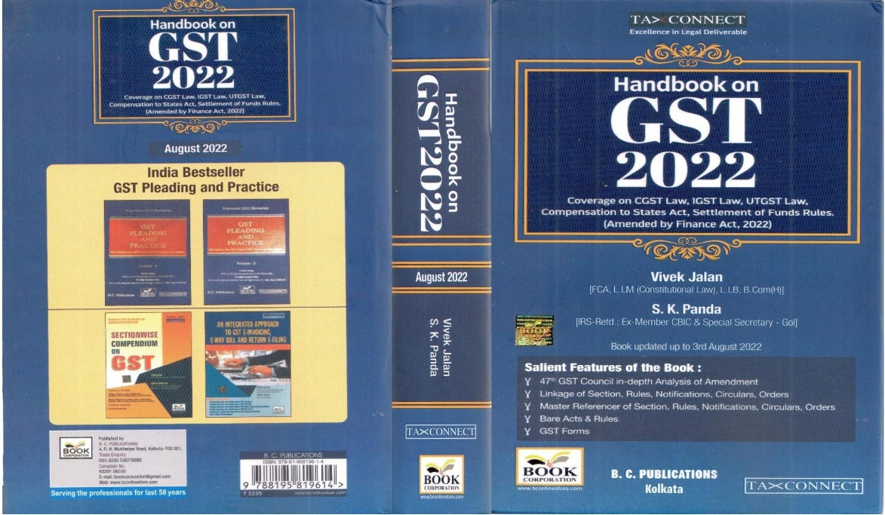

CONTENTS
- 47th GST Council in-depth Analysis of Amendment
- Linkage of Section, Rules, Notifications, Circulars, Orders
- Master Reference of Section, Rules, Notifications, Circulars, Orders
- Bare Acts & Rules
- GST Forms
Author:
Vivek Jalan
[FCA, LL.M (Constitutional Law), LL.B, B.Com(H)]

S.K. Panda
[IRS-Retd.; Ex-Member CBIC & Special Secretary – GoI]

Published by: In Association With:
BOOK CORPORATION TAX CONNECT ACADEMY
4, R. N. Mukherjee Road 6, Netaji Subhas Road,
Kolkata 700001 Kolkata 700001
Phones: (033) 64547999 Cell: 7003384915 Cell: 9830010297, 9331018333 Order by email: info@taxconnect.co.in
Order by email:bookcorporation@gmail.com Website : www.taxconnect.co.in
Website :www.bookcorporation.com

:IN STANDS

How to Handle GST LITIGATION: Assessment, Scrutiny, Audit & Appeal
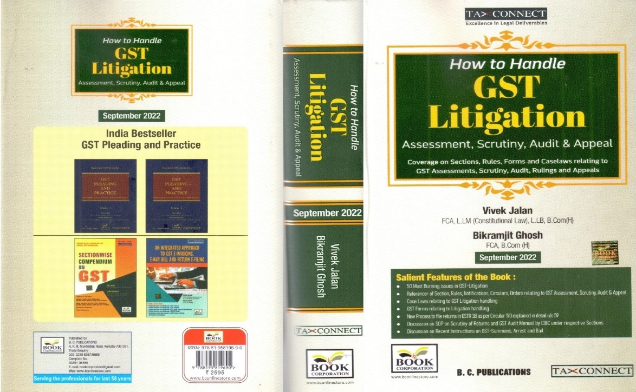

CONTENTS
1. 50 Most Burning issues in GST-Litigation
2. Reference of Section, Rules, Notifications, Circulars, Orders relating to GST Assessment, Scrutiny, Audit & Appeal
3. Case Laws relating to GST Litigation handling
4. GST Forms relating to Litigation handling
5. New process to file returns in GSTR 3B as per circular 170 explained in details u/s 59
6. Discussion on SOP on Scrutiny of Returns and GST Audit Manual by CBIC under respective Sections
7. Discussion on Recent Instruction on GST-Summons, Arrest and Bail

Authors:
Vivek Jalan
[FCA, LL.M (Constitutional Law), LL. B, B. Com(H)]

Bikramjit Ghosh
[FCA, B. Com(H)]

Published by: In Association With:
BOOK CORPORATION TAX CONNECT ACADEMY
4, R. N. Mukherjee Road 6, Netaji Subhas Road,
Kolkata 700001 Kolkata 700001
Phones: (033) 64547999 Cell: 7003384915 Cell: 9830010297, 9331018333 Order by email: info@taxconnect.co.in
Order by email:bookcorporation@gmail.com Website : www.taxconnect.co.in
Website :www.bookcorporation.com

:IN STANDS

GST PLEADING AND PRACTICE: With Section-wise GST Cases & GST Notices and their Replies
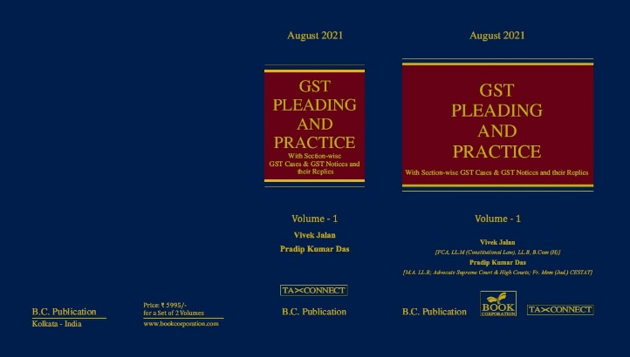

ABOUT THE BOOK: This publication includes:
1. GST Notices and their Replies
2. Orders and Appeals under GST
3. Text of provisions under IGST Act 2017 & CGST Act 2017
4. CGST & IGST Section-wise Synopsis of Case Laws and Notification/Circulars Gist
5. CGST & IGST Section-wise Synopsis of “Question of Law” answered under GST
6. Completely Updated Synopsis of Case Laws under GST by Supreme Court, High Court, AAARs & AARs

Authors:
Vivek Jalan
[FCA, LL.M (Constitutional Law), LL. B, B. Com(H)]

Pradip Kumar Das
[M.A. LL. B; Advocate Supreme Court & High Courts; Fr. Mem (Jud.) CESTAT]

Published by: In Association With:
BOOK CORPORATION TAX CONNECT ACADEMY
4, R. N. Mukherjee Road 6, Netaji Subhas Road,
Kolkata 700001 Kolkata 700001
Phones: (033) 64547999 Cell: 7003384915 Cell: 9830010297, 9331018333 Order by email: info@taxconnect.co.in
Order by email:bookcorporation@gmail.com Website : www.taxconnect.co.in
Website :www.bookcorporation.com

LET’S DISCUSS FURTHER!

OUR OFFICES:
MUMBAI
Unit No. 312, Omega Business Park, Near Kaamgar Hospital, Road No. 33, Wagle Industrial Estate, Thane West,
Maharashtra- 400604

Contact Person: Priyanka Vishwakarma
Email:priyanka.vishwakarma@taxconnect.co.in
BENGALURU
951, 24th Main Road, J P Nagar, Bengaluru, Karnataka – 560078.

Contact Person: Anil Pal

Email:anil.pal@taxconnectdelhi.co.in

DELHI (NCR)
B-139, 2nd Floor, Transport Nagar,
Noida-201301 (U.P)

Contact Person: Poonam Khemka

Email:poonam.khemka@taxconnect.co.in


DUBAI
Azizi Feirouz, 803, 8th Floor, AL Furjan, Opposite Discovery Pavillion,
Dubai, UAE

Contact Person: Rohit Sharma

Email:rohit.sharma@taxconnect.co.in

KOLKATA
R No 119; 1st Floor; Diamond Arcade; 1/72, Cal Jessore Road,
Kolkata – 700055

Contact Person: Uttam Kumar Singh

Email:uttam.singh@taxconnect.co.in
KOLKATA
6, Netaji Subhas Road, 3rd Floor, Royal Exchange Building,
Kolkata - 700001

Contact Person: Tithly Roy

Email:tithly.roy@taxconnect.co.in

Disclaimer:
This e-bulletin is for private circulation only. Views expressed herein are of the editorial team and are based on the information, explanation and documents available on Government portal platforms. Tax Connect or any of its employees do not accept any liability whatsoever direct or indirect that may arise from the use of the information contained herein. No matter contained herein may be reproduced without prior consent of Tax Connect. While this e-article has been prepared on the basis of published/other publicly available information considered reliable, we do not accept any liability for the accuracy of its contents.
Tax Connect 2022. All rights reserved.

