Iz8
_{TAX CONNECT}

419th Issue: 10th September 2023-16th September 2023
12017

sssss

Knowledge Partner:



TAX CONNECT :

Mumbai : Unit No. 312, Omega Business Park, Near-Kaamgar Hospital, Road No. 33, Wagle Industrial Estate,
Thane (West), Maharashtra – 400604
Bengaluru : 46/4, GB Palya, Kudlu Gate, Hosur Road, Bengaluru, Karnataka – 560068.
Delhi (NCR) : B-139, 2ndFloor, Transport Nagar, Noida-201301 (U.P)
Kolkata : 6, Netaji Subhas Road, 3rd Floor, Royal Exchange Building, Kolkata – 700001
- Room No. 119, 1stFloor, “Diamond Arcade” 1/72, Cal Jessore Road, Kolkata – 700055
- Tobacco House, 1, Old Court House St, Radha Bazar, Corner, Kolkata, West Bengal 700001
Dubai : Azizi Feirouz, 803, 8th Floor, AL Furjan, Opposite Discovery Pavillion, Dubai, UAE

Contact : +91 7003384915

Website : www.taxconnect.co.in
Email : info@taxconnect.co.in

Friends,
Section 155(20) of Income Tax Act was Inserted vide The Finance Act, 2023 dated 31-03-2023 and will be applicable w.e.f. 01-10-2023. It provides an important relief and specifies that where any income has been included in the return of income furnished by an assessee under section 139 for any AY and tax on such income has been deducted at source and paid to the credit of the Central Government in a subsequent financial year, the AO shall, on an application made by the assessee within a period of two years from the end of the FY in which such tax was deducted at source, amend the order of assessment or any intimation allowing credit of such tax deducted at source in the relevant assessment year, and the provisions of section 154 shall, so far as may be, apply thereto and the period of four years specified in Sec 154(7) shall be reckoned from the end of the FY in which such tax has been deducted. This situation arises when a diductor withholds tax in the year in which the income is paid to the taxpayer. However, the taxpayer has already included that income on an accrual basis in his earlier tax returns. This causes a TDS mismatch, as the income has already been taxed on accrual basis, but tax is only deducted later when payment is made.

To facilitate this amendment, the CBDT vide Notification No. 73/2023 dated August. 30, 2023, has introduced a new Rule 134 into the Income-tax Rules, 1962. This rule mandates the submission of Form 71 to claim TDS credit in such scenarios.

The following are the salient features of the Form 71 –

1. Form No. 71 will be provided to the Principal DGIT(Systems) the DGIT(Systems) or the person authorized.

2. Form No. 71, will get issued electronically under a DSC if ITR is needed to get provided under a digital signature; or through an electronic verification code.

3. The Principal DGIT (Systems), DGIT (Systems), or a person authorised would forward Form 71 to the Assessing Officer.

4. The Form seeks the following information from the assessee:
-Personal details (Name, Address, PAN, Aadhaar, Residential Status, E-mail Id, Mobile Number and relevant assessment year, date of furnishing return of income etc.)

-Total income of the assessee returned in the relevant assessment year, amount of specified income and rate at which such specified income was subject to tax.

-Amount of tax deducted, date of deduction of tax, section, and rate at Which tax deducted, date of payment of tax deducted to the central Government and amount of tax claimed for the relevant assessment year.

-Name, PAN, and TAN of diductor.

Consequent to this amendment, an amendment has also been made by inserting a proviso to section 244A(1)(a) of the Act to provide that the interest on refund arising out of above rectification shall be for the period from the date of the application to the date on which the refund is granted.

Provided that where refund arises as a result of an order passed by the Assessing Officer in consequence of an application made by the assessee under sub-section (20) of section 155, such interest shall be calculated at the rate of one-half per cent. for every month or part of a month comprised in the period from the date of such application to the date on which the refund is granted

Just to reiterate that we remain available over telecom or e-mail.

Editor:
Vivek Jalan
Partner - Tax Connect Advisory Services LLP

Co-Editor:
Rohit Sharma
Director – Tax Connect Advisory Services LLP

S.NO. | TOPICS | PAGE NO.
1] | TAX CALENDER | 4
2] | INCOME TAX | 5-7
INSTRUCTION | IMPLEMENTATION OF THE JUDGMENT OF THE HON’BLE SUPREME COURT IN THE CASE OF PR. CIT (CENTRAL-3) V/S ABHISAR BUILDWELL PVT. LTD. (CIVIL APPEAL NO. 6580 OF 2021)
3] | GST | 8-9
NOTIFICATION | CBIC’S NEW GST RULES: VALUATION IN ONLINE GAMING & CASINOS
INSTRUCTION | PROCEDURE TO BE FOLLOWED WITH RESPECT TO SUB-SECTION (2) OF SECTION 83 OF CGST ACT, 2017 WHEN PROVISIONAL ATTACHMENT OF PROPERTY CEASES TO HAVE EFFECT
PRESS RELEASE | ₹1.59 LAKH CRORE GST REVENUE, 11% YOY GROWTH IN AUGUST 2023
4] | FEMA | 10
CASE LAW | INTERPRETATION OF STATUTE - COMPOUNDING OF OFFENCE FOR NON-FILING OF THE ANNUAL RETURN BY PAYMENT OF PENALTY - DELAY IN FILING OF THE ANNUAL RETURN - VALIDITY OF NOTIFICATION BEARING NO.S.O. 1070(E) DATED 26.04.2013 ISSUED BY THE RESPONDENT U/S 41 OF THE FOREIGN CONTRIBUTION (REGULATION) ACT, 2010 : DELHI HIGH COURT
5] | CUSTOMS | 11-12
NOTIFICATION | EFFECTIVE RATES OF CUSTOMS DUTY AND IGST FOR GOODS IMPORTED INTO INDIA
NOTIFICATION | AMENDMENT IN EFFECTIVE RATES OF CUSTOMS DUTY AND IGST FOR GOODS IMPORTED INTO INDIA
NOTIFICATION | LAND CUSTOMS STATIONS AND ROUTES FOR IMPORT AND EXPORT OF GOODS BY LAND OR INLAND WATER WAYS - INSERTION OF ENTRIES FOR LAND FRONTIER OF BANGLADESH
NOTIFICATION | RATE OF EXCHANGE OF ONE UNIT OF FOREIGN CURRENCY EQUIVALENT TO INDIAN RUPEES
6] | DGFT | 13-14
TRADE NOTICE | PRE-SHIPMENT AND POST-SHIPMENT EXPORT CREDIT AND PACKING CREDIT IN FOREIGN CURRENCY (PCFC) FOR E-COMMERCE EXPORTS
TRADE NOTICE | MONTHLY WORKSHOPS ON CROSS-BORDER E-COMMERCE
CIRCULAR | SAFEGUARD QUANTITATIVE RESTRICTIONS (QR) IMPOSED ON IMPORT OF ISOPROPYL ALCOHOL (IPA) — CLARIFICATION REGARDING APPLICABILITY OF QR ON IMPORTS BY SEZ UNITS
7] | HANDBOOK ON GST 2022 | 15
8] | HOW TO HANDLE GST LITIGATION: ASSESSMENT, SCRUTINY, AUDIT & APPEAL | 16
9] | GST PLEADING AND PRACTICE: WITH SECTION-WISE GST CASES & GST NOTICES AND THEIR REPLIES | 17
10] | LET’S DISCUSS FURTHER | 18

Due Date | Form/Return/Challan | Reporting Period | Description
10th September | GSTR-7 | Aug-23 | Monthly return filed by individuals who deduct tax at source or TDS under the Goods and Services Tax (GST)
10th September | GSTR-8 | Aug-23 | Monthly return to be filed by e-commerce operators registered under the GST.
11th September | GSTR-1 | Aug-23 | Monthly Statement of Outward Supplies to be furnished by all normal registered taxpayers making outward supplies of goods and services or both and contains details of outward supplies of goods and services.
13th September | GSTR-1 (IFF) | Aug-23 | Details of B2B Supply of a registered person with turnover upto INR 5 Crores during the preceding year and who has opted for quarterly filing of return under QRMP.
13th September | GSTR-6 | Aug-23 | Details of Input Tax Credit (ITC) received and distributed by an Input Service Distributors (ISD).
13th September | GSTR-5 | Aug-23 | Summary of outward taxable supplies and tax payable by a nonresident taxable person.
14th September | TDS Certificate | Jul-23 | Due date for issue of TDS Certificate for tax deducted under section 194-IA, 194-IB, 194M & 194S in the month of June, 2023
15th September | FORM 24G | Aug-23 | Due date for furnishing of Form 24G by an office of the Government where TDS/TCS for the month of August, 2023 has been paid without the production of a challan
15th September | Advance Tax | AY 2024-25 | ​Second instalment of advance tax for the assessment year 2024-25
15th September | FORM 3BB | Aug-23 | ​Due date for furnishing statement in Form no. 3BB by a stock exchange in respect of transactions in which client codes been modified after registering in the system for the month of August, 2023

INSTRUCTION
Implementation of the judgment of the Hon’ble Supreme Court in the case of Pr. CIT (Central-3) v/s Abhisar Buildwell Pvt. Ltd. (Civil Appeal No. 6580 of 2021)
OUR COMMENTS: The Central Board of Direct Taxes, Department of Revenue, Ministry of Finance, vide Instruction No. 01 of 2023 dated 23.08.2023 instructed that:
1. On 24.04.2023, the Hon’ble Supreme Court delivered a judgment in a batch of Income-tax matters, the lead matter being Principal Commissioner of Income Tax, Central-III v. Abhisar Buildwell Pvt. Ltd. (CA No. 6580 of 2021) = 2023 (4) TMI 1056 - SUPREME COURT (hereinafter referred to as the Case). The matter of the civil appeal pertained to the scope and ambit of section 153A/153C of the Income-tax Act, 1961 (hereinafter referred to as the Act).
2. The Hon’ble Supreme Court in Civil Appeal No. 6634 of 2021 in the case of DCIT Central Circle 20 v/s U.K. Paints (Overseas) Ltd. = 2023 (5) TMI 373 - SC ORDER delivered a judgement on 25.04.2023 and dealt with the same issue as was in the case of Abhisar Buildwell case in regard to section 153C of the Act. The Hon’ble Supreme Court in the last paragraph of the judgement held that, “However, so far as the prayer made on behalf of the Revenue to permit them to initiate the reassessment proceedings is concerned, it is observed that it will be open for the revenue to initiate the reassessment proceedings in accordance with law and if permissible under the law.”
3. Background:
Notices under section 153A were issued for block period (six assessment years prior to year of search) and orders were passed considering incriminating material and other material available with the Assessing Officer (hereinafter referred to as the AO). Further, for a search initiated or requisition made after 1.4.2017, notices for four more years (7th to 10th) could also be issued, if the income represented in the form of asset, which has escaped assessment amounts to or is likely to amount to fifty lakh rupees or more in the relevant assessment year. In some cases, orders were passed considering only other material available in the record in the absence of incriminating material. Hon’ble Delhi High Court delivered a decision on 28.08.2015 in the case of Kabul Chawla [ITA No. 707 of 2014 (Commissioner of Income-tax (Central)-III v/s Kabul Chawla) = 2015 (9) TMI 80 - DELHI HIGH COURT]. It was held that the AO does not have jurisdiction for passing order under Section 153A in the absence of incriminating material found during the search under Section 132 or requisition made under Section 132A of the Act.
4. Hon’ble Supreme Court in the cases of Abhisar Buildwell (cited supra) and U.K. Paints (Overseas) Ltd. (cited supra), accordingly provided power to the AO to reopen the completed/unabated assessments u/s 147/148 of the Act, subject to fulfillment of the conditions as envisaged/mentioned under sections 147/148 of the Act, in cases where no incriminating material is found during the search.
5. The implementation of the judgment of Hon’ble Supreme Court is required to be done in uniform manner. Accordingly, in exercise of its power under section 119 of the Act, the Central Board of Direct Taxes (hereinafter referred to as “the Board”) directs that the following may be taken into consideration while implementing this judgment.
6. Scenarios and action suggested to be taken:
6.1 Considering that (i) significant time has elapsed from the decisions received in completed cases wherein the assessment was made based on the ‘other material’ and to provide tax certainty to the taxpayers, the Board has decided that no action is required to be taken under section 147/148 of the Act in cases (except cases covered by paragraph 7.2.1 below) where decisions of the appellate authorities have become final because these decisions have not been contested further in appeal. Further, it is decided that the said judgement is required to be applied in the following cases only:
(a) The lead and tagged cases in the said judgement.
(b) All cases which are pending at appellate levels or before AO or any tax authority.
(c) All cases in which contrary decisions has been given by appellate authorities after the Apex Court judgement in the Abhisar Buildwell case dated 24.04.2023.
7. In this regard, the AOs would have to divide the cases impacted by the judgment into two broad categories i.e.,
(I) pending/abated assessments, and
(II) completed/unabated assessments.
7.1 Pending/abated assessments: The AO would be required to ascertain assessments falling in the category of assessments that became abated on the date of search or requisition. In such cases, if any proceedings initiated or any order of assessment or reassessment have been annulled in appeal or in any other legal proceedings the same shall stand revived from the date of receipt of order of annulment as per provisions of section 153A(2) of the Act, and AO would need to take necessary action as per provisions of section 153A(2) read with section 153(8) of the Act, in respect of such pending/abated assessments.
Provisions of Section 153A(2) and Section 153(8) of the Act are reproduced as hereunder for ready reference:
Section 153A(2)
“[(2) If any proceeding initiated or any order of assessment or reassessment made under sub-section (1) has been annulled in appeal or any other legal proceeding, then, notwithstanding anything contained in sub-section (1) or section 153, the assessment or reassessment relating to any assessment year which has abated under the second proviso to sub-section (1), shall stand revived with effect from the date of receipt of the order of such annulment by the [Principal Commissioner or] Commissioner
Provided that such revival shall cease to have effect, if such order of annuiment is set aside.]”
Section 153(8)
“Notwithstanding anything contained in the foregoing provisions of this section, sub-section (2) of section 153A or sub-section (1) of section 153B, the order of assessment or reassessment, relating to any assessment year, which stands revived under sub-section (2) of section 153A, shall be made within a period of one year from the end of the month of such revival or within the period specified in this section or sub-section (1) of section 153B, whichever is later.”
7.2 Completed/unabated assessments: In respect of cases that were unabated/completed at the time of issue of notices under section 153A/153C and assessments made, the following scenarios will emerge:
7.2.1 In the lead and all the tagged cases necessary action u/s 147/148 need to be taken in the situation stated by the Court in the para 14(iv) of the said order in view of section 150 of the Act. The AO will be required to reopen the cases following the currently applicable procedure for reopening i.e., following the procedure prescribed under section 148A of the Act as inserted by Finance Act, 2021 in accordance with the law laid down by Hon’ble Supreme Court by its order dated 04.05.2022 in Union of India v. Ashish Agarwal case (2022 SSC Online SC 543) = 2022 (5) TMI 240 - SUPREME COURT. In view of the specific provisions of section 153(6) of the Act, all the cases reopened u/s 147/148 of the Act will be required to be completed by 30th April, 2024.
7.2.2 Cases where appeal is pending (filed either by the Department or assessee or both).
Appellate level | CIT(A) | ITAT | High Court
Action to be taken | The said judgement is required to be brought to the notice of CIT(A). | The departmental representative should bring the said judgment to the notice of the ITAT in the cases covered by the judgment. | The Standing Counsel should bring the said judgment to the notice of the High Court in the cases covered by the judgment.
Further, as and when the appeals are disposed of by the appellate authorities, action might be required to be taken by AO in appropriate cases under sections 147/148 of the Act read with section 150 of the Act. It is reiterated that the AO will be required to reopen the cases following the currently applicable procedure for reopening as given in para 7.2.1, above.
7.2.3 In all cases where the decisions of appellate authorities rendered after the Apex Court judgement in the Abhisar Buildwell case dated 24.04.2023 are inconsistent with the same necessary action may be taken to file Miscellaneous Application (MA) and Notice of Motion (NoM) to the ITAT and High Court, respectively, requesting the review of the decision in line with the Abhisar judgement, with a prayer of condonation of delay, wherever necessary. It is brought to attention that the time limit for filing Miscellaneous Application before ITAT is 6 months from the end of the month in which order is passed by the ITAT, as per section 254 of the Act. On receipt of the decision of the Hon’ble ITAT/High Court, as the case may be, necessary action as per law and extant instruction should be taken.
Suggestive template for Miscellaneous Application and Notice of Motion is attached for reference purpose. The facts of the case will be required to be mentioned in the Miscellaneous Application or Notice of Motion.
8. Procedure required to be followed by the field formations to comply with the Supreme Court judgment:
8.1 The procedure required to be followed by the AO, in compliance with the order of the Hon’ble Supreme Court, is as under:
(i) Every AO would have to ascertain which assessments fall in the category of abated assessments and unabated assessments.
(ii) Out of abated assessment cases, those that have been annulled by an appellate authority on some technical ground or otherwise, may be potential cases for revival u/s 153A(2) of the Act.
(iii) In respect of unabated assessment cases, the AO shall ascertain the facts of the case in hand and take necessary action as per para 7.2 above.
(iv) The Hon’ble Supreme Court has held that completed/unabated assessments can be reopened by the AO in exercise of powers u/s 147/148 of the Act, subject to fulfillment of the conditions specified in those sections. The time limit for the issue of notice u/s 148 would be in accordance with the provisions of Section 150 of the Act.
(v) For the issue of applicability of the conditions for reopening the assessments at the relevant time, the monetary limits applicable at present would apply while reopening assessment of earlier years.
(vi) Regarding sanction for issue of notice u/s 151 of the Act, the current provisions of the section will apply.
(vii) Action would be required to be taken under sections 147/148 of the Act read with section 150 of the Act, in cases pending before any appellate authority and depending on the decision, as and when the appellate orders are passed under sections 251, 254, and 260A of the Act.
8.2 The field authorities need to take necessary actions within time limits as mentioned below:
(a) In lead and tagged cases:
– 148A proceedings to be initiated by: 30th September, 2023.
– proceedings u/s 147/148 to be completed by: 30th April, 2024.
(b) In cases where decisions given by appellate authorities after 24.04.2023 are not in consonance with the Supreme Court decision in the case of Abhisar Buildwell:
– Identification of cases where action is to be taken by: 30th September, 2023.
– Filing of Miscellaneous Application/Notice of Motion by: 30th November, 2023
[For further details please refer the instruction]

NOTIFICATION
CBIC’S NEW GST RULES: VALUATION IN ONLINE GAMING & CASINOS
OUR COMMENTS: The Central Board of Indirect Taxes and Customs vide Notification No. 45/2023 dated 06.09.2023 notified In exercise of the powers conferred by section 164 of the Central Goods and Services Tax Act, 2017 (12 of 2017), the Central Government, on the recommendations of the Council, hereby makes the following rules further to amend the Central Goods and Services Tax Rules, 2017, namely: —
1. Short title and commencement.—(1) These rules may be called the Central Goods and Services Tax (Third Amendment) Rules, 2023.
(2) They shall come into force on such date as the Central Government may, by notification in the Official Gazette, appoint.
2. In the Central Goods and Services Tax Rules, 2017, after rule 31A, the following rules shall be inserted, namely:-
“31B. Value of supply in case of online gaming including online money gaming.–
Notwithstanding anything contained in this chapter, the value of supply of online gaming, including supply of actionable claims involved in online money gaming, shall be the total amount paid or payable to or deposited with the supplier by way of money or money’s worth, including virtual digital assets, by or on behalf of the player:
Provided that any amount returned or refunded by the supplier to the player for any reasons whatsoever, including player not using the amount paid or deposited with the supplier for participating in any event, shall not be deductible from the value of supply of online money gaming.
31C. Value of supply of actionable claims in case of casino.– Notwithstanding anything contained in this chapter, the value of supply of actionable claims in casino shall be the total amount paid or payable by or on behalf of the player for –
(i) purchase of the tokens, chips, coins or tickets, by whatever name called, for use in casino; or
(ii) participating in any event, including game, scheme, competition or any other activity or process, in the casino, in cases where the token, chips, coins or tickets, by whatever name called, are not required:
Provided that any amount returned or refunded by the casino to the player on return of token, coins, chips, or tickets, as the case may be, or otherwise, shall not be deductible from the value of the supply of actionable claims in casino.
Explanation.- For the purpose of rule 31B and rule 31C, any amount received by the player by winning any event, including game, scheme, competition or any other activity or process, which is used for playing by the said player in a further event without withdrawing, shall not be considered as the amount paid to or deposited with the supplier by or on behalf of the said player.”
[For further details please refer the notification]
INSTRUCTION
PROCEDURE TO BE FOLLOWED WITH RESPECT TO SUB-SECTION (2) OF SECTION 83 OF CGST ACT, 2017 WHEN PROVISIONAL ATTACHMENT OF PROPERTY CEASES TO HAVE EFFECT
OUR COMMENTS: The Central Board of Indirect Taxes and Customs vide Instruction No. F. No. GST/INV/Provisional Attachment/Advisory/2023-24 dated 02.09.2023 instructed that Attention is invited to section 83 of the CGST Act, 2017. It has the provisions to issue order for provisional attachment of property, including bank account, to protect interests of revenue in appropriate cases. At present, the procedure for provisional attachment and release/restoration of such property is prescribed in rule 159 of CGST Rules, 2017. In this regard, GST Policy Wing has also issued instructions vide CBEC-20/16/05/2021-GST dated 23.02.2021.
2. The section 83(2) of CGST Act, 2017 states - "Every such provisional attachment shall cease to have effect after the expiry of a period of one year from the date of the order made under sub-section (1).” Where such provisions apply, say in the provisional attachment of bank account, there are instances noticed where person concerned filed writ petition seeking that Commissioner should also follow up by issuing intimation of release of such provisional attachment because Banks/relevant authority ask for such communication. Such matters have come up before the Hon’ble High Court of Delhi.
3.1 The matter has been examined in consultation with the policy wing. It is noted that in terms of the legal position of said section 83(2) of the Act, read with said rule 159, in effect, the property is no longer liable to provisional attachment, however, it requires further consultation and actions to incorporate a prescribed language for such type of release/restoration of provisional attachment in a specified Form (like GST DRC-23).
3.2 Therefore, for the present, and keeping in view the convenience of taxpayers, the Board prescribes the procedure that in such types of situations, the Commissioner shall issue communication/an intimation to the concerned authority/bank, drawing attention to the particulars of the Order/Form DRC-22 (which made the provisional attachment) and the provisions of section 83 (2) of the CGST Act, 2017, and further indicating the release/restoration of the relevant property/account, in terms of those provisions. This intimation shall be copied to the person concerned. This procedure be implemented immediately, including for dealing with similar pending cases.
[For further details please refer the instruction]
PRESS RELEASE
₹1.59 LAKH CRORE GST REVENUE, 11% YOY GROWTH IN AUGUST 2023
OUR COMMENTS: The gross GST revenue collected in the month of August, 2023 is ₹1,59,069 crore of which CGST is ₹28,328 crore, SGST is ₹35,794 crore, IGST is ₹83,251 crore (including ₹43,550 crore collected on import of goods) and Cess is ₹11,695 crore (including ₹1,016 crore collected on import of goods).
The government has settled ₹37,581 crore to CGST and ₹31,408 crore to SGST from IGST. The total revenue of Centre and the States in the month of August, 2023 after regular settlement is ₹65,909 crore for CGST and ₹67,202 crore for the SGST.
The revenues for the month of August, 2023 are 11% higher than the GST revenues in the same month last year. During the month, revenue from import of goods was 3% higher and the revenues from domestic transactions (including import of services) are 14% higher than the revenues from these sources during the same month last year.
The chart below shows trends in monthly gross GST revenues during the current year. The Table-1 shows the state-wise figures of GST collected in each State during the month of August, 2023 as compared to August, 2022 and Table-2 shows the SGST and SGST portion of the IGST received/settled to the States/UTs in August, 2023.
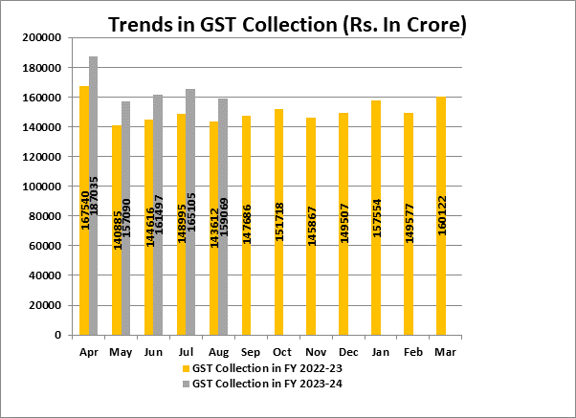
[For further details please refer the press release]

CASE LAW
Interpretation of statute - Compounding of offence for non-filing of the annual return by payment of penalty - delay in filing of the annual return - Validity of Notification bearing No.S.O. 1070(E) dated 26.04.2013 issued by the respondent u/s 41 of the Foreign Contribution (Regulation) Act, 2010 : DELHI HIGH COURT
OUR COMMENTS: It was held that petitioner was required to furnish the annual returns in Form FC-6 along with its final accounts (income and expenditure statement, receipt and payment account and balance sheet) within nine months of the end of the relevant financial year. Therefore, the petitioner was required to file the annual return for the financial year ending on 31st March of any year on or before 31st December of that year.
There is no ambiguity that the petitioner was required to file the annual returns within the prescribed period in compliance with the provisions of the FCR Act.
It is not necessary that all offences be separately listed out in Chapter-VIII of the FCR Act. The plain language of Section 37 of the FCR Act clarifies that the punishment, as specified, would be applicable in case of noncompliance of any provision of the FCR Act for which no specific punishment is prescribed. Thus, violation of any provision of the FCR Act would attract punition, as specified.
The heading of a section of an enactment may be used as an aid for interpretation of that section but does not control the meaning or import of the section where the language of the section is free from ambiguity.
The contention that delay in filing of the annual return under the FCR Act is not an offence, is rejected. The question as noted in paragraph 2(b) is answered in the affirmative.
Composition of certain offences - challenge to the validity of the impugned notification - Section 41 of the FCR Act expressly provides that any offence, other than an offence, which is punishable by imprisonment only, made prior to institution of any prosecution be compounded for such sums as the Central Government may specify.
The impugned notification has been issued by the Central Government in exercise of powers under Section 41 of the FCR Act. It does not fall foul of any provision of the FCR Act. We are unable to accept that the impugned notification is ultra vires to the Constitution of India. It merely stipulates the terms on which given offences can be compounded.Question as noted in paragraph 2(a) is answered in the negative.
Whether the impugned order is sustainable? - Admittedly, the petitioner had failed to file the annual return within the time prescribed and thus, had failed to comply with the provisions of Section 18 of the FCR Act read with Rule 17 of the FCR Rules.
In terms of the impugned notification, the delay in filing of the annual return would be compounded by payment of penalty as stipulated therein. The tabular statement specifying the offences, the amount of penalty and the officer competent to compound the same, as set out in the impugned notification.
The obligation to file the annual return for the financial year 2010-11 had arisen on 01.05.2011 and the same was required to be filed before 31.12.2011. Failure to do so is failure to comply with the provisions of the FCR Act. This does not amount to imputing any act committed prior to the FCR Act coming into force as an offence under the said Act.
The impugned order to the extent it stipulates payment of penalty for the delay in filing the annual return for the financial year 2009-10, is set aside. The questions, as noted in paragraph 2(c) and 2(d), are answered accordingly.
Considering the mitigating circumstances, this Court also considers it apposite to grant the petitioner further four weeks’ time from today to deposit the penalty, as stipulated, for the financial years 2010-11 and 2011-12 along with the requisite application for compounding the offence.

NOTIFICATION
Effective rates of customs duty and IGST for goods imported into India
OUR COMMENTS: The Ministry of Finance, Department of Revenue vide notification no 53/2023-Customs dated 05.09.2023 notified In exercise of the powers conferred by sub-section (1) of section 25 of the Customs Act, 1962 (52 of 1962) and sub-section (12) of section 3 of the Customs Tariff Act, 1975 (51 of 1975), the Central Government, on being satisfied that it is necessary in the public interest so to do, hereby makes the following further amendments in the notification of the Government of India in the Ministry of Finance (Department of Revenue), No. 50/2017-Customs, dated the 30th June, 2017, published in the Gazette of India, Extraordinary, Part II, Section 3, Sub-section (i), vide number G.S.R. 785(E), dated the 30th June, 2017, namely:-
In the said notification, -
I. in the Table, -
(1) S. No. 21F and the entries relating thereto shall be omitted;
(2) S. No. 24AA and the entries relating thereto shall be omitted;
(3) S. No. 32B and the entries relating thereto shall be omitted;
II. after the Table, in the first proviso, for the figures and letters “21C, 21D, 21E, 24A, 24B, 26A, 32A, 177, 177B, 249A, 250A, 371A, 371B, 376A, 377A and 377AA”, the figures and letters “177, 250A, 371A, 371B, 376A, 377A and 377AA” shall be substituted;
3. This notification shall come into force on the 6th Day of September, 2023.
[For further details please refer the notification]
NOTIFICATION
AMENDMENT IN Effective rates of customs duty and IGST for goods imported into India
OUR COMMENTS: The Ministry of Finance, Department of Revenue vide notification no 52/2023-Customs dated 05.09.2023 notified In exercise of the powers conferred by sub-section (1) of section 25 of the Customs Act, 1962 (52 of 1962) and sub-section (12) of section 3 of the Customs Tariff Act, 1975 (51 of 1975), the Central Government, on being satisfied that it is necessary in the public interest so to do, hereby makes the following further amendments in the notification of the Government of India in the Ministry of Finance (Department of Revenue), No. 50/2017-Customs, dated the 30th June, 2017, published in the Gazette of India, Extraordinary, Part II, Section 3, Sub-section (i), vide number G.S.R. 785(E), dated the 30th June, 2017, namely :-
In the said notification, in the Table, for S.No. 460 and the entries relating thereto, the following S. No. and entries shall be substituted, namely:-
(1) | (2) | (3) | (4) | (5) | (6)
“460. | 8446,  8448 | The following goods (other than old and used) for use in the textile industry, namely: -
“460. | 8446,  8448 | (i) Shuttleless Rapier Looms [above 650 meters per minute]; | Nil | - | -
“460. | 8446,  8448 | (ii) Shuttleless Waterjet Looms [above 800 meters per minute]; | Nil | - | -
“460. | 8446,  8448 | (iii) Shuttleless Airjet Looms [above 1000 meters per minute]; | Nil | - | -
“460. | 8446,  8448 | (iv) Parts and components for use in manufacturing of shuttleless looms | Nil | - | 9”.
“460. | 8446,  8448 | Provided that nothing contained in this S.No. shall have effect after 31st March, 2025.
[For further details please refer the notification]
NOTIFICATION
Land Customs Stations and Routes for import and export of goods by land or inland water ways - insertion of entries for land frontier of Bangladesh
OUR COMMENTS: The Ministry of Finance, Department of Revenue vide notification no 65/2023-Customs(N.T) dated 06.09.2023 notified In exercise of the powers conferred by clauses (b) and (c) of sub-section (1) of section 7 of the Customs Act, 1962 (52 of 1962), the Central Board of Indirect Taxes and Customs hereby makes the following further amendments in the notification of the Government of India, Ministry of Finance (Department of Revenue), No. 63/1994-Customs (N.T.) dated the 21st November, 1994, published in the Gazette of India, Extraordinary, Part II, Section 3, Sub-section (ii), vide number S.O. 830 (E), dated the 21st November, 1994, namely:-
In the said notification, in the Table, against serial number 2 relating to land frontier of Bangladesh, in column (3) after item (63) and the corresponding entry relating thereto in column (4), the following entries in columns (3) and (4) shall respectively be inserted, namely:—
(1) | (2) | (3) | (4)
 |  | "(64) Nischintapur Railway Station in West Tripura District, Tripura | Nischintapur (India) to Gangasagar (Bangladesh) Railway line.".
[For further details please refer the notification]
NOTIFICATION
Rate of exchange of one unit of foreign currency equivalent to Indian rupees
OUR COMMENTS: The Ministry of Finance, Department of Revenue vide notification no 64/2023-Customs (N.T) dated 06.09.2023 notified In exercise of the powers conferred by section 14 of the Customs Act, 1962 (52 of 1962), and in supersession of the Notification No. 61/2023-Customs(N.T.), dated 17th August, 2023 except as respects things done or omitted to be done before such supersession, the Central Board of Indirect Taxes and Customs hereby determines that the rate of exchange of conversion of each of the foreign currencies specified in column (2) of each of Schedule I and Schedule II annexed hereto, into Indian currency or vice versa, shall, with effect from 7th September, 2023, be the rate mentioned against it in the corresponding entry in column (3) thereof, for the purpose of the said section, relating to imported and export goods.
SCHEDULE-I
Sl. No. | Foreign Currency | Rate of exchange of one unit of foreign currency equivalent to Indian rupees
(1) | (2) | (3)
 |  | (a) | (b)
 |  | (For Imported Goods) | (For Export Goods)
1. | Australian Dollar | 54.20 | 51.85
2. | Bahraini Dinar | 227.25 | 213.75
3. | Canadian Dollar | 61.90 | 59.90
4. | Chinese Yuan | 11.55 | 11.20
5. | Danish Kroner | 12.15 | 11.75
6. | EURO | 90.75 | 87.60
7. | Hong Kong Dollar | 10.80 | 10.40
8. | Kuwaiti Dinar | 277.75 | 261.15
9. | New Zealand Dollar | 50.25 | 47.90
10. | Norwegian Kroner | 7.85 | 7.60
11. | Pound Sterling | 106.20 | 102.70
12. | Qatari Riyal | 23.50 | 22.10
13. | Saudi Arabian Riyal | 22.85 | 21.50
14. | Singapore Dollar | 62.00 | 60.00
15. | South African Rand | 4.45 | 4.20
16. | Swedish Kroner | 7.60 | 7.35
17. | Swiss Franc | 95.30 | 91.70
18. | Turkish Lira | 3.20 | 3.00
19. | UAE Dirham | 23.35 | 21.95
20. | US Dollar | 83.95 | 82.20
SCHEDULE- II
Sl. No. | Foreign Currency | Rate of exchange of 100 units of foreign currency equivalent to Indian rupees
(1) | (2) | (3)
 |  | (a) | (b)
 |  | (For Imported Goods) | (For Export Goods)
1. | Japanese Yen | 57.2 | 55.45
2. | Korean Won | 6.45 | 6.05
[For further details please refer the notification]

TRADE NOTICE
Pre-shipment and Post-shipment Export Credit and Packing Credit in Foreign Currency (PCFC) for E-Commerce Exports
OUR COMMENTS: The Ministry of Commerce and Industry vide trade notice no. 26/2023-24 dated 04.09.2023 notified Reference Chapter 9 of the new Foreign Trade Policy 2023 on ‘Promoting Cross Border Trade in Digital Economy’, it is submitted that consultations were held with industry representatives, exporters, and nodal departments on outstanding issues pertaining to exports through E-Commerce. One issue flagged was the unavailability of Pre-shipment and Post-shipment export credit for E-Commerce exports. In this regard, consultations were held with RBI.
2. Reference the said consultation with RBI, it is clarified that “Master Circular-Rupee / Foreign Currency Export Credit and Customer Service to Exporters” furnishes a comprehensive framework, allowing for access to Pre-shipment and Post-shipment export credit and Packing Credit in Foreign Currency (PCFC) to all eligible exporters which does not preclude E-Commerce Exporters.
3. Banking and financial institutions concerned are therefore encouraged to extend Pre-shipment and Post-shipment Export Credit and Packing Credit Loan in Foreign Currency (PCFC) to E-Commerce exports based on the extant guidelines issued by RBI. Any issues in availing such Export Credit may be brought to attention by E-Commerce Exporters or banks to this Directorate.
This issues with approval of the Competent Authority.
[For further details please refer the trade notice]

TRADE NOTICE
Monthly workshops on Cross-border E-Commerce
OUR COMMENTS: The Ministry of Commerce and Industry vide notification no. 25/2023-24 dated 01.09.2023 notified Attention is drawn to Para 9.07 of Foreign Trade Policy 2023, wherein handholding and outreach to promote E-Commerce Exports is mandated. In addition to increasing awareness on e-Commerce related rules and processes, actions for capacity building and skill development for promotion of E-Commerce exports is also mandated. In this regard, monthly workshops on E-Commerce Exports are proposed by this directorate.
2. Workshop Topics: The workshops shall cover aspects related to cross-border logistics, Postal and Customs compliances and cross-border payment mechanisms as well as any other topics of relevance.
3. Workshop Schedule: The proposed workshops shall be held during the 1st week of each month through Video Conference. In-person workshops shall also be organised where feasible.
4. Registration Link: Persons interested in attending the given workshops may register at the given link https://forms.gle/SBR2n2TNvcz8g1fX6
5. Calling Experienced E-Commerce Exporters: Experienced E-Commerce Exporters who are desirous of sharing their experience and advise for new export entrepreneurs, are welcomed to participate as guest speakers in the workshop. Expression of Interest for guest speakers, may please be sent over email to ecommerce-dgft@gov.in
6. This is issued with the approval of the Competent Authority.
[For further details please refer the trade notice]
CIRCULAR
Safeguard Quantitative Restrictions (QR) imposed on import of Isopropyl Alcohol (IPA) — Clarification regarding applicability of QR on imports by SEZ units
OUR COMMENTS: The Ministry of Commerce and Industry vide circular no. 04/2023-24 dated 31.08.2023 circulated that Pursuant to issuance of Notification No. 64/2015-20 dated 31.03.2023 by the DGFT imposing safeguard measures in the form of Country-wise Quantitative Restrictions (QR) on import of Isopropyl alcohol (HS code 29051220) for the year 2023-24, various representations have been received in the DGFT from trade & industry and Export Promotion Councils seeking clarification on the applicability of the said measures on imports by the SEZ units.
2. Accordingly, the matter has been examined in consultation with the DGTR and it is noted that the investigation made by the DGTR regarding increase in volume of imports and consequent injury to the domestic industry was largely based on the trend in imports into the Domestic Tariff Area (DTA).
3. Therefore, it is hereby clarified that import of Isopropyl alcohol (HS code 29051220) by SEZ units is out of purview of the said Notification No. 64/2015-20 dated 31.03.2023 and import of IPA in SEZ shall not be subjected to country-wise QR, provided no DTA sale of Isopropyl Alcohol (HS code 29051220) is allowed by SEZ units.
This issues with the approval of DGFT.
[For further details please refer the public notice]

:IN STANDS

HANDBOOK ON GST 2022
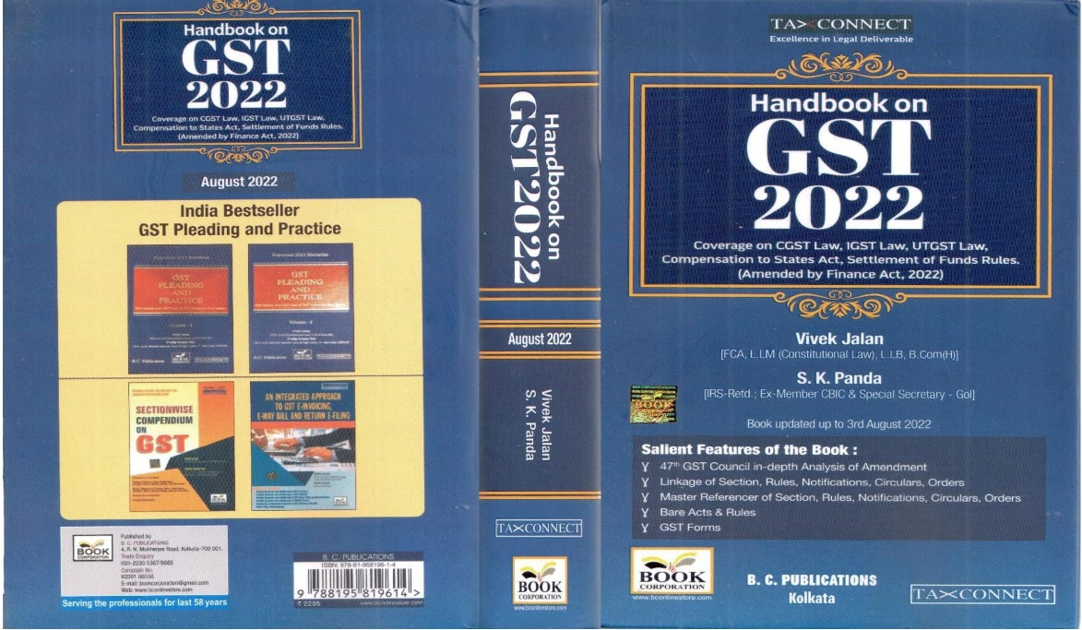

CONTENTS
- 47th GST Council in-depth Analysis of Amendment
- Linkage of Section, Rules, Notifications, Circulars, Orders
- Master Reference of Section, Rules, Notifications, Circulars, Orders
- Bare Acts & Rules
- GST Forms
Author:
Vivek Jalan
[FCA, LL.M (Constitutional Law), LL.B, B.Com(H)]

S.K. Panda
[IRS-Retd.; Ex-Member CBIC & Special Secretary – GoI]

Published by: In Association With:
BOOK CORPORATION TAX CONNECT ACADEMY
4, R. N. Mukherjee Road 6, Netaji Subhas Road,
Kolkata 700001 Kolkata 700001
Phones: (033) 64547999 Cell: 7003384915 Cell: 9830010297, 9331018333 Order by email: info@taxconnect.co.in Order by email:bookcorporation@gmail.com Website : www.taxconnect.co.in
Website :www.bookcorporation.com

:IN STANDS

How to Handle GST LITIGATION: Assessment, Scrutiny, Audit & Appeal
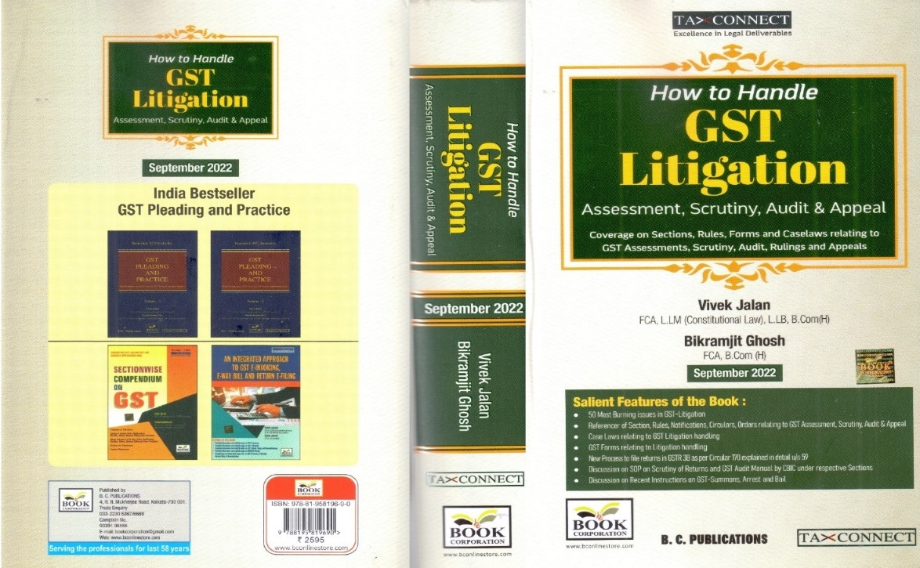

CONTENTS
1. 50 Most Burning issues in GST-Litigation
2. Reference of Section, Rules, Notifications, Circulars, Orders relating to GST Assessment, Scrutiny, Audit & Appeal
3. Case Laws relating to GST Litigation handling
4. GST Forms relating to Litigation handling
5. New process to file returns in GSTR 3B as per circular 170 explained in details u/s 59
6. Discussion on SOP on Scrutiny of Returns and GST Audit Manual by CBIC under respective Sections
7. Discussion on Recent Instruction on GST-Summons, Arrest and Bail

Authors:
Vivek Jalan
[FCA, LL.M (Constitutional Law), LL. B, B. Com(H)]

Bikramjit Ghosh
[FCA, B. Com(H)]

Published by: In Association With:
BOOK CORPORATION TAX CONNECT ACADEMY
4, R. N. Mukherjee Road 6, Netaji Subhas Road,
Kolkata 700001 Kolkata 700001
Phones: (033) 64547999 Cell: 7003384915 Cell: 9830010297, 9331018333 Order by email: info@taxconnect.co.in Order by email:bookcorporation@gmail.com Website : www.taxconnect.co.in
Website :www.bookcorporation.com

:IN STANDS

GST PLEADING AND PRACTICE: With Section-wise GST Cases & GST Notices and their Replies
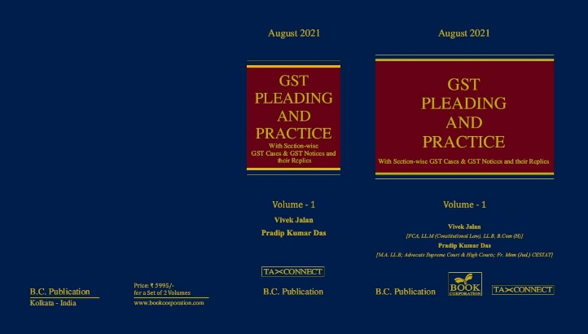

ABOUT THE BOOK: This publication includes:
1. GST Notices and their Replies
2. Orders and Appeals under GST
3. Text of provisions under IGST Act 2017 & CGST Act 2017
4. CGST & IGST Section-wise Synopsis of Case Laws and Notification/Circulars Gist
5. CGST & IGST Section-wise Synopsis of “Question of Law” answered under GST
6. Completely Updated Synopsis of Case Laws under GST by Supreme Court, High Court, AAARs & AARs

Authors:
Vivek Jalan
[FCA, LL.M (Constitutional Law), LL. B, B. Com(H)]

Pradip Kumar Das
[M.A. LL. B; Advocate Supreme Court & High Courts; Fr. Mem (Jud.) CESTAT]

Published by: In Association With:
BOOK CORPORATION TAX CONNECT ACADEMY
4, R. N. Mukherjee Road 6, Netaji Subhas Road,
Kolkata 700001 Kolkata 700001
Phones: (033) 64547999 Cell: 7003384915 Cell: 9830010297, 9331018333 Order by email: info@taxconnect.co.in Order by email:bookcorporation@gmail.com Website : www.taxconnect.co.in
Website :www.bookcorporation.com

LET’S DISCUSS FURTHER!

OUR OFFICES:
MUMBAI
Unit No. 312, Omega Business Park, Near Kaamgar Hospital, Road No. 33, Wagle Industrial Estate, Thane West,
Maharashtra- 400604

Contact Person: Priyanka Vishwakarma
Email:priyanka.vishwakarma@taxconnect.co.in
BENGALURU
#46/4, GB Palya, Kudlu Gate, Hosur Road, Bengaluru,
Karnataka – 560068.

Contact Person: Anil Pal

Email:anil.pal@taxconnectdelhi.co.in

DELHI (NCR)
B-139, 2nd Floor, Transport Nagar,
Noida-201301 (U.P)

Contact Person: Poonam Khemka

Email:poonam.khemka@taxconnect.co.in


DUBAI
Azizi Feirouz, 803, 8th Floor, AL Furjan, Opposite Discovery Pavillion,
Dubai, UAE

Contact Person: Rohit Sharma

Email:rohit.sharma@taxconnect.co.in

KOLKATA
R No 119; 1st Floor; Diamond Arcade; 1/72, Cal Jessore Road,
Kolkata – 700055

Contact Person: Uttam Kumar Singh

Email:uttam.singh@taxconnect.co.in
KOLKATA
6, Netaji Subhas Road, 3rd Floor, Royal Exchange Building,
Kolkata - 700001

Contact Person: Tithly Roy

Email:tithly.roy@taxconnect.co.in

Disclaimer:
This e-bulletin is for private circulation only. Views expressed herein are of the editorial team and are based on the information, explanation and documents available on Government portal platforms. Tax Connect or any of its employees do not accept any liability whatsoever direct or indirect that may arise from the use of the information contained herein. No matter contained herein may be reproduced without prior consent of Tax Connect. While this e-article has been prepared on the basis of published/other publicly available information considered reliable, we do not accept any liability for the accuracy of its contents.
Tax Connect 2022. All rights reserved.

