Iz8
_{TAX CONNECT}

417th Issue: 27th August 2023-2nd September 2023
12017

sssss

Knowledge Partner:



TAX CONNECT :

Mumbai : Unit No. 312, Omega Business Park, Near-Kaamgar Hospital, Road No. 33, Wagle Industrial Estate,
Thane (West), Maharashtra – 400604
Bengaluru : 46/4, GB Palya, Kudlu Gate, Hosur Road, Bengaluru, Karnataka – 560068.
Delhi (NCR) : B-139, 2ndFloor, Transport Nagar, Noida-201301 (U.P)
Kolkata : 6, Netaji Subhas Road, 3rd Floor, Royal Exchange Building, Kolkata – 700001
- Room No. 119, 1stFloor, “Diamond Arcade” 1/72, Cal Jessore Road, Kolkata – 700055
- Tobacco House, 1, Old Court House St, Radha Bazar, Corner, Kolkata, West Bengal 700001
Dubai : Azizi Feirouz, 803, 8th Floor, AL Furjan, Opposite Discovery Pavillion, Dubai, UAE

Contact : +91 7003384915

Website : www.taxconnect.co.in
Email : info@taxconnect.co.in

Friends,
Discipline regarding penal action under various tax laws are widely discussed. Two interesting recent cases under Income Tax allows one to reflect further. Generally, losses are contested and seldom is it seen that assessee accept a loss return to be assessed as NIL. However, what if in spite of an irrefutable loss the assessee in good faith and, to avoid undue litigation, harassment and, to buy peace of mind agrees to get assessed at NIL income instead of declared loss, can a penalty/prosecution proceeding be initiated against the assessee u/s 271(1)(c) of the Income Tax Act? The answer is that it can be initiated. There is no provision for such pleas of bargain under the Income Tax Act to act as estoppels upon AOs. However, in case the plea is not accepted by the AO, the assessee should be show caused and there should be substance
in enquiry and evidence to prove concealment. Penalty proceedings are distinct from assessment proceedings, though they emanate from the assessment proceedings; still, they are separate and independent proceedings all together. The Hon’ble Supreme Court of India in a case has held that notice issued by the Assessing Officer under section 274 read with section 271(1)(c) of the Act was bad in law, as it did not specify under which limb of section 271(1)(c) of the Act, penalty proceedings has been initiated, i.e., whether for concealment of particulars of income or furnishing of inaccurate particulars of income. The assessee should know the grounds which has to meet, otherwise the principles of natural justice are offended. Further, the order has to specify the offence alleged to be committed, which was held in another by ITAT Delhi.

Now coming to penalty proceeding u/s 271D which requires that if a person takes any loan or deposit or specified sum in contravention of the provisions of section 269SS, he shall be liable to pay, by way of penalty, a sum equal to the amount of the loan or deposit or specified sum so taken. The question is whether levy of penalty under this provision is not depending on the outcome of the assessment order and hence there is no requirement of the assessment proceedings in imposing the provision u/s 271D of the Act. Here Section 275 comes to the rescue which presupposes the existence of assessment proceedings/revision proceedings or appeal proceedings arising from the assessment order or revision order and the limitation is provided as per outcome of these proceedings. In absence of assessment, the initiation of penalty is not valid. The Hon’ble Supreme Court in the case of CIT vs. Jain Laxmi Rice Mills has held that in absence of satisfaction recorded regarding the penalty proceedings u/s 271E/ 271D of the Act the order of levy of penalty is not valid. The same was also reiterated in the case of SHRI UMAKANT SHARMA Vs JCIT RATLAM [2023-VIL-1034-ITAT-IND].

Just to reiterate that we remain available over telecom or e-mail.

Editor:
Vivek Jalan
Partner - Tax Connect Advisory Services LLP

Co-Editor:
Rohit Sharma
Director – Tax Connect Advisory Services LLP

S.NO. | TOPICS | PAGE NO.
1] | TAX CALENDER | 4
2] | INCOME TAX | 5-6
NOTIFICATION | INCOME TAX EXEMPTION TO SWASTHYA SATHI SAMITI’S INCOME
NOTIFICATION | EXEMPTION TO UIDAI’S SPECIFIED INCOME
NOTIFICATION | Exemption from specified income U/s 10(46) – Notifies 'Punjab Building and Other Construction Welfare Board' a body constituted by the State Government of Punjab
NOTIFICATION | Exemption from specified income U/s 10(46) – Notifies ‘District Mineral Foundation Trust’
3] | GST | 7
ADVISORY | ADVISORY RELATED TO MERA BILL MERA ADHIKAAR SCHEME
CASE LAW | INPUT TAX CREDIT CANNOT BE CLAIMED WHEN THE SUPPLIER HAS NOT PAID UP THE TAX TO THE GOVERNMENT: PATNA HIGH COURT
4] | FEMA | 8
CASE LAW | OFFENCE UNDER FEMA - LEVY OF PENALTY POST COMPOUNDING ORDERS - POWER TO COMPOUND CONTRAVENTION: BOMBAY HIGH COURT
5] | CUSTOMS | 9
NOTIFICATION | AN EFFECTIVE EXPORT DUTY OF 40% ON ONIONS TILL 31ST DECEMBER 2023
NOTIFICATION | AMENDMENT TO SECOND SCHEDULE TO THE CUSTOMS TARIFF ACT TO PRESCRIBE EXPORT DUTY ON ONIONS.
6] | DGFT | 10
PUBLIC NOTICE | ALLOCATION OF QUANTITY 5841 MT SUGAR BY EU FOR EXPORT FROM INDIA UNDER TRQ FOR THE YEAR 2023-24 (OCTOBER 2023 TO SEPTEMBER 2024)
TRADE NOTICE | AMENDMENT OF EXPORT POLICY OF FOOD SUPPLEMENTS CONTAINING BOTANICALS
7] | HANDBOOK ON GST 2022 | 11
8] | HOW TO HANDLE GST LITIGATION: ASSESSMENT, SCRUTINY, AUDIT & APPEAL | 12
9] | GST PLEADING AND PRACTICE: WITH SECTION-WISE GST CASES & GST NOTICES AND THEIR REPLIES | 13
10] | LET’S DISCUSS FURTHER | 14

Due Date | Form/Return/Challan | Reporting Period | Description
30th August | Challan-cum-Statement | July 2023 | ​​Due date for furnishing of challan-cum-statement in respect of tax deducted under section 194-IA, 194-M, 194-IB, 194S for the month of July, 2023
31st August | FORM 9A | 2022-23 | ​​Application for exercising the option available under Explanation to section 11(1) to apply income of previous year in the next year or in future (if the assessee is required to submit return of income on October 31, 2023).​
31st August | FORM 10 | 2022-23 | ​​​​Statement to be furnished to accumulate income for future application under section 10(21) or section 11(1) (if the assessee is required to submit return of income on October 31, 2023).​

NOTIFICATION
Income Tax exemption to Swasthya Sathi Samiti’s Income
OUR COMMENTS: The Central Board of Direct Taxes, Department of Revenue, Ministry of Finance, vide Notification No. 69/2023 Dated 23.08.2023 notified In exercise of the powers conferred by clause (46) of section 10 of the Income-tax Act, 1961 (43 of 1961), the Central Government hereby notifies for the purposes of the said clause, ‘Swasthya Sathi Samiti’, Kolkata(PAN: AAQAS4322J), a body established by Government of West Bengal, in respect of the following specified income arising to that Body, namely:
(a) Grant received from the Government of West Bengal; and
(b) Interest income received from bank.
2. This notification shall be effective subject to the conditions that Swasthya Sathi Samiti, Kolkata,-
(a) shall not engage in any commercial activity;
(b) activities and the nature of the specified income shall remain unchanged throughout the financial years; and
(c) shall file return of income in accordance with the provision of clause (g) of sub-section (4C) of section 139 of the Income-tax Act, 1961.
3. This notification shall be deemed to have been applied for Assessment Year 2022-2023 relevant to financial year 2021-2022 and shall apply with respect to Assessment Years 2023-2024 to 2026-2027relevant to the financial years 2022-2023 to 2025-2026 respectively.
[For further details please refer the Notification]
NOTIFICATION
Exemption to UIDAI’s Specified Income
OUR COMMENTS: The Central Board of Direct Taxes, Department of Revenue, Ministry of Finance, vide Notification No. 68/2023 Dated 23.08.2023 notified In exercise of the powers conferred by clause (46) of section 10 of the Income-tax Act, 1961 (43 of 1961), the Central Government hereby notifies for the purposes of the said clause, ‘Unique Identification Authority of India’(PAN AAAGU0182Q), a statutory Authority established under the provisions of the AADHAAR Act, 2016 by the Govt. of India, in respect of the following specified income arising to the said Authority, as follows:
(a) Grants/Subsidies received from Central Government;
(b) Fees/ Subscriptions including RTI Fee, Tender Fee, Sale of Scrap, PVC card, etc;
(c) Authentication, Enrolment and Updation service charges received;
(d) Term/Fixed Deposits; and
(e) Interest earned on (a) to (d) above.
2. This notification shall be effective subject to the conditions that Unique Identification Authority of India –
(a) shall not engage in any commercial activity;
(b) activities and the nature of the specified income shall remain unchanged throughout the financial years; and
(c) shall file return of income in accordance with the provision of clause (g) of sub-section (4C) of section 139 of the Income-tax Act, 1961.
3. This notification shall be deemed to have been applied for assessment years 2019-2020 to 2023-2024 relevant for the financial years 2018-2019 to 2022-2023 respectively.
[For further details please refer the Notification]
NOTIFICATION
Exemption from specified income U/s 10(46) – Notifies 'Punjab Building and Other Construction Welfare Board' a body constituted by the State Government of Punjab
OUR COMMENTS: The Central Board of Direct Taxes, Department of Revenue, Ministry of Finance, vide Notification No. 67/2023 Dated 23.08.2023 notified In exercise of the powers conferred by clause (46) of section 10 of the Income-tax Act, 1961 (43 of 1961), the Central Government hereby notifies for the purposes of the said clause, Punjab Building and Other Construction Welfare Board (PAN: AAALP0698P), a body constituted by the State Government of Punjab, in respect of the following specified income arising to that Board, namely:-
(a) Labour Cess collection;
(b) Contribution collection; and
(c) Interest earned on (a) and (b) above.
2. The provisions of this notification shall be effective subject to the conditions that Punjab Building and Other Construction Welfare Board,-
(a) shall not engage in any commercial activity;
(b) activities and the nature of the specified income remain unchanged throughout the financial years;
and
(c) shall file returns of income in accordance with the provision of clause (g) of sub-section (4C) section 139 of the Income-tax Act, 1961.
3. This notification shall be deemed to have been applied for the for the A.Y 2022-2023 and A.Y 2023-2024 relevant for F.Y. 2021-2022 and 2022-2023 respectively.
[For further details please refer the Notification]
NOTIFICATION
Exemption from specified income U/s 10(46) – Notifies ‘District Mineral Foundation Trust’
OUR COMMENTS: The Central Board of Direct Taxes, Department of Revenue, Ministry of Finance, vide Notification No. 66/2023 dated 23.08.2023 notified In exercise of the powers conferred by clause (46) of section 10 of the Income-tax Act, 1961 (43 of 1961), the Central Government hereby notifies for the purposes of the said clause, ‘District Mineral Foundation Trust’ as specified in the schedule to this notification, constituted by Government in exercise of powers conferred under section 9(B) of the Mines and Minerals (Development and Regulation) Amendment Act, 2015 (10 of 2015) as a ‘class of Authority’ , in respect of the following specified income arising to that Authority, namely :-
(a) Contribution by lease Holder to DMF as per the Mines and Minerals (Contribution to District Mineral Foundation) Rules, 2015;
(b) Interest received from lease holders for late payment;
(c) Any Penalty charged to lease holder;
(d) Income from Interest on fund available under DMF;
(e) Interest received on Saving Bank Accounts; and
(f) Interest received on Excess Fund invested in Term Deposit.
2. This notification shall be effective subject to the conditions that each of the District Mineral Foundation Trust-
(a) shall not engage in any commercial activity;
(b) activities and the nature of the specified income shall remain unchanged throughout the financial years; and
(c) shall file return of income in accordance with the provision of clause (g) of sub-section (4C) of section 139 of the Income-tax Act, 1961.
3. This notification shall be deemed to have been applied for the assessment year 2023-2024 to 2027-2028 relevant to financial year 2022-2023 to 2026-2027 in respect of Trusts mentioned in column (2) of the below mentioned schedule.
SCHEDULE
S.No. | Name of DMF Trust | State | PAN
(1) | (2) | (3) | (4)
1. | Angul District Mineral Foundation | Odisha | AAALD1844M
2. | District Mineral Foundation Trust, Jajpur | Odisha | AADTD2632E
3. | District Mineral Foundation, Jharsuguda | Odisha | AADTD1294Q
4. | District Mineral Foundation, Keonjhar | Odisha | AAAGD2339C
5. | District Mineral Foundation, Koraput | Odisha | AAPFD8437K
6. | District Mineral Foundation, Sundargarh | Odisha | AADTD0841P
7. | District Mineral Foundation Trust, Sambalpur | Odisha | AADTD5287H
8. | District Mineral Foundation Trust, Dhenkanal | Odisha | AADTD5665R
9. | District Mineral Foundation Trust, Mayurbhanj | Odisha | AAGTM8219H
10. | District Mineral Foundation Trust, Rayagada | Odisha | AADTD5522D
11. | District Mineral Foundation Trust, Nuapada | Odisha | AADTD6189J
12. | District Mineral Foundation Trust, Puri | Odisha | AADTD6294Q
[For further details please refer the Notification]

ADVISORY
ADVISORY RELATED TO MERA BILL MERA ADHIKAAR SCHEME
OUR COMMENTS: The GSTIN has released a new advisory dated 24.08.2023 relating to “Mera Bill Mera Adhikaar” Scheme where-
1.As per the direction from the Government, the GSTN has developed and launched a mobile application (available on iOS and Android platforms) and also a web portal for the “Mera Bill Mera Adhikaar” scheme.
2.This scheme will be implemented from 1st September, 2023 initially in the States of Gujarat, Assam, Haryana and UTs of Puducherry and Daman & Diu and Dadra & Nagar Haveli, as per the policy decision of the Government.
3.Mobile Application and Web Portal:
• The mobile application is available for download on both iOS and Android platforms and links are given below.
4.User Manual: For ease of use and to guide taxpayers through the process of participating in the scheme via the mobile application or web portal, a detailed user manual is available at the link below for your reference:
•User Manual Download Link:
https://tutorial.gst.gov.in/downloads/news/mbma_user_manual_18_august_2023_final.pdf
5.Please ensure that you download the mobile application only from the Google Play store and Apple App store and access the web portal through the official link provided above to avoid any spurious application of a fraudulent entity.
6.Please refer to the Policy Document for MBMA related policy matters with reference to broad guidelines for its implementation.
[For further details please refer the advisory]

CASE LAW
INPUT TAX CREDIT CANNOT BE CLAIMED WHEN THE SUPPLIER HAS NOT PAID UP THE TAX TO THE GOVERNMENT: PATNA HIGH COURT
OUR COMMENTS: Recently the Hon’ble Patna High Court has held that Input Tax Credit by the very nomenclature contemplates a credit being available for the purchasing dealer in its credit ledger by way of payment of tax by the supplier to the Government.
It is true that Input Tax Credit is a concept introduced in the tax regime, all over the country for the purpose of avoiding the cascading effect of taxes. The benefit of such credit being availed by a purchasing dealer who sells or manufactures goods, using raw materials on which tax has been paid is a benefit or concession conferred under the statute - the contention of double taxation does not impress us especially since the claim is denied only when the supplier who collected tax from the purchaser fails to pay it to the Government. Taxation as has been held is a compulsory extraction made for the purpose of public good, by the welfare State and without the levy being paid to the Government; there can be no claim raised of the liability to tax having been satisfied and hence there is no question of double taxation.
The seller and purchaser have an independent contract without the junction of the Government. The statute provides for a levy of tax on goods and services or both, supplied by one to the other which can be collected but the dealer who collects it has also the obligation to pay it up to the State.
It is clear that the literal nomenclature and the statutory language, mandates that there should be credit available in the credit ledger of the purchaser to claim Input Tax and otherwise the claim would be frustrated. On the above reasoning, it is found that the claim of Input Tax Credit raised by the petitioner cannot be sustained when the supplying/selling dealer has not paid up the amounts to the Government; despite collection of tax from the purchasing dealer.

CASE LAW
Offence under FEMA - Levy of penalty post compounding orders - Power to compound contravention : BOMBAY HIGH COURT
OUR COMMENTS: It was held that the compounding order is passed on 20.11.2008 and the adjudication order levying penalty is passed on 21.11.2008, i.e., one day after the passing of the compounding order. Sub-section (2) of section 15 as alluded to hereinabove clearly envisages a position that once a contravention has been compounded under sub-section (1) (which in the present case has been compounded on 20.11.2008), no proceeding or further proceeding, as the case may be, shall be initiated or continued, as the case may be, against the person committing the contravention.
We cannot hold petitioners responsible for contravention once the compounding orders have been passed. We have noted that there is a gap of “one day” between the passing of the two sets of orders, i.e., compounding orders and adjudicating order. Be that as it may, petitioners cannot be faulted and held liable for contravention once the compounding orders are passed by the Compounding Authority. That is the mandate of the statute.
As also fairly conceded that respondents though aggrieved with the five compounding orders, have not challenged the said orders. If respondents were indeed aggrieved with the compounding orders, it was open for respondents to challenge the said orders. Having not done so, respondents cannot justify passing the adjudication order once the compounding orders have been passed and complied with by petitioners. Passing of the adjudication order after the offence has been compounded, is thus contrary to the statutory provisions discussed hereinabove, is not maintainable and thus without jurisdiction.
The impugned adjudication order passed by respondent No.1 is an appealable order and petitioners should be relegated to the alternate remedy of filing the statutory appeal under section 19 of the said Act before the Appellate Tribunal. This submission deserves to be rejected at the threshold. As held by us, the impugned adjudication order has been passed without jurisdiction in view of the fact that the offence contravened by petitioners have been compounded by the statutory Compounding Authority before the passing of the impugned order. Hence, we reject this submission advanced by Mr. Patil.
Writ Petition stands allowed in terms of prayer clause “c” which reads as under:
“c) that a writ in the nature of Mandamus may be issued commanding the Respondents to act according to law and/or cancel and/or withdraw and/or rescind the impugned order dated 21st November, 2008 passed by the Respondent No.1 and the Show Cause Notice dated 11th June, 2008 issued by the Respondent No.1 and all proceedings there under and/or in pursuance thereof.”

NOTIFICATION
an effective export duty of 40% on onions till 31st December 2023
OUR COMMENTS: The Ministry of Finance, Department of Revenue vide notification no 48/2023-Customs dated 19.08.2023 notified In exercise of the powers conferred by sub-section (1) of section 25 of the Customs Act, 1962 (52 of 1962), the Central Government, on being satisfied that it is necessary in the public interest so to do, hereby exempts the goods of the description specified in column (3) of the Table below, falling within the Chapter, heading, sub–heading or tariff item of the Second Schedule to the Customs Tariff Act, 1975 (51 of 1975), specified in the corresponding entry in column (2) of the said Table, when exported out of India, from so much of the duty of customs leviable thereon under the said Second Schedule as is in excess of the amount calculated at the rate of duty specified in the corresponding entry in column (4) of the said Table, namely: –
TABLE
Sl. No. | Sub-heading or tariff item | Description of goods | Rate of duty
(1) | (2) | (3) | (4)
1. | 0703 10 | Onions | 40%
2. This notification shall come into force with immediate effect, and will remain in force up to and inclusive of the 31st December, 2023.
[For further details please refer the notification]

NOTIFICATION
amendMENT TO Second Schedule to the Customs Tariff Act to prescribe export duty on onions.
OUR COMMENTS: The Ministry of Finance, Department of Revenue vide notification no 47/2023-Customs dated 19.08.2023 notified Whereas, the Central Government is satisfied that export duty should be levied on certain articles and that circumstances exist which render it necessary to take immediate action. Now, therefore, in exercise of the powers conferred by sub-section (1) of section 8 of the Customs Tariff Act, 1975 (51 of 1975)(hereinafter referred to as the Customs Tariff Act), the Central Government, hereby directs that the Second Schedule to the Customs Tariff Act shall be amended in the following manner, namely: -
In the Second Schedule to the Customs Tariff Act, Sl. No. 1 shall be re-numbered as Sl. No. 1A, and before Sl. No. 1A as so re-numbered, the following serial number and entries shall be inserted, namely: -
(1) | (2) | (3) | (4)
“1. | 0703 10 | Onions | 50%”.
[For further details please refer the notification]

PUBLIC NOTICE
Allocation of quantity 5841 MT Sugar by EU for export from India under TRQ for the year 2023-24 (October 2023 to September 2024)
OUR COMMENTS: The Ministry of Commerce and Industry vide public notice no. 29/2023 dated 25.08.2023 notified in exercise of the powers conferred under Paragraphs 2.04 of the Foreign Trade Policy, 2023, the Director General of Foreign Trade hereby allocates quantity of 5841 MT for export of Sugar to EU from India under TRQ for the year 2023-24 (October 2023 to September 2024).
2. As per Notification No. 3/2015-20 dated 20.04.2015, export of sugar (HS Code 17010000) to EU under TRQ is 'Free' subject to the conditions notified in the 'Nature of Restrictions' in the above notification.
3. Certificate of Origin, if required, for preferential export of sugar to EU, shall be issued by Additional Director General of Foreign Trade, Mumbai on recommendation of APEDA regarding entity and quantity for which eligible. Other certification requirement, if any, prescribed specifically for export of sugar to EU would continue to be followed.
4. The quota will be operated by Agriculture and Processed Food Products Export Development Authority (APEDA), New Delhi as the implementing agency for export of TRQ items to EU.
5. The reporting requirement as notified vide Notification No. 3/2015-2020 dated 20.04.2015 read with Notification No. 20 dated 07.09.2015 would be followed.
6. Effect of this Public Notice:
The quantity of 5841 MT Sugar to be exported to EU from India under TRQ for the year 2023-24 (October 2023 to September 2024) has been notified.
[For further details please refer the public notice]

TRADE NOTICE
Amendment of export policy of Food Supplements containing botanicals
OUR COMMENTS: The Ministry of Commerce and Industry vide trade notice no. 24/2023 dated 25.08.2023 notified The Government of India vide Notification No.22/2023 dated 31st July, 2023 notified the following policy conditions for export of Food Supplements containing botanicals under ITC (HS) Code 1302 and 2106, intended for human or animal consumption to European Union and United Kingdom:
"The export of Food Supplements containing botanicals to European Union (EU) and United Kingdom (UK) originating in or consigned from India and intended for human or animal consumption, allowed subject to issuance of the official certificate issued by Export Inspection Council (EIC)/ Export Inspection Agencies (EIAs), the designated Competent Authority for issuance official certificate. The official certificate will be issued based on the satisfactory analytical test report from EIC/EIC approved laboratories fir the purpose as per the requirement laid down by EU."
2. In this regard it is clarified that certificates issued by SHEFEXIL before the issuance of the aforesaid Notification i.e. before 31st July, 2023, shall continue to be recognised even after issuance of the notification.
This issues with the approval of competent authority.
[For further details please refer the trade notice]

:IN STANDS

HANDBOOK ON GST 2022
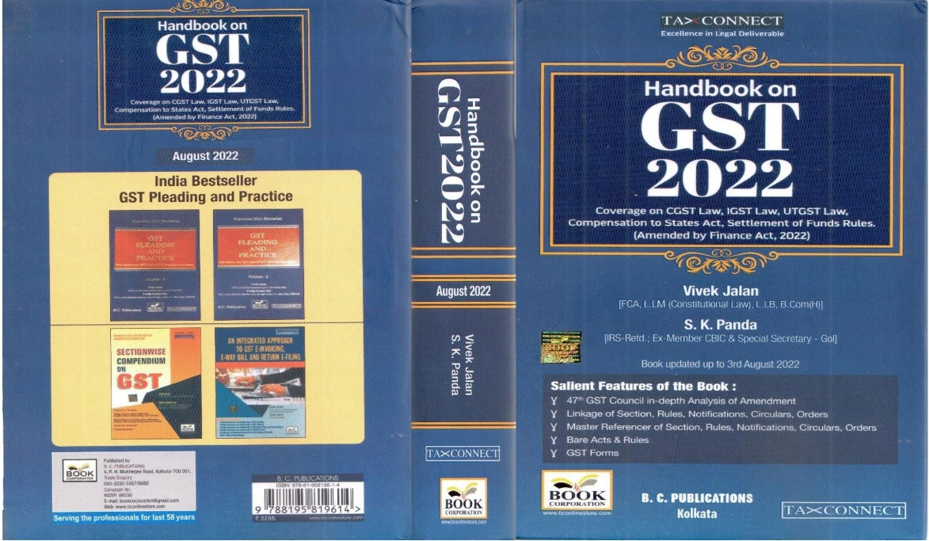

CONTENTS
- 47th GST Council in-depth Analysis of Amendment
- Linkage of Section, Rules, Notifications, Circulars, Orders
- Master Reference of Section, Rules, Notifications, Circulars, Orders
- Bare Acts & Rules
- GST Forms
Author:
Vivek Jalan
[FCA, LL.M (Constitutional Law), LL.B, B.Com(H)]

S.K. Panda
[IRS-Retd.; Ex-Member CBIC & Special Secretary – GoI]

Published by: In Association With:
BOOK CORPORATION TAX CONNECT ACADEMY
4, R. N. Mukherjee Road 6, Netaji Subhas Road,
Kolkata 700001 Kolkata 700001
Phones: (033) 64547999 Cell: 7003384915 Cell: 9830010297, 9331018333 Order by email: info@taxconnect.co.in Order by email:bookcorporation@gmail.com Website : www.taxconnect.co.in
Website :www.bookcorporation.com

:IN STANDS

How to Handle GST LITIGATION: Assessment, Scrutiny, Audit & Appeal
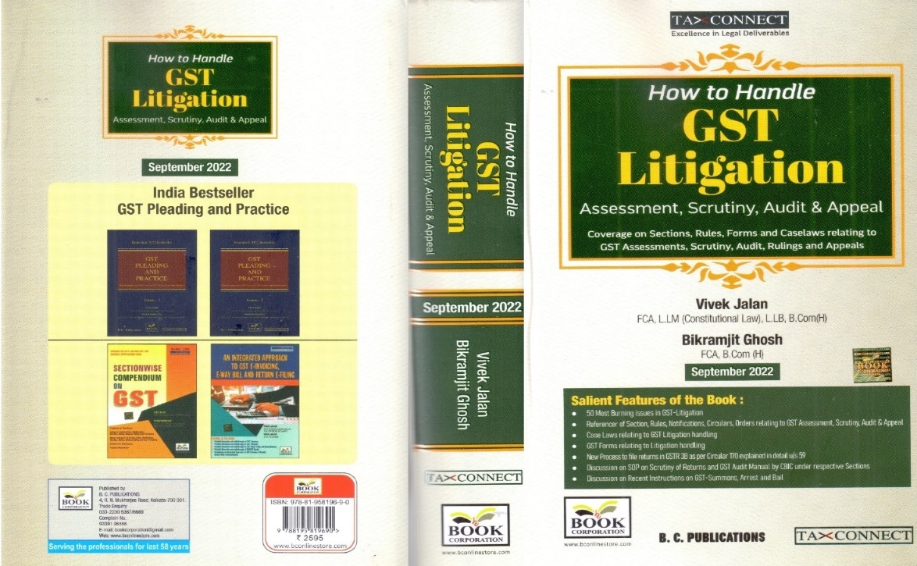

CONTENTS
1. 50 Most Burning issues in GST-Litigation
2. Reference of Section, Rules, Notifications, Circulars, Orders relating to GST Assessment, Scrutiny, Audit & Appeal
3. Case Laws relating to GST Litigation handling
4. GST Forms relating to Litigation handling
5. New process to file returns in GSTR 3B as per circular 170 explained in details u/s 59
6. Discussion on SOP on Scrutiny of Returns and GST Audit Manual by CBIC under respective Sections
7. Discussion on Recent Instruction on GST-Summons, Arrest and Bail

Authors:
Vivek Jalan
[FCA, LL.M (Constitutional Law), LL. B, B. Com(H)]

Bikramjit Ghosh
[FCA, B. Com(H)]

Published by: In Association With:
BOOK CORPORATION TAX CONNECT ACADEMY
4, R. N. Mukherjee Road 6, Netaji Subhas Road,
Kolkata 700001 Kolkata 700001
Phones: (033) 64547999 Cell: 7003384915 Cell: 9830010297, 9331018333 Order by email: info@taxconnect.co.in Order by email:bookcorporation@gmail.com Website : www.taxconnect.co.in
Website :www.bookcorporation.com

:IN STANDS

GST PLEADING AND PRACTICE: With Section-wise GST Cases & GST Notices and their Replies
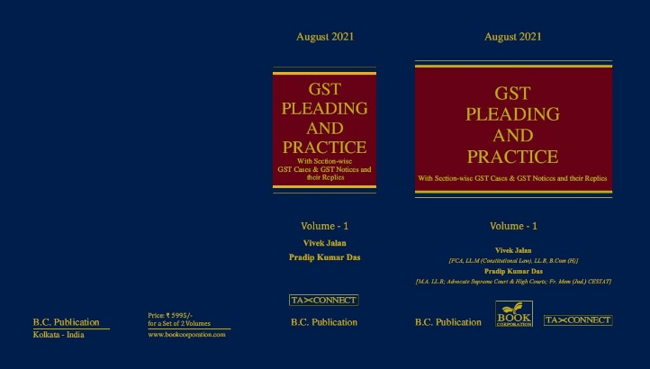

ABOUT THE BOOK: This publication includes:
1. GST Notices and their Replies
2. Orders and Appeals under GST
3. Text of provisions under IGST Act 2017 & CGST Act 2017
4. CGST & IGST Section-wise Synopsis of Case Laws and Notification/Circulars Gist
5. CGST & IGST Section-wise Synopsis of “Question of Law” answered under GST
6. Completely Updated Synopsis of Case Laws under GST by Supreme Court, High Court, AAARs & AARs

Authors:
Vivek Jalan
[FCA, LL.M (Constitutional Law), LL. B, B. Com(H)]

Pradip Kumar Das
[M.A. LL. B; Advocate Supreme Court & High Courts; Fr. Mem (Jud.) CESTAT]

Published by: In Association With:
BOOK CORPORATION TAX CONNECT ACADEMY
4, R. N. Mukherjee Road 6, Netaji Subhas Road,
Kolkata 700001 Kolkata 700001
Phones: (033) 64547999 Cell: 7003384915 Cell: 9830010297, 9331018333 Order by email: info@taxconnect.co.in Order by email:bookcorporation@gmail.com Website : www.taxconnect.co.in
Website :www.bookcorporation.com

LET’S DISCUSS FURTHER!

OUR OFFICES:
MUMBAI
Unit No. 312, Omega Business Park, Near Kaamgar Hospital, Road No. 33, Wagle Industrial Estate, Thane West,
Maharashtra- 400604

Contact Person: Priyanka Vishwakarma
Email:priyanka.vishwakarma@taxconnect.co.in
BENGALURU
#46/4, GB Palya, Kudlu Gate, Hosur Road, Bengaluru,
Karnataka – 560068.

Contact Person: Anil Pal

Email:anil.pal@taxconnectdelhi.co.in

DELHI (NCR)
B-139, 2nd Floor, Transport Nagar,
Noida-201301 (U.P)

Contact Person: Poonam Khemka

Email:poonam.khemka@taxconnect.co.in


DUBAI
Azizi Feirouz, 803, 8th Floor, AL Furjan, Opposite Discovery Pavillion,
Dubai, UAE

Contact Person: Rohit Sharma

Email:rohit.sharma@taxconnect.co.in

KOLKATA
R No 119; 1st Floor; Diamond Arcade; 1/72, Cal Jessore Road,
Kolkata – 700055

Contact Person: Uttam Kumar Singh

Email:info@taxconnect.co.in

KOLKATA
6, Netaji Subhas Road, 3rd Floor, Royal Exchange Building,
Kolkata - 700001

Contact Person: Tithly Roy

Email:tithly.roy@taxconnect.co.in

Disclaimer:
This e-bulletin is for private circulation only. Views expressed herein are of the editorial team and are based on the information, explanation and documents available on Government portal platforms. Tax Connect or any of its employees do not accept any liability whatsoever direct or indirect that may arise from the use of the information contained herein. No matter contained herein may be reproduced without prior consent of Tax Connect. While this e-article has been prepared on the basis of published/other publicly available information considered reliable, we do not accept any liability for the accuracy of its contents.
Tax Connect 2022. All rights reserved.

