Iz8
_{TAX CONNECT}

415th Issue: 13th August 2023-19th August 2023
12017

sssss

Knowledge Partner:



TAX CONNECT :

Mumbai : Unit No. 312, Omega Business Park, Near-Kaamgar Hospital, Road No. 33, Wagle Industrial Estate,
Thane (West), Maharashtra – 400604
Bengaluru : 46/4, GB Palya, Kudlu Gate, Hosur Road, Bengaluru, Karnataka – 560068.
Delhi (NCR) : B-139, 2ndFloor, Transport Nagar, Noida-201301 (U.P)
Kolkata : 6, Netaji Subhas Road, 3rd Floor, Royal Exchange Building, Kolkata – 700001
- Room No. 119, 1stFloor, “Diamond Arcade” 1/72, Cal Jessore Road, Kolkata – 700055
- Tobacco House, 1, Old Court House St, Radha Bazar, Corner, Kolkata, West Bengal 700001
Dubai : Azizi Feirouz, 803, 8th Floor, AL Furjan, Opposite Discovery Pavillion, Dubai, UAE

Contact : +91 7003384915

Website : www.taxconnect.co.in
Email : info@taxconnect.co.in

Friends,
Not very often does a justice starts a judgement with “the case is very interesting” and thereafter praising the writ petitioner. In the case of RAMESH KUMAR PATODIA Vs CITY BANK N.A. AND ORS. [2023-VIL480-CAL] the same has occurred and therefore the case and the impact of the judgement must be understood. The question of law under GST is not very simple “Is the interest on loan availed by a credit card holder same as interest as a credit card service”.

In Sl. No. 28 of the notification No. 9/2017- Integrated Tax (Rate), against heading 9971, except tax levied on interest in credit card services, the services specified in Column-III were exempt from the said tax. Now this interest is different from interest on loan.

Interest in credit card services is charged apropos a transaction wherein the issuer of the card advances a loan to the card holder to pay off the debt incurred by use of the credit card. The interest in case of such deferred payment by the holder of the card is a kind of service rendered can be called card services. Only on this kind of service could IGST be charged, levied and paid. However. merely because a holder of the bank’s card is eligible and provided a loan, it does not convert the interest paid on such loan to the interest paid on deferred payment of credit card bill by a person.

To constitute credit card service, the service should be between the issuer of the card and the holder of the card and that the service should have some relationship or nexus with the holding, operation or use of such card including transactions made with it. The same card holder may be an ordinary savings account holder with the bank. The service rendered by the bank in relation to such ordinary account holding does not have any relationship with the service rendered by the bank to the same customer as a card holder in transactions concerning the card. If the loan is advanced to a card holder through use of the card, then a nexus exists and the service can be treated as a ‘credit card service’. However, if the loan is not generated by charging the appellant’s card, then no such nexus can be said have existed.
Thus, credit card holders who have a separate bank account with the same bank and get an independent loan are absolved from payment of GST @18% on the interest portion. Furthermore, many times banks charge a fee or additional interest for delayed payment of interest too. Again, in these cases, the same concept may apply – in case the original interest has a nexus with the credit card service, the additional interest would also be liable to GST. However, in case the original interest is exempt from GST, then subsequent interest would partake the nature of the original interest too.

This judgement has wide implications on the masses and as well as the Banks and we are sure that it would act as a precedent in numerous cases going forward, until and unless it is challenged. Further it is very much expected that the banks may going forward run to the GST Council to seek clarity on this aspect, wherein they would have a big exposure. Interestingly, while the GST Council is a stakeholder in this case, yet it is not a party to the case.

Just to reiterate that we remain available over telecom or e-mail.

Editor:
Vivek Jalan
Partner - Tax Connect Advisory Services LLP

Co-Editor:
Rohit Sharma
Director – Tax Connect Advisory Services LLP

S.NO. | TOPICS | PAGE NO.
1] | TAX CALENDER | 4
2] | INCOME TAX | 5-6
NOTIFICATION | CBDT EXTENDED APPLICABILITY OF SAFE HARBOUR RULES TO AY 2023-24
NOTIFICATION | EXEMPTION FROM SPECIFIED INCOME U/S 10(46) – NOTIFIES ‘CHANDIGARH BUILDING AND OTHER CONSTRUCTION WORKERS WELFARE BOARD, CHANDIGARH’ A BOARD CONSTITUTED BY THE ADMINISTRATOR, UNION TERRITORY, CHANDIGARH
NOTIFICATION | EXEMPTION FROM SPECIFIED INCOME U/S 10(46) – NOTIFIES ‘STATE POLLUTION CONTROL BOARD ODISHA’ A BOARD CONSTITUTED BY THE STATE GOVERNMENT OF ODISHA
3] | GST | 7-9
CIRCULAR | CLARIFICATION REGARDING GST RATES AND CLASSIFICATION OF CERTAIN GOODS BASED ON THE RECOMMENDATIONS OF THE GST COUNCIL IN ITS 50TH MEETING
CIRCULAR | CLARIFICATIONS REGARDING APPLICABILITY OF GST ON CERTAIN SERVICES
4] | FEMA | 10
CASE LAW | OFFENCE U/S 57 OF THE FERA - NON COMPLAINT FILED IN COMPLIANCE OF THE PROVISIONS OF SECTION 61 (2)(II) OF THE FERA : CALCUTTA HIGH COURT
5] | CUSTOMS | 11-12
NOTIFICATION | APPOINTMENT OF COMMON ADJUDICATING AUTHORITY FOR THE PURPOSE OF ADJUDICATION OF FINALIZATION OF PROVISIONAL ASSESSMENT IN SVB CASE W.R.T. M/S MAGEBA BRIDGE PRODUCTS PVT. LTD, KOLKATA
CIRCULAR | AUTHORIZATION OF BOOKING POST OFFICES AND THEIR CORRESPONDING FOREIGN POST OFFICES IN TERMS OF THE POSTAL EXPORT (ELECTRONIC DECLARATION AND PROCESSING) REGULATIONS, 2022
CASE LAW | CONDONATION OF DELAY IN FILING THE APPEALS - CONDONATION OF PERIOD UNDERGONE BEFORE THE REVISIONARY AUTHORITY UNDER A BONA FIDE BELIEF AND THE APPELLANT HAD ACTED DILIGENTLY IN PURSUING SUCH REMEDY : BOMBAY HIGH COURT
6] | DGFT | 13
PUBLIC NOTICE | IMPLEMENTATION OF THE TRACK AND TRACE SYSTEM FOR EXPORT OF PHARMACEUTICALS AND DRUG CONSIGNMENTS ALONG WITH MAINTAINING THE PARENT-CHILD RELATIONSHIP IN THE LEVELS OF PACKAGING AND THEIR MOVEMENT IN SUPPLY CHAIN - EXTENSION OF DATE OF IMPLEMENTATION
PUBLIC NOTICE | AMENDMENTS IN CONDITIONS OF THE STANDARD INPUT OUTPUT NORMS (SION) AT E-136 FOR EXPORT OF WHEAT FLOUR
7] | HANDBOOK ON GST 2022 | 14
8] | HOW TO HANDLE GST LITIGATION: ASSESSMENT, SCRUTINY, AUDIT & APPEAL | 15
9] | GST PLEADING AND PRACTICE: WITH SECTION-WISE GST CASES & GST NOTICES AND THEIR REPLIES | 16
10] | LET’S DISCUSS FURTHER | 17

Due Date | Form/Return/Challan | Reporting Period | Description
13th August | GSTR-1 (IFF) | July 2023 | Details of B2B Supply of a registered person with turnover upto INR 5 Crores during the preceding year and who has opted for quarterly filing of return under QRMP.
13th August | GSTR-6 | July 2023 | Details of Input Tax Credit (ITC) received and distributed by an  Input Service Distributors (ISD).
13th August | GSTR-5 | July 2023 | Summary of outward taxable supplies and tax payable by a nonresident taxable person.
14th August | TDS Certificate | Jun 2023 | Due date for issue of TDS Certificate for tax deducted under section 194-IA, 194-IB, 194-M, 194S in the month of June, 2023
15th August | Form 24G | July 2023 | ​Due date for furnishing of Form 24G by an office of the Government where TDS/TCS for the month of July, 2023 has been paid without the production of a challan
15th August | Form 3BB | July 2023 | ​Due date for furnishing statement in Form no. 3BB by a stock exchange in respect of transactions in which client codes been modified after registering in the system for the month of July, 2023

NOTIFICATION
CBDT extendED applicability of Safe Harbour rules to AY 2023-24
OUR COMMENTS: The Central Board of Direct Taxes, Department of Revenue, Ministry of Finance, vide Notification No. 58/2023 Dated 09.08.2023 notified In exercise of the powers conferred by section 295 read with sub-section (2) of section 92CB of the Income-tax Act, 1961 (43 of 1961), the Central Board of Direct Taxes hereby makes the following rules further to amend the Income-tax Rules, 1962, namely:___
1. Short title and commencement. –
(1) These rules may be called the Income-tax (Fifteenth Amendment) Rules, 2023.
(2) They shall deemed to have come into force from the 1st day of April 2023.
2. In the Income-tax Rules, 1962, in rule 10TD, in sub-rule (3B), for the words and figures “assessment years 2020-21, 2021-22 and 2022-23”, the words and figures “assessment years 2020-21, 2021-22, 2022-23 and 2023-24” shall be substituted.
[For further details please refer the Notification]
NOTIFICATION
Exemption from specified income U/s 10(46) – Notifies ‘Chandigarh Building and Other Construction Workers Welfare Board, Chandigarh’ a Board constituted by the Administrator, Union territory, Chandigarh
OUR COMMENTS: The Central Board of Direct Taxes, Department of Revenue, Ministry of Finance, vide Notification No. 59/2023 Dated 10.08.2023 notified In exercise of the powers conferred by clause (46) of section 10 of the Income-tax Act, 1961 (43 of 1961), the Central Government hereby notifies for the purposes of the said clause, ‘Chandigarh Building and Other Construction Workers Welfare Board, Chandigarh’(PAN AALC0595J), a Board constituted by the Administrator, Union territory, Chandigarh, in respect of the following specified income arising to the said Board, as follows:
(a) Proceeds of the Cess collected under the Building & Other Construction Workers Welfare Cess Act, 1996 (28 of 1996) and rules made thereunder;
(b) Contribution and registration fees paid by the Beneficiaries under the Building and Other Construction Workers (Regulation of Employment and Conditions of Service) Act, 1996 and rules made thereunder; and
(c) Interest earned on (a) & (b) above.
2. This notification shall be effective subject to the conditions that Chandigarh Building and Other Construction Workers Welfare Board, Chandigarh -
(a) shall not engage in any commercial activity;
(b) activities and the nature of the specified income shall remain unchanged throughout the financial years; and
(c) shall file return of income in accordance with the provision of clause (g) of sub-section (4C) of section 139 of the Income-tax Act, 1961.
3. This notification shall be deemed to have been applied for assessment years 2021-2022 to 2023-2024 relevant for the financial years 2020-2021 to 2022-2023 respectively.
[For further details please refer the Notification]
NOTIFICATION
Exemption from specified income U/s 10(46) – Notifies ‘State Pollution Control Board Odisha’ a Board constituted by the State Government of Odisha
OUR COMMENTS: The Central Board of Direct Taxes, Department of Revenue, Ministry of Finance, vide Notification No. 60/2023 Dated 10.08.2023 notified In exercise of the powers conferred by clause (46) of section 10 of the Income-tax Act, 1961 (43 of 1961), the Central Government hereby notifies for the purposes of the said clause, ‘State Pollution Control Board Odisha’ (PAN AAALS2490J), a Board constituted by the State Government of Odisha, in respect of the following specified income arising to that Board, namely:
(a) Regulatory charges under different Environmental Acts & Rules thereunder;
(b) Penalties & Levies collected under governing statutes;
(c) Grant-in-aid received from Central & State Governments;
(d) Grant in Aid received on behalf of Central & State Governments in the capacity of nodal agency;
(e) Share of contributions received for carrying out environmental studies & research;
(f) Miscellaneous income, like sale of scrap, profit on sale of assets, RTI application fees, forfeiture of Bank Guarantee, tender fees, examination fees, analysis charges and empanelment of consultant fees etc. and
(g) Interest earned on (a) to (f) above.
2. This notification shall be effective subject to the conditions that State Pollution Control Board Odisha,-
(a) shall not engage in any commercial activity;
(b) activities and the nature of the specified income shall remain unchanged throughout the financial years; and
(c) shall file return of income in accordance with the provision of clause (g) of sub-section (4C) of section 139 of the Income-tax Act, 1961.
3. This notification shall be deemed to have been applied for assessment years 2021-2022 to 2023-2024 relevant for the financial years 2020-2021 to 2022-2023 respectively.
[For further details please refer the notification]

CIRCULAR
CLARIFICATION REGARDING GST RATES AND CLASSIFICATION OF CERTAIN GOODS BASED ON THE RECOMMENDATIONS OF THE GST COUNCIL IN ITS 50TH MEETING
OUR COMMENTS: The Ministry of Finance, Department of Revenue vide circular No. 200/12/2023-GST dated 01.08.2023 circulated that Based on the recommendations of the GST Council in its 50th meeting held on 11th July, 2023, clarifications with reference to GST levy related to the following items are being issued through this circular:
i. Un-fried or un-cooked snack pellets, by whatever name called, manufactured through process of extrusion;
ii. Fish Soluble Paste;
iii. Desiccated coconut;
iv. Biomass briquettes;
v. Imitation zari thread or yarn known by any name in trade parlance;
vi. Supply of raw cotton by agriculturist to cooperatives;
vii. Plates, cups made from areca leaves
viii. Goods falling under HSN heading 9021
2. Applicability of GST on un-fried or un-cooked snack pellets, by whatever name called, manufactured through process of extrusion:
2.1 In the 48th meeting of the GST Council, it was clarified that the snack pellets (such as ‘fryums’), which are manufactured through the process of extrusion, are appropriately classifiable under tariff item 1905 90 30, which covers goods with description ‘Extruded or expanded products, savoury or salted’, and thereby attract GST at the rate of 18% vide S. No. 16 of Schedule-III of notification no. 1/2017-Central Tax (Rate), dated the 28th June, 2017.
2.2 In view of the recommendation of the GST Council in the 50th meeting, supply of uncooked/ un-fried extruded snack pellets, by whatever name called, falling under CTH 1905 will attract GST rate of 5% vide S. No. 99B of Schedule I of notification no. 1/2017-Central Tax (Rate), dated the 28th June, 2017 with effect from 27th July,2023. Extruded snack pellets in ready- to-eat form will continue to attract 18% GST under S. No. 16 of Schedule III of notification no. 1/2017-Central Tax (Rate), dated the 28th June, 2017.
2.2 Further, in view of the prevailing genuine doubts regarding the applicability of GST rate on the un-fried or un-cooked snack pellets, by whatever name called, manufactured through process of extrusion, the issue for past period upto 27.7.2023 is hereby regularized on “as is” basis.
3. Applicability of GST on Fish Soluble Paste:
3.1 Fish soluble paste attracted 18% under the residual entry S No. 453 of Schedule III of notification no. 1/2017-Central Tax (Rate), dated the 28th June, 2017. As per recommendation of the GST Council, GST on fish soluble paste, falling under CTH 2309, has been reduced to 5%. Accordingly, the rate has been notified vide S. No. 108A with effect from 27th July, 2023.
3.2 Further, in view of the prevailing genuine doubts regarding the applicability of GST rate on fish soluble paste, the issue for past period upto 27.7.2023 is hereby regularized on “as is” basis.
4. Desiccated coconut- Regularisation of the issue for past period from 01.07.2017 up to and inclusive of 27.07.2017:
As per recommendation of the GST Council, in view of the prevailing genuine interpretational issues regarding the applicability of GST rate on the desiccated coconut, falling under CTH 0801, the issue for past period from 01.07.2017 up to and inclusive of 27.07.2017 is hereby regularized on “as is” basis.
5. Biomass briquettes- Regularisation of the issue for past period from 01.07.2017 up to and inclusive of 12.10.2017:
As per recommendation of the GST Council, in view of the prevailing genuine interpretational issues regarding the applicability of GST rate on the Biomass briquettes, falling under any chapter, the issue for past period from 01.07.2017 up to and inclusive of 12.10.2017 is hereby regularized on “as is” basis.
6. Supply of raw cotton by agriculturist to cooperatives:
6.1 As per recommendation of the GST Council, it is hereby clarified that supply of raw cotton, including kala cotton, from agriculturists to cooperatives is a taxable supply and such supply of raw cotton by agriculturist to the cooperatives (being a registered person) attracts 5% GST on reverse charge basis under notification no. 43/2017-Central Tax (Rate) dated 14th November, 2017.
6.2 In view of prevailing genuine doubts, the issue for the past periods prior to issue of this clarification is hereby regularized on “as is basis”.
7. GST rate on Imitation Zari thread or yarn known by any name in trade parlance:
7.1 In the 15th Council meeting, the Council agreed to tax embroidery or zari articles i.e., imi, zari, kasab, saima, dabka, chumki, gota, sitara, naqsi, kora, glass beads, badla, gizai at the rate of 5%. Based on the recommendation of the 28th GST Council, it was clarified that imitation zari thread or yarn known as “Kasab” or by any other name in trade parlance, would attract a uniform GST rate of 12% under tariff heading 5605.
7.2 As per the recommendation of the GST Council in its 50th meeting, GST on imitation zari thread or yarn known by any name in trade parlance has been reduced from 12% to 5%. Accordingly, the rate has been notified vide S. No. 218AA with effect from 27th July, 2023.
7.2. In view of the confusion in the trade regarding the applicability of GST rate on these products, the issue for past period upto 27.7.2023 is hereby regularized on “as is” basis.
8. Plates, cups made from areca leaves
As per the recommendation of the GST Council, issues relating to GST on plates and cups made from areca leaves are hereby regularized on “as is basis” for the period prior to 01.10.2019.
9. GST rate on goods falling under HSN 9021
9.1 Representations have been received seeking clarification regarding the GST rates applicable on trauma, spine and arthroplasty implants falling under HSN heading 9021 for the period before 18.07.2022 stating that there are interpretational issues due to the duality of rates on similar items leading to ambiguity. The issue has arisen as prior to 18.07.2022 there existed two rates on the goods falling under HSN heading 9021 as per S. No. 257 of schedule I and S. No. 221 of schedule II of notification no. 01/2017-CT (Rate) dated 28.06.2017.
9.2 The issue was examined by GST Council in its 47th meeting and as per its recommendations, a single uniform rate of 5% was prescribed for such goods (except hearing aid, which continued to attract Nil under S.N. 142 of 02/2017-CT(Rate)) falling under HSN heading 9021 with effect from 18.07.2022.
9.3 As per recommendations of the GST council in its 50th Meeting, it is hereby clarified that the GST rate on all such goods falling under heading 9021 would attract a GST rate of 5% and in view of prevailing genuine doubts, the issue for the past periods is hereby regularized on “as is basis”. However, it is clarified that no refunds will be granted in cases where GST has already been paid at higher rate of 12%.
10. It is further clarified that no refunds will be granted where GST has already been paid in any of the above cases.
11. Difficulty if any, in the implementation of this circular may be brought to the notice of the Board.
[For further details please refer the Circular]
CIRCULAR
CLARIFICATIONS REGARDING APPLICABILITY OF GST ON CERTAIN SERVICES
OUR COMMENTS: The Ministry of Finance, Department of Revenue vide notification 201/13/2023-GST dated 01.08.2023 circulated that Representations have been received seeking clarifications on the following issues
1. Whether services supplied by director of a company in his personal capacity such as renting of immovable property to the company or body corporate are subject to Reverse Charge mechanism;
2. Whether supply of food or beverages in cinema hall is taxable as restaurant service.
The above issues have been examined by GST Council in the 50th meeting held on 11th July, 2023. The issue -wise clarifications as recommended by the Council are given below:
Whether services supplied by director of a company in his personal capacity such as renting of immovable property to the company or body corporate are subject to Reverse Charge mechanism:
2. Reference has been received requesting for clarification whether services supplied by a director of a company or body corporate in personal or private capacity, such as renting of immovable property to the company, are taxable under Reverse Charge Mechanism (RCM) or not.
2.1 Entry No. 6 of notification No. 13/2017 CTR dated 28.06.2017 provides that tax on services supplied by director of a company or a body corporate to the said company or the body corporate shall be paid by the company or the body corporate under Reverse Charge Mechanism.
2.2 It is hereby clarified that services supplied by a director of a company or body corporate to the company or body corporate in his private or personal capacity such as services supplied by way of renting of immovable property to the company or body corporate are not taxable under RCM. Only those services supplied by director of company or body corporate, which are supplied by him as or in the capacity of director of that company or body corporate shall be taxable under RCM in the hands of the company or body corporate under notification No. 13/2017-CTR (Sl. No. 6) dated 28.06.2017.
Whether supply of food or beverages in cinema hall is taxable as restaurant service:
3. References have been received requesting for clarification whether supply of food and beverages at cinema halls is taxable as restaurant service which attract GST at the rate of 5% or not.
3.1 As per Explanation at Para 4 (xxxii) to notification No. 11/2017-CTR dated 28.06.2017,
“Restaurant Service’ means supply, by way of or as part of any service, of goods, being food or any other article for human consumption or any drink, provided by a restaurant, eating joint including mess, canteen, whether for consumption on or away from the premises where such food or any other article for human consumption or drink is supplied.”
3.2 Eating joint is a wide term which includes refreshment or eating stalls/ kiosks/ counters or restaurant at a cinema also.
3.3 The cinema operator may run these refreshment or eating stalls/ kiosks/ counters or restaurant themselves or they may give it on contract to a third party. The customer may like to avail the services supplied by these refreshment/snack counters or choose not to avail these services. Further, the cinema operator can also install vending machines, or supply any other recreational service such as through coin-operated machines etc. which a customer may or may not avail.
3.4 It is hereby clarified that supply of food or beverages in a cinema hall is taxable as ‘restaurant service’ as long as:
a) the food or beverages are supplied by way of or as part of a service, and
b) supplied independent of the cinema exhibition service.
3.5 It is further clarified that where the sale of cinema ticket and supply of food and beverages are clubbed together, and such bundled supply satisfies the test of composite supply, the entire supply will attract GST at the rate applicable to service of exhibition of cinema, the principal supply.
4. Difficulties, if any, in implementation of this circular may be brought to the notice of the Board.
[For further details please refer the Circular]

CASE LAW
Offence u/s 57 of the FERA - Non Complaint filed in compliance of the provisions of section 61 (2)(ii) of the FERA : CALCUTTA HIGH COURT
OUR COMMENTS: It was held that as in this case where an offence under Section 57 of the Foreign Exchange Regulation Act, 1973 has been alleged against the accused person, the law provides that either the Enforcement Director or an officer authorised in writing on behalf of the Director or the Central Government or an authorised officer of Reserve Bank, shall be eligible to institute a complaint. The Magistrate has also emphasized that the appellant would not have the locus standi to initiate prosecution in absence of any authorization, without however considering or taking judicial note of his evidence and Exhibit-A (i.e., authorization certificate dated (22.12.2005).
The Magistrate could not ignore the ocular and documentary evidence before it, more so, when all these were uncontroverted. By virtue of holding officer at the particular period of time and having been authorized vide ‘Exhibit-A’ there was no impediment for the appellant to institute prosecution, which the Magistrate has not considered and such non-application of mind has rendered his findings not tenable in the eyes of law.
The Magistrate was duty bound to take note of the same, more particularly, in terms of Section 57(7) of the Evidence Act. It was a mandate of law. The notification dated 24th September, 1993 read with the direct evidence of the appellant before the Trial Court would unfailingly point out to the fact of the appellant to be competent officer under law, to institute prosecution on behalf of the Enforcement Directorate. By not considering all these factual and legal aspects, the Trial Court has committed gross error. The impugned judgment suffers from non-application of mind and illegality.
Thus unable to place occurrence with the finding of the Court in the impugned judgment that provisions of Section 61 (2) (ii) of the Foreign Exchange Regulation Act, 1973 has not been complied with by the complainant in order to institute a case punishable under Section 57, as it is in this particular proceeding. In my considered opinion, the impugned judgment of the Trial Court suffers for non-application of mind and wrong appreciation of the fact situation as well as the settled provisions of law. Accordingly, the same would not be maintainable and liable to be set aside, being not inconfirmity with the laws. The impugned judgment is set aside –
Appeal allowed.

NOTIFICATION
Appointment of Common Adjudicating Authority for the purpose of adjudication of finalization of Provisional Assessment in SVB case w.r.t. M/s Mageba Bridge Products Pvt. Ltd, Kolkata
OUR COMMENTS: The Ministry of Finance, Department of Revenue vide notification no 59/2023-Customs(N.T) dated 07.08.2023 notified In exercise of the powers conferred by sub-section (1) of section 4, read with section 3 and sub-sections (1) and (1A) of section 5 of the Customs Act, 1962 (52 of 1962), the Central Board of Indirect Taxes and Customs, hereby appoints officer mentioned in column (4) of the Table below to exercise the powers and discharge duties conferred or imposed on officers mentioned in column (3) of the said Table in respect of noticee mentioned in column (1) of the Table, for the purpose of adjudication of show cause notices mentioned in column (2) therein, namely:-
TABLE
Name of the Noticee and address (M/s.). | Show Cause Notice  number and date. | Name of Adjudicating Authorities. | Common Adjudicating Authority appointed.
(1) | (2) | (3) | (4)
M/s. Mageba Bridge Products Pvt. Ltd. 45, Jhowtala Road, Kolkata- 700019, West Bengal, India. | (i) SCN No. S206(Misc)- 270/2016 A Grp-II dated 23.02.2017 | (i) Additional or Joint Commissioner of Customs (Port) Customs House, Kolkata. | Additional or Joint Commissioner (Port), Group- IV, Customs House, Kolkata.
 | (ii) SCN No. CUS/APR/ MISC/2529/2022/GR4 O/o PR COMMR-CUS-PORTKOLdated 19.07.2022 | (ii) Assistant Commissioner of Customs, Appr GroupIV(Port), Customs House, Kolkata.
 | (iii) SCN No.ACC/BOND/FNL/SVB/37/2 021/ACCTS-O/O PR.COMMRCUS- AP/ACC-KOLKATA dated 01.09.2022 | (iii) Assistant Commissioner of Customs, Air Cargo Complex, O/o Commissioner of Customs, (Airport and ACC), Kolkata
 | (iv) SCN No. S60(MISC)- 105/2010A Gr-iv(pt) dated 27.09.2022 | (iv) Assistant Commissioner of Customs, Appr Group IV (Port), Customs House, Kolkata.
 | (v) SCN No. S206(MISC)- 12/2020A Gr-II (pt IV) dated 10.10.2022 | (v) Assistant Commissioner of Customs (Port), Group II Chemical- III, Customs House, Kolkata.
 | (vi) SCN No. S206(MISC)- 12/2020A Gr-II (pt IV) dated 10.10.2022 | (vi) Assistant Commissioner of Customs (Port), Group II Chemical- III, Customs House, Kolkata.
 | (vii) SCN No. CUS/APR/SCN/250/2022-GR 3-O/O PR COMMR-CUSPORT- KOLKATA dated 11.10.2022 | (vii) Deputy Commissioner of Customs (Port), APPRAISING Group III, Customs House, Kolkata.
 | (viii) SCN No.1346/22- 23/DC/Gr.IV/CAC/JNCH dated 12.11.2022 | (viii) Deputy Commissioner of Customs, Group IV A, NSIII, JNCH, Mumbai.
[For further details please refer the notification]
CIRCULAR
Authorization of Booking Post Offices and their corresponding Foreign Post Offices in terms of the Postal Export (Electronic Declaration and Processing) Regulations, 2022
OUR COMMENTS: The Ministry of Finance, Department of Revenue vide circular no 20/2023-Customs dated 07.08.2023 circulated that Attention is drawn to the Postal Export (Electronic Declaration and Processing) Regulations, 2022 issued under Notification no. 104/2022-Customs (N.T.) dated 09.12.2022, the Guidelines for their implementation in Circular no. 25/2022-Customs dated 09.12.2022 and Circular No. 06/2023-Customs dated 01.03.2023 vide which authorization of 122 booking post offices by Department of Post was communicated.
2. In terms of Regulation 6(1), the Department of Post vide O.M. dated 31.07.2023 (copy enclosed) has authorized 715 Booking Post Offices to accept consignments for export. The list of Booking Post Offices and the corresponding Foreign Post Offices is also enclosed.
3. The above is for your information, necessary action and implementation. Difficulty, if any, in implementation may kindly be brought to notice of the Board.
[For further details please refer the circular]
CASE LAW
Condonation of delay in filing the appeals - condonation of period undergone before the Revisionary Authority under a bona fide belief and the Appellant had acted diligently in pursuing such remedy : BOMBAY HIGH COURT
OUR COMMENTS: It was held that the impugned order passed by the CESTAT was passed in the absence of the appellant as seen from the appearance as noted in the impugned order.
It is also required to be noted that assailing the order in appeal passed by the Commissioner of Customs (16 March, 2016), the appellant being under a bona fide belief, had approached the revisional authority, by filing a revision application on 09 May, 2016 which came to be rejected after a period of almost more than 4 years i.e. on 14 December, 2020. In assailing the orders passed by the Commissioner (Appeals), the appellant was not sleeping over his rights. The revisional authority was however of the opinion that the revision proceedings as filed by the appellant were not maintainable, as the appropriate remedy for the appellant was to file an appeal before the CESTAT. In this view of the matter, the revisional authority disposed of the revisional proceedings, permitting the appellant to avail of the remedy of an appeal before the CESTAT.
When a litigant like the appellant bona fide adopts a remedy which is not appropriate remedy, Section 14 of the Limitation Act would certainly come to the aid of such litigant - The object and purpose of Section 14 of the Limitation Act is that the litigant ought not to suffer by a delay is caused in bona fide and in good faith pursuing the proceedings against orders which adversely affect the litigant before a wrong forum.
This is a fit case where the appellant having pursued the revisional proceedings and that too bona fide and in good faith, as it is not a case of the revenue that there was any other intention on the part of the appellant in pursuing the revision proceedings the delay in filing the appeal ought to have been condoned by the CESTAT. Thus, these factual circumstances being quite apparent, as also the clear position of applicability of Section 14 of the Limitation Act, to the facts of the case was completely overlooked by the CESTAT, in adjudicating the interim application filed by the appellant, in dismissing the appellant’s interim applications.
The questions answered in favour of the appellant and against the Revenue.

PUBLIC NOTICE
Implementation of the Track and Trace system for export of Pharmaceuticals and drug consignments along with maintaining the Parent-Child relationship in the levels of packaging and their movement in supply chain - Extension of date of implementation
OUR COMMENTS: The Ministry of Commerce and Industry vide public notice no. 26/2023 dated 04.08.2023 In exercise of the powers conferred under Paragraph 2.04 of the Foreign Trade Policy 2023, as amended from time to time, the Director General of Foreign Trade hereby amends Para 2.90A of Handbook of Procedure- 2015-20, as notified vide Public Notice No. 43/2015-20 dated 05.12.2017 read with Public Notice No. 52 / 2015-20 dated 05.01.2016, Public Notice No. 05/2015-20 dated 09.05.2018, Public Notice No. 43/2015- 2020 dated 01.11.2018, Public Notice No. 16/2015- 2020 dated 04.07.2019, Public Notice No. 66/2015- 2020 dated 30.03.2020, Public Notice No. 16/2015-2020 dated 22.9.2020, Public Notice No. 46/2015-20 dated 30.03.2021, Public Notice No. 01/2015-2020 dated 04.01.2022 and Public Notice No. 3/2023 dated 03.04.2023 on laying down the procedure for implementation of the Track and Trace system for export consignments of drug formulations.
2. In Para 2.76 (vi) and (vii) of Handbook of Procedure - 2023 (as amended erstwhile Para 2.90A of HBP 2015-2020), the date for implementation of Track and Trace system for export of drug formulations with respect to maintaining the Parent-Child relationship in packaging levels and its uploading on Central Portal is extended up to 01.02.2024 for both SSI and non SSI manufactured drugs.
3. Effect of this Public Notice:
The date for implementation of Track and Trace system for export of drug formulations with respect to maintaining the Parent-Child relationship in packaging levels and its uploading on Central Portal has been extended up to 01.02.2024 for both SSI and non SSI manufactured drugs.
[For further details please refer the public notice]

PUBLIC NOTICE
Amendments in conditions of the Standard Input Output Norms (SION) at E-136 for export of Wheat Flour
OUR COMMENTS: The Ministry of Commerce and Industry vide public notice no. 25/2023 dated 04.08.2023 In exercise of the powers conferred under Paragraph 1.03 & 2.04 of Foreign Trade Policy (FTP), 2023, as amended from time to time, the Director General of Foreign Trade hereby makes the following amendments:
For the SION E-136 as amended in Public Notice No. 62/2015-20 dated 23.03.2023, note 3 is added as under:
Note 3: Export of 'Wheat Flour (Atta) with Millets' is also allowed subject to the conditions that :
a. The export item will contain a minimum of 65% Wheat Flour (Atta) & a minimum of 15% Millets in addition to other ingredients (if any).
b. Import entitlement of Wheat under the Advance Authorization for such export items, i.e. 'Wheat Flour Atta with Millets' will be calculated in proportion to the %age content of Whole Wheat Flour (Atta) in the export item, i.e. for export of every 1 Kg of Whole Wheat Flour (Atta), import of 1.07 Kg of Wheat will be allowed.
c. Millets & other ingredients being added to the export item will be domestically sourced.
d. The export description in the SB will clearly indicate the % age content of Whole Wheat Flour, % age content of Millets and other ingredients being added.
e. All other conditions specified earlier in Public Notice No. 38/2015-20 dated 25.11.2022 and Public Notice No. 62/2015-20 dated 23.03.2023 will continue to be in force.
Effect to this Public Notice: SION E-136 is being amended to allow export of Wheat Flour (Atta) with Millets.
[For further details please refer the public notice]

:IN STANDS

HANDBOOK ON GST 2022
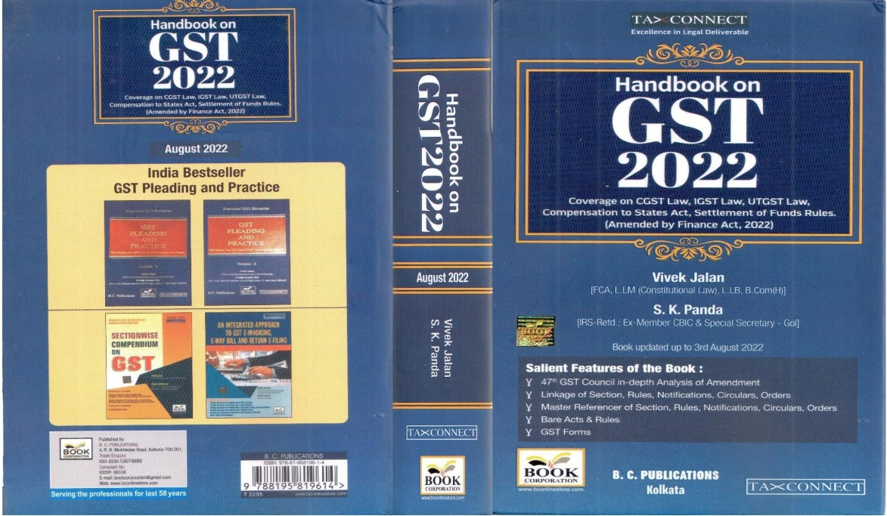

CONTENTS
- 47th GST Council in-depth Analysis of Amendment
- Linkage of Section, Rules, Notifications, Circulars, Orders
- Master Reference of Section, Rules, Notifications, Circulars, Orders
- Bare Acts & Rules
- GST Forms
Author:
Vivek Jalan
[FCA, LL.M (Constitutional Law), LL.B, B.Com(H)]

S.K. Panda
[IRS-Retd.; Ex-Member CBIC & Special Secretary – GoI]

Published by: In Association With:
BOOK CORPORATION TAX CONNECT ACADEMY
4, R. N. Mukherjee Road 6, Netaji Subhas Road,
Kolkata 700001 Kolkata 700001
Phones: (033) 64547999 Cell: 7003384915 Cell: 9830010297, 9331018333 Order by email: info@taxconnect.co.in Order by email:bookcorporation@gmail.com Website : www.taxconnect.co.in
Website :www.bookcorporation.com

:IN STANDS

How to Handle GST LITIGATION: Assessment, Scrutiny, Audit & Appeal
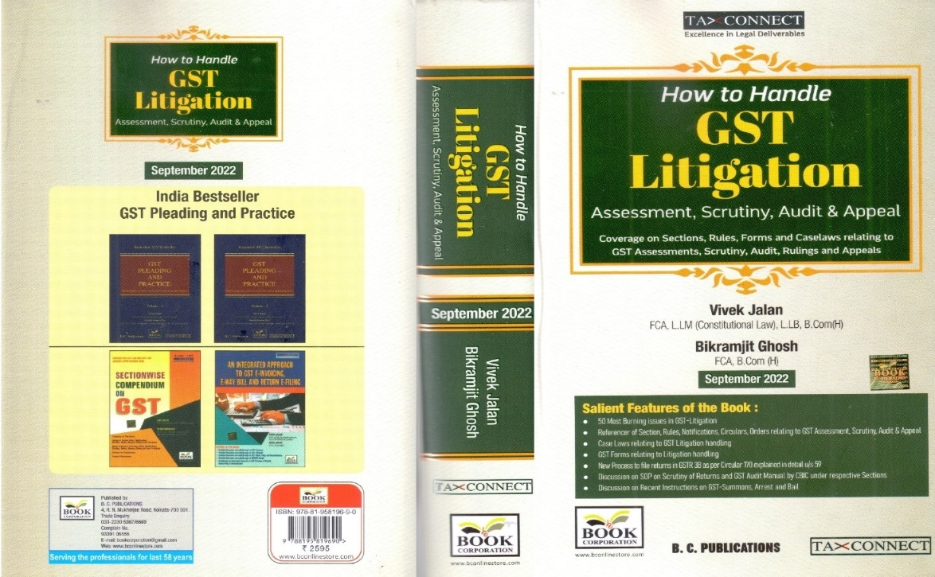

CONTENTS
1. 50 Most Burning issues in GST-Litigation
2. Reference of Section, Rules, Notifications, Circulars, Orders relating to GST Assessment, Scrutiny, Audit & Appeal
3. Case Laws relating to GST Litigation handling
4. GST Forms relating to Litigation handling
5. New process to file returns in GSTR 3B as per circular 170 explained in details u/s 59
6. Discussion on SOP on Scrutiny of Returns and GST Audit Manual by CBIC under respective Sections
7. Discussion on Recent Instruction on GST-Summons, Arrest and Bail

Authors:
Vivek Jalan
[FCA, LL.M (Constitutional Law), LL. B, B. Com(H)]

Bikramjit Ghosh
[FCA, B. Com(H)]

Published by: In Association With:
BOOK CORPORATION TAX CONNECT ACADEMY
4, R. N. Mukherjee Road 6, Netaji Subhas Road,
Kolkata 700001 Kolkata 700001
Phones: (033) 64547999 Cell: 7003384915 Cell: 9830010297, 9331018333 Order by email: info@taxconnect.co.in Order by email:bookcorporation@gmail.com Website : www.taxconnect.co.in
Website :www.bookcorporation.com

:IN STANDS

GST PLEADING AND PRACTICE: With Section-wise GST Cases & GST Notices and their Replies
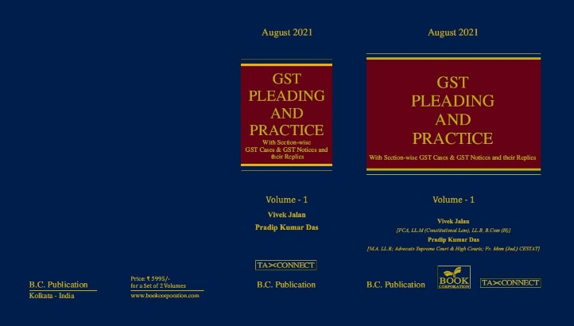

ABOUT THE BOOK: This publication includes:
1. GST Notices and their Replies
2. Orders and Appeals under GST
3. Text of provisions under IGST Act 2017 & CGST Act 2017
4. CGST & IGST Section-wise Synopsis of Case Laws and Notification/Circulars Gist
5. CGST & IGST Section-wise Synopsis of “Question of Law” answered under GST
6. Completely Updated Synopsis of Case Laws under GST by Supreme Court, High Court, AAARs & AARs

Authors:
Vivek Jalan
[FCA, LL.M (Constitutional Law), LL. B, B. Com(H)]

Pradip Kumar Das
[M.A. LL. B; Advocate Supreme Court & High Courts; Fr. Mem (Jud.) CESTAT]

Published by: In Association With:
BOOK CORPORATION TAX CONNECT ACADEMY
4, R. N. Mukherjee Road 6, Netaji Subhas Road,
Kolkata 700001 Kolkata 700001
Phones: (033) 64547999 Cell: 7003384915 Cell: 9830010297, 9331018333 Order by email: info@taxconnect.co.in Order by email:bookcorporation@gmail.com Website : www.taxconnect.co.in
Website :www.bookcorporation.com

LET’S DISCUSS FURTHER!

OUR OFFICES:
MUMBAI
Unit No. 312, Omega Business Park, Near Kaamgar Hospital, Road No. 33, Wagle Industrial Estate, Thane West,
Maharashtra- 400604

Contact Person: Priyanka Vishwakarma
Email:priyanka.vishwakarma@taxconnect.co.in
BENGALURU
#46/4, GB Palya, Kudlu Gate, Hosur Road, Bengaluru,
Karnataka – 560068.

Contact Person: Anil Pal

Email:anil.pal@taxconnectdelhi.co.in

DELHI (NCR)
B-139, 2nd Floor, Transport Nagar,
Noida-201301 (U.P)

Contact Person: Poonam Khemka

Email:poonam.khemka@taxconnect.co.in


DUBAI
Azizi Feirouz, 803, 8th Floor, AL Furjan, Opposite Discovery Pavillion,
Dubai, UAE

Contact Person: Rohit Sharma

Email:rohit.sharma@taxconnect.co.in

KOLKATA
R No 119; 1st Floor; Diamond Arcade; 1/72, Cal Jessore Road,
Kolkata – 700055

Contact Person: Uttam Kumar Singh

Email:info@taxconnect.co.in

KOLKATA
6, Netaji Subhas Road, 3rd Floor, Royal Exchange Building,
Kolkata - 700001

Contact Person: Tithly Roy

Email:tithly.roy@taxconnect.co.in

Disclaimer:
This e-bulletin is for private circulation only. Views expressed herein are of the editorial team and are based on the information, explanation and documents available on Government portal platforms. Tax Connect or any of its employees do not accept any liability whatsoever direct or indirect that may arise from the use of the information contained herein. No matter contained herein may be reproduced without prior consent of Tax Connect. While this e-article has been prepared on the basis of published/other publicly available information considered reliable, we do not accept any liability for the accuracy of its contents.
Tax Connect 2023. All rights reserved.

