Iz8
_{TAX CONNECT}

408th Issue: 25th June 2023-1st July 2023
12017

sssss

Knowledge Partner:



TAX CONNECT
Mumbai: Unit No. 312, Omega Business Park, Near-Kaamgar Hospital, Road No. 33,Wagle Industrial Estate,
Thane (West), Maharashtra – 400604
Bangalore: 46/4, GB Palya, Kudlu Gate, Hosur Road, Bangalore,Karnataka – 560068.
New Delhi: B-139, 2ndFloor, Transport Nagar, Noida-201301 (U.P)
Kolkata: - 6, Netaji Subhas Road, 3rd Floor, Royal Exchange Building, Kolkata – 700001
- Room No. 119, 1stFloor,“Diamond Arcade” 1/72, Cal Jessore Road, Kolkata – 700055
- Tobacco House, 1, Old Court House St, Radha Bazar, Corner, Kolkata, West Bengal 700001

Dubai: AziziFeirouz, 803, 8th Floor, AL Furjan, Opposite Discovery Pavillion, Dubai, UAE

Contact: +91 9830661254
Website: www.taxconnect.co.in
Email: info@taxconnect.co.in

Friends,
Even after six years of GST the big question is specifically for the traders whether a discount provided by the OEM (Original Equipment Manufacturer) / Distributors to the wholesalers/retailers is actually a discount or is it to be treated as a supply of services from the wholesalers/retailers to the OEM/distributors.

Recently, The AAR of Maharashtra, it has held that a channel discount provided by the OEM through the distributors to the wholesalers is actually a supply of services by the wholesaler to the OEM, and not actually a discount.

The Hon’ble AAR of Maharashtra has held against the applicant because of three reasons:

- The agreement was actually of incentive by the OEM to the wholesaler through the distributor. Hence in the agreement the word discount was not mentioned but the word incentive was mentioned.

- The agreement was with the wholesaler and the OEM and not between the OEM and the distributor and distributor and the wholesaler. Therefore, even though it was routed through the distributor the Hon’ble AAR has held that this is a supply of services by the wholesaler to the OEM.

- There was no linking of the discounts or the credit notes for the discounts with the original invoices possible in this case. Therefore, the Hon’ble AAR has held that this is actually a supply of marketing and technical support services provided by the wholesaler to the OEM even though the whole transaction is routed through the distributor.

We recommend our understanding for our readers for the similar matter can be distinguished if these three issues can be taken care of:

- Merely because a trade discount is mentioned as incentive in an agreement a view has been held in this judgement that it is a supply of services. Therefore, the nomenclature which is to be used for such agreements of channel discounts should be “discounts”.

- There should be back-to-back agreements between the OEM and the distributors, distributors and the wholesalers, wholesalers and the retailers and thereafter supplies made to the consumers. If these agreements are there and thereafter the routing is done through the distributor, then such a view should not be taken.

- In case these discounts can be linked with the original invoices then these discounts cannot be categorized as supply of services by the recipient of the discount to the provider of the discounts or the original supplier.

However, after withdrawal of Circular no. 105/24/2019-GST dated 28th June 2019 this issue is wide open and various field officers are taking a view based on their understanding of the particular cases.

Just to reiterate that we remain available over telecom or e-mail.

Editor:
Vivek Jalan
Partner - Tax Connect Advisory Services LLP
Co-Editor:
Rohit Sharma
Director – Tax Connect Advisory Services LLP

S.NO. | TOPICS | PAGE NO.
1] | TAX CALENDER | 4
2] | INCOME TAX | 5-7
NOTIFICATION | NEW TAX REGIME U/S 115BAC IN RESPECT OF INDIVIDUALS, HUF AND OTHERS AS AMENDED BY FINANCE ACT, 2023
NOTIFICATION | CENTRAL GOVERNMENT APPROVED M/S PATANJALI YOG PEETH NYAS, DELHI - 44/2023 - INCOME TAX EXPENDITURE ON SCIENTIFIC RESEARCH U/S 35(1) (III) OF IT ACT 1961.
NOTIFICATION | INCOME-TAX (ELEVENTH AMENDMENT) RULES, 2023 NOTIFIED
3] | GST | 8
NOTIFICATION | CBIC EXTENDED DUE DATE FOR GSTR-7 FILING IN MANIPUR FOR APRIL & MAY 2023
NOTIFICATION | CBIC EXTENDED DUE DATE FOR GSTR-3B FILING IN MANIPUR FOR APRIL & MAY 2023
NOTIFICATION | CBIC EXTENDED TIME LIMIT TO FURNISH FORM GSTR1 IN MANIPUR FOR APRIL TO MAY 2023
4] | FEMA | 9
CIRCULAR | REMITTANCES TO INTERNATIONAL FINANCIAL SERVICES CENTRES (IFSCS) UNDER THE LIBERALISED REMITTANCE SCHEME (LRS)
5] | CUSTOMS | 10
CASE LAW | VIOLATION OF EPCG SCHEME - MACHINES GIVEN ON HIRE -INSTALLATION CERTIFICATE IS ISSUED WITHOUT VERIFICATION AND APPELLANT HAS DIVERTED SOME MACHINES IMPORTED TO OTHER MINES : KARNATAKA HIGH COURT
NOTIFICATION | RATE OF EXCHANGE OF ONE UNIT OF FOREIGN CURRENCY (TURKISH LIRA) EQUIVALENT TO INDIAN RUPEES NOTIFIED
6] | DGFT | 11-13
NOTIFICATION | AMENDMENTS IN CATEGORY 5B OF APPENDIX 3 (SCOMET ITEMS) TO SCHEDULE-2 OF ITC (HS) CLASSIFICATION OF EXPORT AND IMPORT ITEMS
NOTIFICATION | AMENDMENT IN EXPORT POLICY OF HS CODE 2610
NOTIFICATION | AMENDMENT IN POLICY FOR GENERAL AUTHORISATION FOR EXPORT OF CHEMICALS AND RELATED EQUIPMENTS (GAEC)
PUBLIC NOTICE | MODIFICATION OF STANDARD INPUT OUTPUT NORM (SION) E-121
7] | UNION BUDGET 2023: ANALYSIS BY TAX CONNECT | 14
8] | HANDBOOK ON GST 2022 | 15
9] | HOW TO HANDLE GST LITIGATION: ASSESSMENT, SCRUTINY, AUDIT & APPEAL | 16
10] | GST PLEADING AND PRACTICE: WITH SECTION-WISE GST CASES & GST NOTICES AND THEIR REPLIES | 17
11] | LET’S DISCUSS FURTHER | 18

Due Date | Form/Return/Challan | Reporting Period | Description
29th June | 3CEK | FY 2022-23 | ​Due date for e-filing of a statement (in Form No. 3CEK) by an eligible investment fund under section 9A in respect of its activities in financial year 2022-23
30th June | Challan-cum-statement | May 2023 | ​Due date for furnishing of challan-cum-statement in respect of tax deducted under section 194-IA, 194-IB, 194M, 194S in the month of May, 2023
30th June | 64B | FY 2022-23 | ​Due date for furnishing of statement of income distributed by business trust to its unit holders during the financial year 2022-23. This statement is required to be furnished to the unit holders in form No. 64B
30th June | 10BD | FY 2022-23 | Statement of donation in Form 10BD to be furnished by reporting person under section 80G(5)(iii) or section 35(1A)(i) in respect of the financial year 2022-23
30th June | 10BE | FY 2022-23 | ​​Certificate of donation in Form no. 10BE as referred to in section 80G(5)(ix) or section 35(1A)(ii) to the donor specifying the amount of donation received during the financial year 2022-23.

NOTIFICATION
AMENDMENTS IN RULES FOR New Tax Regime u/s 115BAC in respect of Individuals, HUF and others
OUR COMMENTS: The Ministry of Finance, Department of Revenue vide Notification No. 43/2023 dated 21.06.2023 notified In exercise of the powers conferred by clauses (i) and (iii) of sub-section (2), second proviso to sub-section (3) and sub-section (6) of section 115BAC, sub- clause (iii) of clause (c) of sub-section (2) of section 115BAE read with section 295 the Income-tax Act, 1961 (43 of 1961), the Central Board of Direct Taxes hereby makes the following rules further to amend the Income-tax Rules, 1962, namely: -
1. Short title and commencement.—
(1) These rules may be called the Income-tax (Tenth Amendment) Rules, 2023.
(2) Save as otherwise provided in these rules, they shall come into force from the date of their publication in the Official Gazette.
2. In the Income-tax Rules, 1962 (hereafter referred to as the principal rules),—
(a) in rule 2BB, for sub-rule (3), the following sub-rule shall be substituted, namely:-
“(3) Notwithstanding anything contained in sub-rule (1) and (2), an employee, being an assessee, -
(i) who has exercised option under sub-section (5) of section 115BAC; or
(ii) whose income is chargeable to tax under sub-section (1A) of section 115BAC,
shall be entitled to exemption only in respect of the allowances mentioned in sub-clauses (a) to (c) of sub-rule (1) and at serial no. 11 of the Table below sub-rule (2) to the extent and subject to the conditions, if any, specified therein.”;
(b) in rule 3, in sub-rule (7), in clause (iii), for the second proviso, the following proviso shall be substituted, namely:-
“Provided further that the provisions of the first proviso in respect of free food and non-alcoholic beverage provided by the employer through paid voucher shall not apply to an employee, being an assessee, who has exercised an option under sub-section (5) of section 115BAC or whose income is chargeable to tax under sub-section (1A) of section 115BAC.”;
(c) in rule 5, in sub-rule (1) -
(a) for the first proviso, the following proviso shall be substituted, namely: -
“Provided that the allowance under clause (ii) of sub-section (1) of section 32 in respect of depreciation of any block of assets shall not exceed forty per cent. of the written down value of such block of assets in case of -
(i) a domestic company which has exercised option under sub-section (4) of section 115BA, or under sub-section (5) of section 115BAA, or under sub-section (7) of section 115BAB; or
(ii) an individual or a Hindu undivided family which has exercised option under sub-section (5) of section 115BAC; or
(iia) an individual or a Hindu undivided family, or an association of persons (other than a co-operative society) or a body of individuals, whether incorporated or not, or an artificial juridical person referred to in sub-clause (vii) of clause (31) of section 2 whose income is chargeable to tax under sub-section (1A) of section 115BAC; or
(iii) a co-operative society resident in India which has exercised option under sub-section (5) of section 115BAD; or
(iv) a co-operative society resident in India which has exercised option under sub-section (5) of section 115BAE:”;
(b) in the third proviso, for the words, figures and letters “for the purposes of section 115BAC”, the words, figures, letters and brackets “for the purposes of section 115BAC [as it stood immediately before its amendment by the Finance Act, 2023]” shall be substituted;
(c) after the third proviso, the following proviso shall be inserted, namely:-
“Provided also that, where income is chargeable to tax under sub-section (1A) of section 115BAC, the written down value of the block of asset as on the 1st day of April, 2023 shall be increased by such depreciation which is attributable to clause (iia) of sub-section (1) of section 32 and which is not allowed to be set off under sub-clause (a) of clause (ii) of sub-section (2) of section 115BAC if both the following conditions are satisfied, namely: -
(i) the assessee has not exercised option under sub-section (5) for any previous year relevant to the assessment year beginning on or before the 1st day of April, 2023; and
(ii) there is a depreciation allowance in respect of a block of assets which has not been given full effect to prior to the assessment year beginning on the 1st day of April, 2024, and is attributable to the provisions of clause (iia) of sub-section (1) of section 32.”;
(d) after rule 21AG, the following rule shall be inserted, namely:-
“21AGA. Exercise of option under sub-section (6) of section 115BAC.-(1) The option to be exercised in accordance with the provisions of sub-section (6) of section 115BAC by a person, being an individual or Hindu undivided family, or an association of persons (other than a co-operative society) or a body of individuals, whether incorporated or not, or an artificial juridical person referred to in sub-clause (vii) of clause (31) of section 2, for any previous year relevant to the assessment year beginning on or after the 1st day of April, 2024, shall be, -
(a) in Form No. 10-IEA on or before the due date specified under sub-section (1) of section 139 for furnishing the return of income for such assessment year, in the case of a person having income from business or profession;
(b) in the return of income to be furnished under sub-section (1) of section 139 for such assessment year, in the case of a person not having income from business or profession as referred to in clause (i).
(2) The withdrawal of option under the proviso to sub-section (6) of section 115BAC shall also be in Form No. 10-IEA.
(3) Form No. 10-IEA shall be furnished electronically either under digital signature or electronic verification code.
(4) The Principal Director General of Income-tax (Systems) or the Director General of Income-tax (Systems), as the case may be, shall, -
(a) specify the procedure for furnishing of Form No. 10-IEA;
(b) specify the data structure, standards and manner of generation of electronic verification code, referred to in sub-rule (3), for verification of the person furnishing the said Form;
and
(c) be responsible for formulating and implementing appropriate security, archival and retrieval policies in relation to the Form so furnished.
Explanation.—For the purposes of this rule "electronic verification code" means a code generated for the purpose of electronic verification of the person furnishing the Form as per the data structure and standards specified by the Principal Director General of Income-tax (Systems) or the Director General of Income-tax (Systems) as the case may be.”
(e) In the principal rules, in the Appendix, after Form No. 10IE, Form-10-IEA has been inserted.
[For further details please refer the notification]
NOTIFICATION
Central Government approveD M/s Patanjali Yog Peeth Nyas, Delhi - 44/2023 - Income Tax Expenditure on scientific research U/s 35(1) (iii) of IT Act 1961.
OUR COMMENTS: The Ministry of Finance, Department of Revenue vide Notification No. 44/2023 dated 23.06.2023 notified In exercise of the powers conferred by clause (iii) of sub-section (1) of section 35 of the Income-tax Act, 1961 (43 of 1961) read with Rules 5C and 5E of the Income-tax Rules, 1962, the Central Government hereby approves ‘M/s Patanjali Yog Peeth Nyas, Delhi (PAN: AABTP0560H) for its university unit ‘University of Patanjali’, Haridwar’ under the category of ‘University, College or Other Institution’ for research in ‘Social Science or Statistical Research’ for the purposes of clause (iii) of sub-section (1) of section 35 of the Income-tax Act, 1961 read with rules 5C and 5E of the Income-tax Rules, 1962.
2. This Notification shall apply with effect from the date of publication in the Official Gazette (i.e. from the Previous Year 2023-24) and accordingly shall be applicable for Assessment Years 2024-2025 to 2028-2029.
[For further details please refer the notification]
NOTIFICATION
Income-tax (Eleventh Amendment) Rules, 2023 – NOTIFIED
OUR COMMENTS: The Ministry of Finance, Department of Revenue vide Notification No. 45/2023 dated 23.06.2023 notified In exercise of the powers conferred by clauses (i), (ii), (iii) and (iv) of the first proviso to clause (23C) of section 10, ninth proviso to clause (23C) of section 10, clause (b) of the tenth proviso to clause (23C) of section 10, sub-clauses (i) (ii), (iii), (iv), (v) and (vi) of clause (ac) of sub-section (1) of section 12A, sub-clause (ii) of clause (b) of sub-section (1) of section 12A, sub-section (3) of section 12AB, clauses (i), (ii), (iii) and (iv) of the first proviso to sub-section (5) of section 80G, third proviso to sub-section (5) of section 80G read with section 295 of the Income-tax Act, 1961 (43 of 1961), the Central Board of Direct Taxes hereby makes the following rules further to amend the Income-tax Rules, 1962, namely:-
1. Short title and commencement.
(1) These rules may be called the Income-tax (Eleventh Amendment) Rules, 2023.
(2) Save as otherwise provided in these rules, they shall come into force from the 1st day of October, 2023.
2. In the Income-tax Rules, 1962 (hereafter referred to as the principal rules),—
(a) in rule 2C,-
(i) in sub-rule (1), -
(I) in clause (i), for the words, brackets and figure “clause (i) or”, the words, brackets, figure and letter “clause (i) or sub-clause (A) of ” shall be substituted;
(II) in clause (ii), for the word, brackets and figures “clause (iii)”, the words, bracket, figures and letter “clause (iii) or sub-clause (B) of clause (iv)” shall be substituted;
(ii) in sub-rule (7), for the word and figures “section 10”, the words and figures “section 10 as it stood immediately before its amendment by the Finance Act, 2023,” shall be substituted;

(b) in rule 11AA,-
(i) in sub-rule (1),-
(I) in clause (a), for the words, brackets and figure “clause (i) or”, the words, brackets, figure and letter “clause (i) or sub-clause (A) of” shall be substituted;
(II) for clause (b), the following sub-clause shall be substituted, namely:-
“(b) Form No. 10AB in case of application under clause (ii) or clause (iii) or sub-clause (B) of clause (iv) of the first proviso to sub - section (5) of section 80G to the Principal Commissioner or Commissioner authorised under the said proviso.” ;
(ii) for sub-rule (7), the following sub-rule shall be substituted, namely:-
“(7) In case of an application made under,-
(i) clause (iv) of the first proviso to sub-section (5) of section 80G as it stood immediately before its amendment vide the Finance Act, 2023,; or
(ii) sub-clause (A) of clause (iv) of first proviso to sub-section (5) of section 80G,
the provisional approval shall be effective from the assessment year relevant to the previous year in which such application is made.”;

(c) in rule 17A,-
(i) in sub-rule (1),-
(I) in clause (i), for the words, brackets and figure “sub-clause (i) or”, the words, brackets, figure and letter “sub-clause (i) or item (A) of sub-clause” shall be substituted;
(II) in clause (ii), for the word, brackets and figure “or (v)”, the words, brackets, figures and letter “or (v) or item (B) of sub-clause (vi)” shall be substituted;
(ii) in sub-rule (7), for the word, figure and letter “section 12A” the words, figures and letter “section 12A as it stood immediately before its amendment vide the Finance Act, 2023,” shall be substituted.

3. In the principal rules, in the APPENDIX II, amendments on following forms has been notified-
(a) in Form No. 10A, -
(b) in Form No. 10AB, -
[For further details please refer the notification]

NOTIFICATION
CBIC EXTENDED DUE DATE FOR GSTR-7 FILING IN MANIPUR FOR APRIL & MAY 2023
OUR COMMENTS: The Central Board of Indirect Taxes (CBIC) announced Notification No. 16/2023–Central Tax dated 19.06.2023 notified In exercise of the powers conferred by sub-section (6) of section 39 read with section 168 of the Central Goods and Services Tax Act, 2017 (12 of 2017) (hereafter in this notification referred to as the said Act), the Commissioner hereby makes the following further amendment in notification of the Government of India in the Ministry of Finance (Department of Revenue), No. 26/2019 –Central Tax, dated the 28th June, 2019, published in the Gazette of India, Extraordinary, Part II, Section 3, Sub-section (i) vide number G.S.R.452(E), dated the 28th June, 2019, namely:–
In the said notification, in the first paragraph, in the fifth proviso:-
(i) for the words, letter and figure “ month of April, 2023” the words, letter and figure “ months of April 2023 and May 2023” shall be substituted;
(ii) for the words, letters and figure “thirty-first day of May, 2023”, the words, letter and figure “thirtieth day of June, 2023” shall be substituted.
2. This notification shall be deemed to have come into force with effect from the 31st day of May, 2023.
[For further details please refer the notification]
NOTIFICATION
CBIC EXTENDED DUE DATE FOR GSTR-3B FILING IN MANIPUR FOR APRIL & MAY 2023
OUR COMMENTS: The Central Board of Indirect Taxes (CBIC) announced Notification No. 15/2023–Central Tax dated 19.06.2023 notified In exercise of the powers conferred by sub-section (6) of section 39 of the Central Goods and Services Tax Act, 2017 (12 of 2017), the Commissioner, on the recommendations of the Council, hereby makes the following amendment in the notification of the Government of India in the Ministry of Finance (Department of Revenue), No. 12/2023 – Central Tax, dated the 24th May, 2023, published in the Gazette of India, Extraordinary, Part II, Section 3, Sub-section (i) vide number G.S.R. 385(E), dated the 24th May, 2023, namely: —
(i) for the words, letter and figure “ month of April, 2023” the words, letter and figure “ months of April, 2023 and May, 2023” shall be substituted;
(ii) for the words, letters and figure “thirty-first day of May, 2023”, the words, letter and figure “thirtieth day of June, 2023” shall be substituted.
2. This notification shall be deemed to have come into force with effect from the 31st day of May, 2023.
[For further details please refer the notification]
NOTIFICATION
CBIC EXTENDED TIME LIMIT TO FURNISH FORM GSTR1 IN MANIPUR FOR APRIL TO MAY 2023
OUR COMMENTS: The Central Board of Indirect Taxes (CBIC) announced Notification No. 14/2023–Central Tax dated 19.06.2023 notified In exercise of the powers conferred by the proviso to sub-section (1) of section 37 read with section 168 of the Central Goods and Services Tax Act, 2017 (12 of 2017), the Commissioner, on the recommendations of the Council, hereby makes the following further amendment in the notification of the Government of India in the Ministry of Finance (Department of Revenue), No. 83/2020 – Central Tax, dated the 10th November, 2020, published in the Gazette of India, Extraordinary, Part II, Section 3, Sub-section (i) vide number G.S.R. 699(E), dated the 10th November, 2020, namely: —
In the said notification, in the fourth proviso:-
(i) for the words, letter and figure “ tax period April, 2023” the words, letter and figure “ tax periods April 2023 and May 2023” shall be substituted;
(ii) for the words, letters and figure “thirty-first day of May, 2023”, the words, letter and figure “thirtieth day of June, 2023” shall be substituted.
2. This notification shall be deemed to have come into force with effect from the 31st day of May, 2023.
[For further details please refer the notification]

CIRCULAR
Remittances to International Financial Services Centres (IFSCs) under the Liberalised Remittance Scheme (LRS)
OUR COMMENTS: Presently, remittances to IFSCs under liberalised remittance scheme (LRS) can be made only for making investments in securities. Under the LRS scheme, all resident individuals, including minors, are allowed to freely remit up to $2,50,000 per financial year (April – March) for any permissible current or capital account transaction or a combination of both. After the exhaustion of the limit, all resident individuals can approach RBI through their authorised dealer bank for consideration.
The Reserve Bank of India vide circular no. 06 dated 22.06.2023 circulated that attention of Authorised Persons is invited to A.P. (DIR Series) Circular No. 11 dated February 16, 2021, and A.P. (DIR Series) Circular No. 03 dated April 26, 2023, on “Remittances to International Financial Services Centres (IFSCs) in India under the Liberalised Remittance Scheme (LRS)”.
2. Presently, remittances to IFSCs under LRS can be made only for making investments in securities in terms of A.P. (DIR Series) Circular No. 11 dated February 16, 2021. In view of the gazette notification no. SO 2374(E) dated May 23, 2022, issued by the Central Government, it is directed that Authorised Persons may facilitate remittances by resident individuals under purpose ‘studies abroad’ as mentioned in Schedule III of Foreign Exchange Management (Current Account Transactions) Rules, 2000 for payment of fees to foreign universities or foreign institutions in IFSCs for pursuing courses mentioned in the gazette notification ibid.
3. Authorised Persons shall bring the contents of this circular to the notice of their constituents and customers.
4. The directions contained in this circular have been issued under sections 10(4) and 11(1) of the Foreign Exchange Management Act, 1999 (42 of 1999) and are without prejudice to permissions/approvals, if any, required under any other law.
[For further details please refer the circular]

CASE LAW
Violation of EPCG Scheme - machines given on hire -installation certificate is issued without verification and appellant has diverted some machines imported to other mines : KARNATAKA HIGH COURT
OUR COMMENTS: It was held that In the case of ADITYA BIRLA NUVO LTD. [2021 (2) TMI 93 - KARNATAKA HIGH COURT] it was held that, Once the issue is examined by the Joint Director of Foreign Trade, it not open to the Customs Authorities to take a different stand.
With regard to the first authority in COMMISSIONER OF CUSTOMS, CALCUTTA VERSUS INDIAN RAYON & INDUSTRIES LTD. [2008 (7) TMI 401 - SUPREME COURT] Case, it was argued by Shri. Shivadass that the Supreme Court was examining as to whether the assessee therein could shift his stand after failing to reexport the goods. We may record that the assessee therein had initially claimed the benefit of notification No. 158/95-Cus. The goods were rejected by the foreign buyer. The assessee could not re-export the goods. At that point of time assessee sought to claim benefit under Notification No. 94/96-Cus. In those circumstances the Apex Court has held that assessee cannot approbate and reprobate. Hence on facts, the said authority does not support Revenue’s case.
With regard to the second authority in COMMISSIONER OF CUSTOMS, HYDERABAD VERSUS M/S. PENNAR INDUSTRIES LTD. & ANOTHER [2015 (8) TMI 56 - SUPREME COURT], Shri. Shivadass urged that appellant does not deny the power of the customs authority to initiate action. However, once at the instance of the customs authority, the Licensing authority initiates action, examines the factual position and holds the issue in favour of appellant; such finding is binding on the Customs authorities. Further, in the case of Pennar Industries, the goods were raw material and not capital goods. Hence, the ratio of the said authority is applicable to the facts of this case. We have followed the decision of this Court in COMMISSIONER OF CUSTOMS VERSUS M/S. ADITYA BIRLA NUVO LTD., (FORMARLY KNOWN AS M/S. MADURA COATS LTD. / M/S. INDIAN RAYON INDUSTRIES LTD.,) [2021 (2) TMI 93 - KARNATAKA HIGH COURT] and held that the decision of ADGFT is final. Therefore, the authority relied upon by the Revenue does not support its contention.
With regard to the third authority in SHESHANK SEA FOODS PVT. LTD. VERSUS UNION OF INDIA [1996 (11) TMI 67 - SUPREME COURT], it is held that the provisions of import-export policy do not take away the power of Customs Authority. In that case, the assessee had approached this Court seeking a Writ of Prohibition restraining the Customs Authorities from proceeding with search and seizure operations. The writ petition was dismissed by the Hon’ble Single Judge and the writ appeal by the Division Bench. In such circumstances, the Apex Court has held as aforesaid. In contradistinction, in the case on hand the ADGFT has adjudicated the matter and allowed the appeal. Therefore, the said authority does not support Revenue’s case in any manner.
Assessee’s appeal merits consideration - Appeal allowed.
NOTIFICATION
RATE OF EXCHANGE OF ONE UNIT OF FOREIGN CURRENCY (TURKISH LIRA) EQUIVALENT TO INDIAN RUPEES NOTIFIED
OUR COMMENTS: The Central Board of Indirect Taxes (CBIC) announced Notification No. 46/2023 - Customs (N.T.) dated 23.06.2023 notified In exercise of the powers conferred by section 14 of the Customs Act, 1962 (52 of 1962), the Central Board of Indirect Taxes and Customs hereby makes the following amendments in the Central Board of Indirect Taxes and Customs Notification No. 44/2023-CUSTOMS (N.T.), dated 15th June, 2023 with effect from 24th June, 2023.
In the SCHEDULE-I of the said Notification, for serial No.18 and the entries relating thereto, the following shall be substituted, namely: -
SCHEDULE-I
Sl.No. | Foreign Currency | Rate of exchange of one unit of foreign currency equivalent to Indian rupees
(1) | (2) | (3)
 |  | (a) | (b)
 |  | (For Imported | (For Export Goods)
 |  | Goods) | (For Export Goods)
18 | Turkish Lira | 3.40 | 3.15
[For further details please refer the Notification]

NOTIFICATION
Amendments in Category 5B of Appendix 3 (SCOMET Items) to Schedule-2 of ITC (HS) Classification of Export and Import items
OUR COMMENTS: The Ministry of Commerce & Industry vide notification no 14/2023 dated 23.06.2023 notified In exercise of the powers conferred by Section 5 and Section 14A of the Foreign Trade (Development and Regulation) Act, 1992, as amended, read with Para 1.02 and Para 2.01 of the Foreign Trade Policy 2023, as amended from time to time, the Central Government hereby makes the following amendment:
2. The Category 5B of the Appendix 3 (SCOMET List) of Schedule 2 of the ITCHS classification of Import and Export Items is substituted to read as under:
5B Unmanned aerial vehicle systems including cruise missiles, drones, remotely piloted air vehicles, autonomous programmable vehicles, related equipment, technology or software and specially designed components therefor:
(a) i. Complete unmanned aerial vehicle systems (including cruise missile systems, target drones, exclusive delivery drones, drones with encrypted(satellite communication, drones with explosive/warhead/electronic warfare payload capability) or any related technology or software.
Note: Cruise missiles (regardless of their end use) and their related systems will be classified under subcategory 6A004 (Munitions List)
ii. Unmanned aerial vehicle systems including reconnaissance and other drones, remotely piloted air vehicles and autonomous programmable vehicles [not specified above at (a)]
(b) Complete unmanned aerial vehicle systems having an autonomous flight control and navigation capability or capability of controlled flight out of the direct vision range involving a human operator, designed or modified to incorporate an aerosol dispensing system/mechanism, with a capacity greater than 20 liters.
Technical Note: For the purposes of this entry, an aerosol consists of particulate or liquids other than fuel components, by-products or additives, as part of the payload to be dispersed in the atmosphere.
Note: This entry does not control unpowered airborne vehicles such as gliders, hot air balloons etc.
c. Associated launchers and ground support equipment;
d. Related equipment for command and control.
e. Light weight Turbojet and turbofan engines (including turbo compound engines).
f. Ramjet, Scramjet, pulse jet, combined cycle engines, including devices to regulate combustion, and specially designed components.
g. Safing, arming, fusing and firing mechanisms for weapons or warhead.
h. Production facilities and Production equipment specially designed for equipment or materials for 5B.
i. Technology, for the development, production or use of equipment, materials or software specified for 5B.
j. Software, for the development, production or use of equipment or materials specified for 5B.
k. Software which coordinates the function of more than one subsystem, specially designed or modified for use in the systems specified in 5B.
l. Turboprop engine systems' specially designed for the systems in 5B.a, and specially designed components therefor, having a maximum power greater than 10 kW (achieved uninstalled at sea level standard conditions), excluding civil certified engines.
Technical Note: For the purposes of this entry, a turboprop engine system " incorporates all of the following:
i. Turboshaft engine; and
ii. Power transmission system to transfer the power to a propeller
Note: Unmanned aerial vehicle systems including drones, remotely piloted air vehicles and autonomous programmable vehicles specified at 5B(a)(ii), and not covered under SCOMET Categories/sub-categories 5B(a)(i) & 5B(b), 6A010, 8A912, and capable of range equal to or less than 25 km and delivering a payload of not more than 25 kgs (excluding the software and technology of these items), will be subject to the General Licensing procedure under General Authorisation for Export of Drones(GAED) policy.
Effect of this Notification: The Category 5B of the Appendix 3 (SCOMET List) of Schedule 2 of the ITCHS classification of Import and Export Items that controlled the export of all kinds/types of drones/UAVs is amended to simplify and liberalize the SCOMET policy for export of Drones/UAVs.
The export of Drones/UAVs not covered under the specified categories above and capable of range equal to or less than 25 km and delivering a payload of not more than 25 kgs (excluding the software and technology of these items), will now be subject to General Authorisation for Export of Drones (GAED). This will exempt Drone Manufacturers/Exporters with GAED Authorisation from applying for SCOMET license for every similar export shipment, within the validity period subject to post reporting and other documentary requirements. The detailed procedure of GAED to be notified separately.
[For further details please refer the Notification]
NOTIFICATION
Amendment in Export policy of HS Code 2610
OUR COMMENTS: The Ministry of Commerce & Industry vide notification no 13/2023 dated 22.06.2023 notified In exercise of powers conferred by Section 3 read with section 5 of the Foreign Trade (Development & Regulation) Act, 1992 (No. 22 of 1992), as amended, read with Para 1.02 and 2.01 of the Foreign Trade Policy, 2015-20, the Central Government hereby amends Export Policy of items under HS Code 2610 related to Chrome Ore, as under:
S. No. | HS Code | Item Description | Export Policy | Policy  Condition | Revised  Export  Policy | Revised Policy Condition
 | 2610 | Chromium Ores and Concentrates
108A | 26100010 | Chrome ore lumps, containing 47% Cr2O3 and above | Free | - | Restricted | Export permitted under Authorisation.
108B | 26100020 | Chrome ore lumps containing  40% or more but less that  47% Cr2O3 | Free | - | Restricted | Export permitted under Authorisation.
109 | 26100030 | Chrome ore lumps below  40% Cr2O3 | STE | Export through  MMTC Limited | Restricted | Export permitted under Authorisation.
110 | 26100040 | Chrome ore friable and Concentrates fixes containing  47% Cr2O3 and above | STE | Export through  MMTC Limited | Restricted | Export permitted under Authorisation.
1 11 | 26100090 | Other | STE | Export through  MMTC Limited | Restricted | Export permitted under Authorisation.
2. Effect of the Notification:
The export items under HS Code 2610 have been placed under restricted category with immediate effect.
[For further details please refer the Notification]
NOTIFICATION
Amendment in Policy for General Authorisation for Export of Chemicals and related Equipments (GAEC)
OUR COMMENTS: The Ministry of Commerce & Industry vide notification no 12/2023 dated 19.06.2023 notified In exercise of the powers conferred by Section 5 and Section 14A of the Foreign Trade (Development and Regulation) Act, 1992, as amended, read with Para 1.02 and 2.01 of the Foreign Trade Policy 2023, as amended from time to time, the Central Government hereby amends Para 10.08(ix) of the Foreign Trade Policy, 2023 as under:
Existing Paragraph | Revised Paragraph
10.08(ix) General Authorization for export of Chemicals and related equipments(GAEC) except software and technology : Export of chemicals (Excluding Software and Technology) listed in 1C,1D, 3D001 and 3D004 sub-categories is allowed to Australian Group(AG) countries and those listed in 1E sub-category allowed for export to State Parties to the Chemical Weapons Convention (CWC) on the basis of a onetime General authorization for export of Chemicals and related equipments (GAEC) issued by DGFT with one time validity of 5 years subject to the post export reporting of all the exports done under the authorisation. | 10.08(ix) General Authorization for export of Chemicals and related equipments (GAEC) except software and technology :  Export of Chemicals (excluding Software and Technology) for export to specified countries as listed in Paragraph 10.16 of Handbook of Procedure is allowed on the basis of a one time General Authorization for Export of Chemicals and related equipment (GAEC) issued by DGFT with one time validity of 5 years subject to the post export reporting of all the exports done under the authorisation.
Effect of this Notification : Para 10.08(ix) of FTP has been amended to provide reference to Para 10.16 of HBP 2023 for chemicals covered under GAEC.
[For further details please refer the Notification]
PUBLIC NOTICE
Modification of Standard Input Output Norm (SION) E-121
OUR COMMENTS: The Ministry of Commerce & Industry vide public notice no. 16/2023 dated 21.06.2023 In exercise of the powers conferred under Paragraph 1.03 of Foreign Trade Policy, 2023, as amended from time to time, the Director General of Foreign Trade makes the following amendment in SION E-121:
SION No. | Export Item | Quantity | S. No. | Amended Import Item | Amended Quantity
E-121 | Refined Soyabean Oil (Edible grade) FFA content not more than 0.25% | 1 MT | 1 | *Crude Soyabean Oil  (Edible Grade) | 1.02 MT
E-121 |  | 1 MT | 2 | Caustic Lye  (48% Lye) | 3.22 kg
E-121 |  | 1 MT | 3 | Phosphoric acid | 0.19 kg
E-121 |  | 1 MT | 4 | Citric acid | 0.50 kg
E-121 |  | 1 MT | 5 | TONSIL Bleaching earth | 9.87 kg
Effect to this Public Notice: Standard Input Output Norm (SION) E-121 for export of Refined Soyabean Oil (edible grade) has been amended with revised import entitlements.
[For further details please refer the public notice]

:IN STANDS

UNION BUDGET 2023: ANALYSIS BY TAX CONNECT

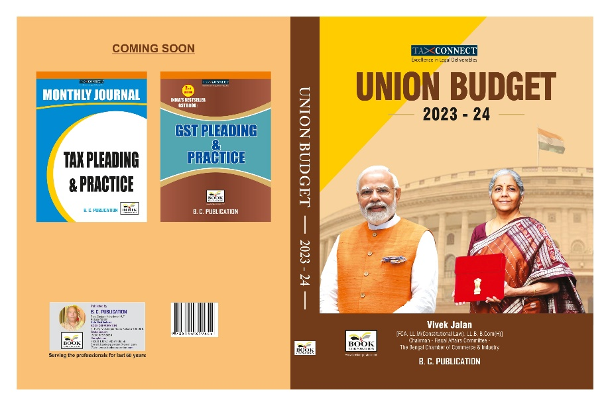

We put before you our detailed Analysis of Direct and Indirect Proposals of Union Budget 2023.
CONTENTS
- Commentary on Budget
- Finance Minister’s Budget Speech
- Budget at a glance
- Memorandum
- Finance Bill
- Notes on Clauses
- Customs Notifications & DO Letter

Authors:
Vivek Jalan
[FCA, LL.M (Constitutional Law), LL.B, B.Com(H)]

Published by: In Association With:
BOOK CORPORATION TAX CONNECT ACADEMY
4, R. N. Mukherjee Road 1, Old Court House Corner
Kolkata 700001 Kolkata 700001
Phones: (033) 64547999 Phones: (033) 40016761
Cell : 9830010297, 9331018333 Cell : 7602672579, 9830661254
Order by email:bookcorporation@gmail.com Order by email: info@taxconnect.co.in Website :www.bookcorporation.com Website : www.taxconnect.co.in
:IN STANDS

HANDBOOK ON GST 2022
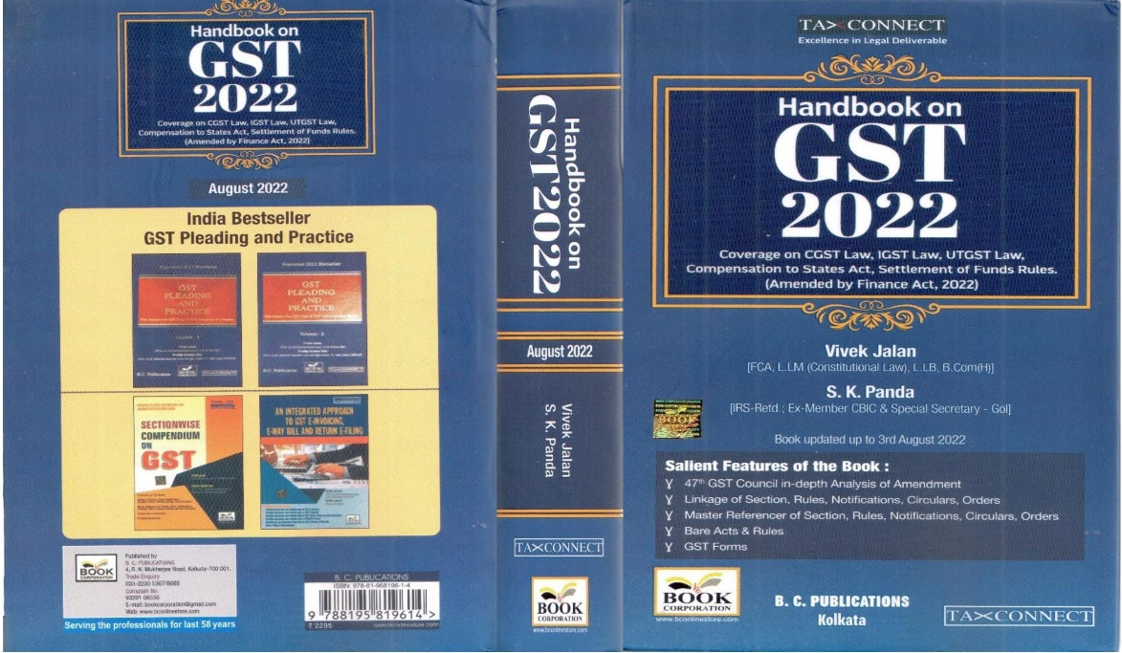

CONTENTS
- 47th GST Council in-depth Analysis of Amendment
- Linkage of Section, Rules, Notifications, Circulars, Orders
- Master Reference of Section, Rules, Notifications, Circulars, Orders
- Bare Acts & Rules
- GST Forms
Author:
Vivek Jalan
[FCA, LL.M (Constitutional Law), LL.B, B.Com(H)]

S.K. Panda
[IRS-Retd.; Ex-Member CBIC & Special Secretary – GoI]

Published by: In Association With:
BOOK CORPORATION TAX CONNECT ACADEMY
4, R. N. Mukherjee Road 6, Netaji Subhas Road,
Kolkata 700001 Kolkata 700001
Phones: (033) 64547999 Phones: (033) 40016761
Cell: 9830010297, 9331018333 Cell:7003384915,9830661254
Order by email:bookcorporation@gmail.com Order by email: info@taxconnect.co.in Website :www.bookcorporation.com Website : www.taxconnect.co.in

:IN STANDS

How to Handle GST LITIGATION: Assessment, Scrutiny, Audit & Appeal
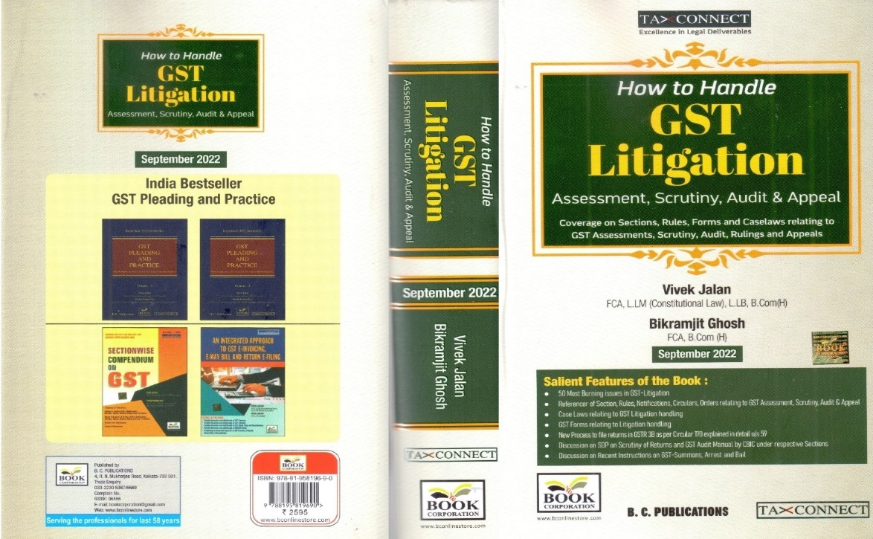

CONTENTS
1. 50 Most Burning issues in GST-Litigation
2. Reference of Section, Rules, Notifications, Circulars, Orders relating to GST Assessment, Scrutiny, Audit & Appeal
3. Case Laws relating to GST Litigation handling
4. GST Forms relating to Litigation handling
5. New process to file returns in GSTR 3B as per circular 170 explained in details u/s 59
6. Discussion on SOP on Scrutiny of Returns and GST Audit Manual by CBIC under respective Sections
7. Discussion on Recent Instruction on GST-Summons, Arrest and Bail

Authors:
Vivek Jalan
[FCA, LL.M (Constitutional Law), LL.B, B.Com(H)]

Bikramjit Ghosh
[FCA, B.Com(H)]

Published by: In Association With:
BOOK CORPORATION TAX CONNECT ACADEMY
4, R. N. Mukherjee Road 6, Netaji Subhas Road,
Kolkata 700001 Kolkata 700001
Phones: (033) 64547999 Phones: (033) 40016761
Cell: 9830010297, 9331018333 Cell: 9830661254
Order by email:bookcorporation@gmail.com Order by email: info@taxconnect.co.in Website :www.bookcorporation.com Website : www.taxconnect.co.in

:IN STANDS

GST PLEADING AND PRACTICE: With Section-wise GST Cases & GST Notices and their Replies
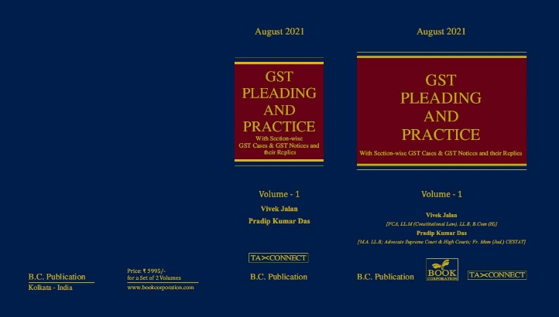

ABOUT THE BOOK: This publication includes:
1. GST Notices and their Replies
2. Orders and Appeals under GST
3. Text of provisions under IGST Act 2017 & CGST Act 2017
4. CGST & IGST Section-wise Synopsis of Case Laws and Notification/Circulars Gist
5. CGST & IGST Section-wise Synopsis of “Question of Law” answered under GST
6. Completely Updated Synopsis of Case Laws under GST by Supreme Court, High Court, AAARs & AARs

Authors:
Vivek Jalan
[FCA, LL.M (Constitutional Law), LL.B, B.Com(H)]

Pradip Kumar Das
[M.A. LL.B; Advocate Supreme Court & High Courts; Fr. Mem (Jud.) CESTAT]

Published by: In Association With:
BOOK CORPORATION TAX CONNECT ACADEMY
4, R. N. Mukherjee Road 6, Netaji Subhas Road,
Kolkata 700001 Kolkata 700001
Phones: (033) 64547999 Phones: (033) 40016761
Cell: 9830010297, 9331018333 Cell: 9830661254
Order by email:bookcorporation@gmail.com Order by email: info@taxconnect.co.in Website :www.bookcorporation.com Website : www.taxconnect.co.in

LET’S DISCUSS FURTHER!

OUR OFFICES:

MUMBAI
Unit No. 312, Omega Business Park, Near Kaamgar Hospital, Road No. 33, Wagle Industrial Estate, Thane West, Maharashtra- 400604

Contact Person: Priyanka Vishwakarma
Email:priyanka.vishwakarma@taxconnect.co.in
BANGALORE
#46/4, GB Palya, Kudlu Gate, Hosur Road, Bangalore,
Karnataka – 560068.

Contact Person: Anil Pal
Email:anil.pal@taxconnectdelhi.co.in

DELHI
B-139, 2nd Floor, Transport Nagar,
Noida-201301 (U.P)

Contact Person: Poonam Khemka
Email:poonam.khemka@taxconnect.co.in


DUBAI
Azizi Feirouz, 803, 8th Floor, AL Furjan, Opposite Discovery Pavillion,
Dubai, UAE

Contact Person: Rohit Sharma
Email:rohit.sharma@taxconnect.co.in

KOLKATA
R No 119; 1st Floor; Diamond Arcade; 1/72, Cal Jessore Road;
Kolkata – 700055

Contact Person: Uttam Kumar Singh
Email:info@taxconnect.co.in

KOLKATA
6, Netaji Subhas Road, 3rd Floor, Royal Exchange Building, Kolkata - 700001

Contact Person: Tithly Roy
Email:tithly.roy@taxconnect.co.in

Disclaimer:
This e-bulletin is for private circulation only. Views expressed herein are of the editorial team and are based on the information, explanation and documents available on Government portal platforms. Tax Connect or any of its employees do not accept any liability whatsoever direct or indirect that may arise from the use of the information contained herein. No matter contained herein may be reproduced without prior consent of Tax Connect. While this e-article has been prepared on the basis of published/other publicly available information considered reliable, we do not accept any liability for the accuracy of its contents.
Tax Connect 2022. All rights reserved.

