Iz8
_{TAX CONNECT}

404th Issue: 28th May 2023-3rd June 2023
12017

sssss

Knowledge Partner:



TAX CONNECT
Mumbai: Unit No. 312, Omega Business Park, Near-Kaamgar Hospital, Road No. 33,Wagle Industrial Estate,
Thane (West), Maharashtra – 400604
Bangalore: 46/4, GB Palya, Kudlu Gate, Hosur Road, Bangalore,Karnataka – 560068.
New Delhi: B-139, 2ndFloor, Transport Nagar, Noida-201301 (U.P)
Kolkata: - 6, Netaji Subhas Road, 3rd Floor, Royal Exchange Building, Kolkata – 700001
- Room No. 119, 1stFloor,“Diamond Arcade” 1/72, Cal Jessore Road, Kolkata – 700055
- Tobacco House, 1, Old Court House St, Radha Bazar, Corner, Kolkata, West Bengal 700001

Dubai: AziziFeirouz, 803, 8th Floor, AL Furjan, Opposite Discovery Pavillion, Dubai, UAE

Contact: +91 9830661254
Website: www.taxconnect.co.in
Email: info@taxconnect.co.in

Friends,
The battle for taxability of online gaming under GST may have been initially won by taxpayers in the Delhi High Court against the DGGI; however online gaming business remains on the radar of CBIC as well as the CBDT; And the CBDT seems to be in a haste. Rule 133 vide notification 28/2023 is published only on 22nd May 2023, while the Section 194BA and Section 115BBJ had already come in force for taxation of online gaming, from 1st April 2023 itself. The new TDS u/s 194BA mandates that a person, who is responsible for paying to any other person any income by way of winnings from any online game during the financial year, must deduct income tax on net winnings in the person's user account. Tax is required to be deducted at the time of withdrawal as well as at the end of the financial year.

Important to note is that any deposit in the form of bonus or incentives credited in a user account will be considered ‘net winnings’, and subject to tax deduction, in case of withdrawal. Some deposits could be money equivalent like coins, coupons, vouchers which will also be considered a taxable deposit. The valuation would be based on fair-market value of the winnings in kind except in cases where the online game intermediary has purchased the winnings before providing it to the user. In that case, the purchase price will be the value of winnings. GST will not be included for the purposes of valuation of winnings for TDS under Section 194BA of the Act.

However, If the deposits are used only for playing and cannot be withdrawn, then it’s not liable for TDS u/s 194BA. Further, in case the user borrows the money and deposits it in his user account, it will be considered a non-taxable deposit.

The calculation of net winnings is illustrated as under –
Net winnings for the purposes of calculating tax required to be deducted under Section 194BA shall be calculated as under

Net winnings =A-(B+C), where
A = Amount withdrawn from the user account;
B = Aggregate amount of non-taxable deposit made in the user account by the owner of such account during the financial year, till the time of such withdrawal; and

C = Opening balance of the user account at the beginning of the financial year;

Important to note is that user account shall include every account of the user, by whatever name called, which is registered with the online gaming intermediary and where any taxable deposit, non-taxable deposit or winnings of the user is credited and withdrawal by the user is debited. Thus, each wallet which qualifies as a user account shall be considered as a user account for the purposes of computing net winnings. GST will not be included for the purposes of valuation of winnings for TDS under Section 194BA of the Act. The deposit, withdrawal or balance in the user account will mean aggregate of deposits, withdrawals, or balances in all user accounts.

Important to note also is that the TDS also extends to cases where the balance in the user account at the time of tax deduction is not sufficient to discharge the tax deduction. The online gamer in such case has to first collect the amount for TDS, then pay TDS and only then release the new wining in cash and kind.

The threshold for non-deduction has been however set as an insignificant amount of Rs 100 a month. Hence, in case net winnings do not exceed a meagre Rs 100 a month, the applicable tax need not be deducted, otherwise it will need to be deducted.

Just to reiterate that we remain available over telecom or e-mail.
Editor:
Vivek Jalan
Partner - Tax Connect Advisory Services LLP
Co-Editors:
Rohit Sharma
Director – Tax Connect Advisory Services LLP

Rajani Kant Choudhary
Senior Manager – Tax Connect Advisory Services LLP

S.NO. | TOPICS | PAGE NO.
1] | TAX CALENDER | 4
2] | INCOME TAX | 5-7
NOTIFICATION | THE TAX EXEMPTION CEILING FOR LEAVE ENCASHMENT UPON RETIREMENT FOR NON-GOVERNMENT SALARIED PERSONNEL INCREASED FROM ₹3 LAKH TO ₹ 25 LAKH
NOTIFICATION | SECTION 56 EXEMPTION ON CONSIDERATION FOR ISSUE OF SHARES EXCEEDING FACE VALUE IN THE CASE OF STARTUP, SUBJECT TO CONDITIONS SPECIFIED
NOTIFICATION | CBDT NOTIFIED CLASSES OF PERSONS FOR INCOME TAX PURPOSES UNDER SECTION 56(2)(VIIB)(II) OF IT ACT 1961 IN RESPECT OF EXEMPTION ON CONSIDERATION FOR ISSUE OF SHARES EXCEEDING FACE VALUE
NOTIFICATION | AMENDMENT IN INCOME TAX RULES, 1962, INSERTION OF NEW RULE 133 FOR PRESCRIBING CALCULATION OF NET WINNINGS FOR ONLINE GAMES, NOTIFICATION OF REVISED FORM NO. 16, FORM 24Q, FORM 26Q, FORM 27Q, AND FORM 27EQ
CIRCULAR | TDS ON WINNINGS FROM ONLINE GAMES - GUIDELINES FOR REMOVAL OF DIFFICULTIES UNDER SUB-SECTION (3) OF SECTION 194BA OF THE INCOME-TAX ACT, 1961
CIRCULAR | CLARIFICATION REGARDING PROVISIONS RELATING TO CHARITABLE AND RELIGIOUS TRUSTS
3] | GST | 8-9
NOTIFICATION | SEEKS TO EXTEND THE DUE DATE FOR FURNISHING FORM GSTR-7 FOR APRIL, 2023 FOR REGISTERED PERSONS WHOSE PRINCIPAL PLACE OF BUSINESS IS IN THE STATE OF MANIPUR.
NOTIFICATION | SEEKS TO EXTEND THE DUE DATE FOR FURNISHING FORM GSTR-3B FOR APRIL, 2023 FOR REGISTERED PERSONS WHOSE PRINCIPAL PLACE OF BUSINESS IS IN THE STATE OF MANIPUR.
NOTIFICATION | SEEKS TO EXTEND THE DUE DATE FOR FURNISHING FORM GSTR-1 FOR APRIL, 2023 FOR REGISTERED PERSONS WHOSE PRINCIPAL PLACE OF BUSINESS IS IN THE STATE OF MANIPUR
INSTRUCTION | SOP FOR SCRUTINY OF RETURNS FOR FY 2019-20 ONWARDS
4] | FEMA | 10
CASE LAW | OFFENCE U/S 57 OF THE FERA - NON COMPLAINT FILED IN COMPLIANCE OF THE PROVISIONS OF SECTION 61 (2)(II) OF THE FERA : CALCUTTA HIGH COURT
5] | CUSTOMS | 11-12
NOTIFICATION | SEEKS TO AMEND AUSTRALIA FTA NOTIFICATION TO MAKE CHANGES IN TARIFF PREFERENCE GIVEN TO COKING COAL AND RAW COTTON ARISING OUT OF FINANCE ACT, 2023
CIRCULAR | FOREIGN TRADE POLICY 2023
6] | DGFT | 13-14
TRADE NOTICE | AMENDMENT UNDER INTEREST EQUALISATION SCHEME
NOTIFICATION | AMENDMENT IN EXPORT POLICY OF BROKEN RICE UNDER HS CODE 1006 40 00
NOTIFICATION | AMENDMENT IN EXPORT POLICY OF COUGH SYRUP
7] | UNION BUDGET 2023: ANALYSIS BY TAX CONNECT | 15
8] | HANDBOOK ON GST 2022 | 16
9] | HOW TO HANDLE GST LITIGATION: ASSESSMENT, SCRUTINY, AUDIT & APPEAL | 17
10] | GST PLEADING AND PRACTICE: WITH SECTION-WISE GST CASES & GST NOTICES AND THEIR REPLIES | 18
11] | LET’S DISCUSS FURTHER | 19

Due Date | Form/Return/Challan | Reporting Period | Description
30th May | Form no. 49C | FY 2022-23 | ​Submission of a statement (in Form No. 49C) by non-resident having a liaison office in India for the financial year 2022-23
30th May | Challan-cum-statement | April 2023 | Due date for furnishing of challan-cum-statement in respect of tax deducted under section 194-IA, 194-IB, 194-M, 194S in the month of April, 2023
30th May | TCS Certificate | January-March 2023 | ​Issue of TCS certificates for the 4th Quarter of the Financial Year 2022-23
31st May | Statement of TDS deposited | January-March 2023 | Quarterly statement of TDS deposited for the quarter ending March 31, 2023
31st May | TDS Return | April 2023 | ​Return of tax deduction from contributions paid by the trustees of an approved superannuation fund​
31st May | Form No. 61A | FY 2022-23 | ​Due date for furnishing of statement of financial transaction (in Form No. 61A) as required to be furnished under sub-section (1) of section 285BA of the Act respect for financial year 2022-23
31st May | Form No. 61B | January-December 2022 | ​Due date for e-filing of annual statement of reportable accounts as required to be furnished under section 285BA(1)(k) (in Form No. 61B) for calendar year 2022 by reporting financial institutions
31st May | Form no. 9A | FY 2022-23 | Application in Form 9A for exercising the option available under Explanation to section 11(1) to apply income of previous year in the next year or in future (if the assessee is required to submit return of income on or before July 31, 2023)
31st May | Form no. 10 | FY 2022-23 | Statement in Form no. 10 to be furnished to accumulate income for future application under section 10(21) or section 11(1) (if the assessee is required to submit return of income on or before July 31, 2023)

NOTIFICATION
the tax exemption ceiling for leave encashment upon retirement for non-government salaried personnel INCREASED from ₹3 lakh to ₹ 25 lakh
OUR COMMENTS: The Ministry of Finance, Department of Revenue vide Notification No. 31/2023 dated 24.05.2023 notified In exercise of the powers conferred by sub-clause (ii) of clause (10AA) of section 10 of the Income-tax Act, 1961 (43 of 1961), the Central Government, having regard to the maximum amount receivable by its employees as cash equivalent of leave salary in respect of the period of earned leave at their credit at the time of their retirement, whether superannuation or otherwise, hereby specifies the amount of Rs. 25,00,000 (twenty-five lakhs rupees only) as the limit in relation to employees mentioned in that sub-clause who retire, whether on superannuation or otherwise.
2. This notification shall be deemed to have come into force with effect from the 1st day of April, 2023.
[For further details please refer the notification]

NOTIFICATION
Section 56 Exemption on consideration for issue of shares exceeding face value in the case of Startup, subject to conditions SPECIFIED
OUR COMMENTS: The Ministry of Finance, Department of Revenue vide Notification No. 30/2023 dated 24.05.2023 notified In exercise of the powers conferred by clause (ii) of the first proviso to clause (viib) of sub-section (2) of section 56 of the Income-tax Act, 1961 (43 of 1961) and in supersession of the notification of Government of India in the Ministry of Finance, Department of Revenue, Central Board of Direct Taxes published in the Gazette of India, Extraordinary, Part-II, Section 3, Sub-section (ii) vide number S.O. 1131(E) dated 5th March 2019, except as respect things done or omitted to be done before such supersession, the Central Government, hereby notifies that the provisions of clause (viib) of sub-section (2) of section 56 of the said Act shall not apply to consideration received by a company for issue of shares that exceeds the face value of such shares, if the said consideration has been received from any person, by a company which fulfills the conditions specified in para 4 of the notification number G.S.R. 127(E), dated the 19th February, 2019 issued by the Ministry of Commerce and Industry in the Department for Promotion of Industry and Internal Trade and published in the Gazette of India, Extraordinary, Part-II, section 3, Sub-Section (i) on 19th February, 2019 and files the declaration referred to in para 5 of the said notification of the Department for Promotion of Industry and Internal Trade.
2. This notification shall be deemed to have come into force from the 1st day of April 2023.
[For further details please refer the notification]

NOTIFICATION
CBDT NotifieD Classes of Persons for Income Tax Purposes under Section 56(2)(viib)(II) of IT Act 1961 in respect of Exemption on consideration for issue of shares exceeding face value
OUR COMMENTS: The Ministry of Finance, Department of Revenue vide Notification No. 29/2023 dated 24.05.2023 notified In exercise of the powers conferred by sub-clause (ii) of the first proviso to clause (viib) of sub-section (2) of Section 56, the Central Government hereby notifies the following class or classes of persons, for the purposes of the said clause, namely:-
(i) Government and Government related investors such as central banks, sovereign wealth funds, international or multilateral organizations or agencies including entities controlled by the Government or where direct or indirect ownership of the Government is seventy-five percent or more;
(ii) Banks or Entities involved in Insurance Business where such entity is subject to applicable regulations in the country where it is established or incorporated or is a resident;
(iii) Any of the following entities, which is a resident of any country or specified territory listed in Annexure as mentioned in the notification, and such entity is subject to applicable regulations in the country where it is established or incorporated or is a resident :––
(a) entities registered with Securities and Exchange Board of India as Category-I Foreign Portfolio Investors;
(b) endowment funds associated with a university, hospitals or charities;
(c) pension funds created or established under the law of the foreign country or specified territory;
(d) Broad Based Pooled Investment Vehicle or fund where the number of investors in such vehicle or fund is more than fifty and such fund is not a hedge fund or a fund which employs diverse or complex trading strategies.
[For further details please refer the notification]

NOTIFICATION
Amendment in Income tax Rules, 1962, insertion of new rule 133 for prescribing calculation of net winnings for online games, notification of revised Form No. 16, Form 24Q, Form 26Q, Form 27Q, and Form 27EQ
OUR COMMENTS: The Ministry of Finance, Department of Revenue vide Notification No. 28/2023 dated 22.05.2023 notified In exercise of the powers conferred by section 295 read with section 115BBJ, section 194BA, sub-section (3) of section 200 and proviso to sub-section (3) of section 206C of the Income-tax Act 1961 (hereinafter referred to as ‘Act’), the Central Board of Direct Taxes hereby makes the following rules in further to amend the Income-tax Rules, 1962, namely:––
1. Short title and commencement.-
(1) These rules may be called the Income-tax (Fifth Amendment) Rules, 2023.
(2) Save as otherwise provided, they shall come into force from date of their publication in the Official Gazette.
. In the Income-tax Rules, 1962 (hereinafter referred to as the principal rules), in rule 31A, in sub-rule(4) with effect from 1st July 2023,––
(a) for clause (ix), the following clause shall be substituted namely:-
“(ix) furnish particulars of amount paid or credited on which tax was not deducted or deducted at lower rate in view of the notification issued under second proviso to section 194N or in view of the exemption provided in fourth proviso to section 194N or in view of the notification issued under fifth proviso to section 194N;”;
(b) in clause (xvii), after sub-clause (a), the following sub-clause shall be inserted, namely:-
“(aa) winnings in terms of sub-section (2) of section 194BA;”.
3. In the principal rules, after rule 132, the rule 133 shall be inserted.
4. In the principal rules, in Appendix II,–
(a) for Form No. 16 the form provided in the notification shall be substituted with effect from 1st July 2023 and shall be applicable for the assessment year 2024-25 and subsequent assessment years.
5. (i) If an assessee is employed under more than one employer during the year, each of the employers shall issue Part A of the certificate in Form No. 16 pertaining to the period for which such assessee was employed with each of the employers.
(ii) Part B (Annexure-I) of the certificate in Form No.16 may be issued by each of the employers or the last employer at the option of the assessee.

(iii) Part B (Annexure-II) of the certificate in Form 16 may be issued by the specified bank to a specified senior citizen.
6. In Part A, in items I and II, in the column for tax deposited in respect of deductee, furnish total amount of tax, surcharge and health and education cess.
7. Deductor shall duly fill details, where available, in item numbers 2(f) and 10(k) before furnishing of Part B (Annexure-I) to the employee.”.
(b) in form 24Q, with effect from 1st July, 2023,–
(i) in serial number 4, in the table, in column No. 4, for the words “Education Cess”, the words “Health and Education Cess” shall be substituted;
(ii) in Annexure I, in the table before “Verification”, in column No. 11, for the words “Education Cess”, the words, “Health and Education Cess”
shall be substituted;
(iii) for “Annexure II”, the “Annexure II” provided in the notification shall be substituted.
[For further details please refer the notification]

CIRCULAR
TDS on Winnings from online games - Guidelines for removal of difficulties under sub-section (3) of section 194BA of the Income-tax Act, 1961
OUR COMMENTS: The Ministry of Finance, Department of Revenue vide Circular No. 5/2023 dated 22.05.2023 circulated that Finance Act 2023 inserted a new section 194BA in the Income-tax Act. 1961 (hereinafter referred to as "the Act") with effect from 1st April 2023.

The new section mandates a person, who is responsible for paying to any person any income by way of winnings from any online game during the financial year to deduct income-tax on the net winnings in the person's user account. Tax is required to be deducted at the time of withdrawal as well as at the end of the financial year. Net winning is required to be computed in the manner as may be prescribed. The manner of computation of net winning has now been prescribed in Rule 133 of the Income-tax Rules 1962. vide notification no. 28/2023 dated 22nd May 2023.

[For further details please refer the circular]

CIRCULAR
Clarification regarding provisions relating to charitable and religious trusts
OUR COMMENTS: The Ministry of Finance, Department of Revenue vide Circular No. 6/2023 dated 24.05.2023 circulated that Income of any fund or institution or trust or any university or other educational institution or any hospital or other medical institution referred to in sub-clause (iv) or sub-clause (v) or sub-clause (vi) or sub-clause (via) of clause (23C) of section 10 of the Income-tax Act, 1961 ( "the Act") or any trust or institution registered under section 12AA or section 12AB of the Act (hereinafter referred to as "the trust") is exempt subject to the fulfilment of the conditions provided under relevant sections of the Act. Taxation and Other Laws (Relaxation and Amendment of Certain Provisions) Act, 2020 amended the provisions related to application by a trust for registration or approval by amending the first and second proviso to clause (23C) of section 10, clause (ac) of sub-section (1) of section 12A of the Act, inserting section 12AB of the Act and amending the first and second proviso to sub-section (5) of section 80G of the Act.

[For further details please refer the circular]

NOTIFICATION
SEEKS TO EXTEND THE DUE DATE FOR FURNISHING FORM GSTR-7 FOR APRIL, 2023 FOR REGISTERED PERSONS WHOSE PRINCIPAL PLACE OF BUSINESS IS IN THE STATE OF MANIPUR.
OUR COMMENTS: The Central Board of Indirect Taxes and Customs vide notification no. 13/2023-Central Tax dated 24.05.2023 notified In exercise of the powers conferred by sub-section (6) of section 39 read with section 168 of the Central Goods and Services Tax Act, 2017 (12 of 2017) (hereafter in this notification referred to as the said Act), the Commissioner hereby makes the following further amendment in notification of the Government of India in the Ministry of Finance (Department of Revenue), No. 26/2019 –Central Tax, dated the 28th June, 2019, published in the Gazette of India, Extraordinary, Part II, Section 3, Sub-section (i) vide number G.S.R. 452 (E), dated the 28th June, 2019, namely:–
In the first paragraph, after the fourth proviso, the following proviso shall be inserted,
“Provided also that the return by a registered person, required to deduct tax at source under the provisions of section 51 of the said Act in FORM GSTR-7 of the Central Goods and Services Tax Rules, 2017 under subsection (3) of section 39 of the said Act read with rule 66 of the Central Goods and Services Tax Rules, 2017, for the month of April, 2023, whose principal place of business is in the State of Manipur, shall be furnished electronically through the common portal, on or before the thirty-first day of May, 2023.”.
2. This notification shall be deemed to have come into force with effect from the 10th day of May, 2023.
[For further details please refer the notification]
NOTIFICATION
SEEKS TO EXTEND THE DUE DATE FOR FURNISHING FORM GSTR-3B FOR APRIL, 2023 FOR REGISTERED PERSONS WHOSE PRINCIPAL PLACE OF BUSINESS IS IN THE STATE OF MANIPUR.

OUR COMMENTS: The Central Board of Indirect Taxes and Customs vide notification no. 12/2023-Central Tax dated 24.05.2023 notified In exercise of the powers conferred by sub-section (6) of section 39 of the Central Goods and Services Tax Act, 2017 (12 of 2017), the Commissioner, on the recommendations of the Council, hereby extends the due date for furnishing the return in FORM GSTR-3B for the month of April, 2023 till the thirty-first day of May, 2023, for the registered persons whose principal place of business is in the State of Manipur and are required to furnish return under sub-section (1) of section 39 read with clause (i) of sub-rule (1) of rule 61 of the Central Goods and Services Tax Rules, 2017.

2. This notification shall be deemed to have come into force with effect from the 20th day of May, 2023.

[For further details please refer the notification]

NOTIFICATION
SEEKS TO EXTEND THE DUE DATE FOR FURNISHING FORM GSTR-1 FOR APRIL, 2023 FOR REGISTERED PERSONS WHOSE PRINCIPAL PLACE OF BUSINESS IS IN THE STATE OF MANIPUR

OUR COMMENTS: The Central Board of Indirect Taxes and Customs vide notification no. 11/2023-Central Tax dated 24.05.2023 notified In exercise of the powers conferred by the proviso to sub-section (1) of section 37 read with section 168 of the Central Goods and Services Tax Act, 2017 (12 of 2017), the Commissioner, on the recommendations of the Council, hereby makes the following further amendment in the notification of the Government of India in the Ministry of Finance (Department of Revenue), No. 83/2020 – Central Tax, dated the 10th November, 2020, published in the Gazette of India, Extraordinary, Part II, Section 3, Sub-section (i) vide number G.S.R. 699(E), dated the 10th November, 2020, namely: —

In the said notification, after the third proviso, the following proviso shall be inserted, namely:-

“Provided also that the time limit for furnishing the details of outward supplies in FORM GSTR-1 of the said rules for the tax period April, 2023, for the registered persons required to furnish return under sub-section (1) of section 39 of the said Act whose principal place of business is in the State of Manipur, shall be extended till the thirty-first day of May, 2023.”.

2. This notification shall be deemed to have come into force with effect from the 11th day of May, 2023.

[For further details please refer the notification]

INSTRUCTION
SOP FOR SCRUTINY OF RETURNS FOR FY 2019-20 ONWARDS

OUR COMMENTS: The Central Board of Indirect Taxes and Customs, GST Policy Wing vide instruction no. 02/2023-GST dated 26.05.2023 instructed that attention is invited to the Instruction No. 02/2022-GST dated 22nd March, 2022, wherein a Standard Operating Procedure (SOP) was provided for scrutiny of returns under section 61 of Central Goods and Services Tax Act, 2017 (hereinafter referred to as “the CGST Act) read with rule 99 of Central Goods and Service Tax Rules, 2017 (hereinafter referred to as “the CGST Rules”) for FY 2017-18 and 2018-19. It was mentioned in the said instruction that the said SOP was issued as an interim measure till the time a Scrutiny Module for online scrutiny of returns is made available on the ACES-GST application.

1.2 In this regard, it is to inform that DG Systems has developed functionality “Scrutiny of Returns”, containing the online workflow for scrutiny of returns in the CBIC ACES-GST application. Advisory No. 22/2023- Returns dated 16.05.2023 has also been issued by DG Systems in this regard, along with a User Manual providing for the detailed workflow of the said functionality. The GSTINs selected for scrutiny for the Financial Year 2019-20 have also been made available on the scrutiny dashboard of the proper officers on ACES-GST application.

1.3 The functionality provides for the detailed workflow for communication of discrepancies noticed, in relation to the details furnished in the returns, by the proper officer in FORM GST ASMT-10 to the registered person, receipt of reply from the registered person in FORM GST ASMT-11, issuance of order in FORM GST ASMT-12 or taking further action for issuance of show cause notice under Section 73 or 74 of CGST Act, 2017 or for referring the matter for Audit or investigation, as the case may be.

2. In view of this, the SOP for scrutiny of returns provided in the Instruction No. 02/2022- GST dated 22nd March 2022 stands modified to the extent in respect of scrutiny of returns for financial years 2019-20 onwards.

[For further details please refer the Instruction]

CASE LAW
Offence u/s 57 of the FERA - Non Complaint filed in compliance of the provisions of section 61 (2)(ii) of the FERA : CALCUTTA HIGH COURT
OUR COMMENTS: HELD THAT:- As in this case where an offence under Section 57 of the Foreign Exchange Regulation Act, 1973 has been alleged against the accused person, the law provides that either the Enforcement Director or an officer authorised in writing on behalf of the Director or the Central Government or an authorised officer of Reserve Bank, shall be eligible to institute a complaint. The Magistrate has also emphasized that the appellant would not have the locus standi to initiate prosecution in absence of any authorization, without however considering or taking judicial note of his evidence and Exhibit-A (i.e., authorization certificate dated (22.12.2005).
The Magistrate could not ignore the ocular and documentary evidence before it, more so, when all these were uncontroverted. By virtue of holding officer at the particular period of time and having been authorized vide ‘Exhibit-A’ there was no impediment for the appellant to institute prosecution, which the Magistrate has not considered and such non-application of mind has rendered his findings not tenable in the eyes of law.
The Magistrate was duty bound to take note of the same, more particularly, in terms of Section 57(7) of the Evidence Act. It was a mandate of law. The notification dated 24th September, 1993 read with the direct evidence of the appellant before the Trial Court would unfailingly point out to the fact of the appellant to be competent officer under law, to institute prosecution on behalf of the Enforcement Directorate. By not considering all these factual and legal aspects, the Trial Court has committed gross error. The impugned judgment suffers from non-application of mind and illegality.
Thus unable to place occurrence with the finding of the Court in the impugned judgment that provisions of Section 61 (2) (ii) of the Foreign Exchange Regulation Act, 1973 has not been complied with by the complainant in order to institute a case punishable under Section 57, as it is in this particular proceeding. In my considered opinion, the impugned judgment of the Trial Court suffers for non-application of mind and wrong appreciation of the fact situation as well as the settled provisions of law. Accordingly, the same would not be maintainable and liable to be set aside, being not in conformity with the laws. The impugned judgment is set aside –
Appeal allowed.

NOTIFICATION
Seeks to amend Australia FTA notification to make changes in tariff preference given to Coking Coal and Raw Cotton arising out of Finance Act, 2023
OUR COMMENTS: The Ministry of Finance, Department of Revenue vide notification No. 38/2023-Customs dated 23.05.2023 notified In exercise of the powers conferred by sub-section (1) of section 25 of the Customs Act, 1962 (52 of 1962), the Central Government, on being satisfied that it is necessary in the public interest so to do, hereby makes the following further amendments in the notification of the Government of India in the Ministry of Finance (Department of Revenue), No. 62/2022-Customs, dated the 26th December, 2022, published in the Gazette of India, Extraordinary, Part II, Section 3, Sub-section (i), vide number G.S.R. 904(E), dated the 26th December, 2022, namely :-
In the said notification,
I. in Table II, -
(i) S.No. 6 and the entries relating thereto shall be omitted;
(ii) against S.No. 7, for the entries in column (2) and column (3), the entries “27011210” and “All Goods” shall be substituted respectively;
(iii) after S. No. 7 and the entries relating thereto, the following S.No. and entries shall be inserted, namely: -
(1) | (2) | (3) | (4) | (5)
“7A. | 27011290 | All goods | 0 | 1.5
7B. | 27011910 | All goods | 0 | 0”.
II. in Table IV, -
(i) against S. No. 1, for the entries in column (2) and column (3), the entries “52010024, 52010025” and “Cotton of minimum 28 mm staple length” shall be substituted respectively.
[For further details please refer the notification]
CIRCULAR
Foreign Trade Policy 2023
OUR COMMENTS: The Ministry of Finance, Department of Revenue vide Circular No. 12/2023-Cus dated 24.05.2023 circulated that The Central Government has notified the Foreign Trade Policy, 2023 (FTP) effective from 1.4.2023 vide Notification No. 01/2023 dated 31.03.2023 and DGFT has issued Public Notices No. 01/2023 dated 01.04.2023 for related Handbook of Procedures (HBP) and No. 10/2023 dated 26.04.2023 for Appendices and ANF. These are available at https://dgft.gov.in.
2. The Customs notifications for purposes of implementation of schemes mentioned in FTP chapters on duty remission/exemption or EPCG schemes that were issued on 01.04.2023 include the Notification Nos. 21 to 24/2023-Customs for Advance Authorization (AA), AA for deemed export, AA for annual requirement, AA for export of prohibited goods, No. 25/2023-Customs for Duty Free Import Authorization, No.26/2023 for EPCG and No. 27/2023 for Special Advance Authorization. Notification Nos. 24 and 25/2023 - Customs (NT) have been issued with respect to RoDTEP and RoSCTL schemes, respectively. These notifications are available at www.cbic.gov.in.
3. It is requested to peruse the details of the above cited notifications.
4. A few aspects of the FTP-HBP are highlighted below -
(a) The Special Advance Authorization Scheme (SAAS) in Para 4.04A of FTP is for import of specialized fabrics meant for export production of garments of Chapter 61 and 62. It has been provided that such authorization may also be issued on the basis of self- declaration with the condition that the norms shall be finalized/fixed in such cases within stipulated time period of 90 days.
(b) The eligibility to apply under Self Ratification Scheme for purposes of Advance Authorization in para 4.06 of FTP has been extended to a manufacturer cum actual user who holds a valid 2-Star or above Status under para 1.25 of FTP if it has already submitted its application on CBIC's AEO portal for grant of AEO certification, provided he obtains the AEO certification within 120 days, else the DGFT's Norms Committee shall have to fix the norms. The field formations and Directorate of International Customs should note this aspect and ensure that AEO applications do not pend on their account and are handled in a timely manner.
(c) In terms of para 4.09 of FTP, a minimum value addition of 25% is now to be achieved for spices under Advance Authorisation Scheme.
(d) In terms of para 4.11 of FTP, all items with a basic customs duty of more than 30% have also been included in the list of ineligible categories of import under self-declaration basis.
(e) Project imports are excluded from EPCG scheme.
(f) In terms of para 6.11 (d) of FTP, facility of exemption from furnishing bank guarantee shall not be available to certain units which have been issued confirmed demand etc. under CGST/SGST/UTGST/IGST Acts. Further, the facility of exemption from furnishing Bank Guarantee at the time of import or going for job work in DTA to EOU / EHTP / STP / BTP has been extended to units having AEO certification, subject to certain conditions. The Circulars No. 54/2004 - Customs dated 13.10.2004 and 36/2011-Customs dated 12.08.2011 would stand modified to the extent mentioned in para 6.11 (d) of FTP.
(g) In terms of para 6.04 (b) (i) of HBP, the EOUs, for setting up, operations or maintenance of wind captive power plant and solar captive power plant would not get tax/duty benefits. Accordingly, the Notification nos. 52/2003 - Customs dated 31.03.2003 and Notification no. 22/2003 - Central Excise dated 31.03.2003 have been amended vide Notification no. 28/2023 - Customs dated 01.04.2023 and Notification no. 20/2023 - Central Excise dated 26.04.2023 respectively.
(h) In terms of para 6.38 (a) of HBP, the conversion to EOU from DTA unit having EPCG licence, would, apart from other conditions, be permitted only if either the DTA unit has fulfilled the stipulated export obligation and obtained EODC or the DTA unit has made payment of applicable duties and taxes and compensation cess on capital goods imported under the EPCG Scheme. Appendix 6M has been suitably modified vide DGFT Public Notice No.10/2023 dated 26.04.2023.
(i) In the Gems and Jewellery schemes the list of Nominated Agencies has been revised. Accordingly, Notification no. 57/2000-Customs dated 08.05.2000 has been amended vide Notification no. 28/2023 - Customs dated 01.04.2023.
5. Suitable Trade/Public Notice may be issued. Difficulties faced, if any, may be brought to the notice of the Board.
[For further details please refer the circular]

TRADE NOTICE
Amendment under Interest Equalisation Scheme
OUR COMMENTS: The Ministry of Commerce & Industry vide Trade Notice no 05/2023-24 dated 25.05.2023 notified that Attention of Trade and Industry is drawn towards the extension of Interest Equalisation Scheme (IES) upto 31.03.2024, as notified by RBI vide its Circular no. DOR.STR.REC.93/04.02.001/2021-22 dated 08.03.2022.
2. The below-mentioned amendment is made with immediate effect for rationalization of the scheme:
"The annual net subvention amount would be capped at Rs. 10 crore per IEC in a given financial year. All disbursements made from 01.04.2023 shall be counted for an IEC for the current financial year."
3. This issues with the approval of the Competent Authority.
[For further details please refer the Trade Notice]

NOTIFICATION
Amendment in Export Policy of broken rice under HS Code 1006 40 00
OUR COMMENTS: The Ministry of Commerce & Industry vide Notification no 07/2023 dated 24.05.2023 notified that The Central Government, in exercise of powers conferred by Section 3 read with section 5 of the Foreign Trade (Development & Regulation) Act, 1992 (No. 22 of 1992), as amended, read with Para 1.02 and 2.01 of the Foreign Trade Policy, 2023, hereby incorporate the Policy Conditions for broken rice against ITC (HS) code 1006 40 00 of Chapter 10 of Schedule 2 of the ITC (HS) Export Policy, as under:-
ITC HS Codes | Description | Export Policy | Policy Condition
1006 4000 | Only for broken rice | Prohibited | Export will be allowed on the basis of permission granted by the Government of India to other countries to meet their food security needs and based on the request of their Government.
2. Effect of this Notification:
The export policy of broken rice is prohibited; however, export will be allowed on the basis of permission granted by the Government of India to other countries to meet their food security needs and based on the request of their Government.
[For further details please refer the Notification]

NOTIFICATION
Amendment in Export Policy of Cough Syrup
OUR COMMENTS: The Ministry of Commerce & Industry vide Notification no 06/2023 dated 22.05.2023 notified In exercise of powers conferred by Section 3 read with Section 5 of the Foreign Trade (Development & Regulation) Act, 1992 (No. 22 of 1992), as amended , read with Para 1.02 and 2.01 of the Foreign Trade Policy, 2023, the Central Government hereby makes following amendment in Chapter 30 of the Schedule 2 of the ITC (HS) Export Policy related to export of Cough Syrup w.e.f. 1st June, 2023 :
Sl. No. | ITC HS Codes | Description | Existing Export Policy | Revised Export Policy
84 A | 3004 | Cough Syrup | Free | Cough Syrup shall be permitted to be exported subject to the export sample being tested and production of Certificate of Analysis (CoA) issued by any of the following laboratories:  Indian Pharmacopoeia Commission, Ghaziabad, Uttar Pradesh  CDL, Kolkata, West Bengal  CDTL, Chennai, Tamil Nadu  CDTL, Mumbai, Maharashtra  CDTL, Hyderabad, Telangana  RDTL, Chandigarh  RDTL, Guwahati, Assam  Any NABL accredited State Drugs Testing Laboratory
2. Effect of this Notification:
The export of "Cough Syrup" under ITC (HS) Codes falling under the Heading 3004 shall be permitted subject to the export sample being tested and production of Certificate of Analysis (CoA) issued by any of the laboratories as mentioned in Para-1 above, with effect from 1st June 2023.
[For further details please refer the Notification]

:IN STANDS

UNION BUDGET 2023: ANALYSIS BY TAX CONNECT

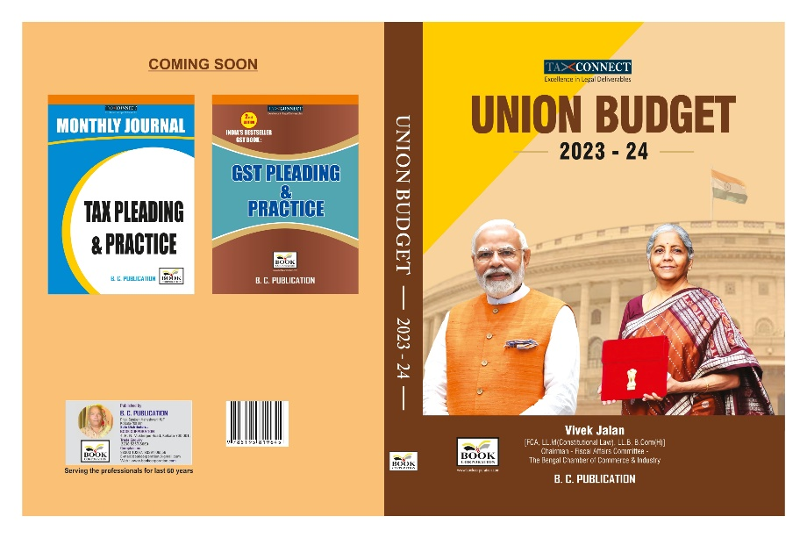

We put before you our detailed Analysis of Direct and Indirect Proposals of Union Budget 2023.
CONTENTS
- Commentary on Budget
- Finance Minister’s Budget Speech
- Budget at a glance
- Memorandum
- Finance Bill
- Notes on Clauses
- Customs Notifications & DO Letter

Authors:
Vivek Jalan
[FCA, LL.M (Constitutional Law), LL.B, B.Com(H)]

Published by: In Association With:
BOOK CORPORATION TAX CONNECT ACADEMY
4, R. N. Mukherjee Road 1, Old Court House Corner
Kolkata 700001 Kolkata 700001
Phones: (033) 64547999 Phones: (033) 40016761
Cell : 9830010297, 9331018333 Cell : 7602672579, 9830661254
Order by email:bookcorporation@gmail.com Order by email: info@taxconnect.co.in Website :www.bookcorporation.com Website : www.taxconnect.co.in
:IN STANDS

HANDBOOK ON GST 2022
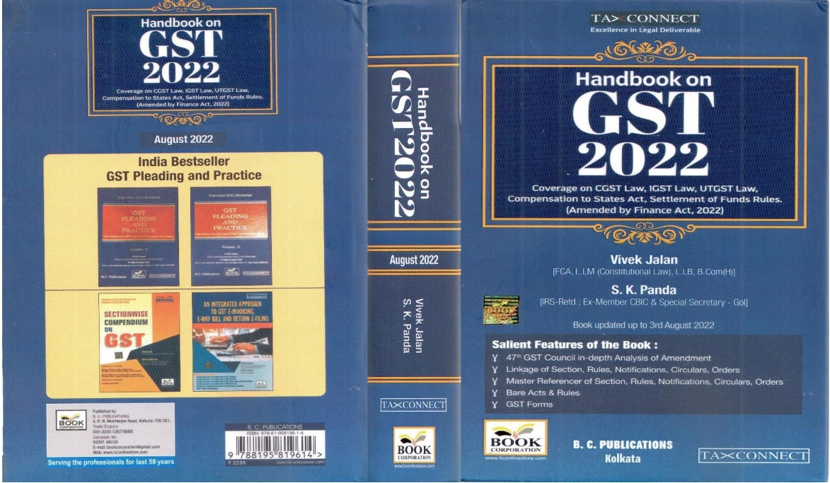

CONTENTS
- 47th GST Council in-depth Analysis of Amendment
- Linkage of Section, Rules, Notifications, Circulars, Orders
- Master Reference of Section, Rules, Notifications, Circulars, Orders
- Bare Acts & Rules
- GST Forms
Author:
Vivek Jalan
[FCA, LL.M (Constitutional Law), LL.B, B.Com(H)]

S.K. Panda
[IRS-Retd.; Ex-Member CBIC & Special Secretary – GoI]

Published by: In Association With:
BOOK CORPORATION TAX CONNECT ACADEMY
4, R. N. Mukherjee Road 6, Netaji Subhas Road,
Kolkata 700001 Kolkata 700001
Phones: (033) 64547999 Phones: (033) 40016761
Cell: 9830010297, 9331018333 Cell:7003384915,9830661254
Order by email:bookcorporation@gmail.com Order by email: info@taxconnect.co.in Website :www.bookcorporation.com Website : www.taxconnect.co.in

:IN STANDS

How to Handle GST LITIGATION: Assessment, Scrutiny, Audit & Appeal
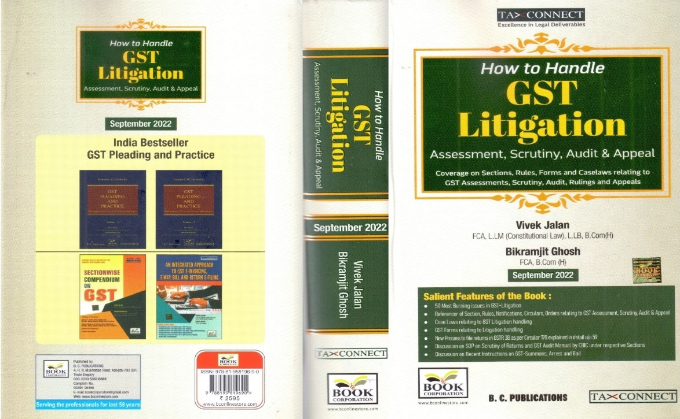

CONTENTS
1. 50 Most Burning issues in GST-Litigation
2. Reference of Section, Rules, Notifications, Circulars, Orders relating to GST Assessment, Scrutiny, Audit & Appeal
3. Case Laws relating to GST Litigation handling
4. GST Forms relating to Litigation handling
5. New process to file returns in GSTR 3B as per circular 170 explained in details u/s 59
6. Discussion on SOP on Scrutiny of Returns and GST Audit Manual by CBIC under respective Sections
7. Discussion on Recent Instruction on GST-Summons, Arrest and Bail

Authors:
Vivek Jalan
[FCA, LL.M (Constitutional Law), LL.B, B.Com(H)]

Bikramjit Ghosh
[FCA, B.Com(H)]

Published by: In Association With:
BOOK CORPORATION TAX CONNECT ACADEMY
4, R. N. Mukherjee Road 6, Netaji Subhas Road,
Kolkata 700001 Kolkata 700001
Phones: (033) 64547999 Phones: (033) 40016761
Cell: 9830010297, 9331018333 Cell: 9830661254
Order by email:bookcorporation@gmail.com Order by email: info@taxconnect.co.in Website :www.bookcorporation.com Website : www.taxconnect.co.in
:IN STANDS

GST PLEADING AND PRACTICE: With Section-wise GST Cases & GST Notices and their Replies
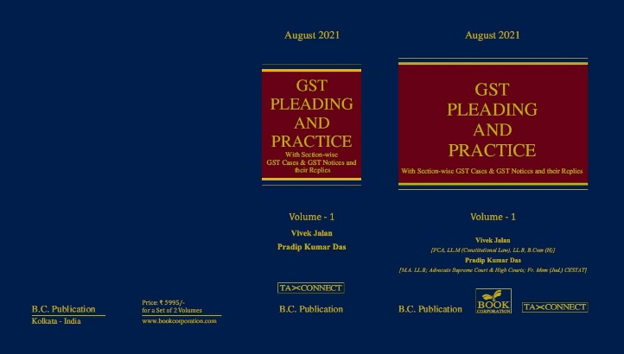

ABOUT THE BOOK: This publication includes:
1. GST Notices and their Replies
2. Orders and Appeals under GST
3. Text of provisions under IGST Act 2017 & CGST Act 2017
4. CGST & IGST Section-wise Synopsis of Case Laws and Notification/Circulars Gist
5. CGST & IGST Section-wise Synopsis of “Question of Law” answered under GST
6. Completely Updated Synopsis of Case Laws under GST by Supreme Court, High Court, AAARs & AARs

Authors:
Vivek Jalan
[FCA, LL.M (Constitutional Law), LL.B, B.Com(H)]

Pradip Kumar Das
[M.A. LL.B; Advocate Supreme Court & High Courts; Fr. Mem (Jud.) CESTAT]

Published by: In Association With:
BOOK CORPORATION TAX CONNECT ACADEMY
4, R. N. Mukherjee Road 6, Netaji Subhas Road,
Kolkata 700001 Kolkata 700001
Phones: (033) 64547999 Phones: (033) 40016761
Cell: 9830010297, 9331018333 Cell: 9830661254
Order by email:bookcorporation@gmail.com Order by email: info@taxconnect.co.in Website :www.bookcorporation.com Website : www.taxconnect.co.in

LET’S DISCUSS FURTHER!

OUR OFFICES:

MUMBAI
Unit No. 312, Omega Business Park, Near Kaamgar Hospital, Road No. 33, Wagle Industrial Estate, Thane West, Maharashtra- 400604

Contact Person: Priyanka Vishwakarma
Email:priyanka.vishwakarma@taxconnect.co.in
BANGALORE
#46/4, GB Palya, Kudlu Gate, Hosur Road, Bangalore,
Karnataka – 560068.

Contact Person: Anil Pal
Email:anil.pal@taxconnectdelhi.co.in

DELHI
B-139, 2nd Floor, Transport Nagar,
Noida-201301 (U.P)

Contact Person: Poonam Khemka
Email:poonam.khemka@taxconnect.co.in


DUBAI
Azizi Feirouz, 803, 8th Floor, AL Furjan, Opposite Discovery Pavillion,
Dubai, UAE

Contact Person: Rohit Sharma
Email:rohit.sharma@taxconnect.co.in

KOLKATA
R No 119; 1st Floor; Diamond Arcade; 1/72, Cal Jessore Road;
Kolkata – 700055

Contact Person: Uttam Kumar Singh
Email:info@taxconnect.co.in

KOLKATA
6, Netaji Subhas Road, 3rd Floor, Royal Exchange Building, Kolkata - 700001

Contact Person: Rajani Kant Choudhary
Email:rajnikant.choudhary@taxconnect.co.in

Disclaimer:
This e-bulletin is for private circulation only. Views expressed herein are of the editorial team and are based on the information, explanation and documents available on Government portal platforms. Tax Connect or any of its employees do not accept any liability whatsoever direct or indirect that may arise from the use of the information contained herein. No matter contained herein may be reproduced without prior consent of Tax Connect. While this e-article has been prepared on the basis of published/other publicly available information considered reliable, we do not accept any liability for the accuracy of its contents.
Tax Connect 2022. All rights reserved.

