Iz8
_{TAX CONNECT}

349th Issue: 8th May 2022- 14th May 2022
12017

sssss

Knowledge Partner:



TAX CONNECT
Mumbai : Unit No. 312, Omega Business Park, Near-Kaamgar Hospital, Road No. 33, Wagle Industrial Estate,
Thane (West), Maharashtra – 400604
Bangalore: H. No.- 2102, 8th Cross, 15th Main, Kodihalli, HAL 3rd Stage, Bengaluru, Karnataka- 560008
New Delhi: B-139, 2nd Floor, Transport Nagar, Noida-201301 (U.P)
Kolkata : 1, Old Court House Corner, “Tobacco House” 1st Floor, Room No.-13 (N), Kolkata-700001

: Room No. 119, 1st Floor, “Diamond Arcade” 1/72, Cal Jessore Road, Kolkata – 700055

Dubai : Azizi Feirouz, 803, 8th Floor, AL Furjan, Opposite Discovery Pavillion, Dubai, UAE

Contact: +91 9830661254
Website: www.taxconnect.co.in
Email: info@taxconnect.co.in



Friends,

GSTN Enables Functionality of AATO For The FY 2021-22 On Taxpayers' Dashboards

The functionality of AATO for the FY 2021-22 has now been made live on taxpayers’ dashboards with the following features:

The taxpayers can view the exact Annual Aggregate Turnover (AATO) for the previous Financial Year (FY).
The taxpayers can also view the Aggregate Turnover of the current FY based on the returns filed till date.
The taxpayers have also been provided with the facility of turnover updation in case taxpayers feel that the system calculated turnover displayed on their dashboard varies from the turnover as per their records.
This facility of turnover update shall be provided to all the GSTINs registered on a common PAN. All the changes by any of the GSTINs in their turnover shall be summed up for computation of Annual Aggregate Turnover for each of the GSTINs.
The taxpayer can amend the turnover twice within the month of May, 2022. Thereafter, the figures will be sent for review of the Jurisdictional Tax Officer who can amend the values furnished by the taxpayer wherever required.

Note: For more details, the taxpayers may check out the ‘Advisory’ section of the aforementioned functionality on their respective dashboards.

Just to reiterate that we remain available over telecom or e-mail.
Truly Yours
Editor:
Vivek Jalan
Partner - Tax Connect Advisory Services LLP
Co-Editors:
Rohit Sharma
Senior Manager – Tax Connect Advisory Services LLP

Rajani Kant Choudhary
Senior Manager – Tax Connect Advisory Services LLP

S.NO. | TOPICS | PAGE NO.
1] | TAX CALENDER | 4
2] | INCOME TAX | 5
NOTIFICATION | Central INCOME TAX RULES HAVE BEEN AMENDED AND 12AC RULE HAS BEEN INSERTED AFTER 12AB
3] | GST | 6
ADVISORY | ADVISORY TO COMPOSITION TAXPAYERS
4] | FEMA | 7
CIRCULAR | Exim Bank's Government of India supported additional Line of Credit (LoC) of USD 190 million to the SBM (Mauritius) Infrastructure Development Company Ltd
5] | CUSTOMS | 8
NOTIFICATION | Fixation of Tariff Value of Edible Oils, Brass Scrap, Areca Nut, Gold and Silver
6] | DGFT | 9
NOTIFICATION | Extension of relaxation of the Provisions under Notification 20/2015-20 dated 24.08.2021
7] | UNION BUDGET 2022-23 | 10
8] | GST PLEADING AND PRACTICE: WITH SECTION-WISE GST CASES & GST NOTICES AND THEIR REPLIES | 11
9] | LET’S DISCUSS FURTHER | 12

Due Date | Form/Return/Challan | Reporting Period | Description
10th May | GSTR-7 | April 2022 | GSTR 7 is a return to be filed by the persons who is required to deduct TDS (Tax deducted at source) under GST
10th May | GSTR-8 | April 2022 | GSTR-8 is a return to be filed by the e-commerce operators who are required to deduct TCS (Tax collected at source) under GST
11th May | GSTR-1 | April 2022 | Taxpayers having an aggregate turnover of more than Rs. 1.50 Crores or opted to file Monthly Return
13th May | GSTR-6 | April 2022 | GST return for the taxpayers who opted for QRMP scheme (Optional)
13th May | GSTR-5 & 5A | April 2022 | Input Service Distributors

NOTIFICATION
Central INCOME TAX RULES HAVE BEEN AMENDED AND 12AC RULE HAS BEEN INSERTED AFTER 12AB
OUR COMMENTS: The Central Board of Direct Taxes vide 48/2022 dated 29.04.2022 hereby made the following rules further to amend Income-tax Rules, 1962, namely: -
(1) These rules may be called the Income-tax (Eleventh Amendment) Rules, 2022.
(2) They shall come into force from the date of their publication in the Official Gazette.
2. In the Income-tax Rules, 1962 (hereinafter referred to as the principal rules), after rule 12AB, the following rule shall be inserted, namely,––
“12AC. Updated return of income.- (1) The return of income to be furnished by any person, eligible to file such return under the sub-section (8A) of section 139, relating to the assessment year commencing on the 1st day of April, 2020 and subsequent assessment years, shall be in the Form ITR-U and be verified in the manner indicated therein.
(2) The return of income referred to in sub-rule (1) shall be furnished by a person, mentioned in column (2) of the
Table below in the manner specified in column (3) thereof:–TABLE
Sl. No. | Person | Manner of furnishing return of income
(1) | (2) | (3)
1. | Individual, or Hindu undivided family or a firm or limited liability partnership or an association of persons or a body of individuals, whether incorporated or not, or a local authority or an artificial juridical person in whose case accounts are required to be audited under section 44AB of the Act or a Company or a political party required to furnish a return in Form ITR-7. | Electronically under digital signature.
2. | Individual, or Hindu undivided family, or firm, or limited liability partnership, or an association of persons or a body of individuals, whether incorporated or not, or a local authority or an artificial juridical person, or a person required to file a return under sub-section (4A) or sub-section (4B) or sub-section (4C) or sub-section (4D) of section 139, other than a person mentioned in column (2) of Sl. No. (1) above. | (A) Electronically under digital signature;  (B) Transmitting the data electronically in the return under electronic verification code.
Explanation.–– For the purposes of this sub-rule, ―electronic verification code‖ means a code generated for the purpose of electronic verification of the person furnishing the return of income as per the data structure and standards specified by Principal Director General of Income-tax (Systems) or Director General of Income-tax (Systems).
(3) The Principal Director-General of Income-tax (Systems) or Director-General of Income-tax (Systems) shall specify the procedures, formats and standards for ensuring secure capture and transmission of data and shall also be responsible for evolving and implementing appropriate security, archival and retrieval policies in relation to furnishing the return in the manners specified in column (3) of the Table.’.
3. In the principal rules, in Appendix-II, after the ITR-Ack, the following Form ITR-U (ITR for updated return) is mentioned in the notification.
[For further details please refer the Notification]

NOTIFICATION
AMENDMENT OF INCOME TAX RULES
OUR COMMENTS: The Central Board of Direct Taxes vide notification 48/2022, dated 29th April, 2022, hereby makes the following rules further to amend Income-tax Rules, 1962, namely: ––
1. Short title and commencement. - (1) These rules may be called the Income-tax (Twelfth Amendment) Rules, 2022.
(2) They shall come into force from the date of their publication in the Official Gazette.
2. In the Income-tax Rules, 1962, (hereinafter referred to as the said rules), in rule 44E,––
(I) in sub-rule (1), the words “in quadruplicate” shall be omitted;
(II) for sub-rule (2), the following sub-rule shall be substituted, namely:–
“(2) The application referred to in sub-rule (1), the verification appended thereto, the annexures to the said application and the statements and documents accompanying the annexures, shall be,-
(a) in the case of an individual,-
(I) signed digitally, if he is required under these rules to furnish his return of income under digital signature,––
(i) by the individual himself; or
(ii) where, for any unavoidable reason, it is not possible for the individual to sign the application, by any person duly authorised by him in this behalf :
Provided that in a case referred to in sub-clause (ii), the person signing the application holds a valid power of attorney from the individual to do so, which shall be attached to the application ; or
(II) communicated through his registered e-mail address, in any other case;
(b) in the case of a Hindu undivided family,-
(I) signed digitally, if it is required under these rules to furnish his return of income under digital signature,––
(i) by the karta thereof; and
(ii) where, for any unavoidable reason, it is not possible for the karta to sign the application, by any other adult member of such family; or
(II) communicated through its registered e-mail address, in any other case;
(c) in the case of a company, digitally signed,-
(i) by the Managing Director thereof; or where for any unavoidable reason such Managing Director is not able to sign and verify the application, or where there is no Managing Director, by any Director thereof ;
(ii) where, for any unavoidable reason, it is not possible for the Managing Director or the Director to sign the application, by any person duly authorised by the company in this behalf :
Provided that in the case referred to in sub-clause (ii), the person signing the application holds a valid power of attorney from the company to do so, which shall be attached to the application ;
(d) in the case of a firm,
(I) signed digitally, if it is required under these rules to furnish his return of income under digital signature,––
(i) by the managing partner thereof; and
(ii) where for any unavoidable reason such managing partner is not able to sign and verify the application, or where there is no managing partner as such, by any partner thereof, not being a minor ;
(II) communicated through its registered e-mail address, in any other case;
(e) in the case of an association of persons,––
(I) signed digitally, if it is required under these rules to furnish his return of income under digital signature, by any member of the association or the principal officer thereof; or
(II) communicated through its registered e-mail address, in any other case;
(f) in the case of any other person,––
(I) signed digitally, if it is required under these rules to furnish his return of income under digital signature, by that person or by some other person competent to act on his behalf; or
(II) communicated through his registered e-mail address, in any other case.”;
3. In the said rules, in Appendix-II, for the forms “FORM No. 34C to FORM No. 34EA”, the following forms shall be substituted, namely

ADVISORY
ADVISORY TO COMPOSITION TAXPAYERS
OUR COMMENTS: Background: Since FY 2019-20, composition taxpayers had to pay the liability through Form GST CMP-08 on quarterly basis while return in Form GSTR-4 is required to be filed on annual basis after end of a financial year.
Reason of Negative Liability in GSTR-4: The liability of the complete year is required to be declared in GSTR-4 under applicable tax rates. Taxpayers should fill up table 6 of GSTR-4 mandatorily. In case, there is no liability, the said table may be filled up with ‘0’ value. If no liability is declared in table 6, it is presumed that no liability is required to be paid, even though, taxpayer may have paid the liability through Form GST CMP-08. In such cases, liability paid through GST CMP-08 becomes excess tax paid and moves to Negative Liability Statement for utilization of same for subsequent tax period’s liability.
What the taxpayer did wrongly: Liability paid through Form GST CMP-08 is auto-populated in table 5 of the GSTR-4 for convenience of the taxpayers. Taxpayers who do not fill up table 6 of GSTR-4 i.e. no liability is declared, even though, taxpayer may have paid the liability through Form GST CMP-08; since the ‘Tax payable’ in GSTR-4 is computed after reducing the liability declared in GST CMP-08 which is auto-populated in table 5. Thus, if nothing is declared in table 6, then the negative liability entry appears in GSTR-4.
Debit of the negative liability – In the past, lot of tickets were received on the Helpdesk for reducing the negative liability from the Negative Liability Statement and the same was being done. For convenience of the taxpayers, the amount available in negative liability statement have been debited for all taxpayers. It has been noticed that some taxpayers had utilised the amount available in negative liability statement for paying the liability to file statement in Form GST CMP-08 or GSTR-4 of subsequent financial year. In such cases, the amount utilised out of negative liability statement has been debited in the cash ledger. Though, such liability should have been paid by depositing the amount through challan but in some cases the amount had not been deposited by the taxpayers. The taxpayer who have deposited the amount in cash ledger, the debited amount has been adjusted whereas in case the amount of liability has not been deposited through challan, the balance in cash ledger becomes negative. In such cases, the taxpayers are advised to deposit the past liability through challan of equal amount urgently.
The details of the debit so made have been communicated to all such taxpayers through emails available on the portal. In case, the liability had been paid through adding in the next years’ liability, the same can be claimed as refund through application in Form GST RFD-01.

CIFRCULAR
EXIM BANK'S GOVERNMENT OF INDIA SUPPORTED ADDITIONAL LINE OF CREDIT (LOC) OF USD 190 MILLION TO THE SBM (MAURITIUS) INFRASTRUCTURE DEVELOPMENT COMPANY LTD
OUR COMMENTS: Vide Circular A.P. (DIR Series) Circular No.02, dated 5.05.2022 states that Export-Import Bank of India (Exim Bank) has entered into an agreement dated January 06, 2022 with the SBM (Mauritius) Infrastructure Development Company Ltd (SBMIDCL), for making available to the latter, Government of India supported Line of Credit (LoC) of USD 190 million (USD One Hundred and Ninety Million Only) for the purpose of financing its participation through Redeemable Preference Shares in public sector entities for implementing the ongoing Metro Express Project and other infrastructure projects in Mauritius. The Credit facility is an additional tranche to the existing Credit of USD 500 million (USD Five Hundred Million) which has been extended to SBMIDCL on the terms and conditions contained in the Dollar Credit Line Agreement dated May 27, 2017.
Under the arrangement, financing of export of eligible goods and services from India, as defined under the agreement, would be allowed subject to their being eligible for export under the Foreign Trade Policy of the Government of India and whose purchase may be agreed to be financed by the Exim Bank under this agreement. Out of the total credit by Exim Bank under the agreement, goods and services of the value of at least 75 per cent of the contract price shall be supplied by the seller from India, and the remaining 25 per cent of goods and services may be procured by the seller for the purpose of the eligible contract from outside India. Provided, however, Indian content requirement for the Metro Express Project shall be 30% of the contract price.
The Agreement under the LoC is effective from April 18, 2022. Under the LoC, the terminal utilization period is 60 months from the scheduled completion date of the project.
Shipments under the LoC shall be declared in Export Declaration Form as per instructions issued by the Reserve Bank from time to time.
No agency commission is payable for export under the above LoC. However, if required, the exporter may use his own resources or utilize balances in his Exchange Earners’ Foreign Currency Account for payment of commission in free foreign exchange. Authorised Dealer (AD) Category- I banks may allow such remittance after realization of full eligible value of export subject to compliance with the extant instructions for payment of agency commission.
AD Category – I banks may bring the contents of this circular to the notice of their exporter constituents and advise them to obtain complete details of the LoC from the Exim Bank’s office at Centre One, Floor 21, World Trade Centre Complex, Cuffe Parade, Mumbai 400 005 or from their website www.eximbankindia.in
The directions contained in this circular have been issued under section 10(4) and 11(1) of the Foreign Exchange Management Act (FEMA), 1999 (42 of 1999) and are without prejudice to permissions/ approvals, if any, required under any other law.
[For further details please refer the Circular]

NOTIFICATION
Fixation of Tariff Value of Edible Oils, Brass Scrap, Areca Nut, Gold and Silver
OUR COMMENTS: The Central Board of Indirect Taxes & Customs, vide 37/2022 dated 29.04.2022 being satisfied that it is necessary and expedient to do so, hereby made the following amendments.
In the said notification, for TABLE-1, TABLE-2, and TABLE-3 the following Tables shall be substituted, namely: -
"TABLE-1
Sl. No. | Chapter/ heading/ sub-heading/tariff item | Description of goods | Tariff value  (USD Per Metric Tonne)
(1) | (2) | (3) | (4)
1 | 1511 10 00 | Crude Palm Oil | 1652
2 | 1511 90 10 | RBD Palm Oil | 1714
3 | 1511 90 90 | Others – Palm Oil | 1683
4 | 1511 10 00 | Crude Palmolein | 1720
5 | 1511 90 20 | RBD Palmolein | 1723
6 | 1511 90 90 | Others – Palmolein | 1722
7 | 1507 10 00 | Crude Soya bean Oil | 1750
8 | 7404 00 22 | Brass Scrap (all grades) | 6055
TABLE-2
Sl. No. | Chapter/ heading/ sub-heading/tariff item | Description of goods | Tariff value  (USD)
(1) | (2) | (3) | (4)
1. | 71 or 98 | Gold, in any form, in respect of which the benefit of entries at serial number 356 of the Notification No. 50/2017-Customs dated 30.06.2017 is availed | 608 per 10 grams
2. | 71 or 98 | Silver, in any form, in respect of which the benefit of entries at serial number 357 of the Notification No. 50/2017-Customs dated 30.06.2017 is availed | 757 per kilogram
3. | 71 | (i) Silver, in any form, other than medallions and silver coins having silver content not below 99.9% or semi-manufactured forms of silver falling under sub-heading 7106 92;  (ii) Medallions and silver coins having silver content not below 99.9% or semi-manufactured forms of silver falling under sub-heading 7106 92, other than imports of such goods through post, courier or baggage. | 757 per kilogram
4. | 71 | (i) Gold bars, other than tola bars, bearing manufacturer's or refiner's engraved serial number and weight expressed in metric units;  (ii) Gold coins having gold content not below 99.5% and gold findings, other than imports of such goods through post, courier or baggage. | 608 per 10 grams
TABLE-3
Sl. No. | Chapter/ heading/ sub-heading/tariff item | Description of goods | Tariff value  (USD Per Metric Tonne)
(1) | (2) | (3) | (4)
1 | 080280 | Areca nuts | 5477(i.e., no change)"
2. This notification shall come into force with effect from the 30th day of April, 2022.
[For further details please refer the Notification]
NOTIFICATION
Extension of relaxation of the Provisions under Notification 20/2015-20 dated 24.08.2021
OUR COMMENTS: The Central Government vide notification number 02/2015-2020 dated 02.05.2022 hereby amends the DGFT Notification No. 20/2015-2020 dated 24.08.2021 read with Notification 23/2015-20 dated 03.09.2021, Notification No. 26/2015-20 dated 13.09.2021, Notification 32/2015-20 dated 25.09.2021 and Notification 36/2015-20 dated 08.10.2021 as under:
i. For import of remaining Quantities of 5.5 Lakh MTs the last date of imports is extended to 30th September 2022, or until further orders, whichever is earlier. The import of given consignments may be considered for Bill of Lading or Lorry Receipt dated on or before 30th September, 2022. Furthermore, ‘Out of charge’ may be authorised by the Customs Authorities on or before 31st December, 2022.
ii. It is reiterated that import is allowed only through the (8) ports as notified earlier i.e., Nhava Sheva Port (INNSA1), LCS Petrapole (INPTPB), Mumbai Sea Port (INBOM1), Tuticorin Sea Port (INTUT1), Vishakhapatnam Sea Port (INVTZ1), Ghojadanga LCS (INGJXB), Kolkata (INCCU1) and Ranaghat Railway Station (INRNG2).
iii. Strict monitoring of import quantity to be ensured by Department of Animal Husbandry and Dairying (DAH&D) so that the mandated quantity of 5.50 lakh MT is not breached.
2. Effect of the Notification:
Relaxation of import provisions under Notification No. 20/2015-20 dated 24.08.2021 to allow import of the remaining quantity of 5.50 Lakh MT upto 30.9.2022 or until further orders, whichever is earlier. Bill of lading of such import consignments to be on or before 30.9.2022 and "Out of Charge" of such consignments to be authorised by customs on or before 31.12.2022.
This issues with the approval of the Minister of Commerce & Industry
[For further details please refer the Notification]

NOTIFICATION
Amendment in import policy of ITC (HS) Codes 71123000, 71129100, 71129200, 71129910, 71129920, and 71129990 under Chapter 71 of Schedule – I (Import Policy) of ITC (HS), 2022 - 01/2015-2020
Foreign Trade Policy, 2015-2020, vide notification no 1/2015-2020 dated 29th April, 2022, as amended from time to time, the Central Government hereby amends the import policy of ITC (HS) Codes under tariff head 7112 under Chapter 71 of ITC (HS), 2022, Schedule – I (Import Policy), with immediate effect, as under:

ITC(HS) | Item Description | Existing  Import Policy | Revised  Import Policy
7112 30 00 | Ash containing precious metal or precious metal compounds | Free | Restricted
7112 91 00 | -Other:--Of gold, including metal clad with gold but excluding sweepings containing other precious metals | Free | Restricted
7112 92 00 | -Other:--Of platinum, including metal clad with platinum but excluding sweepings containing other precious metals | Free | Restricted
7112 99 10 | --Other:---Of silver, including metal clad with silver but excluding sweepings containing other precious metals | Free | Restricted
7112 99 20 | --Other:---Sweepings containing gold or silver | Free | Restricted
7112 99 90 | --Other:--- Other | Free | Restricted

Effect of the Notification: Import policy of ITC (HS) Codes 7112 30 00, 7112 91 00, 7112 92 00, 7112 99 10, 7112 99 20 and 7112 99 90 has been revised from ‘Free’ to ‘Restricted’ with immediate effect.
This issues with the approval of Minister of Commerce & Industry.
[For further details please refer the Notification]

:IN STANDS

UNION BUDGET 2022-23
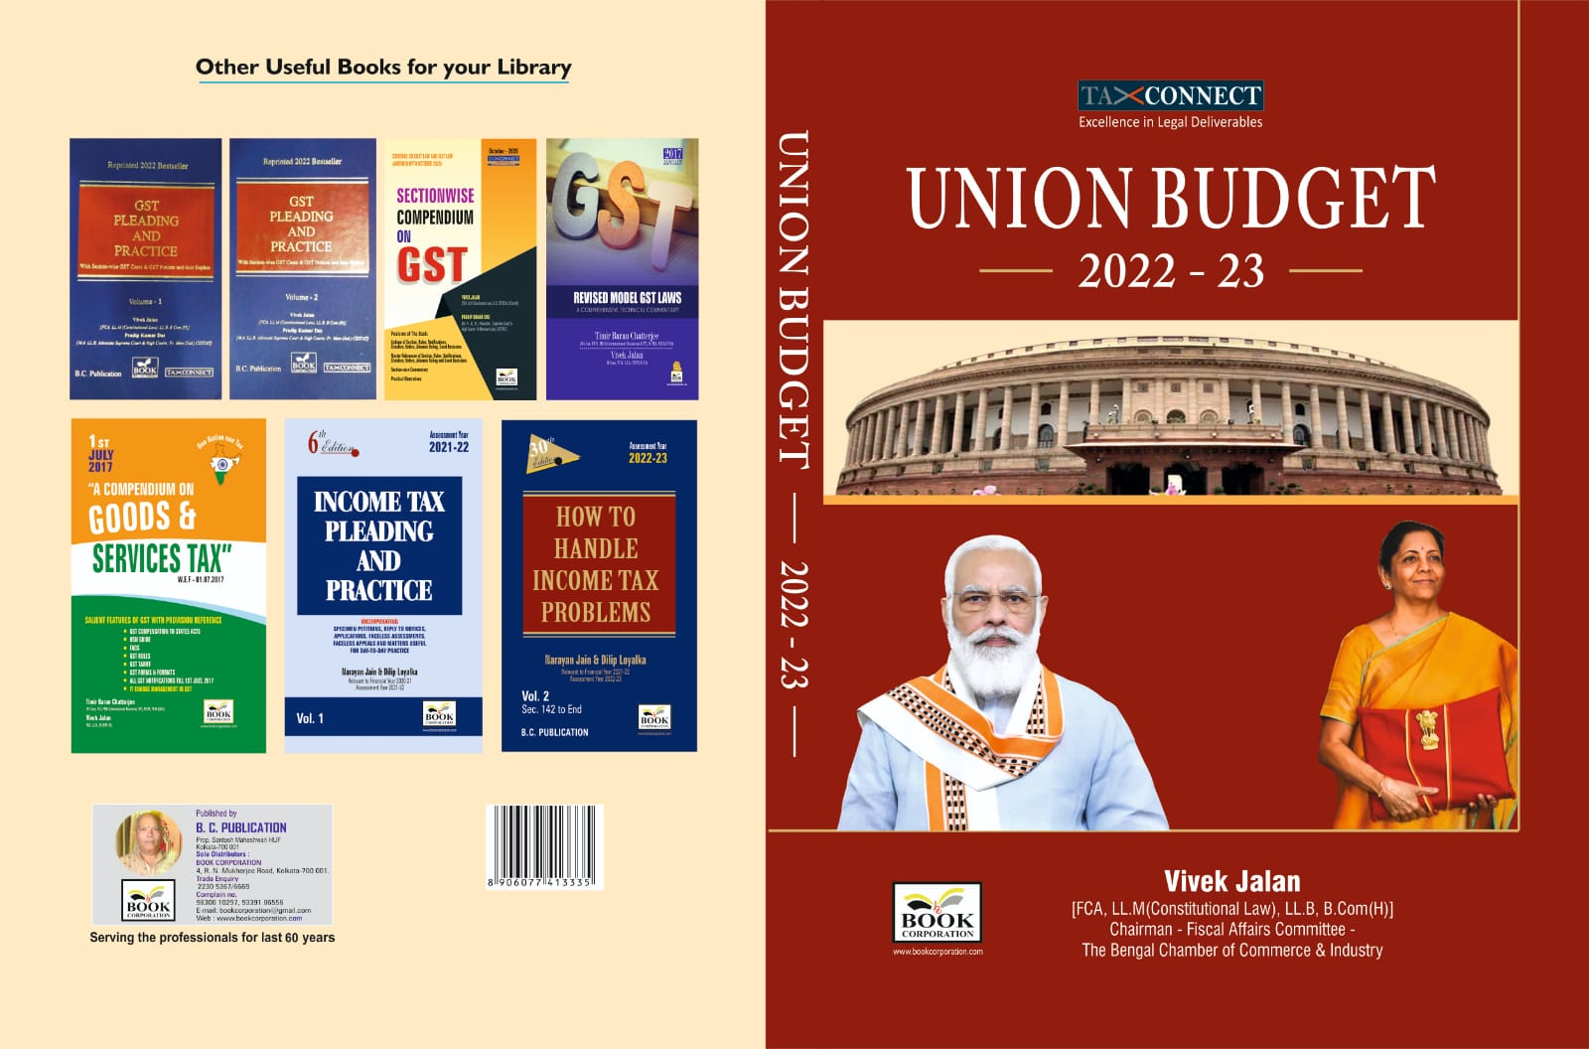

CONTENTS
- Commentary on Budget
- Budget at a glance
- Finance Minister’s Budget Speech
- Finance Bill
- Memorandum
- Notes on Clauses

Authors:
Vivek Jalan
[FCA, LL.M (Constitutional Law), LL.B, B.Com(H)]

Published by: In Association With:
BOOK CORPORATION TAX CONNECT ACADEMY
4, R. N. Mukherjee Road 1, Old Court House Corner
Kolkata 700001 Kolkata 700001
Phones: (033) 64547999 Phones: (033) 40016761
Cell: 9830010297, 9331018333 Cell:7003384915,9830661254
Order by email:bookcorporation@gmail.com Order by email: info@taxconnect.co.in Website :www.bookcorporation.com Website : www.taxconnect.co.in

:IN STANDS

GST PLEADING AND PRACTICE: With Section-wise GST Cases & GST Notices and their Replies
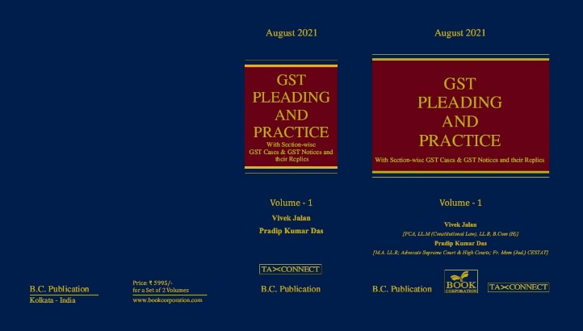

ABOUT THE BOOK: This publication includes:
1. GST Notices and their Replies
2. Orders and Appeals under GST
3. Text of provisions under IGST Act 2017 & CGST Act 2017
4. CGST & IGST Section-wise Synopsis of Case Laws and Notification/Circulars Gist
5. CGST & IGST Section-wise Synopsis of “Question of Law” answered under GST
6. Completely Updated Synopsis of Case Laws under GST by Supreme Court, High Court, AAARs & AARs

Authors:
Vivek Jalan
[FCA, LL.M (Constitutional Law), LL.B, B.Com(H)]

Pradip Kumar Das
[M.A. LL.B; Advocate Supreme Court & High Courts; Fr. Mem (Jud.) CESTAT]

Published by: In Association With:
BOOK CORPORATION TAX CONNECT ACADEMY
4, R. N. Mukherjee Road 1, Old Court House Corner
Kolkata 700001 Kolkata 700001
Phones: (033) 64547999 Phones: (033) 40016761
Cell: 9830010297, 9331018333 Cell: 9830661254
Order by email:bookcorporation@gmail.com Order by email: info@taxconnect.co.in Website :www.bookcorporation.com Website : www.taxconnect.co.in

LET’S DISCUSS FURTHER!



OUR OFFICES:
DELHI
B-139, 2nd Floor, Transport Nagar,
Noida-201301 (U.P)

Contact Person: Poonam Khemka
Email: poonam.khemka@taxconnect.co.in

MUMBAI
Unit No. 312, Omega Business Park, Near Kaamgar Hospital, Road No. 33, Wagle Industrial Estate, Thane West, Maharashtra- 400604

Contact Person: Rajani Kant Choudhary.
Email: rajnikant.choudhary@taxconnect.co.in
BANGALORE
H. NO.- 2102, 8th Cross, 15th Main, Kodihalli, HAL 3rd Stage, Bengaluru,
Karnataka-560008

Contact Person: Poonam Khemka
Email: poonam.khemka@taxconnect.co.in



DUBAI
Azizi Feirouz, 803, 8th Floor, AL Furjan, Opposite Discovery Pavillion,
Dubai, UAE

Contact Person: Rohit Sharma
Email:
rohit.sharma@taxconnect.co.in

KOLKATA
R No 119; 1st Floor; Diamond Arcade; 1/72, Cal Jessore Road;
Kolkata – 700055

Contact Person: Uttam Kumar Singh
Email: uttam.singh@taxconnect.co.in

KOLKATA
1, Old Court House Corner, “Tobacco House”, 1st Floor, Room No. 13 (N), Kolkata-700001

Contact Person: Govind Agarwal
Email: govind.agarwal@taxconnect.co.in

Disclaimer:
This e-bulletin is for private circulation only. Views expressed herein are of the editorial team and are based on the information, explanation and documents available on Government portal platforms. Tax Connect or any of its employees do not accept any liability whatsoever direct or indirect that may arise from the use of the information contained herein. No matter contained herein may be reproduced without prior consent of Tax Connect. While this e-article has been prepared on the basis of published/other publicly available information considered reliable, we do not accept any liability for the accuracy of its contents.
Tax Connect 2022. All rights reserved.

