Iz8
_{TAX CONNECT}

348th Issue: 1st May 2022- 7th May 2022
12017

sssss

Knowledge Partner:



TAX CONNECT
Mumbai : Unit No. 312, Omega Business Park, Near-Kaamgar Hospital, Road No. 33, Wagle Industrial Estate,
Thane (West), Maharashtra – 400604
Bangalore: H. No.- 2102, 8th Cross, 15th Main, Kodihalli, HAL 3rd Stage, Bengaluru, Karnataka- 560008
New Delhi: B-139, 2nd Floor, Transport Nagar, Noida-201301 (U.P)
Kolkata : 1, Old Court House Corner, “Tobacco House” 1st Floor, Room No.-13 (N), Kolkata-700001

: Room No. 119, 1st Floor, “Diamond Arcade” 1/72, Cal Jessore Road, Kolkata – 700055

Dubai : Azizi Feirouz, 803, 8th Floor, AL Furjan, Opposite Discovery Pavillion, Dubai, UAE

Contact: +91 9830661254
Website: www.taxconnect.co.in
Email: info@taxconnect.co.in



Friends,
The CGST department was gearing up all these years and preparing its officials to undertake GST scrutiny in a professional way and now it has come up with Standard Operating Procedure (SOP) for Scrutiny of GST returns for 2017-18 and 2018-19. The CBIC has issued Instruction No. 02/2022-GST dated 22nd March 2022 for Scrutiny of returns for FY 2017-18 and 2018-19. It refers to the Section 61 of CGST Act read with Rule 99 of CGST rules which provides for scrutiny of GST returns and related particulars.

The said SOP gives an indication that the online scrutiny module is underway and as an interim measure, specific Standard Operating Procedure (SOP) has been issued by the Board in order to ensure uniformity in selection/ identification of returns for scrutiny, methodology of scrutiny of such returns and other related procedures.

The taxpayer must evaluate the methodologies of scrutiny and do some exercise at their own before the department comes knocking their doors and follow the methodology.

There will be five step scrutiny process:
- Selection of returns based on robust risk parameters
- Information available with the proper officer in various returns and statements furnished by the registered person and the data/details made available through various sources like DGARM, ADVAIT, GSTN, E-Waybill Portal, etc. may be relied upon for this purpose.
- Informing the registered person of the discrepancies noticed
- conclude the proceedings after informing the registered person
- Where no satisfactory explanation is furnished by the registered person or where the registered person, after accepting the discrepancy, fails to pay, initiate appropriate action.

There should normally not be any need for seeking documents/ records from the taxpayers before issuance of FORM GST ASMT 10 The following should be followed in ASMT 10:
- Quantify the amount of tax, interest and any other amount payable
- Discrepancies be specific in nature and not vague or general
- FORM GST DRC 03 may also be taken into consideration
- One FORM GST ASMT 10 for One Financial year.
- Taxpayer may furnish an explanation for the discrepancy in FORM GST ASMT 11 to the proper officer within the time period prescribed under Rule 99 of CGST Rules
- conclude the proceedings by informing the registered person in FORM GST ASMT 12
- the proper officer, may proceed to determine the tax and other dues under section 73 or section 74 Monetary Limit as per Circular 31/5/2018.

The officer may refer the matter to the jurisdictional Principal Commissioner through the divisional Assistant/ Deputy Commissioner, for the decision whether the matter needs to be referred to Audit Commissionerate or Anti evasion Wing of the Commissionerate, as the case may be.

Just to reiterate that we remain available over telecom or e-mail.
Truly Yours
Editor:
Vivek Jalan
Partner - Tax Connect Advisory Services LLP
Co-Editors:
Rohit Sharma
Senior Manager – Tax Connect Advisory Services LLP

Rajani Kant Choudhary
Senior Manager – Tax Connect Advisory Services LLP

S.NO. | TOPICS | PAGE NO.
1] | TAX CALENDER | 4
2] | INCOME TAX | 5
NOTIFICATION | Central Government notifieD, Tamilnadu Construction Workers Welfare Board, a Board constituted by the state Government of Tamil Nadu FOR THE PURPOSE OF CLAUSE 46 OF SECTION 10.
NOTIFICATION | CLAUSE (VB) HAS BEEN INSERTED UNDER RULE 17C OF THE INCOME TAX RULES
3] | GST | 6
ADVISORY | GSTR-1 ENHANCEMENTS & IMPROVEMENTS
4] | FEMA | 7
DISCUSSION | LEGITIMATE FOREIGN CURRENCY WHILE TRAVELLING ABROAD
5] | CUSTOMS | 8
NOTIFICATION | Rate of exchange of one unit of foreign currency equivalent to Indian rupees
6] | DGFT | 9
TRADE NOTICE | Application for recognition as Pre-Shipment Inspection Agency (PSIA) and issuance and electronic Verification of Pre-Shipment Inspection Certificate (PSIC)
7] | UNION BUDGET 2022-23 | 10
8] | GST PLEADING AND PRACTICE: WITH SECTION-WISE GST CASES & GST NOTICES AND THEIR REPLIES | 11
9] | LET’S DISCUSS FURTHER | 12

Due Date | Form/Return/Challan | Reporting Period | Description
7th May | Challan No. ITNS-281 | April 2022 | Payment of TDS/TCS deducted /collected in April 2022.

NOTIFICATION
Central Government notifieD Tamilnadu Construction Workers Welfare Board a Board constituted by the state Government of TamilNadu FOR THE PURPOSE OF CLAUSE 46 OF SECTION 10
OUR COMMENTS: The Central Government vide N. No. 47/2022 dated 28.4.2022, notified for the purposes of the clause 46 of Section 10 of the Income Tax Act 1961, Tamilnadu Construction Workers Welfare Board (PAN AAATT9440P), a Board constituted by the state Government of Tamil Nadu, in respect of the following specified income arising to that Board, namely:-
(a) Contribution to Fund for benefit of manual workers in the employment in construction or maintenance of dams, bridges, etc.;
(b) Fee collection; and
(c) Interest earned on (a) and (b) above.
2. This notification shall be effective subject to the conditions that Tamilnadu Construction Workers Welfare Board,-
(a) shall not engage in any commercial activity;
(b) activities and the nature of the specified income shall remain unchanged throughout the financial years; and
(c) shall file return of income in accordance with the provision of clause (g) of sub-section (4C) of section 139 of the Income-tax Act, 1961.
3. This notification shall be deemed to have been applied for the financial year 2020-2021 (for period from 01-06-2020 to 31-03-2021) and for the financial year 2021-2022 and shall be applicable with respect to the financial years 2022-2023, 2023-2024 and 2024-2025.
[For further details please refer the Notification]

NOTIFICATION
clause (vb) has been inserted under RULE 17C OF THE INCOME TAX RULES
OUR COMMENTS: The Central Government vide N. No. 42/2022 dated 22.04.2022, hereby made the following rules further to amend the Income-tax Rules, 1962, namely: -
1. Short title and commencement. -
(1) These rules may be called the Income-tax (10th Amendment) Rules, 2022.
(2) They shall come into force on the date of their publication in the Official Gazette.
2. In the Income-tax Rules, 1962, in rule 17C, after clause (va), the following clause shall be inserted, namely:-
“(vb) investment made by a person, authorised under section 4 of the Payment and Settlement Systems Act, 2007 (51 of 2007), in the equity share capital or bonds or debentures of Open Network for Digital Commerce Ltd, being a company incorporated under sub-section (2) of section 7 read with sub-section (1) of section 8 of the Companies Act, 2013 (18 of 2013), for participating in network based open protocol models which enable digital commerce and interoperable digital payments in India;”.
[For further details please refer the Notification]

ADVISORY
GSTR-1 ENHANCEMENTS & IMPROVEMENTS
Our Comments: Certain enhancements in the GSTR-1 have been implemented which was published in the portal on 27.4.2022. Kindly find the enhancements described broadly below:
- The statement of outward supplies in FORM GSTR-1 is to be furnished by all normal taxpayers on a monthly or quarterly basis, as applicable. Quarterly GSTR-1 filers have also been provided with an optional Invoice Furnishing Facility (IFF) for reporting their outward supplies to registered persons (B2B supplies) in the first two months of the quarter. Continuous enhancements & technology improvements in GSTR-1/IFF have been made from time to time to enhance the performance & user-experience of GSTR-1/IFF, which has led to improvements in Summary Generation process, quicker response time, and enhanced user experience for the taxpayers.

- The previous phase of GSTR-1/IFF enhancement was deployed on the GST Portal in November 2021. In that phase, new features like the revamped dashboard, enhanced B2B tables, and information regarding table/tile documents count were provided. In continuation to the same, the next Phase of the GSTR-1/IFF improvements is now available on the Portal.

- GSTR-1/IFF can be viewed as usual by navigating in the following manner: Return Dashboard > Selection of Period > Details of outward supplies of goods or services GSTR-1 > Prepare Online
The following changes are being done in this phase of the GSTR-1/IFF enhancements:
Removal of ‘Submit’ button before filing: The present two-step filing of GSTR-1/IFF involving ‘Submit’ and ‘File’ buttons will be replaced with a simpler single-step filing process . The upcoming ‘File Statement’ button will replace the present two-step filing process and will provide taxpayers with the flexibility to add or modify records till the filing is completed by pressing the ‘File Statement’ button.
Consolidated Summary: Taxpayers will now be shown a table-wise consolidated summary before actual filing of GSTR-1/IFF. This consolidated summary will have a detailed & table-wise summary of the records added by the taxpayers. This will provide a complete overview of the records added in GSTR-1/IFF before actual filing.
Recipient wise summary: The consolidated summary page will also provide recipient-wise summary, containing the total value of the supplies & the total tax involved in such supplies for each recipient. The recipient-wise summary will be made available with respect to the following tables of GSTR-1/IFF, which have counter-party recipients:
- Table 4A : B2B supplies
- Table 4B : Supplies attracting reverse charge
- Table 6B : SEZ supplies
- Table 6C : Deemed exports
- Table 9B : Credit/Debit notes
- It was previously intimated that this enhancement would be made available on the Portal shortly. It is to inform that these changes have now been implemented, and are available on the Portal. For detailed advisory & sample screenshots of the GSTR-1/IFF improvements & enhancements, please visit the GST Portal

DISCUSSION
LEGITIMATE FOREIGN CURRENCY WHILE TRAVELLING ABROAD
OUR COMMENTS: Slowly and steadily after a long gap, several countries have opened their door for foreign tourist. Last two years have been worse hit for travelling both domestic & international whether for fun or for business and education etc. But now since this restriction is almost over so for those who intend to pack their bags & head to for destination – a covid respite here is some information in relation to permissible limit of foreign currency that they can carry while travelling.
When Travelling is for studying Abroad?
After a long Covid break almost all universities are open for international students. So, if you going outside India on student visa, you can buy foreign exchange which is higher of USD30,000 Estimate given by your university
When Travelling is for Medical Treatment?
If you are travelling internationally for medical treatment that you can buy foreign exchange up to USD 50,000 for covering your medical expenses. Additional USD 25000 can also be taken to cover travelling and lodging, boarding expenses. When Travelling for Employment Abroad: If you are going outside India under work permit then you can carry USD 5000 without any restrictions.
When you want to Gift outside India?
If you want to gift your loved ones outside India or you want to make any donations outside India than you can buy USD 5000 pa.
If you are travelling outside India for Vacations or Business Travel:
You can buy USD 10,000 for tourism or for private travel without taking any prior permission from Reserve Bank of India. This limit is not available on visit to Nepal and Bhutan. There is no restriction laid by RBI with regard to currency for Nepal and Bhutan.
When Foreign Currency should be purchased?
Foreign currency can be purchased from money changers or any bank who is authorized to deal in foreign exchange. This purchase can be made 60 days before the journey date and in case if journey could not be undertaken with in the specified limit than this foreign currency should be surrendered to respective bank or money exchanger.
If payment is made through International Credit Cards Use of international credit cards by Indian Residents are free from all restrictions?
A person can spend up to limit restricted by credit card itself. But in any case, ICC cannot be used for purchased of prohibited items E.g.: Lottery tickets, banned as prohibited items etc.
Surrender of Foreign Exchange on Return:
You can retain foreign coins indefinitely. You can retain foreign exchange currency up to USD 2000, either in the form of foreign currency note or in the form of travelers’ cheque. Any foreign currency in excess of USD 2000 has to surrender to bank within 90 days and in case of travelers’ cheque, they have to be surrendered within 180 days of return.

NOTIFICATION
Rate of exchange of one unit of foreign currency equivalent to Indian rupees
OUR COMMENTS: The Central Board of Indirect Taxes and Customs vide notification no 34/ 2022 dated 21.04.2022, hereby determined that the rate of exchange of conversion of each of the foreign currencies specified in column (2) of each of Schedule I and Schedule II annexed hereto, into Indian currency or vice versa, shall, with effect from 22nd April, 2022, be the rate mentioned against it in the corresponding entry in column (3) thereof, for the purpose of the said section, relating to imported and export goods.
SCHEDULE-I
Sl.  No. | Foreign Currency | Rate of exchange of one unit of foreign currency equivalent to Indian rupees
(1) | (2) | (3)
 |  | (a) | (b)
 |  | (For Imported Goods) | (For Export Goods)
1. | Australian Dollar | 57.95 | 55.50
2. | Bahraini Dinar | 208.85 | 196.15
3. | Canadian Dollar | 62.15 | 60.00
4. | Chinese Yuan | 12.05 | 11.70
5. | Danish Kroner | 11.30 | 10.90
6. | EURO | 84.15 | 81.10
7. | Hong Kong Dollar | 9.90 | 9.55
8. | Kuwaiti Dinar | 258.10 | 242.00
9. | New Zealand Dollar | 53.10 | 50.75
10. | Norwegian Kroner | 8.80 | 8.50
11. | Pound Sterling | 101.25 | 97.80
12. | Qatari Riyal | 21.55 | 20.25
13. | Saudi Arabian Riyal | 21.00 | 19.70
14. | Singapore Dollar | 56.85 | 54.95
15. | South African Rand | 5.20 | 4.90
16. | Swedish Kroner | 8.20 | 7.90
17. | Swiss Franc | 81.80 | 78.65
18. | Turkish Lira | 5.35 | 5.05
19. | UAE Dirham | 21.45 | 20.15
20. | US Dollar | 77.15 | 75.45
SCHEDULE-II
Sl.  No. | Foreign Currency | Rate of exchange of 100 units of foreign currency equivalent to Indian rupees
(1) | (2) | (3)
 |  | (a) | (b)
 |  | (For Imported Goods) | (For Export Goods)
1. | Japanese Yen | 60.40 | 58.35
2. | Korean Won | 6.35 | 6.00
[For further details please refer the Notification]
TRADE NOTICE
Application for recognition as Pre-Shipment Inspection Agency (PSIA) and issuance and electronic Verification of Pre-Shipment Inspection Certificate (PSIC)
OUR COMMENTS: Vide Trade Notice No. 03/2022-23 dated 26th April 2022, reference has been invited to paragraph 2.55 and 2.56 of Handbook of Procedures 2015-20 regarding recognition as Pre-Shipment Inspection Agency (PSIA) for metal scrap and issuance of Pre- Shipment Inspection Certificate (PSIC).
2. As a part of IT Revamp, this Directorate proposes a new online module for filing of application for recognition as Pre-Shipment Inspection Agency (PSIA), electronic issuance of Pre-shipment Inspection Certificates (PSICs) and electronic verification of authenticity of the PSICs with effect from 01.05.2022.
3. In this regard, it is submitted that all existing PSIAs as recognised under Appendix 2G of the FTP are required to register online on the DGFT Website (https://dgft.gov.in) → My Dashboard → Register and selecting ‘Register User As’ -‘Pre-Shipment Inspection Agency’. The said PSIA official shall thereafter navigate to Services → Pre-Shipment Inspection → Apply for PSIA and submit required details for activation of their specific online account.
4. Further, any application for amendment in instruments and/or areas of operation of existing PSIA may also be made online post-login as PSIA by navigating to the DGFT website → Services → Pre-Shipment Inspection → Amendment in Area of Operation/Instruments.
5. Further, on successful activation of account, the PSIA may generate and upload Pre-Shipment Inspection Certificates (PSIC) online through the following navigation:
DGFT website → Services → Pre-Shipment Inspection → Generate and upload PSIC. The PSIC shall may be generated by the PSIA after the required inspection has been carried out. Required Video and photographic evidence is to be uploaded by the PSIA during this online PSIC process.
6. Further, the PSIC generated online can be downloaded by the Indian Importer by navigating to the DGFT website → Services → Pre-Shipment Inspection → Download Pre-shipment Inspection Certificate (PSIC). The Importer would be required to enter the PSIC certificate number and the name of PSIA to download any such PSIC.
7. The Customs Authorities at the Indian Port may also consider verifying the genuineness of online PSIC generated using the steps as summarised under para 6 above. The Importer or the Customs Authorities shall not be required to login to the DGFT Website to access the PSIC download or PSIC verification services.
8. The given online process shall not be mandatory in the initial period of go-live and the PSIAs as well as the importers are provided time till 30.06.2022 to onboard and familiarise with the said online process. All PSICs shall be mandatorily generated online through the DGFT Website w.e.f. 01.07.2022. PSICs dated on or after 01.07.2022 not generated using the DGFT online systems may not be accepted by the Indian Customs Authorities.
9. For any help and guidance on this new process, the Help manual & FAQs may be accessed on the DGFT Website → Learn → Application Help & FAQs. For any further assistance, guidance and resolution of issues faced, any of the following channels may be assessed –
i. Raise a service request ticket through the DGFT Helpdesk Service on DGFT Website → Services → DGFT Helpdesk Service
ii. Call the toll-free-Helpline number
iii. Send an email to the Helpdesk on dgftedi@gov.in
10. This issues with the approval of the Competent Authority.
[For further details please refer the Trade Notice]

:IN STANDS

UNION BUDGET 2022-23
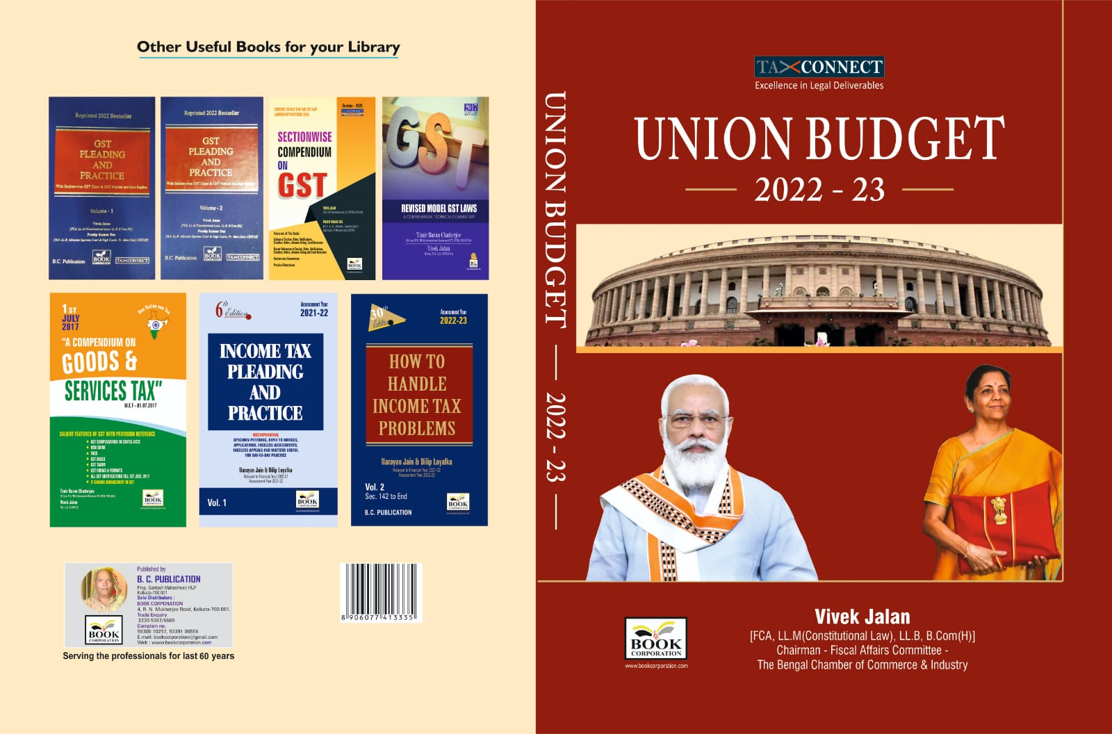

CONTENTS
- Commentary on Budget
- Budget at a glance
- Finance Minister’s Budget Speech
- Finance Bill
- Memorandum
- Notes on Clauses

Authors:
Vivek Jalan
[FCA, LL.M (Constitutional Law), LL.B, B.Com(H)]

Published by: In Association With:
BOOK CORPORATION TAX CONNECT ACADEMY
4, R. N. Mukherjee Road 1, Old Court House Corner
Kolkata 700001 Kolkata 700001
Phones: (033) 64547999 Phones: (033) 40016761
Cell: 9830010297, 9331018333 Cell: 7003384915, 9830661254
Order by email:bookcorporation@gmail.com Order by email: info@taxconnect.co.in Website :www.bookcorporation.com Website : www.taxconnect.co.in

:IN STANDS

GST PLEADING AND PRACTICE: With Section-wise GST Cases & GST Notices and their Replies
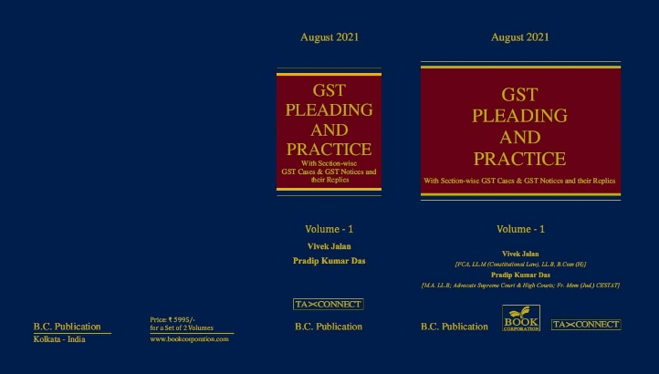

ABOUT THE BOOK: This publication includes:
1. GST Notices and their Replies
2. Orders and Appeals under GST
3. Text of provisions under IGST Act 2017 & CGST Act 2017
4. CGST & IGST Section-wise Synopsis of Case Laws and Notification/Circulars Gist
5. CGST & IGST Section-wise Synopsis of “Question of Law” answered under GST
6. Completely Updated Synopsis of Case Laws under GST by Supreme Court, High Court, AAARs & AARs

Authors:
Vivek Jalan
[FCA, LL.M (Constitutional Law), LL.B, B.Com(H)]

Pradip Kumar Das
[M.A. LL.B; Advocate Supreme Court & High Courts; Fr. Mem (Jud.) CESTAT]

Published by: In Association With:
BOOK CORPORATION TAX CONNECT ACADEMY
4, R. N. Mukherjee Road 1, Old Court House Corner
Kolkata 700001 Kolkata 700001
Phones: (033) 64547999 Phones: (033) 40016761
Cell: 9830010297, 9331018333 Cell: 9830661254
Order by email:bookcorporation@gmail.com Order by email: info@taxconnect.co.in Website :www.bookcorporation.com Website : www.taxconnect.co.in

LET’S DISCUSS FURTHER!



OUR OFFICES:
DELHI
B-139, 2nd Floor, Transport Nagar,
Noida-201301 (U.P)

Contact Person: Poonam Khemka
Email: poonam.khemka@taxconnectdelhi.co.in

MUMBAI
Unit No. 312, Omega Business Park, Near Kaamgar Hospital, Road No. 33, Wagle Industrial Estate, Thane West, Maharashtra- 400604

Contact Person: Rajani Kant Choudhary.
Email: rajnikant.choudhary@taxconnect.co.in
BANGALORE
H. NO.- 2102, 8th Cross, 15th Main, Kodihalli, HAL 3rd Stage, Bengaluru,
Karnataka-560008

Contact Person: Poonam Khemka
Email: poonam.khemka@taxconnectdelhi.co.in



DUBAI
Azizi Feirouz, 803, 8th Floor, AL Furjan, Opposite Discovery Pavillion,
Dubai, UAE

Contact Person: Rohit Sharma
Email:
rohit.sharma@taxconnect.co.in

KOLKATA
R No 119; 1st Floor; Diamond Arcade; 1/72, Cal Jessore Road;
Kolkata – 700055

Contact Person: Uttam Kumar Singh
Email: uttam.singh@taxconnect.co.in

KOLKATA
1, Old Court House Corner, “Tobacco House”, 1st Floor, Room No. 13 (N), Kolkata-700001

Contact Person: Govind Agarwal
Email: govind.agarwal@taxconnect.co.in

Disclaimer:
This e-bulletin is for private circulation only. Views expressed herein are of the editorial team and are based on the information, explanation and documents available on Government portal platforms. Tax Connect or any of its employees do not accept any liability whatsoever direct or indirect that may arise from the use of the information contained herein. No matter contained herein may be reproduced without prior consent of Tax Connect. While this e-article has been prepared on the basis of published/other publicly available information considered reliable, we do not accept any liability for the accuracy of its contents.
Tax Connect 2022. All rights reserved.

