z8
_{TAX CONNECT}

342nd Issue: 20th March 2022- 26th March 2022
12017

sssss

Knowledge Partner:



TAX CONNECT

Mumbai : Unit No. 312, Omega Business Park, Near-Kaamgar Hospital, Road No. 33, Wagle Industrial Estate,
Thane (West), Maharashtra – 400604
Bangalore: H. No.- 2102, 8th Cross, 15th Main, Kodihalli, HAL 3rd Stage, Bengaluru, Karnataka- 560008
New Delhi: B-139, 2nd Floor, Transport Nagar, Noida-201301 (U.P)
Kolkata : 1, Old Court House Corner, “Tobacco House” 1st Floor, Room No.-13 (N), Kolkata-700001

: Room No. 119, 1st Floor, “Diamond Arcade” 1/72, Cal Jessore Road, Kolkata – 700055

Dubai : Azizi Feirouz, 803, 8th Floor, AL Furjan, Opposite Discovery Pavillion, Dubai, UAE

Contact: +91 8777784162; +91 9830661254
Website: www.taxconnect.co.in
Email: info@taxconnect.co.in



Friends,
Wish you all a Happy Holi.

The Government of India has introduced the tax implications for cryptocurrency for the first time in the Union Budget 2022, while the Internal Revenue Service (IRS) of the United States (US) first addressed cryptocurrencies in 2014. Let us see the differences in the income tax treatment of cryptocurrencies of both countries.

Classification of Crypto Assets
In Budget 2022, the government has classified crypto assets as ‘virtual digital assets’. Although they have been defined as assets, virtual digital assets are not treated like other assets. The new income tax provision has been inserted for the taxation of virtual digital assets, which provides that 30% tax must be paid on the profits earned from the transfer of crypto assets. However, no deduction is allowed to be adjusted from the asset’s sale price, except the cost of acquisition.

However, in the US, cryptocurrencies are treated as capital assets. So, when a person transfers cryptocurrency at a profit, he/she is liable to pay tax depending on whether the assets are long-term crypto assets or short-term crypto assets. The US law states that assets sold after one year of purchase are classified as long-term capital assets. Long term assets are subject to lower tax rates. But if the assets are sold within a year of purchase, they are classified as short-term capital assets.

Since the Indian tax law does not treat virtual digital assets as capital assets, crypto investors are not eligible for indexation benefits if the assets are held for long-term and face the full 30% tax rate irrespective of the period of holding.

Further, the US income tax law allows to claim the losses from crypto assets and set off against other income sources. Moreover, if any loss is unadjusted, it can be carried forward to set off against future investment gains.

Similar treatment is given for losses incurred from the sale of capital assets in the Indian Income Tax Act, if there is any loss from sale of capital assets, it can be adjusted against the gain on sale of capital assets, subject to certain conditions. And for any loss that is unadjusted, it can be carried forward to eight subsequent years to set off against the future capital gains. But such benefit is not available to crypto investors if they incur loss on the sale of virtual digital assets.

The treatment of gains or losses from virtual digital assets provided in the Indian income tax law is akin to income from gambling, horse racing and lottery winnings. For gambling and lottery winnings, too, the income is taxed at a flat rate of 30% without any deductions, and in case there is a loss, no set-off is allowed against other income.
Just to reiterate that we remain available over telecom or e-mail.
Truly Yours
Editor:
Vivek Jalan
Partner - Tax Connect Advisory Services LLP
Co-Editors:
Rohit Sharma
Senior Manager – Tax Connect Advisory Services LLP

Rajani Kant Choudhary
Senior Manager – Tax Connect Advisory Services LLP

S.NO. | TOPICS | PAGE NO.
1] | TAX CALENDER | 4
2] | INCOME TAX | 5
CIRCULAR | INCOME-TAX DEDUCTION FROM SALARIES UNDER SECTION 192 OF THE INCOME-TAX ACT, 1961 DURING THE FINANCIAL YEAR 2021-22
3] | GST | 6
NOTIFICATION | POWERS OF ADDITIONAL COMMISSIONER (AC) OR JOINT COMMISSIONER (JC) OF CENTRAL TAX FOR PASSING AN ORDER OR DECISION IN RESPECT OF NOTICES ISSUED BY THE OFFICERS OF DIRECTORATE GENERAL OF GOODS AND SERVICES TAX INTELLIGENCE (DGGI)
4] | FEMA | 7
GUIDELINES | Review of FDI Policy for permitting foreign investment in Life Insurance Corporation of India (LIC) and other modifications for further clarity of the existing FDI Policy
5] | CUSTOMS | 8
NOTIFICATION | Fixation of Traiff Values - Edible Oils, Brass Scrap, Poppy Seeds, Areca Nut, Gold and Sliver etc, (including Crude Palm Oil, RBD Palm Oil, Others)
6] | DGFT | 9
TRADE NOTICE | Operationalisation of new online IT Module for Interest Equalisation Scheme w.e.f. 01.04.2022
7] | UNION BUDGET 2022-23 | 10
8] | GST PLEADING AND PRACTICE: WITH SECTION-WISE GST CASES & GST NOTICES AND THEIR REPLIES | 11
9] | LET’S DISCUSS FURTHER | 12

Due Date | Form/Return/Challan | Reporting Period | Description
20th March | GSTR 5 | February, 2022 | Document/statement that has to be filed by every registered non-resident taxable person for the period during which they carry out businesses transactions in India
20th March | GSTR 5A | February, 2022 | A return form to be filed by non-resident Online Information and Database Access or Retrieval (OIDAR) services provider for the services provided from a place outside India to a person in India to unregistered person or non-taxable customers.
20th March | GSTR 3B | February, 2022 | The summary Return of Outward Supplies and ITC of the taxpayers having an Annual Turnover of more than 5 Crores.
20th March | GST Challan Payment | February, 2022 | If you don’t have enough ITC for February, you’ll have to pay a GST challan (for all Quarterly Filers).

CIRCULAR
INCOME-TAX DEDUCTION FROM SALARIES UNDER SECTION 192 OF THE INCOME-TAX ACT, 1961 DURING THE FINANCIAL YEAR 2021-22
OUR COMMENTS: CBDT issued Income Tax Circular No. 04/2022 on 15th March 2022 and explained all provisions related to deduction of Tax At Source (TDS) on Salary or Income Tax Payable on Salary for the Financial Year 2021-22 / Assessment Year 2022-23.
The Circular contains the rates of deduction of Income-tax from the payment of income chargeable under the head “Salaries” during the financial year 2021-22 and explains certain related provisions of the Act and Income-tax Rules, 1962 (hereinafter the Rules). All the sections and rules referred are of Income-tax Act, 1961 and Income-tax Rules, 1962 respectively unless otherwise specified.
As per section 192 (1) of the Income Tax Act, any person responsible for paying any income chargeable under the head “Salaries” shall, at the time of payment, deduct income-tax on the amount payable at the average rate of income-tax computed on the basis of the rates in force for the financial year in which the payment is made, on the estimated income of the assessee under the head of Salary income for that financial year.
The section also provides that a person responsible for paying any income chargeable under the head “Salaries” shall furnish to the person to whom such payment is made a statement giving correct and complete particulars of perquisites or profits in lieu of salary provided to him and the value thereof.
As per section 15 of the Income Tax Act, the following incomes are chargeable to income-tax under the head “Salaries”—
(a) any salary due from an employer or a former employer to an assessee in the previous year, whether paid or not;
(b) any salary paid or allowed to him in the previous year by or on behalf of an employer or a former employer though not due or before it became due to him;
(c) any arrears of salary paid or allowed to him in the previous year by or on behalf of an employer or a former employer, if not charged to income-tax for any earlier previous year.
Other relevant topics which were highlighted are:
- Definition of "salary", "perquisite" and "profit in lieu of salary" (Section 17).
- Rates of Income-Tax as per Finance Act, 2021.
- Section 192 of the Income-Tax Act, 1961 - Broad scheme of Tax Deduction At Source from "Salaries".
- Persons Responsible For Deducting Tax And Their Duties
- Computation Of Income Under The Head “Salaries”
- Rebate Of Rs12,500 For Individuals Having Total Income Upto Rs 5 lakh [Section 87A]
- TDS on payment of accumulated balance under recognised provident fund and contribution from approved superannuation fund.
- DDOs to obtain evidence/proof of claims
- Calculation of income-tax to be deducted
- Illustrations, Forms, Procedures, Relevant Notifications etc.
- Miscellaneous.
[For further details please refer the Circular]

NORIFICATION
POWERS OF ADDITIONAL COMMISSIONER (AC) OR JOINT COMMISSIONER (JC) OF CENTRAL TAX FOR PASSING AN ORDER OR DECISION IN RESPECT OF NOTICES ISSUED BY THE OFFICERS OF DIRECTORATE GENERAL OF GOODS AND SERVICES TAX INTELLIGENCE (DGGI)
Our Comments: The Central Government vide NOTIFICATION NO. 02/2022-Central Tax, dated 11th March 2022 hereby made the following amendments in the notification of the Government of India in the Ministry of Finance (Department of Revenue) No. 02/2017- Central Tax, dated the 19th June, 2017 published in the Gazette of India, Extraordinary, Part II, Section 3, Sub-section (i) vide number G.S.R. 609(E), dated the 19th June, 2017, namely: In the said notification,–
(i) after paragraph 3, the following paragraph shall be inserted, namely :-
“3A. Notwithstanding anything contained in paragraph 3, the Additional Commissioners or the Joint Commissioners of Central Tax, as the case may be, subordinate to the Principal Commissioners of Central Tax or the Commissioners of Central Tax, as specified in column (2) of Table V, are hereby vested with the powers as specified in the corresponding entry in Column (3) of the said Table.”;
(ii) after Table IV, the following Table shall be inserted, namely:-
“TABLE V
Powers of Additional Commissioner or Joint Commissioner of Central Tax for passing an order or decision in respect of notices issued by the officers of Directorate General of Goods and Services Tax Intelligence
Sl. No. | Principal Commissioner or Commissioner of Central Tax | Powers  (Exercisable throughout the territory of India)
(1) | (2) | (3)
1. | Principal Commissioner Ahmedabad South | Passing an order or decision in respect of notices issued by the officers of Directorate General of Goods and Services Tax Intelligence under sections 67, 73, 74, 76, 122, 125, 127, 129 and 130 of Central Goods and Services Tax Act 2017.".
2. | Principal Commissioner Bhopal
3. | Principal Commissioner Chandigarh
4. | Commissioner Chennai South
5. | Principal Commissioner Delhi North
6. | Principal Commissioner Guwahati
7. | Commissioner Rangareddy
8. | Principal Commissioner Kolkata North
9. | Principal Commissioner Lucknow
10. | Commissioner Thane

FDI GUIDELINES
Review of FDI Policy for permitting foreign investment in Life Insurance Corporation of India (LIC) and other modifications for further clarity of the existing FDI Policy
OUR COMMENTS: The FDI Policy Section of the Department for Promotion of Industry and Internal Trade, Ministry of Commerce & Industry, Government of India has reviewed the extant FDI policy for permitting foreign investment in Life Insurance Corporation of India (LIC) and other modifications for consistency and further clarity of the existing FDI Policy. Accordingly, the following amendments have been made under the Consolidated FDI Policy Circular of 2020, as amended from time to time (FDI Policy):
1.1 Para 2.1.5 of the FDI Policy is amended to be read as under:'Capital' means equity shares; fully, compulsorily and mandatorily convertible preference shares; fully, compulsorily and mandatorily convertible debentures and warrants;
Note: The equity shares issued by an Indian Company in accordance with the provisions of the Companies Act, 2013 or any other applicable law, shall include equity shares that have been partly paid. Preference shares and convertible debentures shall be required to be fully paid, and to be mandatorily and fully convertible. Further, 'warrant' includes Share Warrant issued by an Indian Company in accordance with the regulations made by the Securities and Exchange Board of India (SEBI), the Companies Act, 2013 or any other applicable law.
1.2 Para 2.1.9 of the FDI Policy is amended to be read as under:'Convertible Note' means an instrument issued by a startup company acknowledging receipt of money initially as debt, which is repayable at the option of the holder, or which is convertible into such number of equity shares of such startup company, within a period not exceeding ten years from the date of issue of the convertible note, upon occurrence of specified events as per the other terms and conditions agreed to and indicated in the instrument.
1.3 Para 2.1.17 of FDI Policy is amended to be read as under:`Foreign Investment' means any investment made by a person resident outside India on a repatriable basis in capital instruments of an Indian company or to the capital of a LLP;
Explanation: If a declaration is made by a person as per the provisions of the Companies Act, 2013 or any other applicable law, about a beneficial interest being held by a person resident outside India, then even though the investment may be made by a resident Indian citizen, the same shall be counted as foreign investment;Note: A person resident outside India may hold foreign investment either as FDI or as FPI in any particular Indian company;
1.4 Para 2.1.27 of FDI Policy is amended to be read as under:`Indian Company' means a company as defined in the Companies Act, 2013 which is incorporated in India, or a body corporate established or constituted by or under any Central or State Act;
1.5 A new Para 2.1.47A is inserted under the FDI Policy as follows:
‘Share Based Employee Benefits’ means any issue of capital instruments to employees, pursuant to share based employee benefits schemes formulated by a body corporate established or constituted by or under any Central or State Act.
1.6 A new Para 2.1.48A is inserted under the FDI Policy as follows:
‘Subsidiary' shall have the same meaning as is assigned to it under the Companies Act, 2013, as amended from time to time.
1.7 The existing provisions under Para 3.4.2 (vi) and Para 3.4.2 (vii) of the FDI Policy are re-numbered as new Para 3.4.3 and new Para 3.4.4.
[For further details please refer the Guidelines]

NOTIFICATION
Fixation of Traiff Values - Edible Oils, Brass Scrap, Poppy Seeds, Areca Nut, Gold and Sliver etc, (including Crude Palm Oil, RBD Palm Oil, Others)
OUR COMMENTS: The Central Board of Indirect Taxes & Customs vide notification 17/2022 dated 15th March 2022 made amendments vide, namely:-
“TABLE-1
Sl. No. | Chapter/ heading/ sub-heading/tariff item | Description of goods | Tariff value  (US $Per Metric Tonne)
1 | 1511 10 00 | Crude Palm Oil | 1449
2 | 1511 90 10 | RBD Palm Oil | 1496
3 | 1511 90 90 | Others – Palm Oil | 1473
4 | 1511 10 00 | Crude Palmolein | 1502
5 | 1511 90 20 | RBD Palmolein | 1505
6 | 1511 90 90 | Others – Palmolein | 1504
7 | 1507 10 00 | Crude Soya bean Oil | 1537
8 | 7404 00 22 | Brass Scrap (all grades) | 5926
TABLE-2
1. | 71 or 98 | Gold, in any form, in respect of which the benefit of entries at serial number 356 of the Notification No. 50/2017-Customs dated 30.06.2017 is availed | 629 per 10 grams
2. | 71 or 98 | Silver, in any form, in respect of which the benefit of entries at serial number 357 of the Notification No. 50/2017-Customs dated 30.06.2017 is availed | 825 per kilogram
3. | 71 | (i) Silver, in any form, other than medallions and silver coins having silver content not below 99.9% or semi-manufactured forms of silver falling under sub-heading 7106 92;(ii) Medallions and silver coins having silver content not below 99.9% or semi-manufactured forms of silver falling under sub-heading 7106 92, other than imports of such goods through post, courier or baggage. | 825 per kilogram
4. | 71 | (i) Gold bars, other than tola bars, bearing manufacturer’s or refiner’s engraved serial number and weight expressed in metric units;(ii) Gold coins having gold content not below 99.5% and gold findings, other than imports of such goods through post, courier or baggage. | 629 per 10 grams
TABLE-3
1 | 080280 | Areca nuts | 5589 (i.e., no change)”
2. This notification shall come into force with effect from the 16th day of March, 2022
[For further details please refer the Notification]

TRADE NOTICE
Operationalisation of new online IT Module for Interest Equalisation Scheme w.e.f. 01.04.2022
OUR COMMENTS: Vide Trade Notice number38/2021-2022, dated 15th March 2022, attention of the trade and industry is drawn towards the extension of the Interest Equalisation Scheme (IES) upto 31.3.2024, as notified by RBI vide its circular no. DOR.STR.REC.93/04.02.001/2021-22 dated 08.03.2022. In order to capture granular data about the beneficiaries of the scheme and its effective monitoring, it has been decided to operationalise a new online module for filing of electronic registration for Interest Equalisation Scheme w.e.f. 01.04.2022.
2. All exporters seeking benefit under the Interest Equalisation Scheme need to apply online by navigating to the DGFT website (https:// dgft.gov.in) → Services → Interest Equalisation Scheme. A Unique IES Identification Number (UIN) will get generated automatically which is required to be submitted to the concerned bank when availing Interest Equalisation against their pre and post shipment rupee export credit applications.
3. For generating UIN the following steps need to be followed by all concerned exporters –
i. As a first step, any exporter seeking to apply under IES, need to register on the DGFT Website (if not already registered). It may be ensured that applicant's IEC is linked to its online account, the IEC (ANF-2A) and the Exporter-Importer Profile(ANF-1) is updated to reflect correct and up-to-date details.
ii. Thereafter, exporter need to login with its registered credentials → navigate to Services → Interest Equalisation Scheme → Apply for Interest Equalisation Scheme and fill in the required details. Basic data about the applicant's IEC would get auto-populated.
iii. An acknowledgement containing Unique IES Identification Number (UIN) would be auto-generated when duly completed application is submitted online.
iv. An SMS and email intimation of the UIN generated will be sent to the registered email account and mobile number of the exporter.
v. The user charge for generating a UIN shall be ₹ 200 and is to be paid online.
vi. After generation of the UIN no changes will be allowed. In case of any correction/amendment exporter may generate new UIN.
4. The UIN generated shall have a validity of 1 year from the date of registration, during which an application for availing benefit of IES can be submitted to the concerned bank. The auto generated Acknowledgement containing UIN number need to be submitted to the concerned bank along with the prescribed application by the bank, if any, for availing benefit under IES.
5. It will be mandatory for exporter to submit UIN acknowledgment to concerned bank for all applications made on or after 01.04.2022.
6. Banks will continue to scrutinize and issue benefits as per their own internal process. The guidelines for the bank for validation of submission made by the exporter are being issued separately through RBI.
7. For any help and guidance on this new process, the Help Manual & F AQs may be accessed on DGFT Website (https://dgft.gov.in) → Learn → Application Help & FAQs. For any further assistance, any of the following channels may be accessed-
i. Raise a service request ticket through DGFT Helpdesk service under Services → 'DGFT Helpdesk Service'.
ii. Call the DGFT Toll-free-Helpline number.
iii. Send an email to the Helpdesk on dgftedi@gov.in
8. This issues with the approval of the Competent Authority.
[For further details please refer the Trade Notice]

:IN STANDS

UNION BUDGET 2022-23
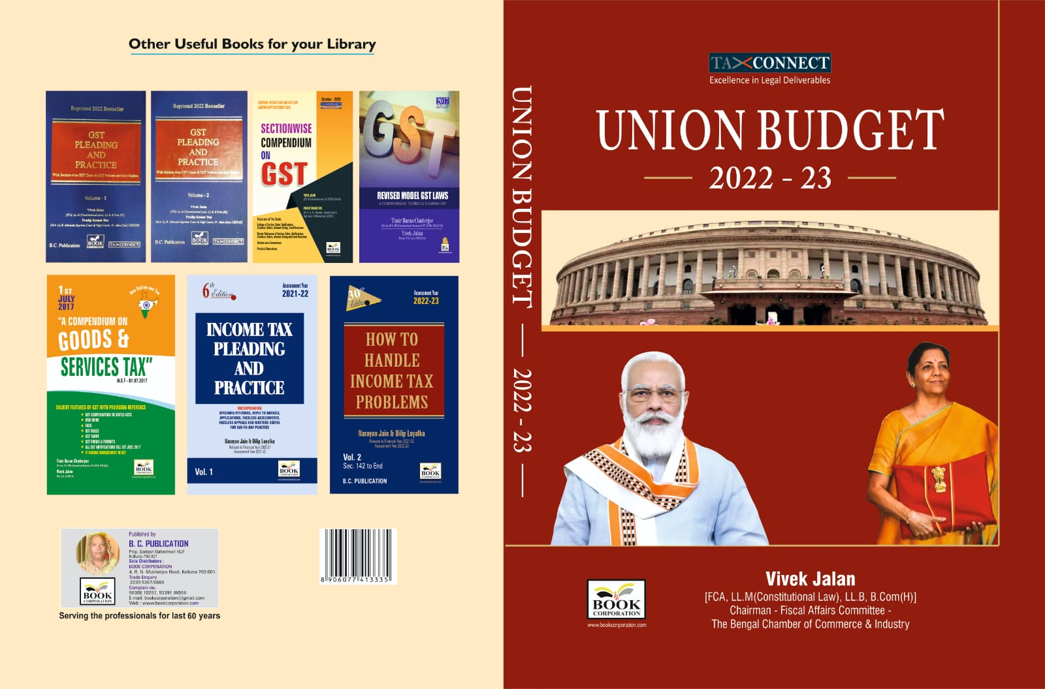

CONTENTS
- Commentary on Budget
- Budget at a glance
- Finance Minister’s Budget Speech
- Finance Bill
- Memorandum
- Notes on Clauses

Authors:
Vivek Jalan
[FCA, LL.M (Constitutional Law), LL.B, B.Com(H)]

Published by: In Association With:
BOOK CORPORATION TAX CONNECT ACADEMY
4, R. N. Mukherjee Road 1, Old Court House Corner
Kolkata 700001 Kolkata 700001
Phones: (033) 64547999 Phones: (033) 40016761
Cell: 9830010297, 9331018333 Cell: 8777784162, 9830661254
Order by email:bookcorporation@gmail.com Order by email: info@taxconnect.co.in Website :www.bookcorporation.com Website : www.taxconnect.co.in

:IN STANDS

GST PLEADING AND PRACTICE: With Section-wise GST Cases & GST Notices and their Replies
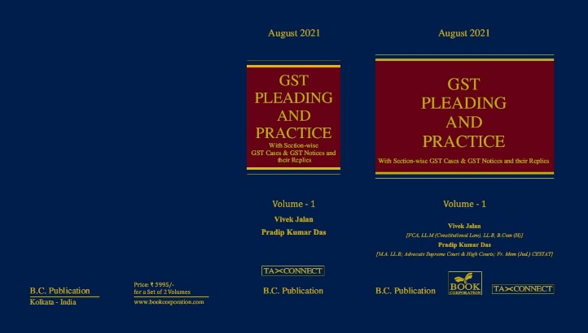

ABOUT THE BOOK: This publication includes:
1. GST Notices and their Replies
2. Orders and Appeals under GST
3. Text of provisions under IGST Act 2017 & CGST Act 2017
4. CGST & IGST Section-wise Synopsis of Case Laws and Notification/Circulars Gist
5. CGST & IGST Section-wise Synopsis of “Question of Law” answered under GST
6. Completely Updated Synopsis of Case Laws under GST by Supreme Court, High Court, AAARs & AARs

Authors:
Vivek Jalan
[FCA, LL.M (Constitutional Law), LL.B, B.Com(H)]

Pradip Kumar Das
[M.A. LL.B; Advocate Supreme Court & High Courts; Fr. Mem (Jud.) CESTAT]

Published by: In Association With:
BOOK CORPORATION TAX CONNECT ACADEMY
4, R. N. Mukherjee Road 1, Old Court House Corner
Kolkata 700001 Kolkata 700001
Phones: (033) 64547999 Phones: (033) 40016761
Cell: 9830010297, 9331018333 Cell: 8777784162, 9830661254
Order by email:bookcorporation@gmail.com Order by email: info@taxconnect.co.in Website :www.bookcorporation.com Website : www.taxconnect.co.in

LET’S DISCUSS FURTHER!



OUR OFFICES:
DELHI
B-139, 2nd Floor, Transport Nagar,
Noida-201301 (U.P)

Contact Person: Poonam Khemka
Email: poonam.khemka@taxconnectdelhi.co.in

MUMBAI
Unit No. 312, Omega Business Park, Near Kaamgar Hospital, Road No. 33, Wagle Industrial Estate, Thane West, Maharashtra- 400604

Contact Person: Rajani Kant Choudhary.
Email: rajnikant.choudhary@taxconnect.co.in
BANGALORE
H. NO.- 2102, 8th Cross, 15th Main, Kodihalli, HAL 3rd Stage, Bengaluru,
Karnataka-560008

Contact Person: Poonam Khemka
Email: poonam.khemka@taxconnectdelhi.co.in



DUBAI
Azizi Feirouz, 803, 8th Floor, AL Furjan, Opposite Discovery Pavillion,
Dubai, UAE

Contact Person: Rohit Sharma
Email:
rohit.sharma@taxconnect.co.in

KOLKATA
R No 119; 1st Floor; Diamond Arcade; 1/72, Cal Jessore Road;
Kolkata – 700055

Contact Person: Kajal Jaiswal
Email: kajal.jaiswal@taxconnectdelhi.co.in

KOLKATA
1, Old Court House Corner, “Tobacco House”, 1st Floor, Room No. 13 (N), Kolkata-700001

Contact Person: Govind Agarwal
Email: govind.agarwal@taxconnect.co.in

Disclaimer:
This e-bulletin is for private circulation only. Views expressed herein are of the editorial team and are based on the information, explanation and documents available on Government portal platforms. Tax Connect or any of its employees do not accept any liability whatsoever direct or indirect that may arise from the use of the information contained herein. No matter contained herein may be reproduced without prior consent of Tax Connect. While this e-article has been prepared on the basis of published/other publicly available information considered reliable, we do not accept any liability for the accuracy of its contents.
Tax Connect 2022. All rights reserved.

