z8
_{TAX CONNECT}

340th Issue: 6th March 2022- 12th March 2022
12017

sssss

Knowledge Partner:



TAX CONNECT

Mumbai : Unit No. 312, Omega Business Park, Near-Kaamgar Hospital, Road No. 33, Wagle Industrial Estate,
Thane (West), Maharashtra – 400604

Bangalore: H. No.- 2102, 8th Cross, 15th Main, Kodihalli, HAL 3rd Stage, Bengaluru, Karnataka- 560008

New Delhi: B-139, 2nd Floor, Transport Nagar, Noida-201301 (U.P)

Kolkata : 1, Old Court House Corner, “Tobacco House” 1st Floor, Room No.-13 (N), Kolkata-700001

: Room No. 119, 1st Floor, “Diamond Arcade” 1/72, Cal Jessore Road, Kolkata – 700055

Dubai : Azizi Feirouz, 803, 8th Floor, AL Furjan, Opposite Discovery Pavillion, Dubai, UAE

Contact: +91 8777784162; +91 9830661254
Website: www.taxconnect.co.in
Email: info@taxconnect.co.in



Friends,
The goal of every tax administration is to foster voluntary compliance with the tax law, and it seeks to accomplish this through a mix of measures directed at rendering high-quality service to the taxpayers, putting in place a fair and responsive administration and establishing a strong system of deterrence that makes it clear that non-compliance will be detected and effectively penalised.

Based on the recommendations of a 13-member task force set up by the Central Board of Direct Taxes CBDT in June 2017, the law was amended in 2018 to provide for a team-based e-environment assessment system with dynamic jurisdiction and the CBDT was empowered to come out with a detailed scheme for Faceless Assessment. The CBDT duly notified the E- Assessment Scheme, 2019 (later revamped as the ‘Faceless assessment Scheme’), which sought to impart greater efficiency, transparency and accountability by eliminating the interface between the assessee and the tax authority, and by introducing a team-based assessment system built around technology-driven processes and functional specialisation. Subsequently, the scheme was codified by the insertion of section 144B in the Income-tax Act vide the Taxation and Other Laws (Relaxation and Amendment of Certain Provisions) Act, 2020, with effect from 1 April 2021.

Considering the difficulties faced by the administration and the taxpayers in the operation of the faceless assessment procedure, the Finance Bill, 2022, has proposed amendments to existing provisions of Section 144B with the objective to streamline the process and address the various legal and procedural issues raised. While the entire section is proposed to be substituted, some very significant changes are:
(a) The role and function of the Technical Unit has now been clearly stated. This should bring out the element of functional specialisation and contribution of the unit in the making of high-quality and team-based assessments.
(b) The report of the Review Unit will now be sent back to the same Assessment Unit that had originally proposed the income-determination statement. This underscores the accountability of a particular Assessment Unit in respect of a particular assessment.
(c) Opportunity of filing a specific response to any proposed variation in the income or loss shall be allowed at a stage much earlier to the making of a draft assessment order. Further, a request for personal hearing will necessarily be granted, without the requirement of any approval from a higher authority and will be conducted by the concerned Assessment Unit. These changes should ensure better compliance with the principles of natural justice.

These changes will hopefully enable a more efficient and effective assessment system, both for the tax administration as well as the taxpayer. This could be remedied to a large extent by restricting the anonymity to within the regions of respective principal chief commissioners of income tax, with the entire regional set-up, including the assessment units, etc, as well as the jurisdictional offices functioning as a team that is ‘in charge’ of all cases falling in that jurisdiction.

Just to reiterate that we remain available over telecom or e-mail.
Truly Yours
Editor:
Vivek Jalan
Partner - Tax Connect Advisory Services LLP
Co-Editors:
Rohit Sharma
Senior Manager – Tax Connect Advisory Services LLP

Rajani Kant Choudhary
Senior Manager – Tax Connect Advisory Services LLP

S.NO. | TOPICS | PAGE NO.
1] | TAX CALENDER | 4
2] | INCOME TAX | 5
CASE LAW | HDFC BANK LTD., VERSUS ASSISTANT COMMISSIONER OF INCOME-TAX-2 (3), COMMISSIONER OF INCOME-TAX-2, UNION OF INDIA, THROUGH THE SECRETARY, DEPARTMENT OF REVENUE, MINISTRY OF FINANCE, NEW DELHI – High Court of BOMBAY.
3] | GST | 6
ADVISORY | ADVISORY ON AUTO-POPULATION OF E-INVOICE DETAILS INTO GSTR-1
4] | FEMA | 7
DISCUSSION | ELIGIBLE INVESTEE ENTITIES & INSTRUMENT OF INVESTMENT UNDER FDI
5] | CUSTOMS | 8
NOTIFICATION | Rate of exchange of one unit of foreign currency equivalent to Indian rupees - Supersession Notification No. 10/2022-Customs(N.T.), dated 17th February, 2022  .
6] | DGFT | 9
NOTIFICATION | AMENDMENT IN EXPORT POLICY OF REMDESIVIR INJECTION AND API, AMPHOTERICIN-B INJECTIONS, ENOXAPARIN (FORMULATION AND API) AND INTRA-VENOUS IMMUNOGLOBULIN (IVIG) (FORMULATION AND API)
7] | UNION BUDGET 2022-23 | 10
8] | GST PLEADING AND PRACTICE: WITH SECTION-WISE GST CASES & GST NOTICES AND THEIR REPLIES | 11
9] | LET’S DISCUSS FURTHER | 12

Due Date | Form/Return/Challan | Reporting Period | Description
7th March | Challan type 281 | February, 2022 | Due date for deposit of Tax deducted/collected for the month of February, 2022 under Income Tax Regime.
10th March | GSTR 7 | February, 2022 | Return to be filed by the persons who are required to deduct TDS (Tax deducted at source) under GST
10th March | GSTR – 8 | February, 2022 | Return to be filed by the e-commerce operators who are required to deduct TCS (Tax collected at source) under GST
11th March | GSTR – 1 | February, 2022 | Taxpayers have an aggregate turnover of more than Rs. 5 Crores or opted to file Monthly Return

CASE LAW
HDFC BANK LTD., VERSUS ASSISTANT COMMISSIONER OF INCOME-TAX-2 (3), COMMISSIONER OF INCOME-TAX-2, UNION OF INDIA, THROUGH THE SECRETARY, DEPARTMENT OF REVENUE, MINISTRY OF FINANCE, NEW DELHI
BREIF: Reopening of assessment u/s 147. Whether the jurisdictional conditions to reopen the assessment were fulfilled or not. Whether the assessee had incorrectly claimed the deduction under section 36(1)(viia).
JUDGMENT: The Hon’ble Bombay High Court stated that it would be inconceivable to assert that the assessee had not made a full disclosure of all the material facts, so far as the claim for deduction under section 36(1)(viia) of the Act, 1961. Through this prism, the reasonability of the belief formed by the AO is required to be appreciated. The trigger for entertaining the belief about the escapement of income is apparently withdrawal by the assessee of the claim for deduction under section 36(1)(viia) for the assessment year 2010-11. This stand of the assessee, it seems, made the revenue to entertain doubt as regards the classification of the branches by the assessee as “rural branches” for the purpose of deduction under section 36(1)(viia) for the preceding years as well. When the revenue voiced its concern, the petitioner, as the record indicates, revived the claim for deduction under section 36(1)(viia).
The Hon’ble court have delved into the matter in a greater detail to satisfy itself that the assessee has not had unjustified deduction. In the affidavit-in-reply, an endeavour was made to demonstrate that the random verification of the branches revealed that the assessee had incorrectly claimed as many as eight ‘non-rural’ branches as ‘rural’ branches (Paragraph No. 16 of the affidavit-in-reply). We have compared the said information with the list of branches furnished by the assessee along with the letter dated 26th November 2007, during the course of the original assessment. Except the branch at Palakkad, District Palakkad, Kerala, none of the rest seven branches was claimed by the assessee as ‘rural’ branch for the assessment year 2006-07. We also notice that along with the annexure to the said letter, the assessee had furnished copies of the license issued by the RBI to open a branch at the rural centre, Chandranagar, in Palakkad District, Kerala. It seems that the respondents have considered the branch at the Palakkad District Headquarters in support of their claim that there was misclassification of the branch though, in fact, a rural branch was opened at Chandranagar in Palakkad District, Kerala.
The last submission on behalf of the revenue that the petitioner had not assailed the reopening of the assessment for the assessment years 2007-08, 2008-09 and 2009-10 on the same ground and, eventually, orders were by the ITAT in the context of the final assessment orders post reopening of the assessment in respect of those assessment years, though appears alluring at the first blush, yet does not advance the cause of the revenue. Once, it is held that the jurisdictional condition for invoking the power under section 147 is not satisfied for a particular assessment year, the notice for reopening cannot be sustained. Then, it does not matter that the assessee did not assail the notice for reopening in respect of preceding or succeeding years.
The conspectus of the aforesaid consideration is that the impugned notice of reopening and the order on objections deserve to be quashed and set aside.
[Decided in favour of Assessee]

ADVISORY
ADVISORY ON AUTO-POPULATION OF E-INVOICE DETAILS INTO GSTR-1
Our Comments: The government vide Advisory dated 3.3.2022 on the GST portal, it has been advised for Generation of e-invoice is mandatory for certain class of taxpayers, as notified by the Government. These taxpayers are required to prepare and issue their e-invoices by reporting their invoice data in the prescribed format (e-invoice schema in FORM GST INV-01) and reporting the same on the Invoice Registration Portal (IRP).
Invoices reported successfully on the Invoice Registration Portal (IRP) are given a unique Invoice Reference Number (IRN). After issuance, the e-invoices could be cancelled on the IRP within a specified period after the generation the e-invoice. The documents (invoices, debit notes, credit notes) reported on the IRP are transmitted electronically to the GST system two days after generation & are auto-populated in the respective tables of the GSTR-1 of such taxpayers. These auto-populated documents appear as Saved records in GSTR-1 of the taxpayers, with source of the document mentioned as ‘E-invoice’ & IRN details also mentioned against every record.
Auto-population in GSTR-1 from IRP:
In this regard, the following may be noted regarding the auto-population of e-invoices in GSTR-1 :
a. The tax-period of GSTR-1 in which the e-invoice will be auto-populated will be as per the Document Date, irrespective of the date on which the document (invoice, debit note, credit note) was reported on the IRP & the IRN was generated (Date of Generation).
b. If the taxpayer reports the document (invoice, debit note, credit note) on the IRP after filing GSTR-1 for that period, then the e-invoice will not be auto-populated in any subsequent GSTR-1. The Excel file containing the e-invoice details can still be downloaded from the GSTR-1 dashboard for the tax-period to which the document (invoice, debit note, credit note) pertains to.
c. If the taxpayer reports the document (invoice, debit note, credit note) on the IRP after manually entering the document in GSTR-1, the manually entered data will not be over-written even if the GSTR-1 is not filed. The Excel file containing the e-invoice details can still be downloaded from the GSTR-1 dashboard of the tax-period to which the document (invoice, debit note, credit note) pertains to. Since the document already exists in GSTR-1 and it is not auto-populated in GSTR-1 from IRP, a message regarding this will be mentioned in the Excel file against the specific document(s).
GST System aggregates the item-level details reported in the e-invoices at Rate-level for the purpose of auto population into GSTR-1. For the records auto-populated in GSTR-1 on the basis of e-invoices, the following additional details will also be displayed in GSTR-a. Source (e-invoice) b. Invoice Reference Number (IRN) c. Invoice Reference Number Date (IRN Date)
GSTR-1 is a statement of outward supplies which is prepared on the basis of the documents (invoices, debit notes, credit notes) issued by the taxpayers, and is a summary of the same for a given tax-period. Data reported in e-invoices should thus match with the data reported in GSTR-1. Consequently, if a taxpayer edits the data auto-populated in GSTR-1 from e-invoices, such edited documents will be treated as if they were not auto populated but uploaded separately by taxpayer. Thus, the data auto-populated in the ‘Source’, ‘IRN’ and ‘IRN date’ fields will be deleted by the system in such cases. Taxpayers are thus advised to modify/update the details auto-populated from e-invoices only if they are not as per the actual documents (invoices, debit notes, credit notes) issued by them.
Outward supplies details other than those reported in on the IRP have to be manually entered in GSTR-1, as earlier. Before filing GSTR-1, taxpayers are advised to review the details of e-invoices auto-populated in specified tables. This can be done by : a. Viewing online on GST Portal, or b. Downloading the JSON from GST Portal, or c. Using APIs through GST Suvidha Providers (GSPs)
Cancellation of e-invoices on the IRP
Documents reported earlier on the Invoice Registration Portal (IRP) can be cancelled within a specified period on the IRP. Upon cancellation, the cancellation data flows to GST system and all cancelled document(s) which were appearing as saved documents in GSTR-1 are deleted from the GSTR-1.
[For further details please refer to the Advisory]

DISCUSSION
Eligible Investee Entities & Instrument of Investment under FDI
OUR COMMENTS: An India, Foreign Direct Investment (FDI) has been an important source of funds, in this article, we will discuss the Eligible Investee Entities and the Instrument of Investments in detail.
ELIGIBLE INVESTEE ENTITIES
India Company
Indian companies can issue capital against FDI.
Partnership Firm/Proprietary Concern
A Non-Resident Indian (NRI) can invest in the capital of a firm or a proprietary concern in India on a non-repatriation basis provided. Amount is invested by inward remittance or out of NRE/FCNR(B)/NRO account maintained with Authorized Dealers/Authorized banks. The firm or proprietary concern is not engaged in any agricultural/plantation or real estate business or print media sector. Investment by non-residents other than NRIs: A person resident outside India other than NRIs may make an application and seek prior approval of Reserve Bank for making investment in the capital of a firm or a proprietorship concern or any association of persons in India. The application will be decided in consultation with the Government of India.
Trust
Investment by a person resident outside India is not permitted in Trusts other than in ‘VCF’ registered and regulated by SEBI and ‘Investment vehicle’.
Limited Liability Partnerships (LLPs)
Foreign Investment in LLPs is permitted subject to the following conditions: Foreign Investment is permitted under the automatic route in Limited Liability Partnership (LLPs) operating in sectors/activities where 100% FDI is allowed through the automatic route and there are no FDI-linked performance conditions. An Indian company or an LLP, having foreign investment, is also permitted to make downstream investment in another company or LLP in sectors in which 100% FDI is allowed under the automatic route and there are no FDI-linked performance conditions.
Investment Vehicle
An entity being ‘investment vehicle’ registered and regulated under relevant regulations framed by SEBI or any other authority designated for the purpose including Real Estate Investment Trusts (REITs) governed by the SEBI (REITs) Regulations, 2014, Infrastructure Investment Trusts (InvIts) governed by the SEBI (InvIts) Regulations, 2014, Alternative Investment Funds (AIFs) governed by the SEBI (AIFs) Regulations, 2012 is permitted to receive foreign investment from a person resident outside India (other than an individual who is citizen of or any other entity which is registered / incorporated in Pakistan or Bangladesh) in the manner and subject to the terms and conditions specified under Schedule VIII of the Foreign Exchange Management (Non-Debt Instruments) Rules, 2019.
Start-up Companies
Start-ups can issue equity or equity linked instruments or debt instruments to FVCI against receipt of foreign remittance, as per the Schedule VII of Foreign Exchange Management (Non-Debt Instruments) Rules, 2019. In addition, start-ups can issue convertible notes to person resident outside India subject to the following conditions: A startup company engaged in a sector where foreign investment requires Government approval may issue convertible notes to a non-resident only with approval of the Government. Explanation: For the purpose of this regulation, the issue of shares against such convertible notes shall have to be in accordance with the Schedule I of the. Foreign Exchange Management (Non-Debt Instruments) Rules, 2019. A person resident outside India may acquire or transfer, by way of sale, convertible notes, from or to, a person resident in or outside India, provided the transfer takes place in accordance applicable pricing guidelines under FEMA. Prior approval from the Government shall be obtained for such acquisitions or transfers in case the startup company is engaged in a sector which requires Government approval.
Other Entities
FDI in resident entities other than those mentioned above is not permitted.

NOTIFICATION
Rate of exchange of one unit of foreign currency equivalent to Indian rupees - Supersession Notification No. 10/2022-Customs(N.T.), dated 17th February, 2022
OUR COMMENTS: The Central Board of Indirect Taxes and Customs vide Notification 13/2022 dated 3rd March 2022, hereby determines that the rate of exchange of conversion of each of the foreign currencies specified in column (2) of each of Schedule I and Schedule II annexed hereto, into Indian currency or vice versa, shall, with effect from 4 th March, 2022, be the rate mentioned against it in the corresponding entry in column (3) thereof, for the purpose of the said section, relating to imported and export goods.
SCHEDULE-I
Sl.  No. | Foreign Currency | Rate of exchange of one unit of foreign currency equivalent to Indian rupees
(1) | (2) | (3)
 |  | (a) | (b)
 |  | (For Imported Goods) | (For Export Goods)
1. | Australian Dollar | 56.55 | 54.20
2. | Bahraini Dinar | 207.50 | 194.85
3. | Canadian Dollar | 61.05 | 58.90
4. | Chinese Yuan | 12.20 | 11.80
5. | Danish Kroner | 11.50 | 11.10
6. | EURO | 85.70 | 82.60
7. | Hong Kong Dollar | 9.85 | 9.50
8. | Kuwaiti Dinar | 258.40 | 242.05
9. | New Zealand Dollar | 52.70 | 50.40
10. | Norwegian Kroner | 8.70 | 8.40
11. | Pound Sterling | 103.35 | 99.85
12. | Qatari Riyal | 21.40 | 20.05
13. | Saudi Arabian Riyal | 20.85 | 19.60
14. | Singapore Dollar | 56.85 | 54.90
15. | South African Rand | 5.10 | 4.80
16. | Swedish Kroner | 7.90 | 7.65
17. | Swiss Franc | 83.90 | 80.70
18. | Turkish Lira | 5.55 | 5.25
19. | UAE Dirham | 21.30 | 20.00
20. | US Dollar | 76.65 | 74.95
SCHEDULE-II
Sl.  No. | Foreign Currency | Rate of exchange of 100 units of foreign currency equivalent to Indian rupees
(1) | (2) | (3)
 |  | (a) | (b)
 |  | (For Imported Goods) | (For Export Goods)
1. | Japanese Yen | 66.70 | 64.35
2. | Korean Won | 6.50 | 6.1
[For further details please refer the Notification]

NOTIFICATION
Amendment in Export Policy of Remdesivir Injection and API, Amphotericin-B Injections, Enoxaparin (Formulation and API) and Intra-Venous Immunoglobulin (IVIG) (Formulation and API)
OUR COMMENTS: The Central Government vide notification 56/2015-2022 dated 24th February 2022 hereby made following amendment in Notification No. 08/2015-20 dated 14.06.2021, Notification No. 07/2015-20 dated 01.06.2021 and Notification No. 50/2015-20 dated 10.01.2022 related to export of Remdesivir Injection and API, Amphotericin-B Injections, Enoxaparin (Formulation and API) and Intra-Venous Immunoglobulin (IVIG) (Formulation and API):
Sl. No. | ITC HS Codes | Description | Existing Policy | Revised Policy
207AA | Ex 293499  Ex 300490 | Injection Remdesivir and  Remdesivir Active Pharmaceutical  Ingredients (API) | Restricted | Free
207AB | Ex 30049029  Ex 30049099 | Amphotericin – B Injections | Restricted | Free
207 AE | Ex 2942  Ex 3001  Ex 3002 | Enoxaparin  (Formulation and API) | Restricted | Free
207 AF | Ex 3002 | Intra-Venous Immunoglobulin  (IVIG)  (Formulation and API) | Restricted | Free
2. Effect of this Notification:
The export policy of Injection Remdesivir and Remdesivir Active Pharmaceutical Ingredients (API), Amphotericin – B injections, Enoxaparin (Formulation and API) and Intra-Venous Immunoglobulin (IVIG) (Formulation and API) falling under HS code as mentioned above or falling under any other HS code has been made ‘Free’ with immediate effect.
[For further details please refer to the Notification]

:IN STANDS

UNION BUDGET 2022-23
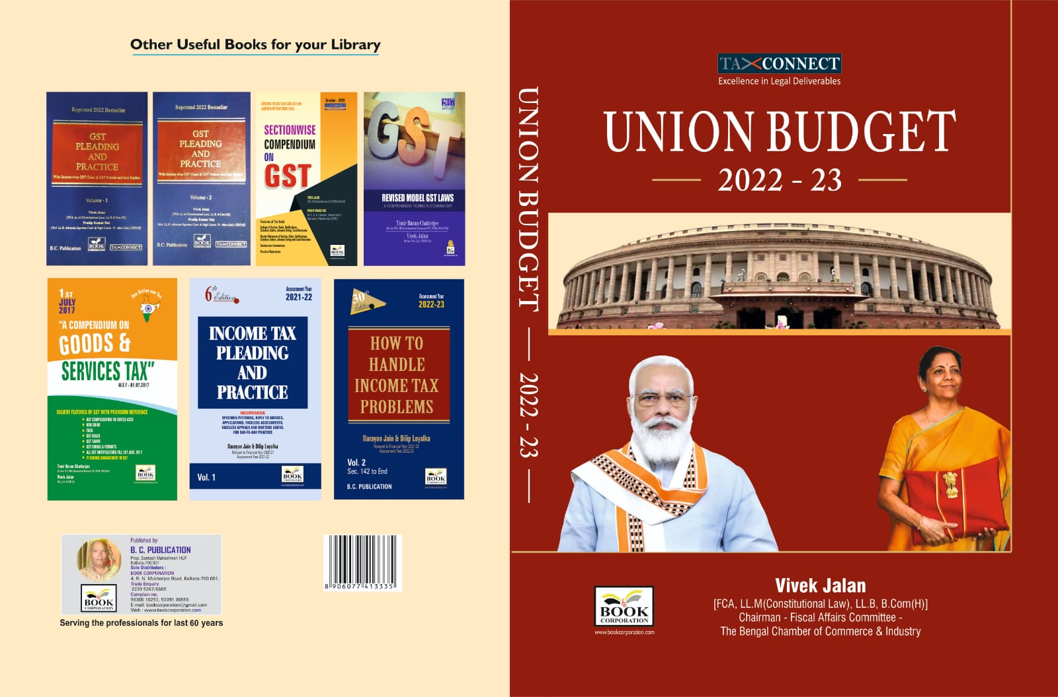

CONTENTS
- Commentary on Budget
- Budget at a glance
- Finance Minister’s Budget Speech
- Finance Bill
- Memorandum
- Notes on Clauses

Authors:
Vivek Jalan
[FCA, LL.M (Constitutional Law), LL.B, B.Com(H)]

Published by: In Association With:
BOOK CORPORATION TAX CONNECT ACADEMY
4, R. N. Mukherjee Road 1, Old Court House Corner
Kolkata 700001 Kolkata 700001
Phones: (033) 64547999 Phones: (033) 40016761
Cell: 9830010297, 9331018333 Cell: 8777784162, 9830661254
Order by email:bookcorporation@gmail.com Order by email: info@taxconnect.co.in Website :www.bookcorporation.com Website : www.taxconnect.co.in

:IN STANDS

GST PLEADING AND PRACTICE: With Section-wise GST Cases & GST Notices and their Replies
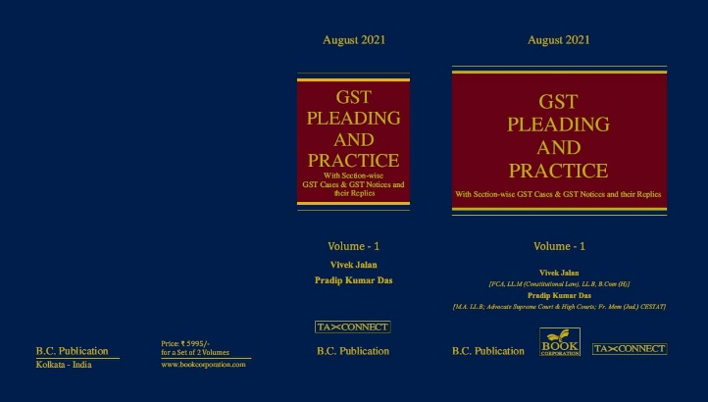

ABOUT THE BOOK: This publication includes:
1. GST Notices and their Replies
2. Orders and Appeals under GST
3. Text of provisions under IGST Act 2017 & CGST Act 2017
4. CGST & IGST Section-wise Synopsis of Case Laws and Notification/Circulars Gist
5. CGST & IGST Section-wise Synopsis of “Question of Law” answered under GST
6. Completely Updated Synopsis of Case Laws under GST by Supreme Court, High Court, AAARs & AARs

Authors:
Vivek Jalan
[FCA, LL.M (Constitutional Law), LL.B, B.Com(H)]

Pradip Kumar Das
[M.A. LL.B; Advocate Supreme Court & High Courts; Fr. Mem (Jud.) CESTAT]

Published by: In Association With:
BOOK CORPORATION TAX CONNECT ACADEMY
4, R. N. Mukherjee Road 1, Old Court House Corner
Kolkata 700001 Kolkata 700001
Phones: (033) 64547999 Phones: (033) 40016761
Cell: 9830010297, 9331018333 Cell: 8777784162, 9830661254
Order by email:bookcorporation@gmail.com Order by email: info@taxconnect.co.in Website :www.bookcorporation.com Website : www.taxconnect.co.in

LET’S DISCUSS FURTHER!



OUR OFFICES:
DELHI
B-139, 2nd Floor, Transport Nagar,
Noida-201301 (U.P)

Contact Person: Poonam Khemka
Email: poonam.khemka@taxconnectdelhi.co.in

MUMBAI
Unit No. 312, Omega Business Park, Near Kaamgar Hospital, Road No. 33, Wagle Industrial Estate, Thane West, Maharashtra- 400604

Contact Person: Rajani Kant Choudhary.
Email: rajnikant.choudhary@taxconnect.co.in
BANGALORE
H. NO.- 2102, 8th Cross, 15th Main, Kodihalli, HAL 3rd Stage, Bengaluru,
Karnataka-560008

Contact Person: Poonam Khemka
Email: poonam.khemka@taxconnectdelhi.co.in



DUBAI
Azizi Feirouz, 803, 8th Floor, AL Furjan, Opposite Discovery Pavillion,
Dubai, UAE

Contact Person: Rohit Sharma
Email:
rohit.sharma@taxconnect.co.in

KOLKATA
R No 119; 1st Floor; Diamond Arcade; 1/72, Cal Jessore Road;
Kolkata – 700055

Contact Person: Kajal Jaiswal
Email: kajal.jaiswal@taxconnectdelhi.co.in

KOLKATA
1, Old Court House Corner, “Tobacco House”, 1st Floor, Room No. 13 (N), Kolkata-700001

Contact Person: Govind Agarwal
Email: govind.agarwal@taxconnect.co.in

Disclaimer:
This e-bulletin is for private circulation only. Views expressed herein are of the editorial team and are based on the information, explanation and documents available on Government portal platforms. Tax Connect or any of its employees do not accept any liability whatsoever direct or indirect that may arise from the use of the information contained herein. No matter contained herein may be reproduced without prior consent of Tax Connect. While this e-article has been prepared on the basis of published/other publicly available information considered reliable, we do not accept any liability for the accuracy of its contents.
Tax Connect 2022. All rights reserved.

