z8
_{TAX CONNECT}

338th Issue: 20th February 2022- 26th February 2022
12017

sssss

Knowledge Partner:



TAX CONNECT

Mumbai : Unit No. 312, Omega Business Park, Near-Kaamgar Hospital, Road No. 33, Wagle Industrial Estate,
Thane (West), Maharashtra – 400604
Bangalore: H. No.- 2102, 8th Cross, 15th Main, Kodihalli, HAL 3rd Stage, Bengaluru, Karnataka- 560008
New Delhi: B-139, 2nd Floor, Transport Nagar, Noida-201301 (U.P)
Kolkata : 1, Old Court House Corner, “Tobacco House” 1st Floor, Room No.-13 (N), Kolkata-700001

: Room No. 119, 1st Floor, “Diamond Arcade” 1/72, Cal Jessore Road, Kolkata – 700055

Dubai : Azizi Feirouz, 803, 8th Floor, AL Furjan, Opposite Discovery Pavillion, Dubai, UAE

Contact: +91 8777784162; +91 9830661254
Website: www.taxconnect.co.in
Email: info@taxconnect.co.in



Friends,
Since implementation of GST, the claim of input tax credit has witnessed multiple amendments with Government’s intention to allow ITC on invoices/debit notes which are uploaded by the suppliers in GSTR-1. At the inception of GST, the availment of ITC was envisaged as a two-way communication whereby the supplier would upload the supply invoice details on the common portal and the recipient, on a real-time basis, would accept/reject the same. However, as the system functionalities were not in place, the two-way communication system could not be implemented. Further, the legislative provisions to normalize the two-way communication, i.e., Section 41, 42, 43 and 43A of the CGST Act is proposed to be omitted vide Finance Bill 2022 giving a go-bye to the ambitious ‘credit-matching’ concept.

Amendment to Section 16(2)(aa) of the CGST Act read with Rule 36(4) of the CGST Rules [effective from Jan’22] provides that ITC shall be not be availed unless the details of invoices have been communicated in Form GSTR-2B. The availment of ITC in GSTR-2B continues to be plagued by certain ambiguity which remains unaddressed as on date. While the invoices are reflected in the GSTR-2B for a month, ITC is not eligible to the recipient due to non-fulfilment of certain other conditions specified in Section 16 of the CGST Act viz. goods in transit not received by the buyer, invoice not received by the buyer, etc.

Imposition of such restrictions on the recipient for the non-compliance of supplier is onerous on the recipient, who has no recourse or control over the supplier; these conditions appear to be retrograde, arbitrary, and irrational and run counter to a robust value-added tax legislation.

With clear mandate from Government to allow ITC only if the same appears in GSTR-2B, it is imperative to have robust internal control system to save and claim ITC on a timely basis which is as good as cash for any business.
We recommend ensuring the following reconciliation before filing GST return for a particular tax period:
- Monthly document wise Reconciliation of ITC as per GST-2B after considering debit note and credit notes also.
- Identify Invoice accounted for in books and also appearing in GSTR-2B.

- Invoice accounted for in books but NOT appearing in GSTR-2B of same month.

- Invoice NOT accounted for in books but appearing in GSTR-2B that month

- Mismatch in ITC due to previous months effects

Just to reiterate that we remain available over telecom or e-mail.
Truly Yours
Editor:
Vivek Jalan
Partner - Tax Connect Advisory Services LLP
Co-Editors:
Rohit Sharma
Senior Manager – Tax Connect Advisory Services LLP

Rajani Kant Choudhary
Senior Manager: Tax Connect Advisory Services LLP

S.NO. | TOPICS | PAGE NO.
1] | TAX CALENDER | 4
2] | INCOME TAX | 5
DISCUSSION | VIRTUAL DIGITAL ASSET
3] | GST | 6
CASE LAW | IGST NOT PAYABLE ON RESIDENTIAL DWELLING RENTED FOR THE PURPOSE HOSTEL
4] | FEMA | 7
CIRCULAR | EXIM BANK'S GOVERNMENT OF INDIA SUPPORTED LINE OF CREDIT (LOC) OF USD 40 MILLION TO THE GOVERNMENT OF THE REPUBLIC OF MALDIVES
5] | CUSTOMS | 8
NOTIFICATION | Rate of exchange of one unit of foreign currency equivalent to Indian rupees.
6] | DGFT | 9
TRADE NOTICE | ISSUANCE OF REPLENISHMENT AUTHORISATION AS PER PARA 4.35 AND 4.36 OF FOREIGN TRADE POLICY (FTP) FROM NEW ONLINE IT MODULE W.E.F. 21.02.2022
NOTIFICATION | IMPORT POLICY FOR MOONG IS REVISED FROM “FREE” TO “RESTRICTED”
7] | UNION BUDGET 2022-23 | 10
8] | GST PLEADING AND PRACTICE: WITH SECTION-WISE GST CASES & GST NOTICES AND THEIR REPLIES | 11
9] | LET’S DISCUSS FURTHER | 12

Due Date | Form/Return/Challan | Reporting Period | Description
20th February | GSTR-5 | January, 2022 | Return to be filed by all Non- Resident Taxpayer in case they don’t wish to avail ITC (Input Tax Credit) on local procurements.
20th February | GSTR – 5A | January, 2022 | Return to be furnished by Online Information and Database Access or Retrieval (OIDAR) services provider to un-registered person or customers
20th February | GSTR – 3B | January, 2022 | Consolidated summary return of inward and outward supplies

DISCUSION
VIRTUAL DIGITAL ASSETS
OUR COMMENTS: The Finance Bill, 2022 proposed to insert a new section 2(47A) to the Income Tax Act, 1961. This section defines the expression ‘virtual digital asset’ as-
- any information or code or number or token (not being Indian currency or foreign currency), generated through cryptographic means or otherwise, by whatever name called, providing a digital representation of value exchanged with or without consideration, with the promise or representation of having inherent value, or functions as a store of value or a unit of account including its use in any financial transaction or investment, but not limited to investment scheme; and can be transferred, stored or traded electronically;
- a non-fungible token or any other token of similar nature, by whatever name called;
- any other digital asset, as the Central Government may, by notification in the Official Gazette specify.
The Central Government by notification in the Official Gazette, exclude any digital asset from the definition of virtual digital asset subject to such conditions as may be specified therein.
Non fungible asset
Clause (a) of Explanation to section 2(47A) defines the expression ‘non fungible asset’ as such digital asset as the Central Government may, by notification in the Official Gazette, specify.
Currency
Clause (b) of Explanation to section 2(47A) provides that the expressions ‘currency’, ‘foreign currency’ and ‘Indian currency’ shall have the same meanings as respectively assigned to them in clauses (h), (m) and (q) of section 2 of the Foreign Exchange Management Act, 1999 (‘FEMA’ for short).
Section 2(h) of FEMA defines the term ‘currency’ as including all currency notes, postal notes, postal orders, money orders, cheques, drafts, travellers cheques, letters of credit, bills of exchange and promissory notes, credit cards or such other similar instruments, as may be notified by the Reserve Bank.
Section 2(m) of FEMA defines the expression ‘foreign currency’ as any currency other than Indian currency.
Section 2(q) of FEMA defines the expression ‘Indian currency’ as currency which is expressed or drawn in Indian rupees but does not include special bank notes and special one rupee notes issued under section 28A of the Reserve Bank of India Act, 1934.
Taxation of virtual digital assets
The Finance Bill inserted new section 115BBH for the purpose of taxing the virtual digital assets. This will come into effect from 01.04.2023. Section 115BBH(1) provides that where the total income of an assessee includes any income from the transfer of any virtual digital asset, the income-tax payable shall be the aggregate of-
- the amount of income-tax calculated on the income from transfer of such virtual digital asset at the rate of 30%; and
- the amount of income-tax with which the assessee would have been chargeable, had the total income of the assessee been reduced by the income referred to above.
Deduction
There will be no deduction in respect of any expenditure (other than cost of acquisition) or allowance or set off of any loss shall be allowed to the assessee under any provision of this Act in computing the income.

Set off
No set off of loss from transfer of the virtual digital asset computed shall be allowed against income computed under any other provision of this Act to the assessee and such loss shall not be allowed to be carried forward to succeeding assessment years.

TDS
The Bill inserted a new section 194S for the purpose of deduction of tax at source on the payment of virtual digital asset.
CASE LAW
IGST NOT PAYABLE ON RESIDENTIAL DWELLING RENTED FOR THE PURPOSE HOSTEL: KARNATAKA HIGH COURT
Brief: The Hon’ble Karnataka High Court in TAGHAR VASUDEVA AMBRISH VERSUS APPELLATE AUTHORITY FOR ADVANCE RULING, KARNATAKA, COMMISSIONER OF CENTRAL TAX BANGALORE, ASSISTANT COMMISSIONER OF COMMERCIAL TAXES LGSTO-90, BENGALURU [2022 (2) TMI 780 - KARNATAKA HIGH COURT] quashed the order passed by the AAAR, denying exemption to the assessee on the service of renting of property used for the purpose of a hostel for the students and working women. Held that, such service will fall within the purview of residential dwelling and is used for residential purposes. Thus, exempted from payment of Integrated Goods and Services Tax (“IGST”).
Our Comments: The Hon’ble Karnataka High Court in TAGHAR VASUDEVA AMBRISH VERSUS APPELLATE AUTHORITY FOR ADVANCE RULING, KARNATAKA, COMMISSIONER OF CENTRAL TAX BANGALORE, ASSISTANT COMMISSIONER OF COMMERCIAL TAXES LGSTO-90, BENGALURU [2022 (2) TMI 780 - KARNATAKA HIGH COURT] held as under:
- Analysed Entry 13 of the Exemption Notification and noted that it provides exemption of Integrated Goods and Services Tax (“IGST”) in respect of 'services by way of renting of residential dwelling by way of use as residence', but the expression 'residential dwelling' has not been defined.

- Further noted that as per the education guide issued by CBIC which provides that in normal trade parlance residential dwelling means any residential accommodation and is different from hotel, motel, inn, guest house etc. which is meant for temporary stay. The clarification is in the absence of anything to the contrary in the Act, binds the Respondent.
- Observed that the residential dwelling is being rented, as a hostel to the students and working women will fall within the purview of residential dwelling as the same is used by the students as well as the working women for the purposes of residence. Further, the residential dwelling is being used for the purposes of residence.

- Further observed that, the Exemption Notification does not require the lessee itself use the premises as residence. Therefore, the benefit of exemption cannot be denied to the Petitioner on the ground that the lessee is not using the premises.

- Relied on the judgement of Hon’ble Supreme Court in KISHORE CHANDRA SINGH DEO VERSUS BABU GANESH PRASAD BHAGAT AND ORS. [1954 (3) TMI 89 - SUPREME COURT] wherein, it was held that expression residence only connotes that a person eats, drinks and sleeps at that place and not necessarily that the person should own it.

- Stated that, when the word is not defined in the Act itself, it is permissible to refer to the dictionaries to find out the general sense in meaning can be assigned to the expression 'residential dwelling' and it cannot be held that the same does not include hostel which used for residential purposes by students or working women.

- Quashed the Impugned Order.

- Held that the service provided by the Petitioner is covered under Entry 13 of the Exemption Notification and is entitled to avail the benefit of exemption.

[Decided in Favour of the Assessee]

CIRCULAR
Exim Bank's Government of India supported Line of Credit (LoC) of USD 40 million to the Government of the Republic of Maldives
OUR COMMENTS: As per Circular issued by Chief General Manager, Reserve Bank of India, A.P. (DIR Series) Circular No. 25, RBI/2021-2022/160, dated February 17, 2022, clarified that Export-Import Bank of India (Exim Bank) has entered into an agreement dated September 02, 2021 with the Government of the Republic of Maldives, for making available to the latter, Government of India supported Line of Credit (LoC) of USD 40 million (USD Forty Million only) for the purpose of development of sports infrastructure. Under the arrangement, financing of export of eligible goods and services from India, as defined under the agreement, would be allowed subject to their being eligible for export under the Foreign Trade Policy of the Government of India and whose purchase may be agreed to be financed by the Exim Bank under this agreement. Out of the total credit by Exim Bank under the agreement, goods, works and services of the value of at least 75 per cent of the contract price shall be supplied by the seller from India, and the remaining 25 per cent of goods and services may be procured by the seller for the purpose of the eligible contract from outside India.
2. The Agreement under the LoC is effective from February 08, 2022. Under the LoC, the terminal utilization period is 60 months from the scheduled completion date of the project.
3. Shipments under the LoC shall be declared in Export Declaration Form as per instructions issued by the Reserve Bank from time to time.
4. No agency commission is payable for export under the above LoC. However, if required, the exporter may use his own resources or utilize balances in his Exchange Earners’ Foreign Currency Account for payment of commission in free foreign exchange. Authorised Dealer (AD) Category- I banks may allow such remittance after realization of full eligible value of export subject to compliance with the extant instructions for payment of agency commission.
5. AD Category – I banks may bring the contents of this circular to the notice of their exporter constituents and advise them to obtain complete details of the LoC from the Exim Bank’s office at Centre One, Floor 21, World Trade Centre Complex, Cuffe Parade, Mumbai 400 005 or from their website www.eximbankindia.in
6. The directions contained in this circular have been issued under section 10(4) and 11(1) of the Foreign Exchange Management Act (FEMA), 1999 (42 of 1999) and are without prejudice to permissions/ approvals, if any, required under any other law.
[For further details please refer to the Circular]

NOTIFICATION
Rate of exchange of one unit of foreign currency equivalent to Indian rupees
OUR COMMENTS: The Central Board of Indirect Taxes and Customs hereby determines that the rate of exchange of conversion of each of the foreign currencies specified in column (2) of each of Schedule I and Schedule II annexed hereto, into Indian currency or vice versa, shall, with effect from 18th February, 2022, be the rate mentioned against it in the corresponding entry in column (3) thereof, for the purpose of the said section, relating to imported and export goods.
Schedule-I
Sl. No. | Foreign Currency | Rate of exchange of 100 units of foreign currency equivalent to Indian rupees
1 | 2 | 3
 |  | (a) | (b)
 |  | For imported goods | For exported goods
1. | Australian Dollar | 54.60 | 52.30
2. | Bahraini Dinar | 205.05 | 192.50
3. | Canadian Dollar | 60.15 | 58.05
4. | Chinese Yuan | 11.95 | 11.60
5. | Danish Kroner | 11.60 | 11.20
6. | EURO | 86.20 | 83.10
7. | Hong Kong Dollar | 9.80 | 9.45
8. | Kuwaiti Dinar | 256.00 | 239.75
9. | New Zealand Dollar | 51.00 | 48.70
10. | Norwegian Kroner | 8.65 | 8.35
11. | Pound Sterling | 103.35 | 99.85
12. | Qatari Riyal | 21.15 | 19.80
13. | Saudi Arabian Riyal | 20.60 | 19.35
14. | Singapore Dollar | 56.55 | 54.65
15. | South African Rand | 5.05 | 4.70
16. | Swedish Kroner | 8.30 | 8.00
17. | Swiss Franc | 83.10 | 79.85
18. | Turkish Lira | 5.70 | 5.40
19. | UAE Dirham | 21.05 | 19.75
20. | US Dollar | 75.75 | 74.05
Schedule-II
Sl. No. | Foreign Currency | Rate of exchange of 100 units of foreign currency equivalent to Indian rupees
1 | 2 | 3
 |  | a | b
 |  | For imported goods | For exported goods
1. | Japanese Yen | 66.45 | 64.05
2. | Korean Won | 6.50 | 6.10
[For further details please refer the Notification]

TRADE NOTICE
ISSUANCE OF REPLENISHMENT AUTHORISATION AS PER PARA 4.35 AND 4.36 OF FOREIGN TRADE POLICY (FTP) FROM NEW ONLINE IT MODULE W.E.F. 21.02.2022
OUR COMMENTS: As part of IT Revamp of its exporter/importer related services, this Directorate now introduces a new online module for filing of electronic, paperless applications for Issuance of Replenishment Authorisation as per Para 4.35 and 4.36 of FTP for Gems and Consumables from new online IT Module w.e.f. 21.02.2022. All applicants seeking Replenishment Authorization for Gems and Consumables may apply online by navigating to the DGFT website.
2. Accordingly, new applications for issuance will need to be submitted in online format and Replenishment Authorisation for Gems and Consumables will continue to be issued on security paper. However, applications submitted before 21.02.2022 through legacy system will continue to be processed through legacy system by RAs.
[For further details please refer the Trade Notice]

NOTIFICATION
IMPORT POLICY FOR MOONG IS REVISED FROM “FREE” TO “RESTRICTED”
Our Comments: In exercise of powers conferred by section 3 read with section 5 of the Foreign Trade (Development and Regulation) Act, 1992 (22 of 1992), read with paragraphs 1.02 and 2.01 of the Foreign Trade Policy, 2015-2020, as amended from time to time, the Central Government hereby amends the Department of Commerce Notification S.O. 5317(E) dated 20.12.2021 as under:-
Exim Code | Item Description | Existing Import Policy | Existing Policy Condition | Revised Import policy | Revised Policy Condition
07133190 | Moong [Beans of the SPP Vigna Radiata (L.) Wilczek] | Free | Import of the item, Bill of Lading should be issued on or before 31.03.2022 and import of such consignment shall need to be cleared from Customs on or before 30.06.2022. | Restricted | ---

Effect of the Notification: Import policy for Moong is revised from “Free” to “Restricted” with immediate effect.
[For further details please refer the Notification]

:IN STANDS

UNION BUDGET 2022-23
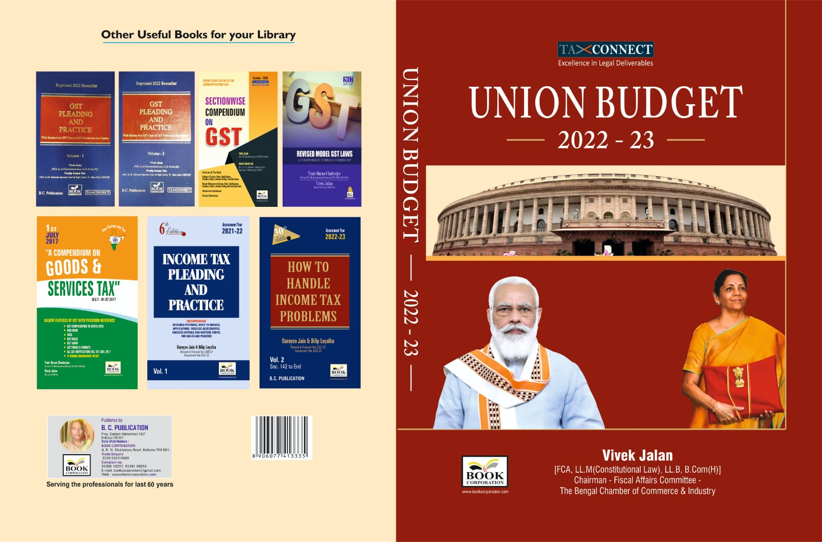

CONTENTS
- Commentary on Budget
- Budget at a glance
- Finance Minister’s Budget Speech
- Finance Bill
- Memorandum
- Notes on Clauses

Authors:
Vivek Jalan
[FCA, LL.M (Constitutional Law), LL.B, B.Com(H)]

Published by: In Association With:
BOOK CORPORATION TAX CONNECT ACADEMY
4, R. N. Mukherjee Road 1, Old Court House Corner
Kolkata 700001 Kolkata 700001
Phones: (033) 64547999 Phones: (033) 40016761
Cell: 9830010297, 9331018333 Cell: 8777784162, 9830661254
Order by email:bookcorporation@gmail.com Order by email: info@taxconnect.co.in Website :www.bookcorporation.com Website : www.taxconnect.co.in
:IN STANDS

GST PLEADING AND PRACTICE: With Section-wise GST Cases & GST Notices and their Replies
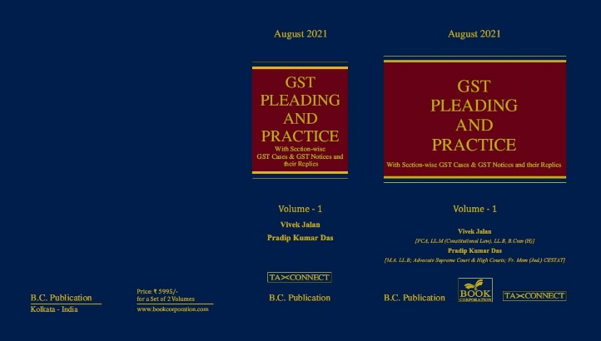

ABOUT THE BOOK: This publication includes:
1. GST Notices and their Replies
2. Orders and Appeals under GST
3. Text of provisions under IGST Act 2017 & CGST Act 2017
4. CGST & IGST Section-wise Synopsis of Case Laws and Notification/Circulars Gist
5. CGST & IGST Section-wise Synopsis of “Question of Law” answered under GST
6. Completely Updated Synopsis of Case Laws under GST by Supreme Court, High Court, AAARs & AARs

Authors:
Vivek Jalan
[FCA, LL.M (Constitutional Law), LL.B, B.Com(H)]

Pradip Kumar Das
[M.A. LL.B; Advocate Supreme Court & High Courts; Fr. Mem (Jud.) CESTAT]

Published by: In Association With:
BOOK CORPORATION TAX CONNECT ACADEMY
4, R. N. Mukherjee Road 1, Old Court House Corner
Kolkata 700001 Kolkata 700001
Phones: (033) 64547999 Phones: (033) 40016761
Cell: 9830010297, 9331018333 Cell: 8777784162, 9830661254
Order by email:bookcorporation@gmail.com Order by email: info@taxconnect.co.in Website :www.bookcorporation.com Website : www.taxconnect.co.in

LET’S DISCUSS FURTHER!



OUR OFFICES:
DELHI
B-139, 2nd Floor, Transport Nagar,
Noida-201301 (U.P)

Contact Person: Poonam Khemka
Email: poonam.khemka@taxconnectdelhi.co.in

MUMBAI
Unit No. 312, Omega Business Park, Near Kaamgar Hospital, Road No. 33, Wagle Industrial Estate, Thane West, Maharashtra- 400604

Contact Person: Rajani Kant Choudhary.
Email: rajnikant.choudhary@taxconnect.co.in
BANGALORE
H. NO.- 2102, 8th Cross, 15th Main, Kodihalli, HAL 3rd Stage, Bengaluru,
Karnataka-560008

Contact Person: Poonam Khemka
Email: poonam.khemka@taxconnectdelhi.co.in



DUBAI
Azizi Feirouz, 803, 8th Floor, AL Furjan, Opposite Discovery Pavillion,
Dubai, UAE

Contact Person: Rohit Sharma
Email:
rohit.sharma@taxconnect.co.in

KOLKATA
R No 119; 1st Floor; Diamond Arcade; 1/72, Cal Jessore Road;
Kolkata – 700055

Contact Person: Kajal Jaiswal
Email: kajal.jaiswal@taxconnectdelhi.co.in

KOLKATA
1, Old Court House Corner, “Tobacco House”, 1st Floor, Room No. 13 (N), Kolkata-700001

Contact Person: Govind Agarwal
Email: govind.agarwal@taxconnect.co.in

Disclaimer:
This e-bulletin is for private circulation only. Views expressed herein are of the editorial team and are based on the information, explanation and documents available on Government portal platforms. Tax Connect or any of its employees do not accept any liability whatsoever direct or indirect that may arise from the use of the information contained herein. No matter contained herein may be reproduced without prior consent of Tax Connect. While this e-article has been prepared on the basis of published/other publicly available information considered reliable, we do not accept any liability for the accuracy of its contents.
Tax Connect 2022. All rights reserved.

