z8
_{TAX CONNECT}

336th Issue: 6th February 2022- 12th February 2022
12017

sssss

Knowledge Partner:



TAX CONNECT

Mumbai : Unit No. 312, Omega Business Park, Near-Kaamgar Hospital, Road No. 33, Wagle Industrial Estate,
Thane (West), Maharashtra – 400604
Bangalore: H. No.- 2102, 8th Cross, 15th Main, Kodihalli, HAL 3rd Stage, Bengaluru, Karnataka- 560008
New Delhi: B-139, 2nd Floor, Transport Nagar, Noida-201301 (U.P)
Kolkata : 1, Old Court House Corner, “Tobacco House” 1st Floor, Room No.-13 (N), Kolkata-700001

: Room No. 119, 1st Floor, “Diamond Arcade” 1/72, Cal Jessore Road, Kolkata – 700055

Dubai : Azizi Feirouz, 803, 8th Floor, AL Furjan, Opposite Discovery Pavillion, Dubai, UAE

Contact: +91 8777784162; +91 9830661254
Website: www.taxconnect.co.in
Email: info@taxconnect.co.in



Friends,

The Hon’ble Finance Minister Smt. Nirmala Sitharaman on 01st February 2022 presented the Union Budget 2022. The budget is vision document and has given ample scope for the youth to turn into entrepreneurs and in turn become employment generators.

Recently, there has been a phenomenal increase in transactions in virtual digital assets. Further, a market is emerging where payment for the transfer of a virtual digital asset can be made through another such asset. Accordingly, for the taxation of virtual digital assets, a new tax scheme is proposed to be inserted. The new provision to tax cryptocurrency gains at 30% will come into force from April 1, 2022. Additionally, all transfers of such assets will attract 1 percent Tax Deducted at Source (TDS). Further, no deduction will be allowed while computing income except cost of acquisition. Loss cannot be set off from any other income. Gift of cryptocurrencies to be taxed at receiver's end. It is to be noted that Crypto is a form of asset that can be monetised, but it is not a currency while on the other hand, digital currency that the Hon’ble Finance spoke about is going to be currency, which will be issued by the Reserve Bank of India (RBI).

Government vows a stable and predictable tax regime. The Budget highlights in the Income Tax regime are:
- Government to provide one-time window to correct omissions in ITRs filed, updated returns to be filed within 2 years.
- Any Cess or surcharge on income not allowed as business expenditure.
- Alternate Minimum Tax for cooperative societies to be cut to 15%.
- Proposal will Reduce surcharge on cooperative societies to 7%, for those whose income is between Rs 1 crore and Rs 10 crore.
- Tax deduction limit increased to 14% on employers’ contribution to NPS account of state govt employees.
- Condition for claiming deduction under section 80DD liberalized.
- TDS on higher of actual consideration or stamp duty value under section 194-IA.

The Union Budget 2022 analysis has already been sent, however we are sharing again a copy of our budget analysis with this bulletin.

Just to reiterate that we remain available over telecom or e-mail.
Truly Yours
Editor:
Vivek Jalan
Partner - Tax Connect Advisory Services LLP
Co-Editors:
Rohit Sharma
Senior Manager – Tax Connect Advisory Services LLP

Rajani Kant Choudhary
Senior Manager: Tax Connect Advisory Services LLP

S.NO. | TOPICS | PAGE NO.
1] | TAX CALENDER | 4
2] | INCOME TAX | 5
NOTIFICATION | Central Government notifieD, ‘West Bengal Electricity Regulatory Commission’, in respect of the specified income arising to that Commission
3] | GST | 6
CASE LAW | NOTICE FOR CANCELLATION OF PETITIONER’S GST REGISTRATION BEREFT OF ANY REASON OR FACT IS QUASHED: DELHI HIGH COURT
4] | FEMA | 7
DISCUSSION | MARGIN FOR DERIVATIVE CONTRACTS
5] | CUSTOMS | 8
NOTIFICATION | amendMENT OF Notification Nos. 104/2010-Customs, 38/96-Customs, 40/2017-Customs, 60/2011-Customs, 148/94-Customs to exempt AIDC/Health cess/RIC on goods imported under the said notifications.
6] | DGFT | 9
NOTIFICATION | EXTENSION OF LAST DATE FOR SUBMITTING APPLICATIONS FOR SCRIP BASED FTP SCHEMES
7] | UNION BUDGET 2022-23 | 10
8] | GST PLEADING AND PRACTICE: WITH SECTION-WISE GST CASES & GST NOTICES AND THEIR REPLIES | 11
9] | LET’S DISCUSS FURTHER | 12

Due Date | Form/Return/Challan | Reporting Period | Description
7^{h} February | Challan-281 | January 2022 | Depositing of TDS/ TCS for Jan, 2022
10th February | GSTR-7 | January 2022 | Filing of GSTR-7 (TDS Deductor) for the month of Jan 2022
10th February | GSTR-8 | January 2022 | Filing of GSTR-8 (TCS Collector) for the month of Jan 2022
10th February | GSTR-1 | December 2021 | Filing of GSTR-1 (other than QRMP) for Jan, 2022

NOTIFICATION
Central Government notifieD, ‘West Bengal Electricity Regulatory Commission’, in respect of the specified income arising to that Commission
OUR COMMENTS: The Central Government vide notification 11/2022 dated 27.01.2022 hereby notified for the purposes of the said clause, ‘West Bengal Electricity Regulatory Commission’, Kolkata (PAN: AAAGW0011J), a Commission constituted by the State Government of West Bengal, in respect of the following specified income arising to that Commission, namely:-
(a) Income from the fund maintained in accordance with the provisions of the West Bengal Electricity Regulatory Commission (Manner of application of Fund) Rules, 2006; and
(b) Income from the fees collected in accordance with the provisions of the West Bengal Electricity (fees for application for grant of license) Rules, 2005, notified by the Government of West Bengal.
This notification shall be effective subject to the conditions that West Bengal Electricity Regulatory Commission, Kolkata -
(a) shall not engage in any commercial activity;
(b) activities and the nature of the specified income shall remain unchanged throughout the financial years; and
(c) shall file return of income in accordance with the provision of clause (g) of sub-section (4C) of section 139 of the Income-tax Act, 1961.
3. This notification shall be applicable for the financial years 2021-2022, 2022-2023, 2023-2024, 2024-2025 and 2025-2026.
[For further details please refer to the Notification]

CASE LAW
NOTICE FOR CANCELLATION OF PETITIONER’S GST REGISTRATION BEREFT OF ANY REASON OR FACT IS QUASHED: DELHI HIGH COURT
Our Comments: Since in the present case, petitioner’s registration has been lying suspended for more than two months on the basis of a show cause notice which is bereft of any reason or fact, this Court quashes the impugned show cause notice dated 11th November, 2021 and directs the respondents to restore the petitioner’s registration forthwith.
However, the respondents are permitted to issue a fresh show-cause notice mentioning all the relevant facts and reasons within a week. The same shall be responded to by the petitioner within a period of seven working days from the date of the service of such notice (Rule 22, DGST).
The Commissioner, Delhi, GST, is also directed to issue a practice direction so that in future, if any show-cause notice for cancellation of GST registration is issued, the same is not bereft of any material particulars or reasons.
The Commissioner, Delhi GST admitted that the impugned show-cause notice dated 11th November, 2021 contains no fact or reason. He also agreed that the impugned show-cause notice is not supported by any document/form on the basis of which the petitioner’s GST registration has been suspended.
Since in the present case, petitioner’s registration has been lying suspended for more than two months on the basis of a show cause notice which is bereft of any reason or fact, this Court quashes the impugned show cause notice dated 11th November, 2021 and directs the respondents to restore the petitioner’s registration forthwith.
However, the respondents are permitted to issue a fresh show-cause notice mentioning all the relevant facts and reasons within a week. The same shall be responded to by the petitioner within a period of seven working days from the date of the service of such notice (Rule 22, DGST). The respondents shall thereafter decide the same in accordance with law within two weeks.

[For further details please refer to the Case Law]

DISCUSSION
MARGIN FOR DERIVATIVE CONTRACTS
OUR COMMENTS: The ‘Foreign Exchange Management (Margin for Derivative Contracts) Regulations, 2020’ allows margin to be posted and collected against permitted derivative contracts.
Derivative
Regulation 2(da) of Foreign Exchange Management (Permissible Capital Account Transactions) Regulations, 2000 defines the term ‘derivative’ as a financial contract, to be settled at a future date, whose value is derived from one or more financial, or non-financial variables.
Margin
.The term ‘margin’ is defined under Regulation 2(iv) of Foreign Exchange Management (Margin for Derivative Contracts) Regulations, 2020 as the collateral that the parties to a derivative contract post with or collect from each other (whether directly or through a third party) to cover some or all of the credit risk that the provider of the collateral poses for the receiver of the collateral.
Permitted derivative contract
The expression ‘permitted derivative contract’ is defined under Regulation 2(v) as-
- Foreign Exchange Derivative Contract undertaken in terms of the Foreign Exchange Management (Foreign Exchange Derivative Contracts) Regulations, 2000 and Master Direction–Risk Management and Inter-bank Dealings, as amended from time to time,
- Interest Rate Derivative Contract undertaken in terms of the Rupee Interest Rate Derivatives (Reserve Bank) Directions, 2019 (Notification No. FMRD.DIRD.20/2019 dated June 26, 2019), as amended from time to time,
- Credit Derivative Contract undertaken in terms of Notification No. IDMD.PCD. No.10/14.03.04/2012-13 dated January 7, 2013, as amended from time to time, and
- Any other derivative contract as may be specified by the Reserve Bank.
Foreign Exchange derivative contract
Section 2(v) of Foreign Exchange Management (Foreign Exchange Derivative Contracts) Regulations, 2000 defines the expression ‘foreign exchange derivative contract’ as a financial contract which derives its value from the change in the exchange rate of two currencies at least one of which is not Indian Rupee or which derives its value from the change in the interest rate of a foreign currency and which is for settlement at a future date, i.e. any date later than the spot settlement date, provided that contracts involving currencies of Nepal and Bhutan shall not qualify under this definition.
Interest Rate derivative contract
An interest rate derivative is a financial instrument with a value that is linked to the movements of an interest rate or rates. These may include futures, options, or swaps contracts. Interest rate derivatives are often used as hedges by institutional investors, banks, companies, and individuals to protect themselves against changes in market interest rates, but they can also be used to increase or refine the holder's risk profile or to speculate on rate moves.
Interest rate derivative transactions carried out on exchanges shall be subject to the following directions:
- Exchanges are permitted to offer any standardized Interest Rate Derivatives product.
- The product design, eligible participants and other details of the IRD product may be finalized by the exchanges.
- Exchanges shall obtain prior approval of the Reserve Bank before introducing any new IRD product or before carrying out modifications to an existing product.

NOTIFICATION
amendMENT OF Notification Nos. 104/2010-Customs, 38/96-Customs, 40/2017-Customs, 60/2011-Customs, 148/94-Customs to exempt AIDC/Health cess/RIC on goods imported under the said notifications.
OUR COMMENTS: The Central Government, vide notification non 8/2022 dated 1.2.2022, on being satisfied that it is necessary to do, hereby further amends the following notifications of the Government of India :
.No. | Notification number and Date | Amendments
1. | Notification No. 104/2010-Customs, dated the 1st October, 2010, published in the Gazette of India, Extraordinary, Part II, Section 3, Sub-section (i), vide number G.S.R. 805(E), dated the 1st October, 2010. | In the said notification, in the preamble, after the words, figures and brackets “from the whole of the duty of Customs leviable thereon under the First Schedule to the Customs Tariff Act, 1975 (51 of 1975)”, the words, figures and brackets “and from the whole of Agriculture Infrastructure and Development Cess, leviable under section 124 of the Finance Act, 2021 (13 of 2021)” shall be inserted.
2. | Notification No.38/96-Customs, dated the 23rd July, 1996, published in the Gazette of India, Extraordinary, Part II, Section 3, Sub-section (i), vide number G.S.R. 290(E), dated the 23rd July, 1996. | In the said notification, in the TABLE, against S.No. 1, for the entry in column 3, the following shall be substituted, namely: -“Duty of Customs leviable thereon under the First Schedule to the Customs Tariff Act, 1975 (51 of 1975), Agriculture Infrastructure and Development Cess, leviable under section 124 of the Finance Act, 2021 (13 of 2021), Health Cess, leviable under section 141 of the Finance Act, 2020 (12 of 2020), Road and Infrastructure Cess, leviable under section 111 of the Finance Act, 2018 (13 of 2018) and integrated tax and goods and services tax compensation cess leviable thereon respectively under sub-sections (7) and (9) of section 3 of the said Act.”
3. | Notification 40/2017-Customs, dated the 30th June, 2017, published in the Gazette of India, Extraordinary, Part II, Section 3, Sub-section (i), vide number G.S.R. 775(E), dated the 30th June, 2017. | In the said notification, in the preamble, after the words, “from the whole of the duty of Customs leviable thereon which is specified in the said First Schedule”, the words, figures and brackets “, the whole of Agriculture Infrastructure and Development Cess, leviable under section 124 of the Finance Act, 2021 (13 of 2021), the whole of Health Cess, leviable under section 141 of the Finance Act, 2020 (12 of 2020) and the whole of Road and Infrastructure Cess, leviable under section 111 of the Finance Act, 2018 (13 of 2018)” shall be inserted.
4. | Notification 60/2011-Customs, dated the 14th July, 2011, published in the Gazette of India, Extraordinary, Part II, Section 3, Sub-section (i), vide number G.S.R. 536(E), dated the 14th July, 2011 | In the said notification, in the preamble, after the words, figures and brackets “from the whole of the duty of Customs leviable thereon under the First Schedule to the Customs Tariff Act, 1975 (51 of 1975)”, the words, figures and brackets “and from the whole of Agriculture Infrastructure and Development Cess, leviable under section 124 of the Finance Act, 2021 (13 of 2021)” shall be inserted.
5. | Notification 148/94-CUSTOMS, dated the 13th July, 1994, published in the Gazette of India, Extraordinary, Part II, Section 3, Sub-section (i), vide number G.S.R. 577(E), dated the 13th July, 1994. | In the said notification, in the preamble, after the words “from the whole of the duty of Customs leviable thereon under the said First Schedule”, the words, figures and brackets “, the whole of Agriculture Infrastructure and Development Cess, leviable under section 124 of the Finance Act, 2021 (13 of 2021), the whole of Health Cess, leviable under section 141 of the Finance Act, 2020 (12 of 2020), the whole of Road and Infrastructure Cess, leviable under section 111 of the Finance Act, 2018 (13 of 2018)” shall be inserted
[For further details please refer the Notification]

NOTIFICATION
EXTENSION OF LAST DATE FOR SUBMITTING APPLICATIONS FOR SCRIP BASED FTP SCHEMES
OUR COMMENTS: The Central Government vide notification 53/2015-2020 dated 1.2.2022, hereby amended the para 3.13A of the FTP 2015-20 (as notified vide Notification no. 26 dated 16th September, 2021 and amended vide Notification No.48 dated 31.12.2021) with immediate effect.
The para 3.13A shall now read as below:
3.13A: Last Date of Submitting Applications for Scrip based Schemes
a. In supersession of the existing laid down provisions in the Hand Book of Procedures, 2015-20 with regard to last date for submitting online applications for scrip based claims, the last date for submitting online applications stands revised to 28th February 2022 for the following schemes i.e.
i. for MEIS (for exports made in the period (s) 01.07.2018 to 31.03.2019, 01.04.2019 to 31.03.2020 and 01.04.2020 to 31.12.2020),
ii. for SEIS (for service exports rendered for FY 18-19 and FY 2019-20),
iii. for 2 % additional ad hoc incentive (under para 3.25 of the FTP for exports made in the period 01.01.2020 to 31.03.2020 only)
iv. for ROSCTL (for exports made from 07.03.2019 to 31.12.2020) and
v. for ROSL (for exports made upto 06.03.2019 for which claims have not yet been disbursed under scrip mechanism).
After 28.02.2022. no further applications would be allowed to be submitted and they would become time-barred. Late cut provisions shall also not be available for submitting claims at a later date.
b. In supersession of the laid down provisions on applicable late cut as in para 9.02 of the HBP, the new late cut for applications submitted upto 28.02.2022 as indicated above shall be:
Sl No. | Scheme | Period of Exports (Let Export Date in the period) / Services rendered in the period | Late Cut (as % age of EntitIement under the Scheme)
1. | MEIS | FY 2018-19 (01.07.2018 to 31.03.2019 | 10%
2 | MEIS | FY 2019-20 and FY 2020-21 (upto 31.12.2020) | Nil
3. | SEIS | FY 2018-19 | 5%
4. | SEIS | FY 2019-20 | Nil
5. | ROSCTL | 07.03.2019 to 31.12.2020 | Nil
6. | ROSL | Upto 06.03.2019 | Nil
Effect of this Notification: The last date of submitting applications under MEIS, SEIS. ROSCTL, ROSL and 2% additional ad hoc incentive (under para 3.25 of FTP) which was earlier notified to be 31.01.2022 has been extended to 28.02.2022.
[For further details please refer the Notification]

:IN STANDS

UNION BUDGET 2022-23
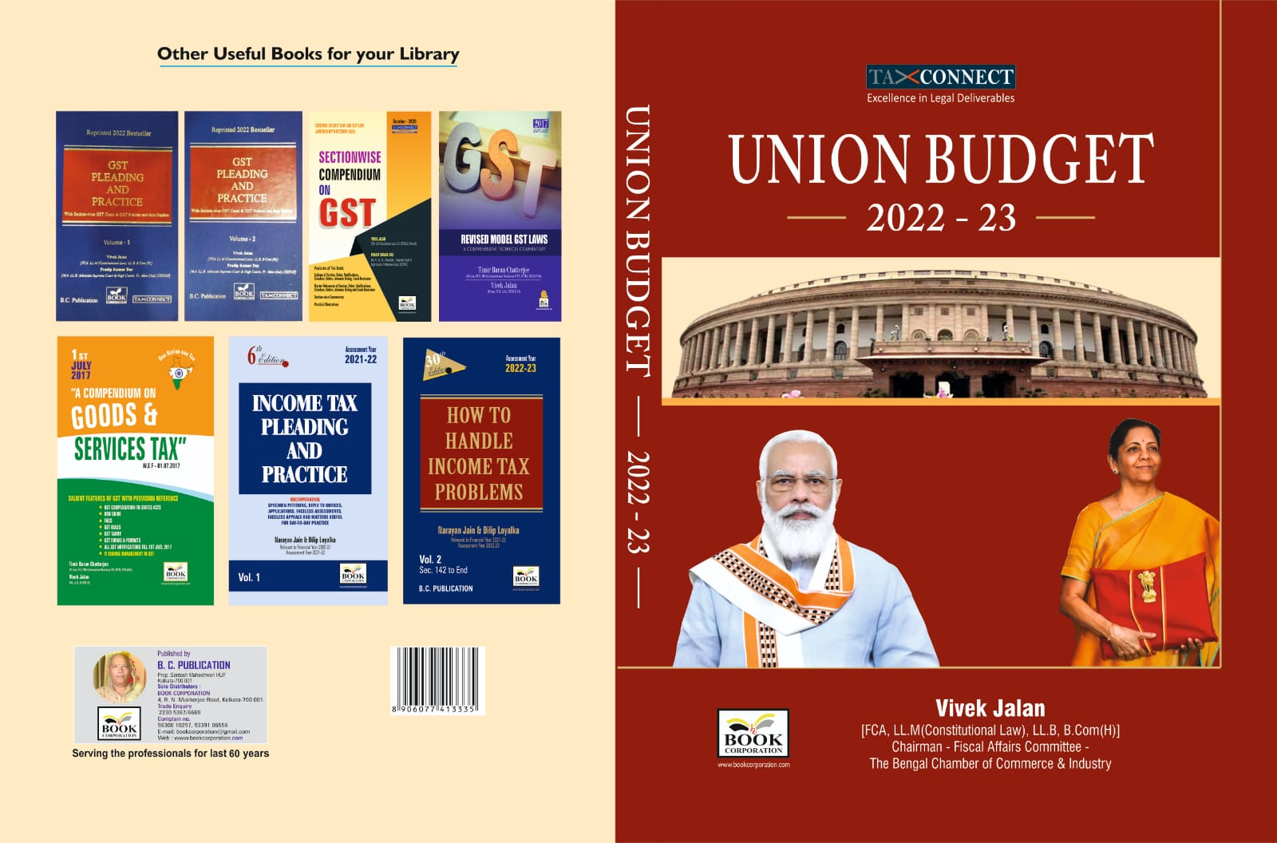

CONTENTS
- Commentary on Budget
- Budget at a glance
- Finance Minister’s Budget Speech
- Finance Bill
- Memorandum
- Notes on Clauses

Authors:
Vivek Jalan
[FCA, LL.M (Constitutional Law), LL.B, B.Com(H)]

Published by: In Association With:
BOOK CORPORATION TAX CONNECT ACADEMY
4, R. N. Mukherjee Road 1, Old Court House Corner
Kolkata 700001 Kolkata 700001
Phones: (033) 64547999 Phones: (033) 40016761
Cell: 9830010297, 9331018333 Cell: 8777784162, 9830661254
Order by email:bookcorporation@gmail.com Order by email: info@taxconnect.co.in Website :www.bookcorporation.com Website : www.taxconnect.co.in
:IN STANDS

GST PLEADING AND PRACTICE: With Section-wise GST Cases & GST Notices and their Replies
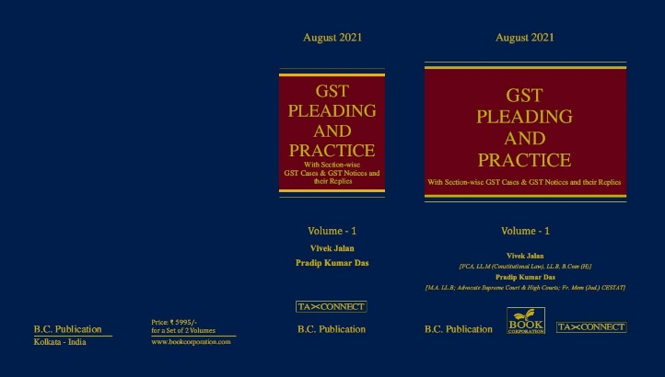

ABOUT THE BOOK: This publication includes:
1. GST Notices and their Replies
2. Orders and Appeals under GST
3. Text of provisions under IGST Act 2017 & CGST Act 2017
4. CGST & IGST Section-wise Synopsis of Case Laws and Notification/Circulars Gist
5. CGST & IGST Section-wise Synopsis of “Question of Law” answered under GST
6. Completely Updated Synopsis of Case Laws under GST by Supreme Court, High Court, AAARs & AARs

Authors:
Vivek Jalan
[FCA, LL.M (Constitutional Law), LL.B, B.Com(H)]

Pradip Kumar Das
[M.A. LL.B; Advocate Supreme Court & High Courts; Fr. Mem (Jud.) CESTAT]

Published by: In Association With:
BOOK CORPORATION TAX CONNECT ACADEMY
4, R. N. Mukherjee Road 1, Old Court House Corner
Kolkata 700001 Kolkata 700001
Phones: (033) 64547999 Phones: (033) 40016761
Cell: 9830010297, 9331018333 Cell: 8777784162, 9830661254
Order by email:bookcorporation@gmail.com Order by email: info@taxconnect.co.in Website :www.bookcorporation.com Website : www.taxconnect.co.in

LET’S DISCUSS FURTHER!



OUR OFFICES:
DELHI
B-139, 2nd Floor, Transport Nagar,
Noida-201301 (U.P)

Contact Person: Poonam Khemka
Email: poonam.khemka@taxconnectdelhi.co.in

MUMBAI
Unit No. 312, Omega Business Park, Near Kaamgar Hospital, Road No. 33, Wagle Industrial Estate, Thane West, Maharashtra- 400604

Contact Person: Rajani Kant Choudhary.
Email: rajnikant.choudhary@taxconnect.co.in
BANGALORE
H. NO.- 2102, 8th Cross, 15th Main, Kodihalli, HAL 3rd Stage, Bengaluru,
Karnataka-560008

Contact Person: Poonam Khemka
Email: poonam.khemka@taxconnectdelhi.co.in



DUBAI
Azizi Feirouz, 803, 8th Floor, AL Furjan, Opposite Discovery Pavillion,
Dubai, UAE

Contact Person: Rohit Sharma
Email:
rohit.sharma@taxconnect.co.in

KOLKATA
R No 119; 1st Floor; Diamond Arcade; 1/72, Cal Jessore Road;
Kolkata – 700055

Contact Person: Kajal Jaiswal
Email: kajal.jaiswal@taxconnectdelhi.co.in

KOLKATA
1, Old Court House Corner, “Tobacco House”, 1st Floor, Room No. 13 (N), Kolkata-700001

Contact Person: Govind Agarwal
Email: govind.agarwal@taxconnect.co.in

Disclaimer:
This e-bulletin is for private circulation only. Views expressed herein are of the editorial team and are based on the information, explanation and documents available on Government portal platforms. Tax Connect or any of its employees do not accept any liability whatsoever direct or indirect that may arise from the use of the information contained herein. No matter contained herein may be reproduced without prior consent of Tax Connect. While this e-article has been prepared on the basis of published/other publicly available information considered reliable, we do not accept any liability for the accuracy of its contents.
Tax Connect 2022. All rights reserved.

