8
_{TAX CONNECT}

328th Issue: 12th December 2021-18th December 2021
12017

Knowledge Partner:



TAX CONNECT

Mumbai : A/1001, Cirrus Bldg, Cosmos Paradise; Pokhran Road No. 1, Thane (West), Maharashtra – 400606
Bangalore: A-414,Carlton Towers,19th Main; Road Hal Old Airport Rd, Domlur, Bengaluru, Karnataka-560008
New Delhi: B-139, 2nd Floor, Transport Nagar, Noida-201301 (U.P)
Kolkata : 1, Old Court House Corner, “Tobacco House” 1st Floor, R.No.-13 (North), Kolkata-700001
: Room No 119; 1st Floor; Diamond Arcade; 1/72, Cal Jessore Road; Kolkata – 700055

Dubai : AziziFeirouz, 803, 8th Floor, AL Furjan, Opposite Discovery Pavillion, Dubai, UAE

Contact: +919874466163; +91 9830661254
Website: www.taxconnect.co.in
Email: info@taxconnect.co.in



Friends,
The Government via their press release dated 5th December 2021, stated that, the number of Income Tax Returns (ITRs) filed per day is over 4 lakh and increasing everyday as the extended due date of 31st December 2021 is approaching.
We recommend taxpayers to ensure the following check and validations before proceed with filing of Income Tax Return (ITR):
- View and reconcile Form 26AS available on Income Tax portal to verify the accuracy of the TDS and Tax Payments details.

- Through the e-filing portal cross check the data in the Annual Information Statement (AIS) and data in your Bank passbook, interest certificate, Form 16 and Capital gains statement from brokerages in case of purchase and sale of equity/Mutual funds etc.

- Verify the details of pre-filling of ITRs and amend the details if required.

- Ensure to link your mobile number with Aadhar so that the e-verification of ITR can be done using Aadhar based OTP. Please note that the return that you file will not be treated valid unless you verify it. Alternatively, for physical verification of the return, print the acknowledgment of ITR-V, sign it in blue ink, and send it to the Centralized Processing Centre (Bangalore) within 120 days of filing your return.

- Validate your Bank Account on the income tax e-filing portal so that the refund (if any) can be processed by the Central Processing Centre (CPC) of the Income Tax department. Taxpayers to ensure that the bank account selected for credit of refund must have their PAN number linked at the bank to avoid refund failures.

- In the simplified process of DSC registration any individual has to register his DSC only once and can use it across any entity where the individual is a partner, director etc. without having to reregister again against each entity or role.

- Please ensure to fill the statutory forms on the e-filing portal of the Income Tax Department i.e. Form 10E for arrears of salary, Form 10BA- for assessee claiming deduction for rent settled on rental property etc.
File your ITR by the due date to avoid penalty and interest for delay filing of return.
Just to reiterate that we remain available over telecom or e-mail.
Truly Yours
Editor:
Vivek Jalan
Partner - Tax Connect Advisory Services LLP
Co-Editors:
Rohit Sharma
Senior Manager – Tax Connect Advisory Services LLP
Rajanikant Choudhury
Manager - Tax Connect Advisory Services LLP
S.NO. | TOPICS | PAGE NO.
1] | TAX CALENDER | 4
2] | INCOME TAX | 5
NOTIFICATION | AMENDMENT OF Agreement between the Government of the Republic of India and the Government of the Kyrgyz Republic for the avoidance of double taxation and the prevention of fiscal evasion with respect to taxes
3] | GST | 6
DISCUSSION | NEW FUNCTIONALITIES ON GST PORTAL
4] | FEMA | 7
CIRCULAR | External Commercial Borrowings (ECB) and Trade Credits (TC) Policy – Changes due to LIBOR transition
5] | CUSTOMS | 8
NOTIFICATION | IMPOSITION OF ADD on "Certain Flat rolled Products of Aluminium" originating in or exported from China PR for a period of 5 years
6] | DGFT | 9
PUBLIC NOTICE | ENLISTMENT OF AGENCIES UNDER APPENDIX 2E OF FTP, 2015-20 AUTHORIZED TO ISSUE CERTIFICATE OF ORIGIN (NON-PREFERENTIAL)
7] | GST PLEADING AND PRACTICE: WITH SECTION-WISE GST CASES & GST NOTICES AND THEIR REPLIES | 10
8] | IN STANDS - AN INTEGRATED APPROACH TO GST E-INVOICING, E-WAYBILL & E-RETURN FILING | 11
9] | IN STANDS –SECTION WISE COMPENDIUM ON GST | 12
10] | IN STANDS – UNION BUDGET 2021 | 13
11] | LET’S DISCUSS FURTHER | 14

Due date | Form/Return/Challan | Reporting Period | Description
13th December, 2021 | GSTR- IFF | NOVEMBER,  2021 | Opted for quarterly filling as per QRMP Scheme (Optional)
13th December, 2021 | GSTR 6 | NOVEMBER,  2021 | Input Service Distributor (ISD)
15th December, 2021 | ITNS 280 | FY-2020-2021 | III installment of advance tax for the assessment year 2022-23 (75% of Advance Tax Liability
15th December, 2021 | Form 16B/16C/16D | NOVEMBER,  2021 | Issue of TDS Certificate for tax deducted under Section 194IA/IB/M in the month of November, 2021
15th December, 2021 | Form 24G | NOVEMBER,  2021 | The due date for furnishing of Form 24G by an office of the Government where TDS/TCS for the month of November 2021 has been paid without the production of a challan
15th December, 2021 | Form No. 3BB | NOVEMBER,  2021 | Monthly statement to be furnished by a stock exchange in respect of transactions in which client codes been modified after registering in the system for month of November, 2021

NOTIFICATION
AMENDMENT OF Agreement between the Government of the Republic of India and the Government of the Kyrgyz Republic for the avoidance of double taxation and the prevention of fiscal evasion with respect to taxes
OUR COMMENTS: The Department of Revenue, Ministry Of Finance, vide Notification No. 135/2021 dated 8th December 2021, stated the Protocol, amending the Agreement between the Government of the Republic of India and the Government of the Kyrgyz Republic for the avoidance of double taxation and for the prevention of fiscal evasion with respect to taxes on income which was signed at New Delhi on 13th April, 1999, has been signed at Bishkek, Kyrgyz Republic on 14th June, 2019.
And whereas, the date of entry into force of the said amending Protocol is the 22nd October, 2020, being the date of the later notification of the completion of the procedures required by the respective laws for the entry into force of the said amending Protocol, in accordance with Article 3 of the said amending Protocol;
Now, therefore, in exercise of the powers conferred by sub-section (1) of section 90 of the Income-tax Act, 1961 (43 of 1961), the Central Government hereby notifies that all the provisions of the said amending Protocol, as annexed hereto, shall have effect in the Union of India.
ANNEXURE
Protocol amending the Agreement between the Government of the Republic of India and the Government of the Kyrgyz Republic for the Avoidance of Double Taxation and for the Prevention of Fiscal Evasion with respect to taxes on income signed at New Delhi on 13th April, 1999.
The Government of the Republic of India and the Government of the Kyrgyz Republic, desiring to amend the Agreement between the Government of the Republic of India and the Government of Kyrgyz Republic for the Avoidance of Double Taxation and for the Prevention of Fiscal Evasion with respect to taxes on income signed at New Delhi on 13th April, 1999 (hereinafter referred to as “the Agreement”).
Have agreed regarding:
- amendment of Article 3,
- Replacement of Article 26 and
- The conditions regarding ENTRY INTO FORCE.
[For further details please refer the Notification]

DISCUSSION
NEW FUNCTIONALITIES ON GST PORTAL
Our Comments: To facilitate the taxpayers and other stakeholders, new Functionalities on GST Portal were announced on 2nd December, 2021. New Functionalities made available for taxpayers by Goods and Service Network in different categories are given below: –
1. Registration
2. Refunds, Registration, Returns and Payment
3. Refunds
4. Appeals
5. Enforcement
6. Recovery
1. Registration: –
- A functionality has been introduced for taxpayers to withdraw their application for cancellation of registration, filled in Form REG-16
- Effective date of Suspension will be displayed on Portal.
2. Refunds, Registration, Returns and Payment: –
- Earlier companies were mandatorily required to use DSC on the GST Portal now the facility of using EVC has been extended to such taxpayers.
3. Refunds: –
- Change in the undertaking to be submitted by taxpayer for issuance of Form PMT 03 by Tax officer.
4. Appeals: –
- To allow the applicant to file Appeal for interest on delayed grant of refund, the earlier validation on value of the interest and penalty amounts to not exceed the claimed amount/amounts in the original order, has been removed from the Appeal form APL-01.
5. Enforcement: –
- Now Demand type will be shown in case of order/rectification order, if issued in Form GST MOV09/11.
- Orders in Forms MOV-09/11 have been provided with a hyperlink ‘Request for rectification’ by clicking which, the details of relevant order will get auto populated and taxpayer will be able to choose the reason for rectification and upload attachments, if needed, verify and submit the same.
6. Recovery: –
- Registered person to file an application in FORM GST DRC-20, seeking extension of time for payment of taxes or any amount due or for allowing payment of such taxes or amount in installments in accordance with the provisions of section 80.
- Commissioner can issue an order in FORM GST DRC-21 allowing the taxable person further time to make payment or to pay in installments, not exceeding twenty-four.
- The taxpayer will now be able to file an application seeking extension of time for payment or request for allowing payments in instalments provided the demand is not less than Rs. 25000.

[For further details please refer to the Advisory available on GST portal]

CIRCULAR
External Commercial Borrowings (ECB) and Trade Credits (TC) Policy – Changes due to LIBOR transition
OUR COMMENTS: The government vide Circular No RBI/2021-22/135 dated 8th December 2021, stated to refer to paragraph 3 of the Governor’s Statement on Developmental and Regulatory Policies dated December 08, 2021. In this connection, attention of Authorised Dealer Category-I (AD Category-I) banks is invited to paragraph 1.5, 2.1.vi. and 14.vi. of the of Master Direction No.5 dated March 26, 2019, on “External Commercial Borrowings, Trade Credits and Structured Obligations”, prescribing the benchmark rates and the maximum spread over benchmark for calculating the all-in-cost for foreign currency (FCY) ECBs and TCs.
2. In view of the imminent discontinuance of LIBOR as a benchmark rate, it has been decided, in consultation with stakeholders, to make the following changes to the all-in-cost benchmark and ceiling for FCY ECBs/ TCs:
i. Redefining Benchmark Rate for FCY ECBs and TCs: Currently, the benchmark rate is defined in paragraph 1.5 of the master direction as “benchmark rate in case of FCY ECB/TC refers to 6-months LIBOR rate of different currencies or any other 6-month interbank interest rate applicable to the currency of borrowing, e.g., EURIBOR”. Henceforth, benchmark rate in case of FCY ECB/TC shall refer to any widely accepted interbank rate or alternative reference rate (ARR) of 6-month tenor, applicable to the currency of borrowing.
ii. Change in all-in-cost ceiling for new ECBs/ TCs: To take into account differences in credit risk and term premia between LIBOR and the ARRs, the all-in-cost ceiling for new FCY ECBs and TCs has been increased by 50 bps to 500 bps and 300 bps, respectively, over the benchmark rates.
iii. One Time Adjustment in all-in-cost ceiling for existing ECBs/ TCs: To enable smooth transition of existing ECBs/ TCs linked to LIBOR whose benchmarks are changed to ARRs, the all-in cost ceiling for such ECBs/ TCs has been revised upwards by 100 basis points to 550 bps and 350 bps, respectively, over the ARR. AD Category-I banks must ensure that any such revision in ceiling is only on account of transition from LIBOR to alternative benchmarks.
3. There is no change in the all-in-cost benchmark and ceiling for INR ECBs/ TCs.
4. All other provisions of the ECB/ TC policy remain unchanged. AD Category-I banks should bring the contents of this circular to the notice of their constituents/ customers.
5. The Master Direction No. 5 dated March 26, 2019, is being updated to reflect the changes.
6. The directions contained in this circular have been issued under section 10(4) and 11(2) of the Foreign Exchange Management Act, 1999 (42 of 1999) and are without prejudice to permissions/ approvals, if any, required under any other law.
[For further details please refer the Circular]
NOTIFICATION
imposITION OF ADD on "Certain Flat rolled Products of Aluminium" originating in or exported from China PR for a period of 5 years
OUR COMMENTS: The government vide Notification No. 68/2021 dated 6th December 2021, stated that in the matter of ‘Certain Flat Rolled Products of Aluminium’ falling under chapter heading 7606 or 7607 of the First Schedule to the Customs Tariff Act, 1975 (51 of 1975), originating in, or exported from People’s Republic of China (hereinafter referred to as the subject country), and imported into India, the designated authority in its final findings vide notification number 6/27/2020-DGTR, dated the 7th September, 2021, published in the Gazette of India, Extraordinary, Part I, Section 1, dated the 7th September, 2021, has come to the conclusion that the-
(i) the dumping margin for the subject goods from the subject country is positive and significant;
(ii) domestic industry has suffered material injury and the injury margin is positive;
(iii) the material injury suffered by the domestic industry has been caused by the dumped imports,
and has recommended imposition of an anti-dumping duty on the imports of subject goods, originating in, or exported from the subject country and imported into India, in order to remove injury to the domestic industry.
Now, therefore, in exercise of the powers conferred by sub-sections (1) and (5) of section 9A of the Customs Tariff Act, read with rules 18 and 20 of the Customs Tariff (Identification, Assessment and Collection of Anti-dumping Duty on Dumped Articles and for Determination of Injury) Rules, 1995, the Central Government, after considering the aforesaid final findings of the designated authority, hereby imposes on the subject goods, the description of which is specified in column (3) of the Table of the notification, falling under heading of the First Schedule to the Customs Tariff Act as specified in the corresponding entry in column (2), originating in the country as specified in the corresponding entry in column (4), exported from the country as specified in the corresponding entry in column (5), produced by the producers as specified in the corresponding entry in column (6), and imported into India, an anti-dumping duty at the rate equal to the amount as specified in the corresponding entry in column (7), in the currency as specified in the corresponding entry in column (9) and as per unit of measurement as specified in the corresponding entry in column (8), of the said Table.
The following products are excluded from the scope of the subject goods:
i. Can-body Stock – also includes Can End Stock (CES) used to make aluminium cans
ii. Aluminium Foil up to 80 microns.
2. The anti-dumping duty imposed under this notification shall be effective for a period of five years (unless revoked, superseded or amended earlier) from the date of publication of this notification in the Official Gazette, and shall be payable in Indian currency.
[For further details please refer the Notification]

PUBLIC NOTICE
Import of Water Melon Seeds - Other under ITC(HS) 12077090 of Chapter-12 of ITC (HS), 2017, Schedule-I (Import Policy) for the period of 01.01.2022 to 31.03.2022
OUR COMMENTS: Directorate General of Foreign Trade vide Public Notice No. 41/2015-2020 dated 6th December 2021, hereby notified the procedure for import of Water Melon Seeds - Other under ITC(HS) 12077090 for the period of 01.01.2022 to 31.03.2022 as follows –
1. As per the recommendation from the concerned ministry, the said imports from 01.01.2022 till 31.03.2022 shall not exceed 15,000 MT. Accordingly, DGFT invites fresh applications for import authorisation for Water Melon Seeds – Other (ITC(HS) 12077090) with effect from the date of this Public Notice and not later than 13.12.2021 as follows -
i. Applications where the date of issuance of their Importer-Exporter Code (IEC) is on or after the date of this Public Notice shall not be considered.
ii. The applications shall be considered on Actual User basis to processors only based upon their own processing capacity.
iii. For each processing unit, applicants shall provide self-certified copy of a document issued by Central/State/District Authorities, indicating its processing capacity. The certificate should be dated prior to issue of this Public Notice.
iv. A valid FSSAI License is required to be provided along with the online application.
v. Only one application against one IEC shall be considered.

2. The import authorisation for each eligible applicant shall be notified as per the decision of the Exim Facilitation Committee (EFC) under para 2.51 of the HBP 2015-20. The EFC, while examining the applications will take into considerations; inter alia, the monthly/annual processing capacity and earlier imports of the applicant. DGFT reserves the right to make any changes in the allocation as deemed fit at any point of time.

3. All import authorisation holders shall ensure that the import consignments against the said authorisations reach the Indian ports on or before 31.03.2022.
This is issued with the approval of the Minister of Commerce and Industry.

Effect of this Public Notice:
Applications are invited for import authorisation for Water Melon Seeds–Other (ITC(HS) 12077090) for the period of 01.01.2022 to 31.03.2022. The last date for submission of online applications is 13.12.2021

[For further details please refer the Public Notice]

:IN STANDS

GST PLEADING AND PRACTICE: With Section-wise GST Cases & GST Notices and their Replies
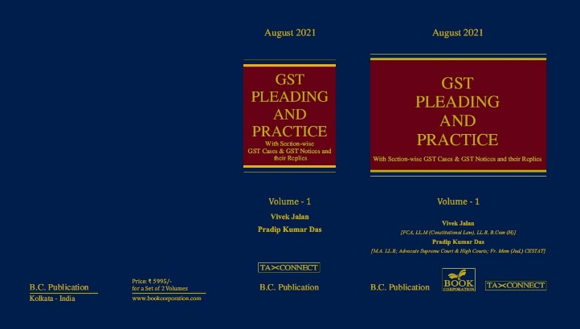

ABOUT THE BOOK: This publication includes:
1. GST Notices and their Replies
2. Orders and Appeals under GST
3. Text of provisions under IGST Act 2017 & CGST Act 2017
4. CGST & IGST Section-wise Synopsis of Case Laws and Notification/Circulars Gist
5. CGST & IGST Section-wise Synopsis of “Question of Law” answered under GST
6. Completely Updated Synopsis of Case Laws under GST by Supreme Court, High Court, AAARs & AARs

Authors:
Vivek Jalan
[FCA, LL.M (Constitutional Law), LL.B, B.Com(H)]

Pradip Kumar Das
[M.A. LL.B; Advocate Supreme Court & High Courts; Fr. Mem (Jud.) CESTAT]

Published by: In Association With:
BOOK CORPORATION TAX CONNECT ACADEMY
4, R. N. Mukherjee Road 1, Old Court House Corner
Kolkata 700001 Kolkata 700001
Phones: (033) 64547999 Phones: (033) 40016761
Cell : 9830010297, 9331018333 Cell : 9874466163, 9830661254
Order by email:bookcorporation@gmail.com Order by email: info@taxconnect.co.in Website :www.bookcorporation.com Website : www.taxconnect.co.in

:IN STANDS

AN INTEGRATED APPROACH TO GST E-INVOICING, E-WAYBILL & E-RETURN FILING
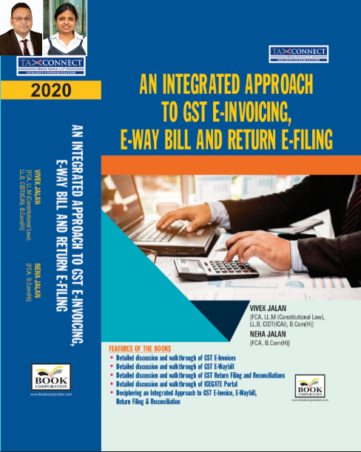
ABOUT THE BOOK: This publication includes:
- Detailed discussion and walkthrough of GST E-Invoices.
- Detailed discussion and walkthrough of GST E-Waybill.
- Detailed discussion and walkthrough of GST Return Filing and Reconciliations.
- Detailed discussion and walkthrough of ICEGATE Portal.
- Deciphering an Integrated Approach to GST E-Invoice, E-Waybill, Return Filing & Reconciliation

Authors:
Vivek Jalan
[FCA, L.LM (Constitutional Law), L.LB, CIDT(ICAI), B.Com(H)]

Neha Jalan
[FCA, B.Com(H)]

Published by: In Association With:
BOOK CORPORATION TAX CONNECT ACADEMY
4, R. N. Mukherjee Road 1, Old Court House Corner
Kolkata 700001 Kolkata 700001
Phones: (033) 64547999 Phones: (033) 40016761
Cell : 9830010297, 9331018333 Cell : 9874466163, 9830661254
Order by email:bookcorporation@gmail.com Order by email: info@taxconnect.co.in Website :www.bookcorporation.com Website : www.taxconnect.co.in

:IN STANDS

Section wise Compendium on GST
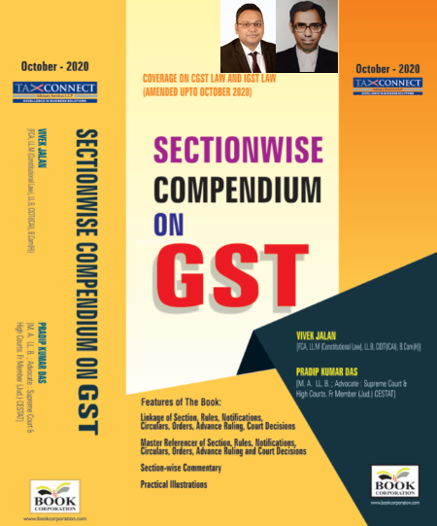
ABOUT THE BOOK: This publication includes:
1. Linkage of Section, Rules, Notifications, Circulars, Orders, Advance Ruling, Court Decisions
2. Master Referencer of Section, Rules, Notifications, Circulars, Orders, Advance Ruling and Court Decisions
3. Section-wise Commentary
4. Practical Illustrations

Authors:
Vivek Jalan
[FCA, L.LM (Constitutional Law), L.LB, CIDT(ICAI), B.Com(H)]

Pradip Kumar Das
[M.A. LL.B; Advocate Supreme Court & High Courts; Fr. Mem (Jud.) CESTAT]

Published by: In Association With:
BOOK CORPORATION TAX CONNECT ACADEMY
4, R. N. Mukherjee Road 1, Old Court House Corner
Kolkata 700001 Kolkata 700001
Phones: (033) 64547999 Phones: (033) 40016761
Cell : 9830010297, 9331018333 Cell : 9874466163, 9830661254
Order by email:bookcorporation@gmail.com Order by email: info@taxconnect.co.in Website :www.bookcorporation.com Website : www.taxconnect.co.in

:IN STANDS

UNION BUDGET 2021
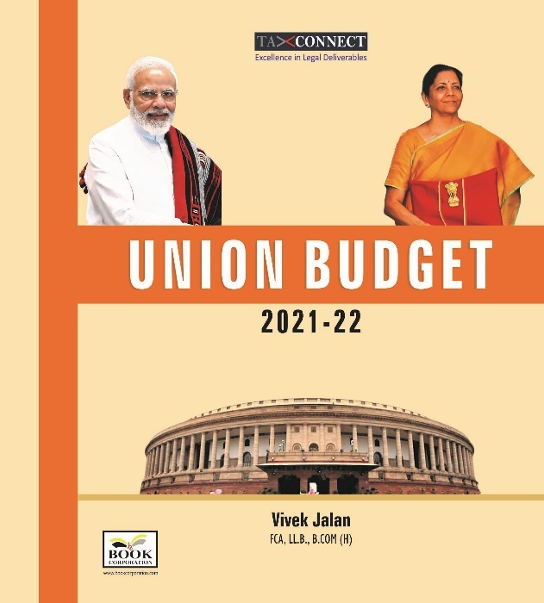
ABOUT THE BOOK: This publication includes:
1.Commentary on Budget
2.Finance Minister’s Budget Speech
3.Budget at a Glance
4.Memorandum
a. Direct Tax
b. Customs
c. Excise
d. GST
5. Finance Bill
6. Notes on Clauses

Authors:
Vivek Jalan
[FCA, L.LM (Constitutional Law), L.LB, CIDT(ICAI), B.Com(H)]

Published by: In Association With:
BOOK CORPORATION TAX CONNECT ACADEMY
4, R. N. Mukherjee Road 1, Old Court House Corner
Kolkata 700001 Kolkata 700001
Phones: (033) 64547999 Phones: (033) 40016761
Cell : 9830010297, 9331018333 Cell : 9874466163, 9830661254
Order by email:bookcorporation@gmail.com Order by email: info@taxconnect.co.in Website :www.bookcorporation.com Website : www.taxconnect.co.in

LET’S DISCUSS FURTHER!

OUR OFFICES:




DUBAI
Azizi Feirouz, 803, 8th Floor, AL Furjan, Opposite Discovery Pavillion, Dubai, UAE
Contact Person: Rohit Sharma
Email: rohit.sharma@taxconnect.co.in

KOLKATA
R No 119; 1st Floor; Diamond Arcade; 1/72, Cal Jessore Road; Kolkata – 700055
Contact Person: Priyanka Chowdhury
Email: priyanka.chowdhury@taxconnect.co.in

KOLKATA
1, Old Court House Corner, “Tobacco House”, 1st Floor, Room No. 13 (N), Kolkata-700001
Contact Person: Priyanka Chowdhury
Email: priyanka.chowdhury@taxconnect.co.in

MUMBAI
Building No.9, Flat- 403, LodhaEternis, 11th Road, MIDC, Andheri(E)-400093
Contact Person: Rajanikant Choudhury
Email: rajnikant.choudhary@taxconnect.co.in
DELHI
B-139, 2nd Floor, Transport Nagar, Noida-201301 (U.P)
Contact Person: Poonam Khemka
Email: poonam.khemka@taxconnectdelhi.co.in

BANGALORE
A-414,Carlton Towers, 19th Main; Road Hal Old Airport Rd, Domlur, Bengaluru, Karnataka-560008
Contact Person: Manmit Sinha
Email: manmit.sinha@taxconnectdelhi.co.in

Disclaimer:
This e-bulletin is for private circulation only. Views expressed herein are of the editorial team and are based on the information, explanation and documents available on Government portal platforms. Tax Connect or any of its employees do not accept any liability whatsoever direct or indirect that may arise from the use of the information contained herein. No matter contained herein may be reproduced without prior consent of Tax Connect. While this e-article has been prepared on the basis of published/other publicly available information considered reliable, we do not accept any liability for the accuracy of its contents.
Tax Connect 2021. All rights reserved.

