8
_{TAX CONNECT}

327th Issue: 5th December 2021-11th December 2021
12017

Knowledge Partner:



TAX CONNECT

Mumbai : A/1001, Cirrus Bldg, Cosmos Paradise; Pokhran Road No. 1, Thane (West), Maharashtra – 400606
Bangalore: A-414,Carlton Towers,19th Main; Road Hal Old Airport Rd, Domlur, Bengaluru, Karnataka-560008
New Delhi: B-139, 2nd Floor, Transport Nagar, Noida-201301 (U.P)
Kolkata : 1, Old Court House Corner, “Tobacco House” 1st Floor, R.No.-13 (North), Kolkata-700001
: Room No 119; 1st Floor; Diamond Arcade; 1/72, Cal Jessore Road; Kolkata – 700055

Dubai : AziziFeirouz, 803, 8th Floor, AL Furjan, Opposite Discovery Pavillion, Dubai, UAE

Contact: +919874466163; +91 9830661254
Website: www.taxconnect.co.in
Email: info@taxconnect.co.in



Friends,
The government intends to introduce the Cryptocurrency and Regulation of Official Digital Currency Bill, 2021, in the ongoing winter session of Parliament. The Bill seeks to “prohibit all private cryptocurrencies”, although it will allow certain exceptions to promote the underlying technology of cryptocurrency and its uses”. It will also create a facilitative framework for the launch of the official digital currency by the RBI. Currently, cryptos remain unregulated in India.
In 2018, the Reserve Bank of India banned banks and other financial institutions from facilitating transactions in cryptocurrency like Bitcoin, Ethereum, Dogecoin, and others. Later, in early 2020, the Supreme Court reversed the order, allowing trading of these virtual coins. Still, they have not yet received the status of a legal tender in India.
Presently there is no specific section or provision in the Income-tax Act, 1961, currently deals with the rate, applicability and collection of tax on the income earned by cryptocurrency exchanges and other platforms that provide such services.
Nevertheless, extant statutory provisions clearly envisage that total income for the purpose of taxation will include entire income from all sources,. The income earned by crypto exchanges and other crypto service providing platforms is liable to tax under the head Business or Profession under Chapter-IV of the Income-tax Act, 1961. Applicability of tax rate will depend on status and category of taxpayer.

Regarding the frauds relating to cryptocurrency, Hon’ble Finance Minister said that the Centre does not collect specific information on such frauds. Further, ‘Police’ and ‘Public Order’ are state subjects as per the Seventh Schedule of the Constitution of India. States/UTs are primarily responsible for the prevention, detection, investigation and prosecution of such crimes, including financial frauds through their law enforcement agencies. However, eight cases of cryptocurrency-related fraud are under investigation by the enforcement directorate, she added.
The Reserve Bank of India (RBI) has raised alarm on cryptocurrencies. The central bank has been cautioning users, holders and traders of virtual currencies (VCs) vide public notices on December 24, 2013, February 01, 2017 and December 05, 2017 that dealing in VCs is associated with potential economic, financial, operational, legal, customer protection and security related risks.
The government is planning to amend the income tax laws to bring cryptocurrencies under the tax net, with some changes expected as early as the next Budget.

Truly Yours
Editor:
Vivek Jalan
Partner - Tax Connect Advisory Services LLP
Co-Editors:
Rohit Sharma
Senior Manager – Tax Connect Advisory Services LLP
Rajanikant Choudhury
Manager - Tax Connect Advisory Services LLP
S.NO. | TOPICS | PAGE NO.
1] | TAX CALENDER | 4
2] | INCOME TAX | 5
CASE LAW | AO HAS NO POWER TO REVIEW AN ASSESSMENT WHICH HAS BEEN CONCLUDED UNLESS HE HAS TANGIBLE MATERIAL TO COME TO THE CONCLUSION THAT THERE IS AN ESCAPEMENT OF INCOME FROM ASSESSMENT.
3] | GST | 6
ADVISORY | A REVAMPED & ENHANCED VERSION OF GSTR-1/IFF IS BEING MADE AVAILABLE ON THE GST PORTAL TO IMPROVE THE TAXPAYER EXPERIENCE
4] | FEMA | 7
DISCUSSION | Checklist for Incorporation of Foreign Subsidiary / Wholly Owned Subsidiary in India
5] | CUSTOMS | 8
NOTIFICATION | rate of exchange of conversion of the foreign currencies into Indian currency or vice versa
6] | DGFT | 9
TRADE NOTICE | ELECTRONIC FILING OF REGISTRATION CUM MEMBERSHIP CERTIFICATE (RCMC)/ REGISTRATION CERTIFICATE (RC) THROUGH THE COMMON DIGITAL PLATFORM W.E.F. 06TH DECEMBER 2021 - DGFT
7] | GST PLEADING AND PRACTICE: WITH SECTION-WISE GST CASES & GST NOTICES AND THEIR REPLIES | 10
8] | IN STANDS - AN INTEGRATED APPROACH TO GST E-INVOICING, E-WAYBILL & E-RETURN FILING | 11
 | IN STANDS –SECTION WISE COMPENDIUM ON GST | 12
10] | IN STANDS – UNION BUDGET 2021 | 13
11] | LET’S DISCUSS FURTHER | 14

Due date | Form/Return/Challan | Reporting Period | Description
7th December 2021 | ITNS -281 | NOVEMBER 2021 | TDS and TCS payment for the month of November 2021
10th December 2021 | GSTR-7 | NOVEMBER 2021 | GSTR 7 is a return to be filed by the persons who are required to deduct TDS (Tax deducted at source) under GST
10th December 2021 | GSTR-8 | NOVEMBER 2021 | TCS return under GST( To be filed by E-Commerce Operator)
11th December 2021 | GSTR-1 | NOVEMBER 2021 | Taxpayers have an aggregate turnover of more than Rs. 1.50 Crores or opted to file Monthly Return

CASE LAW
Reopening of assessment u/s 147 due to Change of opinion - S.A. DEVELOPERS VS. ASSISTANT COMMISSIONER OF INCOME TAX-26(3)
BRIEF: The instant case is about reopening of assessment u/s 147 due to Change of opinion. Assessing officer (AO) has no power to review an assessment which has been concluded unless he has tangible material to come to the conclusion that there is an escapement of income from assessment.
OUR COMMENTS: There are reasons to believe in the present case, The Bombay High Court, do not find even a single ground which can be considered to be tangible basis for re-opening the assessment. AO states that from the partnership deed, audited accounts and Form No.3CD report, it is seen that that the Assessee has 15 partners, one of whom is Dhansukh Nanda HUF. According to the Assessing an HUF cannot become a partner of a firm or enter into a contract with other person and hence the Assessee has not complied with the provisions of Section 184 of the Act and the interest paid to partners cannot be considered for deduction.
This is a clear case of change of opinion because Petitioner had filed Form No.3CD in which Dhansukh Nanda HUF is shown as a partner with 10% profit sharing ratio. Form No.3CD also indicates that a sum has been paid as interest to Dhansukh Nanda HUF. These materials were on the face of a document available before the Assessing Officer who passed the original Assessing Order dated 21/10/2015. The respondent states that in the original Assessment Order, there is no mention about Dhansukh Nanda HUF and therefore it is likely that the original Assessing Officer has failed to note that one of the partners in Petitioner firm was an HUF.
Hon’ble High Court does not agree with the respondent because if Assessment Order does not speak about this, we would consider it as having been accepted by the Assessing Officer who passed the original Assessment Order that it was perfectly okay for an HUF to be a partner in Petitioner firm. We would hasten to add that we are not for a moment opining whether an HUF can be a partner in a firm under the provisions of Indian Partnership Act, 1932. Respondents have not denied these averments. Since we have concluded that it is nothing but a change of opinion, we do not propose to go into the issue as to whether the stand of Respondent that Petitioner has not complied with provisions of Section 184 of the Act is correct
Since Hon’ble High Court have concluded that it is nothing but a change of opinion, we do not propose to go into the issue as to whether the stand of Respondent that Petitioner has not complied with provisions of Section 184 of the Act is correct. - Decided in favour of assessee.

[For further details please refer the Case Law]

ADVIS0RY
A REVAMPED & ENHANCED VERSION OF GSTR-1/IFF IS BEING MADE AVAILABLE ON THE GST PORTAL TO IMPROVE THE TAXPAYER EXPERIENCE
OUR COMMENTS: A revamped & enhanced version of GSTR-1/IFF is being made available on the GST Portal to improve the taxpayer experience. These enhancements, would enable the Saving of the GSTR-1 details on the GST Portal efficient and user friendly.
The enhancements are as under:
- Details of Amendments are available in collapsed mode.

- E-invoice advisory and help buttons have been moved to the top of the dashboard page for ease of access.

- The status of uploaded (Saved, Pending, Errored) documents with their count will also be made available.

- Taxpayer can now ascertain if there are any pending or errored records in any of the tables of GSTR-1/IFF from the dashboard itself.

- System shall update the count of records in the tiles on real time basis which will help in easy reconciliation.

- In case any record added by taxpayer is errored out, then the tile will be highlighted in red color.

- Taxpayers will now be able to view a new record details table with the details of the recipient -wise count of records. Record details table will have the following columns:

- Taxpayer type – Type of recipient taxpayer (Regular, SEZ, and Composition) shall be displayed in this column.
- Processed invoice. On clicking it, the taxpayer will navigate to document details page to view all the records added for the respective recipient(s).
- Pending/errored invoice. On click of it, taxpayer can navigate to pending/errored records details page to view all the records which are in pending or errored status for the respective recipient(s).

- A general search functionality has been added in Document details page. Using this, taxpayer can now search specific record pertaining to a specific GSTIN. This will help taxpayer to search added records seamlessly.

- System will now provide the records per page feature in all the tables under ADD RECORD DETAILS section leading to ease of viewing.
Taxpayer can upload details of outward supplies and file GSTR-1/IFF by following the steps enumerated below:
a. Taxpayer can add or amend records in respective tables of GSTR-1/IFF.
b. Once the records are saved, taxpayer shall click on GENERATE SUMMARY button.
c. After the summary is successfully generated, system will enable PREVIEW and SUBMIT buttons.
d. If the taxpayer intends to verify summary of GSTR-1/IFF, taxpayer can click However, if any new records are added after generating the summary,
e.The SUBMIT and PREVIEW buttons will be disabled till a new summary has been generated by clicking GENERATE SUMMARY button after updating records.
f. Taxpayer will also be informed to generate new summary, in case the latest summary is not available/generated.
g. After the changes done in GSTR-1/IFF, taxpayer shall click on Generate summary button and can submit/file GSTR-1/IFF.
This check will ensure that filing of GSTR-1/IFF always happens with the correct & update summary only, and no mistake happens in this regard.
[For further details please refer the Advisory]

DISCUSSION
Checklist for Incorporation of Foreign Subsidiary / Wholly Owned Subsidiary in India
OUR COMMENTS: We discuss below the checklist for Incorporation of Foreign Subsidiary / Wholly Owned Subsidiary in India:
Following details are required for WOS (to be incorporated):
1. Authorized Share Capital
2. Paid- up Capital
3. Per share value (Face value)
4. Number of Shareholders
5. Registered Office Address
6. Phone No. & Mail id of the Company
7. Copy of the utility bills (not older than two months)
Following details are required for Nominee Shareholder and Director (already having DIN)
1. Proof of identity and residential address- Self-attested PAN and Adhar
2. Mail id and phone number
3. Passport Size photo
Following details are required for Nominee Shareholder and Director (not having DIN)
1. Proof of identity –Self-Attested Passport or Driving License or Voter Id
2. Mail id and phone number
3. Passport Size photo
4. Duration of stay at present address.
5. Educational Qualification
6. Proof of residential address- Self-Attested Bank Statement(not older than 2 months)
7. Self-attested PAN and Adhar
8. Occupation
Following details are required for Authorised Signatory
1. Apostilled copy of Proof of identity – Self attested PAN, Adhar and Passport
2. Apostilled copy of Proof of residential address- Utility bill, Phone bill having complete address
Information/ Documents required from foreign Company
1. Apostilled copy of resolution of foreign Company mentioning the name of authorized representative, no. of subscription of shares.
2. Apostilled copy of Charter of Foreign Company (MOA, AOA, Certificate of Incorporation or any other equivalent document as per the country of Incorporation).
3. Apostilled copy of ID Proof of authorized representative, if such person is non – resident of India
4. Name of one Resident Director.
5. Name of Nominee (in case of incorporation of WOS)
6. In case Director does not have a DIN, it is mandatory to attach- Proof of identity and residential address of the subscribers (Duly apostille or notarized in country of origin)
7. Declaration from the foreign subscribers in respect of not having PAN. (Duly apostille or notarized in country of origin).
8. NOC from the owner of the property.
9. Proof of Office address (Conveyance/ Lease deed/ Rent Agreement etc. along with rent receipts).

NOTIFICATION
rate of exchange of conversion of the foreign currencies into Indian currency or vice versa
OUR COMMENTS: The Central Board of Indirect Taxes & Customs, vide Notification number 95/2021 dated 30.11.2021, being satisfied that it is necessary and expedient to do so, hereby makes the following amendments in the notification of the Government of India in the Ministry of Finance (Department of Revenue), No. 36/2001-Customs (N.T.), dated the 3rd August, 2001, published in the Gazette of India, Extraordinary, Part-II, Section-3, Sub-section (ii), vide number S. O. 748 (E), dated the 3rd August, 2001, namely:-
In the said notification, for TABLE-1, TABLE-2, and TABLE-3 the following Tables shall be substituted, namely: -
Table 1
Sl. No. | Chapter/ heading/ sub- heading/tariff item | Description of goods | Tariff value  (US $Per Metric Tonne)
(1) | (2) | (3) | (4)
1 | 1511 10 00 | Crude Palm Oil | 1307
2 | 1511 90 10 | RBD Palm Oil | 1327
3 | 1511 90 90 | Others – Palm Oil | 1317
4 | 1511 10 00 | Crude Palmolein | 1334
5 | 1511 90 20 | RBD Palmolein | 1337
6 | 1511 90 90 | Others – Palmolein | 1336
7 | 1507 10 00 | Crude Soya bean Oil | 1434
8 | 7404 00 22 | Brass Scrap (all grades) | 5691

Table 2
(1) | (2) | (3) | (4)
1. | 71 or 98 | Gold, in any form, in respect of which the benefit of entries at serial number 356 of the Notification No. 50/2017-Customs dated 30.06.2017 is availed | 575 per 10 grams
2. | 71 or 98 | Silver, in any form, in respect of which the benefit of entries at serial number 357 of the Notification No. 50/2017-Customs dated 30.06.2017 is availed | 750 per kilogram
3. | 71 | (i) Silver, in any form, other than medallions and silver coins having silver content not below 99.9% or semi-manufactured forms of silver falling under sub-heading 7106 92;  (ii) Medallions and silver coins having silver content not below 99.9% or semi-manufactured forms of silver falling under sub-heading 7106 92, other than imports of such goods through post, courier or baggage. | 750 per kilogram
4. | 71 | (i) Gold bars, other than tola bars, bearing manufacturer’s or refiner’s engraved serial number and weight expressed in metric units;  (ii) Gold coins having gold content not below 99.5% and gold findings, other than imports of such goods through post, courier or baggage. | 575 per 10 grams

Table 3
(1) | (2) | (3) | (4)
1 | 080280 | Areca nuts | 5252(i.e., no change)”

[For further details please refer the Notification]
TRADE NOTICE
Electronic filing of Registration Cum Membership Certificate (RCMC)/ Registration Certificate (RC) through the Common Digital Platform w.e.f. 06th December 2021

OUR COMMENTS: Vide trade notice no 27/2021-2022 dated 30.12.2021 A new online common digital platform for issuance of Registration Cum Membership Certificate (RCMC)/ Registration Certificate (RC) has been developed which would be single point of access for all exporters/importers and Issuing agencies. The given platform shall be available at the following URL: https://dgft.gov.in.

2. The objective of the platform is to provide an electronic, contact-less single window for the RCMC/RC related processes including Application for Fresh/ Amendment/ Renewal of RCMC/ RC. Applications for RCMC/ RC may be submitted through the common platform w.e.f. 06th December 2021. Submitting applications on this online platform shall not be mandatory for the exporters in the immediate and there shall be a transition period for issuing agencies as well as Exporters to onboard this common digital platform. The existing procedure of submitting applications directly to the designated issuing agency shall also be in operation in parallel during this transition period. Submission and issuance of RCMC/ RC by the issuing agencies through their system may continue up to 28th February 2022 or until further orders.

3. The authenticity of the online issued shall be verifiable by login to exporter profile on https://dgft.gov.in. The details for RCMC/ RC issued using the DGFT portal will be reflected instantly in the profile of the exporter.
4. The concerned Indian Exporters may please take note of the following points with regard to the process being notified herewith:

- Call the toll-free DGFT Helpdesk numbers
- Send an email to DGFT Helpdesk at dgftedi@gov.in

This issues with the approval of the competent authority.

[For further details please refer the Trade Notice]

:IN STANDS

GST PLEADING AND PRACTICE: With Section-wise GST Cases & GST Notices and their Replies
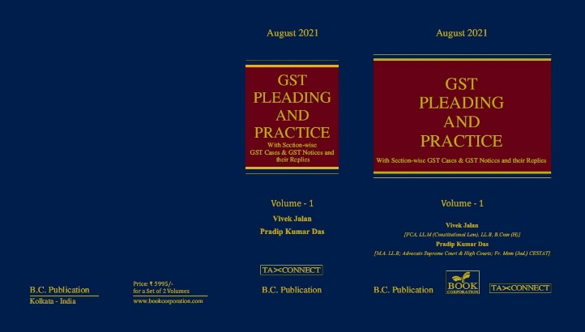

ABOUT THE BOOK: This publication includes:
1. GST Notices and their Replies
2. Orders and Appeals under GST
3. Text of provisions under IGST Act 2017 & CGST Act 2017
4. CGST & IGST Section-wise Synopsis of Case Laws and Notification/Circulars Gist
5. CGST & IGST Section-wise Synopsis of “Question of Law” answered under GST
6. Completely Updated Synopsis of Case Laws under GST by Supreme Court, High Court, AAARs & AARs

Authors:
Vivek Jalan
[FCA, LL.M (Constitutional Law), LL.B, B.Com(H)]

Pradip Kumar Das
[M.A. LL.B; Advocate Supreme Court & High Courts; Fr. Mem (Jud.) CESTAT]

Published by: In Association With:
BOOK CORPORATION TAX CONNECT ACADEMY
4, R. N. Mukherjee Road 1, Old Court House Corner
Kolkata 700001 Kolkata 700001
Phones: (033) 64547999 Phones: (033) 40016761
Cell : 9830010297, 9331018333 Cell : 9874466163, 9830661254
Order by email:bookcorporation@gmail.com Order by email: info@taxconnect.co.in Website :www.bookcorporation.com Website: : www.taxconnect.co.in

:IN STANDS

AN INTEGRATED APPROACH TO GST E-INVOICING, E-WAYBILL & E-RETURN FILING
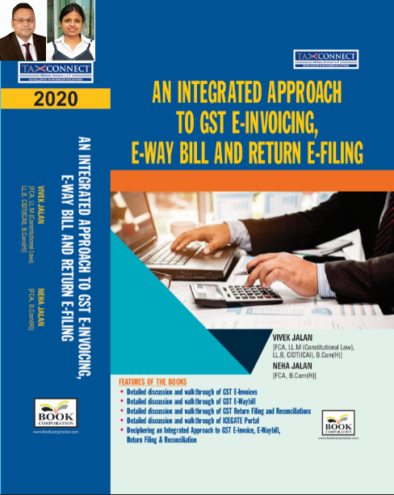
ABOUT THE BOOK: This publication includes:
- Detailed discussion and walkthrough of GST E-Invoices.
- Detailed discussion and walkthrough of GST E-Waybill.
- Detailed discussion and walkthrough of GST Return Filing and Reconciliations.
- Detailed discussion and walkthrough of ICEGATE Portal.
- Deciphering an Integrated Approach to GST E-Invoice, E-Waybill, Return Filing & Reconciliation

Authors:
Vivek Jalan
[FCA, L.LM (Constitutional Law), L.LB, CIDT(ICAI), B.Com(H)]

Neha Jalan
[FCA, B.Com(H)]

Published by: In Association With:
BOOK CORPORATION TAX CONNECT ACADEMY
4, R. N. Mukherjee Road 1, Old Court House Corner
Kolkata 700001 Kolkata 700001
Phones: (033) 64547999 Phones: (033) 40016761
Cell : 9830010297, 9331018333 Cell : 9874466163, 9830661254
Order by email:bookcorporation@gmail.com Order by email: info@taxconnect.co.in Website :www.bookcorporation.com Website : www.taxconnect.co.in

:IN STANDS

Section wise Compendium on GST
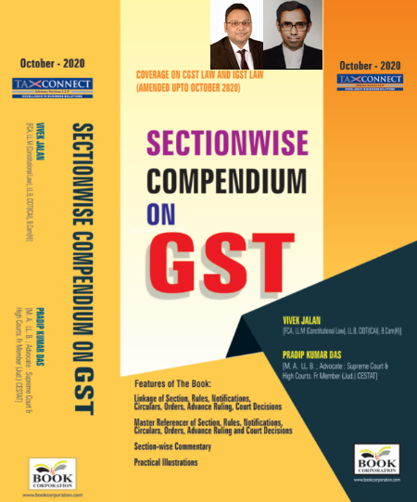
ABOUT THE BOOK: This publication includes:
1. Linkage of Section, Rules, Notifications, Circulars, Orders, Advance Ruling, Court Decisions
2. Master Referencer of Section, Rules, Notifications, Circulars, Orders, Advance Ruling and Court Decisions
3. Section-wise Commentary
4. Practical Illustrations

Authors:
Vivek Jalan
[FCA, L.LM (Constitutional Law), L.LB, CIDT(ICAI), B.Com(H)]

Pradip Kumar Das
[M.A. LL.B; Advocate Supreme Court & High Courts; Fr. Mem (Jud.) CESTAT]

Published by: In Association With:
BOOK CORPORATION TAX CONNECT ACADEMY
4, R. N. Mukherjee Road 1, Old Court House Corner
Kolkata 700001 Kolkata 700001
Phones: (033) 64547999 Phones: (033) 40016761
Cell : 9830010297, 9331018333 Cell : 9874466163, 9830661254
Order by email:bookcorporation@gmail.com Order by email: info@taxconnect.co.in Website :www.bookcorporation.com Website : www.taxconnect.co.in

:IN STANDS

UNION BUDGET 2021
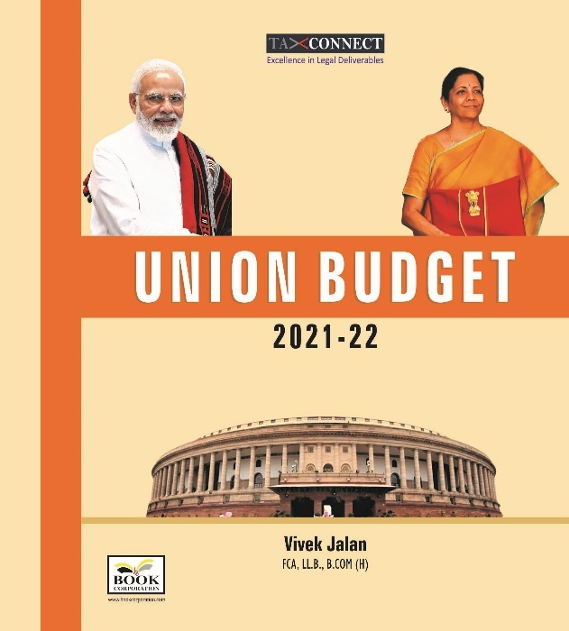
ABOUT THE BOOK: This publication includes:
1.Commentary on Budget
2.Finance Minister’s Budget Speech
3.Budget at a Glance
4.Memorandum
a. Direct Tax
b. Customs
c. Excise
d. GST
5. Finance Bill
6. Notes on Clauses

Authors:
Vivek Jalan
[FCA, L.LM (Constitutional Law), L.LB, CIDT(ICAI), B.Com(H)]

Published by: In Association With:
BOOK CORPORATION TAX CONNECT ACADEMY
4, R. N. Mukherjee Road 1, Old Court House Corner
Kolkata 700001 Kolkata 700001
Phones: (033) 64547999 Phones: (033) 40016761
Cell : 9830010297, 9331018333 Cell : 9874466163, 9830661254
Order by email:bookcorporation@gmail.com Order by email: info@taxconnect.co.in Website :www.bookcorporation.com Website : www.taxconnect.co.in

LET’S DISCUSS FURTHER!

OUR OFFICES:




DUBAI
Azizi Feirouz, 803, 8th Floor, AL Furjan, Opposite Discovery Pavillion, Dubai, UAE
Contact Person: Rohit Sharma
Email: rohit.sharma@taxconnect.co.in

KOLKATA
R No 119; 1st Floor; Diamond Arcade; 1/72, Cal Jessore Road; Kolkata – 700055
Contact Person: Priyanka Chowdhury
Email: priyanka.chowdhury@taxconnect.co.in

KOLKATA
1, Old Court House Corner, “Tobacco House”, 1st Floor, Room No. 13 (N), Kolkata-700001
Contact Person: Priyanka Chowdhury
Email: priyanka.chowdhury@taxconnect.co.in

MUMBAI
Building No.9, Flat- 403, LodhaEternis, 11th Road, MIDC, Andheri(E)-400093
Contact Person: Rajanikant Choudhury
Email: rajnikant.choudhary@taxconnect.co.in
DELHI
B-139, 2nd Floor, Transport Nagar, Noida-201301 (U.P)
Contact Person: Poonam Khemka
Email: poonam.khemka@taxconnectdelhi.co.in

BANGALORE
A-414,Carlton Towers, 19th Main; Road Hal Old Airport Rd, Domlur, Bengaluru, Karnataka-560008
Contact Person: Manmit Sinha
Email: manmit.sinha@taxconnectdelhi.co.in

Disclaimer:
This e-bulletin is for private circulation only. Views expressed herein are of the editorial team and are based on the information, explanation and documents available on Government portal platforms. Tax Connect or any of its employees do not accept any liability whatsoever direct or indirect that may arise from the use of the information contained herein. No matter contained herein may be reproduced without prior consent of Tax Connect. While this e-article has been prepared on the basis of published/other publicly available information considered reliable, we do not accept any liability for the accuracy of its contents.
Tax Connect 2021. All rights reserved.

