8
_{TAX CONNECT}

326th Issue: 28th November 2021-4th December 2021
12017

Knowledge Partner:



TAX CONNECT

Mumbai : A/1001, Cirrus Bldg, Cosmos Paradise; Pokhran Road No. 1, Thane (West), Maharashtra – 400606
Bangalore: A-414,Carlton Towers,19th Main; Road Hal Old Airport Rd, Domlur, Bengaluru, Karnataka-560008
New Delhi: B-139, 2nd Floor, Transport Nagar, Noida-201301 (U.P)
Kolkata : 1, Old Court House Corner, “Tobacco House” 1st Floor, R.No.-13 (North), Kolkata-700001
: Room No 119; 1st Floor; Diamond Arcade; 1/72, Cal Jessore Road; Kolkata – 700055

Dubai : AziziFeirouz, 803, 8th Floor, AL Furjan, Opposite Discovery Pavillion, Dubai, UAE

Contact: +919874466163; +91 9830661254
Website: www.taxconnect.co.in
Email: info@taxconnect.co.in



Friends,
CBDT issued Circular No. 20 of 2021 dated 25th November and attempted to provide more clarity and relief to those taxpayers whose practical issues left unattended, particularly in the case of buyers of petroleum products where TDS on state taxes have resulted in an unnecessary cascading effect despite the fact that the amount of states taxes are shown separately on the invoice. Guidelines under section 194-O(4), section 194Q (3) and section 206C (1l) of the Income-tax Act, 1961 issued to clarify the following matters:
1. E-auction services carried out through electronic portal: The provisions of section 194-O of the Act shall not apply in relation to e-auction activities carried out by e-auctioneers if all the facts listed at (a) to (f) of para 5.1.2 of the circulars are satisfied. This clarification shall not apply if any of these facts are not satisfied. Further, it is clarified that the buyer and seller would still be liable to deduct/ collect tax as per the provisions of section 194Q and 206C (1H) of the Act, as the case may be.
2. Adjustment of various state levies and taxes other than GST : In case of purchase of goods which are not covered within the purview of GST, when tax is deducted at the time of credit of amount in the account of seller and in terms of the agreement or contract between the buyer and the seller, the component of VAT/Sales tax/Excise duty/CST, as the case may be, has been indicated separately in the invoice, then the tax is to be deducted under section 194Q of the Act on the amount credited without including such VAT/Excise duty/Sales tax/CST, as the case may be. However, if the tax is deducted on payment basis, if it is earlier than the credit, the tax is to be deducted on the whole amount as it will not be possible to identify the payment with VAT/Excise duty/Sales tax/CST component to be invoiced in the future. Furthermore, in case of purchase returns, the clarification as provided in Para 4.3.3 of circular no. 13 of 2021 shall also apply to purchase return relating to non GST products liable to VAT/excise duty/sales tax CST etc.
3. Applicability of section 194Q of the Act in cases where exemption has been provided under section 206C (1A) of the Act : The provisions of section 194Q of the Act does not apply in respect to those transactions where tax is collectible under section 206C [except sub-section (1H) thereof] of the Act. Since by virtue of sub-section (1A) of section 206C of the Act, the tax is not required to be collected for goods covered under sub-section (1) of the said section, it is hereby clarified that in such cases, the provisions of section 194Q of the Act will apply and the buyer shall be liable to deduct tax under the said section if the conditions specified therein are fulfilled.
4. Applicability of the provisions of section 194Q in case of department of Government not being a public sector undertaking or corporation : For the purposes of section 194Q, Central Government or State Government shall not be considered as 'seller' and no tax is to be deducted by the buyer, in cases where any Department of Central or State Government are seller of goods. Further clarified that any other person, such as a Public sector Undertaking or corporation established under Central or State Act or any other such body, authority or entity, shall be required to comply with the provisions of section 194Q and tax shall be deducted accordingly.
Truly Yours
Editor:
Vivek Jalan
Partner - Tax Connect Advisory Services LLP
Co-Editors:
Rohit Sharma
Senior Manager – Tax Connect Advisory Services LLP
Rajanikant Choudhury
Manager - Tax Connect Advisory Services LLP
S.NO. | TOPICS | PAGE NO.
1] | TAX CALENDER | 4
2] | INCOME TAX | 5
NOTIFICATION | SUBSTITUTED FORM NO. 52A - STATEMENT TO BE FURNISHED TO THE ASSESSING OFFICER UNDER SECTION 285B OF THE INCOME-TAX ACT, 1961, IN RESPECT OF PRODUCTION OF A CINEMATOGRAPH FILM
3] | GST | 6
NOTIFICATION | PRESCRIBED CGST @ 6% ON CERTAIN TEXTILE AND TEXTILE PRODUCTS AND GARMENTS FALLING UNDER CHAPTER 50, 51, 52, 53, 54, 55, 56, 58, 59, 60, 63, 64 W.E.F. 1.1.2022
NOTIFICATION | NEW CATEGORY OF SERVICES HAS BEEN INCLUDED IN THE CATEGORY OF SERVICES THE TAX ON INTRA-STATE SUPPLIES OF WHICH SHALL BE PAID BY THE ELECTRONIC COMMERCE OPERATOR (ECO)
4] | FEMA | 7
CIRCULAR | Exim Bank's Government of India supported Line of Credit (LoC) of USD 10.40 million to the Government of the Kingdom of Eswatini (Swaziland)
5] | CUSTOMS | 8
NOTIFICATION | RATE OF EXCHANGE OF CONVERSION OF THE FOREIGN CURRENCIES INTO INDIAN CURRENCY OR VICE VERSA
6] | DGFT | 9
NOTIFICATION | AMENDMENT IN POLICY CONDITIONS GOVERNING IMPORT AND EXPORT IN ROUGH DIAMONDS FALLING UNDER CHAPTER-71 OF SCHEDULE (L) OF ITC(HS) 2017 AND SCHEDULE (II) OF ITC(HS) 2018 - 43/2015-2020
PUBLIC NOTICE | ALLOCATION OF ADDITIONAL QUANTITY OF 303 MT FOR EXPORT OF RAW SUGAR TO USA UNDER TARIFF RATE QUOTA (TRQ) FOR THE FISCAL YEAR 2021
7] | GST PLEADING AND PRACTICE: WITH SECTION-WISE GST CASES & GST NOTICES AND THEIR REPLIES | 10
8] | IN STANDS - AN INTEGRATED APPROACH TO GST E-INVOICING, E-WAYBILL & E-RETURN FILING | 11
9] | IN STANDS –SECTION WISE COMPENDIUM ON GST | 12
10] | IN STANDS – UNION BUDGET 2021 | 13
11] | LET’S DISCUSS FURTHER | 14

Due date | Form/Return/Challan | Reporting Period | Description
30th November 2021 | Form No. 26QB /26QC/26QD | OCTOBER 2021 | Due date for furnishing of challan-cum-statement in respect of tax deducted under section 194-IA, 194-IB, 194-IM, in the month of October 2021
30th November 2021 | Form 3CEFB |  | To exercise option of safe harbour rules for Domestic transaction.
30th November 2021 | Form 3CEB |  | Report to be furnished in Form 3CEB in respect of International transaction and specified domestic transaction.
30th November 2021 | Form No. 64 | FY-2020-2021 | Statement of income distribution by Venture Capital Company or venture capital fund in respect of income Distributed during previous Year 2020-21
30th November 2021 | Form No. 64D | FY 2020-2021 | Statement to be furnished in Form No. 64D by Alternative Investment Fund (AIF) to Principal CIT or CIT in respect of income Distributed (during previous year 2020-21) to unit holders.
30th November 2021 | Form No. 10BBB | April 2021 to June 2021 | Intimation to be made by a Pension Fund in respect of each investment ) made by it in India in Form No. 10BBB for the quarter ending on 30th June,2021

NOTIFICATION
SUBSTITUTED FORM NO. 52A - Statement to be furnished to the Assessing Officer under section 285B of the Income-tax Act, 1961, in respect of production of a cinematograph film
OUR COMMENTS: The Central Board of Direct Taxes (CBDT), Department of Revenue, Ministry of Finance vide Notification No. 132/2021 dated 23rd November 2021, notified the Income tax (32nd Amendment), Rules, 2021. In the Income-tax Rules, 1962, in Appendix II, for Form No. 52A, [Statement to be furnished to the Assessing Officer under section 285B of the Income-tax Act, 1961, in respect of production of a cinematograph film] the following Form shall be substituted, namely:-
FORM NO. 52A
[See rule 121A]

Statement to be furnished to the Assessing Officer under section 285B of the Income-tax Act, 1961, in respect of production of a cinematograph film
Sr.  No. | Particulars |  |  | Details
1. | Name and address of the producer |  |  | Details of Producer
1. |  |  |  | Name
1. |  |  |  | Status
1. |  |  |  | Residential status
1. |  |  |  | Permanent Account Number
1. |  |  |  | Tax Deduction Account Number
1. |  |  |  | Address
2. | Relevant previous year
3. | Details of the film |  |  | Name of the Film
3. |  |  |  | Nature of the Film | Celluloid Film |  | Other than Celluloid Film
4. | Date on which the production of the film was started
5. | If the production of the film has been completed, the date of completion
6. | Financial year to which the statement relates
7. | Details of payments of over ₹ 50,000 in the aggregate made by the producer or due from him to each person engaged in the production of the film as employee or otherwise:
7. | (i) | Details of the person to whom payment has been made or is due
7. | (i) | Name of the Person |  | Address of the Person | PAN of the Person
7. | (ii) | Details of payment made to person mentioned in (i) above
7. | (ii) | Amount |  | Date on which payment was made or became due |  | Tax deducted at source or not
7. |  | Whether paid in cash if yes, then amount
7. |  | paid in cash
Verification:
I ____, do hereby declare that what is stated above is true to the best of my knowledge and belief. Verified today, the day of _____
Place:
Date:
[For further details please refer the Notification]

NOTIFICATION
PRESCRIBED CGST @ 6% ON CERTAIN TEXTILE AND TEXTILE PRODUCTS AND GARMENTS FALLING UNDER CHAPTER 50, 51, 52, 53, 54, 55, 56, 58, 59, 60, 63, 64 W.E.F. 1.1.2022
OUR COMMENTS: The Department of Revenue, Ministry of Finance, vide Notification No. 14/2021-Central Tax (Rate) dated 18th November, 2021 amended Notification No 1/2017- Central Tax (Rate) dated 28.06.2017 and prescribed CGST @ 6% on certain Textile and textile products and Garments falling under chapter 50, 51, 52, 53, 54, 55, 56, 58, 59, 60, 63, 64.
[For further details please refer the Notification]

NOTIFICATION
NEW CATEGORY OF SERVICES HAS BEEN INCLUDED IN THE CATEGORY OF SERVICES THE TAX ON INTRA-STATE SUPPLIES OF WHICH SHALL BE PAID BY THE ELECTRONIC COMMERCE OPERATOR (ECO)
OUR COMMENTS: The Department of Revenue, Ministry of Finance, vide Notification No. 17/2021-Central Tax (Rate) dated 18th November, 2021 amended Notification No. 17/2017-Central Tax (Rate) dated 28.06.2017 and notified that in case of the following categories of services, the tax on intra-State supplies shall be paid by the electronic commerce operator –
- Services by way of transportation of passengers by omnibus or any other motor vehicle;

- supply of restaurant service other than the services supplied by restaurant, eating joints etc. located at specified premises.”

Further, Explanation has been amended as under:
- in item (b), for the words, brackets, numbers and figures “and “motor cycle” shall have the same meanings as assigned to them respectively in clauses (22), (25) and (26) of section 2 of the Motor Vehicle Act, 1988 (59 of 1988).”, the words, brackets, numbers and figures ,”, motor cycle, motor vehicle and omnibus shall have the same meanings as assigned to them respectively in clauses (22), (25), (27), (28) and (29) of section 2 of the Motor Vehicle Act, 1988 (59 of 1988).” shall be substituted;

- after item (b), the following shall be inserted namely, -
“(c) specified premises means premises providing hotel accommodation service having declared tariff of any unit of accommodation above seven thousand five hundred rupees per unit per day or equivalent.”

This notification shall come into force with effect from the 1st day of January, 2022.

[For further details please refer the Notification]

CIRCULAR
Exim Bank's Government of India supported Line of Credit (LoC) of USD 10.40 million to the Government of the Kingdom of Eswatini (Swaziland)
OUR COMMENTS: Vide Circular No. 17 dated 8th November 2021, Export-Import Bank of India (Exim Bank) has entered into an agreement dated February 01, 2021 with the Government of the Kingdom of Eswatini (Swaziland), for making available to the latter, Government of India supported Line of Credit (LoC) of USD 10.40 million (USD Ten million and four hundred thousand only) for the purpose of financing construction of a Disaster Recovery Site, subject to preparation and appraisal of Detailed Project Report (DPR) at a cost not exceeding 1% of the credit, in the Kingdom of Eswatini (Swaziland). Under the arrangement, financing of export of eligible goods and services from India, as defined under the agreement, would be allowed subject to their being eligible for export under the Foreign Trade Policy of the Government of India and whose purchase may be agreed to be financed by the Exim Bank under this agreement. Out of the total credit by Exim Bank under the agreement, goods, works and services of the value of at least 75 per cent of the contract price shall be supplied by the seller from India, and the remaining 25 per cent of goods and services may be procured by the seller for the purpose of the eligible contract from outside India.
The Agreement under the LoC is effective from September 27, 2021. Under the LoC, the terminal utilization period is 60 months after the scheduled completion date of the Project.
Shipments under the LoC shall be declared in Export Declaration Form as per instructions issued by the Reserve Bank from time to time.
No agency commission is payable for export under the above LoC. However, if required, the exporter may use his own resources or utilize balances in his Exchange Earners’ Foreign Currency Account for payment of commission in free foreign exchange. Authorised Dealer (AD) Category- I banks may allow such remittance after realization of full eligible value of export subject to compliance with the extant instructions for payment of agency commission.
AD Category – I banks may bring the contents of this circular to the notice of their exporter constituents and advise them to obtain complete details of the LoC from the Exim Bank’s office at Centre One, Floor 21, World Trade Centre Complex, Cuffe Parade, Mumbai 400 005 or from their website www.eximbankindia.in
The directions contained in this circular have been issued under section 10(4) and 11(1) of the Foreign Exchange Management Act (FEMA), 1999 (42 of 1999) and are without prejudice to permissions/ approvals, if any, required under any other law.
[For further details please refer the Circular]

NOTIFICATION
rate of exchange of conversion of the foreign currencies into Indian currency or vice versa
OUR COMMENTS: The Central Board of Indirect Taxes and Customs vide notification number 92/2021 dated 8th November 2021, hereby determines that the rate of exchange of conversion of each of the foreign currencies specified in column (2) of each of Schedule I and Schedule II annexed hereto, into Indian currency or vice versa, shall, with effect from 19th November, 2021, be the rate mentioned against it in the corresponding entry in column (3) thereof, for the purpose of the said section, relating to imported and export goods.-
SCHEDULE-I
Sl.  No. | Foreign Currency | Rate of exchange of one unit of foreign currency equivalent to Indian rupees
(1) | (2) | (3)
 |  | (a) | (b)
 |  | (For Imported Goods) | (For Exported Goods)
1. | Australian Dollar | 55.20 | 52.85
2. | Bahraini Dinar | 203.30 | 190.85
3. | Canadian Dollar | 59.90 | 57.75
4. | Chinese Yuan | 11.80 | 11.45
5. | Danish Kroner | 11.50 | 11.10
6. | EURO | 85.60 | 82.55
7. | Hong Kong Dollar | 9.70 | 9.35
8. | Kuwaiti Dinar | 253.70 | 237.55
9. | New Zealand Dollar | 53.50 | 51.20
10. | Norwegian Kroner | 8.65 | 8.35
11. | Pound Sterling | 101.90 | 98.45
12. | Qatari Riyal | 20.95 | 19.65
13. | Saudi Arabian Riyal | 20.45 | 19.20
14. | Singapore Dollar | 55.65 | 53.80
15. | South African Rand | 4.95 | 4.65
16. | Swedish Kroner | 8.55 | 8.25
17. | Swiss Franc | 81.65 | 78.40
18. | Turkish Lira | 7.05 | 6.60
19. | UAE Dirham | 20.85 | 19.60
20. | US Dollar | 75.10 | 73.40

SACHEDULE-II
Sl.  No. | Foreign Currency | Rate of exchange of one unit of foreign currency equivalent to Indian rupees
(1) | (2) | (3)
 |  | (a) | (b)
 |  | (For Imported Goods) | (For Exported Goods)
1. | Japanese Yen | 66.25 | 63.90
2. | Korean Won | 6.50 | 6.10

[For further details please refer the Notification]

NOTIFICATION
Amendment in policy conditions governing import and export in rough diamonds falling under Chapter-71 of Schedule (l) of ITC(HS) 2017 and Schedule (II) of ITC(HS) 2018 - 43/2015-2020
OUR COMMENTS: The Central Government hereby revises the policy conditions governing import and export of rough diamonds falling under Chapter-71 of Schedule (I) of ITC(HS) 2017 and Schedule (II) of ITC(HS) 2018 as under -
2. Policy condition No.05 is inserted under chapter-71 of Schedule-I (Import Policy) of ITC (HS) 2017, as under:
Import of rough diamonds shall not be permitted unless the concerned importer is registered with Gems & Jewellery EPC, which is the designated importing and exporting authority of India for Kimberley Process Certification Scheme (KPCS).

3. Further, a Policy Condition No. 01 is inserted in the Chapter-71 of Schedule-II (Export Policy) of ITC(HS) 2018, as under:
Export of rough diamonds shall not be permitted unless the concerned exporter is registered with Gems & Jewellery EPC, which is the designated importing and exporting authority of India for Kimberley Process Certification Scheme (KPCS).

Effect of this Notification: Import or export of rough diamonds shall not be permitted unless the concerned importer and exporter is registered with G&JEPC.

[For further details please refer the Notification]

PUBLIC NOTICE
Allocation of additional quantity of 303 MT for export of raw sugar to USA under Tariff Rate Quota (TRQ) for the Fiscal Year 2021
OUR COMMENTS: The Foreign Trade Policy, 2015-2020, vide public notice number Public Notice No. 39/2015-2020 dated 23rd November 2021, the Director General of Foreign Trade hereby allocates an additional quantity of 303 MT raw sugar for export under Tariff Rate Quota (TRQ) to USA for the fiscal year 2021 (October 1, 2020 to December 31, 2021). With this additional allocation, quantity for export of sugar to USA under TRQ for the fiscal year 2021 would be as under: -
Public Notice No. & Date | Quantity of sugar allocated MT
Quantity allocated under Public Notice No. 33/2015-20 dated 18.12.2020 | 8424
Additional Quantity Allocated | 303
Total Quantity Allocated | 8727
2. Export of sugar (HS Code 17010000) to USA under TRQ is 'Free' subject to the conditions notified in the 'Nature of Restrictions' in Notification No. 3/2015-20 dated 20.04.2015. The reporting requirement as per Public Notice No.-33/2015-20 dated 18.12.2020 would continue to be followed.
3. Certificate of Origin, if required, for export of preferential sugar to USA, shall be issued by Additional Director General of Foreign Trade, Mumbai. Other certification requirement, if any, prescribed specifically for export of sugar to USA would continue to be followed.
4. Effect of this Public Notice: Additional quantity of 303 MT of raw sugar, for export to USA, under TRQ, upto 31.12.2021, has been notified.
[For further details please refer the Public Notice]

:IN STANDS

GST PLEADING AND PRACTICE: With Section-wise GST Cases & GST Notices and their Replies
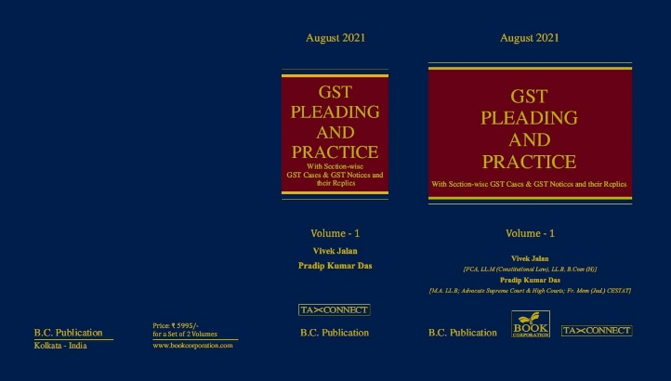

ABOUT THE BOOK: This publication includes:
1. GST Notices and their Replies
2. Orders and Appeals under GST
3. Text of provisions under IGST Act 2017 & CGST Act 2017
4. CGST & IGST Section-wise Synopsis of Case Laws and Notification/Circulars Gist
5. CGST & IGST Section-wise Synopsis of “Question of Law” answered under GST
6. Completely Updated Synopsis of Case Laws under GST by Supreme Court, High Court, AAARs & AARs

Authors:
Vivek Jalan
[FCA, LL.M (Constitutional Law), LL.B, B.Com(H)]

Pradip Kumar Das
[M.A. LL.B; Advocate Supreme Court & High Courts; Fr. Mem (Jud.) CESTAT]

Published by: In Association With:
BOOK CORPORATION TAX CONNECT ACADEMY
4, R. N. Mukherjee Road 1, Old Court House Corner
Kolkata 700001 Kolkata 700001
Phones: (033) 64547999 Phones: (033) 40016761
Cell : 9830010297, 9331018333 Cell : 9874466163, 9830661254
Order by email:bookcorporation@gmail.com Order by email: info@taxconnect.co.in Website :www.bookcorporation.com Website: : www.taxconnect.co.in

:IN STANDS

AN INTEGRATED APPROACH TO GST E-INVOICING, E-WAYBILL & E-RETURN FILING
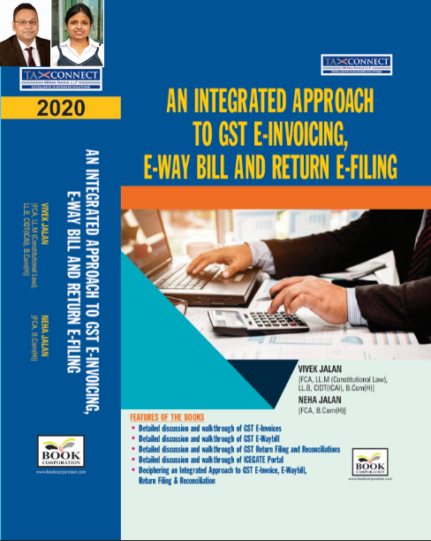
ABOUT THE BOOK: This publication includes:
- Detailed discussion and walkthrough of GST E-Invoices.
- Detailed discussion and walkthrough of GST E-Waybill.
- Detailed discussion and walkthrough of GST Return Filing and Reconciliations.
- Detailed discussion and walkthrough of ICEGATE Portal.
- Deciphering an Integrated Approach to GST E-Invoice, E-Waybill, Return Filing & Reconciliation

Authors:
Vivek Jalan
[FCA, L.LM (Constitutional Law), L.LB, CIDT(ICAI), B.Com(H)]

Neha Jalan
[FCA, B.Com(H)]

Published by: In Association With:
BOOK CORPORATION TAX CONNECT ACADEMY
4, R. N. Mukherjee Road 1, Old Court House Corner
Kolkata 700001 Kolkata 700001
Phones: (033) 64547999 Phones: (033) 40016761
Cell : 9830010297, 9331018333 Cell : 9874466163, 9830661254
Order by email:bookcorporation@gmail.com Order by email: info@taxconnect.co.in Website :www.bookcorporation.com Website : www.taxconnect.co.in

:IN STANDS

Section wise Compendium on GST
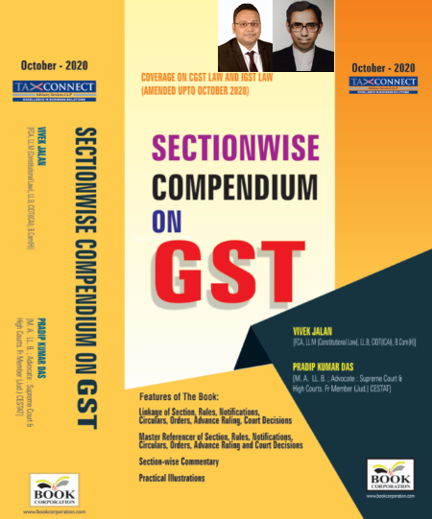
ABOUT THE BOOK: This publication includes:
1. Linkage of Section, Rules, Notifications, Circulars, Orders, Advance Ruling, Court Decisions
2. Master Referencer of Section, Rules, Notifications, Circulars, Orders, Advance Ruling and Court Decisions
3. Section-wise Commentary
4. Practical Illustrations

Authors:
Vivek Jalan
[FCA, L.LM (Constitutional Law), L.LB, CIDT(ICAI), B.Com(H)]

Pradip Kumar Das
[M.A. LL.B; Advocate Supreme Court & High Courts; Fr. Mem (Jud.) CESTAT]

Published by: In Association With:
BOOK CORPORATION TAX CONNECT ACADEMY
4, R. N. Mukherjee Road 1, Old Court House Corner
Kolkata 700001 Kolkata 700001
Phones: (033) 64547999 Phones: (033) 40016761
Cell : 9830010297, 9331018333 Cell : 9874466163, 9830661254
Order by email:bookcorporation@gmail.com Order by email: info@taxconnect.co.in Website :www.bookcorporation.com Website : www.taxconnect.co.in

:IN STANDS

UNION BUDGET 2021
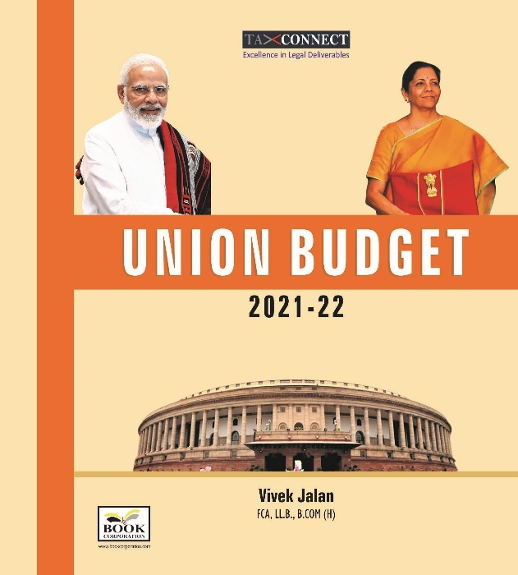
ABOUT THE BOOK: This publication includes:
1.Commentary on Budget
2.Finance Minister’s Budget Speech
3.Budget at a Glance
4.Memorandum
a. Direct Tax
b. Customs
c. Excise
d. GST
5. Finance Bill
6. Notes on Clauses

Authors:
Vivek Jalan
[FCA, L.LM (Constitutional Law), L.LB, CIDT(ICAI), B.Com(H)]

Published by: In Association With:
BOOK CORPORATION TAX CONNECT ACADEMY
4, R. N. Mukherjee Road 1, Old Court House Corner
Kolkata 700001 Kolkata 700001
Phones: (033) 64547999 Phones: (033) 40016761
Cell : 9830010297, 9331018333 Cell : 9874466163, 9830661254
Order by email:bookcorporation@gmail.com Order by email: info@taxconnect.co.in Website :www.bookcorporation.com Website : www.taxconnect.co.in

LET’S DISCUSS FURTHER!

OUR OFFICES:




DUBAI
Azizi Feirouz, 803, 8th Floor, AL Furjan, Opposite Discovery Pavillion, Dubai, UAE
Contact Person: Rohit Sharma
Email: rohit.sharma@taxconnect.co.in

KOLKATA
R No 119; 1st Floor; Diamond Arcade; 1/72, Cal Jessore Road; Kolkata – 700055
Contact Person: Priyanka Chowdhury
Email: priyanka.chowdhury@taxconnect.co.in

KOLKATA
1, Old Court House Corner, “Tobacco House”, 1st Floor, Room No. 13 (N), Kolkata-700001
Contact Person: Priyanka Chowdhury
Email: priyanka.chowdhury@taxconnect.co.in

MUMBAI
Building No.9, Flat- 403, LodhaEternis, 11th Road, MIDC, Andheri(E)-400093
Contact Person: Rajanikant Choudhury
Email: rajnikant.choudhary@taxconnect.co.in
DELHI
B-139, 2nd Floor, Transport Nagar, Noida-201301 (U.P)
Contact Person: Poonam Khemka
Email: poonam.khemka@taxconnectdelhi.co.in

BANGALORE
A-414,Carlton Towers, 19th Main; Road Hal Old Airport Rd, Domlur, Bengaluru, Karnataka-560008
Contact Person: Manmit Sinha
Email: manmit.sinha@taxconnectdelhi.co.in

Disclaimer:
This e-bulletin is for private circulation only. Views expressed herein are of the editorial team and are based on the information, explanation and documents available on Government portal platforms. Tax Connect or any of its employees do not accept any liability whatsoever direct or indirect that may arise from the use of the information contained herein. No matter contained herein may be reproduced without prior consent of Tax Connect. While this e-article has been prepared on the basis of published/other publicly available information considered reliable, we do not accept any liability for the accuracy of its contents.
Tax Connect 2021. All rights reserved.

