8
_{TAX CONNECT}

321st Issue: 24th October 2021 – 30th October 2021
12017

Knowledge Partner:



TAX CONNECT

Mumbai : A/1001, Cirrus Bldg, Cosmos Paradise; Pokhran Road No. 1, Thane (West), Maharashtra – 400606
Bangalore: A-414,Carlton Towers,19th Main; Road Hal Old Airport Rd, Domlur, Bengaluru, Karnataka-560008
New Delhi: B-139, 2nd Floor, Transport Nagar, Noida-201301 (U.P)
Kolkata : 1, Old Court House Corner, “Tobacco House” 1st Floor, R.No.-13 (North), Kolkata-700001
: Room No 119; 1st Floor; Diamond Arcade; 1/72, Cal Jessore Road; Kolkata – 700055

Dubai : AziziFeirouz, 803, 8th Floor, AL Furjan, Opposite Discovery Pavillion, Dubai, UAE

Contact: +919874466163; +91 9830661254
Website: www.taxconnect.co.in
Email: info@taxconnect.co.in



Friends,
The concept of discounts is a prevalent practice in the supply chain management. Discounts are offered by the principal manufacturers to the super-stockists/ distributors/retailers/dealers to incentivize greater sale of goods in the market to further business operations. However, the concept of post-sale discount under GST has created quite a fuss and is a potential area of litigation.
Post-sale discount from its plain reading suggests a discount which is given after the completion of the sales. In this regard, section 15 of the Central Goods and Services Tax Act, 2017 provides that the value of supply shall not include any post-sale discounts which is given:
- such discount is established in terms of an agreement entered into at or before the time of such supply
- such discount is specifically linked to relevant invoices ; and
- input tax credit as is attributable to the discount on the basis of document issued by the supplier has been reversed by the recipient of the supply.
Therefore, for a person to avail the benefit of a post-sale discount, all the above conditions have to be cumulatively satisfied.
Further, it is not sufficient that the mere mention of discounts is made in the agreement; the agreement should appropriately capture the quantum of the post-sale discount that will be offered or the methodology by which the discount will be arrived at. Hence, the post-sale

discount cannot be left entirely at the discretion of the supplier of goods/services. However, to what extent would such information be required to be captured in an agreement would be subject to interpretation basis the facts involved in each case.
In this backdrop, it is necessary to refer to the decision of the recent ruling given by The Kerala AAAR and observed that for a post-sale discount to be excluded from the value of supply it is necessary that the criteria for arriving at the quantum of the discount or percentage of the discount must be specified in the agreement.
The decision of the Kerala AAAR has opened the doors to multiple inquiries and investigations by the GST authorities on principal suppliers, distributors, super-stockists, dealers with regards to eligibility of discounts.
Therefore, it is imperative that principal suppliers, distributors, super-stockists, dealers undertake a review of their existing agreements and discount policies to ensure that it is in compliance with the provisions of the CGST Act, 2017 and rules made thereunder.

Just to reiterate that we remain available over telecom or e-mail.
Truly Yours
Editor:
Vivek Jalan
Partner - Tax Connect Advisory Services LLP
Co-Editors:
Rohit Sharma
Senior Manager – Tax Connect Advisory Services LLP
Rajanikant Choudhury
Manager - Tax Connect Advisory Services LLP
S.NO. | TOPICS | PAGE NO.
1] | TAX CALENDER | 4
2] | INCOME TAX | 5
NOTIFICATION | RELAXATION OF VALIDATION (SECTION 119 OF THE FINANCE ACT, 2012) RULES, 2021 NOTIFIED
NOTIFICATION | SPECIFIED INCOME OF PUNJAB STATE ELECTRICITY REGULATORY COMMISSION (PAN- AAAGT0052L) IS NOT TAXABLE
3] | GST | 6
CIRCULAR | CLARIFICATION REGARDING GST RATES & CLASSIFICATION(GOODS)
4] | FEMA | 7
NOTIFICATION | AMENDMENTS TO THE FOREIGN EXCHANGE MANAGEMENT (DEBT INSTRUMENTS) REGULATIONS, 2019 NOTIFIED
5] | CUSTOMS | 8-9
NOTIFICATION | FIXATION OF TARIFF VALUE OF EDIBLE OILS, BRASS SCRAP, ARECA NUT, GOLD AND SILVER.
6] | DGFT | 10
NOTIFICATION | AMENDMENT IN EXPORT POLICY OF SYRINGES.
7] | GST PLEADING AND PRACTICE: WITH SECTION-WISE GST CASES & GST NOTICES AND THEIR REPLIES | 11
8] | IN STANDS - AN INTEGRATED APPROACH TO GST E-INVOICING, E-WAYBILL & E-RETURN FILING | 12
9] | IN STANDS –SECTION WISE COMPENDIUM ON GST | 13
10] | IN STANDS – UNION BUDGET 2021 | 14
11] | LET’S DISCUSS FURTHER | 15

Due date | Form/Return/Challan | Reporting Period | Description
24th October 2021 | GSTR-3B | JULY 2021 TO SEPTEMBER 2021 | For Taxpayer with Annual Turnover Up-to Rs 5 crore – Category – 1 (North India)
30th October 2021 | Form 27D | JULY 2021 TO SEPTEMBER 2021 | Quarterly TCS certificate (in respect of tax collected by any person) for the quarter ending September 30, 2021
30th October 2021 | Form 26QB | September 2021 | Due Date for Furnishing of Challan-Cum-Statement in Respect of Tax Deducted Under Section 194IA In the Month of September, 2021
30th October 2021 | Form 26QC | September 2021 | Due Date for Furnishing of Challan-Cum-Statement in Respect of Tax Deducted Under Section 194IB in The Month of September, 2021
30th October 2021 | Form 26QD | September 2021 | Due Date for Furnishing of Challan-Cum-Statement in Respect of Tax Deducted Under Section 194M in The Month of September, 2021

NOTIFICATION
Relaxation of Validation (section 119 of the Finance Act, 2012) Rules, 2021 NOTIFIED
OUR COMMENTS: Department of Revenue, Ministry of Finance, Central Board of Direct Taxes, notified Relaxation of Validation (section 119 of the Finance Act, 2012) Rules, 2021 vide Notification No. 120/2021 Dated: 13th October, 2021.
Form and manner of furnishing undertaking under first proviso to section 119.- The form and manner of furnishing undertaking under Explanation to fifth and sixth proviso to Explanation 5 to clause (i) of sub-section (1) of section 9 of the Income-tax Act, 1961 (43 of 1961), as prescribed under sub-rule (1) and sub-rule (3) of rule 11UE and rule 11UF of the Income-tax Rules, 1962, shall mutatis mutandis apply to clauses (i), (ii) and (iii) of the first proviso to section 119 of the Finance Act, 2012 (23 of 2012).
Conditions under clause (iv) of first proviso to section 119.- The conditions for the purposes of clause (iv) of the Explanation to fifth and sixth proviso to Explanation 5 to clause (i) of sub-section (1) of section 9 of the Income-tax Act, 1961 (43 of 1961), as prescribed under sub-rule (2) of rule 11UE of the Income-tax Rules, 1962, shall mutatis mutandis apply to clause (iv) of the first proviso to section 119 of the Finance Act, 2012 (23 of 2012).
[For further details please refer the notification]

NOTIFICATION
SPECIFIED INCOME OF punjab state electricity regulatory commission (PAN- AAAGT0052L) IS NOT TAXABLE
OUR COMMENTS: Department of Revenue, Ministry of Finance, Central Board of Direct Taxes, u/s 10(46) of Income Tax Act 1961 notified vide Notification No. 121/2021 Dated: 13th October, 2021 ‘Punjab State Electricity Regulatory Commission’ Chandigarh (PAN- AAAGT0052L), a commission established by the state government of Punjab, in respect of the specified income arising to that commission namely:-
(a) amount received in the form of processing fee for the determination of tariff;
(b) amount received in the form of licence fee;
(c) amount received in the form of petition fee; and
(d) amount of interest income earned on bank deposits.
2. This notification shall be effective subject to the conditions that Punjab State Electricity Regulatory Commission, Chandigarh,-
(a) shall not engage in any commercial activity;
(b) activities and the nature of the specified income shall remain unchanged throughout the financial years; and
(c) shall file return of income in accordance with the provision of clause (g) of sub-section (4C) of section 139 of the Income-tax Act, 1961.3.
This notification shall apply with respect to the financial years 2021-2022, 2022-2023, 2023-2024, 2024-2025 and 2025-2026.
[For further details please refer the notification]
CIRCULAR
CLARIFICATION REGARDING GST RATES & CLASSIFICATION (GOODS)
OUR COMMENTS: Department of Revenue, Ministry of Finance, Government of India, vide Circular No. 163/19/2021-GST and F. No. 190354/206/2021-TRU dated 06.10.2021, issued clarification regarding GST rates & classification (goods) based on the recommendations of the GST Council in its 45th meeting held on 17th September, 2021 at Lucknow as under:
- The exemption from GST on fresh fruits and nuts covers only such products which are not frozen or dried in any manner.

- With effect from 1.10.2021, tamarind and other seeds falling under heading 1209, (i.e. including tamarind seeds), if not supplied as seed for sowing, would attract GST at the rate of 5%.

- Copra, classified under heading 1203, attracts GST rate of 5% irrespective of use.

- Pure henna powder and henna leaves, having no additives, is classifiable under tariff item 1404 90 90 and shall attract GST rate of 5%. Further, the GST rate on mehndi paste in cones falling under heading 1404 and 3305 shall be 5%.

- Scented sweet supari falls under tariff item 2106 90 30 as “Betel nut product” known as “Supari” and attracts GST rate of 18%. Flavored and coated illaichi generally consists of Cardamom Seeds, Aromatic Spices, Silver Leaf, Saffron, Artificial Sweeteners falls under sub-heading 2106. It accordingly attracts GST at the rate of 18%.

- Brewers' Spent Grain (BSG), Dried Distillers’ Grains with Soluble [DDGS] and other such residues are classifiable under heading 2303, attracting GST at the rate of 5%.

- Entry 65 covers all goods as specified in Chapter Note 4 and Chapter Note 4 in turn covers all goods covered under Heading 3006. Therefore, said entry 65 covers all goods falling under heading 3006, irrespective of the fact that such goods are specifically mentioned in said entry. Therefore, all goods falling under heading 3006 attract GST rate of 12% under entry 65 in the 12% rate schedule.

- GST rate @ 12% will be applicable on all laboratory reagents and other goods falling under heading 3822.

- Only Original/ import Essentiality certificate, issued by the Directorate General of Hydrocarbons (DGH) is required on each inter-State stock transfer of goods imported at concessional GST rate for petroleum operations. There is no need for taking a certificate every time on inter-state movement of goods within the same company / stock transfer so long as the goods are the same as those imported by the company at concessional rate.

- UPS/ inverter would attract GST rate of 18% under heading 8504, while external batteries would attract the GST rate as applicable to it under heading 8507 (28% for all batteries except lithium-ion battery).

- GST on Solar PV Power Projects can be paid in terms of the 70:30 ratio for goods and services, respectively, for the period of 1st July, 2017 to 31st December, 2018, in the same manner as has been prescribed for the period on or after 1st January, 2019. However, no refunds will be granted if GST already paid is more than the amount determined using this mechanism.

- GST @ 18% on Fibre Drums, whether corrugated or non-corrugated classifiable under heading 4819 (with effect from 1st October, 2021. For the period prior to 1.10.2021, supplies of such Fibre Drums even if made at 12% GST (during the period from 1.7.2017 to 30.9.2021), would be treated as fully GST-paid. Therefore, no action for recovery of differential tax (over and above 12% already paid) would arise. However, as this decision has only been taken to regularize the past practice in view of certain ambiguity, as detailed in para 14.1, no refund of GST already paid shall be allowed if already paid at 18%. [For further details please refer to the circular]
NOTIFICATION
amendments to the Foreign Exchange Management (Debt Instruments) Regulations, 2019 NOTIFIED
OUR COMMENTS: The Financial Markets Regulation Department, Reserve Bank of India makes the following amendments to the Foreign Exchange Management (Debt Instruments) Regulations, 2019 (Notification No. FEMA.396/2019-RB dated October 17, 2019) (hereinafter referred to as 'the Principal Regulation'), vide notification No. FEMA.396(1)/2021-RB,dated 13th October, 2021 namely:-
(i) These Regulations shall be called the Foreign Exchange Management (Debt Instruments) (First Amendment) Regulations, 2021.
(ii) They shall come into force with effect from the date of their publication in the Official Gazette i.e. 13th October, 2021.
Amendment to Regulation 2 of the Foreign Exchange Management (Debt Instruments) Regulations, 2019 (Principal Regulation):
- In Regulation 2 of the Principal Regulation, after clause (i), the following new clause shall be inserted:

“(ia) “Infrastructure Investment Trust” or “InvIT” means a business trust as defined in sub-clause (i) of clause 13A of section 2 of the Income-tax Act, 1961.”

- In Regulation 2 of the Principal Regulation, after clause (q), the following new clause shall be inserted:

“(qa) “Real Estate Investment Trust” or “REIT” means a business trust as defined in sub-clause (ii) of clause 13A of section 2 of the Income-tax Act, 1961.”

Amendment to Schedule 1 to the Foreign Exchange Management (Debt Instruments) Regulations, 2019 (Principal Regulation):
- In sub-paragraph A of paragraph 1 of Schedule 1 to the Principal Regulation, after clause (k), the following new clause shall be inserted: -

“(l) debt securities issued by (i) InvITs and (ii) REITs.”
[For further details please refer the notification]

NOTIFICATION
Fixation of Tariff Value of Edible Oils, Brass Scrap, Areca Nut, Gold and Silver.
OUR COMMENTS: The Department of Revenue, Ministry of Finance, Central Board of Indirect Taxes and Customs vide Notification No. 81/2021-CUSTOMS (N.T.) dated 14th October 2021 notified the revised tariff for Edible Oils, Brass Scrap, Poppy Seeds, Areca Nut, Gold and Silver etc. :
In the said notification, for TABLE-1, TABLE-2, and TABLE-3 the following Tables shall be substituted, namely: -
“TABLE-1
Sl. No. | Chapter/ heading/ sub-heading/tariff item | Description of goods | Tariff value
Sl. No. | Chapter/ heading/ sub-heading/tariff item | Description of goods | (US $Per Metric Tonne)
1 | 1511 10 00 | Crude Palm Oil | 1203
2 | 1511 90 10 | RBD Palm Oil | 1214
3 | 1511 90 90 | Others – Palm Oil | 1209
4 | 1511 10 00 | Crude Palmolein | 1221
5 | 1511 90 20 | RBD Palmolein | 1224
6 | 1511 90 90 | Others – Palmolein | 1215
7 | 1507 10 00 | Crude Soya bean Oil | 1388
8 | 7404 00 22 | Brass Scrap (all grades) | 5300

“TABLE 2
Sl. No. | Chapter/ heading/ sub-heading/tariff item | Description of goods | Tariff value (US $)
1 | 71 or 98 | Gold, in any form, in respect of which the benefit of entries at serial number 356 of the Notification No. 50/2017-Customs dated 30.06.2017 is availed | 575 per 10 grams
2 | 71 or 98 | Silver, in any form, in respect of which the benefit of entries at serial number 357 of the Notification No. 50/2017-Customs dated 30.06.2017 is availed | 739 per kilogram
3 | 71 | (i) Silver, in any form, other than medallions and silver coins having silver content not below 99.9% or semi-manufactured forms of silver falling under sub-heading 7106 92; | 739 per kilogram
3 | 71 | (ii) Medallions and silver coins having silver content not below 99.9% or semi-manufactured forms of silver falling under sub-heading 7106 92, other than imports of such goods through post, courier or baggage. | 739 per kilogram
3 | 71 | Explanation. - For the purposes of this entry, silver in any form shall not include foreign currency coins, jewellery made of silver or articles made of silver. | 739 per kilogram
4 | 71 | (i) Gold bars, other than tola bars, bearing manufacturer’s or refiner’s engraved serial number and weight expressed in metric units; | 575 per 10 grams
4 | 71 | (ii) Gold coins having gold content not below 99.5% and gold findings, other than imports of such goods through post, courier or baggage. | 575 per 10 grams
4 | 71 | Explanation. - For the purposes of this entry, “gold findings” means a small component such as hook, clasp, clamp, pin, catch, screw back used to hold the whole or a part of a piece of Jewellery in place. | 575 per 10 grams

“TABLE 3

Sl. No. | Chapter/ heading/ sub-heading/tariff item | Description of goods | Tariff value
Sl. No. | Chapter/ heading/ sub-heading/tariff item | Description of goods | (US $ Per Metric Tonne)
1 | 80280 | Areca nuts | 5252”

This notification shall come into force with effect from the 15th day of October, 2021.

[For further details please refer the Notifications]

NOTIFICATION
Amendment in Export Policy of Syringes
OUR COMMENTS: The Directorate General of Foreign Trade, Department of Commerce, Ministry of Commerce and Industry, Government of India Vide Notification No. 38/2015-2020 dated 14th October 2021, notified the following amendment to the Notification No.34/2015-2020 dated 4th October, 2021 pertaining to Chapter 90 of Schedule - 2 of ITC (HS) Export Policy, 2018 related to export of Syringes:
Current Policy (As per Notification No. 34 dated 04/10/2021):
S. No. | ITC HS Codes | Existing Description | Export Policy
207AD | 90183100 | Syringes with or without Needles | Restricted

Revised Policy
S.No. | ITC HS Codes | Revised Description | Export Policy
207AD | 90183100 | Syringes with or without Needles of the following denominations : | Restricted
207AD | 90183100 | - 0.5 ml/ 1ml AD syringes. | Restricted
207AD | 90183100 | - 0.5 ml/1 ml/2 ml/3 ml disposable syringes. | Restricted
207AD | 90183100 | - 1ml/2 ml/3 ml RUP Syringes | Restricted

Effect of this Notification:
The export of Syringes with or without Needles of denominations (i) 0.5 ml/ 1ml AD syringes (ii) 0.5 ml/1 ml/2 ml/3 ml disposable syringes and (iii) 1ml/2 ml/3 ml RUP Syringes falling under HS code specified above or under any other HS code has been put under Restricted category with immediate effect.
All other syringes falling under HS code specified above or under any other HS code are freely exportable. The procedure for submission and approval of applications for export of syringes has been notified vide Trade Notice No. 20/2021-22 dated 5th October, 2021.
[For further details please refer the Notification]

:IN STANDS

GST PLEADING AND PRACTICE: With Section-wise GST Cases & GST Notices and their Replies
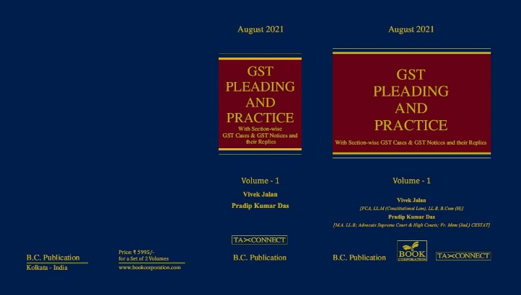

ABOUT THE BOOK: This publication includes:
1. GST Notices and their Replies
2. Orders and Appeals under GST
3. Text of provisions under IGST Act 2017 & CGST Act 2017
4. CGST & IGST Section-wise Synopsis of Case Laws and Notification/Circulars Gist
5. CGST & IGST Section-wise Synopsis of “Question of Law” answered under GST
6. Completely Updated Synopsis of Case Laws under GST by Supreme Court, High Court, AAARs & AARs

Authors:
Vivek Jalan
[FCA, LL.M (Constitutional Law), LL.B, B.Com(H)]

Pradip Kumar Das
[M.A. LL.B; Advocate Supreme Court & High Courts; Fr. Mem (Jud.) CESTAT]

Published by: In Association With:
BOOK CORPORATION TAX CONNECT ACADEMY
4, R. N. Mukherjee Road 1, Old Court House Corner
Kolkata 700001 Kolkata 700001
Phones: (033) 64547999 Phones: (033) 40016761
Cell : 9830010297, 9331018333 Cell : 9874466163, 9830661254
Order by email:bookcorporation@gmail.com Order by email: info@taxconnect.co.in Website :www.bookcorporation.com Website
: www.taxconnect.co.in

:IN STANDS

AN INTEGRATED APPROACH TO GST E-INVOICING, E-WAYBILL & E-RETURN FILING
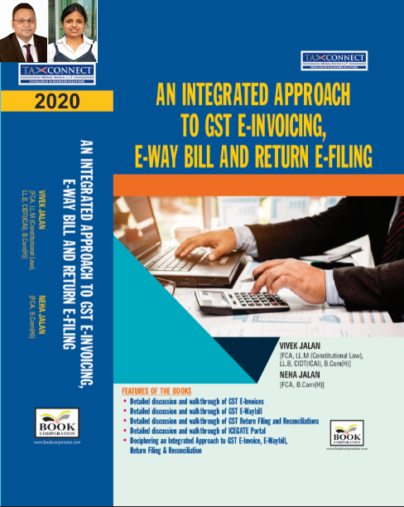
ABOUT THE BOOK: This publication includes:
- Detailed discussion and walkthrough of GST E-Invoices.
- Detailed discussion and walkthrough of GST E-Waybill.
- Detailed discussion and walkthrough of GST Return Filing and Reconciliations.
- Detailed discussion and walkthrough of ICEGATE Portal.
- Deciphering an Integrated Approach to GST E-Invoice, E-Waybill, Return Filing & Reconciliation

Authors:
Vivek Jalan
[FCA, L.LM (Constitutional Law), L.LB, CIDT(ICAI), B.Com(H)]

Neha Jalan
[FCA, B.Com(H)]

Published by: In Association With:
BOOK CORPORATION TAX CONNECT ACADEMY
4, R. N. Mukherjee Road 1, Old Court House Corner
Kolkata 700001 Kolkata 700001
Phones: (033) 64547999 Phones: (033) 40016761
Cell : 9830010297, 9331018333 Cell : 9874466163, 9830661254
Order by email:bookcorporation@gmail.com Order by email: info@taxconnect.co.in Website :www.bookcorporation.com Website : www.taxconnect.co.in

:IN STANDS

Section wise Compendium on GST
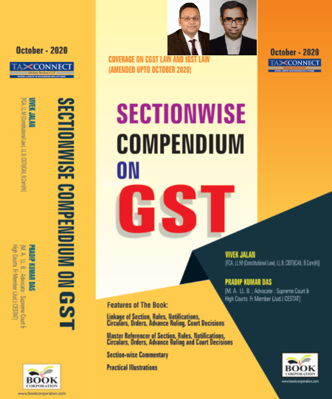
ABOUT THE BOOK: This publication includes:
1. Linkage of Section, Rules, Notifications, Circulars, Orders, Advance Ruling, Court Decisions
2. Master Referencer of Section, Rules, Notifications, Circulars, Orders, Advance Ruling and Court Decisions
3. Section-wise Commentary
4. Practical Illustrations

Authors:
Vivek Jalan
[FCA, L.LM (Constitutional Law), L.LB, CIDT(ICAI), B.Com(H)]

Pradip Kumar Das
[M.A. LL.B; Advocate Supreme Court & High Courts; Fr. Mem (Jud.) CESTAT]

Published by: In Association With:
BOOK CORPORATION TAX CONNECT ACADEMY
4, R. N. Mukherjee Road 1, Old Court House Corner
Kolkata 700001 Kolkata 700001
Phones: (033) 64547999 Phones: (033) 40016761
Cell : 9830010297, 9331018333 Cell : 9874466163, 9830661254
Order by email:bookcorporation@gmail.com Order by email: info@taxconnect.co.in Website :www.bookcorporation.com Website : www.taxconnect.co.in

:IN STANDS

UNION BUDGET 2021
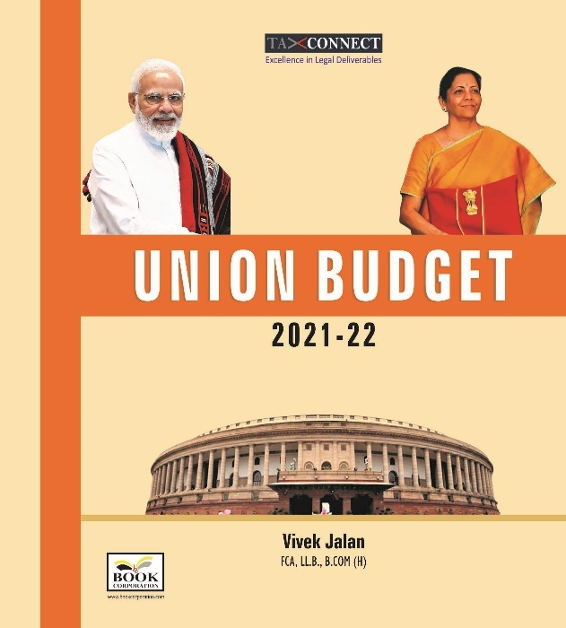
ABOUT THE BOOK: This publication includes:
1.Commentary on Budget
2.Finance Minister’s Budget Speech
3.Budget at a Glance
4.Memorandum
a. Direct Tax
b. Customs
c. Excise
d. GST
5. Finance Bill
6. Notes on Clauses

Authors:
Vivek Jalan
[FCA, L.LM (Constitutional Law), L.LB, CIDT(ICAI), B.Com(H)]

Published by: In Association With:
BOOK CORPORATION TAX CONNECT ACADEMY
4, R. N. Mukherjee Road 1, Old Court House Corner
Kolkata 700001 Kolkata 700001
Phones: (033) 64547999 Phones: (033) 40016761
Cell : 9830010297, 9331018333 Cell : 9874466163, 9830661254
Order by email:bookcorporation@gmail.com Order by email: info@taxconnect.co.in Website :www.bookcorporation.com Website : www.taxconnect.co.in

LET’S DISCUSS FURTHER!

OUR OFFICES:




DUBAI
Azizi Feirouz, 803, 8th Floor, AL Furjan, Opposite Discovery Pavillion, Dubai, UAE
Contact Person: Rohit Sharma
Email: rohit.sharma@taxconnect.co.in

KOLKATA
R No 119; 1st Floor; Diamond Arcade; 1/72, Cal Jessore Road; Kolkata – 700055
Contact Person: Priyanka Chowdhury
Email: priyanka.chowdhury@taxconnect.co.in

KOLKATA
1, Old Court House Corner, “Tobacco House”, 1st Floor, Room No. 13 (N), Kolkata-700001
Contact Person: Priyanka Chowdhury
Email: priyanka.chowdhury@taxconnect.co.in

MUMBAI
Building No.9, Flat- 403, LodhaEternis, 11th Road, MIDC, Andheri(E)-400093
Contact Person: Rajanikant Choudhury
Email: rajnikant.choudhary@taxconnect.co.in
DELHI
B-139, 2nd Floor, Transport Nagar, Noida-201301 (U.P)
Contact Person: Poonam Khemka
Email: poonam.khemka@taxconnectdelhi.co.in

BANGALORE
A-414,Carlton Towers, 19th Main; Road Hal Old Airport Rd, Domlur, Bengaluru, Karnataka-560008
Contact Person: Manmit Sinha
Email: manmit.sinha@taxconnectdelhi.co.in

Disclaimer:
This e-bulletin is for private circulation only. Views expressed herein are of the editorial team and are based on the information, explanation and documents available on Government portal platforms. Tax Connect or any of its employees do not accept any liability whatsoever direct or indirect that may arise from the use of the information contained herein. No matter contained herein may be reproduced without prior consent of Tax Connect. While this e-article has been prepared on the basis of published/other publicly available information considered reliable, we do not accept any liability for the accuracy of its contents.
Tax Connect 2021. All rights reserved.

