8
_{TAX CONNECT}

320th Issue: 17th October 2021 – 23rd October 2021
12017

Knowledge Partner:



TAX CONNECT

Mumbai : A/1001, Cirrus Bldg, Cosmos Paradise; Pokhran Road No. 1, Thane (West), Maharashtra – 400606
Bangalore: A-414,Carlton Towers,19th Main; Road Hal Old Airport Rd, Domlur, Bengaluru, Karnataka-560008
New Delhi: B-139, 2nd Floor, Transport Nagar, Noida-201301 (U.P)
Kolkata : 1, Old Court House Corner, “Tobacco House” 1st Floor, R.No.-13 (North), Kolkata-700001
: Room No 119; 1st Floor; Diamond Arcade; 1/72, Cal Jessore Road; Kolkata – 700055

Dubai : AziziFeirouz, 803, 8th Floor, AL Furjan, Opposite Discovery Pavillion, Dubai, UAE

Contact: +919874466163; +91 9830661254
Website: www.taxconnect.co.in
Email: info@taxconnect.co.in



Friends,
GST at the rate of 18 per cent is imposed on royalty given to the state governments for mining rights. Recently, the Hon’ble Supreme Court has stayed the imposition of GST on royalty paid mining rights given to a petitioner.
While the rate schedule was earlier amended to impose GST on this royalty from January 1, 2019, the tax research unit of the Central Board of Indirect Taxes and Customs (CBIC) recently clarified that the tax would also be applied from July 1, 2017 and December 31, 2018.
Any order by the Supreme Court on the issue would also have ramifications on other sectors such as casino and telecom, where GST is imposed on the license fee.
Royalty paid to the state government for mining rights is a statutory levy and accordingly the question of applicability of GST is subject to judicial review as there is no quid pro quo for the payment.

STATE CANNOT IMPOSE TAX ON SALES OF ENA: Further, the hon’ble Allahabad high court held recently that the State lost its legislative competence to enact laws, to impose tax on sales of Extra Neutral Alcohol (ENA), upon the enactment of the 101st Constitution Amendment. Consequently, and upon considering Section 174(1)(i) of UPGST Act, 2017, the impugned Notification dated 17.12.2019, insofar as it seeks to impose UPVAT on ENA, Rectified Spirit and Special Denatured Spirit (SDS), is ultra vires, both on account of lack of (i) legislative competence and (ii) valid delegation. It is therefore quashed. Consequentially, all assessment Orders/Notices issued to the petitioner, impugned in these writ petitions, holding otherwise are also quashed.

It is further directed, subject to applicability of the rule against unjust enrichment, any amount that may have been deposited by the petitioners (except petitioners claiming under this order, in Writ Tax 355 of 2020), by way of UPVAT on ENA on or after 01.07.2017, may be refunded to them, within a period of one month from the date of order.

Just to reiterate that we remain available over telecom or e-mail.

Truly Yours
Editor:
Vivek Jalan
Partner - Tax Connect Advisory Services LLP
Co-Editors:
Rohit Sharma
Senior Manager – Tax Connect Advisory Services LLP
Rajanikant Choudhury
Manager - Tax Connect Advisory Services LLP
S.NO. | TOPICS | PAGE NO.
1] | TAX CALENDER | 4
2] | INCOME TAX | 5
NOTIFICATION | EXEMPTION TO SPECIFIED PERSONS FROM REQUIREMENT OF FURNISHING A RETURN OF INCOME FOR ASSESSMENT YEAR 2021-2022
3] | GST | 6
CIRCULAR | CLARIFICATION ON THE ISSUES IN RESPECT OF REFUND OF TAX WRONGFULLY PAID
4] | FEMA | 7
NOTIFICATION | FOREIGN EXCHANGE MANAGEMENT (NON-DEBT INSTRUMENTS) (FOURTH AMENDMENT) RULES, 2021
5] | CUSTOMS | 8
NOTIFICATION | BCD ON CRUDE AND REFINED SOYA, SUNFLOWER AND PALM OILS REDUCED TILL 31.03.2022
NOTIFICATION | AGRICULTURE INFRASTRUCTURE AND DEVELOPMENT CESS (AIDC) ON CRUDE SOYA, SUNFLOWER AND PALM OILS REDUCED TILL 31.03.2022
6] | DGFT | 9
NOTIFICATION | RELAXATION IN EXPORT POLICY OF RED SANDERS WOOD
NOTIFICATION | AMENDMENT IN EXPORT POLICY OF MELT BLOWN FABRIC
7] | GST PLEADING AND PRACTICE: WITH SECTION-WISE GST CASES & GST NOTICES AND THEIR REPLIES | 10
8] | IN STANDS - AN INTEGRATED APPROACH TO GST E-INVOICING, E-WAYBILL & E-RETURN FILING | 11
9] | IN STANDS –SECTION WISE COMPENDIUM ON GST | 12
10] | IN STANDS – UNION BUDGET 2021 | 13
11] | LET’S DISCUSS FURTHER | 14

Due date | Form/Return/Challan | Reporting Period | Description
20th October 2021 | GSTR-3B | September 2021 | Return form for the tax period September 2021 by Taxpayer with Annual Turnover More than Rs 5 crore & for Taxpayer who has not opted for QRMP Scheme having Turnover up to 5 crores.
22nd October 2021 | GSTR-3B | September 2021 | Return form for the tax period September 2021 by Taxpayer with Annual Turnover Up-to Rs 5 crore – Category – 1
24th October 2021 | GSTR-3B | September 2021 | Return form for the tax period September 2021 by Taxpayer with Annual Turnover Up-to Rs 5 crore – Category – 2
18th October 2021 | CMP 08 | July-September 2021 | Details or summary of self-assessed tax which is payable for a given quarter by taxpayers who are registered as composition taxable person or taxpayer who have opted for composition levy.
20th October 2021 | GSTR 5 | September 2021 | Return to be filed by Non-Resident taxable person
20th October 2021 | GSTR 5A | September 2021 | Return to be filed by to be filed by the OIDAR.

NOTIFICATION
Exemption to specified persons from requirement of furnishing a return of income for assessment year 2021-2022
OUR COMMENTS: Department of Revenue, Ministry of Finance, Central Board of Direct Taxes, notified Exemption to specified persons from requirement of furnishing a return of income under section 139(1) for assessment year 2021-2022 vide Notification No. 119/2021 Dated: 11th October, 2021.
TABLE
Sl. No. | class of Persons | Conditions
(1) | (2) | (3)
1. | (i) a non-resident, not being a company; or  (ii) a foreign company. | (i) The said class of persons does not earn any income in India, during the previous year, other than the income from investment in the specified fund referred to in sub-clause (i) of clause (c) of Explanation to clause (4D) of section 10 of the said Act; and  (ii) The provisions of section 139A of the said Act are not applicable to the said class of persons subject to fulfillment of the conditions mentioned in sub-rule (1) of rule 114AAB of the Income-tax Rules, 1962 (hereinafter referred to as ‘said rules’).
2 | a non-resident, being an  eligible foreign investor. | (i) The said class of persons, during the previous year, has made transaction only in capital asset referred to in clause (viiab) of section 47 of the said Act, which are listed on a recognised stock exchange located in any International Financial Services Centre and the consideration on transfer of such capital asset is paid or payable in foreign currency;  (ii) The said class of persons does not earn any income in India, during the previous year, other than the income from transfer of capital asset referred to in clause (viiab) of section 47 of the said Act; and  (iii) The provisions of section 139A of the said Act are not applicable to the said class of persons subject to fulfillment of the conditions mentioned in sub-rule (2A) of rule 114AAB of the said rules.
Explanation. -For the purposes of this Notification. -
(a) "eligible foreign investor" means a non-resident who operates in accordance with the Securities and Exchange Board of India, circular IMD/HO/FPIC/CIR/P/2017/003 dated 04th January, 2017;
(b) “International Financial Services Centre” shall have the same meaning as assigned to it in clause (q) of section 2 of the Special Economic Zones Act, 2005 (28 of 2005);
(c) "recognised stock exchange" shall have the meaning as assigned to it in clause (ii) of Explanation 1 to sub-section (5) of section 43 of the said Act.

The above exemption from the requirement of furnishing a return of income shall not be available to the class of persons mentioned in the column (2) of the said Table where a notice under sub-section (1) of section 142 or section 148 or section 153A or section 153C of the said Act has been issued for filing a return of income for the assessment year specified therein.

[For further details please refer the Notification]

CIRCULAR
CLARIFICATION ON THE ISSUES IN RESPECT OF REFUND OF TAX WRONGFULLY PAID
OUR COMMENTS: The GST Policy Wing, Central Board of Indirect Taxes and Customs, Department of Revenue, Ministry of Finance, Government of India, vide Circular No. 162/18/2021-GST and F. No. CBIC-20001/8/2021-GST dated 25.09.2021, issued Clarification on the issues in respect of refund of tax wrongfully paid as specified in section 77(1) of the CGST Act, 2017 and section 19(1) of the IGST Act, 2017.
It is clarified through the circular that the term “subsequently held” in section 77 of CGST Act, 2017 or under section 19 of IGST Act, 2017 covers both the cases where the inter-State or intra-State supply made by a taxpayer, is either subsequently found by taxpayer himself as intra-State or inter-State respectively or where the inter-State or intra-State supply made by a taxpayer is subsequently found/ held as intra-State or inter-State respectively by the tax officer in any proceeding.
Accordingly, refund claim under the said sections can be claimed by the taxpayer in both the above mentioned situations, provided the taxpayer pays the required amount of tax in the correct head.
It is clarified through the circular that the refund under section 77 of CGST Act/ Section 19 of IGST Act, 2017 can be claimed before the expiry of two years from the date of payment of tax under the correct head, i.e. integrated tax paid in respect of subsequently held inter-State supply, or central and state tax in respect of subsequently held intra-State supply, as the case may be. However, in cases, where the taxpayer has made the payment in the correct head before the date of issuance of notification No.35/2021-Central Tax dated 24.09.2021, the refund application under section 77 of the CGST Act/ section 19 of the IGST Act can be filed before the expiry of two years from the date of issuance of the said notification. i.e. from 24.09.2021.
Rule 89 (1A) of the CGST Rules would be applicable for section 19 of the IGST Act also, where the taxpayer has initially paid IGST on a specific transaction which later on is held as intra-State supply and the taxpayer accordingly pays CGST and SGST on the said transaction. It is also clarified that any refund applications filed, whether pending or disposed off, before issuance of notification No.35/2021-Central Tax, dated 24.09.2021, would also be dealt in accordance with the provisions of rule 89 (1A) of the CGST Rules, 2017.
It is further clarified that Refund under section 77 of the CGST Act / section 19 of the IGST Act would not be available where the taxpayer has made tax adjustment through issuance of credit note under section 34 of the CGST Act in respect of the said transaction.
[For further details please refer the circular]
NOTIFICATION
FOREIGN Exchange Management (Non-debt Instruments) (FOURTH Amendment) Rules, 2021 NOTIFIED
OUR COMMENTS: The Department of Economic Affairs, Ministry of Finance made the following rules further to amend the Foreign Exchange Management (Non-debt Instruments) Rules, 2019, vide Notification No. S.O. 4242(E) - dated 12th October 2021.
In the Foreign Exchange Management (Non-debt Instruments) Rules, 2019, in Schedule I, in the Table, -
(i) against Sl. No. 14.1, -
(a) in column (2), under the heading “Sector/Activity”, for the entry, the following entry shall be substituted, namely:-
“All telecom services including Telecom Infrastructure Providers Category-I, viz. Basic, Cellular, United Access Services, Unified license (Access services), Unified License, National/International Long Distance, Commercial V-Sat, Public Mobile Radio Trunked Services (PMRTS), Global Mobile Personal Communications Services (GMPCS), all types of ISP licenses, Voice Mail/Audiotex/UMS, Resale of IPLC, Mobile Number Portability services, Infrastructure Provider Category-I (providing dark fibre, right of way, duct space, tower), Other Service Providers and such other services as may be permitted by the Department of Telecommunications (DoT).”;
(b) in column (4), under the heading “Entry Route”, for the entry, the following entry shall be substituted, namely: -

“Automatic”;
(ii) against Sl. No. 14.2, in column (2), under the sub-heading “Other conditions”, for the entry, the following entry shall be substituted, namely: -
“The licensing, security and any other terms and conditions as notified by Department of Telecommunications (DoT) from time to time, shall be observed by licensee/entities providing services as referred in serial number 14.1 above as well as investors.”
[For further details please refer the notification]

NOTIFICATION
BCD on crude and refined soya, sunflower and palm oils REDUCED till 31.03.2022
OUR COMMENTS: The Department of Revenue, Ministry of Finance, Government of India Vide Notification No. 48/2021-Customs dated 13th October 2021 notified reduction in BCD on crude and refined soya, sunflower and palm oils till 31.03.2022.
Through the notification, it is hereby exempts the goods of the description specified in column (3) of the Table below, falling within the Chapter, heading, sub–heading or tariff item of the First Schedule to the Customs Tariff Act, 1975 (51 of 1975) specified in column (2) of the said Table, when imported into India, from so much of the duty of customs leviable thereon under the said First Schedule to the Customs Tariff Act, 1975 (51 of 1975), as is in excess of the amount calculated at the standard rate specified in the corresponding entry in column (4) of the said Table, namely –
Table
S. No. | Chapter or Heading or sub-heading or tariff item | Description of goods | Standard rate
(1) | (2) | (3) | (4)
1. | 1507 10 00 | Crude Soya-bean oil, whether or not degummed | Nil
2. | 1507 90 10 | Soya-bean oil, edible grade | 17.5%
3. | 1511 10 00 | Crude Palm Oil | Nil
4. | 1511 90 | Refined bleached deodorized(RBD) palm oil, RBD palmolein, RBD palm stearin and any palm oil other than crude palm oil | 17.5%
5. | 1512 11 10 | Crude Sunflower seed oil | Nil
6. | 1512 19 10 | Sunflower oil, edible grade | 17.5%

This notification shall come into effect on the 14th October, 2021, and will remain in force up to and inclusive of the 31st March, 2022.
NOTIFICATION
Agriculture Infrastructure and Development Cess (AIDC) on crude soya, sunflower and palm oils REDUCED till 31.03.2022
OUR COMMENTS: The Department of Revenue, Ministry of Finance, Government of India Vide Notification No. 49/2021-Customs dated 13th October 2021 notified reduction in AIDC on crude soya, sunflower and palm oils till 31.03.2022.
Through the notification, it is hereby exempts goods of the description specified in column (3) of the Table below and falling within the Chapter, heading or sub-heading or tariff item of the First Schedule to the Customs Tariff Act, 1975 (51 of 1975) as specified in column (2) of the said Table, from so much of the Agriculture Infrastructure and Development Cess leviable thereon under the said section of the Finance Act, 2021 (13 of 2021), as is in excess of the amount calculated at the rate specified in column (4) of the said Table, namely: -
Table
S. No. | Chapter or Heading or sub-heading or tariff item of the First Schedule | Description of goods | Rate
(1) | (2) | (3) | (4)
1. | 1507 10 00 | Crude Soya-bean oil, whether or not degummed | 5%
2. | 1511 10 00 | Crude Palm Oil | 7.5%
3. | 1512 11 10 | Crude Sunflower seed oil | 5%
2. This notification shall come into effect on the 14th October, 2021, and will remain in force up to and inclusive of the 31st March, 2022.
[For further details please refer the Notifications]

NOTIFICATION
Relaxation in Export Policy of Red Sanders Wood
OUR COMMENTS: The Directorate General of Foreign Trade, Department of Commerce, Ministry of Commerce and Industry, Government of India Vide Notification No. 35/2015-2020 dated 7th October 2021, notified amendment in the S.No.188, Schedule - 2 of ITC (HS) Export Policy, 2018 for providing relaxation in Export Policy of Red Sanders Wood.
The export policy as stipulated in Column 5 against S.No. 188 of Chapter 44 of Schedule - 2 of ITC (HS) Export Policy, 2018 shall be relaxed to allow export of 810.1894 MT of red Sanders Wood in the form of log fallen due to cyclone from Paralakhemundi Forest Division in the state of Odisha".
On the recommendation of Ministry of Environment, forest and Climate Change vide O.M. E.F. No.5-10/2019-SU (Pt.) dated 06.8.2021 and dated 21.09.2021, Forest, Environment & Climate Change Department, Government of Odisha is hereby permitted to export 810.1894 MT Red Sanders Wood in log form.
Forest, Environment & Climate Change Department, Government of Odisha shall finalize the modalities for export of the respective quantity within 12 months from the date of issuance of the notification.
Effect of this Notification:
Prohibition on export of Red Sanders wood in log form has been relaxed for export of 810.1894 MT of Red Sanders wood in log form by Forest, Environment & Climate Change Department, Government of Odisha.
[For further details please refer the Notification]

NOTIFICATION
Amendment in Export Policy of Melt Blown Fabric
S.No | ITCHS  Codes | Description | Existing Policy | Revised Policy
207 C | 560312  560392  560311  569313  560314  560391  560393  560394 | Melt Blown Fabric of any GSM | Prohibited | Free
OUR COMMENTS: The Directorate General of Foreign Trade, Department of Commerce, Ministry of Commerce and Industry, Government of India Vide Notification No. 36/2015-2020 dated 14th October 2021, notified amendment in Notification No. 28/2015-20 dated 18.08.2020 for Amendment in Export Policy of Melt Blown Fabric.

Effect of this Notification:
The Melt Blown Fabric of any GSM has been made freely exportable with immediate effect.

[For further details please refer the Notification]
:IN STANDS

GST PLEADING AND PRACTICE: With Section-wise GST Cases & GST Notices and their Replies
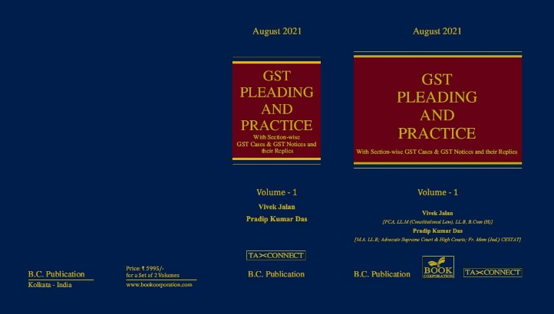

ABOUT THE BOOK: This publication includes:
1. GST Notices and their Replies
2. Orders and Appeals under GST
3. Text of provisions under IGST Act 2017 & CGST Act 2017
4. CGST & IGST Section-wise Synopsis of Case Laws and Notification/Circulars Gist
5. CGST & IGST Section-wise Synopsis of “Question of Law” answered under GST
6. Completely Updated Synopsis of Case Laws under GST by Supreme Court, High Court, AAARs & AARs

Authors:
Vivek Jalan
[FCA, LL.M (Constitutional Law), LL.B, B.Com(H)]

Pradip Kumar Das
[M.A. LL.B; Advocate Supreme Court & High Courts; Fr. Mem (Jud.) CESTAT]

Published by: In Association With:
BOOK CORPORATION TAX CONNECT ACADEMY
4, R. N. Mukherjee Road 1, Old Court House Corner
Kolkata 700001 Kolkata 700001
Phones: (033) 64547999 Phones: (033) 40016761
Cell : 9830010297, 9331018333 Cell : 9874466163, 9830661254
Order by email:bookcorporation@gmail.com Order by email: info@taxconnect.co.in Website :www.bookcorporation.com Website : www.taxconnect.co.in

:IN STANDS

AN INTEGRATED APPROACH TO GST E-INVOICING, E-WAYBILL & E-RETURN FILING
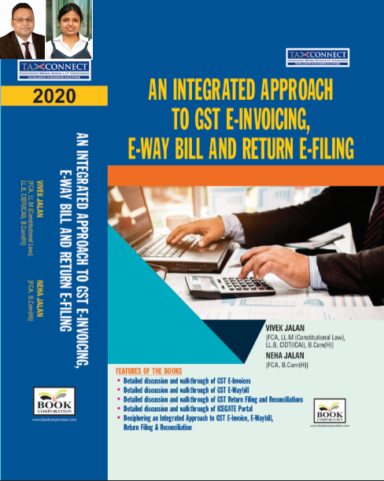
ABOUT THE BOOK: This publication includes:
- Detailed discussion and walkthrough of GST E-Invoices.
- Detailed discussion and walkthrough of GST E-Waybill.
- Detailed discussion and walkthrough of GST Return Filing and Reconciliations.
- Detailed discussion and walkthrough of ICEGATE Portal.
- Deciphering an Integrated Approach to GST E-Invoice, E-Waybill, Return Filing & Reconciliation

Authors:
Vivek Jalan
[FCA, L.LM (Constitutional Law), L.LB, CIDT(ICAI), B.Com(H)]

Neha Jalan
[FCA, B.Com(H)]

Published by: In Association With:
BOOK CORPORATION TAX CONNECT ACADEMY
4, R. N. Mukherjee Road 1, Old Court House Corner
Kolkata 700001 Kolkata 700001
Phones: (033) 64547999 Phones: (033) 40016761
Cell : 9830010297, 9331018333 Cell : 9874466163, 9830661254
Order by email:bookcorporation@gmail.com Order by email: info@taxconnect.co.in Website :www.bookcorporation.com Website : www.taxconnect.co.in

IN STANDS

Section wise Compendium on GST
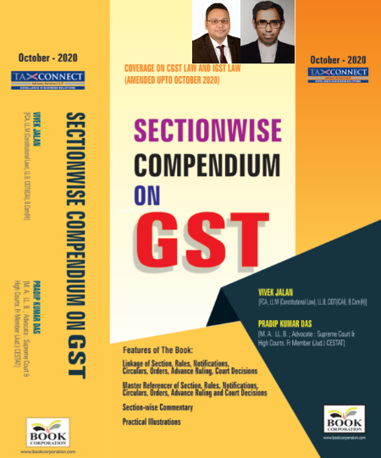
ABOUT THE BOOK: This publication includes:
1. Linkage of Section, Rules, Notifications, Circulars, Orders, Advance Ruling, Court Decisions
2. Master Referencer of Section, Rules, Notifications, Circulars, Orders, Advance Ruling and Court Decisions
3. Section-wise Commentary
4. Practical Illustrations

Authors:
Vivek Jalan
[FCA, L.LM (Constitutional Law), L.LB, CIDT(ICAI), B.Com(H)]

Pradip Kumar Das
[M.A. LL.B; Advocate Supreme Court & High Courts; Fr. Mem (Jud.) CESTAT]

Published by: In Association With:
BOOK CORPORATION TAX CONNECT ACADEMY
4, R. N. Mukherjee Road 1, Old Court House Corner
Kolkata 700001 Kolkata 700001
Phones: (033) 64547999 Phones: (033) 40016761
Cell : 9830010297, 9331018333 Cell : 9874466163, 9830661254
Order by email:bookcorporation@gmail.com Order by email: info@taxconnect.co.in Website :www.bookcorporation.com Website : www.taxconnect.co.in

IN STANDS

UNION BUDGET 2021
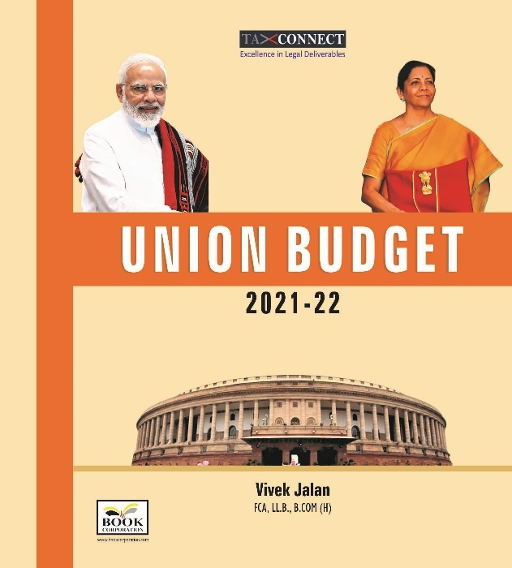
ABOUT THE BOOK: This publication includes:
1.Commentary on Budget
2.Finance Minister’s Budget Speech
3.Budget at a Glance
4.Memorandum
a. Direct Tax
b. Customs
c. Excise
d. GST
5. Finance Bill
6. Notes on Clauses

Authors:
Vivek Jalan
[FCA, L.LM (Constitutional Law), L.LB, CIDT(ICAI), B.Com(H)]

Published by: In Association With:
BOOK CORPORATION TAX CONNECT ACADEMY
4, R. N. Mukherjee Road 1, Old Court House Corner
Kolkata 700001 Kolkata 700001
Phones: (033) 64547999 Phones: (033) 40016761
Cell : 9830010297, 9331018333 Cell : 9874466163, 9830661254
Order by email:bookcorporation@gmail.com Order by email: info@taxconnect.co.in Website :www.bookcorporation.com Website : www.taxconnect.co.in

LET’S DISCUSS FURTHER!

OUR OFFICES:




DUBAI
Azizi Feirouz, 803, 8th Floor, AL Furjan, Opposite Discovery Pavillion, Dubai, UAE
Contact Person: Rohit Sharma
Email: rohit.sharma@taxconnect.co.in

KOLKATA
R No 119; 1st Floor; Diamond Arcade; 1/72, Cal Jessore Road; Kolkata – 700055
Contact Person: Priyanka Chowdhury
Email: priyanka.chowdhury@taxconnect.co.in

KOLKATA
1, Old Court House Corner, “Tobacco House”, 1st Floor, Room No. 13 (N), Kolkata-700001
Contact Person: Priyanka Chowdhury
Email: priyanka.chowdhury@taxconnect.co.in

MUMBAI
Building No.9, Flat- 403, LodhaEternis, 11th Road, MIDC, Andheri(E)-400093
Contact Person: Rajanikant Choudhury
Email: rajnikant.choudhary@taxconnect.co.in
DELHI
B-139, 2nd Floor, Transport Nagar, Noida-201301 (U.P)
Contact Person: Poonam Khemka
Email: poonam.khemka@taxconnectdelhi.co.in

BANGALORE
A-414,Carlton Towers, 19th Main; Road Hal Old Airport Rd, Domlur, Bengaluru, Karnataka-560008
Contact Person: Manmit Sinha
Email: manmit.sinha@taxconnectdelhi.co.in

Disclaimer:
This e-bulletin is for private circulation only. Views expressed herein are of the editorial team and are based on the information, explanation and documents available on Government portal platforms. Tax Connect or any of its employees do not accept any liability whatsoever direct or indirect that may arise from the use of the information contained herein. No matter contained herein may be reproduced without prior consent of Tax Connect. While this e-article has been prepared on the basis of published/other publicly available information considered reliable, we do not accept any liability for the accuracy of its contents.
Tax Connect 2021. All rights reserved.

