8
_{TAX CONNECT}

318th Issue: 3rd October 2021 – 9th October 2021
12017

Knowledge Partner:



TAX CONNECT

Mumbai : A/1001, Cirrus Bldg, Cosmos Paradise; Pokhran Road No. 1, Thane (West), Maharashtra – 400606
Bangalore: A-414,Carlton Towers,19th Main; Road Hal Old Airport Rd, Domlur, Bengaluru, Karnataka-560008
New Delhi: B-139, 2nd Floor, Transport Nagar, Noida-201301 (U.P)
Kolkata : 1, Old Court House Corner, “Tobacco House” 1st Floor, R.No.-13 (North), Kolkata-700001
: Room No 119; 1st Floor; Diamond Arcade; 1/72, Cal Jessore Road; Kolkata – 700055

Dubai : AziziFeirouz, 803, 8th Floor, AL Furjan, Opposite Discovery Pavillion, Dubai, UAE

Contact: +919874466163; +91 9830661254
Website: www.taxconnect.co.in
Email: info@taxconnect.co.in



Friends,

CBIC has issued 22 GST Rate Notifications on 30.09.2021 to give effect to recommendations of 45th GST Council meeting. Notifications amends GST Rate on Services and Goods, Exempts certain services and Goods from GST, and imposed Compensation Cess on Carbonated Beverages of Fruit Drink or Carbonated Beverages with Fruit Juice w.e.f. October 01, 2021. Highlights of the changes are as follows:-
- Post 31.3.2022 incase where such a charitable organization does not get itself registered u/s 12AB of Income Tax Act, it will not be eligible for 12% GST Rate benefit on Works Contract Service.
- Transfer of IPR related to IT Software to be liable to be charged GST at 18%.
- Services by way of job work in relation to manufacture of alcoholic liquor for human consumption will be now taxable @18%.
- Services by way of printing of all goods falling under Chapter 48 or 49 [including newspapers, books (including Braille books), journals and periodicals], which attract CGST @ 6 per cent. or 2.5per cent. or Nil, where only content is supplied by the publisher and the physical inputs including paper used for printing belong to the printer to also be taxed at 18% instead of earlier 12%.
- Any entry to a place which even has casinos or race clubs will be taxable at 28% and not 18%.
- Multimodal Transport of goods from a place in India to another place in India to be classified under SAC 996541.
- Services by way of right to admission to the events organised under AFC Women's Asia Cup 2022 shall be exempt.
- Exemption provided for Services provided by and to Asian Football Confederation (AFC) and its subsidiaries directly or indirectly related to any of the events under AFC Women's Asia Cup 2022 to be hosted in India. Provided that Director (Sports), Ministry of Youth Affairs and Sports certifies that the services are directly or indirectly related to any of the events under AFC Women's Asia Cup 2022.
- Services by way of transportation of goods by an aircraft or vessel from customs station of clearance in India to a place outside India shall be exempt till 30th Sept 2022.
- Services of leasing of assets (rolling stock assets including wagons, coaches, locos) by the Indian Railways Finance Corporation to Indian Railways shall now be taxable.
- Services by way of granting National Permit to a goods carriage to operate through-out India / contiguous States shall be exempt. However, this exemption shall be applicable from 1.10.2021.
- Services provided to the Central Government, State Government, Union territory administration under any training programme for which 75% or more of the total expenditure is borne by the Central Government, State Government, Union territory administration shall be exempt.
- Tamarind seeds meant for any use other than sowing shall be taxable at 5% and not be exempt. Only for use of sowing shall be exempt.
- Further all Seeds, fruit and spores, of a kind used for sowing shall be exempt.
- All ores and concentrates [other than slag, dross (other than granulated slag), scalings and other waste from the manufacture of iron or steel; slag, ash and residues (other than from the manufacture of iron or steel) containing metals, arsenic or their compounds; other slag and ash, including seaweed ash (kelp); ash and residues from the incineration of municipal waste]; - All these items will not be taxed at 5%.
- Iron ores and concentrates, including roasted iron pyrites; Manganese ores and concentrates, including ferruginous manganese ores and concentrates with a manganese content of 20% or more, calculated on the dry weight; Copper ores and concentrates; Nickel ores and concentrates; Cobalt ores and concentrates; Aluminium ores and concentrates; Lead ores and concentrates; Zinc ores and concentrates; Tin ores and concentrates; Chromium ores and concentrates; - All these items to be taxed at 18% and not 5%.
- Bio-diesel supplied to Oil Marketing Companies for blending with High Speed Diesel – It will be taxed at 5% and other Bio-Diesel will be supplied at 12%.
- Waste, parings or scrap, of plastics – These will not be taxed at 5% but 18%.
- Specified renewable energy devices & parts for their manufacture shall be taxed at 12% and not 5%.
- “Retro fitment kits for vehicles used by the disabled“ – This will be taxed at 5%.
- Cartons, boxes and cases of corrugated paper or paper board – Will be taxed at 18% and not 12%.
- Plans and drawings for architectural, engineering, industrial, commercial, topographical or similar purposes, being originals drawn by hand; hand-written texts; photographic reproductions on sensitised paper and carbon copies of the foregoing; Unused postage, revenue or similar stamps of current or new issue in the country in which they have, or will have, a recognised face value; stamp-impressed paper; banknotes; cheque forms; stock, share or bond certificates and similar documents of title 29[other than Duty Credit Scrips; Transfers (decalcomanias); Printed or illustrated postcards; printed cards bearing personal greetings, messages or announcements, whether or not illustrated, with or without envelopes or trimmings; Calendars of any kind, printed, including calendar blocks; Other printed matter, including printed pictures and photographs; such as Trade advertising material, Commercial catalogues and the like, printed Posters, Commercial catalogues, Printed inlay cards, Pictures, designs and photographs, Plan and drawings for architectural engineering, industrial, commercial, topographical or similar purposes reproduced with the aid of computer or any other devices – It will not be taxed at 12% but at 18%.
- Ball point pens; felt tipped and other porous-tipped pens and markers; fountain pens; stylograph pens and other pens; duplicating stylos; pen holders, pencil holders and similar holders; parts (including caps and clips) of the foregoing articles, other than those of heading 9609 – These will not be taxed at 12% but at 18%.
- Carbonated Beverages of Fruit Drink or Carbonated Beverages with Fruit Juice – these will be taxed at 28% plus Compensation Cess of 12%.
- Fortified Rice Kernel (Premix) supply for ICDS or similar scheme duly approved by the Central Government or any State Government – Such intra state supplies shall be taxed at 5% GST subject to the conditions specified.
We do hope that this bulletin adds value to your professional sphere.
Just to reiterate that we remain available over telecom or e-mail.

Truly Yours
Editor:
Vivek Jalan
Partner - Tax Connect Advisory Services LLP
Co-Editors:
Rohit Sharma
Senior Manager – Tax Connect Advisory Services LLP
Rajanikant Choudhury
Manager - Tax Connect Advisory Services LLP
S.NO. | TOPICS | PAGE NO.
1] | TAX CALENDER | 5
2] | INCOME TAX | 6
CASE LAWS | TRANSFERRING THE CASE U/S 127 WITHOUT GIVING OPPORTUNITY OF HEARING AND WITHOUT RECORDING THE REASON FOR NOT GIVING OPPORTUNITY OF HEARING IS ILLEGAL, INVALID AND NOT SUSTAINABLE IN LAW- CALCUTTA HIGH COURT
3] | GST | 7
NOTIFICATION | CHANGES IN CGST EXEMPTION ON SUPPLY OF SERVICES W.E.F. 01.10.2021
4] | FEMA | 8
CIRCULAR | EXIM BANK'S GOVERNMENT OF INDIA SUPPORTED LINE OF CREDIT (LOC) OF USD 15 MILLION TO THE GOVERNMENT OF THE REPUBLIC OF SIERRA LEONE
5] | CUSTOMS | 9
NOTIFICATION | CBIC notifieD the manner to issue duty credit for goods exported under the continuation of Scheme for Rebate of State and Central Taxes and Levies (RoSCTL)
6] | DGFT | 11
NOTIFICATION | LAST DATE FOR FILING MEIS / SEIS APPLICATION
7] | GST PLEADING AND PRACTICE: WITH SECTION-WISE GST CASES & GST NOTICES AND THEIR REPLIES | 12
8] | IN STANDS - AN INTEGRATED APPROACH TO GST E-INVOICING, E-WAYBILL & E-RETURN FILING | 13
9] | IN STANDS –SECTION WISE COMPENDIUM ON GST | 14
10] | IN STANDS – UNION BUDGET 2021 | 15
11] | LET’S DISCUSS FURTHER | 16

Due date | Form/Return/Challan | Reporting Period | Description
7TH October 2021 | Challan Form ITNS 281 | September 2021 | Monthly payment of TDS on all types of payments for September 2021. (Except in the case where amounted is credited in the Month of March 31).
7th October 2021 | Challan Form ITNS 281 | September 2021 | Monthly payment of TCS u/s 206C (other than government assessee) for September 2021.
7th October 2021 | Form No. 27C | September 2021 | Last date of submission of declaration i.e., for no TCS u/s 206C(1A) obtained from manufacturer to the Commissioner/Chief Commissioner of Income Tax as the case may be.
7th October 2021 | Challan Form ITNS 281 | September 2021 | Submission of copy of declaration forms received from deductee by the deductor for non-deduction of TDS under section 197A before the Chief Commissioner or Commissioner.

CASE LAWS
TRANSFERRING THE CASE U/S 127 without giving opportunity of hearing and without recording the reason for not giving opportunity of hearing is illegal, invalid and not sustainable in law- CALCUTTA HIGH COURT
OUR COMMENTS: The impugned order of transfer under Section 127 (2) of the Income Tax Act dated 18th February, 2021 transferring the case of the petitioner was passed by The Principal Commissioner of Income Tax II without giving opportunity of hearing to the petitioner and without recording the reason for not giving opportunity of hearing to the petitioner before passing such order of transfer of the case of the petitioner under Section 127 (2) of the Income Tax Act, 1961, from Kolkata to Delhi and without considering and disposing the reply/objection to the show-cause notice by the petitioner against the proposed action of transfer of case of the petitioner by the respondent is illegal, invalid and not sustainable in law and the said impugned order of transfer dated 18th July, 2019 under Section 127 (2) of the Income Tax Act, 1961 is accordingly quashed and the respondents concerned are directed to send back the case of the petitioner from Delhi to Kolkata immediately after receipt of communication of this order.
The Petitioner submits that without considering and disposing the aforesaid letters/representations and giving any opportunities of hearing and without communication of the formal order of disposal and/or rejection of the petitioner’s prayer made in the aforesaid letters such decision of transfer of the case of the petitioner under Section 127 (2) of the Income Tax Act, 1961, was passed and even such order of transfer has not been communicated to the petitioner and after about eighteen months from his second letter dated 3rd October, 2019, petitioner came to know from the official portal of income tax on 17th July, 2021 that his case has been transferred from Kolkata to Delhi.
It has been held by the Hon’ble High Court that the submission of the parties and relevant records and in view of the factual and legal position that the impugned order of transfer under Section 127 (2) of the Income Tax Act dated 18th February, 2021 transferring the case of the petitioner was passed without giving opportunity of hearing to the petitioner and without recording the reason for not giving opportunity of hearing to the petitioner before passing such order of transfer of the case of the petitioner under Section 127 (2) of the Income Tax Act, 1961, from Kolkata to Delhi and without considering and disposing the reply/objection to the show-cause notice by the petitioner against the proposed action of transfer of case of the petitioner by the respondent is illegal, invalid and not sustainable in law and the said impugned order of transfer dated 18th July, 2019 under Section 127 (2) of the Income Tax Act, 1961 is accordingly quashed and the respondents concerned are directed to send back the case of the petitioner from Delhi to Kolkata immediately after receipt of communication of this order.

NOTIFICATION
CHANGES IN CGST EXEMPTION ON SUPPLY OF SERVICES W.E.F. 01.10.2021
OUR COMMENTS: CBIC amend notification No. 12/2017- Central Tax (Rate) so as to implement recommendations made by GST Council in its 45th meeting held on 17.09.2021 related to Changes in CGST exemption on Supply of services w.e.f. 01.10.2021 vide Notification No. 07/2021- Central Tax (Rate) | Dated: 30th September, 2021.
In the said notification, in the Table, –
(i) against serial number 1, in column (3), after the figures and letters “12AA”, the word, figures and letters ” or 12AB” shall be inserted;
(ii) against serial number 9AA, in column (3), after the words “hosted in India”, the words “whenever rescheduled” shall be inserted;
(iii) after serial number 9AA and the entries relating thereto, the following shall be inserted, namely : –
(1) | (2) | (3) | (4) | (5)
“9AB | Chapter 99 | Services provided by and to Asian Football Confederation (AFC) and its subsidiaries directly or indirectly related to any of the events under AFC Women’s Asia Cup 2022 to be hosted in India | Nil | Provided that Director (Sports), Ministry of Youth Affairs and Sports certifies that the services are directly or indirectly related to any of the events under AFC Women’s Asia Cup 2022.”;
(iv) against serial numbers 9D and 13, in column (3), after the figures and letters “12AA”, the word, figures and letters ” or 12AB” shall be inserted;
(v) against serial numbers 19A and 19B, in column (5), for the figures “2021”, the figures “2022” shall be substituted;
(vi) serial number 43 and the entries relating thereto shall be omitted;
(vii) after serial number 61 and the entries relating thereto, the following shall be inserted, namely:-
(1) | (2) | (3) | (4) | (5)
“61A | Heading 9991 | Services by way of granting National Permit to a goods carriage to operate through-out India / contiguous States. | Nil | Nil”;
(viii) against serial number 72, in column (3), after the words “for which”, the figures, symbol and words “75% or more of the” shall be inserted;
(ix) against serial numbers 74A and 80, in column (3), after the figures and letters “12AA”, word, figures and letters ” or 12AB” shall be inserted;
(x) after serial number 82A and the entries relating thereto, the following shall be inserted, namely : –
(1) | (2) | (3) | (4) | (5)
82B | Heading 9996 | Services by way of right to admission to the events organized under AFC Women’s Asia Cup 2022 | NIL | NIL
[For further details please refer the notification]
CIRCULAR
Exim Bank's Government of India supported Line of Credit (LoC) of USD 15 million to the Government of the Republic of Sierra Leone
OUR COMMENTS: The Chief General Manager, Reserve Bank of India issued a circular vide RBI/2021-2022/102, A.P. (DIR Series) Circular No.14 dated 30th September 2021 to All Category-I Authorised Dealer Banks reg. Exim Bank's Government of India supported Line of Credit (LoC) of USD 15 million to the Government of the Republic of Sierra Leone.
Export-Import Bank of India (Exim Bank) has entered into an agreement dated December 17, 2020 with the Government of the Republic of Sierra Leone, for making available to the latter, Government of India supported Line of Credit (LoC) of USD 15 million (USD Fifteen Million only) for the purpose of expansion of the ongoing projects for rehabilitation of existing potable water facilities in four communities in the Republic of Sierra Leone. Under the arrangement, financing of export of eligible goods and services from India, as defined under the agreement, would be allowed subject to their being eligible for export under the Foreign Trade Policy of the Government of India and whose purchase may be agreed to be financed by the Exim Bank under this agreement. Out of the total credit by Exim Bank under the agreement, goods, works and services of the value of at least 75 per cent of the contract price shall be supplied by the seller from India, and the remaining 25 per cent of goods and services may be procured by the seller for the purpose of the eligible contract from outside India.
The Agreement under the LoC is effective from August 31, 2021. Under the LoC, the terminal utilization period is 60 months from the scheduled completion date of the project.
Shipments under the LoC shall be declared in Export Declaration Form as per instructions issued by the Reserve Bank from time to time.
No agency commission is payable for export under the above LoC. However, if required, the exporter may use his own resources or utilize balances in his Exchange Earners’ Foreign Currency Account for payment of commission in free foreign exchange. Authorised Dealer (AD) Category- I banks may allow such remittance after realization of full eligible value of export subject to compliance with the extant instructions for payment of agency commission.
AD Category – I banks may bring the contents of this circular to the notice of their exporter constituents and advise them to obtain complete details of the LoC from the Exim Bank’s office at Centre One, Floor 21, World Trade Centre Complex, Cuffe Parade, Mumbai 400 005 or from their website www.eximbankindia.in
The directions contained in this circular have been issued under section 10(4) and 11(1) of the Foreign Exchange Management Act (FEMA), 1999 (42 of 1999) and are without prejudice to permissions/ approvals, if any, required under any other law.
[For further details please refer the circular]
NOTIFICATION
CBIC notifies the manner to issue duty credit for goods exported under the continuation of Scheme for Rebate of State and Central Taxes and Levies (RoSCTL)
OUR COMMENTS: The (Department of Revenue), Ministry of Finance, Central Government Vide Notification No. 77/2021-Customs N.T.) dated 24th September, 2021 notified the manner to issue duty credit for goods exported under the Scheme for Rebate of State and Central Taxes and Levies (RoSCTL).
1. The duty credit shall be subject to the following conditions, namely-
(1) that the duty credit is issued -
(a) against exports of garments and made-ups (hereinafter referred to as the said goods) and their respective rate andcap as listed in Schedules 1, 2, 3 and 4 to the notification of Government of India, Ministry of Textiles’ notification No.14/26/2016-IT (Vol.II), dated the 8th March, 2019 for the Scheme:
Provided that the value of the said goods for calculation of duty credit to be allowed under the Scheme shall be the declared export Free on Board (FOB) value of the said goods or up to 1.5 times the market price of the said goods, whichever is less;
(b) against claim of duty credit under the Scheme made by an exporter by providing the appropriate declaration at the item level in the shipping bill or bill of export in the customs automated system;
(c) against the shipping bill or bill of export, presented under section 50 of the said Act on or after the 1st day of January, 2021, and where the order permitting clearance and loading of goods for exportation under section 51 of the said Act has been made;
(d) after the claim is allowed by Customs upon necessary checks, including on the basis of risk evaluation through appropriate selection criteria, and after filing of export manifest or export report;
(e) in accordance with any rules or regulations issued in relation to duty credit, e-scrip or electronic duty credit ledger;
(2) that such duty credit shall be used for payment of the duty of customs leviable under the First Schedule to the Customs Tariff Act, 1975 (51 of 1975) on goods when imported into India;
(3) that the export categories or sectors listed in Table-1 annexed hereto shall not be eligible for duty credit under the Scheme;
(4) that the duty credit allowed under the Scheme, against export of goods notified vide notification No. 14/26/2016-IT(Vol.II), dated the 8th March, 2019 for the Scheme, shall be subject to realisation of sale proceeds in respect of such goods in India within the period allowed under the Foreign Exchange Management Act, 1999 (42 of 1999), failing which such duty credit shall be deemed to be ineligible;
(5) that the imports and exports are undertaken through the seaports, airports or through the inland container depots or through the land customs stations which allow the bill of entry and shipping bill or bill of export to be presented and processed electronically on the customs automated system;
(6) that the exporter has realised the sale proceeds against export of goods made earlier by the said exporter where the period allowed for realisation, including any extension of the said period by the Reserve Bank of India, has expired:
Provided that duty credit shall be issued by Customs in excess of the ineligible amount of duty credit pertaining to the unrealised portion of sale proceeds against export of goods made earlier:
Provided further that if the Principal Commissioner of Customs or Commissioner of Customs has reason to believe, on the basis of risk evaluation or on the basis of enquiry, that the claim of duty credit made by an exporter on export goods may not be bona fide, he may direct, for reasons to be recorded in writing, to allow duty credit after realisation of sale proceeds of such exports;
(7) that duty credit under the Scheme for exports made to Nepal, Bhutan and Myanmar shall be allowed only upon realisation of sale proceeds against irrevocable letters of credit in freely convertible currency established by importers in Nepal, Bhutan and Myanmar in favour of Indian exporters for the value of such goods.
2. Cancellation of duty credit. – Where a person contravenes any of the provisions of the Customs Act or any other law for the time being in force or the rules or regulations made thereunder in relation to exports to which the duty credit relates, or in relation to the e-scrip, the Principal Commissioner of Customs or Commissioner of Customs having jurisdiction over the customs station of registration of the e-scrip may, after enquiry, pass an order to cancel the said duty credit or e-scrip.
Where the e-scrip is so cancelled, the duty credit amount in the said e-scrip shall be deemed never to have been allowed and the proper officer of Customs shall proceed to recover the duty credit amount used in such e-scrip or transferred from such e-scrip.
The proper officer of Customs may, without prejudice to any other action that may be taken under the said Act or any other law for the time being in force, suspend the operation of the said e-scrip or the electronic duty credit ledger of such exporter or any duty credit transferred from such e-scrip, during pendency of the enquiry under sub-clause (1).
3. Recovery of amount of duty credit. – Where an amount of duty credit has, for any reason, been allowed in excess of what the exporter is entitled to, the exporter shall repay the amount so allowed in excess, himself or on demand by the proper officer, along with interest, at the rate as fixed under section 28AA of the said Act for the purposes of that section, on that portion of duty credit allowed in excess, which has been used or transferred, and where the exporter fails to repay the amount along with interest, as applicable, it shall be recovered in the manner provided in section 142 of the said Act.
The duty credit amount that an exporter is so required to repay under sub-clause (1) shall be deemed never to have been allowed, and if the exporter fails to repay the said amount within a period of fifteen days along with interest so demanded, then the proper officer of Customs may, without prejudice to any action against the exporter, proceed for recovery of the said duty credit amount from the transferee in the manner as provided in section 142 of the said Act.
4. Recovery of amount of duty credit where export proceeds are not realised. – Where an amount of duty credit has been allowed to an exporter but the sale proceeds in respect of such export goods have not been realized by the exporter in India within the period allowed under the Foreign Exchange Management Act, 1999, the exporter shall, himself or on demand by the proper officer, repay the amount of duty credit, along with interest, within fifteen days of expiry of the said period.
In case any extension of the said period for realisation of sale proceeds has been given by the Reserve Bank of India and the exporter produces evidence of such extension to the proper officer, and if the said sale proceeds are not realised in such extended period, the exporter shall repay the said amount of duty credit along with the said interest, within fifteen days of expiry of the said period.
If a part of the sale proceeds has been realised, the amount of duty credit to be recovered shall be the amount equal to that portion of the amount of duty credit allowed which bears the same proportion as the portion of the sale proceeds not realised bears to the total amount of sale proceeds.
Where the exporter fails to repay the duty credit amount within the said period of fifteen days, the said duty credit shall be deemed never to have been allowed and it shall be recovered, along with the said interest, in the manner as provided in section 142 of the said Act.
The proper officer of Customs may, without prejudice to any action against the exporter, proceed for recovery of said duty credit amount from the transferee in the manner as provided in section 142 of the said Act.
5. During the pendency of any recovery, as provided in clauses 4 and 5, no further duty credit, on any subsequent exports, shall be allowed to such exporter till the time such recovery is made and any unutilized duty credit with the exporter or the transferee shall be suspended pending such recovery.[For further details please refer the Notification]

NOTIFICATION
Last Date for filing MEIS / SEIS Application
OUR COMMENTS: Many of us are awaiting for DGFT online portal to start with online application filing of MEIS, SEIS and RoSL / RoSCTL for the exports made till December 2020. In the meantime, the Commerce Ministry has issued Notification No. 26/2015-2020 dated 16 September 2021 to notify Last date for submitting applications for scrip based FTP schemes and validity period of duty credit scrips. Below are excerpts from notification for your quick reference:
Last date for submitting online applications stands revised to 31 December 2021 for following schemes:
– MEIS for, 01.07.2018 to 31.03.2019, 01.04.2019 to 31.03.2020 and 01.04.2020 to 31.12.2020;
– SEIS for, 2018-19 and 2019-20;
– 2% additional ad hoc incentive under para 3.25 of the FTP for export made in 01.01.2020 to 31.03.2020 only;
– ROSCTL for, 07.03.2019 to 31.12.2020; and
– ROSL for, exports made upto 06.03.2019
AFTER 31 DECEMBER 2021, NO FURTHER APPLICATIONS WOULD BE ALLOWED TO BE SUBMITTED AND THEY WOULD BECOME TIME BARRED. LATE CUT PROVISIONS SHALL ALSO NOT BE AVAILABLE FOR SUBMITTING CLAIMS AT A LATER DATE.
In suppression of existing late cut provisions, new late cut provisions for application submitted upto 31 Dec 2021 (as stated below) shall apply:
1 | MEIS | FY 2018-19 (01.07.2018 to 31.03.2019) | 10%
2 | MEIS | FY 2019-20 and FY 2020-21 (upto 31.12.2020) | Nil
3 | SEIS | FY 2018-19 | 5%
4 | SEIS | FY 2019-20 | Nil
5 | ROSCTL | 07.03.2019 to 31.12.2020 | Nil
6 | ROSL | Upto 06.03.2019 | Nil

Validity period of Scrip:
The new validity period of a duty Credit Scrip issued on or after 16.09.2021 shall be 12 months from the date of issue.
We humble request you all to have a look on your exports and benefits availed / not availed so as to take maximum benefit of benefit before notified last date.

:IN STANDS

GST PLEADING AND PRACTICE: With Section-wise GST Cases & GST Notices and their Replies
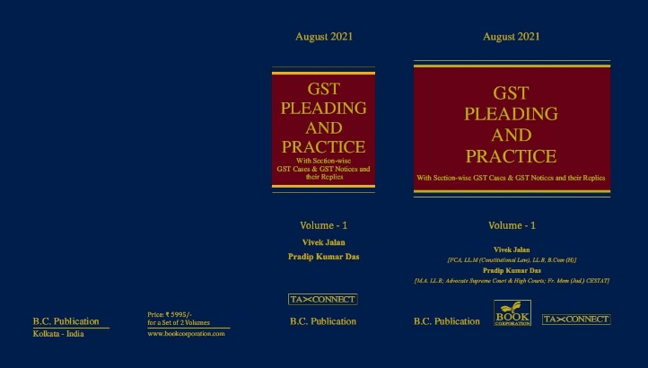

ABOUT THE BOOK: This publication includes:
1. GST Notices and their Replies
2. Orders and Appeals under GST
3. Text of provisions under IGST Act 2017 & CGST Act 2017
4. CGST & IGST Section-wise Synopsis of Case Laws and Notification/Circulars Gist
5. CGST & IGST Section-wise Synopsis of “Question of Law” answered under GST
6. Completely Updated Synopsis of Case Laws under GST by Supreme Court, High Court, AAARs & AARs

Authors:
Vivek Jalan
[FCA, LL.M (Constitutional Law), LL.B, B.Com(H)]

Pradip Kumar Das
[M.A. LL.B; Advocate Supreme Court & High Courts; Fr. Mem (Jud.) CESTAT]

Published by: In Association With:
BOOK CORPORATION TAX CONNECT ACADEMY
4, R. N. Mukherjee Road 1, Old Court House Corner
Kolkata 700001 Kolkata 700001
Phones: (033) 64547999 Phones: (033) 40016761
Cell : 9830010297, 9331018333 Cell : 9874466163, 9830661254
Order by email:bookcorporation@gmail.com Order by email: info@taxconnect.co.in Website :www.bookcorporation.com Website : www.taxconnect.co.in

:IN STANDS

AN INTEGRATED APPROACH TO GST E-INVOICING, E-WAYBILL & E-RETURN FILING
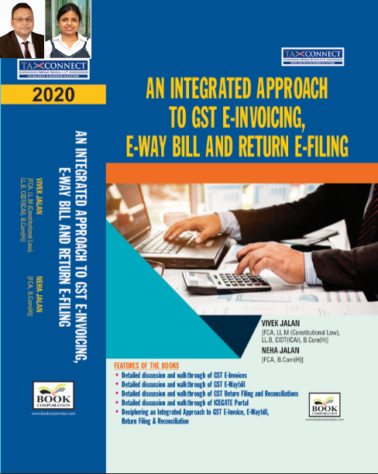
ABOUT THE BOOK: This publication includes:
- Detailed discussion and walkthrough of GST E-Invoices.
- Detailed discussion and walkthrough of GST E-Waybill.
- Detailed discussion and walkthrough of GST Return Filing and Reconciliations.
- Detailed discussion and walkthrough of ICEGATE Portal.
- Deciphering an Integrated Approach to GST E-Invoice, E-Waybill, Return Filing & Reconciliation

Authors:
Vivek Jalan
[FCA, L.LM (Constitutional Law), L.LB, CIDT(ICAI), B.Com(H)]

Neha Jalan
[FCA, B.Com(H)]

Published by: In Association With:
BOOK CORPORATION TAX CONNECT ACADEMY
4, R. N. Mukherjee Road 1, Old Court House Corner
Kolkata 700001 Kolkata 700001
Phones: (033) 64547999 Phones: (033) 40016761
Cell : 9830010297, 9331018333 Cell : 9874466163, 9830661254
Order by email:bookcorporation@gmail.com Order by email: info@taxconnect.co.in Website :www.bookcorporation.com Website : www.taxconnect.co.in

IN STANDS

Section wise Compendium on GST
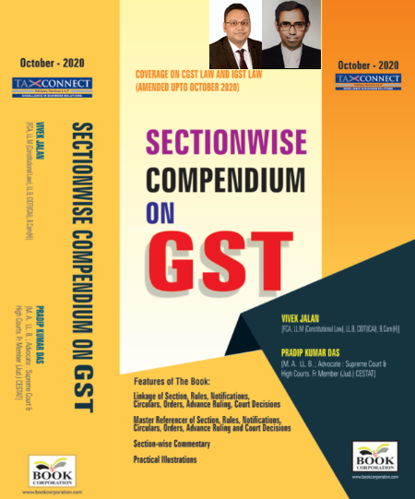
ABOUT THE BOOK: This publication includes:
1. Linkage of Section, Rules, Notifications, Circulars, Orders, Advance Ruling, Court Decisions
2. Master Referencer of Section, Rules, Notifications, Circulars, Orders, Advance Ruling and Court Decisions
3. Section-wise Commentary
4. Practical Illustrations

Authors:
Vivek Jalan
[FCA, L.LM (Constitutional Law), L.LB, CIDT(ICAI), B.Com(H)]

Pradip Kumar Das
[M.A. LL.B; Advocate Supreme Court & High Courts; Fr. Mem (Jud.) CESTAT]

Published by: In Association With:
BOOK CORPORATION TAX CONNECT ACADEMY
4, R. N. Mukherjee Road 1, Old Court House Corner
Kolkata 700001 Kolkata 700001
Phones: (033) 64547999 Phones: (033) 40016761
Cell : 9830010297, 9331018333 Cell : 9874466163, 9830661254
Order by email:bookcorporation@gmail.com Order by email: info@taxconnect.co.in Website :www.bookcorporation.com Website : www.taxconnect.co.in

IN STANDS

UNION BUDGET 2021
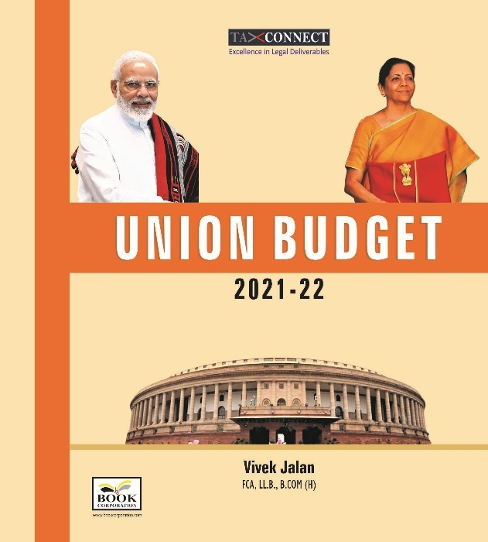
ABOUT THE BOOK: This publication includes:
1.Commentary on Budget
2.Finance Minister’s Budget Speech
3.Budget at a Glance
4.Memorandum
a. Direct Tax
b. Customs
c. Excise
d. GST
5. Finance Bill
6. Notes on Clauses

Authors:
Vivek Jalan
[FCA, L.LM (Constitutional Law), L.LB, CIDT(ICAI), B.Com(H)]

Published by: In Association With:
BOOK CORPORATION TAX CONNECT ACADEMY
4, R. N. Mukherjee Road 1, Old Court House Corner
Kolkata 700001 Kolkata 700001
Phones: (033) 64547999 Phones: (033) 40016761
Cell : 9830010297, 9331018333 Cell : 9874466163, 9830661254
Order by email:bookcorporation@gmail.com Order by email: info@taxconnect.co.in Website :www.bookcorporation.com Website : www.taxconnect.co.in

LET’S DISCUSS FURTHER!

OUR OFFICES:




DUBAI
Azizi Feirouz, 803, 8th Floor, AL Furjan, Opposite Discovery Pavillion, Dubai, UAE
Contact Person: Rohit Sharma
Email: rohit.sharma@taxconnect.co.in

KOLKATA
R No 119; 1st Floor; Diamond Arcade; 1/72, Cal Jessore Road; Kolkata – 700055
Contact Person: Priyanka Chowdhury
Email: priyanka.chowdhury@taxconnect.co.in

KOLKATA
1, Old Court House Corner, “Tobacco House”, 1st Floor, Room No. 13 (N), Kolkata-700001
Contact Person: Priyanka Chowdhury
Email: priyanka.chowdhury@taxconnect.co.in

MUMBAI
Building No.9, Flat- 403, LodhaEternis, 11th Road, MIDC, Andheri(E)-400093
Contact Person: Rajanikant Choudhury
Email: rajnikant.choudhary@taxconnect.co.in
DELHI
B-139, 2nd Floor, Transport Nagar, Noida-201301 (U.P)
Contact Person: Poonam Khemka
Email: poonam.khemka@taxconnectdelhi.co.in

BANGALORE
A-414,Carlton Towers, 19th Main; Road Hal Old Airport Rd, Domlur, Bengaluru, Karnataka-560008
Contact Person: Manmit Sinha
Email: manmit.sinha@taxconnectdelhi.co.in

Disclaimer:
This e-bulletin is for private circulation only. Views expressed herein are of the editorial team and are based on the information, explanation and documents available on Government portal platforms. Tax Connect or any of its employees do not accept any liability whatsoever direct or indirect that may arise from the use of the information contained herein. No matter contained herein may be reproduced without prior consent of Tax Connect. While this e-article has been prepared on the basis of published/other publicly available information considered reliable, we do not accept any liability for the accuracy of its contents.
Tax Connect 2021. All rights reserved.

