_{TAX CONNECT}

317th Issue: 26th September 2021 – 2nd October 2021
12017

Knowledge Partner:



TAX CONNECT

Mumbai : A/1001, Cirrus Bldg, Cosmos Paradise; Pokhran Road No. 1, Thane (West), Maharashtra – 400606
Bangalore: A-414,Carlton Towers,19th Main; Road Hal Old Airport Rd, Domlur, Bengaluru, Karnataka-560008
New Delhi: B-139, 2nd Floor, Transport Nagar, Noida-201301 (U.P)
Kolkata : 1, Old Court House Corner, “Tobacco House” 1st Floor, R.No.-13 (North), Kolkata-700001
: Room No 119; 1st Floor; Diamond Arcade; 1/72, Cal Jessore Road; Kolkata – 700055

Dubai : AziziFeirouz, 803, 8th Floor, AL Furjan, Opposite Discovery Pavillion, Dubai, UAE

Contact: +919874466163; +91 9830661254
Website: www.taxconnect.co.in
Email: info@taxconnect.co.in



Friends,
Recently, the CBIC came up with circular No. 159/15/2021-GST regarding Clarification on doubts related to scope of "Intermediary".
It has been accepted that broadly there is no change in the scope of intermediary services in the GST regime vis-à-vis the Service Tax regime, except addition of supply of securities in the definition of intermediary in the GST Law.
The following are the requirements for intermediary services:
- Minimum of Three Parties: two of them transacting in the supply of goods or services or securities (the main supply) and one arranging or facilitating (the ancillary supply) the said main supply.
- Two distinct supplies: Main supply and ancillary supply.
- Intermediary service provider to have the character of an agent, broker or any other similar person: It must arrange or facilitate some other supply, which is the main supply, and does not himself provides the main supply. Thus, the role of intermediary is only supportive.
- Does not include a person who supplies such goods or services or both or securities on his own account
- Sub-contracting for a service is not an intermediary service
However, the biggest question on Place of Supply u/s 13(8)(b) and section 8(2) of the IGST Act, 2017, incase of intermediary services to the extent that it seeks to levy GST on services provided to, used and consumed by recipients located outside India and treating the same as intra-state supply leviable to GST, has not been dwelt with in the Circular.
Further, Notification No. 9/2017 -IGST-Rate, Item No 12AA Exempts Services provided by an intermediary when location of both supplier and recipient of goods is outside the taxable territory. However, the same is not the case in case of supply of ‘service’. Hence to this extent, the service providers are treated unequally with suppliers of goods. Industry may apply to the Ministry to further dwell on the issue.
While the circular does provide some insights on the topic of intermediary services, yet, it does not dwell upon critical aspects as cited above. Trade and Industry may apply to the Ministry to further dwell on the issues not answered in the Circular.
We do hope that this bulletin adds value to your professional sphere.
Just to reiterate that we remain available over telecom or e-mail.

Truly Yours
Editor:
Vivek Jalan
Partner - Tax Connect Advisory Services LLP
Co-Editors:
Rohit Sharma
Senior Manager – Tax Connect Advisory Services LLP
Rajanikant Choudhury
Manager - Tax Connect Advisory Services LLP
S.NO. | TOPICS | PAGE NO.
1] | TAX CALENDER | 4
2] | INCOME TAX | 5
NOTIFICATION | NO SECTION 194A TDS ON INTEREST PAYMENT TO SCHEDULED TRIBE BY SCHEDULED BANK
3] | GST | 6
CIRCULAR | CBIC ISSUES CLARIFICATION RELATING TO EXPORT OF SERVICES-CONDITION (V) OF SECTION 2(6) OF THE IGST ACT 2017
4] | FEMA | 7
DISCUSSION | PROCESS FOR FC-GPR Filing
5] | CUSTOMS | 8
NOTIFICATION | Electronic Duty Credit Ledger Regulations
6] | DGFT | 9
NOTIFICATION | AMENDMENT OF POLICY CONDITION NO. 5 OF CHAPTER 27 OF ITC (MS), 2017, SCHEDULE — I (IMPORT POLICY) - 27/2015-2020
7] | GST PLEADING AND PRACTICE: WITH SECTION-WISE GST CASES & GST NOTICES AND THEIR REPLIES | 10
8] | IN STANDS - AN INTEGRATED APPROACH TO GST E-INVOICING, E-WAYBILL & E-RETURN FILING | 11
9] | IN STANDS –SECTION WISE COMPENDIUM ON GST | 12
10] | IN STANDS – UNION BUDGET 2021 | 13
11] | LET’S DISCUSS FURTHER | 14

Due date | Form/Return/Challan | Reporting Period | Description
30th September 2021 | 26QB | August 2021 | Due date for furnishing of challan-cum-statement in respect of tax deducted under section 194-IA (Payment on transfer of certain immovable property other than agricultural land) in the month of August, 2021.
30th September 2021 | 26QC | August 2021 | Due date for furnishing of challan-cum-statement in respect of tax deducted under section 194-IB (Payment of rent by certain individuals or Hindu undivided family) in the month of August, 2021
30th September 2021 | 26QD | August 2021 | Due date for furnishing of challan-cum-statement in respect of tax deducted under section 194M (Payment of certain sums by certain individuals or Hindu undivided family) in the month of August, 2021.
30th September 2021 | ITNS - 280 | August 2021 | Deposit of Income Tax - Self-assessment tax

CIRCULAR
No DUDUCTION OF TAX UNDER Section 194A on Interest payment to Scheduled Tribe by Scheduled Bank
CBDT notified vide Notification No. 110/2021 dated 17th September 2021 that no deduction of tax shall be made under Section 194A by ‘Scheduled Bank on payment of interest, other than interest on securities to Scheduled Tribe located in any specified area, as referred to in section 10(26) of the Income Tax Act if the payment made or aggregate of payments made during the previous year does not exceed twenty lakh rupees.
OUR COMMENTS: Central Government relaxed provisions of TDS u/s 194A of the Income-tax Act, 1961 in view of section of 10(26) of the Act :
The Central Government notified that no deduction of tax shall be made under section 194A of the Act, on the income namely payment in the nature of interest, other than interest on securities, made by a Scheduled Bank (hereinafter the ‘payer’) located in a specified area to a member of Scheduled Tribe (hereinafter the ‘receiver’) residing in any specified area as referred to in s.10(26) of the Act, subject to the following conditions:
i. the payer satisfies itself that the receiver is a member of Scheduled Tribe residing in any specified area, and the payment as referred above is accruing or arising to the receiver as referred to in section 10(26) of the Act, during the previous year relevant for the assessment year in which the payment is made, by obtaining necessary documentary evidences in support of the same;
ii. the payer reports the above payment in the statements of deduction of tax as referred to in sub-section (3) of section 200 of the Act;
iii. the payment made or aggregate of payments made during the previous year does not exceed twenty lakh rupees.
For the purposes of the said notification, ‘Scheduled Bank’ means a bank included in the Second Schedule of the Reserve Bank of India Act,1934.

[For further details please refer the Notification]
CIRCULAR
CBIC ISSUES CLARIFICATION RELATING TO EXPORT OF SERVICES-CONDITION (V) OF SECTION 2(6) OF THE IGST ACT 2017
OUR COMMENTS: CBIC vide its Circular No. 161/17/2021- GST dated 20th September’ 2021 provided clarity on the supply of service by a subsidiary/ sister concern/ group concern, etc. of a foreign company in India, which is incorporated under the laws in India, to the foreign company incorporated under laws of a country outside India, will hit by condition (v) of sub-section (6) of section 2 of IGST Act.
Emphasis has been added in the Circular to the provision of Section 2 (6)(v) of the CGST Act, 2017 which defines “export of services” to mean the supply of any service when the supplier of service and the recipient of service are not merely establishments of a distinct person in accordance with Explanation 1 in section 8;
Explanation 1 (Section 8 of IGST Act, 2017) reads as ‘For the purposes of this Act, where a person has,––
(i) an establishment in India and any other establishment outside India;
(ii) an establishment in a State or Union territory and any other establishment outside that State or Union territory; or
(iii) an establishment in a State or Union territory and any other establishment being a business vertical registered within that State or Union territory, then such establishments shall be treated as establishments of distinct persons’
Further, Explanation 2 (Section 8 of IGST Act, 2017) reads as ‘A person carrying on a business through a branch or an agency or a representational office in any territory shall be treated as having an establishment in that territory.’

Analysis & clarification of the issues:
- it is clarified that a company incorporated in India and a body corporate incorporated by orunder the laws of a country outside India, which is also referred to as foreign company under Companies Act, are separate persons under CGST Act, and thus are separate legal entities. Accordingly, these two separate persons would not be considered as “merely establishments of a distinct person in accordance with Explanation 1 in section 8”.

- Supply of services by a subsidiary/ sister concern/ group concern, etc. of a foreign company, which is incorporated in India under the Companies Act, 2013 (and thus qualifies as a ‘company’ in India as per Companies Act), to the establishments of the said foreign company located outside India (incorporated outside India), would not be barred by the condition (v) of the sub-section (6) of the section 2 of the IGST Act 2017 for being considered as export of services, as it would not be treated as supply between merely establishments of distinct persons under Explanation 1 of section 8 of IGST Act 2017 .

- The supply from a company incorporated in India to its related establishments outside India, which are incorporated under the laws outside India, would not be treated as supply to merely establishments of distinct person under Explanation 1 of section 8 of IGST Act 2017. Such supplies, therefore, would qualify as ‘export of services’, subject to fulfilment of other conditions as provided under sub-section (6) of section 2 of IGST Act.
[For further details please refer the Circular]
NOTIFICATION
PROCESS FOR FC-GPR Filing
OUR COMMENTS: The Reserve Bank has recently introduced an online application i.e., FIRMS (Foreign Investment Reporting and Management System), which provides the reporting of 9 forms for foreign investment including FC-GPR, FC-TRS, LLP-I, LLP-II, CN, DRR, ESOP, DI and InVi in single form i.e., SMF (Single Master Form). The same can be accessed on FIRMS website i.e. https://firms.rbi.org.in).
The relevant details relating to FC-GPR are as under:
FC-GPR (FOREIGN CURRENCY- GROSS PROVISIONAL RETURN)
1. PURPOSE OF FILING -FORM FC-GPR
In Form FC-GPR, the transaction being reported is for issue of capital instruments by an Indian Company to a person resident outside India i.e., allotment of Equity shares/Compulsorily Convertible Preference Shares/Compulsorily Convertible Debentures, whether at the time of incorporation or post incorporation of the Company.
2. APPLICABLE PROVISIONS
- The Foreign Investment is subject to Consolidated FDI Policy (relating to sectoral caps and whether entry is through automatic or approval route, pricing guidelines etc.) and;
- The securities issued are in accordance with the provisions of Foreign Exchange Management Act, 1999, Companies Act, 2013 and SEBI Regulations and other applicable laws and rules made thereunder.
3. FDI PROCESS AND DOCUMENTS
Transmission of Money
- By inward remittance through normal banking channels; or
- By debit to NRE/FCNR account of the person concerned maintained with an authorized dealer.
Preliminary documents required with FDI transactions: –
- FIRC copies and KYC report issued by the Authorized dealer bank of the non-resident investor.
- In case, if amount is received from NRE account, then instead of FIRC, the Bank shall issue NRE Letter.
4. DUE DATE FOR FILING
The transaction should be reported by the Investee Company issuing its securities to the non-resident investor within 30 days from the date of allotment.

NOTIFICATION
Electronic Duty Credit Ledger Regulations
OUR COMMENTS: The Central Board of Indirect taxes and Customs has notified the Electronic Duty Credit Ledger Regulations, 2021 on September 23, 2021 vide notification 75/ 2021. Key features of the regulations are:
- Issuance of duty credit in the scroll – Any bill of export under section 50 of the Customs Act, 1962 on or after the January 1, 2021 and having a claim of duty credit under the Scheme shall be processed in the customs automated system. The claim shall be allowed by Customs according to the conditions and restrictions notified for the Scheme. Once the claim is allowed, a scroll for duty credit will be generated separately for each Scheme. The scroll details shall be visible in the customs automated system to the exporter who is the recipient of such duty credit.
- E-scrip creation – The exporter shall have the option to combine the duty credits under a particular Scheme to carry forward the said duty credits to create an e-scrip for that Scheme in the ledger within a period of one year from the date of generation of the scroll in the customs automated system.
- Registration of e-scrip – The customs station of export shall be the customs station of registration for an e-scrip, which shall be automatic and separate application for the same shall not be required to be filed.
- Validity of e-scrip – The e-scrip shall be valid for a period of one year from the date of its creation in the ledger and any duty credit in the said e-scrip remaining unutilized at the end of this period shall lapse.
- Transfer of duty credit in e-scrip – The duty credit in e-scrip can be transferred within the customs automated system from the ledger of a person to the ledger of another person who is a holder of an Importer-exporter Code Number issued in terms of the Foreign Trade (Development and Regulation) Act, 1992.
- Suspension or cancellation of duty credit – In contravention of any of the provisions in relation to the exports to which the duty credit relates, or in relation to the e-scrip, the said duty credit or e-scrip may be suspended or cancelled in the ledger in the manner as notified by the Central Government under section 51B of the Customs Act, 1962.
[For further details please refer the Notification]

NOTIFICATION
Amendment of policy condition no. 5 of Chapter 27 of ITC (MS), 2017, Schedule — I (Import Policy) - 27/2015-2020
OUR COMMENTS: Policy condition no.5 of Chapter 27 of ITC (HS), 2017, Schedule – I (Import Policy) amended in terms of Government Resolution No. P-12029(11)/2/2018-OMC-PNG dated 08.11.2019.
Government of India Ministry of Commerce & Industry
Department of Commerce Directorate General of Foreign Trade Notification No. 27/2015-2020 – DGFT
New Delhi, Dated:/16th September, 2021
In exercise of powers conferred by Section 3 read with Section 5 of FT (D&R) Act, 1992, read with paragraph 1.02 and 2.01 of the Foreign Trade Policy, 2015-2020, as amended from time to time, the Central Government hereby amends policy condition no.5 of Chapter 27 of ITC (HS), 2017, Schedule I (Import Policy) as under:
Existing Policy Condition | Revised Policy Condition
Import allowed through IOC subject to para 2.20 of Foreign Trade Policy, except for the companies who have been granted rights for marketing of transportation fuels in terms of Ministry of P and NGs Resolution No P23015/1/2001-MKT.Dated 8.3.2002 including HPCL, BPCL and IBP who have been marketing transportation fuels before this date. | Import allowed through IOC subject to para 2.20 of Foreign Trade Policy, except for the who have been granted rights for marketing of transportation fuels in terms of MoP&NG Resolution No. P-23015/1/2001-MKT dated 08.03.2002 for products excluding gasoline conforming to standard IS 2796 (ITC HS Code: 27101241) Wand Automotive diesel fuel, not containing biodiesel, conforming to standard IS 1460 (ITC HS Code 27101944) which would be allowed to be imported by entities in terms of MoPNG Resolution No. P-12029(11)/2/2018-OMC-PNG dated 08.11.2019″.

2. Effect of the Notification: Policy condition no. 5 of Chapter 27 of ITC (HS), 2017, Schedule-I (Import Policy) amended in terms of Government Resolution No. P-12029(11)/2/2018-OMC-PNG dated 08.11.2019.
This is issued with the approval of Minister of Commerce & Industry.
[For further details please refer the Notification]

:IN STANDS

GST PLEADING AND PRACTICE: With Section-wise GST Cases & GST Notices and their Replies
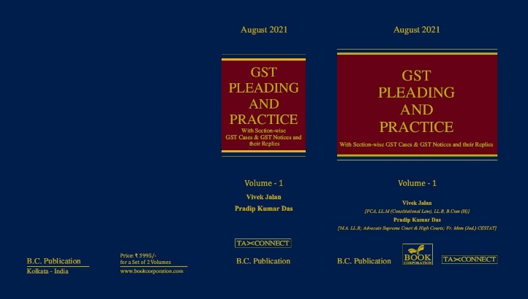

ABOUT THE BOOK: This publication includes:
1. GST Notices and their Replies
2. Orders and Appeals under GST
3. Text of provisions under IGST Act 2017 & CGST Act 2017
4. CGST & IGST Section-wise Synopsis of Case Laws and Notification/Circulars Gist
5. CGST & IGST Section-wise Synopsis of “Question of Law” answered under GST
6. Completely Updated Synopsis of Case Laws under GST by Supreme Court, High Court, AAARs & AARs

Authors:
Vivek Jalan
[FCA, LL.M (Constitutional Law), LL.B, B.Com(H)]

Pradip Kumar Das
[M.A. LL.B; Advocate Supreme Court & High Courts; Fr. Mem (Jud.) CESTAT]

Published by: In Association With:
BOOK CORPORATION TAX CONNECT ACADEMY
4, R. N. Mukherjee Road 1, Old Court House Corner
Kolkata 700001 Kolkata 700001
Phones: (033) 64547999 Phones: (033) 40016761
Cell : 9830010297, 9331018333 Cell : 9874466163, 9830661254
Order by email:bookcorporation@gmail.com Order by email: info@taxconnect.co.in Website :www.bookcorporation.com Website : www.taxconnect.co.in

:IN STANDS

AN INTEGRATED APPROACH TO GST E-INVOICING, E-WAYBILL & E-RETURN FILING
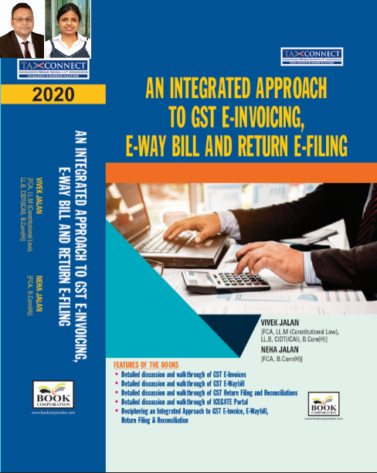
ABOUT THE BOOK: This publication includes:
- Detailed discussion and walkthrough of GST E-Invoices.
- Detailed discussion and walkthrough of GST E-Waybill.
- Detailed discussion and walkthrough of GST Return Filing and Reconciliations.
- Detailed discussion and walkthrough of ICEGATE Portal.
- Deciphering an Integrated Approach to GST E-Invoice, E-Waybill, Return Filing & Reconciliation

Authors:
Vivek Jalan
[FCA, L.LM (Constitutional Law), L.LB, CIDT(ICAI), B.Com(H)]

Neha Jalan
[FCA, B.Com(H)]

Published by: In Association With:
BOOK CORPORATION TAX CONNECT ACADEMY
4, R. N. Mukherjee Road 1, Old Court House Corner
Kolkata 700001 Kolkata 700001
Phones: (033) 64547999 Phones: (033) 40016761
Cell : 9830010297, 9331018333 Cell : 9874466163, 9830661254
Order by email:bookcorporation@gmail.com Order by email: info@taxconnect.co.in Website :www.bookcorporation.com Website : www.taxconnect.co.in

IN STANDS

Section wise Compendium on GST
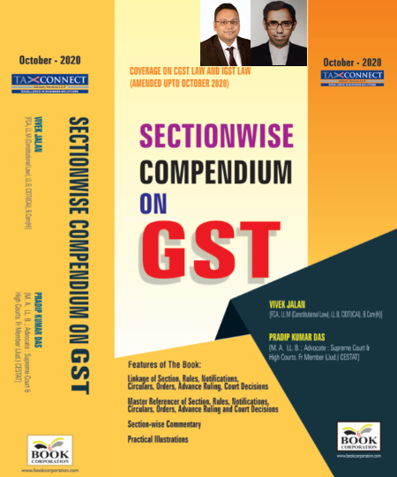
ABOUT THE BOOK: This publication includes:
1. Linkage of Section, Rules, Notifications, Circulars, Orders, Advance Ruling, Court Decisions
2. Master Referencer of Section, Rules, Notifications, Circulars, Orders, Advance Ruling and Court Decisions
3. Section-wise Commentary
4. Practical Illustrations

Authors:
Vivek Jalan
[FCA, L.LM (Constitutional Law), L.LB, CIDT(ICAI), B.Com(H)]

Pradip Kumar Das
[M.A. LL.B; Advocate Supreme Court & High Courts; Fr. Mem (Jud.) CESTAT]

Published by: In Association With:
BOOK CORPORATION TAX CONNECT ACADEMY
4, R. N. Mukherjee Road 1, Old Court House Corner
Kolkata 700001 Kolkata 700001
Phones: (033) 64547999 Phones: (033) 40016761
Cell : 9830010297, 9331018333 Cell : 9874466163, 9830661254
Order by email:bookcorporation@gmail.com Order by email: info@taxconnect.co.in Website :www.bookcorporation.com Website : www.taxconnect.co.in

IN STANDS

UNION BUDGET 2021
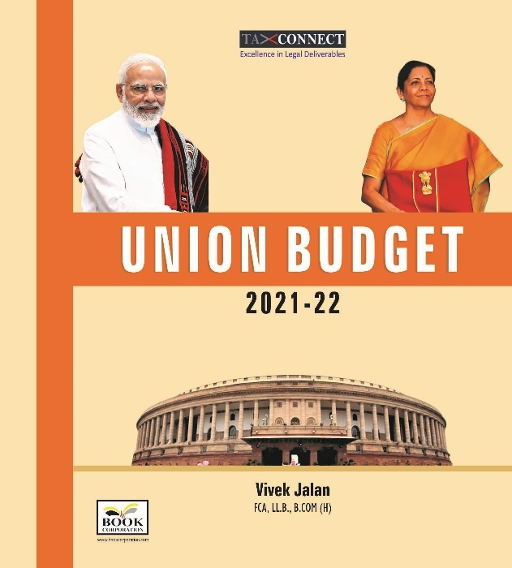
ABOUT THE BOOK: This publication includes:
1.Commentary on Budget
2.Finance Minister’s Budget Speech
3.Budget at a Glance
4.Memorandum
a. Direct Tax
b. Customs
c. Excise
d. GST
5. Finance Bill
6. Notes on Clauses

Authors:
Vivek Jalan
[FCA, L.LM (Constitutional Law), L.LB, CIDT(ICAI), B.Com(H)]

Published by: In Association With:
BOOK CORPORATION TAX CONNECT ACADEMY
4, R. N. Mukherjee Road 1, Old Court House Corner
Kolkata 700001 Kolkata 700001
Phones: (033) 64547999 Phones: (033) 40016761
Cell : 9830010297, 9331018333 Cell : 9874466163, 9830661254
Order by email:bookcorporation@gmail.com Order by email: info@taxconnect.co.in Website :www.bookcorporation.com Website : www.taxconnect.co.in

LET’S DISCUSS FURTHER!

OUR OFFICES:




DUBAI
Azizi Feirouz, 803, 8th Floor, AL Furjan, Opposite Discovery Pavillion, Dubai, UAE
Contact Person: Rohit Sharma
Email: rohit.sharma@taxconnect.co.in

KOLKATA
R No 119; 1st Floor; Diamond Arcade; 1/72, Cal Jessore Road; Kolkata – 700055
Contact Person: Priyanka Chowdhury
Email: priyanka.chowdhury@taxconnect.co.in

KOLKATA
1, Old Court House Corner, “Tobacco House”, 1st Floor, Room No. 13 (N), Kolkata-700001
Contact Person: Priyanka Chowdhury
Email: priyanka.chowdhury@taxconnect.co.in

MUMBAI
Building No.9, Flat- 403, LodhaEternis, 11th Road, MIDC, Andheri(E)-400093
Contact Person: Rajanikant Choudhury
Email: rajnikant.choudhary@taxconnect.co.in
DELHI
B-139, 2nd Floor, Transport Nagar, Noida-201301 (U.P)
Contact Person: Poonam Khemka
Email: poonam.khemka@taxconnectdelhi.co.in

BANGALORE
A-414,Carlton Towers, 19th Main; Road Hal Old Airport Rd, Domlur, Bengaluru, Karnataka-560008
Contact Person: Manmit Sinha
Email: manmit.sinha@taxconnectdelhi.co.in

Disclaimer:
This e-bulletin is for private circulation only. Views expressed herein are of the editorial team and are based on the information, explanation and documents available on Government portal platforms. Tax Connect or any of its employees do not accept any liability whatsoever direct or indirect that may arise from the use of the information contained herein. No matter contained herein may be reproduced without prior consent of Tax Connect. While this e-article has been prepared on the basis of published/other publicly available information considered reliable, we do not accept any liability for the accuracy of its contents.
Tax Connect 2021. All rights reserved.

