_{TAX CONNECT}

314th Issue: 5th September 2021 – 11th September 2021
12017

Knowledge Partner:



TAX CONNECT

Mumbai :A/1001, Cirrus Bldg, Cosmos Paradise; Pokhran Road No. 1, Thane (West), Maharashtra – 400606
Bangalore:A-414,Carlton Towers,19th Main; Road Hal Old Airport Rd, Domlur, Bengaluru, Karnataka-560008
New Delhi :B-139, 2nd Floor, Transport Nagar, Noida-201301 (U.P)
Kolkata :1, Old Court House Corner, “Tobacco House” 1st Floor, R.No.-13 (North), Kolkata-700001
:Room No 119; 1st Floor; Diamond Arcade; 1/72, Cal Jessore Road; Kolkata – 700055

Dubai:AziziFeirouz, 803, 8th Floor, AL Furjan, Opposite Discovery Pavillion, Dubai, UAE

Contact: +919874466163; +91 9830661254
Website: www.taxconnect.co.in
Email: info@taxconnect.co.in



Friends,
The Hon’ble Finance Minister will chair the 45th meeting of the GST council on 17th September (Friday) at Lucknow which among other things may review concessional rates on Covid essentials. In the meeting, the council members could discuss compensation to states for loss of revenue, review of rates on Covid essentials, and inverted duty on certain goods.

As of now, interest earned on provident fund balance is fully exempted from tax in the hands of the employee. However, in Budget 2021, the Finance Minister Nirmala Sitharaman had proposed taxability of interest on various provident funds, where the specified limit exceeds. Now, the CBDT has come up with the Notification no. 95/2021 dated 31st August, 2021 and inserted a new Rule 9D under the income tax Rules, reg. Calculation of taxable interest relating to contribution in a provident fund or recognised provided fund, exceeding specified limit, which shall be applicable for the FY 2021-22 and onwards.

As per this new Rule 9D, two Provident Fund accounts shall be maintained from the FY 2021-22 and onwards to calculate the portion of interest that is to be taxed for a contribution made above threshold limit which is Rs. 2.5 lacs for other than government employees and Rs. 5 lacs for government employees.

This Rule 9D also specifies the method of arriving the balance of both “Taxable” and “Non Taxable contribution” as follows:-

a) Non Taxable Contribution account shall be the aggregate of the following:

i) Closing balance in the account as on 31st March, 2021.

ii) any contribution made by the person in the account during the previous year 2021-22 and subsequent previous years, which is not included in the taxable contribution account; and

iii) interest accrued on sub clause (i) and sub clause (ii) above.

as reduced by the withdrawal, if any, from such account.

b) Taxable Contribution account shall be the aggregate of the following:-

i) contribution made by the person in a previous year in the account during the previous year 2021-22 and subsequent previous years, which is in excess of the threshold limit as specified above.

ii) interest accrued on sub clause (i) above,

as reduced by the withdrawal, if any, from such account.

We do hope that this bulletin adds value to your professional sphere.
Just to reiterate that we remain available over telecom or e-mail.
Truly Yours
Editor:
Vivek Jalan
Partner - Tax Connect Advisory Services LLP
Co-Editors:
Rohit Sharma
Senior Manager – Tax Connect Advisory Services LLP
Rajanikant Choudhury
Manager - Tax Connect Advisory Services LLP
Stay Safe and Healthy
S.NO. | TOPICS | PAGE NO.
1] | TAX CALENDER | 4
2] | INCOME TAX | 5
CIRCULAR | Extension of timeline for electronic filing of various Forms under the Income-tax Act vide circular number 16/ 2021, DATED 29TH AUGUST 2021
3] | GST | 6
NOTIFICATION | Central Goods and Services Tax (Seventh Amendment) Rules, 2021 - 32/2021 –DATED 29TH AUGUST 2021.
NOTIFICATION | clarification of notification 33/2021- DATED 29TH AUGUST, 2021.
4] | FEMA | 7
NOTIFICATION | RBI issues Master Directions on Prepaid Payment Instruments DATED 27TH AUGUST 2021 VIDE NOTIFICATION NO. SRBI/DPSS/2021-22/82  CO.DPSS.POLC.No.S-479/02.14.006/2021-22
5] | CUSTOMS | 8
NOTIFICATION | NOTIFICATION NO. 71/2021- CUSTOMS (N.T.), CENTRAL TAX DATED: 2ND SEPTEMBER 2021, RATE OF EXCHANGE OF FOREIGN CURRENCY INTO INR AND VICE VERSA
6] | DGFT | 9
NOTIFICATION | Amendment in Policy Condition No. 1 of Chapter 88 of ITC (HS) 2017, Schedule-I (Import Policy) - 21/2015-2020 DATED 31ST AUGUST 2021
7] | IN STANDS - AN INTEGRATED APPROACH TO GST E-INVOICING, E-WAYBILL & E-RETURN FILING | 10
8] | IN STANDS –SECTION WISE COMPENDIUM ON GST | 11
9] | IN STANDS – UNION BUDGET 2021 | 12
10] | LET’S DISCUSS FURTHER | 13

Due date | Form/Return/Challan | Reporting Period | Description
07th September 2021 | ITNS-281 | August 2021 | Payment of TDS/TCS deducted /collected in August 2021 under Income Tax Act.
10th September 2021 | GSTR-7 | August 2021 | Return to be filed by the persons who is required to deduct TDS (Tax deducted at source) under GST
10th September 2021 | GSTR-8 | August 2021 | Return to be filed by the e-commerce operators who are required to deduct TCS (Tax collected at source) under GST
11th September 2021 | GSTR-1 | August 2021 | Taxpayers having an aggregate turnover of more than Rs. 1.50 Crores or opted to file Monthly Return

CIRCULAR
Extension of TIMELINE for electronic filing of various Forms under the Income-tax Act vide circular number 16/ 2021, DATED 29TH AUGUST 2021
OUR COMMENTS: On consideration of difficulties reported the taxpayers and other stakeholders in electronic filing of certain Forms under the provisions of Income-tax Act, 1961 read with Income-tax Rules, 1962, the Central Board of Direct Taxes (CBDT),extended the due dates for electronic filing of the followings Forms vide Circular No. 16/2021 dated 29.08.2021.
1) FORM 10A - The application for registration or intimation or approval under Section 10(23C), 12A, 35(1)(ii)/(iia)/(iii) or 80G of the Income Tax Act now can be filed on or before March 31, 2022.
2) FORM 10AB - The application for registration or approval under Section 10(23C), 12A or 80G of the Income Tax Act now can be filed on or before March 31, 2022.
3) Form 1- The Equalisation Levy Statement in Form No.1 for the Financial Year 2020- 21 can be filed on or before December 31, 2021.
4) Form 15CC - The quarterly statement to be furnished by authorised dealer in respect of remittances made for Q1 and Q2 of FY 2021-22, can now be furnished on or before November 30, 2021 and December 31, 2021 respectively.
5) Form No. 15G/15H - Deadline for uploading of the declarations received from recipients during the Q1 and Q2 of the FY 2021-22 has been extended till November 30, 2021 and December 31, 2021 respectively.
6) Form II SWF - Intimation to be made by Sovereign Wealth Fund in respect of investments made by it in India for Q1 and Q2 of FY 2021-22, can now be made on or before November 30, 2021 and December 31, 2021 respectively.
7) Form No. 10BBB - Intimation to be made by a Pension Fund in respect of each investment made by it in India for Q1 and Q2 of FY 2021-22, can now be made on or before November 30, 2021 and December 31, 2021 respectively.
8) Form No.3CEAC - Intimation by a constituent entity, resident in India, of an international group, the parent entity of which is not resident in India, for the purposes of sub-section (1) of section 286 of the Act can now be made on or before December 31, 2021.
9) Form No. 3CEAD - Report by a parent entity or an alternate reporting entity or any other constituent entity, resident in India, for the purposes of sub-section (2) or sub-section (4) of section 286 of the Act can be made till December 31, 2021.
10) Form No. 3CEAE - For intimidation on behalf of an international group for the purposes of the proviso to sub-section (4) of section 286 of the Act, the deadline has been extended till December 31, 2021.
[For further details please refer the circular]
NOTIFICATION
Central Goods and Services Tax (Seventh Amendment) Rules, 2021 - 32/2021 –DATED 29TH AUGUST 2021
OUR COMMENTS: The Central Board of Indirect Taxes And Customs, made the following rules further to amend the Central Goods and Services Tax Rules, 2017, namely: -
(1) These rules may be called the Central Goods and Services Tax (Seventh Amendment) Rules, 2021.
(2) Save as otherwise provided in these rules, they shall come into force on the date of their publication in the Official Gazette.
2. In the Central Goods and Services Tax Rules, 2017, -
(i) in sub-rule (1) of rule 26, -
(a) in the fourth proviso, for the figures, letters and words “31st day of August, 2021”, the figures, letters and words “31st day of October, 2021” shall be substituted;
Hence the companies also be allowed to furnish the return GSTR-1 and GSTR 3B or IFF (invoice furnishing facility) for August 2021 verified through electronic verification code (EVC).
(b) with effect from the 1st day of November, 2021, all the provisos shall be omitted;
(ii) with effect from the 1st day of May, 2021, in Rule 138E, after the fourth proviso, the following proviso shall be inserted, namely: -
“Provided also that the said restriction shall not apply during the period from the 1st day of May, 2021 till the 18th day of August, 2021, in case where the return in FORM GSTR-3B or the statement of outward supplies in FORM GSTR-1 or the statement in FORM GST CMP-08, as the case may be, has not been furnished for the period March, 2021 to May, 2021.”;
(iii) in FORM GST ASMT-14, -
(a) after the words, “with effect from ------”, the words, “vide Order Reference No. -------, dated ------” shall be inserted;
(b) the words, “for conducting business without registration despite being liable for registration” shall be omitted;
(c) at the end after “Designation”, the word “Address” shall be inserted.
NOTIFICATION
clarification of notification 33/2021- DATED 29TH AUGUST, 2021.
In view of the notification 34/2021 -Central dated 29th Aug 2021, where the due date of filing of application for revocation of cancellation of registration falls between 1st March, 2020 to 31st August, 2021, the time limit for filing of application for revocation of cancellation of registration is extended to 30th September, 2021.
The benefit of said notification is extended to all the cases where cancellation of registration has been done under clause (b) or clause (c) of sub-section (2) of section 29 of the CGST Act, 2017 and where the due date of filing of application for revocation of cancellation of registration falls between 1st March, 2020 to 31st August, 2021.
It is further clarified that the benefit of notification would be applicable in those cases also where the application for revocation of cancellation of registration is either pending with the proper officer or has already been rejected by the proper officer.

[For further details please refer the Notification]
NOTIFICATION
RBI issues Master Directions on Prepaid Payment Instruments DATED 27TH AUGUST 2021 VIDE NOTIFICATION NO. SRBI/DPSS/2021-22/82
CO.DPSS.POLC.No.S-479/02.14.006/2021-22
OUR COMMENTS: The Reserve Bank of India on Friday issued Master Directions on Prepaid Payment Instruments (PPIs) with fresh classification of the instruments.
Keeping in view the recent updates to PPI guidelines, it has been decided to issue the Master Directions afresh, according to the RBI.
No entity can set up and operate payment systems for PPIs without prior approval or authorisation of the RBI.
The master directions classify PPIs in two categories – small PPIs and full KYC PPIs. They were earlier classified as closed systems, semi-closed systems and open system PPIs.
Small PPIs: Issued by banks and non-banks after obtaining minimum details of the PPI holder. They shall be used only for purchase of goods and services. Funds transfer or cash withdrawal from such PPIs shall not be permitted as per the RBI said.
PPI Classification
Small PPIs can have cash upto ₹10,000 loaded per month, not exceeding ₹1.2 lakh in a year.
Full-KYC PPIs will be issued by banks and non-banks after completing Know Your Customer (KYC) of the PPI holder.
“These PPIs shall be used for the purchase of goods and services, funds transfer or cash withdrawal,” it further said, adding that the amount outstanding shall not exceed ₹2 lakh at any point of time.
The RBI has also said that PPI issuer shall have a board-approved policy for PPI interoperability.
Where PPIs are issued in the form of wallets, interoperability across PPIs should be enabled through UPI. Where PPIs are issued in the form of cards (physical or virtual), the cards should be affiliated to the authorised card networks, it said.
PPI for mass transit systems should remain exempted from interoperability, while Gift PPI issuers (both banks and non-banks) have the option to offer interoperability.
“Interoperability shall be mandatory on the acceptance side as well. QR codes in all modes shall be interoperable by March 31, 2022,” it further said.
The RBI has also said the PPI issuer shall put in place a formal, publicly disclosed customer grievance redressal framework, including designating a nodal officer to handle customer complaints or grievances, the escalation matrix and turn-around-times for complaint resolution.
In the case of PPIs issued by banks and non-banks, customers shall have recourse to the Banking Ombudsman Scheme and Ombudsman Scheme for Digital Transactions respectively for grievance redressal.
[For further details please refer the Notification]
NOTIFICATION
Notification No. 71/2021- CUSTOMS (N.T.), Central Tax Dated: 2nd SEPTEMBER 2021, RATE OF EXCHANGE OF FOREIGN CURRENCY INTO INR AND VICE VERSA
SCHEDULE-I
Sl. No. | Foreign Currency | Rate of exchange of one unit of foreign currency equivalent to Indian rupees
(1) | (2) | (3)
 |  | (a) | (b)
 |  | (For Imported Goods) | (For Exported Goods)
1 | Australian Dollar | 55.05 | 52.75
2 | Bahraini Dinar | 200.15 | 187.8
3 | Canadian Dollar | 58.95 | 56.85
4 | Chinese Yuan | 11.5 | 11.15
5 | Danish Kroner | 11.85 | 11.4
6 | EURO | 88.1 | 84.95
7 | Hong Kong Dollar | 9.55 | 9.2
8 | Kuwaiti Dinar | 251.25 | 235.2
9 | New Zealand Dollar | 53 | 50.65
10 | Norwegian Kroner | 8.55 | 8.25
OUR COMMENTS: The Central Board of Indirect Taxes and Customs hereby determined the rate of exchange of conversion of each of the foreign currencies into Indian currency or vice versa, shall, with effect from 3rd September 2021, relating to imported and export goods.

11 | Pound Sterling | 102.4 | 98.95
12 | Qatari Riyal | 20.55 | 19.2
13 | Saudi Arabian Riyal | 20.1 | 18.9
14 | Singapore Dollar | 55.3 | 53.4
15 | South African Rand | 5.25 | 4.9
16 | Swedish Kroner | 8.65 | 8.35
17 | Swiss Franc | 81.45 | 78.25
18 | Turkish Lira | 9.1 | 8.5
19 | UAE Dirham | 20.55 | 19.3
20 | US Dollar | 73.95 | 72.25

SCHEDULE 2
Sl. No. | Foreign Currency | Rate of exchange of 100 units of foreign currency equivalent to Indian rupees
(1) | (2) | (3)
 |  | (a) | (b)
 |  | (For Imported Goods) | (For Export Goods)
1 | Japanese Yen | 67.70 | 65.20
2 | Korean Won | 6.50 | 6.10

[For further details please refer the Notification]

NOTIFICATION
Amendment in Policy Condition No. 1 of Chapter 88 of ITC (HS) 2017, Schedule-I (Import Policy) - 21/2015-2020 DATED 31ST AUGUST 2021
OUR COMMENTS: In exercise of powers conferred by Section 3 and Section 5 of FT (D&R) Act, 1992, read with paragraph 1.02 and 2.01 of the Foreign Trade Policy, 2015-2020, as amended from time to time, the Central Government, amended Policy Condition 1 of Chapter 88 ITC (HS) 2017, Schedule-I (Import Policy), as under:
Existing Policy Condition No.1 | Revised Policy Condition No.1
1. Aircraft and Helicopters (including used/second hand aircraft and helicopters) may be imported by the following without the need to obtain an import license from Directorate General of Foreign Trade.  (a) Air India  (b) Pawan Hans Limited  (c) Airports Authority of India  (d) Indira Gandhi Rashtriya Uran Akademi (IGRUA)/and such other flying clubs/Academies recognised by the Ministry of Civil Aviation, Government of India  (e) Any person who has been granted permission by the Ministry of Civil Aviation, to operate scheduled or non-scheduled air transport services, based on which DGCA has issued permission to import aircraft/ helicopter for operating such air transport services. | 1. Aircraft and Helicopters (including used/second hand aircraft and helicopters) may be imported by the following without the need to obtain an import license from Directorate General of Foreign Trade. (a) Air India  (b) Pawan Hans Limited  (c) Airports Authority of India  (d) Indira Gandhi Rashtriya Uran Akademi (IGRUA)/and such other flying clubs/Academies recognised by the Ministry of Civil Aviation, Government of India  (e) International Financial Leasing Centre (IFSC) based Aircraft Leasing Entity  (f) Any person/entity who has been granted NOC for import of aircraft/helicopters by DGCA, for undertaking Scheduled/Scheduled Commuter/ Non-Scheduled Air Transport Services or Aerial Work operations

Effect of this Notification: Policy Condition no.1 of Chapter 88 of ITC (HS) 2017, Schedule- I (Import Policy),is revised in part (e) to allow import of aircrafts by Aircraft Leasing Entities in IFSC, located in GIFT city, Gandhinagar, Gujrat in line with the revised Air Transport Circular 02/2017 issued by DGCA. Further, the existing part (e) of Policy Condition 1 is revised and is now part (f) in the revised Policy condition due to amendment in Rule 134B of Aircraft Rules, 1937 and doing away of permission by Ministry of Civil Aviation which is as part of measures to reduce transaction cost and for ease of doing business.
[For further details please refer the Notification]

:IN STANDS

AN INTEGRATED APPROACH TO GST E-INVOICING, E-WAYBILL & E-RETURN FILING
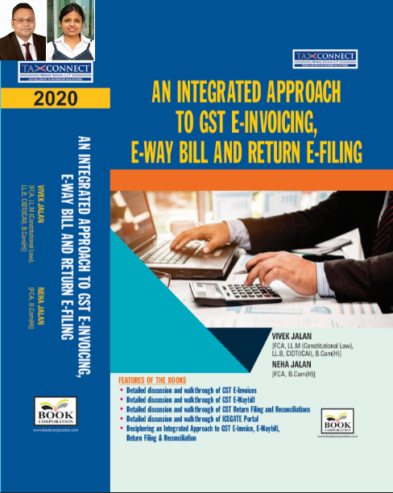
ABOUT THE BOOK: This publication includes:
- Detailed discussion and walkthrough of GST E-Invoices.
- Detailed discussion and walkthrough of GST E-Waybill.
- Detailed discussion and walkthrough of GST Return Filing and Reconciliations.
- Detailed discussion and walkthrough of ICEGATE Portal.
- Deciphering an Integrated Approach to GST E-Invoice, E-Waybill, Return Filing & Reconciliation

Authors:
Vivek Jalan
[FCA, L.LM (Constitutional Law), L.LB, CIDT(ICAI), B.Com(H)]

Neha Jalan
[FCA, B.Com(H)]

Published by: In Association With:
BOOK CORPORATION TAX CONNECT ACADEMY
4, R. N. Mukherjee Road 1, Old Court House Corner
Kolkata 700001 Kolkata 700001
Phones: (033) 64547999 Phones: (033) 40016761
Cell : 9830010297, 9331018333 Cell : 9874466163, 9830661254
Order by email:bookcorporation@gmail.com Order by email: info@taxconnect.co.in Website :www.bookcorporation.com Website : www.taxconnect.co.in

IN STANDS

Section wise Compendium on GST
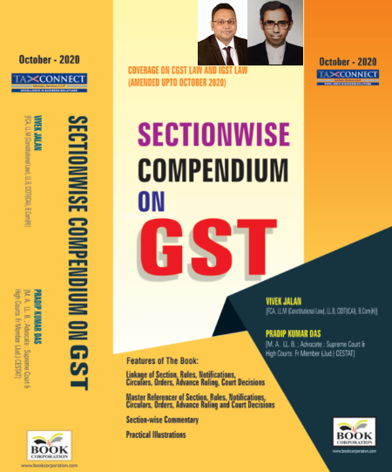
ABOUT THE BOOK: This publication includes:
1. Linkage of Section, Rules, Notifications, Circulars, Orders, Advance Ruling, Court Decisions
2. Master Referencer of Section, Rules, Notifications, Circulars, Orders, Advance Ruling and Court Decisions
3. Section-wise Commentary
4. Practical Illustrations

Authors:
Vivek Jalan
[FCA, L.LM (Constitutional Law), L.LB, CIDT(ICAI), B.Com(H)]

Pradip Kumar Das
[M.A. LL.B; Advocate Supreme Court & High Courts; Fr. Mem (Jud.) CESTAT]

Published by: In Association With:
BOOK CORPORATION TAX CONNECT ACADEMY
4, R. N. Mukherjee Road 1, Old Court House Corner
Kolkata 700001 Kolkata 700001
Phones: (033) 64547999 Phones: (033) 40016761
Cell : 9830010297, 9331018333 Cell : 9874466163, 9830661254
Order by email:bookcorporation@gmail.com Order by email: info@taxconnect.co.in Website :www.bookcorporation.com Website : www.taxconnect.co.in

IN STANDS

UNION BUDGET 2021
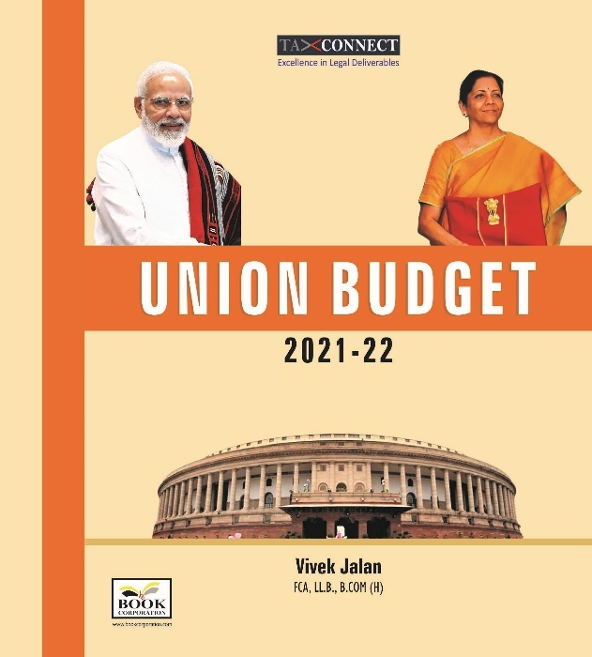
ABOUT THE BOOK: This publication includes:
1.Commentary on Budget
2.Finance Minister’s Budget Speech
3.Budget at a Glance
4.Memorandum
a. Direct Tax
b. Customs
c. Excise
d. GST
5. Finance Bill
6. Notes on Clauses

Authors:
Vivek Jalan
[FCA, L.LM (Constitutional Law), L.LB, CIDT(ICAI), B.Com(H)]

Published by: In Association With:
BOOK CORPORATION TAX CONNECT ACADEMY
4, R. N. Mukherjee Road 1, Old Court House Corner
Kolkata 700001 Kolkata 700001
Phones: (033) 64547999 Phones: (033) 40016761
Cell : 9830010297, 9331018333 Cell : 9874466163, 9830661254
Order by email:bookcorporation@gmail.com Order by email: info@taxconnect.co.in Website :www.bookcorporation.com Website : www.taxconnect.co.in

LET’S DISCUSS FURTHER!

OUR OFFICES:




DUBAI
Azizi Feirouz, 803, 8th Floor, AL Furjan, Opposite Discovery Pavillion, Dubai, UAE
Contact Person: Rohit Sharma
Email: rohit.sharma@taxconnect.co.in

KOLKATA
R No 119; 1st Floor; Diamond Arcade; 1/72, Cal Jessore Road; Kolkata – 700055
Contact Person: Priyanka Chowdhury
Email: priyanka.chowdhury@taxconnect.co.in

KOLKATA
1, Old Court House Corner, “Tobacco House”, 1st Floor, Room No. 13 (N), Kolkata-700001
Contact Person: Priyanka Chowdhury
Email: priyanka.chowdhury@taxconnect.co.in

MUMBAI
Building No.9, Flat- 403, LodhaEternis, 11th Road, MIDC, Andheri(E)-400093
Contact Person: Rajanikant Choudhury
Email: rajnikant.choudhary@taxconnectdelhi.co.in
DELHI
B-139, 2nd Floor, Transport Nagar, Noida-201301 (U.P)
Contact Person: Poonam Khemka
Email: poonam.khemka@taxconnectdelhi.co.in

BANGALORE
A-414,Carlton Towers, 19th Main; Road Hal Old Airport Rd, Domlur, Bengaluru, Karnataka-560008
Contact Person: Manmit Sinha
Email: manmit.sinha@taxconnectdelhi.co.in

Disclaimer:
This e-bulletin is for private circulation only. Views expressed herein are of the editorial team and are based on the information, explanation and documents available on Government portal platforms. Tax Connect or any of its employees do not accept any liability whatsoever direct or indirect that may arise from the use of the information contained herein. No matter contained herein may be reproduced without prior consent of Tax Connect. While this e-article has been prepared on the basis of published/other publicly available information considered reliable, we do not accept any liability for the accuracy of its contents.
Tax Connect 2021. All rights reserved.

