_{TAX CONNECT}

312th Issue: 22nd August 2021 – 28th August 2021
12017

Knowledge Partner:



TAX CONNECT

Mumbai :A/1001, Cirrus Bldg, Cosmos Paradise; Pokhran Road No. 1, Thane (West), Maharashtra – 400606
Bangalore:A-414,Carlton Towers,19th Main; Road Hal Old Airport Rd, Domlur, Bengaluru, Karnataka-560008
New Delhi :B-139, 2nd Floor, Transport Nagar, Noida-201301 (U.P)
Kolkata :1, Old Court House Corner, “Tobacco House” 1st Floor, R.No.-13 (North), Kolkata-700001
:Room No 119; 1st Floor; Diamond Arcade; 1/72, Cal Jessore Road; Kolkata – 700055

Dubai:AziziFeirouz, 803, 8th Floor, AL Furjan, Opposite Discovery Pavillion, Dubai, UAE

Contact: +919874466163; +91 9830661254
Website: www.taxconnect.co.in
Email: info@taxconnect.co.in



Friends,
Recently, the GSTN introduced the facility to file Annual Return (Form GSTR 9) and Reconciliation Statement (Form GSTR 9C) for the financial year 2020-21 on the GST portal (www.gst.gov.in). Specified class of taxpayers are required to file Form GSTR-9 along with GSTR 9C for the financial year 2020-21 on or before 31st December 2021 to avoid the late fees and penalty.

The major changes in GSTR 9 and GSTR 9C to be filed for F.Y. 2020-21 has been listed below:
- Taxpayers having aggregate turnover upto INR 5 crores have been exempted from filing of reconciliation statement in GSTR-9C.

- Registered persons with aggregate turnover upto INR 2 crores in FY 2020-21 have been exempted from filing of Form GSTR-9 for FY 2020-21.

- The relaxations provided in reporting of data for certain tables of Form GSTR-9C in FY 2020-21 will continue for FY 2020-21 as well.

- The due date to file GSTR-9 and GSTR-9C for FY 2020-21 is on or before 31 December 2021.

- Any registered person failing to furnish the GSTR-9 by the due date, shall be liable to pay a late fee of INR 200 (INR 100 for CGST and SGST each) every day during which such failure continues subject to a maximum of an amount calculated at a half per cent of his turnover in the State or Union territory.

- Verification table by Chartered Accountant or Cost Accountant in Part B of Form GSTR-9C has been deleted. Now, only verification by the registered person is required in GSTR-9C for applicable registered taxpayers.

- Mandatory requirement of audit under GST by a Chartered Accountant or Cost Accountant has been eliminated. Hence, for the Financial Year 2020-21, Form GSTR-9C has to be self-certified by the taxpayer instead of being certified by Chartered Accountant or Cost Accountant. We understand that by eliminating the requirement of certification by a Chartered Accountant or Cost Accountant, the government has tried to reduce the compliance burden on taxpayers but at the same time there will be more onus on the taxpayer itself for authentication of figures and compliances. to provide, true and correct information in the annual return and reconciliation statement.

We do hope that this bulletin adds value to your professional sphere.
Just to reiterate that we remain available over telecom or e-mail.
Truly Yours

Editor:
Vivek Jalan
Partner - Tax Connect Advisory Services LLP
Co-Editors:
Rohit Sharma
Senior Manager – Tax Connect Advisory Services LLP
Rajanikant Choudhury
Manager - Tax Connect Advisory Services LLP
Stay Safe and Healthy
S.NO. | TOPICS | PAGE NO.
1] | TAX CALENDER | 4
2] | INCOME TAX | 5
NOTIFICATION | Income tax (23rd Amendment), Rules, 2021. - 92/2021 dated 10th august 2021
3] | GST | 6
CASE LAW | LEVY OF GST ON AMOUNT COLLECTED FROM THE EMPLOYEES TOWARDS CANTEEN CHARGES- AUTHORITY FOR ADVANCE RULING, GUJARAT
4] | FEMA | 7
BULLETIN | RESERVE BANK BULLETIN FOR THE RECENT UPDATES RELATING TO THE RECENT ECONOMIC IMPACTS DATED 17TH AUGUST 2021
5] | CUSTOMS | 8
NOTIFICATION | fixation of Tariff Value of Edible Oils, Brass Scrap, Areca Nut, Gold and Silver - 67/2021 – Customs dated 13 august 2021
6] | DGFT | 9
NOTIFICATION | Scheme Guidelines for Remission of Duties and Taxes on Exported Products (RoDTEP) - 19/2015-2020 DATED 17TH AUGUST 2021
7] | IN STANDS - AN INTEGRATED APPROACH TO GST E-INVOICING, E-WAYBILL & E-RETURN FILING | 10
8] | IN STANDS –SECTION WISE COMPENDIUM ON GST | 11
9] | IN STANDS – UNION BUDGET 2021 | 12
10] | LET’S DISCUSS FURTHER | 13

Due date | Form/Return/Challan | Reporting Period | Description
25th August 2021 | PMT-06 | July 2021 | Payment of net cash liability for July 2021 by taxpayers registered under QRMP scheme.

NOTIFICATION
INTRODUCTION OF RULE-10rb- Relief in tax payable under sub-section (1) of section 115JB due to operation of sub-section (2D) of section 115JB
OUR COMMENTS: The Central Board of Direct taxes hereby introduced Rule 10RB under vide notifying Income tax (23rd Amendment), Rules, 2021., through Notification No. 92/2021 dated 10th August 2021.
In the Income-tax Rules, 1962, (hereinafter referred to as principal rules) after rule 10RA, the following rule shall be inserted, namely:-
“10RB. Relief in tax payable under sub-section (1) of section 115JB due to operation of sub-section (2D) of section 115JB.-
(1) For the purposes of sub-section (2D) of section 115JB, the tax payable by the assessee company under sub-section (1) of section 115JB, for the previous year referred to in that section, shall be reduced by the amount calculation mentioned in the notification
(2) For the purposes of sub-rule (1) past income shall be the amount of income of past year or years included in the book profit or the previous year on account of an advance pricing agreement entered into by the assessee under section 92CC or on account of secondary adjustment required to be made under section 92CE.
(3) On application of provision of sub-rule (1), the tax credit allowed to the assessee under section 115JAA shall be reduced by the amount which is equal to the amount of reduction that has been allowed under sub-rule (1).
(4) The assessee company shall make a claim for relief under sub-section (2D) of section 115JB in Form No. 3CEEA electronically by uploading signed printout of said Form in the manner specified by the Principal Director General of Income-tax (Systems) or the Director General of Income-tax (Systems), as the case may be.
(5) Form No.3CEEA shall be verified by the person who is authorised to verify the return of income of the assessee company under section 140.
(6) The Principal Director General of Income-tax (Systems) or the Director General of Income-tax (Systems), as the case may be, shall specify the procedure for filing of the Form No. 3CEEA and shall also be responsible for evolving and implementing appropriate security, archival and retrieval policies in relation to the statements so furnished under this rule.
In the principal rules, in Appendix II, after Form No.3CEEA, shall be inserted as per the notification.

[For further details please refer the notification]

ADVANCE RULING
LEVY OF GST ON amount collected from the employees towards canteen charges- AUTHORITY FOR ADVANCE RULING, GUJARAT
Our Comments: The applicant has arranged a canteen for its employees, which is run by a third party Canteen Service Provider. As per their arrangement, part of the Canteen charges is borne by the applicant whereas the remaining part is borne by its employees. The said employees’ portion canteen charges are collected by the applicant and paid to the Canteen Service Provider. The applicant submitted that it does not retain with itself any profit margin in this activity of collecting employees’ portion of canteen charges. This activity carried out by applicant is without consideration.
The Advance ruling Authority passed the ruling that GST, at the hands on the applicant, is not leviable on the amount representing the employees portion of canteen charges, which is collected by the applicant and paid to the Canteen service provider.
Brief Facts: The applicant, has sought Ruling on whether it is required by the applicant to charge GST on the amount collected from the employees towards canteen charges. The applicant submitted as follows:
i. Company is providing canteen facility to their employee as it is mandatory as per Section 46 of the Factories Act, 1948. This facility provided to employee without making any profit and working as mediator between employee and contractor of canteen service provider. They are collecting amount from the employee and paid to the contractor of canteen.
ii. With reference to the Gujarat Appellate Authority Advance Ruling (Appeal) No. GUJ/GAAAR/APPEAL/2021/07 dated 08.03.2021, Tax is not applicable on the collection of employee portion of amount towards food stuff supplied by the third party/canteen service provider.
iii. Service in relation to supply of food and beverages by a canteen maintained in a factory covered under the factories Act, 1948 was exempted under the Service Tax as per Sr. No. 19 of Mega exemption Notification No. 25/2012-ST dated 20.06.2012.
iv. They are of the opinion that this activity does not fall within the scope of supply as the same is not in the course or furtherance of its business. They are facilitating the supply of food to the employees which is statutory requirement and is recovering only employees share as actual expenditure incurred in a connection with the food supply without making any profit.
v. The canteen service provider charging GST on supply of food and same is not entitled to avail as ITC as it has been restricted by virtue of Section 17 (5) of CGST Act, 2017. In such case canteen service provided by company should not be construed as “service” and no GST shall be payable.
Findings and Ruling by the Advance Ruling authority is extracted hereunder:
We have carefully considered all the submissions made by the applicant. We find that the applicant has arranged a canteen for its employees, which is run by a third party Canteen Service Provider. As per their arrangement, part of the Canteen charges is borne by the applicant whereas the remaining part is borne by its employees. The said employees’ portion canteen charges is collected by the applicant and paid to the Canteen Service Provider. The applicant submitted that it does not retain with itself any profit margin in this activity of collecting employees’ portion of canteen charges. This activity carried out by applicant is without consideration. Thus, we pass the Ruling that GST, at the hands on the applicant, is not leviable on the amount representing the employees portion of canteen charges, which is collected by the applicant and paid to the Canteen service provider.

BULLETIN
RESERVE BANK BULLETIN FOR THE RECENT UPDATES RELATING TO THE RECENT ECONOMIC IMPACTS DATED 17TH AUGUST 2021
OUR COMMENTS: The Reserve Bank of India today released the August 2021 issue of its monthly Bulletin. The Bulletin includes Monetary Policy Statement, 2020-21: Resolution of the Monetary Policy Committee (MPC) August 3-6, 2021, two Speeches, four Articles and Current Statistics. The four articles are:
- State of the Economy;
- COVID-19 Impact on Food Price Mark-ups in India;
- TLTRO and Structural Liquidity: A Shot in the Arm for NBFCs
- Performance of Small Finance Banks – An Early Reflection.
I. State of the Economy The course of the economy over the month and a half gone by has been altered by the slow retreat of the second wave of the pandemic. Aggregate demand conditions are buoyed by the release of pent-up demand post unlock, while the supply situation is improving with the monsoon catching up to its normal levels and sowing activity gaining pace. Reaffirming the traction that the economy is gaining, the manufacturing activity is gradually turning around, while contraction in services has moderated. Spurred by comfortable liquidity conditions, financial conditions stay benign and supportive of the recovery.
II. COVID-19 Impact on Food Price Mark-ups in India The behaviour of food price mark-ups exhibited dramatic shifts following the outbreak of COVID-19 and the associated lockdown measures to contain its spread. Using centre-wise daily data on retail and wholesale prices of 22 food items released by the Department of Consumer Affairs (DCA), this article finds that mark-ups increased on average during the first nation-wide lockdown (March-May 2020) and persisted even during the subsequent unlocking phase. Furthermore, the increase in margins was found to be driven predominantly by market centres, which faced high intensity lockdowns as measured by the mobility indices. However, reflecting less stringent and localised nature of lockdowns as well as better supply chain management during the second wave of COVID-19 (April-May 2021), the extent of increase in mark-ups was relatively modest.
III. TLTRO and Structural Liquidity: A Shot in the Arm for NBFCs? In the wake of the COVID-19 pandemic, liquidity position of Non-Banking Financial Companies (NBFCs) worsened and their funding challenges intensified as markets and banks pulled back. The Reserve Bank and the Government of India introduced many liquidity enhancing schemes to help them get through the rough patch. This article investigates the impact of one such scheme, namely the Targeted Long-Term Repo Operations (TLTRO), on NBFCs’ structural liquidity by employing a difference-in-difference strategy. The results suggest that NBFCs, which received funds via the TLTRO witnessed an improvement in their short-term liquidity buckets compared to others.
IV. Performance of Small Finance Banks – An Early Reflection The Small Finance Banks (SFBs) is a relatively new bank group provided license with the objective to serve the under-served and marginalised sections of society. The article carries out a preliminary analysis based on available data to shed light on various aspects of SFBs’ functioning. The salient findings of the study are as below: Highlights: • A basic examination of operational financials reveals relatively high credit deposit ratio of SFBs. Additionally, most of the SFBs are displaying healthy profitability with further improvements in recent quarters. • The empirical results based on quarterly data spanning from March 2017 to March 2020 indicate that bank-level factors like efficiency, leverage, liquidity and banking business are significant in determining SFBs’ profitability during this early period of operation
[For further details please refer the press release]
NOTIFICATION
fixation of Tariff Value of Edible Oils, Brass Scrap, Areca Nut, Gold and Silver - 67/2021 – Customs, dated 13 august 2021
OUR COMMENTS: The Central Board of Indirect Taxes & makes the following amendments in the notification of the Government of India in the Ministry of Finance (Department of Revenue), No. 36/2001-Customs (N.T.), dated the 3rd August, 2001, which stated different values of the commodities mentioned below.
In the said notification, certain tables shall be substituted, namely: -
Sl. No. | Chapter/ heading/ sub-heading/tariff item | Description of goods | (US $Per Metric Tonne)
(1) | (2) | (3) | (4)
1 | 1511 10 00 | Crude Palm Oil | 1029 (i.e., no change)
2 | 1511 90 10 | RBD Palm Oil | 1055 (i.e., no change)
3 | 1511 90 90 | Others – Palm Oil | 1042 (i.e., no change)
4 | 1511 10 00 | Crude Palmolein | 1061 (i.e., no change)
5 | 1511 90 20 | RBD Palmolein | 1064 ((i.e., no change)
6 | 1511 90 90 | Others – Palmolein | 1063 (i.e., no change)
7 | 1507 10 00 | Crude Soya bean Oil | 1228 (i.e., no change)
8 | 7404 00 22 | Brass Scrap (all grades) | 5538
Table 2
(1) | (2) | (3) | (4)
1. | 71 or 98 | Gold, in any form, in respect of which the benefit of entries at serial number 356 of the Notification No. 50/2017-Customs dated 30.06.2017 is availed | 563 per 10 grams
2. | 71 or 98 | Silver, in any form, in respect of which the benefit of entries at of same notification. | 1759 per kilogram
3. | 71 | (i) Silver, in any form, other than medallions and silver coins having silver content not below 99.9% or semi-manufactured forms of silver falling under sub-heading 7106 92;(ii) Medallions and silver coins having silver content not below 99.9% or semi-manufactured forms of silver falling under sub-heading 7106 92, other than imports of such goods through post, courier or baggage. | 1759 per kilogram
4. | 71 | (i) Gold bars, other than tola bars, bearing manufacturer’s or refiner’s engraved serial number and weight expressed in metric units;(ii) Gold coins having gold content not below 99.5% and gold findings, other than imports of such goods through post, courier or baggage. | 563 per

[For further details please refer the Notification]

NOTIFICATION
Scheme Guidelines for Remission of Duties and Taxes on Exported Products (RoDTEP) - 19/2015-2020 DATED 17TH AUGUST 2021
Our Comments: Centre has notified the rates and guidelines for Remission of Duties and Taxes on Exported Products (RoDTEP) export incentive scheme. The scheme for zero rating of exports will boost our exports and competitiveness in the global markets, said Ministry of Commerce and Industry in a statement on Tuesday.
The rates under RoDTEP scheme for different sectors include 0.5 per cent, 2.5 per cent and 4 per cent. These rates will apply to 8,555 tariff lines. The scheme will take effect from January 1, 2021.
The RoDTEP scheme is based on the principle that taxes and duties should not be exported, and taxes and levies borne on the exported products should be either exempted or remitted to exporters, the ministry added.
Under the RoDTEP scheme, duties, taxes and levies charged at state and local levels on exported products, including prior stage cumulative indirect taxes on goods & services used in production of the exported product, and their distribution will be refunded. The rebate under this scheme will not apply to duties and taxes already exempted, remitted or credited.
RoDTEP is going to give a boost to Indian exports by providing a level playing field to domestic industry abroad,
Effect of the Notification: Para 2.07 of the FTP regarding principles of prohibition and restrictions , is amended to be in line with international agreements.
The key takeaways are:
- The scheme will be effective for exports made from 1 January 2021.
- Rebate amount shall be granted in the form of a transferable duty credit/ electronic scrip (e-scrip), which will be maintained in an electronic ledger.
- Receipt of sale proceeds within the time allowed under the Foreign Exchange Management Act, 1999 (FEMA) is mandatory.
- Rebate would be granted to eligible exporters at the notified rate as a percentage of Free on Board (FOB) value with a value cap per unit of exported product, wherever required.
- The scrips can be used only for payment of Basic Customs Duty (BCD).
- Categories of exports/ exporters not eligible for rebate under the scheme have also been notified.
Final view points
- The scheme, which covers around two-third of the export of the country, is likely to help in easing the liquidity of the exporters, ensuring predictability and stability. Prescription of rates may also help them in determining the competitive export prices.
- The budgeted allocation under RoDTEP is much lower as compared to the government's annual outlay under MEIS that has been replaced.
- It is relevant to note that export of certain products including steel, chemicals and pharmaceuticals are not covered under the scheme.
- Benefit of RoDTEP scheme if considered for exports made by EOUs, Advance Authorisation holder, SEZ unit and customs warehouse, may boost the export industry.

[For further details please refer the Notification]

:IN STANDS

AN INTEGRATED APPROACH TO GST E-INVOICING, E-WAYBILL & E-RETURN FILING
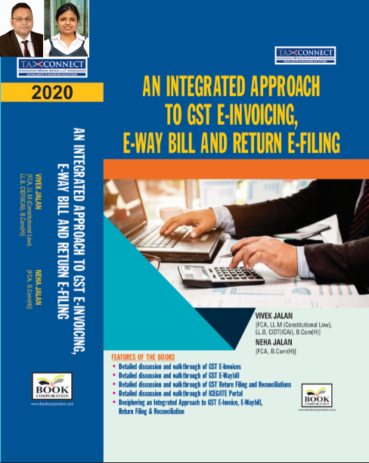
ABOUT THE BOOK: This publication includes:
- Detailed discussion and walkthrough of GST E-Invoices.
- Detailed discussion and walkthrough of GST E-Waybill.
- Detailed discussion and walkthrough of GST Return Filing and Reconciliations.
- Detailed discussion and walkthrough of ICEGATE Portal.
- Deciphering an Integrated Approach to GST E-Invoice, E-Waybill, Return Filing & Reconciliation

Authors:
Vivek Jalan
[FCA, L.LM (Constitutional Law), L.LB, CIDT(ICAI), B.Com(H)]

Neha Jalan
[FCA, B.Com(H)]

Published by: In Association With:
BOOK CORPORATION TAX CONNECT ACADEMY
4, R. N. Mukherjee Road 1, Old Court House Corner
Kolkata 700001 Kolkata 700001
Phones: (033) 64547999 Phones: (033) 40016761
Cell : 9830010297, 9331018333 Cell : 9874466163, 9830661254
Order by email:bookcorporation@gmail.com Order by email: info@taxconnect.co.in Website :www.bookcorporation.com Website : www.taxconnect.co.in

IN STANDS

Section wise Compendium on GST
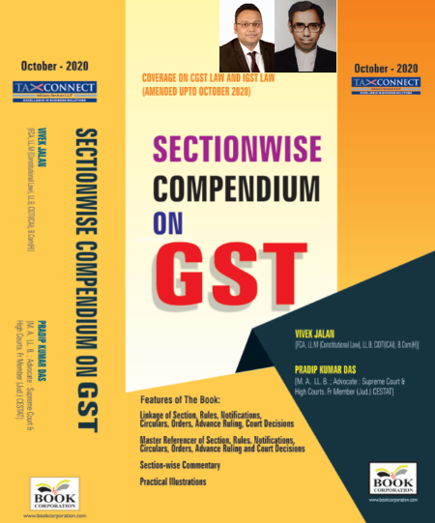
ABOUT THE BOOK: This publication includes:
1. Linkage of Section, Rules, Notifications, Circulars, Orders, Advance Ruling, Court Decisions
2. Master Referencer of Section, Rules, Notifications, Circulars, Orders, Advance Ruling and Court Decisions
3. Section-wise Commentary
4. Practical Illustrations

Authors:
Vivek Jalan
[FCA, L.LM (Constitutional Law), L.LB, CIDT(ICAI), B.Com(H)]

Pradip Kumar Das
[M.A. LL.B; Advocate Supreme Court & High Courts; Fr. Mem (Jud.) CESTAT]

Published by: In Association With:
BOOK CORPORATION TAX CONNECT ACADEMY
4, R. N. Mukherjee Road 1, Old Court House Corner
Kolkata 700001 Kolkata 700001
Phones: (033) 64547999 Phones: (033) 40016761
Cell : 9830010297, 9331018333 Cell : 9874466163, 9830661254
Order by email:bookcorporation@gmail.com Order by email: info@taxconnect.co.in Website :www.bookcorporation.com Website : www.taxconnect.co.in

IN STANDS

UNION BUDGET 2021
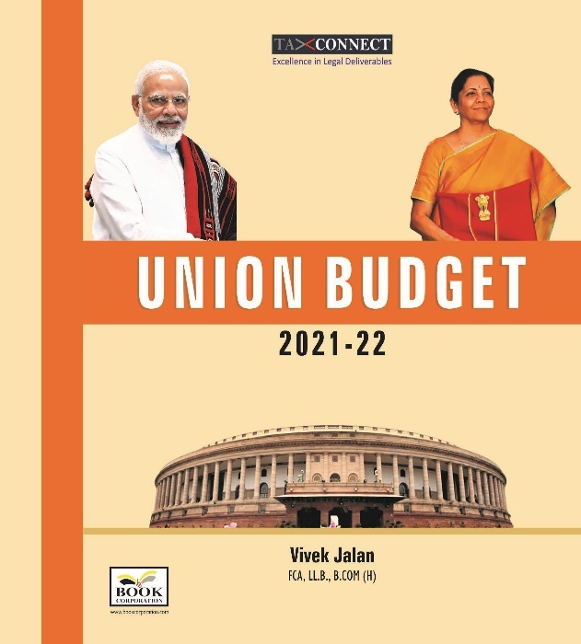
ABOUT THE BOOK: This publication includes:
1.Commentary on Budget
2.Finance Minister’s Budget Speech
3.Budget at a Glance
4.Memorandum
a. Direct Tax
b. Customs
c. Excise
d. GST
5. Finance Bill
6. Notes on Clauses

Authors:
Vivek Jalan
[FCA, L.LM (Constitutional Law), L.LB, CIDT(ICAI), B.Com(H)]

Published by: In Association With:
BOOK CORPORATION TAX CONNECT ACADEMY
4, R. N. Mukherjee Road 1, Old Court House Corner
Kolkata 700001 Kolkata 700001
Phones: (033) 64547999 Phones: (033) 40016761
Cell : 9830010297, 9331018333 Cell : 9874466163, 9830661254
Order by email:bookcorporation@gmail.com Order by email: info@taxconnect.co.in Website :www.bookcorporation.com Website : www.taxconnect.co.in

LET’S DISCUSS FURTHER!

OUR OFFICES:




DUBAI
Azizi Feirouz, 803, 8th Floor, AL Furjan, Opposite Discovery Pavillion, Dubai, UAE
Contact Person: Rohit Sharma
Email: rohit.sharma@taxconnect.co.in

KOLKATA
R No 119; 1st Floor; Diamond Arcade; 1/72, Cal Jessore Road; Kolkata – 700055
Contact Person: Priyanka Chowdhury
Email: priyanka.chowdhury@taxconnect.co.in

KOLKATA
1, Old Court House Corner, “Tobacco House”, 1st Floor, Room No. 13 (N), Kolkata-700001
Contact Person: Priyanka Chowdhury
Email: priyanka.chowdhury@taxconnect.co.in

MUMBAI
Building No.9, Flat- 403, LodhaEternis, 11th Road, MIDC, Andheri(E)-400093
Contact Person: Rajanikant Choudhury
Email: rajnikant.choudhary@taxconnect.co.in
DELHI
B-139, 2nd Floor, Transport Nagar, Noida-201301 (U.P)
Contact Person: Poonam Khemka
Email: poonam.khemka@taxconnectdelhi.co.in

BANGALORE
A-414,Carlton Towers, 19th Main; Road Hal Old Airport Rd, Domlur, Bengaluru, Karnataka-560008
Contact Person: Manmit Sinha
Email: manmit.sinha@taxconnectdelhi.co.in

Disclaimer:
This e-bulletin is for private circulation only. Views expressed herein are of the editorial team and are based on the information, explanation and documents available on Government portal platforms. Tax Connect or any of its employees do not accept any liability whatsoever direct or indirect that may arise from the use of the information contained herein. No matter contained herein may be reproduced without prior consent of Tax Connect. While this e-article has been prepared on the basis of published/other publicly available information considered reliable, we do not accept any liability for the accuracy of its contents.
Tax Connect 2021. All rights reserved.

