_{TAX CONNECT}

311th Issue: 15th August 2021 – 21st August 2021
12017

Knowledge Partner:



TAX CONNECT

Mumbai :A/1001, Cirrus Bldg, Cosmos Paradise; Pokhran Road No. 1, Thane (West), Maharashtra – 400606
Bangalore:A-414,Carlton Towers,19th Main; Road Hal Old Airport Rd, Domlur, Bengaluru, Karnataka-560008
New Delhi :B-139, 2nd Floor, Transport Nagar, Noida-201301 (U.P)
Kolkata :1, Old Court House Corner, “Tobacco House” 1st Floor, R.No.-13 (North), Kolkata-700001
:Room No 119; 1st Floor; Diamond Arcade; 1/72, Cal Jessore Road; Kolkata – 700055

Dubai:AziziFeirouz, 803, 8th Floor, AL Furjan, Opposite Discovery Pavillion, Dubai, UAE

Contact: +919874466163; +91 9830661254
Website: www.taxconnect.co.in
Email: info@taxconnect.co.in



Friends,
There are certain key functionalities that got launched in the recent week on the new income tax website incometax.go.in, like user profile, ITR 1, 2 and 4 filing, e-proceedings, viewing of old ITRs etc. The new income tax e-filing portal www.incometax.gov.in had a bumpy start from the day of its launch on June 7 as it continued to face tech glitches. The tax department has taken corrective measures through Infosys based on feedback from taxpayers, tax professionals and representatives of the Institute of Chartered Accountants of India (ICAI).
E-WAY GENERATION TO BE BLOCKED FROM AUGUST 15 FOR RETURN NON-FILERS: GSTN
The Taxpayers who are yet to file GST returns for two months or quarters up to June 2021 will not be able to generate e-way bills from August 15. This action would help increase Goods and Services Tax collections in August as pending GST returns are expected to be filed. The Central Board of Indirect Taxes and Customs (CBIC) had earlier suspended the blocking of electronic way (e-way) bill generation for non-filers of GST returns, to give taxpayers compliance relief during the COVID pandemic.
In an advisory dated August 4 to taxpayers, it was mentioned that, the government has now decided to resume the blocking of EWB (eway bill) generation facility on the EWB portal, for all the taxpayers from August 15 onwards.

I-T DEPT TO REFUND EXCESS INTEREST, LATE FEE COLLECTED WHILE FILING RETURNS FOR FY2020-21
Recently a situation arised on the income tax portal whereby taxpayers were charged late fee while filing ITR despite the last date for it being extended, the I-T Department was sure that the ITR software was rectified on 1st Aug 2021 itself to remove the error due to incorrect computation of interest u/s 234A and late fee u/s 234F. Taxpayers are thus advised to use the latest version of the ITR preparation software or file online. The I-T department had extended the last date for filing ITR for last financial year to September 30, 2021, from July 31 to give relief to taxpayers during the pandemic. Moreover if, by any chance, someone has already submitted the ITR with such incorrect interest or late fee, the same will be correctly calculated while processing at CPC-ITR and the excess amount paid, if any, will be refunded in the normal course as communicated by the income tax department..

We do hope that this bulletin adds value to your professional sphere.
Just to reiterate that we remain available over telecom or e-mail.
Truly Yours

Editor:
Vivek Jalan
Partner - Tax Connect Advisory Services LLP
Co-Editors:
Rohit Sharma
Senior Manager – Tax Connect Advisory Services LLP
Rajanikant Choudhury
Manager - Tax Connect Advisory Services LLP
Stay Safe and Healthy
S.NO. | TOPICS | PAGE NO.
1] | TAX CALENDER | 4
2] | INCOME TAX | 5
NOTIFICATION | U/s 10(46) of IT Act 1961 - Central Government notifies ‘Real Estate Regulatory Authority’ in respect of the specified income arising to that Authority - 86/2021 - Income Tax
3] | GST | 6
ADVISORY | ADVISORY FOR TAXPAYERS REGARDING BLOCKING OF E-WAY BILL (EWB) GENERATION FACILITY RESUME AFTER 15TH AUGUST, 2021.
ADVISORY | UPDATING THE ANNUAL AGGREGATE TURNOVER (AATO) BY TAXPAYERS.
4] | FEMA | 7
NOTIFICATION | FOREIGN EXCHANGE MANAGEMENT (NONDEBT INSTRUMENTS) (AMENDMENT) RULES, 2021. - S.O. 3206(E) - FOREIGN EXCHANGE MANAGEMENT
PRESS RELEASE | RATIONALISATION OF OVERSEAS INVESTMENT REGULATIONS UNDER FEMA, 1999 – RBI DRAFT RULES/REGULATIONS FOR COMMENTS AND RELEASED THE PRESS RELEASE NO. 2021-2022/661 ON 9.8.2021
5] | CUSTOMS | 8
NOTIFICATION | NOTIFICATION NO. 43/2021 -Customs (ADD) dated 9th August, 2021 Seeks to levy anti dumping duty on imports of Phthalic Anhydride (PAN) originating in or exported from China PR, Indonesia, Korea RP and Thailand for a period of five years. - 43/2021 - Anti Dumping Duty
6] | DGFT | 9
TRADE NOTICE | NOTIFICATION NO. 16/2015-2020 DATED 09.08.2021 Extension in period of modification of IEC till 31.08.2021 and waiver of fees for IEC updation done during August, 2021- reg.
7] | IN STANDS - AN INTEGRATED APPROACH TO GST E-INVOICING, E-WAYBILL & E-RETURN FILING | 10
8] | IN STANDS –SECTION WISE COMPENDIUM ON GST | 11
9] | IN STANDS – UNION BUDGET 2021 | 12
10] | LET’S DISCUSS FURTHER | 13

Due date | Form/Return/Challan | Reporting Period | Description
15th August 2021 | Form No. 16A | April 2021-June, 2021 | Quarterly TDS certificate (in respect of tax deducted for payment other than salary) for the quarter ending June 21
20th August 2021 | GSTR 3B | July 2021 | Due date of filing of GSTR 3B for the month of July 2021 for taxpayer having turnover more than INR 5 Crore
20th August 2021 | GSTR-5 | July 2021 | Return by Non-resident taxable person for July 2021
20th August 2021 | GSTR-5A | July 2021 | OIDAR - Details of supplies of online information and database access or retrieval services by a person located outside India made to non-taxable persons in India

NOTIFICATION
1U/s 10(46) of IT Act 1961 - Central Government notifies ‘Real Estate Regulatory Authority’ in respect of the specified income arising to that Authority - 86/2021 - Income Tax
OUR COMMENTS: The Central Government notified ‘Real Estate Regulatory Authority’ as specified in the schedule to this notification, constituted by Government in exercise of powers conferred under sub-section (1) of section 20 of the Real Estate (Regulation and Development) Act, 2016 (16 of 2016) as a ‘class of Authority’ in respect of the following specified income arising to that Authority, namely:-
(a) Amount received as Grants-in-aid or loan/advance from Government;
(b) Fee/penalty received from builders/developers, agents or any other stakeholders as per the provisions of the Real Estate (Regulation and Development) Act, 2016;and
(c) Interest earned on (a) and (b) above.
2. This notification shall be effective subject to the conditions that Real Estate Regulatory Authority, Himachal Pradesh, Shimla-
(a) shall not engage in any commercial activity;
(b) activities and the nature of the specified income shall remain unchanged throughout the financial years;
(c) shall file return of income in accordance with the provision of clause (g) of sub-section (4C) of section 139 of the Income-tax Act, 1961; and
(d) shall file the Audit report along with the Return, duly verified by the accountant as provided in explanation to section 288(2) of the Income-tax Act, 1961 along with a certificate from the chartered accountant that the above conditions are satisfied.
3. This notification shall apply to the Real Estate Regulatory Authority, mentioned at column (2) below, with respect to the assessment years mentioned in column (4) below.
SCHEDULE
S. No. | Name of the Real Estate Regulatory Authority | PAN | Financial Years
(1) | (2) | (3) | (4)
1. | Real Estate Regulatory Authority, Himachal Pradesh, Shimla | AAAGR1176F | 2020-2021, 2021-2022, 2022-2023, 2023-2024 and 2024-2025

[For further details please refer the notification]

ADVISORIES
Advisory for Taxpayers regarding Blocking of E-Way Bill (EWB) generation facility resume after 15th August, 2021.
OUR COMMENTS: The facility of blocking E way bill generation had been temporarily suspended due to pandemic, in terms of Rule 138 E (a) and (b) of the CGST Rules, 2017, the E Way Bill generation facility of a person is liable to be restricted, in case the person fails to file their return in Form GSTR-3B / statement in CMP-08, for a consecutive period of two months / Quarters or more.
The GSTN on 04th August 2021 came up with an Advisory for taxpayer regarding Blocking of E-Way Bill (EWB) generation facility resume after 15th August, 2021.
The government has now decided to resume the blocking of EWB generation facility on the EWB portal, for all the taxpayers in terms of Rule 138 E (a) and (b) of the CGST Rules, 2017, from 15th August onwards.
Thus, after 15th August 2021, the System will check the status of returns filed in Form GSTR-3B or the statements filed in Form GST CMP-08, and restrict the generation of EWB in case of:
- Non filing of two or more returns in Form GSTR-3B for the months up to June, 2021 and
(b) Non filing of 02 or more statements in Form GST CMP-08 for the quarters up to April to June, 2021
To avail continuous EWB generation facility on EWB Portal, the taxpayers are therefore advised to file their pending GSTR 3B returns/ CMP-08 Statement immediately.

ADVISORIES
Updating the Annual Aggregate Turnover (AATO) by taxpayers.
OUR COMMENTS: The GSTN on 04th August 2021 came up with an another Advisory for Updating the Annual Aggregate Turnover (AATO) by taxpayers.
The Annual Aggregate Turnover (AATO) has been calculated by the GSTN based on the returns filed by the taxpayers. The detailed advisory on calculation methodology of AATO has been specified under the ‘Advisory’ hosted at Taxpayers’ Dashboard.
A functionality has been provided at the Common Portal to modify the AATO where taxpayers have reason to believe that the AATO has been calculated wrongly. In such cases, taxpayers may modify the Annual Aggregate Turnover (AATO). In case such modification is made beyond a certain limit (as specified in the ‘Advisory’), the same shall be sent to the jurisdictional officer’s Dashboard for appropriate action, if required.
However, it has been seen that many taxpayers have used the functionality to modify AATO just for confirming it, which is not required. In case, the AATO is correct in their opinion, they are not required to take any action.

NOTIFICATION
FOREIGN EXCHANGE MANAGEMENT (NON DEBT INSTRUMENTS) (AMENDMENT) RULES, 2021. - S.O. 3206(E) - FOREIGN EXCHANGE MANAGEMENT
OUR COMMENTS: The Central Government hereby makes the following rules further to amend the Foreign Exchange Management (Non-debt Instruments) Rules, 2019, namely:-
1. Short title and commencement. –
(1) These rules may be called the Foreign Exchange Management (Nondebt Instruments) (Amendment) Rules, 2021.
(2) They shall come into force on the date of their publication in the Official Gazette.
2. In the Foreign Exchange Management (Non-debt Instruments) Rules, 2019, under Rule 23 in sub-rule (7), in clause (i), after sub-clause (B), for the purpose of sub-clause (A), the following Explanation shall be inserted, namely:-
Explanation: An investment made by an Indian entity which is owned and controlled by NRI(s), on a non-repatriation basis, shall not be considered for calculation of indirect foreign investment.
[For further details please refer the press note]

PRESS RELEASE
RATIONALISATION OF OVERSEAS INVESTMENT REGULATIONS UNDER FEMA, 1999 – RBI DRAFT RULES/REGULATIONS FOR COMMENTS AND RELEASED THE PRESS RELEASE NO. 2021-2022/661 ON 9.8.2021
OUR COMMENTS: Overseas Investments and acquisition of immovable properties outside India by persons resident in India is presently governed by the provisions contained in Notification No. FEMA 120/RB-2004 dated July 07, 2004 [Foreign Exchange Management (Transfer or Issue of any Foreign Security) Regulations, 2004] and Notification No. FEMA 7 (R)/2015-RB dated January 21, 2016 [Foreign Exchange Management (Acquisition and Transfer of Immovable Property Outside India) Regulations 2015] respectively. With a view to further liberalize regulatory framework and also to promote ease of doing business, it has been decided to rationalize the existing provisions governing overseas investment. The Rules and Regulations will be finalized after public consultations. Accordingly, the Reserve Bank of India (RBI) has today placed on its website two documents viz draft Foreign Exchange Management (Non-debt Instruments - Overseas Investment) Rules, 2021 and draft Foreign Exchange Management (Overseas Investment) Regulations, 2021. Comments/feedback on the draft rules/regulations are invited from all stakeholders. Comments/feedback may be forwarded through email by August 23, 2021 with the subject line “Feedback on draft Overseas Investment rules & regulations”
[For further details please refer the press release]
NOTIFICATION
levy anti dumping duty on imports of Phthalic Anhydride (PAN) originating in or exported from China PR, Indonesia, Korea RP and Thailand for a period of five years. - 43/2021 - Anti Dumping Duty
OUR COMMENTS: In the matter of “Phthalic Anhydride” (hereinafter referred to as the subject goods), falling under tariff item 2917 35 00 of the First Schedule to the Customs Tariff Act, 1975 (51 of 1975) (hereinafter referred to as the Customs Tariff Act), originating in, or exported from China PR, Indonesia, Korea RP and Thailand (hereinafter referred to as the subject countries) and imported into India, the designated authority in its final findings vide notification No. 6/16/2020-DGTR, dated the 19th May, 2021, published in the Gazette of India, Extraordinary, Part I, Section 1, dated the 19th May, 2021, has come to the conclusion that-
(i) the product under consideration has been exported at a price below normal value, thus resulting in dumping;
(ii) the domestic industry has suffered material injury;
(iii) there is causal link between dumping of product under consideration and injury to the domestic industry,
and has recommended imposition of definitive anti-dumping duty on imports of the subject goods, originating in, or exported from the subject countries and imported into India, in order to remove injury to the domestic industry.
Now, therefore, in exercise of the powers conferred by sub-sections (1) and (5) of section 9A of the Customs Tariff Act, read with rules 18 and 20 of the Customs Tariff (Identification, Assessment and Collection of Anti-dumping Duty on Dumped Articles and for Determination of Injury) Rules, 1995, the Central Government, after considering the aforesaid final findings of the designated authority, hereby imposes on the subject goods, the description of which is specified in column (3) of the Table mentioned in the notification, falling under the tariff item of the First Schedule to the Customs Tariff Act as specified in the corresponding entry in column (2), originating in the countries as specified in the corresponding entry in column (4), exported from the countries as specified in the corresponding entry in column (5), produced by the producers as specified in the corresponding entry in column (6), and imported into India, an anti-dumping duty at the rate equal to the amount as specified in the corresponding entry in column (7), in the currency as specified in the corresponding entry in column (9) and as per unit of measurement as specified in the corresponding entry in column (8) of the mentioned table. Provided that in respect of goods originating in or exported from Korea RP where duty of customs leviable under First Schedule to the Customs Tariff Act (hereinafter referred to as the said customs duty) is paid in accordance with notification of the Government of India, in the Ministry of Finance (Department of Revenue) No. 152/2009- Customs, dated the 31st December, 2009, published in the Gazette of India, Extraordinary, Part II, Section 3, Subsection (i) vide number G.S.R. 943 (E), dated the 31st December, 2009, the anti-dumping duty under this notification shall apply in such cases where the said customs duty is less than the amount indicated in Column 7 of the table above and in such cases, the anti-dumping duty imposed under this notification shall be equal to the difference between the said amount and the said customs duty.
2. The anti-dumping duty imposed under this notification shall be levied for a period of five years (unless revoked, superseded or amended earlier) from the date of publication of this notification in the Official Gazette and shall be payable in Indian currency.
Explanation.- For the purposes of this notification, rate of exchange applicable for the purpose of calculation of such anti-dumping duty shall be the rate which is specified in the notification of the Government of India, in the Ministry of Finance (Department of Revenue), issued from time to time, in exercise of the powers conferred by section 14 of the Customs Act, 1962 (52 of 1962), and the relevant date for the determination of the rate of exchange shall be the date of presentation of the bill of entry under section 46 of the said Customs Act.
[for further details please refer the notification no. 43/2021 -customs (add) dated 9th august, 2021]

NOTIFICATION
NOTIFICATION NO. 16/2015-2020 DATED 9.08.2021 Extension in period of modification of IEC till 31.08.2021 and waiver of fees for IEC updation done during August, 2021- reg.
Our Comments : The Central Government hereby amends the existing Para 2.07 of Foreign Trade Policy, 2015-2020 to read as under:
Principles of Restrictions and Prohibitions for Imports/Exports:
Existing Provision | Revised Provision
DGFT may, through a Notification, impose restrictions on export and import, necessary for: -  (a) Protection of public morals;  (b) Protection of human, animal or plant life or health;  (c) Protection of patents, trademarks and copyrights, and the prevention of deceptive practices;  (d) Prevention of use of prison labour;  (e) Protection of national treasures of artistic, historic or archaeological value;  (f) Conservation of exhaustible natural resources;  (g) Protection of trade of fissionable material or material from which they are derived;  (h) Prevention of traffic in arms, ammunition and implements of war  (i) Relating to the importation or exportation of gold or silver | DGFT may, through a Notification, impose 'Prohibition' or 'Restriction': -  a. on export of foodstuffs or other essential products for preventing or relieving critical shortages;  b. on imports and exports necessary for the application of standards or regulations for the classification, grading or marketing of commodities in international trade;  c. on imports of fisheries product, imported in any form, for enforcement of governmental measures to restrict production of the domestic product or for certain other purposes;  d. on imports to safeguard country's external financial position and to ensure a level of reserves.  e. on imports to promote establishment of a particular industry;  f. for preventing sudden increases in imports from causing serious injury to domestic producers or to relieve producers who have suffered such injury;  g. for protection of public morals or to maintain public order;  h. for protection of human, animal or plant life or health  i. relating to the importations or exportations of gold or silver;  j. necessary to secure compliance with laws and regulations including those relating to the protection of patents, trademarks and copyrights, and the prevention of deceptive practices  k. relating to the products of prison labour  l. for the protection of national treasures of artistic, historic or archaeological value  m. for the conservation of exhaustible natural resources  n. for ensuring essential quantities for the domestic processing industry  o. essential to the acquisition or distribution of products in general or local short supply;  p. for the protection of country's essential security interests:  i. relating to fissionable materials or the materials from which they are derived;  ii. relating to the traffic in arms, ammunition and implements of war;  iii. taken in time of war or other emergency in international relations; or  q) in pursuance of country's obligations under the United Nations Charter for the maintenance of international peace and security.
Effect of the Notification: Para 2.07 of the FTP regarding principles of prohibition and restrictions , is amended to be in line with international agreements.
[For further details please refer the Notification]

:IN STANDS

AN INTEGRATED APPROACH TO GST E-INVOICING, E-WAYBILL & E-RETURN FILING
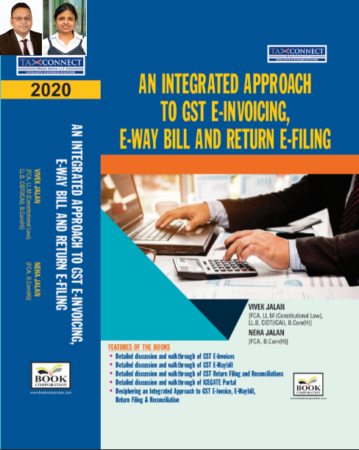
ABOUT THE BOOK: This publication includes:
- Detailed discussion and walkthrough of GST E-Invoices.
- Detailed discussion and walkthrough of GST E-Waybill.
- Detailed discussion and walkthrough of GST Return Filing and Reconciliations.
- Detailed discussion and walkthrough of ICEGATE Portal.
- Deciphering an Integrated Approach to GST E-Invoice, E-Waybill, Return Filing & Reconciliation

Authors:
Vivek Jalan
[FCA, L.LM (Constitutional Law), L.LB, CIDT(ICAI), B.Com(H)]

Neha Jalan
[FCA, B.Com(H)]

Published by: In Association With:
BOOK CORPORATION TAX CONNECT ACADEMY
4, R. N. Mukherjee Road 1, Old Court House Corner
Kolkata 700001 Kolkata 700001
Phones: (033) 64547999 Phones: (033) 40016761
Cell : 9830010297, 9331018333 Cell : 9874466163, 9830661254
Order by email:bookcorporation@gmail.com Order by email: info@taxconnect.co.in Website :www.bookcorporation.com Website : www.taxconnect.co.in

IN STANDS

Section wise Compendium on GST
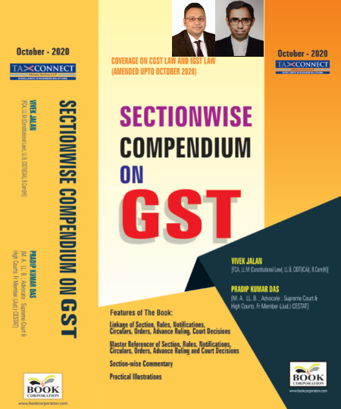
ABOUT THE BOOK: This publication includes:
1. Linkage of Section, Rules, Notifications, Circulars, Orders, Advance Ruling, Court Decisions
2. Master Referencer of Section, Rules, Notifications, Circulars, Orders, Advance Ruling and Court Decisions
3. Section-wise Commentary
4. Practical Illustrations

Authors:
Vivek Jalan
[FCA, L.LM (Constitutional Law), L.LB, CIDT(ICAI), B.Com(H)]

Pradip Kumar Das
[M.A. LL.B; Advocate Supreme Court & High Courts; Fr. Mem (Jud.) CESTAT]

Published by: In Association With:
BOOK CORPORATION TAX CONNECT ACADEMY
4, R. N. Mukherjee Road 1, Old Court House Corner
Kolkata 700001 Kolkata 700001
Phones: (033) 64547999 Phones: (033) 40016761
Cell : 9830010297, 9331018333 Cell : 9874466163, 9830661254
Order by email:bookcorporation@gmail.com Order by email: info@taxconnect.co.in Website :www.bookcorporation.com Website : www.taxconnect.co.in

IN STANDS

UNION BUDGET 2021
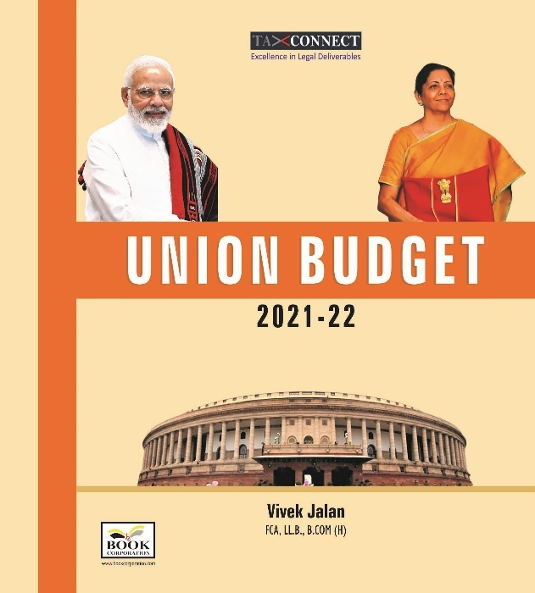
ABOUT THE BOOK: This publication includes:
1.Commentary on Budget
2.Finance Minister’s Budget Speech
3.Budget at a Glance
4.Memorandum
a. Direct Tax
b. Customs
c. Excise
d. GST
5. Finance Bill
6. Notes on Clauses

Authors:
Vivek Jalan
[FCA, L.LM (Constitutional Law), L.LB, CIDT(ICAI), B.Com(H)]

Published by: In Association With:
BOOK CORPORATION TAX CONNECT ACADEMY
4, R. N. Mukherjee Road 1, Old Court House Corner
Kolkata 700001 Kolkata 700001
Phones: (033) 64547999 Phones: (033) 40016761
Cell : 9830010297, 9331018333 Cell : 9874466163, 9830661254
Order by email:bookcorporation@gmail.com Order by email: info@taxconnect.co.in Website :www.bookcorporation.com Website : www.taxconnect.co.in

LET’S DISCUSS FURTHER!

OUR OFFICES:




DUBAI
Azizi Feirouz, 803, 8th Floor, AL Furjan, Opposite Discovery Pavillion, Dubai, UAE
Contact Person: Rohit Sharma
Email: rohit.sharma@taxconnect.co.in

KOLKATA
R No 119; 1st Floor; Diamond Arcade; 1/72, Cal Jessore Road; Kolkata – 700055
Contact Person: Priyanka Chowdhury
Email: priyanka.chowdhury@taxconnect.co.in

KOLKATA
1, Old Court House Corner, “Tobacco House”, 1st Floor, Room No. 13 (N), Kolkata-700001
Contact Person: Priyanka Chowdhury
Email: priyanka.chowdhury@taxconnect.co.in

MUMBAI
Building No.9, Flat- 403, LodhaEternis, 11th Road, MIDC, Andheri(E)-400093
Contact Person: Rajanikant Choudhury
Email: rajnikant.choudhary@taxconnectdelhi.co.in
DELHI
B-139, 2nd Floor, Transport Nagar, Noida-201301 (U.P)
Contact Person: Poonam Khemka
Email: poonam.khemka@taxconnectdelhi.co.in

BANGALORE
A-414,Carlton Towers, 19th Main; Road Hal Old Airport Rd, Domlur, Bengaluru, Karnataka-560008
Contact Person: Manmit Sinha
Email: manmit.sinha@taxconnectdelhi.co.in

Disclaimer:
This e-bulletin is for private circulation only. Views expressed herein are of the editorial team and are based on the information, explanation and documents available on Government portal platforms. Tax Connect or any of its employees do not accept any liability whatsoever direct or indirect that may arise from the use of the information contained herein. No matter contained herein may be reproduced without prior consent of Tax Connect. While this e-article has been prepared on the basis of published/other publicly available information considered reliable, we do not accept any liability for the accuracy of its contents.
Tax Connect 2021. All rights reserved.

