_{TAX CONNECT}

310th Issue: 8th August 2021 – 14th August 2021
12017

Knowledge Partner:



TAX CONNECT

Mumbai :A/1001, Cirrus Bldg, Cosmos Paradise; Pokhran Road No. 1, Thane (West), Maharashtra – 400606
Bangalore:A-414,Carlton Towers,19th Main; Road Hal Old Airport Rd, Domlur, Bengaluru, Karnataka-560008
New Delhi :B-139, 2nd Floor, Transport Nagar, Noida-201301 (U.P)
Kolkata :1, Old Court House Corner, “Tobacco House” 1st Floor, R.No.-13 (North), Kolkata-700001
:Room No 119; 1st Floor; Diamond Arcade; 1/72, Cal Jessore Road; Kolkata – 700055

Dubai:AziziFeirouz, 803, 8th Floor, AL Furjan, Opposite Discovery Pavillion, Dubai, UAE

Contact: +919874466163; +91 9830661254
Website: www.taxconnect.co.in
Email: info@taxconnect.co.in



Friends,
To attract foreign investment so to have boost in recovering economy from COVID-19 slowdown, to provide tax certainty to foreign investors, and to provide a positive message to foreign investors to invest in India by assuring tax certainty the Government of India on 04th August 2021 introduced a Bill in the Parliament to amend Explanation 5 to sec. 9 of the Income Tax Act, 1961 seeking to nullify a retrospective levy of tax on indirect transfer of shares of an Indian entity by a foreign entity which took place before 28th May, 2012. The Bill also provides that if taxes are already recovered, same shall also be refunded, however, without any interest.

DUE DATE EXTENDED FOR COMPLIANCES UNDER INCOME TAX ACT:
The CBDT further extended due dates for e-filing of various Forms under the Income-tax Act, vide Circular No. 15/2021 dt. 03-08-2021.
Form 15CC- The quarterly statement to be furnished by authorised dealers in respect of remittances made for the quarter ending on June 30, 2021 under Rule 37BB of The Income Tax Rules, can now be filed by August 31 2021. The original due date for filing this statement was July 15, 2021.

Form 1- The Equalization Levy Statement or the Financial Year 2020-21, can now be filed by August 31, 2021. The original due date for filing this statement was June 30, 2021.

Form No. 64C: The Statement of income distributed by an investment fund to be provided to the unit holder under for the Previous Year 2020-21 under Rule 12CB of the Income Tax Rules, can now be filed by September 30, 2021. The original due date for filing this statement was June 30, 2021.

Form No. 64D: The Statement of Income paid or credited by an investment fund for the Previous Year 2020-21 under Rule 12CB of the Income Tax Rules can now be filed by September 15, 2021. The original due date for filing this statement was June 15, 2021.

Further, considering the non-availability of the utility for e-filing of certain Forms, the CBDT has decided to extend the due dates for electronic filing of such Forms as under:

Form 10BBB: Intimation to be made by a Pension Fund in respect of each investment made by it in India for the quarter ending on 30th June,2021 can now be filed by September 30, 2021. The original due date for filing this statement was July 31, 2021.

Form II SWF- Intimation to be made by Sovereign Wealth Fund in respect of investments made by it in India for the quarter ending on 30th June, 2021 can now be filed by September 30, 2021. The original due date for filing this statement was July 31, 2021.

We do hope that this bulletin adds value to your professional sphere.
Just to reiterate that we remain available over telecom or e-mail.
Truly Yours

Editor:
Vivek Jalan
Partner - Tax Connect Advisory Services LLP
Co-Editors:
Rohit Sharma
Senior Manager – Tax Connect Advisory Services LLP
Rajanikant Choudhury
Manager - Tax Connect Advisory Services LLP
Stay Safe and Healthy
S.NO. | TOPICS | PAGE NO.
1] | TAX CALENDER | 4
2] | INCOME TAX | 5
NOTIFICATION | AMENDMENT NOTIFICATION NO. 83/2021 DATED 29TH JULY,2021
3] | GST | 6-7
NOTIFICATION | AMENDMENT NOTIFICATION NO. 30/2021 DATED 30TH JULY,2021
4] | FEMA | 8
PRESS NOTE | Review of Foreign Direct Investment (FDI) policy on Petroleum & Natural Gas Sector
5] | CUSTOMS | 9
NOTIFICATION | Seeks to amend notification No. 48/2017-Customs (ADD), dated the 9th October, 2017 to extend the levy of Anti-Dumping duty on ' Wire Rod of Alloy or Non-Alloy Steel ' originating in or exported from China PR up to and inclusive of 31st January, 2022. VIDE NOTIFICATION NO. - 42/2021 – DATED 1ST AUGUST, 2021, Anti Dumping Duty
6] | DGFT | 10
TRADE NOTICE | Foreign Trade Policy 2015-20 - Introduction of online Deemed Exports Application Module - DGFT VIDE TRADE NOTICE NO. 12/2021-2022 DATED 28.07.2021
7] | IN STANDS - AN INTEGRATED APPROACH TO GST E-INVOICING, E-WAYBILL & E-RETURN FILING | 11
8] | IN STANDS –SECTION WISE COMPENDIUM ON GST | 12
9] | IN STANDS – UNION BUDGET 2021 | 13
10] | LET’S DISCUSS FURTHER | 14

Due date | Form/Return/Challan | Reporting Period | Description
11th August, 2021 | GSTR - 1 | July 2021 | Details of outward supplies of goods or services
13th August, 2021 | IFF | July 2021 | Details of B2B supplies on the IFF (optional facility for the taxpayers opting into the QRMP scheme), for May 2021
13th August, 2021 | GSTR - 6 | July 2021 | ISD - Return for input service distributor [Date has been extended to 31.5.2018 for the period July 2017 to April 2018]
10th August 2021 | GSTR-7 | July 2021 | Return to be filed by the person who is required to deduct TDS under GST
10th August 2021 | GSTR-8 | July 2021 | Return to be filed by the e-commerce operators who are required to deduct TCS (Tax collected at source) under GST
14th August 2021 | Form 16B | June, 2021 | Due date for issue of TDS Certificate for tax deducted under section 194-IA in the month of June, 2021
14th August 2021 | Form 16C | June, 2021 | Due date for issue of TDS Certificate for tax deducted under section 194-IB in the month of June, 2021
14th August 2021 | Form 16D | June, 2021 | Due date for issue of TDS Certificate for tax deducted under section 194M in the month of June, 2021

NOTIFICATION
AMENDMENT NOTIFICATION NO. 83/2021 DATED 29TH JULY,2021
OUR COMMENTS: The Central Board of Direct Taxes hereby makes the following rules further to amend the Income-tax Rules, 1962, namely:-
1. Short title and commencement.––
(1) These rules may be called the Income-tax (21st Amendment) Rules, 2021.
(2) They shall come into force from the date of publication of notification in the Official Gazette
2. In the Income-tax Rules, 1962, after rule 129, the following rules shall be inserted, namely:-
“Rule 130. Omission of certain rules and Forms and savings.-(1) Rules 5A, 5AB, 6ABB, 12B, 12BA, 16D, 16DD, 16E, 16F, 18B, 18BB, 18BBA, 18DD, 18DDA, 20AB, 29AA, 29D, 37, 37E, 37F, 44A, 48, 123 and rule 124 shall be omitted.
(2) In Appendix II, Forms ITR-8, 2B, 2C, 2E, 3AA, 3AAA, 3BA, 4, 5, 5A, 10AA, 10C, 10CC, 10CCA, 10CCAA, 10CCAB, 10CCABA, 10CCAC, 10CCAD, 10CCAE, 10CCAF, 10CCAG, 10CCAH, 10CCAI, 10CCBA, 10CCBB, 10CCBBA, 10CCBC, 10CCBD, 10DB, 10DC, 10G, 10HA, 11, 11A, 12, 12A, 15I, 15J, 16AA, 22, 24, 26, 27E, 30, 34A, 34B, 34BA, 37, 37EE, 37F, 37G, 37H, 37-I, 54, 55, 56A, 56AA, 56B, 56BA, 56C, 56CA, 56E, 56F, 56FF, 56G, 56H, 58A, 58B, 63, 63A and Form 63AA shall be omitted.
(3) Notwithstanding such omission, on and from the date of commencement of this rule–
(i) any proceeding pending before any income-tax authority, any Appellate Tribunal or any court, by way of appeal, reference or revision, shall be continued and disposed of as if rules and forms mentioned in sub-rule (1) and sub-rule (2) have not been omitted;
(ii) any agreement entered into, appointment made, approval given, recognition granted, direction, instruction, notification or order issued under the rules and Forms mentioned in sub-rule (1) and sub-rule (2) shall be deemed to continue in force as if rules and forms mentioned in sub-rule (1) and sub-rule (2) have not been omitted.
Rule 131. Electronic furnishing of Forms, Returns, Statements, Reports, orders etc.- (1) The Principal Director General of Income-tax (Systems) or the Director General of Income-tax (Systems), as the case may be, may with the approval of the Board specify that any of the Forms, returns, statements, reports, orders, by whatever name called, prescribed in Appendix II, shall be furnished electronically-
(i) under digital signature, if the return of income is required to be furnished under digital signature; or
(ii) through electronic verification code in a case not covered under clause (i).
(2) The Principal Director General of Income-tax (Systems) or the Director General of Income-tax (Systems), as the case may be, shall-
(i) with the approval of the Board specify the Forms, returns, statements, reports, orders, referred to in sub-rule (1), which are to be furnished electronically;
(ii) lay down the data structure, standards and procedure of furnishing and verification of such Forms, returns, statements, reports, orders, including modification in format, if required, to make it compatible for furnishing electronically; and
(iii) be responsible for formulating and implementing appropriate security, archival and retrieval policies in relation to the said Forms, returns, statements, reports, orders.”.
[For further details please refer the notificatio
NOTIFICATION
AMENDMENT NOTIFICATION NO. 30/2021 DATED 30TH JULY,2021
OUR COMMENTS: The Central Goods and Services Tax Act, 2017 (12 of 2017), makes the following rules further to amend the Central Goods and Services Tax Rules, 2017, namely:-
1. Short title and commencement. -
(1) These rules may be called the Central Goods and Services Tax (Sixth Amendment) Rules, 2021.
(2) They shall come into force from the 1st day of August, 2021.
2. In the Central Goods and Services Tax Rules, 2017 for Rule 80 shall be substituted.
3. In the said rules, in FORM GSTR-9, in the instructions, -
(a) in paragraph 4, -
(A) after the word, letters and figures “or FY 2019-20”, the word, letters and figures “or FY 2020-21” shall be inserted;
(B) in the Table, in second column, for the word and figures “and 2019-20” wherever they occur, the word and figures “, 2019-20 and 2020-21” shall be substituted;
(b) in paragraph 5, in the Table, in second column, -
(A) against serial number 6B, after the letters and figures “FY 2019-20”, the letters, figures and word “and 2020-21” shall be inserted;
(B) against serial numbers 6C and 6D, -
(I) after the word, letters and figures “For FY 2019-20”, the word and figures “and 2020-21” shall be inserted;
(II) for the word and figures “and 2019-20”, the figures and word “, 2019-20 and 2020-21” shall be substituted;
(C) against serial number 6E, for the letters and figures “FY 2019-20”, the letters, figures and word “FY 2019-20 and 2020-21” shall be substituted;
(D) against serial number 7A, 7B, 7C, 7D, 7E, 7F, 7G and 7H, in the entry, for the figures and word “2018-19 and 2019-20”, the figures and word “2018-19, 2019-20 and 2020-21” shall be substituted;
(c) in paragraph 7, -
(A) after the words and figures “April 2020 to September 2020.”, the following shall be inserted, namely: -
“For FY 2020-21, Part V consists of particulars of transactions for the previous financial year but paid in the FORM GSTR-3B between April 2021 to September 2021.”;
(B) in the Table, in second column, -
(I) against serial numbers 10 and 11, after the entries, the following entry shall be inserted, namely: -
“For FY 2020-21, details of additions or amendments to any of the supplies already declared in the returns of the previous financial year but such amendments were furnished in Table 9A, Table 9B and Table 9C of FORM GSTR-1 of April 2021 to September 2021 shall be declared here.”;
(II) against serial number 12, -
(1) after the words, letters and figures “For FY 2019-20, the registered person shall have an option to not fill this table.”, the following entry shall be inserted, namely: -
“For FY 2020-21, aggregate value of reversal of ITC which was availed in the previous financial year but reversed in returns filed for the months of April 2021 to September 2021 shall be declared here. Table 4(B) of FORM GSTR-3B may be used for filling up these details.”;
(2) for the figures and word “2018-19 and 2019-20”, the figures and word “2018-19, 2019-20 and 2020-21” shall be substituted;
(III) against serial number 13, -
(1) after the words, letters and figures “reclaimed in FY 2020-21, the details of such ITC reclaimed shall be furnished in the annual return for FY 2020-21,”, the following entry shall be inserted, namely: -
“For FY 2020-21, details of ITC for goods or services received in the previous financial year but ITC for the same was availed in returns filed for the months of April 2021 to September 2021 shall be declared here. Table 4(A) of FORM GSTR-3B may be used for filling up these details. However, any ITC which was reversed in the FY 2020-21 as per second proviso to sub-section (2) of section 16 but was reclaimed in FY 2021-22, the details of such ITC reclaimed shall be furnished in the annual return for FY 2021-22.”;
(2) for the figures and word “2018-19 and 2019-20”, the figures and word “2018-19, 2019-20 and 2020-21” shall be substituted;
(d) in paragraph 8, in the Table, in second column, for the figures and word “2018-19 and 2019-20” wherever they occur, the letters, figures and word “2018-19, 2019-20 and 2020-21” shall be substituted.”.
4. In the said rules, in FORM GSTR-9C, -
(i) in Part A, in the table -
(a) in Sl no 9, after the entry relating to serial number K, the following serial number and entry relating thereto shall be inserted, namely: -
“K-1 | Others |  |  |  |  | .”;
(b) in Sl no 11, after entry relating to “0.10%”, the following entry shall be inserted, namely: -
“Others |  |  |  |  | .”;
(c) against Pt. V, -
(I) in the heading, for the words “Auditor’s recommendation on additional Liability due to non-reconciliation”, the words “Additional Liability due to non reconciliation” shall be substituted;
(II) after entry relating to “0.10%”, the following entry shall be inserted, namely: -
“Others |  |  |  |  | .”;
(ii) after the table, for the portion beginning with “Verification:” and ending with “and balance sheet etc.”, the following shall be substituted, namely: -
“Verification of registered person:
I hereby solemnly affirm and declare that the information given herein above is true and correct and nothing has been concealed there from. I am uploading this self-certified reconciliation statement in FORM GSTR-9C. I am also uploading other statements, as applicable, including financial statement, profit and loss account and balance sheet, etc.”;
(iii) in the instructions, -
(a) in paragraph 4, in the Table, in second column, for the figures and word “2018-19 and 2019-20” wherever they occur, the figures and word “2018-19, 2019-20 and 2020-21” shall be substituted;
(b) in paragraph 6, in the Table, in second column, for the figures and word “2018-19 and 2019-20” wherever they occur, the figures and word “2018-19, 2019-20 and 2020-21” shall be substituted.
(c) for paragraph 7, the following paragraph shall be substituted, namely, -
“7. Part V consists of the additional liability to be discharged by the taxpayer due to non-reconciliation of turnover or non-reconciliation of input tax credit. Any refund which has been erroneously taken and shall be paid back to the Government shall also be declared in this table. Lastly, any other outstanding demand which is to be settled by the taxpayer shall be declared in this Table.”;
(iv) Part B Certification shall be omitted.

[For further details please refer the notification]

PRESS NOTE
REVIEW OF FOREIGN DIRECT INVESTMENT (FDI) POLICY ON PETROLEUM & NATURAL GAS SECTOR
OUR COMMENTS: The Government of India has reviewed the extant FDI policy on Petroleum & Natural Gas sector and has made the following amendment in the Consolidated FDI Policy Circular of 2020, as amended from time to time (FDI Policy):
2. A new Para 5.2.4.3 is inserted under Para 5.2.4 of the FDI Policy. Accordingly, Para 5.2.4 of FDI Policy is amended to be read as under:
5.2.4 Petroleum & Natural Gas
Sector/Activity | % of Equity/ FDI cap | Entry Route
5.2.4.1  Exploration activities of oil and natural gas fields, infrastructure related to marketing of petroleum products and natural gas, marketing of natural gas and petroleum products, petroleum product pipelines, natural gas/pipelines, LNG Regasification infrastructure, market study and formulation and Petroleum refining in the private sector, subject to the existing sectoral policy and regulatory framework in the oil marketing sector and the policy of the Government on private participation in exploration of oil and the discovered fields Of national oil companies | 100% | Automatic
5.2.4.2  Petroleum refining by the Public Sector Undertakings (PSU), without any disinvestment or dilution of domestic equity in the existing PSUs | 49% | Automatic
5.2.4.3 Notwithstanding anything contained at Para 5.2.4.2 above, foreign investment up to 100% under the automatic route is allowed in case an 'in-principle' approval for strategic disinvestment of a PSU has been granted by the Government.
3. The above decision will take effect from the date of FEMA notification.
[For further details please refer the press note]

NOTIFICATION
notification No. 48/2017-Customs (ADD), dated the 9th October, 2017 to extend the levy of Anti-Dumping duty on ' Wire Rod of Alloy or Non-Alloy Steel ' originating in or exported from China PR up to and inclusive of 31st January, 2022. VIDE NOTIFICATION NO. - 42/2021 – DATED 1ST AUGUST, 2021, Anti Dumping Duty
OUR COMMENTS: The designated authority vide initiation notification No. 7/17/2021-DGTR, dated 28th July, 2021, published in the Gazette of India, Extraordinary, Part I, Section 1, dated the 28th July, 2021, has initiated review in terms of sub-section (5) of section 9A of the Customs Tariff Act, 1975 (51 of 1975) (hereinafter referred to as the Customs Tariff Act) and in pursuance of rule 23 of the Customs Tariff (Identification, Assessment and Collection of Anti-dumping Duty on Dumped Articles and for Determination of Injury) Rules, 1995 (hereinafter referred to as the said rules), in the matter of continuation of anti-dumping duty on imports of “Wire Rod of Alloy or Non-Alloy Steel” (hereinafter referred to as the subject goods) falling under headings 7213 or 7227 of the First Schedule to the Customs Tariff Act, originating in or exported from Peoples’ Republic of China (hereinafter referred to as the subject country), imposed vide notification of the Government of India, in the Ministry of Finance (Department of Revenue) No. 48/2017-Customs (ADD), dated the 9th October, 2017, published in the Gazette of India, Extraordinary, Part II, Section 3, Sub-section (i), vide number G.S.R. 1228(E), dated the 9th October, 2017 and had requested for extension of the said anti-dumping duty in terms of sub-section (5) of section 9A of the Customs Tariff Act;
Now, therefore, in exercise of the powers conferred by sub-sections (1) and (5) of section 9A of the said Customs Tariff Act, read with rules 18 and 23 of the said rules, the Central Government hereby makes the following amendment in the notification of the Government of India, in the Ministry of Finance (Department of Revenue), No. 48/2017-Customs (ADD), dated the 9th October, 2017, published in the Gazette of India, Extraordinary, Part II, Section 3, Sub-section (i), vide number G.S.R. 1228(E), dated the 9th October, 2017, namely: -
In the said notification, after paragraph 2, and before the Explanation, the following paragraph shall be inserted, namely: -
“3. Notwithstanding anything contained in paragraph 2, the anti-dumping duty imposed under this notification shall remain in force up to and inclusive of the 31st January, 2022, unless revoked, superseded or amended earlier.”.
[For further details please refer the Notification]

TRADE NOTICE
Foreign Trade Policy 2015-20 - Introduction of online Deemed Exports Application Module - DGFT VIDE TRADE NOTICE NO. 12/2021-2022 DATED 28.07.2021
OUR COMMENTS: The members of trade are hereby informed that this Directorate is introducing an online Deemed Exports Module on the DGFT website as a part of IT Revamp for receiving applications under the Chapter 7 of FTP 2015-20.

2. Henceforth, the following applications are required to be submitted online through the importer/exporter's dashboard on the DGFT Website :

i. Refund of Terminal Excise Duty (TED)
ii. Grant of Duty Drawback as per AIR and
iii. Fixation of Brand Rate for Duty Drawback

3. The members of trade can login to the portal, fill in the requisite details in the form, upload the necessary documents and submit the application after paying requisite fee. The system will generate a file number which can be used for tracking purposes through the portal. The RAs would issue online deficiency letters calling for any additional information/document required and the exporter would be able to reply to the deficiency letters online only. However, the applicants will have to submit the corresponding supporting physical documents as prescribed under ANF -7A to concerned RAs within 7 days of online submission of such applications for processing of the applications at RAs.
4. Please note that this new application Module will cater to new applications filed in this regard by the applicants and old/legacy physical applications submitted earlier manually will continue to be processed manually by concerned RAs.
5. The members of trade can file application in e-TED/DBK module through following navigation:
https//dgft.gov.in>Deemed Exports to access the new e-module.
6. For guidance on these new processes, the Help manual & FAQs may be accessed at https://dgft.gov.in> Learn > 'Application Help & FAQs'. For any further assistance you may utilize any of the following channels-

i. Raise a service request ticket through the DGFT Helpdesk service under Services a 'Trade Helpdesk Service'
ii. Call the toll-free DGFT Helpdesk number 1800111550
iii. Send an email to the Helpdesk on dgftedi@gov.in

[For further details please refer the Public Notice]
:IN STANDS

AN INTEGRATED APPROACH TO GST E-INVOICING, E-WAYBILL & E-RETURN FILING
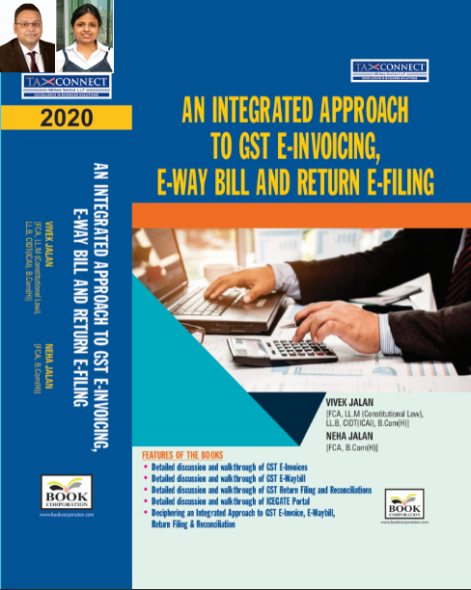
ABOUT THE BOOK: This publication includes:
- Detailed discussion and walkthrough of GST E-Invoices.
- Detailed discussion and walkthrough of GST E-Waybill.
- Detailed discussion and walkthrough of GST Return Filing and Reconciliations.
- Detailed discussion and walkthrough of ICEGATE Portal.
- Deciphering an Integrated Approach to GST E-Invoice, E-Waybill, Return Filing & Reconciliation

Authors:
Vivek Jalan
[FCA, L.LM (Constitutional Law), L.LB, CIDT(ICAI), B.Com(H)]

Neha Jalan
[FCA, B.Com(H)]

Published by: In Association With:
BOOK CORPORATION TAX CONNECT ACADEMY
4, R. N. Mukherjee Road 1, Old Court House Corner
Kolkata 700001 Kolkata 700001
Phones: (033) 64547999 Phones: (033) 40016761
Cell : 9830010297, 9331018333 Cell : 9874466163, 9830661254
Order by email:bookcorporation@gmail.com Order by email: info@taxconnect.co.in Website :www.bookcorporation.com Website : www.taxconnect.co.in

IN STANDS

Section wise Compendium on GST
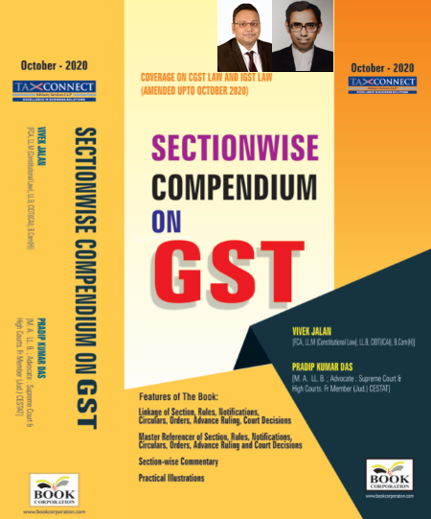
ABOUT THE BOOK: This publication includes:
1. Linkage of Section, Rules, Notifications, Circulars, Orders, Advance Ruling, Court Decisions
2. Master Referencer of Section, Rules, Notifications, Circulars, Orders, Advance Ruling and Court Decisions
3. Section-wise Commentary
4. Practical Illustrations

Authors:
Vivek Jalan
[FCA, L.LM (Constitutional Law), L.LB, CIDT(ICAI), B.Com(H)]

Pradip Kumar Das
[M.A. LL.B; Advocate Supreme Court & High Courts; Fr. Mem (Jud.) CESTAT]

Published by: In Association With:
BOOK CORPORATION TAX CONNECT ACADEMY
4, R. N. Mukherjee Road 1, Old Court House Corner
Kolkata 700001 Kolkata 700001
Phones: (033) 64547999 Phones: (033) 40016761
Cell : 9830010297, 9331018333 Cell : 9874466163, 9830661254
Order by email:bookcorporation@gmail.com Order by email: info@taxconnect.co.in Website :www.bookcorporation.com Website : www.taxconnect.co.in

IN STANDS

UNION BUDGET 2021
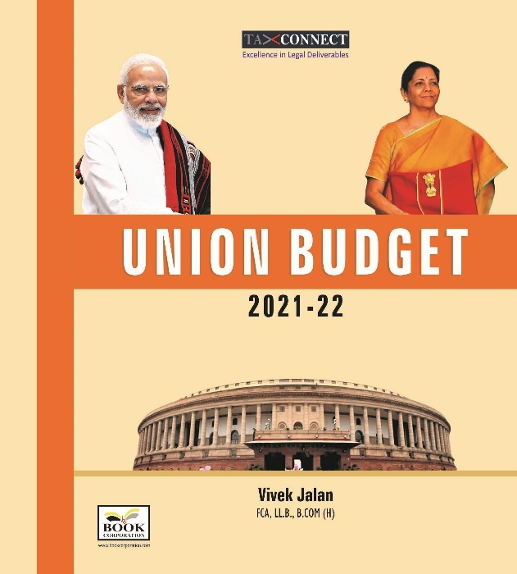
ABOUT THE BOOK: This publication includes:
1.Commentary on Budget
2.Finance Minister’s Budget Speech
3.Budget at a Glance
4.Memorandum
a. Direct Tax
b. Customs
c. Excise
d. GST
5. Finance Bill
6. Notes on Clauses

Authors:
Vivek Jalan
[FCA, L.LM (Constitutional Law), L.LB, CIDT(ICAI), B.Com(H)]

Published by: In Association With:
BOOK CORPORATION TAX CONNECT ACADEMY
4, R. N. Mukherjee Road 1, Old Court House Corner
Kolkata 700001 Kolkata 700001
Phones: (033) 64547999 Phones: (033) 40016761
Cell : 9830010297, 9331018333 Cell : 9874466163, 9830661254
Order by email:bookcorporation@gmail.com Order by email: info@taxconnect.co.in Website :www.bookcorporation.com Website : www.taxconnect.co.in

LET’S DISCUSS FURTHER!

OUR OFFICES:




DUBAI
Azizi Feirouz, 803, 8th Floor, AL Furjan, Opposite Discovery Pavillion, Dubai, UAE
Contact Person: Rohit Sharma
Email: rohit.sharma@taxconnect.co.in

KOLKATA
R No 119; 1st Floor; Diamond Arcade; 1/72, Cal Jessore Road; Kolkata – 700055
Contact Person: Priyanka Chowdhury
Email: priyanka.chowdhury@taxconnect.co.in

KOLKATA
1, Old Court House Corner, “Tobacco House”, 1st Floor, Room No. 13 (N), Kolkata-700001
Contact Person: Priyanka Chowdhury
Email: priyanka.chowdhury@taxconnect.co.in

MUMBAI
Building No.9, Flat- 403, LodhaEternis, 11th Road, MIDC, Andheri(E)-400093
Contact Person: Rajanikant Choudhury
Email: rajnikant.choudhary@taxconnectdelhi.co.in
DELHI
B-139, 2nd Floor, Transport Nagar, Noida-201301 (U.P)
Contact Person: Poonam Khemka
Email: poonam.khemka@taxconnectdelhi.co.in

BANGALORE
A-414,Carlton Towers, 19th Main; Road Hal Old Airport Rd, Domlur, Bengaluru, Karnataka-560008
Contact Person: Manmit Sinha
Email: manmit.sinha@taxconnectdelhi.co.in

Disclaimer:
This e-bulletin is for private circulation only. Views expressed herein are of the editorial team and are based on the information, explanation and documents available on Government portal platforms. Tax Connect or any of its employees do not accept any liability whatsoever direct or indirect that may arise from the use of the information contained herein. No matter contained herein may be reproduced without prior consent of Tax Connect. While this e-article has been prepared on the basis of published/other publicly available information considered reliable, we do not accept any liability for the accuracy of its contents.
Tax Connect 2021. All rights reserved.

