_{TAX CONNECT}

309th Issue: 1st August 2021 – 7th August 2021
12017

Knowledge Partner:



TAX CONNECT

Mumbai :A/1001, Cirrus Bldg, Cosmos Paradise; Pokhran Road No. 1, Thane (West), Maharashtra – 400606
Bangalore:A-414,Carlton Towers,19th Main; Road Hal Old Airport Rd, Domlur, Bengaluru, Karnataka-560008
New Delhi :B-139, 2nd Floor, Transport Nagar, Noida-201301 (U.P)
Kolkata :1, Old Court House Corner, “Tobacco House” 1st Floor, R.No.-13 (North), Kolkata-700001
:Room No 119; 1st Floor; Diamond Arcade; 1/72, Cal Jessore Road; Kolkata – 700055

Dubai:AziziFeirouz, 803, 8th Floor, AL Furjan, Opposite Discovery Pavillion, Dubai, UAE

Contact: +919874466163; +91 9830661254
Website: www.taxconnect.co.in
Email: info@taxconnect.co.in



Friends,
Tax is a mandatory fee levied by the Government on an individual or entity to collect revenue for public work and we all are aware of the importance of tax for the development of any country.
But, in many instances, we come across the news in our surroundings about tax evasion or non-payment of tax by the entity or individuals, etc. by using some illegal or legal techniques.
Actually, any business or person in search of saving tax often comes up with these terms viz, Tax Planning, Tax Avoidance, and Tax Evasion. The tax liability of a person/entity can be reduced through these ways, and in common parlance, these terms are used interchangeably, but technically these terms are different from each other.

The other relevant changes in last week are as under:

Amendment to Limited Liability Partnership Act:
The Cabinet approved amendments to the Limited Liability Partnership (LLP) Act on 28th July, 2021 for decriminalizing offences under the law as the government looks to improve ease of doing business and encourage start-ups.

There were 24 penal provisions in the LLP Act, 21 compoundable offences, and three non-compoundable offences before amendment.

After the amendments, the penal provisions will be cut to 22, compoundable offences will be only seven and non-compoundable will remain three.

BLATANT ABUSE OF POWER IN DETAINING GOODS BY TREATING VALIDITY OF THE EXPIRY ON THE E-WAY BILL AS AMOUNTING TO EVASION
Recently, The Hon’ble Telangana High Court in Satyam Shivam Papers Pvt. Ltd. v. Assistant Commissioner ST & Ors. set aside the order passed by the Revenue Department, imposing tax and penalty on the assessee due to the expiry of the E-Way Bill and deprecated the Revenue Authority for blatant abuse of power in detaining goods by treating validity of the expiry on the e-way bill as amounting to evasion of tax. Held that, no presumption can be drawn that there was an intention to evade tax on account of non-extension of the validity of the e-way bill by the Petitioner or the auto trolley driver.
Further stated that, there was no material before the Respondent to come to the conclusion that there was evasion of tax by the Petitioner merely on account of lapse of time mentioned in the e-way bill and this is plainly arbitrary, illegal and violative of Article 14 of the Constitution of India.

We do hope that this bulletin adds value to your professional sphere.
Just to reiterate that we remain available over telecom or e-mail.
Truly Yours

Editor:
Vivek Jalan
Partner - Tax Connect Advisory Services LLP
Co-Editors:
Rohit Sharma
Senior Manager – Tax Connect Advisory Services LLP
Rajanikant Choudhury
Manager - Tax Connect Advisory Services LLP

Stay Safe and Healthy
S.NO. | TOPICS | PAGE NO.
1] | TAX CALENDER | 4
2] | INCOME TAX | 5
NOTIFICATION | AMENDMENT NOTIFICATION NO. 82/2021 DATED 27TH JULY,2021
NOTIFICATION | U/s 35(1) (ii) of IT Act 1961 Central Government approved M/s Patanjali Research Foundation Trust, Haridwar - 79/2021 - DATED 12TH JULY,2021
3] | GST | 6
CIRCULAR | Clarification regarding extension of limitation under GST Law in terms of Hon’ble Supreme Court’s Order dated 27.04.2021.
4] | FEMA | 7
DISCUSSION | FCRA ACCOUNT
5] | CUSTOMS | 8
NOTIFICATION | Sea Cargo Manifest and Transhipment (Fifth Amendment) Regulations, 2021. - 61/2021 - Customs - Non Tariff DATED 23RD JULY, 2021.
6] | DGFT | 9
PUBLIC NOTICE | Amendments in the Appendix -3B, Table 2 of the Merchandise Exports from India Scheme (MEIS)- - DGFT VIDE PUBLIC NOTICE NO. 18/2015-2020 DATED 27.07.2021
7] | IN STANDS - AN INTEGRATED APPROACH TO GST E-INVOICING, E-WAYBILL & E-RETURN FILING | 10
8] | IN STANDS –SECTION WISE COMPENDIUM ON GST | 11
9] | IN STANDS – UNION BUDGET 2021 | 12
10] | LET’S DISCUSS FURTHER | 13

Due date | Form/Return/Challan | Reporting Period | Description
6th August, 2021 | GAR - 7 | July 2021 | Monthly - Electronic payment of Central Excise Duties for the previous month
7th August, 2021 | ITNS 281 | July 2021 | Monthly payment of TDS on all types of payments (Except in the case where amounted is credited in the Month of March 31)
7th August, 2021 | ITNS 281 | July 2021 | Monthly payment of TCS u/s 206C  (other than government assessee)
7th August, 2021 | Form No. 27C | April to July 2021 | Last date of submission of declaration i.e., for no TCS u/s 206C(1A) obtained from manufacturer to the Commissioner/Chief Commissioner of Income Tax as the case may be.
7th August, 2021 | Form 15G and Form 15H | April to July 2021 | Submission of copy of declaration forms received from deductee by the deductor for non deduction of TDS under section 197A before the Chief Commissioner or Commissioner
7th August, 2021 | Form No.26QB | July 2021 | Payment on transfer of certain immovable property other than agricultural land

NOTIFICATION
AMENDMENT NOTIFICATION NO. 82/2021 DATED 27TH JULY,2021

OUR COMMENTS: The Central Board of Direct Taxes hereby makes the following rules further to amend Income-tax Rules, 1962, namely:-
1. Short title and commencement.-
(1) These rules may be called the Income-tax (20th Amendment) Rules, 2021.
(2) They shall come into force from the date of their publication in the Official Gazette.
2. In the Income-tax Rules, 1962, in rule 12,––
(a) in sub-rule (1), in the opening portion, for the words, brackets and figures “or sub-section (1) of section 148”, the words and figures “or section 148” shall be substituted;
(b) in sub-rule (5), for the figure “2019”, the figure “2020” shall be substituted.
[For further details please refer the notification]

NOTIFICATION
Central Government approved M/s Patanjali Research Foundation Trust, Haridwar - 79/2021 - DATED 12TH JULY,2021

OUR COMMENTS: Central Government hereby approves M/s Patanjali Research Foundation Trust, Haridwar (PAN:- AABTP8183E) under the category “Research Association” for Scientific Research for the purposes of clauses (ii) of sub-section (1) of section 35 of the Income-tax Act, 1961 read with rules 5C and 5D of the Income-tax Rules, 1962.
2. This Notification shall apply with effect from the date of publication in the Official Gazette (i.e. from the Previous Year 2021-2022) and accordingly shall be applicable for Assessment Year(s) 2022-23 to 2027-28.
[For further details please refer the notification]

CIRCULAR
Clarification regarding extension of limitation under GST Law in terms of Hon’ble Supreme Court’s Order dated 27.04.2021.

OUR COMMENTS: CBIC has issued a Circular No 157/13/2021-GST dated 20th July, 2021 clarifying on extension of limitation for various actions under the GST Laws pursuant to Hon’ble Supreme Court’s Order dated 27th April, 2021
The Government has issued notifications under Section 168A of the CGST Act, 2017, wherein the time limit for completion of various actions, by any authority or by any person, under the CGST Act, which falls during the specified period, has been extended up to a specific date, subject to some exceptions as specified in the said notifications.
The matter of extension of period of limitation under Section 168A of the CGST Act, 2017 was deliberated in the 43rd Meeting of GST Council. Council, while providing various relaxations in the compliances for taxpayers, also recommended that wherever the timelines for actions have been extended by the Hon’ble Supreme Court, the same would apply. Legal opinion was solicited on this issue and the matter has been examined on the basis of the legal opinion received in the matter. On the basis of the legal opinion, it is hereby clarified that various actions/ compliances under GST can be broadly categorised as follows –

S. No | Action | Impact
A | Proceedings that need to be initiated or compliances that need to be done by the taxpayers | These actions would continue to be governed only by the statutory mechanism and time limit provided/ extensions granted under the statute itself
B | Quasi-Judicial proceedings by tax authorities | The tax authorities can continue to hear and dispose off proceedings which include disposal of application for refund, application for revocation of cancellation of registration, adjudication proceedings of demand notices, etc
C | Appeals by taxpayers/ tax authorities against any quasi- judicial order | Wherever any appeal is required to filed by Taxpayer, the time line for the same would stand extended as per the Hon’ble Supreme Court’s order
Note – The extension of timelines granted by Hon’ble Supreme Court vide its Order dated 27.04.2021 is applicable in respect of any appeal which is required to be filed before Department Authorities, Appellate Authority for Advance Ruling, Tribunal and various courts against any quasi-judicial order or where proceeding for revision or rectification of any order is required to be undertaken, and is not applicable to any other proceedings under GST Laws.
[For further details please refer the circular]

DISCUSSSION
‘FCRA’ ACCOUNT’
The section 17(1) of The Foreign Contribution (Regulation) Act provides that every person who has been granted certificate or prior permission under section 12 of this act shall receive foreign contribution only in an account designated as ‘FCRA Account’ by the bank, which shall be opened by him for the purpose of remittances of foreign contribution in such branch of the State Bank of India at New Delhi, as the Central Government may, by notification, specify in this behalf. Such person may also open another ‘FCRA Account’ in any of the scheduled bank of his choice for the purpose of keeping or utilizing the foreign contribution which has been received from his ‘FCRA Account’ in the specified branch of State Bank of India at New Delhi. No funds other than foreign contribution shall be received or deposited in any such account.
The following is the procedure to open FCRA account-
- Any entity which seeks to receive foreign contribution may approach either the nearest SBI Branch or any other SBI Branch of their choice for submitting the completed Account Opening Form (AOF) for KYC/photo/signature verification, scanning and forwarding through mail as well as sending hard copy of their AOF for opening of ‘FCRA Account’ at NDMB.

- The applicant shall receive an acknowledgement in this regard from the AOF accepting Branch.

- The AOF accepting branch of SBI would scrutinize AOF and KYC documents and email the verified documents to SBI, NDMB within 3 working days from the date of receipt of completed documents. SBI, NDMB shall confirm to the applicant entity through an email regarding receipt of AOF and other documents within working day of its receipt.

- The NDMB will intimate to the applicant entity the details of “FCRA Account” so opened within 3 working days from the date of receipt of duly verified scanned copies of complete set of AOF and KYC documents from e-mail ID of the receiving branch. The intimation will be sent by registered email ID as well as through SMS.

- The applicant is to wait for Ministry of Home Affairs’ decision on the application of the entities / persons for grant of prior permission or registration certificate. As soon as the Ministry of Home Affairs approval for such registration or prior permission is conveyed to NDMB through an e-mail, NDMB shall allow inflow of foreign contribution into the relevant account from that date.

- ‘Entity’ can maintain their existing FCRA Accounts for Keeping or Utilization purposes.

NOTIFICATION
AMENDMENT IN Sea Cargo Manifest and Transhipment Regulations.
OUR COMMENTS: The Central Board of Indirect Taxes and Customs hereby makes the following regulations further to amend the Sea Cargo Manifest and Transhipment Regulations, 2018, vide Notification No. 61/2021-Customs (N.T.) dated 23rd July 2021 namely: –
- In the Sea Cargo Manifest and Transhipment Regulations, 2018 (hereinafter referred to as the said regulations), in regulation 3,-
(a) the sub-regulations 3(2) shall be substituted, namely:-
“(2) Where the Jurisdictional Commissioner of Customs is satisfied with the information provided by the applicant in the Form-I, he shall register such applicant for transacting business under these regulations”;
(b) the sub-regulation 3(4) shall be substituted, namely: –
“(4) The registration shall be valid unless and until revoked in terms of the provisions under regulation 3A or regulation 11:
Provided that the registration of the authorised carrier shall be deemed invalid if the authorised carrier is found to be inactive for a period of one year.
Explanation.- The term ‘inactive’ refers to an authorised carrier who does not transact any business pertaining to Customs during a period of one year, excluding the period for which registration has been suspended under regulation 11.”;
(c) the sub-regulation 3(5) shall be inserted, namely: –
“(5) Subject to the provisions of sub- regulation (1A), the Jurisdictional Commissioner of Customs may, on an application made by the authorised carrier in Form IA, after the registration has been deemed invalid under sub regulation (4), renew the registration from the date of expiration, after satisfying himself that the applicant is otherwise eligible for registration under this regulation within one month of the date of receipt of the application”.
- After regulation 3, the regulation 3A shall be inserted regarding Surrender of registration.
- the sub- regulation 11(2) shall be substituted, namely:
“ (2) The Commissioner of Customs may, subject to the provisions of regulation 12, suspend the operations of such authorised carrier in his jurisdiction by an order, for reason to be recorded in writing, on any of the following grounds, namely: —
(a) failure to comply with any of the provisions of these regulations, within his jurisdiction or anywhere else;
(b) failure to comply with any of the conditions of the bond executed by him under these regulations;
(c) any misconduct, within his jurisdiction, which in the opinion of the Commissioner of Customs renders him unfit to transact any business in the Customs Station;
(d) adjudicated as an insolvent;
(e) of unsound mind;
(f) convicted by a competent court for an offence involving moral turpitude or otherwise”.
- the sub-regulation 12(5) shall be substituted, namely: –
“(5) At the conclusion of the inquiry, the Deputy Commissioner of Customs or Assistant Commissioner of Customs, as the case may be, shall prepare the report of inquiry and after recording his findings thereon, submit the report within a period of ninety days from the date of issue of a notice under sub-regulation (1)”.
[For further details please refer the Notification]

TRADE NOTICE
Amendments in the Appendix -3B, Table 2 of the Merchandise Exports from India Scheme (MEIS)- - DGFT VIDE PUBLIC NOTICE NO. 18/2015-2020 DATED 27.07.2021
OUR COMMENTS: the Directorate General of Foreign Trade hereby makes the following amendments in the Appendix 3B, Table 2 of MEIS, issued vide Public Notice 61 dated 07.03.2017 and amended from time to time.

Two entries are added in the Appendix 3B, Table 2 as below:
MEIS Serial No. | HS code | Description | MEIS rate for exports made in the period 01.01.2017 to 31.12.2020
8145 | 30036000 | Other, containing antimalarial active principles described in Sub-heading Note 2 of chapter 30 of ITC HS | 3
8146 | 30046000 | Other, containing antimalarial active principles described in Sub-heading Note 2 of chapter 30 of ITC HS | 3
Effect of Public Notice: Two ITC HS codes 30036000 and 30046000 have been included in the MEIS Schedule and are eligible for MEIS benefits for exports made in the period 01.01.2017 to 31.12.2020 at the rate of 3%.
[For further details please refer the Public Notice]
:IN STANDS

AN INTEGRATED APPROACH TO GST E-INVOICING, E-WAYBILL & E-RETURN FILING
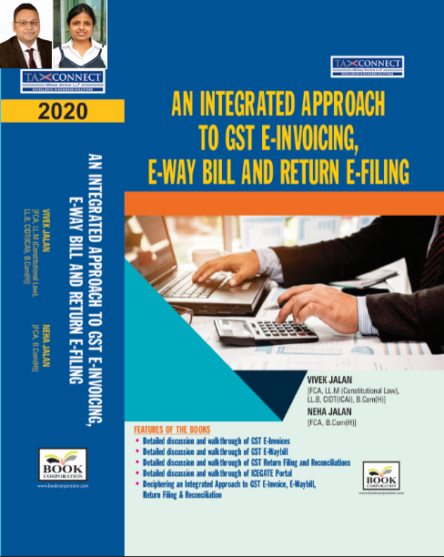
ABOUT THE BOOK: This publication includes:
- Detailed discussion and walkthrough of GST E-Invoices.
- Detailed discussion and walkthrough of GST E-Waybill.
- Detailed discussion and walkthrough of GST Return Filing and Reconciliations.
- Detailed discussion and walkthrough of ICEGATE Portal.
- Deciphering an Integrated Approach to GST E-Invoice, E-Waybill, Return Filing & Reconciliation

Authors:
Vivek Jalan
[FCA, L.LM (Constitutional Law), L.LB, CIDT(ICAI), B.Com(H)]

Neha Jalan
[FCA, B.Com(H)]

Published by: In Association With:
BOOK CORPORATION TAX CONNECT ACADEMY
4, R. N. Mukherjee Road 1, Old Court House Corner
Kolkata 700001 Kolkata 700001
Phones: (033) 64547999 Phones: (033) 40016761
Cell : 9830010297, 9331018333 Cell : 9874466163, 9830661254
Order by email:bookcorporation@gmail.com Order by email: info@taxconnect.co.in Website :www.bookcorporation.com Website : www.taxconnect.co.in

IN STANDS

Section wise Compendium on GST
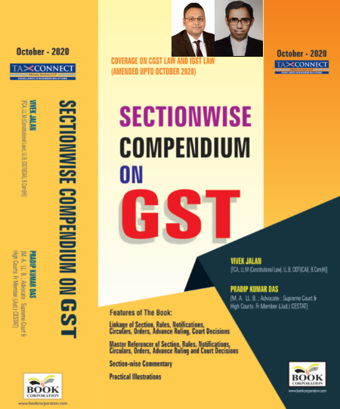
ABOUT THE BOOK: This publication includes:
1. Linkage of Section, Rules, Notifications, Circulars, Orders, Advance Ruling, Court Decisions
2. Master Referencer of Section, Rules, Notifications, Circulars, Orders, Advance Ruling and Court Decisions
3. Section-wise Commentary
4. Practical Illustrations

Authors:
Vivek Jalan
[FCA, L.LM (Constitutional Law), L.LB, CIDT(ICAI), B.Com(H)]

Pradip Kumar Das
[M.A. LL.B; Advocate Supreme Court & High Courts; Fr. Mem (Jud.) CESTAT]

Published by: In Association With:
BOOK CORPORATION TAX CONNECT ACADEMY
4, R. N. Mukherjee Road 1, Old Court House Corner
Kolkata 700001 Kolkata 700001
Phones: (033) 64547999 Phones: (033) 40016761
Cell : 9830010297, 9331018333 Cell : 9874466163, 9830661254
Order by email:bookcorporation@gmail.com Order by email: info@taxconnect.co.in Website :www.bookcorporation.com Website : www.taxconnect.co.in

IN STANDS

UNION BUDGET 2021
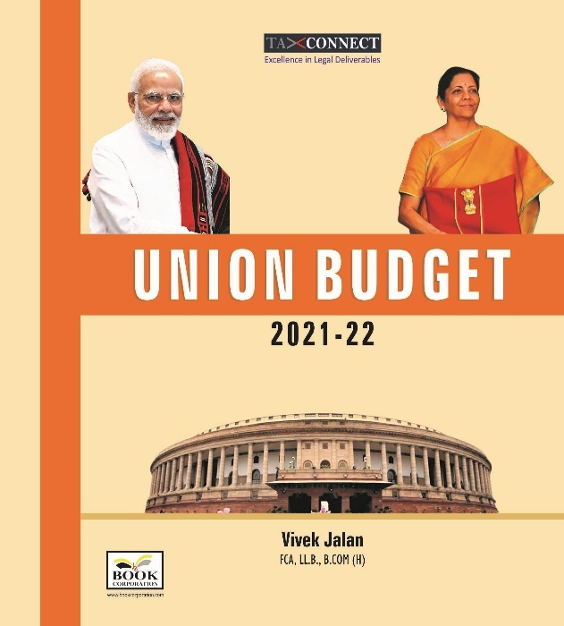
ABOUT THE BOOK: This publication includes:
1.Commentary on Budget
2.Finance Minister’s Budget Speech
3.Budget at a Glance
4.Memorandum
a. Direct Tax
b. Customs
c. Excise
d. GST
5. Finance Bill
6. Notes on Clauses

Authors:
Vivek Jalan
[FCA, L.LM (Constitutional Law), L.LB, CIDT(ICAI), B.Com(H)]

Published by: In Association With:
BOOK CORPORATION TAX CONNECT ACADEMY
4, R. N. Mukherjee Road 1, Old Court House Corner
Kolkata 700001 Kolkata 700001
Phones: (033) 64547999 Phones: (033) 40016761
Cell : 9830010297, 9331018333 Cell : 9874466163, 9830661254
Order by email:bookcorporation@gmail.com Order by email: info@taxconnect.co.in Website :www.bookcorporation.com Website : www.taxconnect.co.in

LET’S DISCUSS FURTHER!

OUR OFFICES:




DUBAI
Azizi Feirouz, 803, 8th Floor, AL Furjan, Opposite Discovery Pavillion, Dubai, UAE
Contact Person: Rohit Sharma
Email: rohit.sharma@taxconnect.co.in

KOLKATA
R No 119; 1st Floor; Diamond Arcade; 1/72, Cal Jessore Road; Kolkata – 700055
Contact Person: Priyanka Chowdhury
Email: priyanka.chowdhury@taxconnect.co.in

KOLKATA
1, Old Court House Corner, “Tobacco House”, 1st Floor, Room No. 13 (N), Kolkata-700001
Contact Person: Priyanka Chowdhury
Email: priyanka.chowdhury@taxconnect.co.in

MUMBAI
Building No.9, Flat- 403, LodhaEternis, 11th Road, MIDC, Andheri(E)-400093
Contact Person: Rajanikant Choudhury
Email: rajnikant.choudhary@taxconnectdelhi.co.in
DELHI
B-139, 2nd Floor, Transport Nagar, Noida-201301 (U.P)
Contact Person: Poonam Khemka
Email: poonam.khemka@taxconnectdelhi.co.in

BANGALORE
A-414,Carlton Towers, 19th Main; Road Hal Old Airport Rd, Domlur, Bengaluru, Karnataka-560008
Contact Person: Manmit Sinha
Email: manmit.sinha@taxconnectdelhi.co.in

Disclaimer:
This e-bulletin is for private circulation only. Views expressed herein are of the editorial team and are based on the information, explanation and documents available on Government portal platforms. Tax Connect or any of its employees do not accept any liability whatsoever direct or indirect that may arise from the use of the information contained herein. No matter contained herein may be reproduced without prior consent of Tax Connect. While this e-article has been prepared on the basis of published/other publicly available information considered reliable, we do not accept any liability for the accuracy of its contents.
Tax Connect 2021. All rights reserved.

