GST Revenue collection for February 2021

- ₹ 1,13,143 crore gross GST revenue collected in the month

Revenues for the month of February 2021, 7% higher than the GST revenues in the same month last year
The gross GST revenue collected in the month of February 2021 is ₹ 1,13,143 crore of which CGST is ₹ 21,092 crore, SGST is ₹ 27,273 crore, IGST is ₹ 55,253 crore (including ₹ 24,382 crore collected on import of goods) and Cess is ₹ 9,525 crore (including ₹ 660 crore collected on import of goods). The government has settled ₹ 22,398 crore to CGST and ₹ 17,534 crore to SGST from IGST as regular settlement. In addition, Centre has also settled ₹ 48,000 crore as IGST ad-hoc settlement in the ratio of 50:50 between Centre and States/UTs. The total revenue of Centre and the States after regular settlement and ad-hoc settlement in the month of February 2021 is ₹ 67,490 crore for CGST and ₹ 68,807 crore for the SGST. In line with the trend of recovery in the GST revenues over past five months, the revenues for the month of February 2021 are 7% higher than the GST revenues in the same month last year. During the month, revenues from import of goods was 15% higher and the revenues from domestic transaction (including import of services) are 5% higher than the revenues from these sources during the same month last year. The GST revenues crossed ₹ 1 lakh fifth time in a row and crossed ₹ 1.1 lakh crore third time in a row post pandemic despite this being revenue collection of the month of February. The chart below shows trends in monthly gross GST revenues during the current year. The table shows the state-wise figures of GST collected in each State during the month of February 2021 as compared to February 2020.
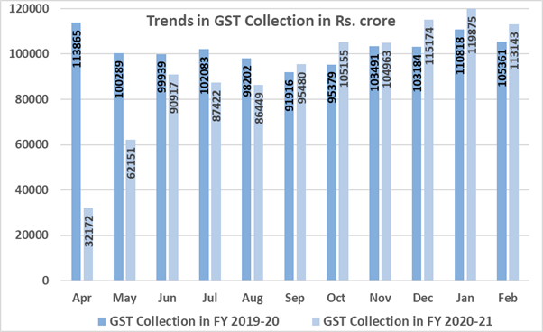

State-wise growth of GST Revenues during February 2021[1]

 | State | Feb-20 | Feb-21 | Growth
1 | Jammu and Kashmir | 316.17 | 329.89 | 4%
2 | Himachal Pradesh | 620.69 | 663.12 | 7%
3 | Punjab | 1,228.94 | 1,299.37 | 6%
4 | Chandigarh | 172.37 | 148.5 | -14%
5 | Uttarakhand | 1,280.93 | 1,181.13 | -8%
6 | Haryana | 5,266.43 | 5,589.81 | 6%
7 | Delhi | 3,834.75 | 3,727.46 | -3%
8 | Rajasthan | 2,932.09 | 3,223.70 | 10%
9 | Uttar Pradesh | 5,775.91 | 5,996.62 | 4%
10 | Bihar | 1,120.50 | 1,127.99 | 1%
11 | Sikkim | 182.65 | 222.35 | 22%
12 | Arunachal Pradesh | 48.36 | 61.36 | 27%
13 | Nagaland | 24.93 | 34.83 | 40%
14 | Manipur | 37.36 | 32.34 | -13%
15 | Mizoram | 24.84 | 21.06 | -15%
16 | Tripura | 63.26 | 63.25 | 0%
17 | Meghalaya | 156.57 | 146.5 | -6%
18 | Assam | 923.87 | 945.84 | 2%
19 | West Bengal | 3,941.54 | 4,334.98 | 10%
20 | Jharkhand | 2,070.87 | 2,321.03 | 12%
21 | Odisha | 2,790.16 | 3,340.57 | 20%
22 | Chhattisgarh | 2,274.41 | 2,453.10 | 8%
23 | Madhya Pradesh | 2,621.03 | 2,791.57 | 7%
24 | Gujarat | 7,215.54 | 8,221.23 | 14%
25 | Daman and Diu | 94.47 | 2.61 | -97%
26 | Dadra and Nagar Haveli | 145.41 | 235.09 | 62%
27 | Maharashtra | 15,734.66 | 16,103.50 | 2%
29 | Karnataka | 7,413.83 | 7,581.45 | 2%
30 | Goa | 410.61 | 343.8 | -16%
31 | Lakshadweep | 2.14 | 0.46 | -79%
32 | Kerala | 1,754.12 | 1,806.10 | 3%
33 | Tamil Nadu | 6,426.49 | 7,008.21 | 9%
34 | Puducherry | 158.86 | 158.05 | -1%
35 | Andaman and Nicobar Islands | 36.01 | 23.26 | -35%
36 | Telangana | 3,667.13 | 3,636.44 | -1%
37 | Andhra Pradesh | 2,563.33 | 2,652.57 | 3%
38 | Ladakh | 0 | 9.06
97 | Other Territory | 145.11 | 134.33 | -7%
99 | Centre Jurisdiction | 100.14 | 129.03 | 29%
 | Grand Total | 83,581.02 | 88,101.59 | 5%

[1] Does not include GST on import of goods

