
Weekly GST Communique
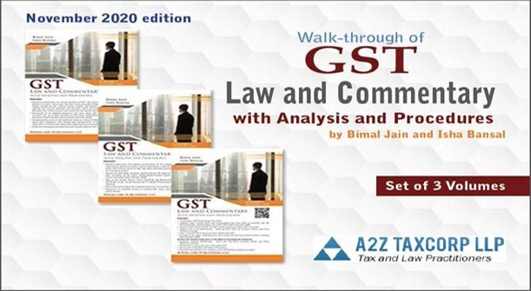

GST Law and Commentary with Analysis and Procedures by Bimal Jain and Isha Bansal
✡️ Volume I, ✡️ Volume II, ✡️ Volume III

6th Edition (November 2020) of our GST book

Have a look at the complete tour of the Book at: https://rb.gy/3hifj3
❇️ !!! Hurry Buy Now !!! ❇ Order/Payment Link:- https://rb.gy/benrpb

Special 30% discount available for a limited time only.

For more details, Call us at: 8076563802 or E-Mail us at: info@a2ztaxcorp.com

GST

Important Judgments of the week
- Writ admitted for examining validity of provisions restricting ITC on construction of building for letting out on rent
- Denial of refund of IGST to Advance-Authorisation holders is valid but operates prospectively w.e.f October 23, 2017
Important Notifications, Circulars etc. of the week
- CBIC instructs to make UOI a Respondent in GST related petitions
- CBIC issued notification to extend the due date for furnishing GSTR-9 and 9C for FY 2018-19 till 31.12.2020
- CBIC issued Circular on manufacturing and other operations undertaken in bonded warehouses under Section 65 of the Customs Act
- DGFT issued Trade Notice for submission of data to RoDTEP Committee
- DGFT issued Trade Notice for Linking/Registration of IECs in the new revamped DGFT Online environment
- J&K Government extended last date for filing of claims under Budgetary Support till Dec 31, 2020
Important Press Releases of the week
- CGST officials bust racket for generating fraudulent input tax credit through fake billing of around Rs 1,278 crore
- Detection of evasion of customs duty by exporter on export of Iron Ore Fines; recovery of customs duty more than Rs. 8 Crore
- DGGI Gurugram arrests man for forging input tax credit of around Rs 392 crore
- Shri Piyush Goyal: Futuristic vision combined with decisiveness has provided India with a solid Startup ecosystem
- GIFT IFSC prescribes framework for listing of Depository Receipts
Important Updates of the week
- CBIC has released a guidebook for Faceless Assessment
- GST: E-invoicing system enabled for taxpayers having turnover > INR 100 cr
- Filing NIL Form CMP-08 statement through SMS on GST Portal
- GSTN issued FAQ on filing nil Form GST CMP-08 through SMS
- CBIC issued FAQ on Manufacture and Other Operations in Customs Warehouse
Videos of the week
- Waiver of Late fees vs. Extension in Due Date for filing GSTR 9/9C || CA Bimal Jain
- What is Summon and Who can issue and to whom under GST || CA Bimal Jain
- Inspection, Search and Seizure by GST Officials - When and How to Handle || CA Bimal Jain
- Walkthrough of the 6th Edition Book of GST Law and Commentary with Analysis and Procedures

Income Tax

Important Notifications, Circulars of the week
- Govt extends last date for availing direct tax dispute resolution scheme till December 31, 2020
- CBDT notified Equalisation Levy (Amendment) Rules, 2020
- CBDT issued notification for extension of due date of furnishing of Income Tax Returns and Audit Reports
- CBDT issued clarifications in respect of the Direct Tax Vivad se Vishwas Act, 2020
Important Press Releases of the week
- Income Tax Department conducts searches in Delhi-NCR, Haryana, Punjab, Uttarakhand and Goa
- Income Tax Department conducts searches in Tamil Nadu
- Income Tax Department conducts searches in Uttar Pradesh
- Income Tax Department conducts searches in Bihar
- Income tax exemption for payment of deemed LTC fare for non-Central Government employees
Important Update of the week
- CBDT has issued refunds of over Rs. 1,26,909 crore to more than 39.14 lakh taxpayers between April 01, 2020 to October 27, 2020

[This space has been intentionally left blank]

GST

Important Judgments of the week

Writ admitted for examining validity of provisions restricting ITC on construction of building for letting out on rent
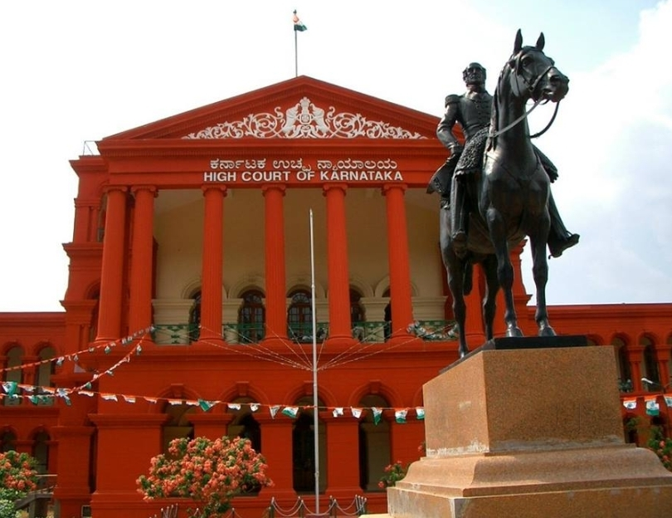
The Hon’ble HC, Karnataka in Bagmane Developers v. Union of India [W.P. No. 9430/2020 dated October 22, 2020] stayed demand of Rs. 62 crore in a writ petition challenging credit restriction under Section 17(5)(c) and (d) of Central Goods and Services Tax Act, 2017 (“CGST Act”) on construction of building used for letting out wherein GST is paid on rent.
Facts:
Bagmane Developers (“the Petitioner”) is engaged in taxable services such as commercial/industrial construction service, works contract services, repair services and renting of immovable properties. The Petitioner has filed returns in GSTR – 3B and GSTR – I for the period between July 2017 and April 2019 but without availing input tax credit (“ITC”) on goods and services utilized in construction of commercial complexes which are rented after completion. The Petitioner has filed GSTR – 3B for the month of May 2019 availing substantial ITC prompting the GST department to issue notice dated March 6, 2020 (“Impugned notice”) to show cause as to why ITC availed amounting to Rs. 62 crore (approx.) in GSTR-3B for the month of May, 2019 should not be held as ineligible and demanded and recovered from the Petitioner along with interest and penalty.
Issues:
- Challenged the validity of Section 17(5)(c) and (d), 16(4), 61(5), 50 and 164(3) of the CGST Act.
- Whether Section 17(5)(c) and (d), 16(4) of the CGST Act can be read down to permit the use of ITC on goods and services used in the construction in “business-to-business” cases with the denial for ITC only in “business-to-consumer” cases.
Petitioner’s contentions:
- The Petitioner for the period between July 2017 and April 2019 filed its returns in Form GSTR-3B and GSTR- 1 and availed ITC on the costs incurred for construction of the land owners’ share where the properties are developed under Joint Development Agreement with such land owners, but without reporting availment of ITC on goods and services used in the construction of commercial complexes which are rented out because of lack of clarity.
- Relied on the Hon’ble HC, Orissa in Safari Retreats Private Limited v. Chief Commissioner of CGST [2019 (25) G. S. T. L. 341 (Ori.)] to read down Section 17(5)(c) and (d) of the CGST Act. Further contended that he has filed GSTR – 3B availing the ITC as per the Safari Retreat case.
- Section 17(5)(c) and (d) of the CGST Act are unreasonable and arbitrary inter alia for the reason that these provisions deny the advantage of ITC though there is continuity of transaction without break in chain. Section 16 of GST Act entitles a registered person to the use of ITC on any supply of goods or services to him which are used or intended to be used in the course of the business as part of a transactional chain. Thus, the continuity of transaction without break in chain is the essence of the scheme under GST.
- Section 17(5)(d) of the CGST Act makes an unreasonable discrimination between those assesses who could avail ITC when the goods and services availed are utilized in the course of or in furtherance of their business as contemplated under Section 16(1) of the CGST Act and those who are engaged in the business of construction of immovable property in the course of or in furtherance of their business only because the business of the assessee is construction or works contract. Section 17(5)(c) of the CGST Act are also arbitrary and unreasonable as these provisions create an artificial distinction.
- The Petitioner has a vested and an accrued right to avail ITC once the conditions as contemplated under Section 16(1) of the CGST Act are satisfied with a simultaneous right to claim adjustment of tax on outward supply of goods and services. This right would be an indefeasible right and therefore such right cannot be taken away in any manner that is impermissible in law. The law of limitation can only bar a remedy and cannot negate an accrued or a vested right. Section 16(4) of the CGST Act in imposing a negation of the accrued and vested rights violate this seminal proposition and as such, Section 16(4) of the GST Act is in violation of Article 300A of the Constitution of India.
Departmental Contentions:
- The Petitioner has in effect challenged only Impugned notice under the guise of challenging the constitutional validity of Section 17(5)(c) and (d), 16(4) and other provisions of the CGST Act. The contention that Section 17(5)(c) and (d), 16(4) of the CGST Act and the other provisions thereof are unconstitutional and contrary to the scheme under the CGST Act, when not well grounded, is impermissible.
- The Petitioner cannot rely upon the decision in Safari Retreats supra as the same is challenged by the Department before the Hon’ble Apex Court as admitted by the Petitioner and mentioned in the Impugned notice.
- The ITC, in the scheme of the CGST Act, is only a concession and the same cannot be categorized as a vested right or an accrued right or a substantive right. The constitutional validity of Section 16(4) of the CGST Act has been upheld by HC, Bombay in Nelco Limited v. Union of India [W.P. No. 6998/2018 dated March 20, 2020].
Held:
The Hon’ble HC, Karnataka in W.P. No. 9430/2020 dated October 22, 2020 stated as under:
- The Court shall examine the validity of Section 17(5)(c) and (d), 16(4) of the CGST Act and the other provisions thereof in the light of the decision by the Division Bench of the Orissa High Court in Safari Retreats supra.
- This Court shall also have to examine whether the ITC under the CGST Act is contemplated as a mere concession or as a right that accrues if the conditions stipulated under Section 16 of the CGST Act are satisfied, and if it is a right that accrues, whether such right could be extinguished prescribing the time limit within which such right has to be exercised.
- Granted stay to the Impugned notice on the condition that the Petitioner shall maintain a minimum of the 10% of the disputed availment in its electronic credit ledger subject to the outcome of the writ petition.
- The matter is next listed on November 20, 2020

Denial of refund of IGST to Advance-Authorisation holders is valid but operates prospectively w.e.f October 23, 2017
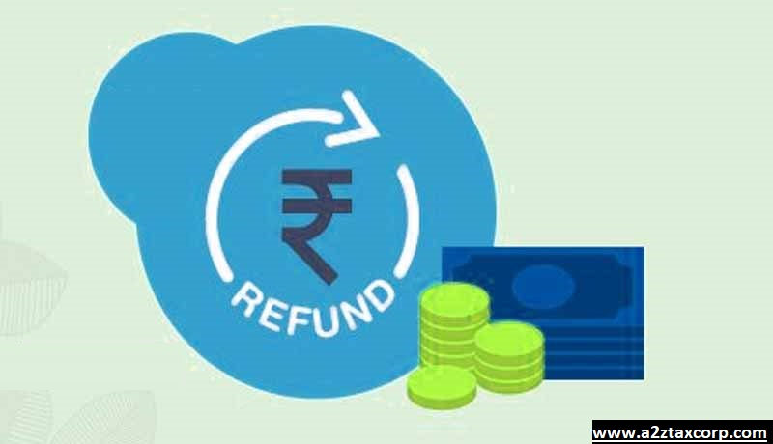
The Hon’ble HC, Gujarat in Cosmo Films India v. Union of India & Ors. [R/SLP No. 15833/2018 dated October 20, 2020] upheld the validity of rule 96(10) of the Central Goods and Services Tax Rules, 2017 (“CGST Rules”) and rules that notification is required to be made applicable prospectively only w.e.f. October 23, 2017 and not prior thereto from the inception of Rule 96(10) of the CGST Rules w.e.f. July 1, 2017.
Facts:
Cosmo Films India (“the Petitioner”) is a public limited company engaged in the business of manufacturing and sale of flexible packaging films and holds Advance Authorization Licenses (“the AA License”) granted in terms of the Foreign Trade Policy, issued and amended from time to time.
The Petitioner was entitled to import raw materials without payment of IGST under the AA License and pay IGST on exports and claim Rebate (Refund) of the IGST so paid on exports. The Petitioner has received benefits of rebate of IGST at the relevant point of time. Thereafter, subrule (10) of Rule 96 of the CGST Rules was amended by Notification No. 39/2018- Central Tax dated September 4, 2018 with retrospective effect from October 23, 2017, providing that rebate on exports cannot be availed by the Petitioner, if the inputs procured by the Petitioner have enjoyed AA benefits or Deemed Export Benefits under the said notification. Therefore, the Petitioner was unable to utilize the benefit of dutyfree imports under AA Licenses and take the benefit of rebate on exports.
Thereafter, by Notification No. 53/2018Central Tax dated October 9, 2018, subclause (a) and (b) of subrule 10 of Rule 96 of the CGST Rules were merged. Thereafter, vide Notification No. 54/2018-Central Tax dated October 9, 2018 (“Impugned Notification”), the subrule 10 of Rule 96 of the CGST Rules was again demerged and “with effect from October 23, 2017”.
Issue:
Challenged the validity of sub-rule (10) of Rule 96 of CGST Rules substituted vide Notification No. 54/2018Central Tax dated October 9, 2018 denying the option to claim rebate to the Petitioner for importing goods under AA licenses.
Held:
The Hon’ble HC, Gujarat in R/SLP No. 15833/2018 dated October 20, 2020 held as under:
- Rule 96 (10) as it originally existed, when the Rules came into force provided that the persons claiming refund of Integrated Tax (IGST) paid on export of goods or services should not have received supplies on which the supplier has availed the benefit from Government of India, Ministry of Finance.
- On conjoint readings of the provision of Section 16 of the Integrated Goods and Services Tax Act, 2017 (“IGST Act”), Section 54 of Central Goods and Services Tax Act, 2017 (“CGST Act”), and Rule 96(10) of CGST Rules, which is substituted by Impugned Notification, it is apparent that the person who has availed the benefits of Notification No. 48/2017- Central Tax dated October 18, 2017 and other Notifications as stated in subrule 10 of Section 96 ibid shall not have the benefit of claiming refund of integrated tax paid on exports of goods or services. The Petitioner has availed benefits under Advance Authorization License scheme as per the Notification No. 18/2015- Customs dated April 1, 2015 which was amended by Notification No. 79/2017- Customs dated October 13, 2017 and paid integrated tax on the goods procured by the Petitioners for the export purpose.
- Considering the effect of the Impugned Notification, the contentions raised on behalf of the department that there is no discrimination qua the petitioner is tenable in law, as by the amendment made by Impugned Notification it clearly denied the benefit which is granted to the Petitioner by the Notification No. 39/2018- Central Tax dated September 4, 2018 was withdrawn as the same was not made applicable from October 23, 2017.
- Recently, vide Notification No. 16/2020-Central Tax dated March, 23 2020 an amendment has been made by inserting explanation to Rule 96(10) of CGST Rules, 2017 as amended (with retrospective effect from October 23, 2017). By virtue of which the option of claiming refund is not restricted to the exporters who only avails BCD exemption and pays IGST on the raw materials thereby exporters who wants to claim refund under second option can switch over now.
- The above amendment was made retrospectively thereby avoiding the anomaly during the intervention period and exporters who already claimed refund under second option need to payback IGST along with interest and avail ITC, in view of which, the grievance of the Petitioner was therefore taken care of..
- However, it is also made clear that Impugned Notification is required to be made applicable w.e.f. October 23, 2017 and not prior thereto from the inception of the Rule 96(10) of the CGST Act. Therefore, in effect Notification No. 39/2018- Central Tax dated September 4, 2018 shall remain in force as amended by the Impugned Notification by substituting subrule (10) of Rule 96 of CGST Rules, in consonance with sub-section (3) of Section 54 of the CGST Act and Section 16 of the IGST Act.
- The Impugned Notification is therefore held to be effective w.e.f. October 23,

[This space has been intentionally left blank]

Important Notifications, Circulars etc. of the week

CBIC instructs to make UOI a Respondent in GST related petitions
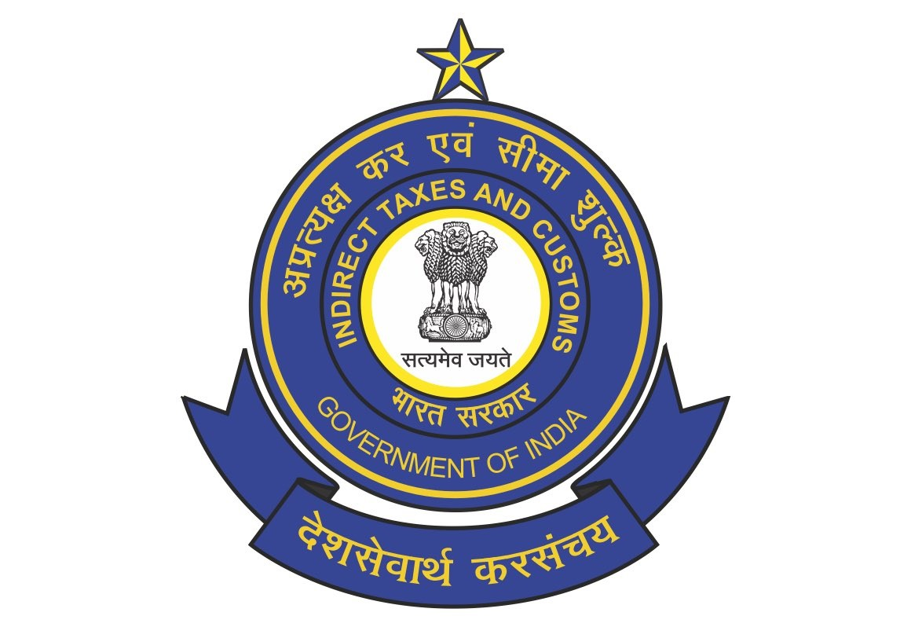
The CBIC issued Instruction vide F. No. 276/262/2015-CX.8A (Pt. III) dated October 27, 2020 regarding residual action by CGST Commissionerates in respect of the adverse orders of Hon’ble High Courts, wherein the taxpayer is assigned to respective State tax administration.
Issue:
The CBIC received references regarding the action required to be taken by CGST Commissionerates in respect of adverse orders of Hon’ble High Courts, wherein the taxpayer is assigned to the respective State tax administration.
Instruction:
Instructed that whenever GST related petitions are filed before respective High Court, Union of India is usually made one of the Respondents. In such cases, even if the jurisdiction of the Petitioner lies with the State Government, Central GST Commissionerate are authorized to defend the issue before respective High Court as CGST Act and ensuing Rules are akin to respective State/UT GST Acts and ensuing Rules, and also in terms of DoR Master Instructions dated August 14, 2019, as amended from time to time.
The said authorization does not cease to exist at the disposal of the Petition by the High Court. Rather, remedial judicial action, for protection of the interests of Revenue continue to rest with the authorized Commissionerate. Infact, Board has been processing SLP proposals and filing SLPs pertaining to the orders by the High Courts wherein the Petitioners fall under respective State Jurisdiction. In such case, where an appeal is proposed to be filed, it shall be desirable that the Zone concerned interacts with the officials of the State GST so that there is no divergence of views while filing the appeal.
Specifically, on the issue of TRAN-1, a number of SLPs have been filed, in terms of Board’s Instructions dated November 13, 2018 and August 1, 2019 vide file of even no, by Board, wherein the tax payers are assigned to State Jurisdiction. Since the order issued by the High Courts, irrespective of the jurisdictional control of the taxpayers, holds a precedence value, GST Council Secretariat has also been requested to sensitize the respective States/UTs to take necessary steps, including filing of Review Petition/Writ Appeal/ SLP, as the case may be, to safeguard the interests of Revenue.
Further, observed that in some cases, Union of India/ Department of Revenue/ CBIC has not been made as respondents, even though some central legislation/ delegated legislation is under challenge. At the outset, such practice is against the Principles of Natural justice as Union should be made a Respondent before assailing any law enacted by Union. Nevertheless, to ensure efficacious defence pertaining to GST related petitions, Addendum to Master Instruction dated August 14, 2019 was issued vide the letter dated August 17, 2020, (enclosure) which makes it imperative for Commissioner (State Taxes) to request policy comments directly from CBIC Policy wings in such cases.
The Instruction can be accessed at: https://www.cbic.gov.in/resources//htdocs-cbec/legalaffairs/Instruction_2810.pdf
The Enclosure can be accessed at: https://www.cbic.gov.in/resources//htdocs-cbec/legalaffairs/enco.pdf

CBIC issued notification to extend the due date for furnishing GSTR-9 and 9C for FY 2018-19 till 31.12.2020

The CBIC vide Notification No. 80/2020- Central Tax dated October 28, 2020 amended Notification No. 41/2020- Central Tax dated May 5, 2020 to extend the due date for furnishing of Form GSTR 9 and 9C for FY 2018-19 till December 31, 2020. The Notification now reads as under:
“In exercise of the powers conferred by sub-section (1) of section 44 of the Central Goods and Services Tax Act, 2017 (12 of 2017) (hereafter in this notification referred to as the said Act), read with rule 80 of the Central Goods and Services Tax Rules, 2017 (hereafter in this notification referred to as the said rules), and in supersession of notification No. 15/2020-Central Tax, dated the 23rd March, 2020, published in the Gazette of India, Extraordinary, Part II, Section 3, Sub-section (i), vide number G.S.R. 198(E), dated the 23rd March, 2020, except as respects things done or omitted to be done before such supersession, the Commissioner, on the recommendations of the Council, hereby extends the time limit for furnishing of the annual return specified under section 44 of the said Act read with rule 80 of the said rules, electronically through the common portal, for the financial year 2018-2019 till the 31st December, 2020.”
The Notification can be accessed: http://www.egazette.nic.in/WriteReadData/2020/222783.pdf

CBIC issued Circular on manufacturing and other operations undertaken in bonded warehouses under Section 65 of the Customs Act

The CBIC vide Circular No. 48/2020-Customs dated October 27, 2020 issued Clarification on manufacturing and other operations undertaken in bonded warehouses under Section 65 of the Customs Act, 1962.
Section 65 of the Customs Act, 1962 provides that the owner of any warehoused goods may carry on any manufacturing process or other operations in the warehouse in relation to such goods, with the permission of the Principal Commissioner of Customs or Commissioner of Customs and subject to such conditions as may be prescribed. Manufacture and Other Operations in Warehouse (no.2) Regulations 2019, were issued vide Notification No.69/2019-Customs (N.T.) dated 01.10.2019, hereinafter referred to as, "MOOWR, 2019" prescribing the procedure, documentation and compliances to be followed under Section 65 of the Customs Act, 1962.
Board has from time to time received suggestions and requests from members of the trade and industry on the scheme of Manufacturing and other Operations in a Warehouse under Section 65 of the Customs Act, 1962. The requests revolve around making the scheme more investor friendly and seeking more clarity with regard to certain aspects. A Committee was therefore constituted by the Board to study the provisions of Section 65 of the Customs Act, 1962 and the regulations issued there under and make recommendations for consideration of the Board. The committee has since submitted its report.
The issues raised by the trade and the recommendations of the Committee have been examined. To bring in greater regulatory clarity and certainty for investors, Board has decided to clarify the following issues:
(i) Job work for a Section 65 unit: Trade has sought clarity on the goods eligible to be sent for job work and the procedure to be followed for removal of goods for job work by a Section 65 unit.
Clarification: Circular No. 34/2019-Customs dated 1 ^{st} October 2019 had provided, in Annex B (Form to be maintained by a unit operating under section 65 of the Customs Act, 1962 for the receipt, processing and removal of goods) for removal of goods from a Section 65 unit for job work and receipt after job work, as part of the manufacture or other operations. Thus, only inputs are allowed to be sent out from a Section 65 unit for job work. The capital goods can be sent outside the Section 65 unit for repair, with the permission of the bond officer.
The job work shall be subject to the following conditions:
(i) The goods upon import should be first deposited in the Section 65 premises and duly accounted for before the same is sent for job work.
(ii) It should be possible to establish the identity/ correlate the goods after job work with those sent for job work.
(iii) On completion of the job work, the goods can be brought back to the Section 65 unit or exported/ cleared to DTA from the job worker's premises. In case the goods are exported/ cleared to DTA from the job worker's premises, the procedure as per Regulations 14 and 15 of MOOWR 2019, as applicable shall be followed and the date of removal from job workers premise shall be deemed to be the date of removal from the warehouse.
(iv) Scrap, waste or remnants generated during the job work shall be either returned to the Section 65 unit or cleared from job-worker's premises on payment of applicable duties.
(v) The procedure and timeline for the return of goods sent for job work under Section 65 unit will be in line with GST provisions, as the Section 65 Unit is also a GST registrant.
(vi) The account to be maintained under Circular No. 34/2019-Customs dated 1st October 2019 will be kept updated as regards job work at all times.
Trade has also requested that moulds, jigs, tools, fixtures, tackles, instruments, hangers, patterns and drawings be allowed to be sent to the job workers premises for use in the job work. Considering the nature of goods sought to be removed from a Section 65 unit for the purposes of job work, Board has decided to allow the said goods viz moulds, jigs, tools, fixtures, tackles, instruments, hangers, patterns and drawings to be sent to the premises of a job worker, subject to due accounting of the goods by the Section 65 unit in the account specified. Such goods will be used by the job worker exclusively for the concerned Section 65 unit. The procedure and timeline will be in line with the GST provisions.
It may also be noted that the bond to be executed by a Section 65 unit, prescribed through the aforementioned circular, stays in full force notwithstanding the removal of goods for job work from a Section 65 unit.
In case of violation of any of the above provisions, the goods shall be deemed to be cleared for home consumption on the date of clearance of the goods for job work. The applicable duties, interest and penalties shall be reckoned accordingly.
(ii) Job work for others by a Section 65 unit: Trade has sought clarity on whether the Section 65 unit can itself carry out job work for other units and the procedure to be followed for the same.
Clarification: The issue has been examined with a view to enhance capacity utilization and acknowledging the realities of manufacturing environment where various units support each other in producing the final product. It is clarified that a Section 65 unit being a GST registered unit, can perform job work operations and shall maintain due accounting of such job work as per the provisions of GST law.
In case any imported inputs which are warehoused are consumed during the job work process, duty shall be paid on such goods (i.e. the warehoused goods) by filing Ex-Bond Bill of Entry, when such job worked goods are returned to the principal/owner. In case the goods after job work are exported from the premises of the Section 65 unit, the import duty on the warehoused goods used for the job work need not be paid as per section 69 of the Customs Act, 1962.
(iii) Whether a Section 65 unit can procure goods from FTWZ: Circular 34/2019Customs dated 1st October 2020, does not explicitly mention sourcing of goods from FTWZ. Hence there is apprehension on whether such sourcing is allowed.
Clarification: Vide para 14 of Circular No. 34/2019-Customs dated 1st October 2020, Board has clarified that the objective of Section 65 is to enable manufacture and other operations in customs bonded warehouses. For this purpose, the units should be able to procure required raw materials, consumables, capital goods etc., imported or procured from domestic market.
There are no restrictions imposed on sourcing of goods by units operating under Section 65. Moreover, the units are GST registrants, which are also allowed to procure goods from SEZ/FTWZs. In view of the foregoing, it is clarified that a Section 65 unit may source capital goods or inputs from a SEZ/FTWZ, following the applicable procedures.
The Circular can be accessed at: https://www.cbic.gov.in/resources/htdocs-cbec/customs/cs-circulars/cs-circulars-2020/Circular-No-48-2020.pdf

[This space has been intentionally left blank]

DGFT issued Trade Notice for submission of data to RoDTEP Committee
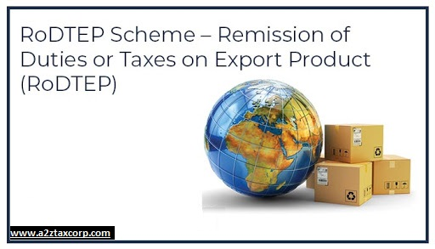
The DGFT issued Trade Notice No. 32/2020-2021 dated October 28, 2020 for submission of data to Remission of Duties and Taxes on Exported Products (RoDTEP) Committee.
Members of trade are already aware that a new Scheme, Remission of Duties and Taxes on Exported Products (RoDTEP) has been approved for introduction by the Government. In this regard, attention is invited to a RoDTEP Committee formed under the chair of Shri G.K. Pillai in the Drawback Division, CBIC, Department of Revenue, which has been tasked by the Government to determine the rates of refund for items covered under the Scheme. The Committee has started collection of data and is having stakeholder consultations to fulfill its mandate. The relevant circulars/ data formats published in this regard may be seen at URL https://www.cbic.gov.in/htdocs-cbec/home_links/RoDTEP-Committee
In this regard, members of Trade, EPCs and Industry Associations which are involved in export of items falling under Chapter 86, 88 and 89 are requested to urgently submit data for their respective export items in the required format (as is available at the above URL) so that the RoDTEP Committee is able to work out suitable rates for export items. The industry may kindly note that in absence of such data , rates for items in the chapter 86, 88 and 89 under RoDTEP may not be notified.
Data in the requisite format has to be sent to atreyee.devroy@gov.in & shakti.singh1981@gov.in. For any clarification required in the matter, Shri Copal Krishna Jha, Director, Drawback Division, CBIC, Department of Revenue, may be contacted at 011-23360581.
The Trade Notice can be accessed at: https://content.dgft.gov.in/Website/dgftprod/b07c1035-3759-4bbe-85e6-9fc61751371b/TN-32%20dt-28-10-2020.pdf

DGFT issued Trade Notice for Linking/Registration of IECs in the new revamped DGFT Online environment
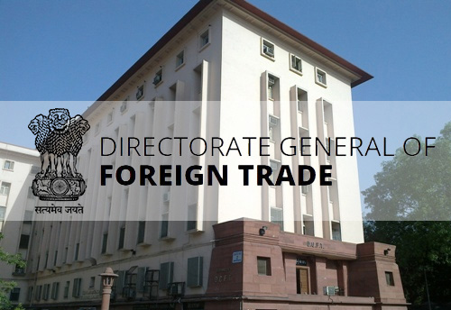
The DGFT issued Trade Notice No. 33/2020-2021 dated October 28, 2020 for Linking/Registration of IECs in the new revamped DGFT Online environment.
In continuation to the earlier Trade Notice 16/2020-21 dated 25.06.2020, it is informed that various revamped DGFT services are planned to be introduced into the new DGFT IT platform. The objective of introducing these revamped systems is to provide paperless, digital, efficient and transparent services to the exporters and importers, and to further the overall goal of Trade Facilitation and Digital India. The platform would be accessible through the existing website: https://dgft.gov.in
The online processes relating to entire lifecycle of Advance Authorisation, EPCG & DFIA including their paperless Exports Obligation Discharge (EODC) shall be rolled out soon. In addition to these processes, Norms Fixation, Free Sale & Commerce Certificate, Steel Import Monitoring System(SIMS), Import Licencing and some other processes shall also be rolled out soon. Among other services, the new online system will have a two-way communication between the DGFT and the exporter/importer and would allow the applicant to apply, monitor the status of the applications, reply to the deficiencies, raise queries etc.
In relation to this proposed roll-out, attention of all exporters and importers is invited to the following action points:
  - The new platform is accessible through user-based IDs for applying online. All IEC holders are encouraged to create login IDs through an online registration process preferably well before the roll out of next phase of the platform in the 2-3 weeks.
  - For user ID creation, mobile number/email ids will be a mandatorily required. The same will be authenticated by the process of OTP/email based authentication process.
  - Users would be required to link their login Ids to their specific IEC. The process of linking would be available post login through an authentication process using a Digital Signature Certificate or Aadhaar based e-Sign.
  - Only the Aadhaar e-sign of the proprietors/directors/partners/Karta etc. as mentioned on their IEC may be used for Aadhaar based authentication.
  - For Digital Signature certificates (DSC) a Class-II/Class-III Certificate is allowed. The given DSC may be of either of the 3 types –
    - Individual DSC of the proprietors/directors/partners/Karta etc.
    - Organization-based DSC where the firm name matches the name on the IEC. The given DSC type may be issued in the name of any authorized signatory (as per the rules of the Controller of Certifying Authorities).
    - IEC based DSC wherein IEC is embedded as a parameter in the DSC
  - Post linking of the IEC, the IEC holders are requested to complete the IEC auto validation process by using the ‘Modify IEC’ process after logging in.
  - IEC holders are further required to update the Profile details using the ‘Manage Profile’ option. Details related to Industrial Registrations, Export Performance details and other should be duly filled in. Please note that the profile updation is an automatic process and does not require any approval or fees.
  - IEC holders are requested to go through Help manuals & Frequently Asked Questions (FAQs) available on the new DGFT website under the ‘Learn’ section.
Export Promotion Councils & Commodity Boards are also requested to take necessary steps to inform their registered exporters about the new platform and revamped service delivery mechanisms of DGFT, through their newsletters and email communication.
For further guidance, please refer to the Help Manuals & FAQs available under https://dgft.gov.in > Learn > Application Help & FAQs. For any further assistance, you may utilize any of the following channels —
- Raise a ticket for your Complaints, Suggestions, or Feedback using the feature under https://dgft.gov.in > Services
- Call the toll-free Helpline number 1800-111-550
- Send an email to dgftedi@nic.in
The Trade Notice can be accessed at: https://content.dgft.gov.in/Website/dgftprod/6d43e4ea-8c2e-4309-ac99-840ee71adfa6/Trade%20Notice%2033%20for%20Stage%201B%20go-live.pdf

[This space has been intentionally left blank]

J&K Government extended last date for filing of claims under Budgetary Support till Dec 31, 2020
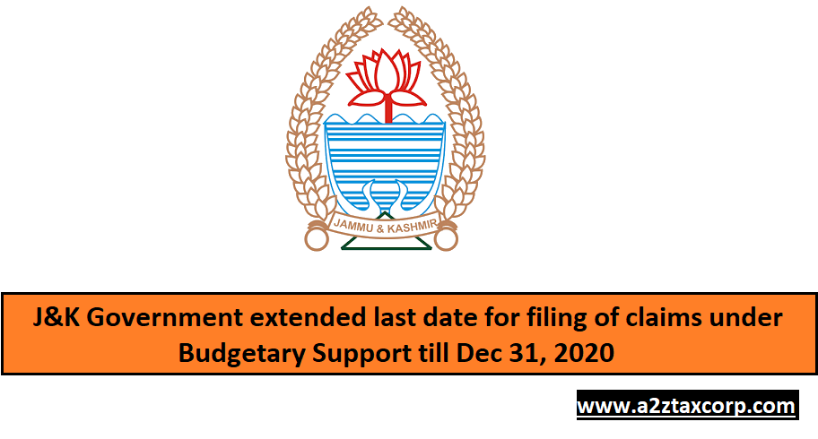
Jammu and Kashmir Government vide Notification SO- 325 to 328 all dated October 23, 2020 modified Notification SRO 521/2017 and SRO 519/2017 both dated December 21, 2017 and SRO 431/2018 dated September 25, 2018 to allow industrial units to file their claims under Budgetary Support Scheme (Scheme) before the concerned jurisdictional officer by or before December 31, 2020.
Inserted third proviso to clause 5.1 of the Jammu and Kashmir Reimbursement of Central Taxes, State tax and Integrated tax for promotion of Industries in the State of Jammu and Kashmir:
“Provided further that the industrial unites which has failed to file their claims up to the period 31st December, 2019 can also avail the benefit of the Scheme subject to the condition that they had filed all their due returns up to the month of August, 2020. All such Industrial units shall file their claims before the concerned jurisdictional officer by or before 31st December, 2020”
Notification SO- 325 dated October 23, 2020 can be accessed at: http://www.jakfinance.nic.in/SOs/SO_2020/SO-325%20dated%2023.10.2020.pdf
Notification SO- 326 dated October 23, 2020 can be accessed at: http://www.jakfinance.nic.in/SOs/SO_2020/SO-326%20dated%2023.10.2020.pdf
Notification SO- 327 dated October 23, 2020 can be accessed at: http://www.jakfinance.nic.in/SOs/SO_2020/SO-327%20dated%2023.10.2020.pdf
Notification SO- 328 dated October 23, 2020 can be accessed at: http://www.jakfinance.nic.in/SOs/SO_2020/SO-328%20dated%2023.10.2020.pdf

Important Press Releases of the week

CGST officials bust racket for generating fraudulent input tax credit through fake billing of around Rs 1,278 crore
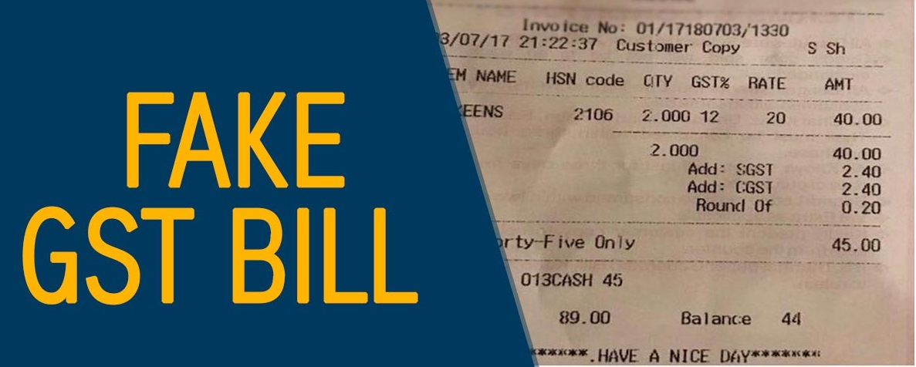
Based upon specific intelligence, the officers of the Anti Evasion branch of CGST, Commissionerate, Delhi (East) have busted a major racket for generation of huge inadmissible ITC through fake billing of Rs 1,278 crore (approx). The well established syndicate was being operated by floating seven different fake firms with the intent of passing of inadmissible credit to the tune of Rs 137 crores (approx). Searches were conducted over more than nine places spread over different locations in the state of Delhi and Haryana to identify the taxpayers, who were defrauding the Government of its legitimate taxes. The modus operandi of the fraudulent taxpayers includes bogus invoices/bills creation, without actual movement of goods. All the e-way bills generated to transport the goods were fake.
The mastermind of the entire racket Shri Ashish Aggarwal has been arrested under Section 132 of the CGST Act on 29.10.2020 and has been remanded to the transit judicial custody by the duty Metropolitan Magistrate till the hearing of regular judicial remand application by the CJM Patiala House Court. The accused kingpin of this fake billing racket has been absconding for more than 60 days and after intense coordinated efforts of the officers of Anti Evasion branch, his presence was secured to record the statement, wherein he admitted his guilt and was arrested subsequently.
The primary beneficiary firm of this bogus billing network, was M/s Maya Impex, which has been registered in the name of Shri Ashish Aggarwal’s 66 years old mother through which fake ITC of Rs 77 crore has been passed on. Shri Ashish Aggarwal knowingly committed offences under Section 132(1)(b) and 132(1)(c) of the CGST Act, 2017 which are cognizable and non-bailable offences as per the provisions of Section 132(5) and punishable under clause (i) of the sub section (1) of Section 132 of the Act ibid. The fake billing operation was primarily engaged in generating and passing of fake ITC primarily to the milk products industry. Bogus invoices were raised against fictitious sale of milk products such as Ghee, milk powder etc. It is pertinent to mention here that apart from the other number of distinct companies, major brands like M/s Milk Food Ltd. was one of the major beneficiary of this inadmissible credit. During the course of search operations huge quantum of incriminating documents pertaining to this racket were recovered.
So far the inadmissible input tax credit of more than Rs 7 crore has been recovered and further investigations are underway to expose the other fictitious billing entities associated with this syndicate, who have defrauded the exchequer.
The Press Release can be accessed at: https://www.pib.gov.in/PressReleasePage.aspx?PRID=1668567

Detection of evasion of customs duty by exporter on export of Iron Ore Fines; recovery of customs duty more than Rs. 8 Crore

On the basis of specific intelligence, under the direction of the Commissioner of Customs (Preventive), Bhubaneswar Shri Debashish Sahu, investigation was initiated and relevant business premises of Exporter and Customs House Agent at various places was searched. Prima facie evasion of Customs duty to the extent of Rs. 8,07,66,314/- (Rupees Eight Crore Seven Lakh Sixty Six Thousand Three Hundred and Fourteen) only by M/s. B S Minerals, Keonjhar, Odisha-758001 on Iron Ore fines which was to be exported from Paradeep, India to Main Port, China in vessel “MV MAGNUM FORTUNE” was detected by the Customs officials. Thereafter, 52051 MT of goods valued at Rs. 26,92,21,045/-were seized.
Subsequently the exporter deposited Customs duty to the tune of Rs. 8,07,66,314/- (Rupees Eight Crore Seven Lakh Sixty Six Thousand Three Hundred and Fourteen) only and submitted Bank Guarantee of Rs. One Crore to the government exchequer for taking provisional release of the goods in addition to depositing a Bond of Rs. 5.4 Crore with the Customs Authorities.
Further investigation is under progress.
The Press Release can be accessed at: https://www.cbic.gov.in/resources//htdocs-cbec/press-release/PressRelease-29oct.pdf

DGGI Gurugram arrests man for forging input tax credit of around Rs 392 crore

The Directorate General of GST Intelligence (DGGI) Gurugram Zonal Unit (GZU), Haryana has arrested one Kabir Kumar, resident of New Delhi on charges of creating and operating fictitious firms on forged documents and passing fake input tax credit by way of issuance of invoices without any actual receipt or supply of goods or services.
It is apparent from the investigation conducted till date, that Kabir Kumar created multiple proprietary companies merely on paper based in Gurgaon, New Delhi, Faridabad, Solan, Noida, Jhajjhar, Sirsa etc. During the investigation of his premises, it was revealed that Kabir had also attempted to flee the city, however, he was prevented from doing so at IGI Airport by the DGGI Officers with the support of Customs and CISF officials.
Further to that, he admitted to creation of 31 firms which have generated bogus invoices without actual supply of goods amounting to Rs. 2993.86 crore and ITC amounting to Rs 392.37 crore. Mutiple evidences, such as laptop, mobile phones and 140 SIM cards were resumed from his person.
The investigation spanned multiple locations in Delhi and based on documentary evidence and statement recorded, it was established that Kabir Kumar is the key person in orchestrating this racket of making fake firms on forged documents. Accordingly, Kabir Kumar was arrested today and produced before Duty Magistrate, Delhi, who ordered judicial custody. A total fake ITC of more than Rs. 392 crore has been thus passed by the accused.
Further investigations in the matter are under progress.
The Press Release can be accessed at: https://www.pib.gov.in/PressReleasePage.aspx?PRID=1668645

[This space has been intentionally left blank]

Shri Piyush Goyal: Futuristic vision combined with decisiveness has provided India with a solid Startup ecosystem

Union Commerce and Industry Minister Shri Piyush Goyal today said that Futuristic vision combined with decisiveness has provided India with a solid Startup ecosystem. At the inauguration of the 1st Shanghai Cooperation Organisation (SCO) Startup Forum, he said that Youth is our wealth, and in these times of vulnerability & uncertainty, they have responded with agility, adaptability & ability.
Shri Goyal said that our Startups have demonstrated their ability to convert this severe adversity into a great potential of the future. Lauding Indian Startups for demonstrating high energy & enthusiasm to give many timely & cost-effective solutions, he said “Our hunger for growth is demonstrated by the number of EdTech apps for upscaling & education which have provided free access to content for learning to millions of Indians during the COVID period. All our youngsters have created many critical applications which have helped many sectors go digital and face the problems of the pandemic with confidence & emerge successfully as we unlock economy and expand economic activity.”
Shri Goyal said that Young firms in India have reacted fast & very flexibly to the COVID pandemic by sharing our best practices & knowledge, engaging corporates & investors, Monetising & mobilising capital, Setting up incubators and Providing exposure & scale. He said that through these, innovative ideas of startups will get larger engagement.
Shri Goyal said that India recognised some very interesting Startups in the first-ever national Startup award programme. “We provided an encouraging framework to have more Startups come up with brilliant ideas”, he added. He said that the Prime Minister has been at the forefront of India's engagement with the startups. The Prime Minister Shri Narendra Modi has said, "Startups are the engines of exponential growth manifesting the power of innovation”.
Lauding the initiative of SCO to include several sessions including exclusive discussions to promote women entrepreneurship, Shri Goyal said that In India, a large number of startups have been founded by women. Shri Goyal said today's launch of the SCO startup forum is the reflection of the positive attitude of all the member states to further expand the engagement & nurture the spirit of innovation amongst our member states. He said that one of the common threads that knit the SCO member states together is the spirit of entrepreneurship. Launch of the SCO Startup Forum is the reflection of the positive attitude of all member states to nurture innovation amongst all, he added. He said that this engagement with Startups of all member states will further develop this ecosystem and encourage & expand the Startups' vision, as in this globalised world, our problems have also become planetary in scale & effect.
The Press Release can be accessed at: https://www.pib.gov.in/PressReleasePage.aspx?PRID=1667798

GIFT IFSC prescribes framework for listing of Depository Receipts

The International Financial Services Centres Authority (IFSCA), with an objective to develop the financial products and financial services in the Gujarat International Finance Tec-City International Financial Services Centre (GIFT IFSC) has prescribed the regulatory framework for listing of Depository Receipts (DRs).
The framework provides for listing of DRs by companies that are listed in FATF compliant jurisdictions (including India). The framework enables the eligible listed companies to raise capital through issuance and listing of DRs on the stock exchanges in GIFT IFSC.
Additionally, the framework enables eligible companies having DRs listed on any exchange in a FATF-compliant jurisdiction to list and trade such DRs on the stock exchange(s) in GIFT IFSC as an additional venue for trading, without any fresh public offering.
While IFSCA has prescribed the framework for essential disclosure requirements such as financial statements, material or price sensitive information, shareholding pattern, change of depository and corporate actions, the listed companies shall continue to comply with the applicable requirements of their respective home jurisdictions with respect to corporate governance norms and several other disclosure requirements, without additional regulatory burden. The listed companies will be required to release all the disclosures made in the home jurisdiction to the stock exchange(s) in GIFT IFSC.
Further details on the framework for listing of DRs on the stock exchanges in IFSC are available on the IFSCA website at the URL: https://www.ifsca.gov.in/Circular
The Press Release can be accessed at: https://www.pib.gov.in/PressReleasePage.aspx?PRID=1668142

[This space has been intentionally left blank]

Important Updates of the week

CBIC has released a guidebook for Faceless Assessment
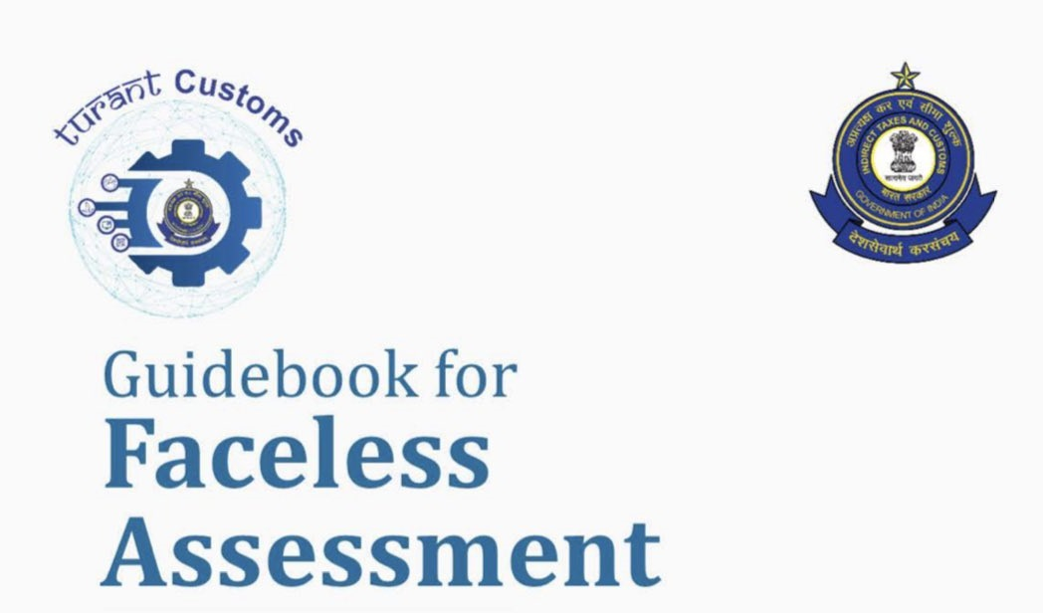
As per the recent tweet of CBIC, the CBIC has released a guidebook for Faceless Assessment to assist the concerned stakeholders in the successful implementation of Faceless Assessment across the country.
The Complete E-Book can be accessed at: https://www.cbic.gov.in/resources//htdocs-cbec/deptt_offcr/Guidebook_Faceless_Assessment_29Oct2020.pdf

[This space has been intentionally left blank]

GST: E-invoicing system enabled for taxpayers having turnover > INR 100 cr

E-Invoice System is enabled on Trial sites( for APIs & Offline tools) for taxpayers with PAN based turnover more than Rs. 100 Cr. in a financial year (https://einv-apisandbox.nic.in, https://einvoice1-trial.nic.in).
E-Invoice API Access Mechanism
Taxpayers with Aggregate Turnover of Company more than Rs. 500 Crores | Taxpayers with Aggregate Turnover of Company less than Rs. 500 Crores
- Direct Access to API to integrate the ERP system of the Company – They need to whitelist their public IPs. In addition to username and password to each GSTIN (Taxpayer) of the company, the company gets the Client Id and Client Secret to get the access to APIs.  Through GSPs – The GSTIN (Taxpayer) generates his own username and password and ties up with GSPs to get the access to API using the Client Id and Client Secret of the GSPs.  Through ERPs – The GSTIN (Taxpayer) generates his own username and password and ties up with ERPs to get the access to API using the Client Id and Client Secret of the ERPs. | - Through 'Companies having direct Access to APIs' – If the taxpayer has tie up or using the ERP of the ‘Company which has direct access to API, then he/she can use the API through that company. The GSTIN (Taxpayer) generates his own username and password and gets the access to API using the Client Id and Client Secret of the Company, which has access.  Tax Payers having access to E-Way Bill APIs – If the taxpayer has direct access to E-Way Bill APIs, then he/she can use the same Client Id, Client Secret, username and password to get the access to e-Invoice system.  Through GSPs – The GSTIN (Taxpayer) generates his own username and password and ties up with GSPs to get the access to API using the Client Id and Client Secret of the GSPs.  Through ERPs – The GSTIN (Taxpayer) generates his own username and password and ties up with ERPs to get the access to API using the Client Id and Client Secret of the ERPs.
New API for Get e-Waybill Details for a given IRN 'Get e-Waybill Details by IRN' is made available in the Sandbox, Please refer to the API documentation here.
Source from: https://einv-apisandbox.nic.in/announcements.html

Filing NIL Form CMP-08 statement through SMS on GST Portal
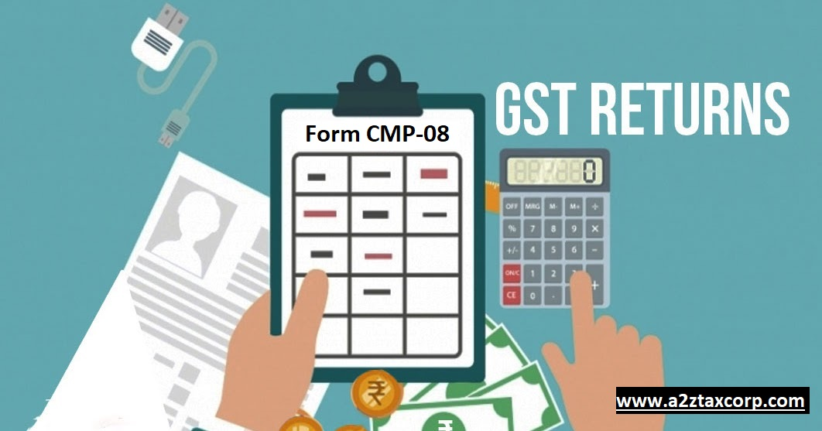
A Composition taxpayer may now file NIL statement in Form GST CMP-08 for a quarter, through an SMS, apart from filing it through online mode, on GST Portal.
To file NIL Form GST CMP-08 through SMS, the taxpayer must fulfil following conditions:
- Taxpayer must be registered as composition taxable person (by filing Form GST REG-01) or the taxpayer might have opted for composition levy (by filing Form GST CMP-02).
- Taxpayer must have filed all the applicable statement(s) in Form GST CMP-08 for the previous quarter(s).
- Authorized signatory and his/ her phone number must be registered on the GST Portal.
- There must not be any data in save stage, in online version of Form GST CMP-08, on the GST Portal.
NIL Form CMP-08 for a tax period must be filed by the taxpayer, if there is no:
- outward supplies;
- liability due to reverse charge (including import of services); and
- other tax liability for the quarter, for which the statement is being filed.
- Steps to File Nil Form GST CMP-08 through SMS are as below:
Send SMS to 14409 number to file Nil Form CMP-08 i.e. NIL space Return Type space GSTIN space Return Period
- (For example for NIL Filing for Tax Period Apr-Jun 2020: NIL C8 07AQDPP8277H8Z6 062020)
- Send SMS again on the same number 14409 with Verification Code to confirm filing of Nil Form CMP-08
- (For Example: If Verification Code received here is 324961: CNF space Return Type space Code - CNF C8 324961)
- After successful validation of “Verification Code", GST Portal will send back ARN to same mobile number and on registered e-mail ID of the taxpayer to intimate successful Nil filing of Form GST CMP-08.
All the authorized representatives for a particular GSTIN, with unique mobile number can file NIL Form GST CMP-08 through SMS.
The due date for filing of Form GST CMP-08 is 18th of the month following the quarter.
Source from: https://www.gst.gov.in/newsandupdates/read/409

GSTN issued FAQ on filing nil Form GST CMP-08 through SMS

The GSTN has issued Frequently Asked Question (“FAQ”) on the filing of Nil Form GST CMP-08 through SMS on the GST Portal. Some important FAQ are discussed as hereunder:-
1. About Nil Form CMP-08
Q. When can Form CMP-08 be filed as Nil?
Ans. Form CMP-08 can be filed as a nil statement if there are no outward supplies, any liability due to reverse charge (including import of services) and any other tax liability for the quarter, for which the statement is being filed.
Q. Is filing of Form CMP-08 as Nil statement mandatory?
Ans. Filing of Form CMP-08 is mandatory for all taxpayers who have opted to pay tax under composition scheme, even if there is no business activity in any particular tax period. So, for such tax period(s), the statement can be filed as NIL (if all conditions for filing Nil Form CMP-08 are satisfied).
Q. From which date onwards can I file Nil Form CMP-08 for a tax period?
Ans. You can file Nil Form CMP-08 on quarterly basis and its due date is 18th of the month succeeding the quarter. For example, Nil Form CMP-08 for the quarter of July to September can be filed from 1st October onwards.
2. About Filing Nil Form CMP-08 through SMS
Q. Can I file Nil Form CMP-08 through SMS, instead of filing online through GST Portal?
Ans. Yes, you can file Nil Form CMP-08 through SMS, instead of filing it through online mode on GST Portal.
Q. Who is eligible to file Nil Form CMP-08 through SMS?
Ans. Any taxpayer who fulfills below conditions, are eligible to file Nil Form CMP-08, through SMS:
- Taxpayers must be registered as composition taxable person through Form GST REG-01 or taxpayers who have opted for composition levy through Form GST CMP-02.
- Taxpayer must have filed all the applicable GST CMP-08 for the previous quarter(s)
- Authorized signatory and his/ her phone number must be registered on the GST Portal.
- There must not be any data in save stage in online version of Form CMP-08, on the GST Portal.
3. Help SMS Format
Q. How do I get help on Nil Form CMP-08 filing through SMS?
Ans. You need to send SMS in below format to get help related to filing Nil Form CMP-08 through SMS to 14409: SMS Format: HELP space<Return Type>
Example: HELP C8
4. Filing Nil Form CMP-08 through SMS
Q. I have saved my data/summary for a particular return period on the GST Portal. Can I file Nil Form CMP-08 through SMS for that period?
Ans. You cannot file Nil Form CMP-08 through SMS, for the tax period, for which you have saved data/summary on the GST Portal. If you have some saved data in your Form CMP-08 on GST Portal, you need to either file your Form CMP-08 through online mode on GST Portal or delete the saved data from the portal and then file Nil Form CMP-08 through SMS.
Q. Is there any difference in filing Nil Form GSTR-1, GSTR-3B and CMP-08 through SMS?
Ans. There is no difference in filing Nil Form GSTR-1, GSTR-3B and CMP-08 through SMS except the return type format. Return type format for Form GSTR-1 is R1, for Form GSTR-3B is 3B and for Form CMP-08 is C8, as given in table below:
Send SMS to 14409 for | Filing Form GSTR-1 | Filing Form GSTR-3B | Filing Form CMP-08
Getting Help Assistance | Help R1 | Help 3B | Help C8
Filing Nil Return | Monthly Filing - NIL R1 07AQDPP8277H8Z6 042020  Quarterly Filing - NIL R1 07AQDPP8277H8Z6 062020 | NIL 3B 07AQDPP8277H8Z6 042020 | NIL C8 07AQDPP8277H8Z6 062020
Sending Verification Code | CNF R1 324961 | CNF 3B 324961 | CNF C8 324961
For help on filing Nil Form GSTR-3B by SMS, click here.
For help on filing Nil Form GSTR-1 by SMS, click here.
5. Verification Code
Q. What is the validity of Verification Code?
Ans. Verification Code is valid for 30 minutes.
Q. Verification Code consists of how many digits?
Ans. Verification Code consists of 6 numeric digits only.
Q. Can I use Verification Code multiple times?
Ans. No, Verification Code is usable only once.
6. Post Filing of Nil Form CMP-08 through SMS
Q. What will happen after successful filing of Nil Form CMP-08, through SMS?
Ans. After successful filing of Nil Form CMP-08, through SMS:
- ARN will get generated.
- The status of Form CMP-08 will change to Filed on GST Portal.
- An SMS and e-mail will be sent to the e-mail and mobile number of the primary authorized signatory.
- In case, sender is an authorized signatory but not the primary authorized signatory, SMS will be sent to his/her mobile number also.
Q. I have filed Nil Form CMP-08 through SMS. Do I need to login again to the GST Portal to file Nil Form CMP-08?
Ans. Once you have filed Nil Form CMP-08 through SMS, you do not need to login to the GST Portal again to file Nil Form CMP-08. After successful filing of Nil Form CMP-08, through SMS, the status of Form CMP-08 is changed to Filed on GST Portal.
The Complete FAQ can be accessed at: https://tutorial.gst.gov.in/userguide/returns/index.htm#t=FAQs_SMS.htm

CBIC issued FAQ on Manufacture and Other Operations in Customs Warehouse

The CBIC has launched a revamped and streamlined program to attract investments into India and strengthen Make in India. This program is based upon Section 65 of the Customs Act, 1962, which enables conduct of manufacture and other operations in a Customs bonded warehouse. The program has been introduced vide the Manufacture and Other Operations in Warehouse (no. 2) Regulations, 2019, (hereinafter referred to as MOOWR, 2019) and explained through Circular-34/2019- Customs dated 01st October, 2019.
Under this program a unit can import goods (both inputs and capital goods) under customs duty deferment with no interest liability. There is no investment threshold or export obligation. The duties are fully remitted if the goods resulting from such operations are exported. Import duty is payable only if the resulting goods or imported goods are cleared in the domestic market (ex-bonding).
The salient features of the program are:
- No geographical limitation on where such units can be set up.
- A single application cum approval form for uniformity of practice with a single point of approval to set up the operations of such units.
- Improved liquidity with deferment of import duty and no interest liability.
- iv. Allows procurement of GST compliant goods from the domestic market for use in manufacture and other operations in a Section 65 unit.
- A single digital account for ease of doing business and easy compliance.
- Enables efficient capacity utilization, as there is no limit on quantum of clearances that can be exported or cleared to the domestic market.
CBIC has gathered certain queries through trade consultations which have been consolidated and answered below.
Q. Who is eligible for applying for manufacture and other operations in a bonded warehouse?
Ans. Response: The following persons are eligible to apply for manufacture and other operations in a bonded warehouse,-
(i) A person who has been granted a licence for a warehouse under Section 58 of the Customs Act, in accordance with Private Warehouse Licensing Regulations, 2016.
(ii) A person can also make a combined application for licence for a warehouse under Section 58, along with permission for undertaking manufacturing or other operations in the warehouse under Section 65 of the Act.
The persons mentioned have to be a citizen of India or an entity incorporated or registered in India.
Q. Can a factory which is solely into manufacturing goods, which are to be sold in the domestic market, eligible for applying for manufacture and other operations in a bonded warehouse?
Ans. Response: The eligibility of a factory for manufacture and other operations in a bonded warehouse does not depend upon whether the final goods will be sold in the domestic market or exported. There is no quantitative restriction on sale of finished goods in the domestic market. Any factory can avail a license under Section 58 of the Customs Act along with permission under Section 65 if they intend to import goods without upfront payment of Customs duty at point of import and deposit them in the warehouse, either as capital goods or as inputs for further processing.
Q. Is an existing factory which solely manufactured goods to be sold in the domestic market, eligible for application for manufacture and other operations in a bonded warehouse? How will the existing capital goods and inputs be accounted?
Ans. Response: Yes. Any unit in Domestic Tariff Area (DTA) is eligible for making an application for manufacture and other operations in a bonded warehouse i.e. an old factory in DTA is eligible for applying. The accounting form prescribed for the units undertaking manufacture and other operations in a bonded warehouse provides for accounting of DTA receipts. Thus the existing capital goods and inputs must be accounted in the accounting form prescribed. The form also provides for a remarks column in case certain remarks are to be entered.
Q. Is manufacture and other operations in a bonded warehouse allowed in Public Bonded Warehouse licensed under Section 57 of the Customs Act?
Ans. Response: No. At present, manufacture and other operations in a bonded warehouse is allowed only in a Private Bonded Warehouse licensed under Section 58 of the Customs Act.
Q. Will a unit licensed under Section 65 and Section 58 of the Customs Act, 1962, be under the physical control of Customs?
Ans. Response: No. There is no physical control of a unit licensed under Section 65 and Section 58 of the Customs Act, 1962, on a day to day basis. The unit will be subject to risk based audits.
Q. Can the license under Section 65 and Section 58 of the Customs Act, 1962, be obtained on bare land with identified boundaries or a built structure is imperative for obtaining the said license?
Ans. Response: The regulations do not mandate that a fully enclosed structure is a prerequisite for grant of license. What is important is that the site or building is suitable for secure storage of goods and discharge of compliances, such as proper boundary walls, gate(s) with access control and personnel to safeguard the premises. Moreover, depending on the nature of goods used, the operations and the industry, some units may operate without fully closed structures. The Principal Commissioner/Commissioners of Customs will take into consideration the nature of premises, the facilities, equipment and personnel put in place for secure storage of goods, while considering grant of license.
Q. Do we need to renew license under Section 58 or permission under Section 65?
Ans. Response: The license and permission granted is valid unless it is cancelled or surrendered, or the license issued under Section 58 is cancelled or surrendered. Thus no renewal of the license under Section 58 or permission under Section 65 is required.
Q. Can a unit undertaking manufacture and other operations in a bonded warehouse import capital goods without payment of duty? If yes, whether only BCD or both BCD and IGST on imports is covered? For how long is duty deferment available? Is interest payable after some time?
Ans. Response: A unit licensed under Sections 58 and 65 can import capital goods and warehouse them without payment of duty. Manufacture and other operations in a bonded warehouse is a duty deferment scheme. Thus both BCD and IGST on imports stand deferred. In the case of capital goods, the import duties (both BCD and IGST) stand deferred till they are cleared from the warehouse for home consumption or are exported. The capital goods can be cleared for home consumption as per Section 68 read with Section 61 of the Customs Act on payment of applicable duty without interest. The capital goods can also be exported after use, without payment of duty as per Section 69 of the Customs Act. The duty deferment is without any time limitation.
The Complete FAQ can be accessed at: https://www.cbic.gov.in/resources/htdocs-cbec/customs/FAQ-Section-65-october-2020.pdf

[This space has been intentionally left blank]

Videos of the week

Waiver of Late fees vs. Extension in Due Date for filing GSTR 9/9C || CA Bimal Jain
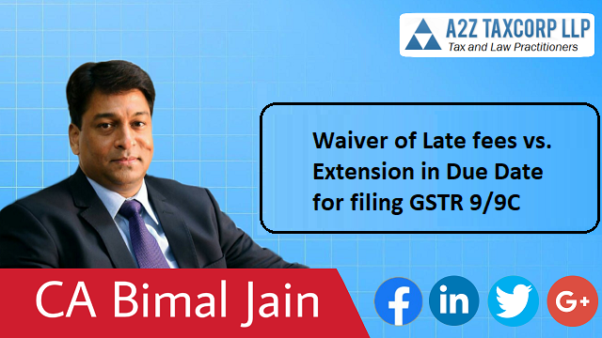
You can access the complete video on “Waiver of Late fees vs. Extension in Due Date for filing GSTR 9/9C || CA Bimal Jain” at following link: https://youtu.be/lte0yu2McB8

[This space has been intentionally left blank]

What is Summon and Who can issue and to whom under GST || CA Bimal Jain
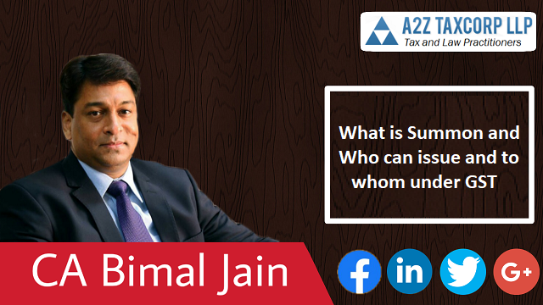
You can access the complete video on “What is Summon and Who can issue and to whom under GST || CA Bimal Jain” at following link: https://youtu.be/mOF4kufjpq4

[This space has been intentionally left blank]

Inspection, Search and Seizure by GST Officials - When and How to Handle || CA Bimal Jain
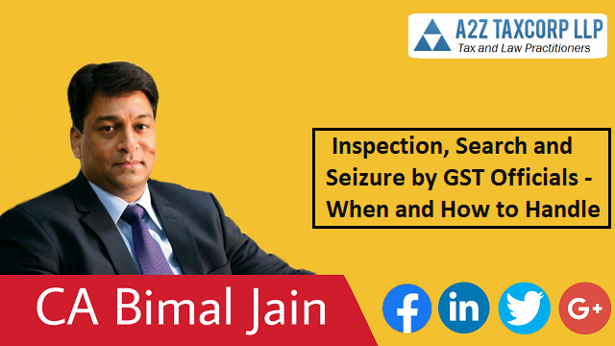
You can access the complete video on “Inspection, Search and Seizure by GST Officials - When and How to Handle || CA Bimal Jain” at following link: https://youtu.be/aDvMgWh7Q5I

[This space has been intentionally left blank]

Walkthrough of the 6th Edition Book of GST Law and Commentary with Analysis and Procedures
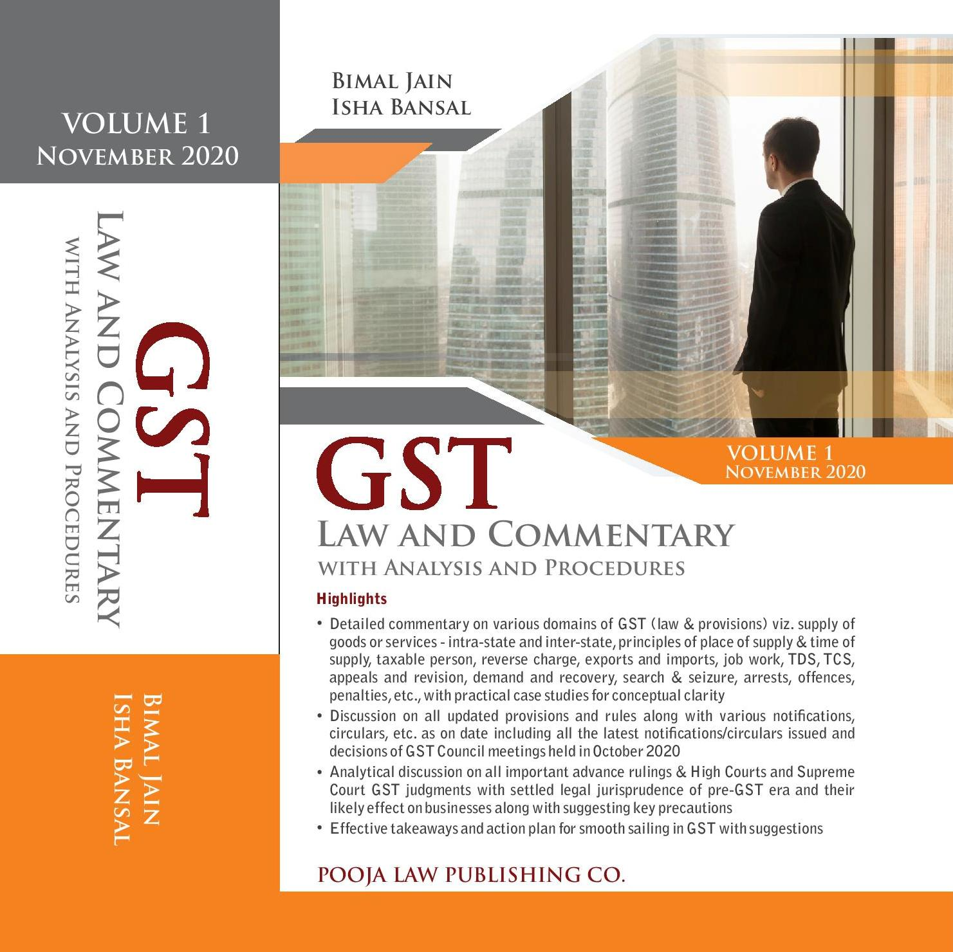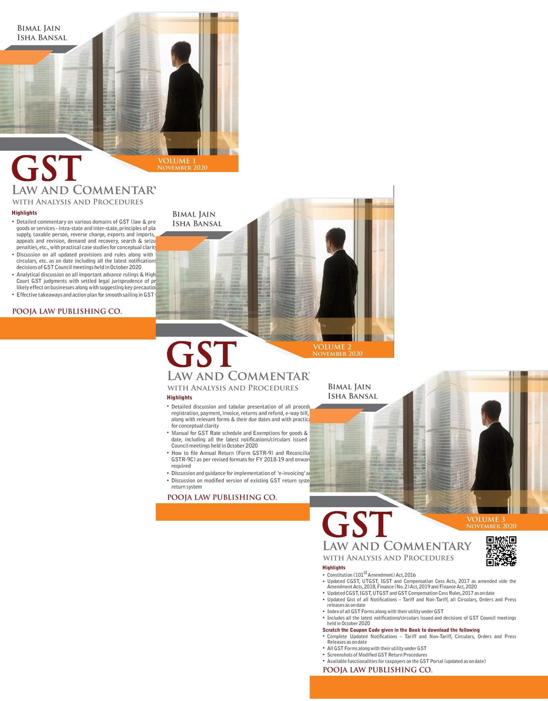
You can access the complete video on “Walkthrough of the 6th Edition Book of GST Law and Commentary with Analysis and Procedures” at following link: https://youtu.be/JE6KpNrBdgs

[This space has been intentionally left blank]

Income Tax

Important Notifications, Circular of the week

Govt extends last date for availing direct tax dispute resolution scheme till December 31, 2020
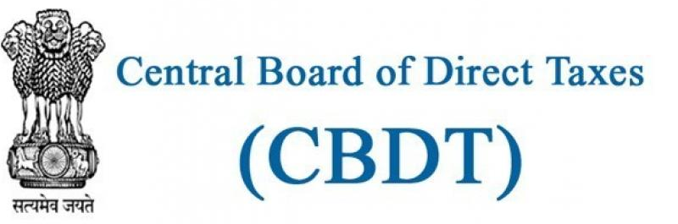
The government has extended the last date for availing the direct tax dispute resolution scheme till December 31, 2020, the finance ministry notified on Tuesday.
Taxpayers willing to settle their tax disputes under the Direct Tax Vivad se Vishwas Act can file their declarations till December 31, and will be mandated to pay the settled tax amount by March 31, 2021, with a complete waiver of interest and penalty. After April 1, 2021, a 10% higher amount will have to be paid.
Further, where arrears relate to disputed interest or penalty only, then 25% of the amount is to be paid by March 31, 2021 and 30% after April 1, 2021. The extension has been provided “in order to provide further relief to the taxpayers desirous of settling disputes under the scheme,” the Central Board of Direct Taxes (CBDT) said.
Finance secretary Ajay Bhushan Pandey has asked tax officials to expedite the Scheme which, he said, is highly beneficial to the taxpayers, after reviewing the progress made so far by the income tax department on the scheme in a high level meeting on Tuesday. “We need to advance the Vivad se Vishwas Scheme with greater persuasion and perseverance and must reach out to the taxpayers to facilitate all necessary handholding,” he said.
In the meeting, suggestions and comments of the field officers were also discussed regarding the action plan for successful implementation of the Scheme in a time bound manner. The scheme provides instant disposal of the dispute with no further cost of litigation besides monetary benefits in the form of waiver of penalty, interest and prosecution.
CBDT chairman PC Mody mentioned the importance of cleaning up of demand for facilitating and persuading the taxpayers for filing declarations under the scheme.
He emphasized on principal chief commissioners of income tax to carry out all possible actions such as disposing pending rectifications, giving pending appeal effects, removing duplicate demands, etc. so as to arrive at a final demand for each assessee so that whenever a taxpayer files Form 1 or 2 under the Vivad se Vishwas Scheme, the principal chief commissioners of income tax concerned is in a position to issue Form 3 promptly.
The progress of the scheme will now be reviewed every fortnight. Over 35,074 taxpayers have opted for the Direct Tax Vivad Se Vishwas Act since its enactment till September 8, 2020, minister of state for finance Anurag Thakur said in a written response to Rajya Sabha recently.
"The revenue generated till date through the Act is Rs 9,538 crore. This figure does not include the payments made by the taxpayers who are yet to file their declarations under the Scheme," he said.
The Notification can be accessed at: http://www.egazette.nic.in/WriteReadData/2020/222764.pdf
Source from: https://economictimes.indiatimes.com/news/economy/policy/govt-extends-the-last-date-for-availing-the-direct-tax-dispute-resolution-scheme-till-december-31/articleshow/78897175.cms

CBDT notified Equalisation Levy (Amendment) Rules, 2020
The CBDT vide Notification No. 87/2020 dated October 28, 2020 notified the Equalisation levy (Amendment) Rules, 2020 to further amend the Equalisation levy Rules, 2016.
The Notification can be accessed at: https://www.incometaxindia.gov.in/communications/notification/notification_87_2020.pdf

[This space has been intentionally left blank]

CBDT issued notification for extension of due date of furnishing of Income Tax Returns and Audit Reports

The CBDT vide Notification No. 88/2020 dated October 29, 2020 extended the due dates of Income Tax Returns and Audit Reports for AY 2020-21 in following manner:
(A) The due date for furnishing of Income Tax Returns for the taxpayers (including their partners) who are required to get their accounts audited [for whom the due date (as per the Income Tax Act, 1961 (“Income Tax Act”) is October 31, 2020] has been extended to January 31, 2021.
(B) The due date for furnishing of Income Tax Returns for the taxpayers who are required to furnish report in respect of international/specified domestic transactions [for whom the due date as per the Income Tax Act is November 30, 2020] has been extended to January 31, 2021.
(C) The due date for furnishing of Income Tax Returns for the other taxpayers [for whom the due date as per the Income Tax Act was July 31, 2020 has been extended to December 31, 2020.
(D) The date for furnishing of various audit reports under the Income Tax Act including tax audit report and report in respect of international/specified domestic transaction has also been extended to December 31, 2020.
The Notification can be accessed at: https://www.incometaxindia.gov.in/communications/notification/notification_88_2020.pdf

[This space has been intentionally left blank]

CBDT issued clarifications in respect of the Direct Tax Vivad se Vishwas Act, 2020
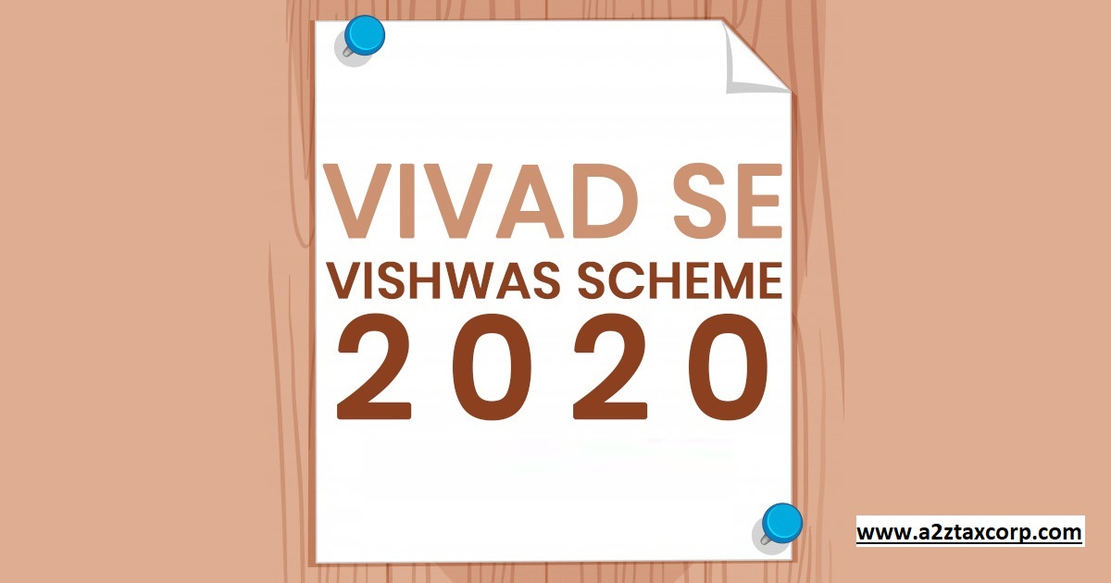
The CBDT vide Circular No. 18/2020 dated October 28, 2020 issued Clarifications in respect of the Direct Tax Vivad se Vishwas Act, 2020.
With the objective to reduce pending income tax litigation, generate timely revenue for the Government and benefit taxpayers by providing them peace of mind, certainty and savings on account of time and resources that would otherwise be spent on the long-drawn and vexatious litigation process, the Direct Tax Vivad se Vishwas Act, 2020 (hereinafter referred to as ‘Vivad se Vishwas’) was enacted on 17th March, 2020. The provisions of Vivad se Vishwas had been amended by the Taxation and Other Laws (Relaxation and Amendment of Certain Provisions) Act, 2020 to provide certain relaxation in view of the COVID-19 pandemic and also to empower the Central Government to notify certain dates.
The Central Government vide the notification S.O. 3847(E), dated 27th October, 2020, has extended the date for payment without additional amount under Vivad se Vishwas from 31st December, 2020 to 31st March, 2021. The said notification also notified the last date for filing declaration under Vivad se Vishwas as 31st December, 2020.
Under the existing provisions of sub-section (2) of section 5 of the Vivad se Vishwas, the declarant is required to pay the amount within a period of 15 days from the date of receipt of certificate from the designated authority. However, as per the aforesaid notification, a declarant who files declaration on or before 31st December, 2020 can make payment without additional amount on or before 31st March, 2021. Hence, requiring payment by the declarant within a period of 15 days from the date of receipt of certificate from the designated authority may result into undue hardship for the declarant in whose case the period of 15 days expires before 31st March, 2021.
In order to mitigate undue hardship and remove difficulty that may be caused by the aforesaid requirement of payment within 15 days from the date of receipt of certificate from the designated authority, in exercise of powers conferred under section 10 and II of Vivad se Vishwas, it is hereby clarified that where a declarant files a declaration under Vivad se Vishwas on or before 31 st December, 2020, the designated authority, while issuing the certificate under sub-section (I) of section 5 of the Vivad se Vishwas, shall allow e declarant to make payment without additional amount on or before 31st March, 2021.
The Circular can be accessed at: https://www.incometaxindia.gov.in/communications/circular/circular_18_2020.pdf

Important Press Releases of the week

Income Tax Department conducts searches in Delhi-NCR, Haryana, Punjab, Uttarakhand and Goa
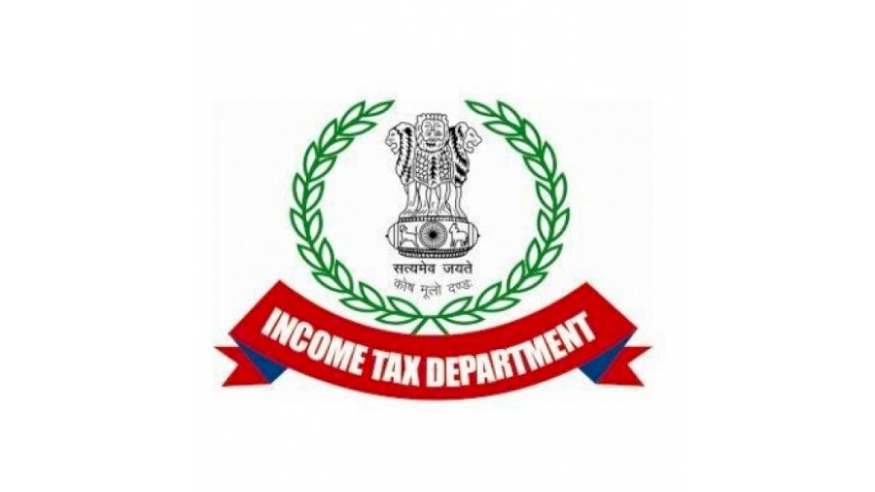
The Income tax Department has carried out a search and seizure action on 26.10.2020 on a large network of individuals running the racket of entry operation and generation of huge cash through fake billing. The search operations have been conducted on 42 premises across Delhi- NCR, Haryana, Punjab, Uttarakhand and Goa.
The search has led to seizure of evidences exposing the entire network of the entry operators, intermediaries, cash handlers, the beneficiaries and the firms and companies involved. So far, documents evidencing accommodation entries of more than Rs. 500 crore have already been found and seized.
Several shell entities/firms were used by the searched entry operators for layering of unaccounted money and cash withdrawals against fake bills issued and unsecured loans given. The personal staff/employees/associates had been made dummy directors/partners of these shell entities and all bank accounts were managed and controlled by these entry operators. Statements of such entry operators, their dummy partners/employees, the cash handlers as well as the covered beneficiaries have also been recorded clearly validating the entire money trail.
The searched persons were also found to be controller and beneficial owners of several bank accounts and lockers, opened in names of their family members and trusted employees and shell entities, which they were managing in collusion with the bank officials, through the digital media. The same are being further investigated.
The beneficiaries have been found to have made huge investments in real estate properties in prime cities and in fixed deposits to the tune of several hundred crores of rupees.
During the search, cash of Rs. 2.37 crore and jewellery worth Rs. 2.89 crore has been found along with 17 bank lockers, which are yet to be operated.
Further investigations are in progress.
The Press Release can be accessed at: https://www.pib.gov.in/PressReleasePage.aspx?PRID=1667736

Income Tax Department conducts searches in Tamil Nadu
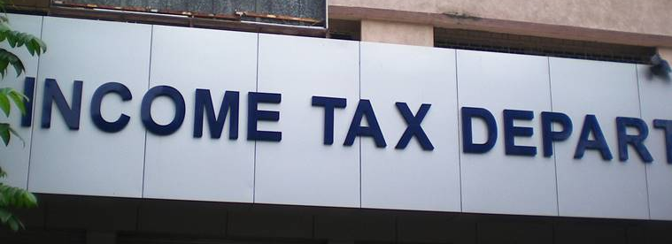
The Income Tax Department has carried out searches on 28.10.2020 at 22 premises in Coimbatore, Erode, Chennai, and Namakkal on a group engaged in the running of Educational Institutions and their associates, including a civil contractor. The search was carried out on the basis of information that fees collected from students were not fully accounted for in the regular books of accounts.
Evidences found during the search reveal that the allegations regarding suppression of fees received are true and the unaccounted receipts are siphoned off to the personal accounts of the trustees, which in turn are invested in real estate through a company. The other shareholders of the company, viz., an architect from Tirupur and a textile businessman were also covered. Electronic devices seized during the course of the search are being examined.
During the searches in the case of the civil contractors from Namakkal, inflation of expenditure by booking bogus expenses under labour charges, material purchase, etc. has been found.
The search has led to the identification of unaccounted investments and on-money payments to the extent of around Rs.150 crore. Cash amounting to Rs. 5 crore has been seized. Some lockers are yet to be operated. The search is still continuing.
The Press Release can be accessed at: https://www.pib.gov.in/PressReleasePage.aspx?PRID=1668340

[This space has been intentionally left blank]

Income Tax Department conducts searches in Uttar Pradesh
A search action was started by the Income Tax Department on 28.10.2020 in the case of a Bijnor based group engaged in real estate business and it’s associates. There were allegations that the group companies were having huge security premium reserves and massive liabilities in the form of loans and advances from related parties/others and other payables, even then they had advanced substantial loans to others. The sales of the group were not commensurate with the loans and advances shown.
During the search unexplained cash of more than Rs. 50 lakh and unexplained jewellery weighing approximately 2.5 kg has been found, so far. The allegations regarding share premium have been found to be correct during the search. They are not commensurate with the income of the concerned shareholders, who could not explain their sources.
During the search, more than 20 companies were found to be running from a single premise out of which many companies are dummy companies and do not show any operations. Companies are not having any worth but are showing significant amounts of share premium. The dummy companies are being used as conduit for layering of funds.
One of the group members has financial interest in one UK based foreign company and one property in London, the sources of investment therein are being examined. Apart from this, incriminating documents relating to investments in many properties have also been recovered from several premises and the same are being investigated. The sources of investment in properties owned by the group are being verified. Hand-written papers relating to certain payments/receipts have also been found during the search and are being examined.
So far 6 bank lockers have been found and further investigations are going on.
The Press Release can be accessed at: https://www.pib.gov.in/PressReleasePage.aspx?PRID=1668571

[This space has been intentionally left blank]

Income Tax Department conducts searches in Bihar
The Income Tax Department has carried out searches on 29.10.2020 in the cases of four prominent contractor groups based in Patna, Bhagalpur, Hilsa, and Katihar. In addition, surveys have been conducted on some traders of mined rocks in Gaya.
All the four groups have been found to have been evading taxes by inflating expenses for the supply of material and labour.
In one case payments have been made to various parties without any evidence of having received any services or supplies. Payments made to bogus parties are received back as an unsecured loan or sometimes withdrawn in cash. Such loans are of about Rs. 10 crore. Further, substantial bogus purchases have been debited in the books. These parties do not exist, but are shown as ‘creditors’ in the books. Such creditors amount to about Rs. 20 crore. Further, bank documents, accounts and other incriminating material of some bogus parties have been seized from the premises of the assessee. These documents and consequential field investigations clearly show that the parties are not genuine and bank accounts have been opened and are being operated by the assessee only. The cash generated has been used in acquiring properties etc.
Seized documents in another case also show that the payments for inflated expenses are being made by bearer cheques. These payments are withdrawn from the bank account by the assessee’s own persons. Such amounts are being quantified. There are sundry creditors for unpaid labour of about Rs 15 crore. These have also been found to be bogus during the search.
There are documents showing inflation of expenses of about Rs 15 crore in another group. This group has made investments in properties in Bihar, Orissa, and Madhya Pradesh.
In another case, evidence of payments made for bogus purchases through cheques but received back in cash has been seized. The cash generated has been invested in purchasing properties and construction of a commercial building. Evidence of such concealment of income of about Rs. 10 crore, using this modus operandi, has been found.
Various incriminating documents, including diaries, purchase deeds, documents showing receipts and payments in cash have been seized.
During surveys also, evidences of unaccounted cash entries, unaccounted sales and purchases have been found totalling to more than Rs. 8 crore. In addition, sales and purchases of stone etc have been found to be not recorded in the books of accounts.
During the search, cash totalling upto Rs 3.21 crore has been seized. Fixed deposits of Rs. 30 crore have been placed under prohibitory orders. Further, properties worth Rs. 16 crore are being placed under prohibitory orders.
The searches have led to unearthing of unaccounted income of about Rs. 75 crore, so far. Further investigations are continuing.
The Press Release can be accessed at: https://www.pib.gov.in/PressReleasePage.aspx?PRID=1668954

Income tax exemption for payment of deemed LTC fare for non-Central Government employees

In view of the COVID-19 pandemic and resultant nationwide lockdown as well as disruption of transport and hospitality sector, as also the need for observing social distancing, a number of employees are not able to avail of Leave Travel Concession (LTC) in the current Block of 2018-21.
With a view to compensate Central Government employees and incentivise consumption, thereby giving a boost to consumption expenditure, the Government of India allowed payment of cash allowance equivalent to LTC fare to Central Government employees subject to fulfilment of certain conditions vide OM No F. No 12(2)/2020-EII (A) dated 12th October 2020. It has also been provided that since the cash allowance of LTC fare is in lieu of deemed actual travel, the same shall be eligible for income-tax exemption on the lines of existing income-tax exemption available for LTC fare.
In order to provide the benefits to other employees (i.e. non-Central Government employees) who are not covered by the above mentioned OM, it has been decided to provide similar income-tax exemption for the payment of cash equivalent of LTC fare to the non-Central Government employees also. Accordingly, the payment of cash allowance, subject to maximum of Rs 36,000 per person as Deemed LTC fare per person (Round Trip) to non-Central Government employees, shall be allowed income-tax exemption subject to fulfilment of conditions specified in para 4.
The income-tax exemption to receipt of deemed LTC fare by a non-Central Government employee (‘the employee’) shall be allowed subject to fulfilment of the following conditions:-
(a) The employee exercises an option for the deemed LTC fare in lieu of the applicable LTC in the Block year 2018-21.
(b) The employee spends a sum equals to three times of the value of the deemed LTC fare on the purchase of goods/services which carry a GST rate of not less than 12% from GST registered vendors/service providers (‘the specified expenditure’) through digital mode during the period from the 12th of October, 2020 to 31st of March, 2021 (‘specified period’) and obtains a voucher indicating the GST number and the amount of GST paid.
(c) An employee who spends less than three times of the deemed LTC fare on specified expenditure during the specified period shall not be entitled to receive full amount of deemed LTC fare and the related income-tax exemption and the amount of both shall be reduced proportionately as explained in Example-A below.
The DDOs shall allow income-tax exemption subject to fulfilment of the above conditions after obtaining copies of invoices of specified expenditure incurred during the specified period. Further, as this exemption is in lieu of the exemption provided for LTC fare, an employee who has exercised an option to pay income tax under concessional tax regime under section 115BAC of the Income-tax Act, 1961 shall not be entitled for this exemption.
The clarifications issued by the Department of Expenditure, Ministry of Finance for the Central Government employees vide OM F. No 12(2)/2020-EII (A) Dated 20th October, 2020 and subsequent clarification, if any, issued in this regard shall apply mutatis mutandis to non-Central Government employees also subject to fulfilment of conditions specified in the preceding paras.
The legislative amendment to the provisions of the Income-tax Act, 1961 for this purpose shall be proposed in due course.
Example-A
Deemed LTC Fare: Rs.20,000 x 4 = Rs. 80,000
Amount to be spent: Rs. 80,000 x 3 = Rs. 2,40,000
Thus, if an employee spends Rs. 2,40,000 or above on specified expenditure, he shall be entitled for full deemed LTC fare and the related income-tax exemption. However, if the employee spends Rs. 1,80,000 only, then he shall be entitled for 75% (i.e. Rs. 60,000) of deemed LTC fare and the related income-tax exemption. In case the employee already received Rs. 80,000 from employer in advance, he has to refund Rs. 20,000 to the employer as he could spend only 75% of the required amount.
The Press Release can be accessed at: https://www.pib.gov.in/PressReleasePage.aspx?PRID=1668609

[This space has been intentionally left blank]

Important Update of the week

CBDT has issued refunds of over Rs. 1,26,909 crore to more than 39.14 lakh taxpayers between April 01, 2020 to October 27, 2020
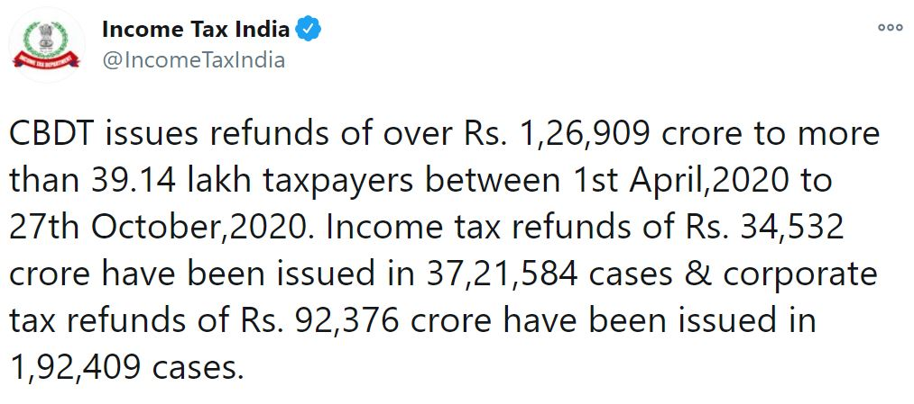
As per the recent tweet of Income Tax India, the CBDT issues refunds of over Rs. 1,26,909 crore to more than 39.14 lakh taxpayers between April 01, 2020 to October 27, 2020.
Income tax refunds of Rs. 34,532 crore have been issued in 37,21,584 cases & corporate tax refunds of Rs. 92,376 crore have been issued in 1,92,409 cases.
Source from: https://twitter.com/IncomeTaxIndia/status/1321368321497853952

[This space has been intentionally left blank]

GST News Flash

Maruti Chairman: Auto industry doesn’t require GST cut now
https://www.a2ztaxcorp.com/maruti-chairman-auto-industry-doesnt-require-gst-cut-now/

Jump in cost of raw materials due to COVID lead to GST complications
https://www.a2ztaxcorp.com/jump-in-cost-of-raw-materials-due-to-covid-lead-to-gst-complications/

Government to prepare a list of ‘risky’ companies created to evade GST
https://www.a2ztaxcorp.com/government-to-prepare-a-list-of-risky-companies-created-to-evade-gst/

GST filing adds to MSME woes amid pandemic
https://www.a2ztaxcorp.com/gst-filing-adds-to-msme-woes-amid-pandemic/

Finance Ministry issues guidelines for implementation of interest waiver on loan
https://www.a2ztaxcorp.com/finance-ministry-issues-guidelines-for-implementation-of-interest-waiver-on-loan/

If GST has failed, revert to old tax system: Uddhav Thackeray
https://www.a2ztaxcorp.com/if-gst-has-failed-revert-to-old-tax-system-uddhav-thackeray/



About us:
A2Z TAXCORP LLP is a boutique Indirect Tax firm having professionals from Multi disciplines which includes Goods and Services Tax (GST), Central Excise, Custom, Service Tax, VAT, DGFT, Foreign Trade Policy, SEZ, EOU, Export – Import Laws, Free Trade Policy etc.

Thanks & Best Regards,
Our Address:

A2Z TAXCORP LLP
Tax and Law Practitioners

Flat No. 34B,
Ground Floor, Pocket – 1,
Mayur Vihar Phase-1
Delhi – 110091 (India)
Tel: +91 11 42427056
Web: www.a2ztaxcorp.com

Bimal Jain
FCA, FCS, LLB, B. Com (Hons)
Author of a book on Goods and Services Tax, titled, "GST Law and Analysis (with conceptual procedures) [5thEdition]
Connect With Us:

DISCLAIMER: The views expressed are strictly of the author and A2Z Taxcorp LLP. The contents of this weekly newsletter are solely for informational purpose. It does not constitute professional advice or recommendation of firm. Neither the author nor firm and its affiliates accepts any liabilities for any loss or damage of any kind arising out of any information in this weekly newsletter nor for any actions taken in reliance thereon.

