GSTR 9

Background

Under GST, registered taxpayers including those registered under composition scheme have to file Annual Returns once in a year. Formats of GST Annual Return Forms GSTR-9(for regular taxpayers) and GSTR-9A(for taxpayers registered under composition scheme) were notified by CBIC along with requisite instructions vide Notification No. 39/2018 – Central Tax dated 04th September 2018 and updated on 31st Dec 2018 via Notification 74/2018.

Points to Note on Annual GST Returns

- Every registered person is required to file annual return on or before 30th June of the year succeeding the financial year in form GSTR-9. Example – For F.Y 2017-18 annual return would be filed on 30th June 2019. Person paying tax under composition scheme is required to file annual return in form GSTR – 9A – Proviso to Sub Rule (1) of Rule 80.
- Person paying tax under composition scheme is required to file annual return in form GSTR– 9A
– Proviso to Sub Rule (1) of Rule 80.
- Every electronic commerce operator who is required to collect tax at source under section 52 shall furnish annual statement in form GSTR – 9B – Sub Rule 2 of Rule 80.
- Nil Annual Return- A person registered under GST but having no transactions during the year is still required to file a Nil Annual Return. A person who has got his registration cancelled during the year is also required to file the respective Annual returns.

A Registered person who has opted in or opted out of composition is required to file both GSTR 9 & GSTR 9A for the relevant periods.
- The exceptions to filing of the Annual return applies to the following category of registered persons
  - Input Service Distributor
  - A person required to deduct TDS
  - Casual Taxable Person
  - Non-Resident Taxable Person
- In case of the regular registered persons whose aggregate turnover exceeds Rs. 2 Crore, they are required to furnish the following
  - GSTR 9 – The Annual Return
  - Audited Annual Accounts
  - GSTR 9C – A reconciliation statement mapping the annual returns Vs. the Audited Annual Accounts

Annual Return Filing Process:
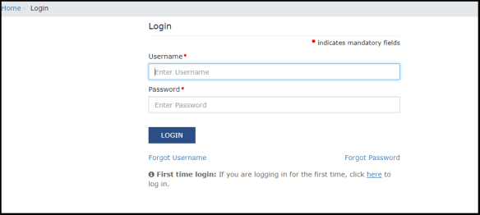
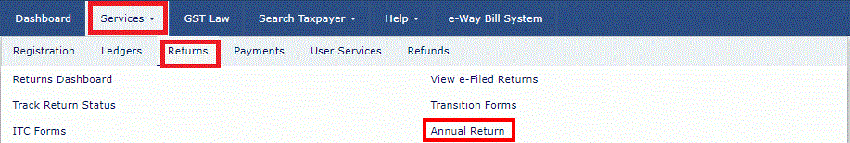
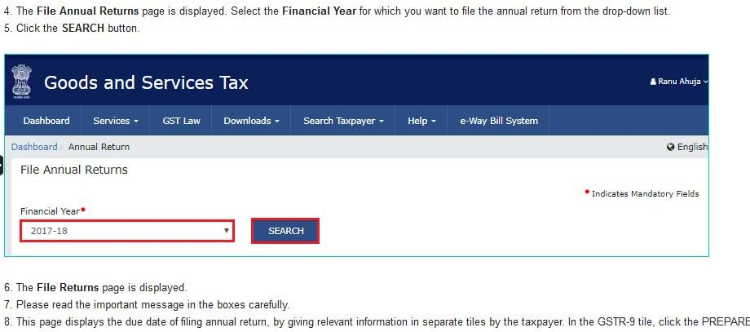

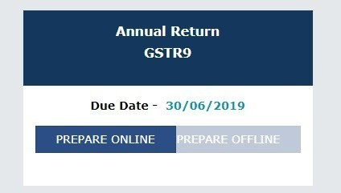
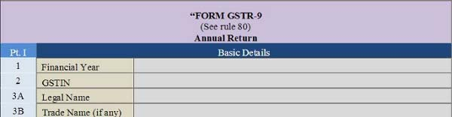

Table number | Heading | Description | Source
Part I | Basic Details
1 | Financial Year | FY relevant for the year in which annual return is being filed. | Auto-populated on GSTN
2 | GSTIN | GST identification number. Note that GSTR-9 will be filed for each GST registration taken during the year 2017-18. | Auto-populated on GSTN
3A | Legal N ame | Legal name of the business as registered with the GSTN | Auto-populated on GSTN
3B | Trade Name(if any) | To be declared only if present. Trade name and legal name are not used interchangeably. | Auto-populated on GSTN

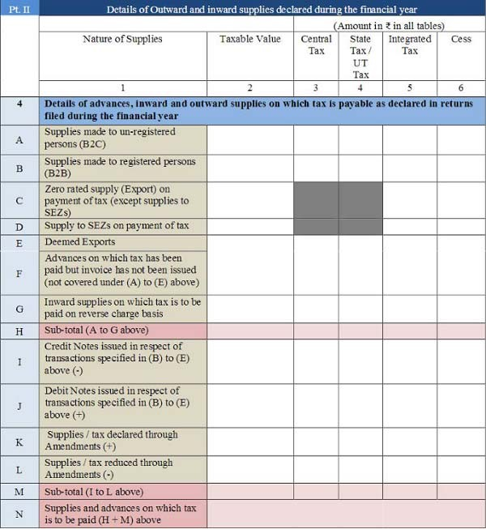

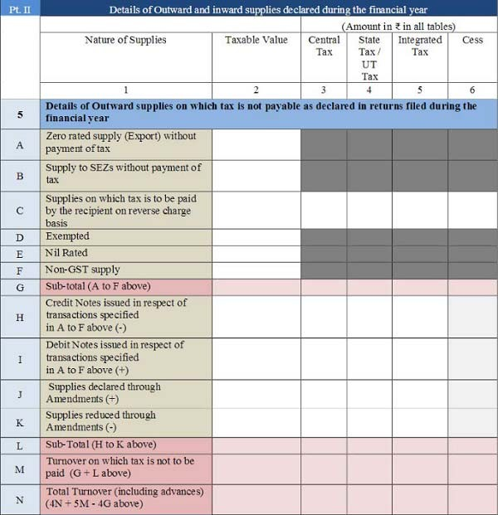

Part II | Details of Outward and inward supplies declared during the financial year
4A | Supplies made to unregistered persons (B2C) | The total value of all supplies made between July 2017- March 2018 to customers and unregistered persons, by self or through an e-commerce platform, net of credit or debit notes and CGST, SGST and/or IGST, cess if any, charged on the same | Table 5, Table 7 along with respective amendments in Table 9 and Table 10 of FORM GSTR-  1 for the period
4B | Supplies made to registered persons (B2B) | The total value of all supplies made between July 2017- March 2018 to registered persons(including UIN), by self or through an e-commerce platform, and CGST, SGST and/or IGST, cess if any, charged on the same( tax)Note that supplies made where reverse charge provision applies is not to be included. Credit and debit notes raised on these must be declared separately at Table 4I and 4J | Table 4A and Table 4C of FORM GSTR-1
4C | Zero-rated supply (Export) on payment of tax (except supplies to SEZs) | The total value of exports (except supplies to SEZs) on which tax has been paid shall be declared here. Those supplies on which tax is not paid by obtaining LUT/bond must not be declared here | Table 6A of FORM GSTR-1 must be bifurcated between tax paid and not paid supplies and then used
4D | Supply to SEZs on payment of tax | Total supplies to SEZs on which tax has been paid | Table 6B of GSTR-1 must be bifurcated between tax paid and not paid  supplies and then  used
4E | Deemed Exports | The total value of supplies in the nature of deemed exports on which tax has been paid | Table 6C of FORM GSTR-1 must be bifurcated between tax paid and not paid supplies and then used
4F | Advances on which tax has been paid but invoice has not been issued | Details of all unadjusted advances i.e. advance have been received and tax has been paid but invoice has not been issued in the current year ( Not covered in tables 4A to 4E) | Table 11A of FORM GSTR-1 to be referred.

4G | Inward supplies on which tax is to be paid on a reverse charge basis | The total value of supplies received(purchase) and tax, where tax is paid by the taxpayer under RCM  Includes advances and net of credit and debit notes  Includes the aggregate value of all import of services | Table 3.1(d) of FORM GSTR-3B is to  be referred
4I | Credit Notes issued in respect of transactions specified in (B) to  (E) above (-) | The total value of credit notes issued by taxpayer in respect of B to B supplies (4B),exports (4C), supplies to SEZs (4D) and deemed exports (4E) and tax thereon | Table 9B of FORM GSTR-1
4J | Debit Notes issued in respect of transactions specified in (B) to  (E) above (+) | The total value of credit notes issued by taxpayer in respect of B to B supplies (4B),exports (4C), supplies to SEZs (4D) and deemed exports (4E) and tax thereon | Table 9B of FORM GSTR-1
4K | Supplies/tax declared through Amendments (+) | The total value of amendments made and tax thereon, to B to B supplies (4B), exports (4C), supplies to SEZs (4D) and deemed exports (4E), credit notes (4I), debit notes (4J) and refund vouchers  The total must be of those amendments that have an effect of increasing value and tax | Table 9A and Table 9C of FORM GSTR-1
4L | Supplies/tax reduced through Amendments (-) | The total value of amendments made and tax thereon, to B to B supplies (4B), exports (4C), supplies to SEZs (4D) and deemed exports (4E), credit notes (4I), debit notes (4J) and refund vouchers  The total must be of those amendments that have an effect of decreasing value and tax | Table 9A and Table 9C of FORM GSTR-1

5A | Zero-rated supply (Export) without payment of tax | The aggregate value of exports (except supplies to SEZs) on which tax has not been paid | Table 6A of FORM GSTR-1 must be bifurcated between tax paid and not paid supplies and then used
5B | Supply to SEZs without payment of tax | The total value of supplies to SEZs on which tax has not been paid | Table 6B of GSTR-1 must be  bifurcated between tax paid and not paid supplies and then used
5C | Supplies on which tax is to be paid by the recipient on reverse charge basis | The total value of supplies made to registered persons on which tax is payable by the recipient of the taxpayer on a reverse charge basis | Table 4B of FORM GSTR-1
5D | Exempted | The total value of exempt supplies must be declared. | Table 8 of GSTR-1 can be referred
5E | Nil Rated | The total value of Nil-rated supplies must be declared. Example: Supply of Petrol | Table 8 of GSTR-1 can be referred
5F | Non-GST supply | The total value of Non-GST supplies must be declared. Example: Supply of alcoholic beverages | Table 8 of GSTR-1 can be referred
5H | Credit Notes issued in respect of transactions specified in A to F above (-) | The total value of credit notes issued in respect of supplies declared in 5A,5B,5C, 5D, 5E and 5F | Table 9B of FORM GSTR-1

5I | Debit Notes issued in respect of transactions specified in A to F above (+) | The total of debit notes issued in respect of supplies declared in 5A,5B,5C, 5D, 5E and 5F | Table 9B of FORM GSTR-1
5J | Supplies declared through Amendment s (+) | - The total value of amendments made to exports (except supplies to SEZs) and supplies to SEZs on which tax has not been paid must be declared  - The total must be of those amendments that have an effect of increasing value | Table 9A and 14  Table 9C of FORM GSTR-1
5K | Supplies reduced through Amendments (-) | The total value of amendments made to exports (except supplies to SEZs) and supplies to SEZs on which tax has not been paid must be declared.  The total must be of those amendments that have an effect of decreasing value | Table 9A and Table 9C of FORM  GSTR-1

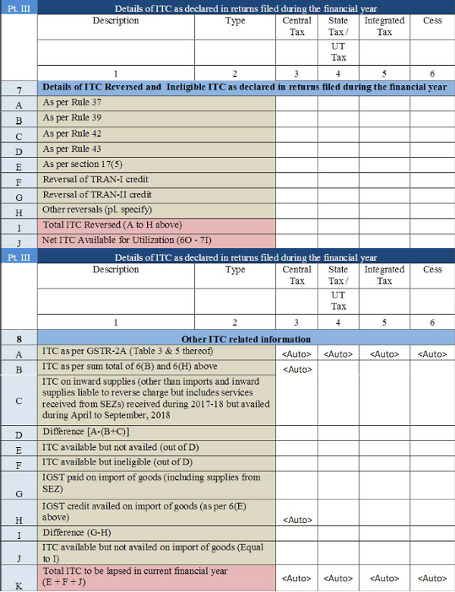

Part III | Details of ITC as declared in returns filed during the financial year
6A | The total amount of input tax credit availed through FORM GSTR-3B | This is the sum total of Table 4A of FORM GSTR-3B for 9 months | Auto-populated
6B | Inward supplies (other than imports and inward supplies liable to reverse charge but includes services received from SEZs) | Proper classification of ITC as Inputs, Input services and Capital goods is required while declaring CGST, SGST, IGST and cess, if any  Note that this shall not include ITC which was availed, reversed and then reclaimed in the ITC ledger as it will be separately declared at 6H | Table 4(A)(5) of FORM GSTR-3B can be used
6C | Inward supplies received from unregistered persons liable to reverse charge (other than B above) on which tax is paid & ITC availed | Proper classification of ITC as Inputs, Input services and Capital goods is required while declaring CGST, SGST, IGST and cess, if any.  Purchases made from unregistered persons on which RCM applies must be declared here | Table 4(A)(3) of FORM GSTR-3B may be used
6D | Inward supplies received from registered persons liable to reverse charge (other than B above) on which tax is paid and ITC availed | Proper classification of ITC as Inputs, Input services and Capital goods is required while declaring CGST, SGST, IGST and cess, if any.  Purchases made from unregistered persons on which RCM applies must be declared here | Table 4(A)(3) of FORM GSTR-3B should be referred
6E | Import of goods (including supplies  from SEZs) | Proper classification of ITC as Inputs and Capital goods is required while declaring CGST, SGST, IGST and cess, if any. | Table  4(A)(1) of FORM  GSTR-3B to be referred

6F | Import of services (excluding inward supplies from SEZs) | Note that this should exclude purchases from SEZs | Table 4(A)(2) of FORM GSTR- 15 3B may be used for filling up these details
6G | Input Tax credit received from ISD | The total value of input tax credit received from input service distributor should be declared | Table 4(A)(4) of FORM GSTR-3B may be used and confirmed with GSTR-6A
6H | Amount of ITC reclaimed (other than B above) under the provisions of the Act | The total value of input tax credit availed, reversed and reclaimed under the provisions of the Act shall be declared here | This must be the amount that was identified while calculating 6B of this form
6J | Difference (6I - 6A above) | Where I=totals of 6B to 6H  The difference between the total amount of input tax credit availed through FORM GSTR-3B and input tax credit declared in row B to H shall be declared here. Ideally, this amount should be zero. | Will be calculated based on values entered in Table 6 of this form. The purpose of identifying the amount is to know any excess or short credit claimed.
6K | Transition Credit through TRAN-I (including revisions if any) | Details of transition credit received in the electronic credit ledger on filing of FORM GST TRAN-I including revision of TRAN-I | TRAN-I as reflected in electronic credit ledger
6L | Transition Credit through TRAN-II | Details of transition credit received in the electronic credit ledger after filing of FORM GST TRAN-II | TRAN-II as reflected in electronic credit ledger

6M | Any other ITC availed but not specified above | Details of ITC availed but not covered in any of heads specified under 6B to 6L above shall be declared here | FORM ITC01 and FORM ITC-  02 if any filed in the financial year 2017-18 must be referred
7A , 7B,  7C, 7D,  7E, 7F,  7G and 7H | Details of ITC reversed and Ineligible ITC as declared in returns filed during the financial year | Following are covered:  - Rule 37: Reversal due to non-payment of the invoice within 180 days of Invoice date  - Rule 39: Reversal of ITC received from ISD due to the credit note  - Rule 42: Reversal of credit portion of inputs/input services attributable to exempt supplies or  non-business purpose  - Rule 43: Reversal of credit portion of capital goods attributable to exempt supplies or non-business purpose  - Section 17(5): Ineligible credit  - [Reversal of TRAN-I  - Reversal of TRAN-II]: ineligible transition credit  - Others | Table 4(B) of FORM GSTR-3B  may be used. Also for Table  7H-others, refer ITC reversed in ITC-03
8A | ITC as per GSTR-2A  (Table 3 & 5 thereof) | This would be the aggregate of all the input tax credit that has been declared by the corresponding suppliers in their FORM GSTR-I, as reflected in GSTR-2A of the taxpayer. | Auto-populated
8B | ITC as per sum total of 6(B) and 6(H) above | Total ITC eligible and claimed during the year must be declared | The input tax credit as declared in Table 6B and 6H of this form shall be auto-populated here.

8C | ITC on inward supplies (other than imports and inward supplies liable to reverse charge but includes services received from SEZs) received during 2017-18 but availed during April to September, 2018 | ITC that is claimed between April 2018 to September 2018 but relates to the FY 2017-18 | Table 4(A)(5) of FORM GSTR-3B may be used
8D | Difference[8A-( 8B+8C)] | Difference between ITC available in GSTR-2A and ITC availed in the GSTR-3B for FY 2017-18 | Will be calculated based on values entered in Table 6 of this form. The purpose of identifying the amount is to know any excess or short credit claimed between GSTR-3B and GSTR-2A
8E | ITC available but not availed | Aggregate value of the input tax credit which was available in | Refer 8D of this form after thorough
 | (out of D) | FORM GSTR2A (table 3 & 5 only) but not availed/ missed it, in any of the FORM GSTR- 3B returns | reconciliation at invoice level. 8E and 8F must add up to 8D
8F | ITC available  but ineligible (out of D) | Aggregate value of the input tax credit that was not availed as the same was ineligible | Refer 8D of this form after thorough reconciliation at invoice level. 8E and 8F must add up to 8D
8G | IGST paid on import of goods (including supplies from SEZ) | Aggregate value of IGST paid at the time of imports (including imports from SEZs) during the financial year shall be declared here | Refer Table 4A(1) of GSTR-3B for FY 2017-18

8H | IGST credit availed on import of goods (as per 6(E) | The input tax credit availed on import of goods, as declared in Table 6E of this form | Auto-populated
8J | ITC available but not availed on import of goods | Difference between 8G and 8H of this form | Must be calculated to know the difference of ITC that can still be claimed on import of goods( IGST)
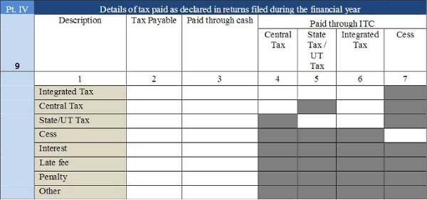

Part IV | Details of tax paid as declared in returns filed during the financial year
9 | Tax paid in the form of CGST, SGST, IGST, UTGST, Cess,  Interest, Late fees, Penalty, Other | Proper bifurcation for each item must be as tax payable, Tax paid through cash and by using ITC. These are the actual tax paid during the financial year | Table 6.1 of FORM GSTR- 3B Payment of Tax is to be referred

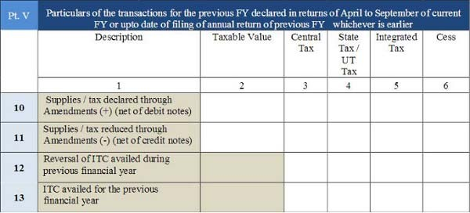

Part V | Particulars of the transactions for the previous FY declared in returns of April to September of current FY or upto date of filing of annual return of previous FY whichever is earlier
10 & 11 | Supplies / tax declared through Amendments | Details of additions or amendments to any of the supplies already declared in the returns of the previous financial | Table 9A, Table 9B and Table 9C of FORM GSTR-1 of April 2018 to
 | (+) (net of debit notes)  & | year 2017-18, made between April 2018 and September 2018 | September 2018 or date of filing of Annual Return for the previous financial year, whichever is earlier
Supplies / tax reduced through Amendments
(-) (net of credit notes)
12 | Reversal of ITC availed during previous financial year | Total value of reversal of ITC which was availed in the previous financial year 2017-18 but reversed in returns filed for the months of April 2018 to September 2018 or date of filing of Annual Return for previous financial year , whichever is earlier | Table 4(B) of FORM GSTR- 3B may be used

13 | ITC availed for the previous financial year | Details of ITC for goods or services received in the previous financial year 2017-18 but ITC for the same was availed in returns filed for the months of April 2018 to September 2018 or date of filing of Annual Return for the previous financial year whichever is earlier | Table 4(A) of FORM GSTR-3B  may be used
14 | Differential tax paid on  account of declaration in 10 & 11 above | This will be the tax to be paid and the amount of tax paid on amendments pf FY 2017-18 made between April 2018 to September 2018 in the form of CGST, SGST, UTGST, IGST,  Cess and Interest | Table 9A, Table 9B and Table 9C of FORM GSTR-1 of April 2018 to September 2018
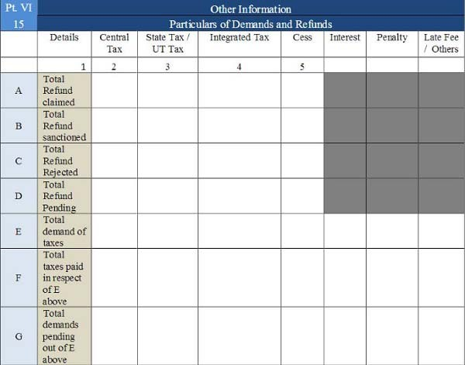

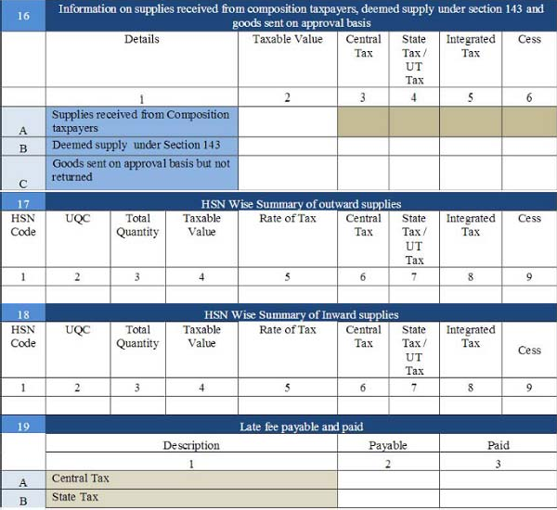

Part VI | Other Information
15A,15B,  15C and 15D | Total Refund claimed, sanctioned, rejected, | -Total refund claimed will be the aggregate value of all the refund claims filed in the financial year 2017-18 starting

 | pending sanction | July 2017 and will include refunds which have been sanctioned, rejected or are pending for processing.  -Refund sanctioned means the aggregate value of all refund sanction orders.  -Refund pending will be the aggregate amount in all refund application for which acknowledgement has been received and will exclude provisional refunds received.  These will not include details of non-GST refund claims.
15E,15F & 15G | Total amount of taxes demanded, paid and pending payment | The total value of demands of taxes for which an order confirming the demand has been issued by the GST authority and along with details of payment made or pending recovery must be declared
16A | Supplies received from Composition taxpayers | Aggregate value of supplies received from composition taxpayers | Table 5 of FORM GSTR- 3B may be used
16B | Deemed supply under Section 143 | Aggregate value of all deemed supplies from the principal to the job-worker in terms of sub- section (3) inputs and sub- section (4) capital goods of Section 143 of the CGST Act, are not received within the stipulated time of one and three years respectively | By verifying Job works initiated during the year as per books of accounts.  Since time limit of 1 year and 3 year will not get triggered as on 31st March 2018, there will not be any 13 transaction to be reported here.
 |  |  | Note goods sent to job worker before July 2017 and returned between the periods July 2017 to March 2018 will not get attracted here.
16C | Goods sent on approval basis but not returned | Aggregate value of all deemed supplies for goods which were sent on approval basis but were not returned to the principal supplier within 180 days of such supply | From the books of accounts/ stock records

17 | HSN Wise Summary of outward supplies | Summary of supplies effected against a particular HSN code to be reported only in this table.  Quantity is to be reported net of returns | Table 12 of FORM GSTR-1 can be referred
18 | HSN Wise Summary of Inward supplies | Summary of supplies received against a particular HSN code to be reported only in this table.  Quantity is to be reported net of returns | Purchase register and the Stock register
19 | Late fee payable and paid | The late fee will be payable if annual return is filed after the due date for the Central tax and the State tax separately | Not applicable

Summary
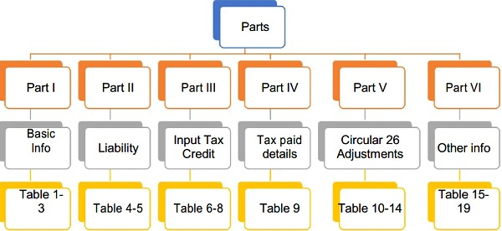

This material is prepared by GSAP & Associates LLP (GSAP). This material (including any information contained in it is intended to provide general information on a particular subject(s) and is not an exhaustive treatment of such subject(s) or a substitute to obtaining professional services or advice. This material may contain information sourced from publicly available information or other third party sources. GSAP does not independently verify any such sources and is not responsible for any loss whatsoever caused due to reliance placed on information sourced from such sources. GSAP is not, by means of this material, rendering any kind of investment, legal or other professional advice or services. You should seek specific advice of the relevant professional(s) for these kind of services. This material or information is not intended to be relied upon as the sole basis for any decision which may affect you or your business. Before making any decision or taking any action that might affect your personal finances or business, you should consult a qualified professional adviser. GSAP shall not be responsible for any loss whatsoever sustained by any person or entity by reason of access to, use of or reliance on, this material. By using this material or any information contained in it, the user accepts this entire notice and terms of use.
©2019 GSAP & Associates LLP

