CONTENTS
Business of plying, hiring or leasing of goods carriages under Income tax Act……………2
Presumptive Taxation Scheme of Section 44AE …………………………………………………..2-3
Rate for Income Calculation(with illustrations)………………………………………………………3-4
Disallow of further expenses under presumptive scheme……………………………………………4
No need to maintain books of account as prescribed under section 44AA………………………...5
Applicability of the provisions relating to payment of advance tax………………………………….5
TDS on payment to transporter…………………………………………………………………………6
Goods Transport Agency under GST 7
What service of transportation of goods is exempt under GST? 7
What is a GTA? 7
What is a consignment note? 7
What are the services provided by a GTA? 8
What was the situation under Service Tax? 8
What is the rate of GST on GTA? 8
Is a GTA liable to register? 9
Who pays GST while hiring a GTA? 12
Which businesses are liable to pay GST under reverse charge for a GTA? 12
Who will pay under Reverse Charge? 12
Various Scenarios to Determine Who is Liable to pay GST in case of a GTA 13
Reverse Charge if the GTA Is Unregistered 14
Input Tax Credit 15
If GTA pays GST 15
If Service Receiver pays GST under RCM 15
Various Scenarios to Determine Eligibility of ITC 15
Invoicing for GTA 15
Payment of Tax by a GTA 16
Returns to be Filed by a GTA 16
How to determine Place of Supply for a GTA 16
Examples for determining place of supply 16
FAQs on GTA…………………………………………………………………..…………………………………………………………….17

1 Business of plying, hiring or leasing of goods carriages under Income tax Act
Don’t have to maintain books of account and option for presumptive scheme u/s44AE
Have to maintain books of accounts as per Sec 44AA and get books of account Audited under sec 44AB(if required)
Less or Equal to 10 Good Carriage vehicle during the year
More Then 10 Good Carriage Vehicle at any point time during the year
Business of plying, hiring or leasing of goods carriages under Income tax Act

1.1 Presumptive Taxation Scheme of Section 44AE
1.1.A Applicability of the presumptive taxation scheme of section 44AE
The scheme of section 44AE is designed to give relief to small taxpayers engaged in the business of plying, hiring or leasing of goods carriages.
1.1.B Eligible taxpayer and eligible business for the purpose of the presumptive taxation scheme of section 44AE
The provisions of section 44AE are applicable to every person (i.e., an individual, HUF, firm, company, etc.).
The presumptive taxation scheme of section 44AE can be adopted by a person who is engaged in the business of plying, hiring or leasing of goods carriages and who does not own more than 10 goods vehicles at any time during the year.
A person who owns more than 10 goods vehicles cannot adopt the presumptive taxation scheme of section 44AE
The presumptive taxation scheme of section 44AE can be adopted by a person who is engaged in the business of plying, hiring or leasing of goods carriages and who does not own more than 10 goods vehicles at any time during the year.
The important criterion of the scheme is the restriction on owning of not more than 10 goods vehicles at any time during the year. Thus, if a person owns more than 10 goods vehicles at any time during the year, then he cannot take advantage of this scheme.
The manner of computation of taxable business income in case of a person adopting the presumptive taxation scheme of section 44AE
In case of a person who is willing to opt for the presumptive taxation scheme of section 44AE, income will be computed on an estimated basis.
1.2 Rate for Income Calculation
For Heavy Goods Vehicle, income will be computed at the rate of Rs. 1,000 per ton of gross vehicle weight for every month or part of a month during which the heavy goods vehicle is owned by taxpayer.
In case of vehicles other than heavy goods vehicle (i.e, Light vehicle) , income will be computed at the rate of 7,500 for every month or part of a month during which the goods carriage is owned by taxpayer. Part of the month would be considered as full month.
Note 1 : If the actual income is higher than the presumptive rate, i.e., higher than Rs. 1,000/Rs. 7,500, then such higher income can be declared.
Note 2 : “Heavy Goods Vehicle” means any goods carriage having gross vehicle weight exceeding 12,000 kilograms.
Illustration 1
Mr. Khush is engaged in the business of plying, hiring or leasing of goods carriage. Throughout the year 2018-19 he owned 9 goods vehicles (other than heavy goods vehicles). What will be the taxable income from the business of plying, hiring or leasing of goods carriages if he adopts the provisions of section 44AE?
As per the provisions of section 44AE, for Heavy Goods Vehicle, income will be computed at the rate of Rs. 1,000 per ton of gross vehicle weight for every month or part of a month during which the heavy goods vehicle is owned by taxpayer. In case of vehicles other than heavy goods vehicle, income will be computed at the rate of 7,500 for every month or part of a month during which the goods carriage is owned by taxpayer.
In the present case, Mr. Khush owned 9 goods vehicles (other than heavy goods vehicles) throughout the year and, hence, income will be computed as follows:
Particulars | Amount (Rs.)
Income per month per goods vehicle | 7,500
(×) No. of goods vehicles | 9
Monthly income as per the provisions of section 44AE from 9 goods vehicles | 67,500
(×) No. of months in the year during which the vehicles were owned | 12
Total income from business of plying, hiring or leasing goods carriages as per the provisions of section 44AE | 8,10,000

Illustration 2
Mr. Sunil engaged in the business of plying, hiring or leasing goods carriages. He owned 5 heavy goods vehicle having gross weight of 13,000 kilograms and 4 other goods vehicle during the previous year 2018-19. What will be his taxable income as per the provisions of section 44AE?
**
As per the provisions of section 44AE, for Heavy Goods Vehicle, income will be computed at the rate of Rs. 1,000 per ton of gross vehicle weight for every month or part of a month during which the heavy goods vehicle is owned by taxpayer. In case of vehicles other than heavy goods vehicle, income will be computed at the rate of 7,500 for every month or part of a month during which the goods carriage is owned by taxpayer.
In the present case, Mr. Sunil owned total 9 goods vehicles in which 5 are heavy goods vehicles having gross weight of 13,000 Kilograms. Hence, income will be computed as follows:
Particulars | Rs.
Income per month per heavy goods vehicle ( 13,000 kilograms i.e., 13 ton) | 1,000 x 13
(x) No. of heavy goods vehicle | 5
Monthly income in case of heavy goods vehicleas per the provisions of section 44AE | 65,000
(x) No. of months in a year | 12
Total income as per the provisions of section 44AE from heavy goods vehicle (A) | 7,80,000
Income per month per goods vehicle (other than heavy vehicle) | 7,500
(x) No. of vehicles other than heavy goods vehicle | 4
Monthly income as in case of vehicles other than heavy goods vehicleas per the provisions of section 44AE | 30,000
(*) No. of months in a year | 12
Total income as per the provisions of section 44AE from vehicles other than heavy goods vehicle(B) | 3,60,000
Total income from business of plying, hiring or leasing goods carriages as per the provisions of section 44AE (A+B) | 11,40,000

1.4 Disallow of further expenses under presumptive scheme
The presumptive income computed at the rate of Rs. 1,000 per ton or Rs. 7,500 per goods vehicle per month is the final income and no further expenses will be allowed or disallowed
Under the normal provisions of the Income-tax Act, taxable business income will be computed after allowing deduction in respect of expenses which are deductible as per the Income-tax Act and after disallowing expenses which are not deductible as per the Income-tax Act.
In case of a person who is opting for the presumptive taxation scheme of section 44AE, the provisions of allowance/disallowances as provided for under the Income-tax Act, will not apply and income computed at the presumptive rate of Rs. 1,000/Rs. 7,500 will be the final income. In other words, the income computed at the rate of Rs. 1,000/Rs. 7,500 per goods vehicle per month will be the final taxable income of the business and no further expenses will be allowed or disallowed.
However, in case of a taxpayer, being a partnership firm, opting for the presumptive taxation scheme, from the income computed at the presumptive rate of Rs. 7,500 per goods vehicle per month, further deduction can be claimed on account of remuneration and interest paid to partners (computed as per the Income-tax Act).
While computing income as per the provisions of section 44AE, separate deduction on account of depreciation is not available, however, the written down value of any asset used in such business shall be calculated as if depreciation as per section 32 is claimed and has been actually allowed.
1.5 No need to maintain books of account as prescribed under section 44AA
Section 44AA of the Income-tax Act, 1961 has provisions relating to maintenance of books of account by a person engaged in business/profession. Thus, a person engaged in business/profession has to maintain books of account of his business/profession according to the provisions of section 44AA.
No need to maintain books of account as prescribed under section 44AA
In case of a person opting for the presumptive taxation scheme of section 44AE, the provisions of section 44AA relating to maintenance of books of account will not apply. In other words, if a person adopts the provisions of section 44AE and declares his income at the rate of Rs. 7,500 per goods vehicle per month, then he is not required to maintain the books of account as provided for under section 44AA in respect of business covered under the presumptive taxation scheme of section 44AE.
1.6 Applicability of the provisions relating to payment of advance tax
There is no concession as regards payment of advance tax in case of a person who adopts the presumptive taxation scheme of section 44AE and, hence, he will be liable to pay advance tax even if he adopts the presumptive taxation scheme of section 44AE.
Provisions to be applied if a person does not opt for the presumptive taxation scheme of section 44AE and declares income at a lower rate, i.e., at less than Rs. 1,000 per ton or Rs. 7,500 per goods vehicle per month
A person can declare his income at lower rate (i.e., at less than Rs. 1,000 per ton or Rs. 7,500 per goods vehicle per month). However, if he does so, then he is required to maintain the books of account as per the provisions of section 44AA and has to get his accounts audited under section 44AB.

1.7 TDS on payment to transporter
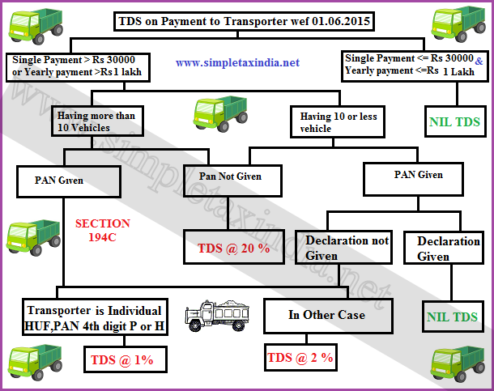

2 Goods Transport Agency under GST

2.1 What service of transportation of goods is exempt under GST?
Services by way of transportation of goods are exempted:
(a) by road except the services of:
(i) a goods transportation agency;
(ii) a courier agency
(b) by inland waterways.
Therefore, the service of transportation of goods by road continue to be exempt even under the GST regime. GST is applicable only on goods transport agency, GTA.

2.2 What is a GTA?
As per Notification No. 11/2017-Central Tax (Rate) dated 28th June, 2017, “goods transport agency” or GTA means any person who provides service in relation to transport of goods by road and issues consignment note, by whatever name called.
This means, while others might also hire out vehicles for goods transportation, only those issuing a consignment note are considered as a GTA. Thus, a consignment note is an essential condition to be considered as a GTA.

2.3 What is a consignment note?
A consignment note is a document issued by a goods transportation agency against the receipt of goods for the purpose of transporting the goods by road in a goods carriage.
If a consignment note is not issued by the transporter, the service provider will not come within the ambit of goods transport agency.
If a consignment note is issued, it means that the lien on the goods has been
transferred to the transporter. Now the transporter is responsible for the goods till its safe delivery to the consignee.
A consignment note is serially numbered and contains –
- Name of consignor
- Name of consignee
- Registration number of the goods carriage in which the goods are transported
- Details of the goods
- Place of origin
- Place of destination.
- Person liable to pay GST – consignor, consignee, or the GTA.

2.4 What are the services provided by a GTA?
The service includes not only the actual transportation of goods, but other intermediate/ancillary service provided such as-
- Loading/unloading
- Packing/ unpacking
- Trans-shipment
- Temporary warehousing etc.
If these services are included and not provided as independent activities, then they are also covered under GTA.

2.5 What was the situation under Service Tax?
RCM applied under Service tax. There was an abatement of 60% (40% taxable) for transportation of used household goods and 70% (30% taxable) for transportation of normal goods.

2.6 What is the rate of GST on GTA?

Service by a GTA | GST rate
Carrying-  - agricultural produce  - milk, salt and food grain including flour, pulses and rice  - organic manure  - newspaper or magazines registered with the Registrar of Newspapers  - relief materials meant for victims of natural or man-made disasters  - defence or military equipment | 0%
Carrying-  goods, where consideration charged for the transportation of goods on a consignment transported in a single carriage is less than Rs. 1,500 | 0%
Carrying-  goods, where consideration charged for transportation of all such goods for a single consignee does not exceed Rs. 750 | 0%
Any other goods | 5% No ITC  OR  12% with ITC
Used household goods for personal use | 0% **
Transporting goods of unregistered persons | 0% **
Transporting goods of unregistered casual taxable persons | 0% **
Transporting goods (GST paid by GTA)* | 5% No ITC  or  12% with ITC
Transporting goods of 7 specified recipients* | 12% with ITC (paid by GTA)  Or  RCM 5% with ITC
Hiring out vehicle to a GTA | 0%

*As per Notification No. 20/2017-Central Tax (Rate) 22nd August, 2017
** As per Notification No. 32/2017- Central Tax (Rate) dated 13th October, 2017

2.7 Is a GTA liable to register?
There was a lot of confusions whether a GTA has to register under GST.
As per Notification No. 5/2017- Central Tax dated 19/06/2017, a person who is engaged in making only supplies of taxable goods/services on which reverse charge applies is exempted from obtaining registration under GST.
Thus, a GTA does not have to register under GST if he is exclusively transporting goods where the total tax is required to be paid by the recipient under reverse charge basis (even if the turnover exceeds 20 lakhs).
2.8 Scenarios for Registration for a Goods Transport Agency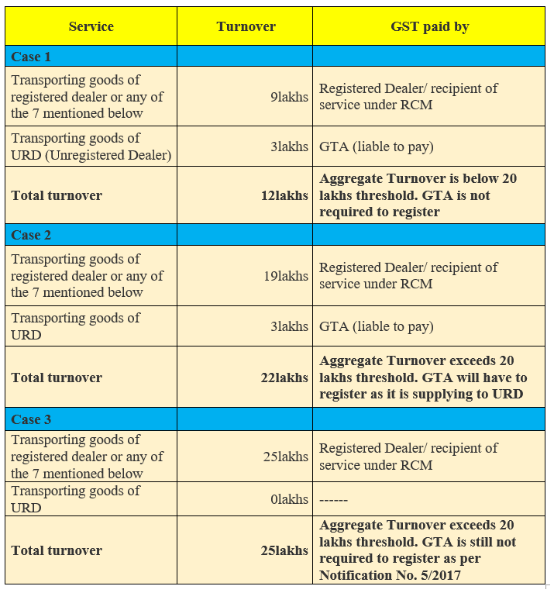

2.9 Who pays GST while hiring a GTA?
If a GTA provides the services to the certain businesses, recipient of services is required to pay GST under reverse charge.

2.10 Which businesses are liable to pay GST under reverse charge for a GTA?
The following businesses (recipient of services) is required to pay GST under reverse charge:-
- Factory registered under the Factories Act,1948;
- A society registered under the Societies Registration Act, 1860 or under any other law
- A co-operative society established under any law;
- A GST registered person
- A body corporate established by or under any law; or
- A partnership firm whether registered or not (including AOP)
- Casual taxable person

2.11 Who will pay under Reverse Charge?
As per Notification No. 13/2017- Central Tax dated 28/06/2017 the person who pays or is liable to pay freight for the transportation of goods by road in goods carriage, located in the taxable territory shall be treated as the receiver of service.
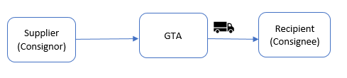
Payment is by sender
If the supplier of goods (consignor) pays the GTA, then the sender will be treated as the recipient. If he belongs to the category of persons above then he will pay GST on reverse charge basis.
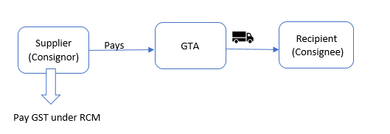

Payment by Receiver
If the liability of freight payment lies with the receiver (Consignee), then the receiver of goods will be treated as a receiver of transportation services. If he belongs to any of the above category of persons, then he will pay GST on reverse charge basis.
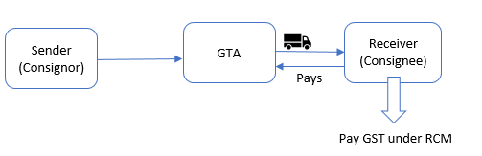

Various Scenarios to Determine Who is Liable to pay GST in case of a GTA

Service Provider | Supplier/ Consignor | Receiver of goods/ Consignee | Person paying Freight | Person liable to pay GST
GTA | A company  (Whether or not registered under GST) | Partnership Firm  (Whether or not registered under GST) | Company | Company
GTA | Partnership Firm  (Whether or not registered under GST) | Registered Dealer X | X | X
GTA | Partnership Firm  (Whether or not registered under GST) | Registered Dealer X | Firm | Firm
GTA | A Co-Op Society Ltd (Whether or not registered under GST) | Registered Dealer X | X | X
GTA | A Co-Op Society Ltd (Whether or not registered under GST) | Registered Dealer X | A Co-Op Society Ltd | A Co-Op Society Ltd
GTA | Company A Ltd.  (Whether or not registered under GST) | Company B Ltd.  (Whether or not registered under GST) | B Ltd | B Ltd
GTA | URD  A | Registered Dealer X | A | X
GTA | URD A | Registered Dealer X | X | X
GTA | URD A | URD F | F | Exempted**

** GTA services to an unregistered person is exempted as per Notification No. 32/2017- Central Tax (Rate) dated 13th October 2017

2.11 Reverse Charge if the GTA Is Unregistered
As per Notification No.8/2017-Central Tax (Rate) dated 28th June 2017, intra-state supplies of goods or services or both received by a registered person from any unregistered supplier, is exempted from GST if it does not exceed Rs. 5,000 in a day.
If the transport charges (from an unregistered GTA) are less than Rs. 5,000 per day then no GST will be payable.

Input Tax Credit

If GTA pays GST
GTA has 2 options-
12% GST with ITC *
OR
5% GST with no ITC*
However, the GTA has to opt at the beginning of financial year.
*As per Notification No. 20/2017-Central Tax (Rate) 22nd August, 2017

If Service Receiver pays GST under RCM
Service receiver can always avail ITC on GST paid under RCM.

Various Scenarios to Determine Eligibility of ITC
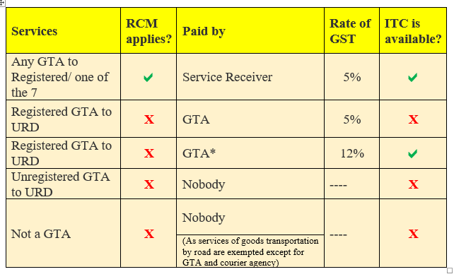
*As per Notification No. 20/2017-Central Tax (Rate) 22nd August, 2017

2.12 Invoicing for GTA
Any GST compliant invoice of a GTA must have following details-
- Name of the consignor and the consignee
- Registration number of goods carriage in which the goods are transported
- Details of goods transported
- Gross weight of the consignment
- Details of place of origin and destination
- GSTIN of the person liable for paying tax whether as consigner, consignee or goods transport agency
- Name, address and GSTIN (if applicable) of the GTA
- Tax invoice number (it must be generated consecutively and each tax invoice will have a unique number for that financial year)
- Date of issue
- Description of service
- Taxable value of supply
- Applicable rate of GST (Rates of CGST, SGST, IGST, UTGST and cess clearly mentioned)
- Amount of tax (With breakup of amounts of CGST, SGST, IGST, UTGST and cess)
- Whether GST is payable on reverse charge basis
- Signature of the supplier

2.13 Payment of Tax by a GTA
A GTA cannot enjoy any ITC on any of the inputs. So, payment of tax will be only through cash in the normal modes of card/netbanking/cash (only for taxes upto Rs.10,000).

2.14 Returns to be Filed by a GTA
If all the services of the GTA fall under RCM then a GTA is not required to register.
If a GTA registers, then it will have to file the normal 3 monthly returns – GSTR-1 (sales), GSTR-2 (purchases-no ITC available) & GSTR-3 (monthly summary & tax liability).

2.15 How to determine Place of Supply for a GTA
The place of supply of services by way of transportation of goods, including by mail or courier to––
(a) a registered person, shall be the location of such person
(b) a person other than a registered person, shall be the location at which such goods are handed over for their transportation.

Examples for determining place of supply
Rajesh is a registered dealer in Bangalore. He hires a GTA to deliver goods to Mumbai.
Place of supply will be Bangalore.
Anita is unregistered dealer in Gujarat who hires a GTA to deliver goods to Rajasthan.
Place of supply will be Gujarat where Anita hands over the goods to the transporter.
Vikas is registered in both Mumbai and Bangalore. He hires a transporter (based in Mumbai) to deliver from Bangalore to Delhi.
CGST & SGST will be applicable.
If the transporter is based in Chennai, then IGST will be applicable.

FAQs on GTA
Ajay hired a GTA to transport his goods. The consideration charged was Rs. 1,200. Will Ajay pay GST?
Ajay will not pay GST under RCM as the consideration for transportation of goods on a consignment transported in a single carriage is less than Rs. 1,500.

Vinod hired a GTA to transport goods. The GTA was asked to come 2 days as Vinod would receive the goods in batches. The entire consideration was Rs. 600. Will Vinod pay GST?
Vinod will not pay GST because the consideration charged for transportation of all such goods for a single consignee does not exceed Rs. 750.

Mr. Ajay, a working professional, is moving houses and hires XYZ GTA to transport his household items. XYZ demands Ajay to pay GST under RCM as moving charges are Rs. 6,000. Ajay is confused.
Ans: Ajay is unregistered and if XYZ GTA is also unregistered under GST then, GST is not applicable.
If XYZ is registered, then it will pay GST of 5%. RCM will not apply on Ajay.
Anand, a garments shop owner in Kolkata, hires a truck to deliver goods from wholesaler to his (Anand’s) shop. Anand’s turnover is less than 20 lakhs and he has not registered under GST. The GTA demands that Anand should pay tax under RCM. Anand argues that since he is not registered, he does not have to pay any GST.
Ans: Only the persons above (Notification No. 13/2017- Central Tax (Rate) dated 28th June, 2017) are required to pay GST under RCM. Unregistered dealers (Anand) purchasing goods/services from unregistered GTA do not have to pay GST under reverse charge mechanism. If the URD hires from a registered GTA, then the registered GTA is liable to pay GST.
So, Anand is not liable to pay GST under RCM.

Anand now purchases garments from Assam and pays for a truck to deliver the goods to his shop in Kolkata. The GTA says that Anand has to register for GST as he is making an inter-state purchase as only registered dealers can have inter-state trade.
Ans: An unregistered person can make inter-state purchases. For making inter-state sales, he will have to be compulsorily registered.
Since, Anand is an unregistered dealer and the GTA is also unregistered then the concept of RCM does not arise.

The GTA is registered at Assam and its branch is collecting cash in kolkata on his behalf. Recipient of service Anand is in kolkata. If Anand was registered, would he have charged IGST or SGST/CGST under RCM?
If the original transporter in Assam bills Anand, then IGST should be charged. If he bills the branch then SGST/CGST will apply.

Anand has received a one-time contract to sell garments to a dealer in Mumbai. Anand hires a truck to send the goods.
Since, Anand is not registered under GST, he cannot make any inter-state sale. To make an inter-state sale, he must register as a casual taxable person. Then when he hires a truck to send the garments, automatically he is liable to pay GST under RCM.

Anand is sick of all this and decides to voluntarily register. He hires a truck again to transfer goods from the wholesaler to his shop. GTA asks him to pay GST on RCM as he is registered. But Anand’s view is that his turnover is still below 20 lakhs.
Ans: The threshold of turnover does not matter if a person is voluntarily registered. All provisions of GST Act will apply to a registered person. Anand is liable to pay GST under RCM.

Anand’s turnover has increased to 45 lakhs. He wants to shift to composition scheme as he sells mainly to end consumers. But he is worried as his GTA has told him they would not deliver his goods if he is registered under composition scheme as the GTA become liable for GST.
Ans: This is a myth. Even composition dealers are liable to pay GST under RCM. Anand will pay GST on RCM if he hires a GTA whether he is registered as a composition dealer or as a normal dealer.

