E-way bill
Meaning:
E-way bill is an electronic way bill for movement of goods which can be generated on the GSTN common portal. When an E-way bill is generated, a unique E-way bill number (EBN) is allocated and is available to supplier , recipient , transporter. E-way bill also be allowed to be generated or cancelled through SMS.

Condition:
Every registered person,
Movement of goods,
Consignment value> Rs.50,000.

When should an E-way bill be generated ?
In relation to a supply; or for reasons other than supply(say a return); or due to inward supply from an unregistered person, due to Job work

When to issue E-way Bill?
Before commencement of movement of goods, Furnish information relating to the said goods in Part A of FORM GST INS-01, electronically, on the common portal.

Who should Generate an eWay Bill?
Registered Person – E-way bill must be generated when there is a movement of goods of more than Rs 50,000 in value to or from a Registered Person. A Registered person or the transporter may choose to generate and carry e-way bill even if the value of goods is less than Rs 50,000.
Unregistered Persons – Unregistered persons are also required to generate e-Way Bill. However, where a supply is made by an unregistered person to a registered person, the receiver will have to ensure all the compliances are met as if they were the supplier.

Transporter – Transporters carrying goods by road, air, rail, etc. also need to generate e-Way Bill if the supplier has not generated an e-Way Bill.

Acceptance or rejection by Recipient

Actual Acceptance
The details of e-way bill generated shall be made available to the recipient, if registered, on the common portal, who shall communicate his acceptance or rejection of the consignment covered by the e-way bill.

Deemed Acceptance
Where the recipient does not communicate his acceptance or rejection within seventy two hours of the details being made available to him on the common portal, it shall be deemed that he has accepted the said details.

List of Forms:

FORM | DISCRIPTION
FORM GST EWB-01 | E-WAY BILL FORM
FORM GST EWB-02 | Consolidated e-way bill form to be generated by transporter.
FORM GST EWB-03 | Inspection report to be filled up by proper officer.
FORM GST EWB-04 | Form to upload details by transporter, if vehicle detained for more than 30 minutes.

FORM GST EWB-01 | • Part A Details of consignment  • Part B Transporter / Conveyance Details
FORM GST EWB-03 | • Part A Summary Report  • Part B Final Report

Form GST EWB-01

Table of Distance with Period

Sr. NO. | DISTANCE | VALIDITY PERIOD
1. | Less than 100 km | One day
2. | 100 km or more but less than 300km | Three day
3. | 300 km or more but less than 500km | Five days
4. | 500 km or more but less than 1000km | Ten days
5. | 1000 km or more | Fifteen days

Summary of Eway Bill:-
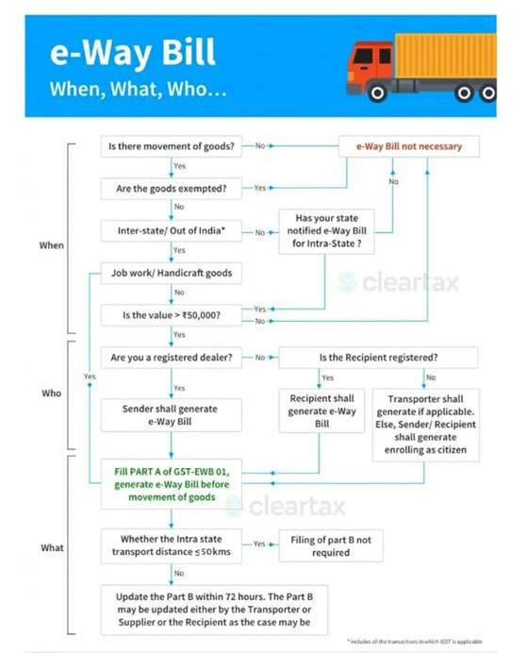

*for more details you can reach at us @ casahilthakral7@gmail.com or cathakral.com

