How to Generate E-waybill Key Number
Who need to create key number?- Consignee is required to generate waybill key number
and furnish the same to consignor or consignor’s agent. Using this key number, consignor or consignor’s agent will generate e-waybill.

For generating waybill key number, only 2 steps need to be performed as mentioned below-

Step 1: Login to respective state commercial tax website using login credentials-

Go to Google > and type “state commercial tax” as shown in the picture with red arrow-

(Put name of the state)

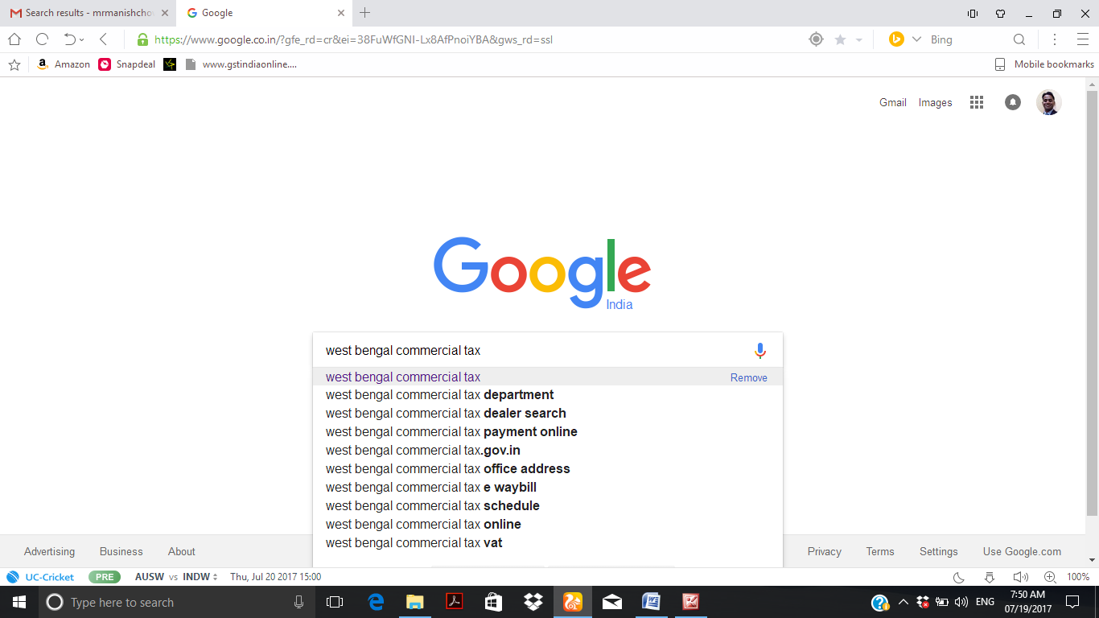

Then the following screen will come, and click on state commercial tax department website (as shown in picture with red arrow)-
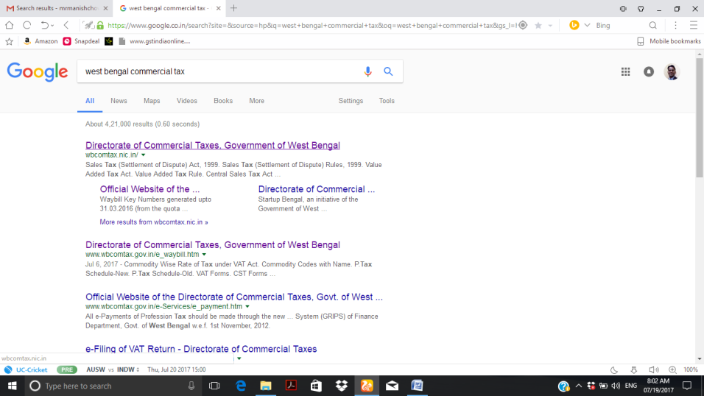

Following screen will appear, and then go to e-Services tab > Waybill > e-Waybill, as shown in the picture below with red arrow and red circle-
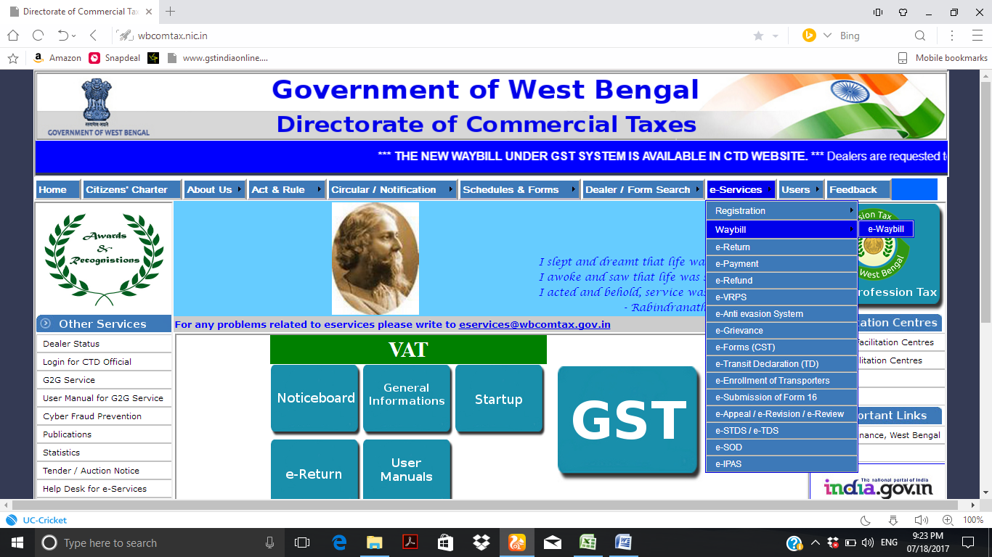

Then click on “Login for e-Waybill (Dematerialised Waybill for GST)” in the following screen as shown in the picture with red arrow-
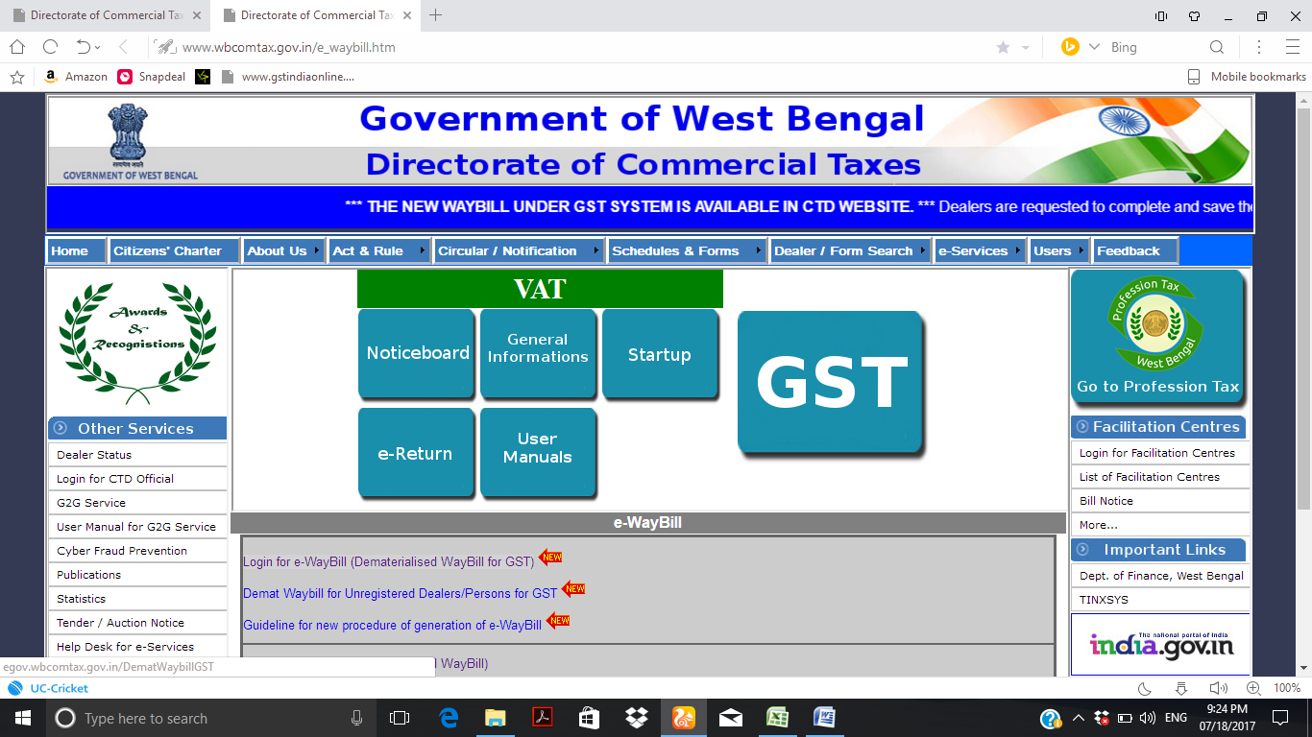

Then click on “Dematerialized Waybill- Consignee” in the following screen as shown in the picture with red arrow –
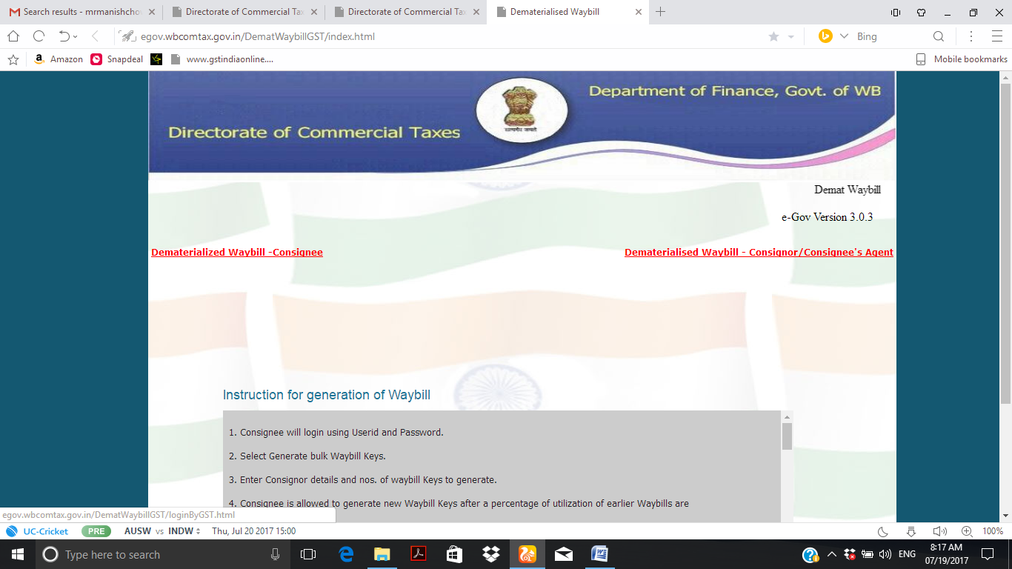

Then click on “Sign In for users having GSTIN only” in the following screen as shown in the picture with red arrow –
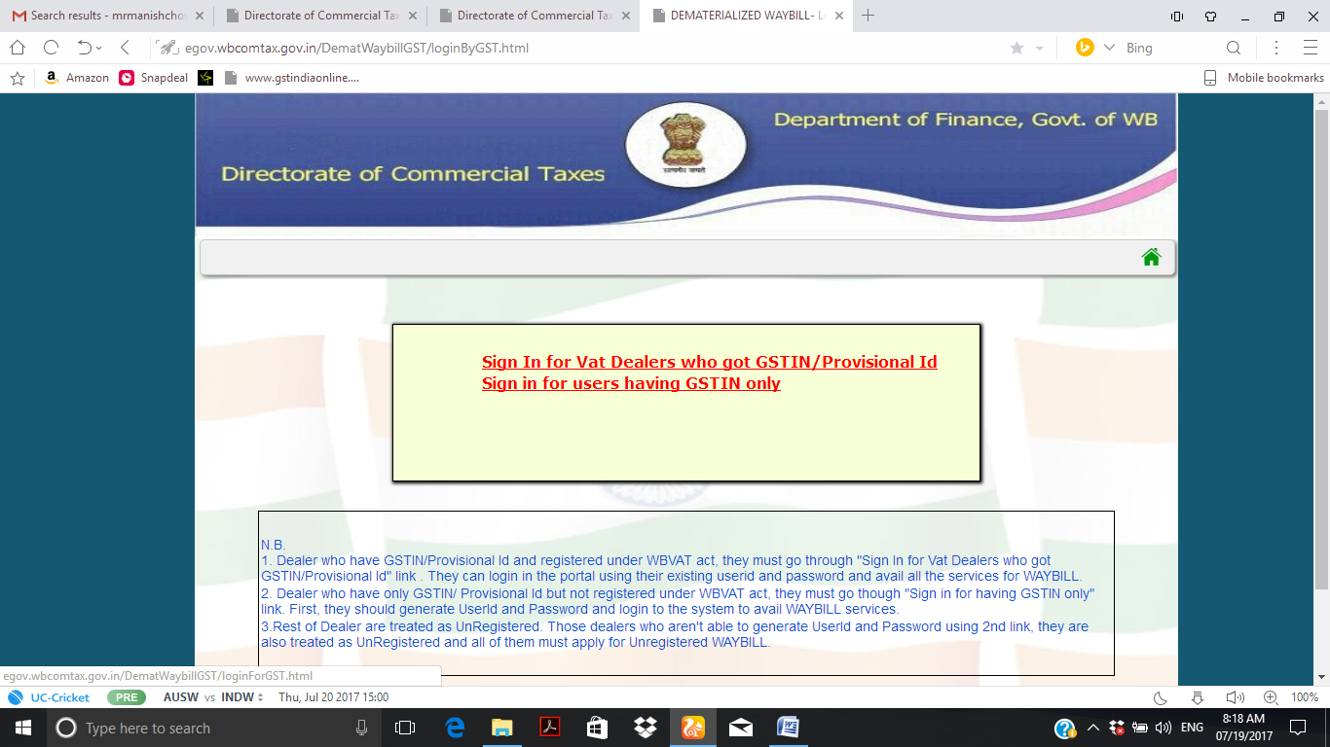

Then login page will come. Login with your login credentials as shown in the picture with red arrow –
Please note: If you are first time user, then please click on sign up button (indicated with black arrow) ,and sign up with mail id and mobile number, and set your password. Then go for login with your login credentials.
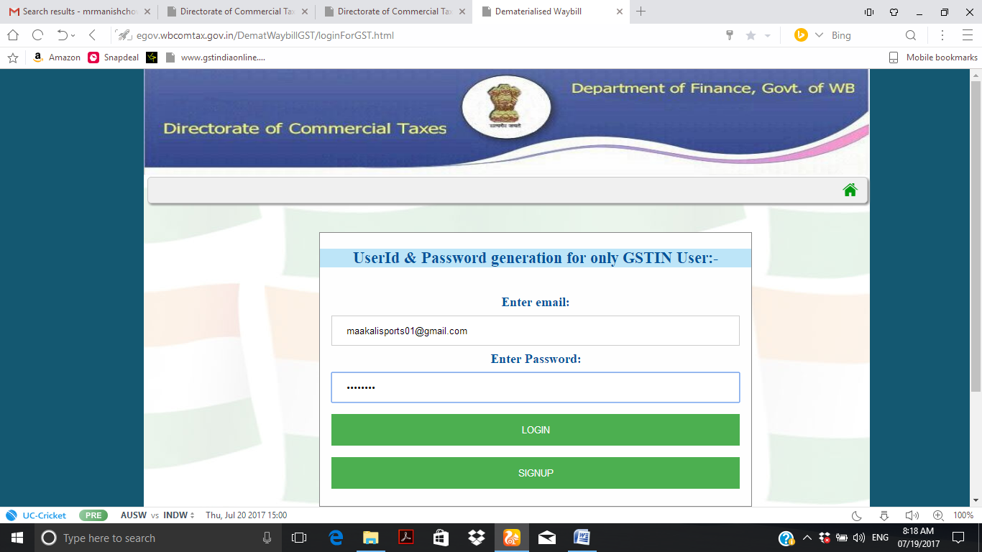

Step 2: After login, the next step is to generate the waybill key number. Once we login the following screen will come, then click on “Generate bulk Waybill Keys” as shown in picture with red arrow.
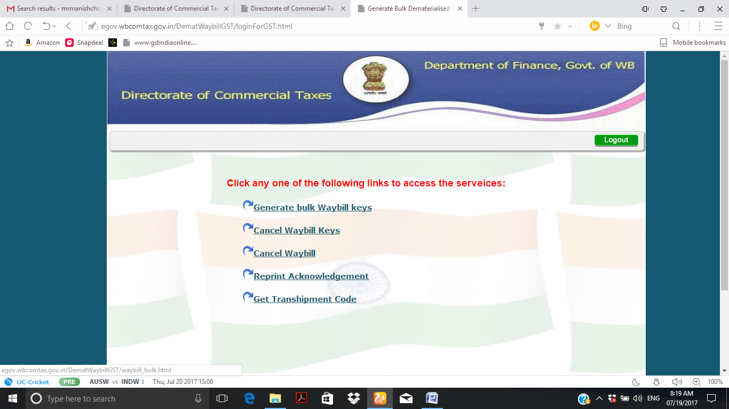

Then the following screen will come. Fill the details as shown in the picture with red circle and click on “submit” button as shown with red arrow in picture-
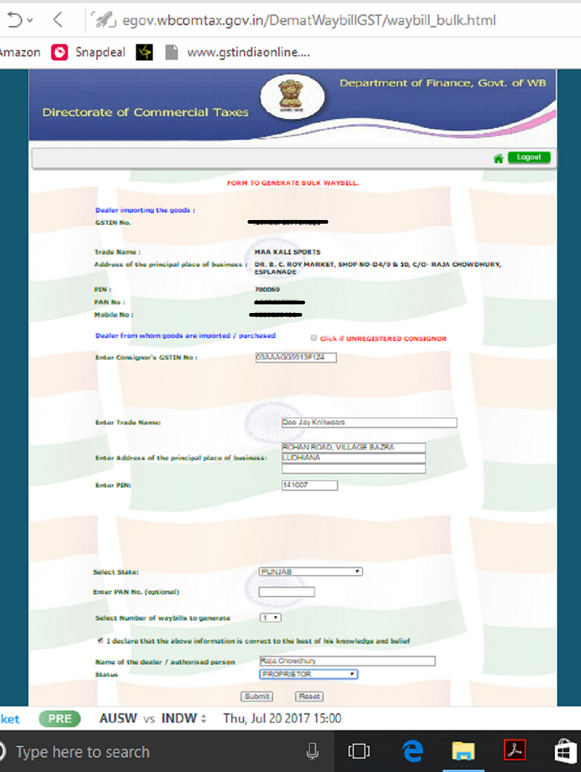
Put Consignor GSTIN No
Put Consignor Name & address.
Put Consignor State name
Put Consignee name & Designation.

The moment we click on “submit” button, the “Acknowledgement Slip” screen will come as shown in below picture.
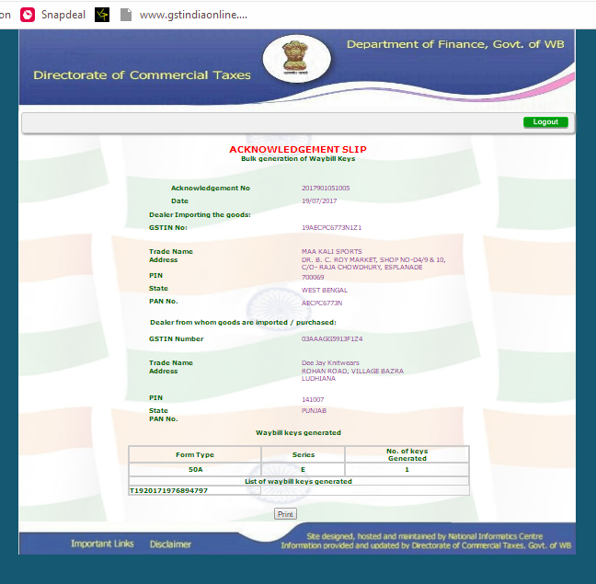
Click on “print” and save it in your device, and send to consignor through mail or whatsapp. The consignor or his agent will generate Waybill using the key number generated by you.

Thank you!

