TIME OF SUPPLY (POINT OF TAXATION) UNDER GST

It is great news for business fraternity that Upper House of parliament has passed the much awaited GOODS and SERVICE TAX. Now the dream that one India and one tax will be completed very soon. The GST regime is the biggest change in history of Indian taxation since its independence. The government is committed to provide all facilities of ease of doing business. India will be super power till 2015 and we are preparing ourselves for taking responsibility to lead the world. The new decade will be decade of India and Indian goods and services.

We have discussed of various facts and rules related to Goods and Service Tax. In this article we are going to discuss the concept of “TIME OF SUPPLY”. The time of supply or point of taxation is an important concept for deciding taxability of Goods and Services. This concept should be implemented after thorough discussion under GST.

The Discussion Paper issued by the government on GST has not cleared the status of Time of Supply, but discussed little bit. The paper explained about the “Time” at which a supply will be treated as taxable supply under Goods and Service Tax regime.

THE POINT OF TAXATION is the point in time when liability of supplier will accrue to pay GST on taxable supply of Goods and Services. This is also important for calculation of registration and turnover of entities. There may be different rules and regulations for Goods and Services. Since goods are tangible and physically removed from one place to another, but in case of services same rule cannot work.

TREATMENT FOR GOODS; general principles related to supply of Goods are;

- If there are removal of goods then time of supply is “ date of removal”;
- If there is no removal of goods, then time of supply is the “date when they are available to the person to whom they are supplied, or to any person on his behalf.”

Generally the supply of goods are accompanied by an Invoice issue by the supplier of Goods and time of supply or time of removal of goods are same as date of invoice. In some cases it may be happen that the supplier may get payment before supply of goods , they at this it is necessary to decide “time of supply” of goods. Now in these cases the time of supply will be determined by following principal, which proposes that the time of supply will be actual tax point or basic tax point, whoever is earlier. The time of supply cannot after basic tax point. There may be cases in relation to which the basic tax point will be different. These difficulties should be discussed under GST.

There are some exceptions from general principal related to time of supply of goods;

- In case of interstate or intra state supply of goods between units of same entity having different registration number, the time of supply will be the date of removal of goods.

- Since water and gas will be treated as goods under GST, then for continuous supply of these goods the suppliers are issuing successive statements for raising bill and receiving payments. The supplies will be deemed to complete on the period for which successive statement of account is expired. If they not issue successive statement, then the time of supply will be date of invoice or date of payment received, whichever earlier.

TAX POINT IN CASE OF CHANGE IN RATE OF TAX ON SUPPLY OF GOODS;
The time of supply in relation to goods are generally determined on basis of two points, i.e. date of payment or date of issue of invoice . But in case of change in rate of taxes, such principal does not apply; in such cases the time of supply will be determined on basis of time of removal or time of payment. I

- If payment was received and removal held before change in tax rates, then old rate of taxes apply;

- If any point i.e. removal or payment falls after date of change in rate of taxes, then whole supply will be taxed with new tax rates.

TREATMENT OF SERVICES; the General Principal related to Point of Taxation or Time of Supply of services are the date performance of the service. The Government has promulgated “The Point of Taxation Rules, 2011” for determination of “Time of Supply” of services under present regime of Service Tax. General principals are ;

- Date of invoice or the payment , whoever is earlier if the invoice is issued within the prescribed period of 30 days from the date of completion of the provision of service;

- The date of completion of service or date of payment , whoever is earlier , if the invoice is not issued within the prescribed period of 30 days as mentioned;

- For different situations, different point of taxation is defined under “The Point of Taxation Rules, 2011.

TIME OF SUPPLY IN CASE OF REVERSE CHARGE MACHANISM; the “ Time of supply” will be

- Date of receipt of service, or
- Date ,when payment is made, or
- Date of receipt of invoice from supplier, whichever is earlier

In case when services are performed over period of time against only one payment for all service as a whole, then the time of supply of service will be time of supply ,when all services has been provided.

TAX POINT IN CASE OF CHANGE IN RATE OF TAX ON SERVICES; GENERAL PRINCIPALS for determination of “time of supply” of services are not applicable in case of change in rate of taxes. Now let’s consider various situations

- Service provided before change in rate of tax

- If the invoice is issued and payment received before the change in rate, then the time of supply will be date of invoice or date of payment, whichever is earlier, i.e. old rate of tax will be applicable;

- If the invoice has been issued prior to change in rate of tax but the payment is received after the change, the point of taxation will be date of issue of invoice, i.e. old tax rate will be applicable in this case;

- If the payment is received before change in rate of tax but invoice is issued after the change the time of supply will be date of payment,i.e. old rate will apply;

- Services provided after change in rate of taxation

- If the payment for the invoice is made after the change in rate of tax but the invoice was issued prior to the change, then point of taxation will be date of payment, i.e. new tax will apply;

- If invoice was issued and payment was received before change in rate of taxes , the point of taxation will be date of invoice or date of payment , whichever is earlier, i.e. old rate of taxes will applied;

- If the invoice is issued after the change in taxation rates but payment is received before the change, then time of supply will be date of invoice, i.e. new rate of taxes will applied.

INTERNATIONAL PERSPECTIVES;

UNITED KINGDOM; time of supply for goods;

- When goods are removed, or
- When they are not removed , when they are made available to the recipient of the supply [Section6(2)]

For services;

- The time of supply will be ,when service are performed [ Section 6(3)]

SINGAPORE GOODS AND SERVICE TAX; time of supply of goods is; Section 11 of Goods and Service Tax Act

- If the goods are to be removed, at the time of removal;

- If the goods are not to be removed , at the time when they are made available to the person to whom they are supplied;

- If the goods ( being sent or taken on approval or sale or return or similar terms) are removed before it is known whether a supply will take place at the time when it become certain that the supply has taken place or 12 months after the removal, whichever is the earlier.

Section 12 of GST ; Relates to time of supply of services;

- Notwithstanding Sections 11, 11A and 11B, the Comptroller may, at the request of a taxable person, by direction in writing alter the time at which supplies made by the taxable person( or such supplies made by him as may be specified in the direction ) are to be treated as taking place, either-

- By directing that those supplies be treated as taking place-
- At times on dates determined by or by reference to the occurrence of some event described in the direction ; or
- At times or on dates determined by or by reference to the time when some event so described would in the ordinary course of events occur, the resulting times or dates being in every case earlier than would otherwise apply; or
- By directing that those supplies shall ( to the extent that they are not treated at taking place at the time any invoice is issued or any consideration is received in respect thereof) be treated as taking place-
- At the beginning of the relevant working period( as defined in his case in and for the purpose of direction) ; or
- At the end of the relevant working period (as so defined).

MALASIAN GOODS AND SERVICE TAX: Time of Supply;

The time of supply is important because it determines the taxable period in which the output tax should be accounted for.
The rules vary depending whether it is a supply of goods or services.
The basic time of supply for goods is :
- If the goods are to be removed/delivered, at the time of removal of goods.
- If the goods are not delivered, at the time when the goods are made available to the customers.
- If the goods are on consignment, at the time when it becomes certain that the taxable supply has taken place or 12 months after the removal, whichever is the earlier.
The basic time of supply of services is the time when the services are performed. The service is considered as performed when the work is done or completed by the supplier.
Where the tax invoice is issued or payment is received prior to the basic tax point, the date of such issue or receipt is taken as the time of supply.

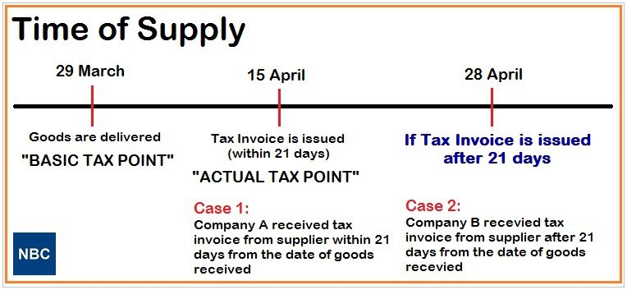

Note: we welcome step of Central Government for One India, One Tax regime and hope same will be converted into law soon.

DISCLAIMER:
This write up is the personal property of the author to this article. If this write-up is circulated, content of this disclaimer and credit to CS Deepak Pratap Singh shall be retained.
The content of this write up is purely academic and is intended to provide a general guide to the subject matter and not intended to be a professional advice and should not be relied upon for real life facts and the views are of personal opinion in nature. Specialist advice should be sought about your specific circumstances, if any.

