
Key Highlights of Union Budget 2020

Changes under GST, Customs and Excise





The Finance Minister Nirmala Sitharaman presented Union Budget 2020 in Parliament on Saturday, February 1st, 2020. She stated that the government shall work towards taking the country forward so that we can leapfrog to the next level of health, prosperity and well-being.
The budget was presented in the backdrop of two cross-cutting developments:
a) Proliferation of technologies, specially analytics, machine learning, robotics, bio-informatics and Artificial Intelligence; and
b) The number of people in the productive age group i.e. 15-65 years in India, being at its highest.
This combination is special to contemporary India. The energy, enthusiasm and the innovation of our youth are the ignition required to push forward. The Indian spirit of entrepreneurship which weathered several storms over the centuries inspires and motivates all of us alike and hence the government recognised the need to support and further energise this spirit.
This budget is woven around 3 prominent themes:
- Aspirational India in which all sections of the society seek better standards of living, with access to health, education and better jobs.
- Economic development for all, indicated in the Prime Minister’s exhortation of “SabkaSaath, SabkaVikas, SabkaVishwas". This would entail reforms across swathes of the economy. Simultaneously, it would mean yielding more space for the private sector. Together, they would ensure higher productivity and greater efficiency.
- Ours shall be a Caring Society that is both humane and compassionate. Antyodaya is an article of faith.
The aim towards this budget has been to lift up the dampened spirits of the Indian economy and to provide a stimulus towards growth whilst recovering from the current slowdown faced by businesses.

GST
Amendments carried out through the Finance Bill, 2020 will come into effect on the date of its enactment (unless otherwise specified), concurrently with the corresponding amendments to the Acts passed by the States & Union territories with legislature.
Proposed Amendments in the CGST Act, 2017
Current provisions | Proposed provisions | Effect
Section 2(114) – Definition of Union Territory
“Union territory” means the territory of-  ……..  (c) Dadra and Nagar Haveli and Daman and Diu; | “Union territory” means the territory of-  ……..  (c) Dadra and Nagar Haveli and Daman and Diu;  (d) Ladakh | Seeks to align the definition of “Union territory” in line with the Jammu and Kashmir Reorganisation Act, 2019 and the Dadra and Nagar Haveli and Daman and Diu (Merger of Union Territories), Act, 2019
Section 10(2) – Composition Scheme
Clause (b), (c) and (d):  (2) The registered person shall be eligible to opt under sub-section (1), if––  ….....  (b) he is not engaged in making any supply of goods which are not leviable to tax under this Act;  (c) he is not engaged in making any inter-State outward supplies of goods;  (d) he is not engaged in making any supply of goods through an electronic commerce operator who is required to collect tax at source under section 52……. | Clause (b), (c) and (d):  The registered person shall be eligible to opt under sub-section (1), if––  …....  (b) he is not engaged in making any supply of goods or services which are not leviable to tax under this Act;  (c) he is not engaged in making any inter-State outward supplies of goods or services;  (d) he is not engaged in making any supply of goods or services through an electronic commerce operator who is required to collect tax at source under section 52……. | Seeks to harmonise the conditions for eligibility for opting to pay tax under Composition Scheme as sub-section (1) and sub-section (2A) of Section 10 of the CGST Act.
Section 16(4) – Time period for availing Input Tax Credit (ITC)
A registered person shall not be entitled to take input tax credit in respect of any invoice or debit note for supply of goods or services or both after the due date of furnishing of the return under section 39 for the month of September following the end of financial year to which such invoice or invoice relating to such debit note pertains or furnishing of the relevant annual return, whichever is earlier. | A registered person shall not be entitled to take input tax credit in respect of any invoice or debit note for supply of goods or services or both after the due date of furnishing of the return under section 39 for the month of September following the end of financial year to which such invoice or invoice relating to such debit note pertains or furnishing of the relevant annual return, whichever is earlier. | Seeks to delink the date of issuance of debit note from the date of issuance of the underlying invoice for purposes of availing ITC.
Section 29(1)(c) – Cancellation of registration by proper officer
(1) The proper officer may, either on his own motion or on an application filed by the registered person or by his legal heirs, in case of death of such person, cancel the registration, in such manner and within such period as may be prescribed, having regard to the circumstances where,––  ………  (c) the taxable person, other than the person registered under sub-section (3) of section 25, is no longer liable to be registered under section 22 or section 24. | (1) The proper officer may, either on his own motion or on an application filed by the registered person or by his legal heirs, in case of death of such person, cancel the registration, in such manner and within such period as may be prescribed, having regard to the circumstances where,––  ………  (c) the taxable person, other than the person registered under sub-section (3) of section 25, is no longer liable to be registered under section 22 or section 24 or intends to opt out of the registration voluntarily made under sub-section (3) of section 25. | Seeks to amend clause (c) so as to provide for cancellation of registration obtained voluntarily under sub-section (3) of Section 25.
Proviso to Section 30(1) – Revocation of Cancellation of Registration
Subject to such conditions as may be prescribed, any registered person, whose registration is cancelled by the proper officer on his own motion, may apply to such officer for revocation of cancellation of the registration in the prescribed manner within thirty days from the date of service of the cancellation order. | Subject to such conditions as may be prescribed, any registered person, whose registration is cancelled by the proper officer on his own motion, may apply to such officer for revocation of cancellation of the registration in the prescribed manner within thirty days from the date of service of the cancellation order.  Provided that such period may, on sufficient cause being shown, and for reasons to be recorded in writing, be extended,––  (a) by the Additional Commissioner or the Joint Commissioner, as the case may be, for a period not exceeding thirty days;  (b) by the Commissioner, for a further period not exceeding thirty days, beyond the period specified in clause (a) | Inserting new proviso to empower the jurisdictional tax authorities to extend the period provided to file an application for revocation of cancellation of registration.
Proviso to Section 31(2) – Time period for issuing Tax Invoice
A registered person supplying taxable services shall, before or after the provision of service but within a prescribed period, issue a tax invoice, showing the description, value, tax charged thereon and such other particulars as may be prescribed:  Provided that the Government may, on the recommendations of the Council, by notification and subject to such conditions as may be mentioned therein, specify the categories of services in respect of which––  (a) any other document issued in relation to the supply shall be deemed to be a tax invoice; or  (b) tax invoice may not be issued. | A registered person supplying taxable services shall, before or after the provision of service but within a prescribed period, issue a tax invoice, showing the description, value, tax charged thereon and such other particulars as may be prescribed:  Provided that the Government may, on the recommendations of the Council, by notification and subject to such conditions as may be mentioned therein, specify the categories of services in respect of which––  (a) specify the categories of services or supplies in respect of which a tax invoice shall be issued, within such time and in such manner as may be prescribed;  (b) subject to the condition mentioned therein, specify the categories of services in respect of which––  (i) any other document issued in relation to the supply shall be deemed to be a tax invoice; or  (ii) tax invoice may not be issued. | Seeks to empower the Government to notify the categories of services or supplies in respect of which tax invoice or any other document shall be issued and to make rules regarding the time and manner of its issuance.
Section 51 – Tax Deduction at Source
Section 51(3):  The deductor shall furnish to the deductee a certificate mentioning therein the contract value, rate of deduction, amount deducted, amount paid to the Government and such other particulars in such manner as may be prescribed. | Section 51(3):  A certificate of tax deduction at source shall be issued in such form and in such manner as may be prescribed. | Seeks to empower the Government to make rules to provide for the form and manner in which a certificate of tax deduction at source shall be issued.
Section 51(4):  If any deductor fails to furnish to the deductee the certificate, after deducting the tax at source, within five days of crediting the amount so deducted to the Government, the deductor shall pay, by way of a late fee, a sum of one hundred rupees per day from the day after the expiry of such five days period until the failure is rectified, subject to a maximum amount of five thousand rupees. | Section 51(4):  If any deductor fails to furnish to the deductee the certificate, after deducting the tax at source, within five days of crediting the amount so deducted to the Government, the deductor shall pay, by way of a late fee, a sum of one hundred rupees per day from the day after the expiry of such five days period until the failure is rectified, subject to a maximum amount of five thousand rupees. | Seeks to omit provisions w.r.t. late fee for failure to furnish TDS certificate within 5 days.
Section 109(6) – Constitution of Appellate Tribunal and Benches Thereof
The Government shall, by notification, specify for each State or Union territory except for the State of Jammu and Kashmir, a Bench of the Appellate Tribunal (hereafter in this Chapter, referred to as “State Bench”) for exercising the powers of the Appellate Tribunal within the concerned State or Union territory:  Provided that for the State of Jammu and Kashmir, the State Bench of the Goods and Services Tax Appellate Tribunal constituted under this Act shall be the State Appellate Tribunal constituted under the Jammu and Kashmir Goods and Services Tax Act, 2017:  Provided further that the Government shall, on receipt of a request from any State Government, constitute such number of Area Benches in that State, as may be recommended by the Council:……. | The Government shall, by notification, specify for each State or Union territory except for the State of Jammu and Kashmir, a Bench of the Appellate Tribunal (hereafter in this Chapter, referred to as “State Bench”) for exercising the powers of the Appellate Tribunal within the concerned State or Union territory:  Provided that for the State of Jammu and Kashmir, the State Bench of the Goods and Services Tax Appellate Tribunal constituted under this Act shall be the State Appellate Tribunal constituted under the Jammu and Kashmir Goods and Services Tax Act, 2017:  Provided further that the Government shall, on receipt of a request from any State Government, constitute such number of Area Benches in that State, as may be recommended by the Council:……. | Seeks to make the provisions for Appellate Tribunal and its benches thereof applicable in the Union territories of Jammu & Kashmir and Ladakh.
Section 122 – Penalty for Certain Offences
After Sub-Section 1: | After Sub-Section 1:  (1A) Any person who retains the benefit of a transaction covered under clauses (i), (ii), (vii) or clause (ix) of sub-section (1) and at whose instance such transaction is conducted, shall be liable to a penalty of an amount equivalent to the tax evaded or input tax credit availed of or passed on. | Seeks to insert a new sub-section (1A) so as to make the beneficiary of certain transactions at whose instance such transactions are conducted liable for penalty.
Section 132(1) – Punishment for Certain Offences
(1) Whoever commits any of the following offences, namely:-  a) supplies any goods or services or both without issue of any invoice, in violation of the provisions of this Act or the rules made thereunder, with the intention to evade tax;  (b) issues any invoice or bill without supply of goods or services or both in violation of the provisions of this Act, or the rules made thereunder leading to wrongful availment or utilisation of input tax credit or refund of tax;  (c) avails input tax credit using such invoice or bill referred to in clause (b);  (d) collects any amount as tax but fails to pay the same to the Government beyond a period of three months from the date on which such payment becomes due;  (e) evades tax, fraudulently avails input tax credit or fraudulently obtains refund and where such offence is not covered under clauses (a) to (d); | (1) Whoever commits, or causes to commit and retain the benefits arising out of, any of the following offences  a) supplies any goods or services or both without issue of any invoice, in violation of the provisions of this Act or the rules made thereunder, with the intention to evade tax;  (b) issues any invoice or bill without supply of goods or services or both in violation of the provisions of this Act, or the rules made thereunder leading to wrongful availment or utilisation of input tax credit or refund of tax;  (c) avails input tax credit using the invoice or bill referred to in clause (b) or fraudulently avails input tax credit without any invoice or bill  (d) collects any amount as tax but fails to pay the same to the Government beyond a period of three months from the date on which such payment becomes due;  (e) evades tax, fraudulently avails input tax credit or fraudulently obtains refund and where such offence is not covered under clauses (a) to (d); | Seeks to amend Section 132 so as to make the offence of fraudulent availment of ITC without invoice or bill cognizable and non-bailable under sub-section (1) of Section 69 and to make any person who retains the benefit of certain transactions and at whose instance such transactions are conducted liable for punishment.
Section 140 – Transitional Arrangements for ITC
Sub-Section (1):  A registered person, other than a person opting to pay tax under section 10, shall be entitled to take, in his electronic credit ledger, the amount of CENVAT credit of eligible duties carried forward in the return relating to the period ending with the day immediately preceding the appointed day, furnished by him under the existing law in such manner as may be prescribed:  ………. | Sub-Section (1):  A registered person, other than a person opting to pay tax under section 10, shall be entitled to take, in his electronic credit ledger, the amount of CENVAT credit of eligible duties carried forward in the return relating to the period ending with the day immediately preceding the appointed day, furnished by him under the existing law within such time and in such manner as may be prescribed:  ………….. | Seeks to amend Section 140 relating to transitional arrangements for ITC, so as to prescribe the time limit and the manner for availing ITC against certain unavailed credit under the existing law.  This amendment shall take effect retrospectively from July 1, 2017.
Sub-Section (2):  A registered person, other than a person opting to pay tax under section 10, shall be entitled to take, in his electronic credit ledger, credit of the unavailed CENVAT credit in respect of capital goods, not carried forward in a return, furnished under the existing law by him, for the period ending with the day immediately preceding the appointed day in such manner as may be prescribed:  ………….. | Sub-Section (2):  A registered person, other than a person opting to pay tax under section 10, shall be entitled to take, in his electronic credit ledger, credit of the unavailed CENVAT credit in respect of capital goods, not carried forward in a return, furnished under the existing law by him, for the period ending with the day immediately preceding the appointed day within such time and in such manner as may be prescribed:  .............
Sub-Section (3):  A registered person, who was not liable to be registered under the existing law, or who was engaged in the manufacture of exempted goods or provision of exempted services, or who was providing works contract service and was availing of the benefit of notification No. 26/2012-Service Tax, dated the 20th June, 2012 or a first stage dealer or a second stage dealer or a registered importer or a depot of a manufacturer, shall be entitled to take, in his electronic credit ledger, credit of eligible duties in respect of inputs held in stock and inputs contained in semi-finished or finished goods held in stock on the appointed day subject to the following conditions, namely:––  .......... | Sub-Section (3):  A registered person, who was not liable to be registered under the existing law, or who was engaged in the manufacture of exempted goods or provision of exempted services, or who was providing works contract service and was availing of the benefit of notification No. 26/2012-Service Tax, dated the 20th June, 2012 or a first stage dealer or a second stage dealer or a registered importer or a depot of a manufacturer, shall be entitled to take, in his electronic credit ledger, credit of eligible duties in respect of inputs held in stock and inputs contained in semi-finished or finished goods held in stock on the appointed day, within such time and in such manner as may be prescribed, subject to the following conditions, namely:––  ........
Sub-Section (5):  A registered person shall be entitled to take, in his electronic credit ledger, credit of eligible duties and taxes in respect of inputs or input services received on or after the appointed day but the duty or tax in respect of which has been paid by the supplier under the existing law, subject to the condition that the invoice or any other duty or tax paying document of the same was recorded in the books of account of such person within a period of thirty days from the appointed day:  ………. | Sub-Section (5):  A registered person shall be entitled to take, in his electronic credit ledger, credit of eligible duties and taxes in respect of inputs or input services received on or after the appointed day but the duty or tax in respect of which has been paid by the supplier under the existing law, within such time and in such manner as may be prescribed, subject to the condition that the invoice or any other duty or tax paying document of the same was recorded in the books of account of such person within a period of thirty days from the appointed day:  ...........
Sub-Section (6):  A registered person, who was either paying tax at a fixed rate or paying a fixed amount in lieu of the tax payable under the existing law shall be entitled to take, in his electronic credit ledger, credit of eligible duties in respect of inputs held in stock and inputs contained in semi-finished or finished goods held in stock on the appointed day subject to the following conditions, namely:––  ………. | Sub-Section (6):  A registered person, who was either paying tax at a fixed rate or paying a fixed amount in lieu of the tax payable under the existing law shall be entitled to take, in his electronic credit ledger, credit of eligible duties in respect of inputs held in stock and inputs contained in semi-finished or finished goods held in stock on the appointed day, within such time and in such manner as may be prescribed, subject to the following conditions, namely:––  .........
Sub-Section (7):  Notwithstanding anything to the contrary contained in this Act, the input tax credit on account of any services received prior to the appointed day by an Input Service Distributor shall be eligible for distribution as credit under this Act even if the invoices relating to such services are received on or after the appointed day. | Sub-Section (7):  Notwithstanding anything to the contrary contained in this Act, the input tax credit on account of any services received prior to the appointed day by an Input Service Distributor shall be eligible for distribution as credit under this Act, within such time and in such manner as may be prescribed, even if the invoices relating to such services are received on or after the appointed day.
Sub-Section (8):  Where a registered person having centralised registration under the existing law has obtained a registration under this Act, such person shall be allowed to take, in his electronic credit ledger, credit of the amount of CENVAT credit carried forward in a return, furnished under the existing law by him, in respect of the period ending with the day immediately preceding the appointed day in such manner as may be prescribed:  ……… | Sub-Section (8):  Where a registered person having centralised registration under the existing law has obtained a registration under this Act, such person shall be allowed to take, in his electronic credit ledger, credit of the amount of CENVAT credit carried forward in a return, furnished under the existing law by him, in respect of the period ending with the day immediately preceding the appointed day within such time and in such manner as may be prescribed:  .........
Sub-Section (9):  Where any CENVAT credit availed for the input services provided under the existing law has been reversed due to non-payment of the consideration within a period of three months, such credit can be reclaimed subject to the condition that the registered person has made the payment of the consideration for that supply of services within a period of three months from the appointed day. | Sub-Section (9):  Where any CENVAT credit availed for the input services provided under the existing law has been reversed due to non-payment of the consideration within a period of three months, such credit can be reclaimed within such time and in such manner as may be prescribed, subject to the condition that the registered person has made the payment of the consideration for that supply of services within a period of three months from the appointed day.
Section 168(2) – Power to Issue Instructions or Directions
The Commissioner specified in clause (91) of section 2, sub-section (3) of section 5, clause (b) of sub-section (9) of section 25, sub-sections (3) and (4) of section 35, sub-section (1) of section 37, sub-section (2) of section 38, sub-section (6) of section 39, sub-section (1) of section 44, sub-sections (4) and (5) of section 52, sub-section (5) of section 66, sub-section (1) of section 143, sub-section (1) of section 151, clause (l) of sub-section (3) of section 158 and section 167 shall mean a Commissioner or Joint Secretary posted in the Board and such Commissioner or Joint Secretary shall exercise the powers specified in the said sections with the approval of the Board. | The Commissioner specified in clause (91) of section 2, sub-section (3) of section 5, clause (b) of sub-section (9) of section 25, sub-sections (3) and (4) of section 35, sub-section (1) of section 37, sub-section (2) of section 38, sub-section (6) of section 39, sub-section (1) of section 44, sub-sections (4) and (5) of section 52, sub-section (5) of section 66, sub-section (1) of section 143, except the second proviso thereof, sub-section (1) of section 151, clause (l) of sub-section (3) of section 158 and section 167 shall mean a Commissioner or Joint Secretary posted in the Board and such Commissioner or Joint Secretary shall exercise the powers specified in the said sections with the approval of the Board. | Seeks to make provisions for enabling the jurisdictional Commissioners to exercise powers under sub-section (5) of Section 66 and also under second proviso to sub-section (1) of Section 143.  Section 66(5): Special Audit  The expenses of the examination and audit of records under sub-section (1), including the remuneration of such chartered accountant or cost accountant, shall be determined and paid by the Commissioner and such determination shall be final.  Second proviso to sub-section (1) of Section 143: Job work procedure  Provided further that the period of one year and three years may, on sufficient cause being shown, be extended by the Commissioner for a further period not exceeding one year and two years respectively
Section 172(1) – Removal of Difficulties
If any difficulty arises in giving effect to any provisions of this Act, the Government may, on the recommendations of the Council, by a general or a special order published in the Official Gazette, make such provisions not inconsistent with the provisions of this Act or the rules or regulations made thereunder, as may be necessary or expedient for the purpose of removing the said difficulty:  Provided that no such order shall be made after the expiry of a period of three years from the date of commencement of this Act. | If any difficulty arises in giving effect to any provisions of this Act, the Government may, on the recommendations of the Council, by a general or a special order published in the Official Gazette, make such provisions not inconsistent with the provisions of this Act or the rules or regulations made thereunder, as may be necessary or expedient for the purpose of removing the said difficulty:  Provided that no such order shall be made after the expiry of a period of three years five years from the date of commencement of this Act. | Seeks to extend the time limit provided for removal of difficulties thereunder from three years to five years, with effect from the date of commencement of the said Act.
Schedule II – Activities or Transactions to be Treated as Supply of Goods or Supply of Services
Paragraph 4:  Transfer of business assets  (a) where goods forming part of the assets of a business are transferred or disposed of by or under the directions of the person carrying on the business so as no longer to form part of those assets, whether or not for a consideration, such transfer or disposal is a supply of goods by the person;  (b) where, by or under the direction of a person carrying on a business, goods held or used for the purposes of the business are put to any private use or are used, or made available to any person for use, for any purpose other than a purpose of the business, whether or not for a consideration, the usage or making available of such goods is a supply of services;  ………. | Paragraph 4:  Transfer of business assets  (a) where goods forming part of the assets of a business are transferred or disposed of by or under the directions of the person carrying on the business so as no longer to form part of those assets, whether or not for a consideration, such transfer or disposal is a supply of goods by the person;  (b) where, by or under the direction of a person carrying on a business, goods held or used for the purposes of the business are put to any private use or are used, or made available to any person for use, for any purpose other than a purpose of the business, whether or not for a consideration, the usage or making available of such goods is a supply of services;  .......... | Seeks to omit the words “whether or not for consideration” so as to give clarity to the meaning of the entries (a) and (b) of said paragraph, while aligning the same with Section 7(1) and Schedule I (supply without consideration) of the CGST Act.  This amendment shall take effect retrospectively from July 1, 2017.
Retrospective exemption from, or levy or collection of, CGST in certain cases
Relevant clause of the Finance Bill, 2020 | Effect
Clause 130 | Clause 130 of the Bill seeks to provide retrospective exemption from CGST on supply of fishmeal, during the period from July 1, 2017 up to September 30, 2019 (both days inclusive).  It further seeks to retrospectively levy CGST at the reduced rate of 6% on supply of pulley, wheels and other parts (falling under heading 8483) and used as parts of agricultural machinery of headings 8432, 8433 and 8436 during the period from the July 1, 2017 up to December 31, 2018 (both days inclusive).  It also seeks to provide that no refund shall be made of the tax which has already been collected.
Clause 131 | The refund of accumulated credit of compensation cess on tobacco products arising out of inverted duty structure in Compensation Cess is disallowed w.e.f October 1, 2019 vide Notification No. 31/2019- Compensation Cess (Rate) dated September 30, 2019.  Clause 131 of the Bill seeks to give retrospective effect to the above notification w.e.f. July 1, 2017 onwards. Accordingly, no refund on account of inverted duty structure would be admissible on any tobacco products.

Proposed Amendments in the IGST Act, 2017
Current provisions | Proposed provisions | Effect
Section 25(1)- Removal of difficulties
(1) If any difficulty arises in giving effect to any provision of this Act, the Government may, on the recommendations of the Council, by a general or a special order published in the Official Gazette, make such provisions not inconsistent with the provisions of this Act or the rules or regulations made thereunder, as may be necessary or expedient for the purpose of removing the said difficulty:  Provided that no such order shall be made after the expiry of a period of three years from the date of commencement of this Act | (1) If any difficulty arises in giving effect to any provision of this Act, the Government may, on the recommendations of the Council, by a general or a special order published in the Official Gazette, make such provisions not inconsistent with the provisions of this Act or the rules or regulations made thereunder, as may be necessary or expedient for the purpose of removing the said difficulty:  Provided that no such order shall be made after the expiry of a period of three years five years from the date of commencement of this Act. | Seeks to extend the time limit provided for removal of difficulties from three years to five years with effect from the date of commencement of the said Act.
Retrospective exemption from, or levy or collection of, IGST in certain cases
Relevant clause of the Finance Bill, 2020 | Effect
Clause 133 | Clause 133 of the Bill seeks to provide retrospective exemption from IGST on supply of fishmeal, during the period from July 1, 2017 up to September 30, 2019 (both days inclusive).  It further seeks to retrospectively levy IGST at the reduced rate of 12% on supply of pulley, wheels and other parts (falling under heading 8483) and used as parts of agricultural machinery of headings 8432, 8433 and 8436, during the period from July 1, 2017 up to December 31, 2018 (both days inclusive).  It also seeks to provide that no refund shall be made of the tax which has already been collected.

Proposed Amendments in the UTGST Act, 2017
Current provisions | Proposed provisions | Effect
Section 1(2)- Short title, extent and commencement
(2) It extends to the Union territories of the Andaman and Nicobar Islands, Lakshadweep, Dadra and Nagar Haveli, Daman and Diu, Chandigarh and other territory. | (2) It extends to the Union territories of the Andaman and Nicobar Islands, Lakshadweep, Dadra and Nagar Haveli and Daman and Diu, Ladakh, Chandigarh and other territory. | Seeks to give effect to the change in the status of Union territory of Dadra and Nagar Haveli and Union territory of Daman and Diu to make UTGST Act, 2017 applicable to the Union territory of Ladakh.
Section 2(8) - Definitions
‘‘Union territory’’ means the territory of,-  …….  (iii) Dadra and Nagar Haveli  (iv) Daman and Diu | ‘‘Union territory’’ means the territory of,-  …….  (iii) Dadra and Nagar Haveli and Daman and Diu  (iv) Ladakh | Seeks to align the definition of “Union Territory” in line with the Jammu and Kashmir Reorganisation Act, 2019 and Dadar and Nagar Haveli and Daman and Diu (Merger of Union Territories) Act, 2019.
Section 26(1)- Removal of Difficulties
(1) If any difficulty arises in giving effect to any provision of this Act, the Central Government may, on the recommendations of the Council, by a general or a special order published in the Official Gazette, make such provisions not inconsistent with the provisions of this Act or the rules or regulations made thereunder, as may be necessary or expedient for the purpose of removing the said difficulty:  Provided that no such order shall be made after the expiry of a period of three years from the date of commencement of this Act. | (1) If any difficulty arises in giving effect to any provision of this Act, the Central Government may, on the recommendations of the Council, by a general or a special order published in the Official Gazette, make such provisions not inconsistent with the provisions of this Act or the rules or regulations made thereunder, as may be necessary or expedient for the purpose of removing the said difficulty:  Provided that no such order shall be made after the expiry of a period of three years five years from the date of commencement of this Act. | Seeks to extend the time limit provided for removal of difficulties from three years to five years.
Retrospective exemption from, or levy or collection of, UTGST in certain cases
Relevant clause of the Finance Bill, 2020 | Effect
Clause 137 | Clause 137 of the Bill seeks to provide retrospective exemption from UTGST on supply of fishmeal, during the period from July 1, 2017 up to September 30, 2019 (both days inclusive).  It further seeks to retrospectively levy UTGST at the reduced rate of 6% on supply of pulley, wheels and other parts (falling under heading 8483) and used as parts of agricultural machinery of headings 8432, 8433 and 8436, during the period from July 1, 2017 up to December 31, 2018 (both days inclusive).  It also seeks to provide that no refund shall be made of the tax which has already been collected.

Proposed Amendments in the GST (Compensation to States) Act, 2017
Current provisions | Proposed provisions | Effect
Section 14(1)- Power to remove difficulties
(1) If any difficulty arises in giving effect to the provisions of this Act, the Central Government may, on the recommendations of the Council, by order published in the Official Gazette, make such provisions, not inconsistent with the provisions of this Act, as appear to it to be necessary or expedient for removing the difficulty:  Provided that no order shall be made under this section after the expiry of three years from the commencement of this Act. | (1) If any difficulty arises in giving effect to the provisions of this Act, the Central Government may, on the recommendations of the Council, by order published in the Official Gazette, make such provisions, not inconsistent with the provisions of this Act, as appear to it to be necessary or expedient for removing the difficulty:  Provided that no order shall be made under this section after the expiry of three years five years from the commencement of this Act. | Seeks to extend the time limit provided for removal of difficulties from three years to five years with effect from the date of commencement of the said Act.

[This space has been intentionally left blank]

CUSTOMS
Unless otherwise stated, all changes in rate of Customs duty take effect from the midnight of 1st February/2nd February, 2020. A declaration has been made under the Provisional Collection of Taxes Act, 1931 in respect of clauses 115(a), 115(b) [Amendment of First Schedule to the Customs Tariff Act], 139 [Health Cess] and 145 [Amendment in levy of NCCD] of the Finance Bill, 2020 so that changes proposed therein takes effect from the midnight of 1st February/2nd February, 2020. The remaining legislative changes would come into effect only upon the enactment of the Finance Bill, 2020.
Proposed Amendments in the Customs Act, 1962
Current provisions | Proposed provisions | Effect
Section – 11 (Power to prohibit importation or exportation of goods)
(2) The purposes referred to in sub-section (1) are the following: -  ……………  (f) the prevention of injury to the economy of the country by the uncontrolled import or export of gold or silver. | (2) The purposes referred to in sub-section (1) are the following: -  …………  (f) the prevention of injury to the economy of the country by the uncontrolled import or export of gold or silver or any other goods. | Seeks to include any other goods along with gold or silver to enable the Central Government to prohibit either absolutely or conditionally the import or export of such goods to prevent injury to the economy on account of uncontrolled import or export of such goods.
Section - 28 (Recovery of duties not levied or not paid or short-levied or short-paid or erroneously refunded)
Explanation 4.- For the removal of doubts, it is hereby declared that in cases where notice has been issued for non-levy, not paid, short-levy or short-paid or erroneous refund after the 14th day of May, 2015, but before the date on which the Finance Bill, 2018 receives the assent of the President, they shall continue to be governed by the provisions of section 28 as it stood immediately before the date on which such assent is received. | “Explanation 4.—For the removal of doubts, it is hereby declared that notwithstanding anything to the contrary contained in any judgment, decree or order of the Appellate Tribunal or any Court or in any other provision of this Act or the rules or regulations made thereunder, or in any other law for the time being in force, in cases where notice has been issued for non-levy, short-levy, non-payment, short-payment or erroneous refund, prior to the 29th day of March, 2018, being the date of commencement of the Finance Act, 2018, such notice shall continue to be governed by the provisions of section 28 as it stood immediately before such date.” | An explanation is being substituted to explicitly clarify that any notice issued under the said section, prior to enactment of the Finance Act, 2018, shall continue to be governed by Section 28, as it existed before the said enactment, notwithstanding order of the Appellate Tribunal, Court or any other provisions of the Customs Act or rules made thereunder or any other law to the contrary.  This amendment shall come into effect retrospectively from March 29, 2018, i.e. the date of commencement of the Finance Act, 2018.
Section - 28AAA (Recovery of duties in certain cases)
(1) Where an instrument issued to a person has been obtained by him by means of-  (a) collusion; or  (b) wilful misstatement; or  (c) suppression of facts,  for the purposes of this Act or the Foreign Trade (Development and Regulation) Act, 1992, Act of 22 of 1992, by such person or his agent or employee and such instrument is utilised under the provisions of this Act or the rules made or notifications issued thereunder, by a person other than the person to whom the instrument was issued, the duty relatable to such utilisation of instrument shall be deemed never to have been exempted or debited and such duty shall be recovered from the person to whom the said instrument was issued:  Provided that the action relating to recovery of duty under this section against the person to whom the instrument was issued shall be without prejudice to an action against the importer under section 28.  Explanation 1.- For the purposes of this sub-section, "instrument" means any scrip or authorisation or licence or certificate or such other document, by whatever name called, issued under the Foreign Trade (Development and Regulation) Act, 1992, (22 of 1992) with respect to a reward or incentive scheme or duty exemption scheme or duty remission scheme or such other scheme bestowing financial or fiscal benefits, which may be utilised under the provisions of this Act or the rules made or notifications issued thereunder. | (1) Where an instrument issued to a person has been obtained by him by means of-  (a) collusion; or  (b) wilful misstatement; or  (c) suppression of facts,  for the purposes of this Act or the Foreign Trade (Development and Regulation) Act, 1992, Act of 22 of 1992, or any other law, or any scheme of the Central Government, for the time being in force, by such person or his agent or employee and such instrument is utilised under the provisions of this Act or the rules or regulations made or notifications issued thereunder, by a person other than the person to whom the instrument was issued, the duty relatable to such utilisation of instrument shall be deemed never to have been exempted or debited and such duty shall be recovered from the person to whom the said instrument was issued:  Provided that the action relating to recovery of duty under this section against the person to whom the instrument was issued shall be without prejudice to an action against the importer under section 28.  Explanation 1.- For the purposes of this sub-section, "instrument" means any scrip or authorisation or licence or certificate or such other document, by whatever name called, issued under the Foreign Trade (Development and Regulation) Act, 1992, (22 of 1992) or duty credit issued under section 51B, with respect to a reward or incentive scheme or duty exemption scheme or duty remission scheme or such other scheme bestowing financial or fiscal benefits, which may be utilised under the provisions of this Act or the rules made or notifications issued thereunder. | Section 28AAA of the Customs Act is amended so as to provide for recovery of duty from a person against utilisation of instruments issued under any other law, or under any scheme of the Central Government, for the time being in force, in addition to the Foreign Trade (Development and Regulation) Act, 1992.  It also seeks to expand the scope of the term “instrument” to include duty credit issued under Section 51B.  Note: Section 51B is newly inserted to enable duty credit in lieu of duty remission to be given in respect of exports or other such benefits in electronic form for its usage, transfer, etc. The provisions for recovery of duties provided under section 28AAA of the Customs Act are also being expanded to include such electronic credit of duties.
Chapter VAA – Administration of Rules of Origin Under Trade Agreement
- Clause108 of the Bill seeks to insert a new Chapter VAA and a new Section 28DA in the Customs Act so as to provide enabling provision for administering the preferential tariff treatment regime under Trade Agreements.

- The proposed new section seeks to specifically provide for certain obligations on importer and prescribe for time bound verification from exporting country in case of doubt.

- Pending verification preferential tariff treatment shall be suspended and goods shall be cleared only on furnishing security equal to differential duty. In certain cases, the preferential tax treatment may be denied without further verification.

Section VIIA - Payments through Electronic Cash Ledger and Electronic Duty Credit Ledger
Insertion of New Section - 51B (Ledger for duty credit)
……………………… | - The Central Government may, by notification in the Official Gazette, specify the manner in which it shall issue duty credit,––  (a) in lieu of remission of any duty or tax or levy, chargeable on any material used in the manufacture or processing of goods or for carrying out any operation on such goods in India that are exported; or  (b) in lieu of such other financial benefit subject to such conditions and restrictions as may be specified therein.  - The duty credit issued under sub-section (1) shall be maintained in the customs automated system in the form of an electronic duty credit ledger of the person who is the recipient of such duty credit, in such manner as may be prescribed.  - The duty credit available in the electronic duty credit ledger may be used by the person to whom it is issued or the person to whom it is transferred, towards making payment of duties payable under this Act or under the Customs Tariff Act, 1975 in such manner and subject to such conditions and restrictions and within such time as may be prescribed.”. | New Section 51B in Customs Act so as to provide for creation of an Electronic Duty Credit Ledger in the customs system. This will enable duty credit in lieu of duty remission to be given in respect of exports or other such benefit in electronic form for its usage, transfer, etc.  The provision for recovery of duties provided under Section 28AAA of the Customs Act, are also being expanded to include such electronic credit of duties.
Section - 111 (Confiscation of improperly imported goods, etc.)
The following goods brought from a place outside India shall be liable to confiscation: -  ………………  (p) any notified goods in relation to which any provisions of Chapter IVA or of any rule made under this Act for carrying out the purposes of that Chapter have been contravened. | The following goods brought from a place outside India shall be liable to confiscation: -  ………………  (p) any notified goods in relation to which any provisions of Chapter IVA or of any rule made under this Act for carrying out the purposes of that Chapter have been contravened.  (q) any goods imported on a claim of preferential rate of duty which contravenes any provision of Chapter VAA or any rule made thereunder. | New clause (q) is inserted so as to provide for confiscation of improperly imported goods for contravention of the provisions of Chapter VAA [Newly inserted chapter for Administration of Rules of Origin under Trade Agreement].
Section - 156 (General power to make rules)
2) In particular and without prejudice to the generality of the foregoing power, such rules may provide for all or any of the following matters, namely: -  …………………  (h) the amount to be paid for compounding and the manner of compounding under sub-section (3) of section 137 | 2) In particular and without prejudice to the generality of the foregoing power, such rules may provide for all or any of the following matters, namely: -  …………………  (h) the amount to be paid for compounding and the manner of compounding under sub-section (3) of section 137  (i) the form, time limit, manner, circumstances, conditions, restrictions and such other matters for carrying out the provisions of Chapter VAA. | New clause (i) is inserted so as to empower the Central Government to make rules providing for the form, time limit, manner, circumstances, conditions, restrictions and other matters for carrying out the provisions of Chapter VAA [Newly inserted chapter for Administration of Rules of Origin under Trade Agreement].
Section - 157 (General power to make regulations)
(2) In particular and without prejudice to the generality of the foregoing power, such regulations may provide for all or any of the following matters, namely: -  ……………….  (j) the conditions, restrictions and the manner of making deposits in electronic cash ledger, the utilisation and refund therefrom and the manner of maintaining such ledger; | (2) In particular and without prejudice to the generality of the foregoing power, such regulations may provide for all or any of the following matters, namely: -  ……………….  (j) the conditions, restrictions and the manner of making deposits in electronic cash ledger, the utilisation and refund therefrom and the manner of maintaining such ledger.  (ja) the manner of maintaining electronic duty credit ledger, making payment from such ledger, transfer of duty credit from ledger of one person to the ledger of another and the conditions, restrictions and time limit relating thereto; | Seeks to amend Section 157 so as to empower the Board to make regulations for the manner of maintaining electronic duty ledger, making of payment from that ledger, transfer of duty credit from ledger of one person to the ledger of another and the conditions, restrictions and the time limit relating thereto.

Proposed Amendments in the Customs Tariff Act, 1975
Current provisions | Proposed provisions | Effect
Section – 8B (Power of Central Government to apply safeguard measures)
(1) If the Central Government, after conducting such enquiry as it deems fit, is satisfied that any article is imported into India in such increased quantities and under such conditions so as to cause or threatening to cause serious injury to domestic industry, then, it may, by notification in the Official Gazette, impose a safeguard duty on that article:  Provided that no such duty shall be imposed on an article originating from a developing country so long as the share of imports of that article from that country does not exceed three per cent or where the article is originating from more than one developing countries, then, so long as the aggregate of the imports from developing countries each with less than three per cent import share taken together does not exceed nine per cent of the total imports of that article into India.  Provided further that the Central Government may, by notification in the Official Gazette, exempt such quantity of any article as it may specify in the notification, when imported from any country or territory into India, from payment of the whole or part of the safeguard duty leviable thereon.  (2) The Central Government may, pending the determination under sub-section (1), impose a provisional safeguard duty under this sub-section on the basis of a preliminary determination that increased imports have caused or threatened to cause serious injury to a domestic industry:  Provided that where, on final determination, the Central Government is of the opinion that increased imports have not caused or threatened to cause serious injury to a domestic industry, it shall refund the duty so collected:  Provided further that the provisional safeguard duty shall not remain in force for more than two hundred days from the date on which it was imposed.  (2A) Notwithstanding anything contained in sub-section (1) and sub-section (2), a notification issued under sub-section (1) or any safeguard duty imposed under sub-section (2), ²[shall not apply to articles imported by a hundred per cent. export-oriented undertaking or a unit in a special economic zone unless,-  (i) specifically made applicable in such notifications or such impositions, as the case may be; or  (ii) the article imported is either cleared as such into the domestic tariff area or used in the manufacture of any goods that are cleared into the domestic tariff area and in such cases safeguard duty shall be levied on that portion of the article so cleared or so used as was leviable when it was imported into India.  Explanation. - For the purposes of this section, the expressions "hundred per cent. export-oriented undertaking", and "special economic zone" shall have the meanings assigned to them in Explanation 2 to sub-section (1) of section 3 of Central Excise Act, 1944 (1 of 1944).  (3) The duty chargeable under this section shall be in addition to any other duty imposed under this Act or under any other law for the time being in force.  (4) The duty imposed under this section shall, unless revoked earlier, cease to have effect on the expiry of four years from the date of such imposition:  Provided that if the Central Government is of the opinion that the domestic industry has taken measures to adjust to such injury or threat thereof and it is necessary that the safeguard duty should continue to be imposed, it may extend the period of such imposition :  Provided further that in no case the safeguard duty shall continue to be imposed beyond a period of ten years from the date on which such duty was first imposed.  (4A) The provisions of the Customs Act, 1962 (52 of 1962) and the rules and regulations made thereunder, including those relating to the date for determination of rate of duty, assessment, non-levy, short levy, refunds, interest, appeals, offences and penalties shall, as far as may be, apply to the duty chargeable under this section as they apply in relation to duties leviable under that Act.  (5) The Central Government may, by notification in the Official Gazette, make rules for the purposes of this section, and without prejudice to the generality of the foregoing, such rules may provide for the manner in which articles liable for safeguard duty may be identified and for the manner in which the causes of serious injury or causes of threat of serious injury in relation to such articles may be determined and for the assessment and collection of such safeguard duty.  (6) For the purposes of this section, -  (a) "developing country" means a country notified by the Central Government in the Official Gazette for the purposes of this section.  (b) "domestic industry" means the producers -  (i) as a whole of the like article or a directly competitive article in India; or  (ii) whose collective output of the like article or a directly competitive article in India constitutes a major share of the total production of the said article in India.  (c) "serious injury" means an injury causing significant overall impairment in the position of a domestic industry;  (d) "threat of serious injury" means a clear and imminent danger of serious injury.  (7) Every notification issued under this section shall, as soon as may be after it is issued, be laid before each House of Parliament. | (1) If the Central Government, after conducting such enquiry as it deems fit, is satisfied that any article is imported into India in such increased quantity and under such conditions so as to cause or threaten to cause serious injury to domestic industry, it may, by notification in the Official Gazette, apply such safeguard measures on that article, as it deems appropriate.  (2) The safeguard measures referred to in sub-section (1) shall include imposition of safeguard duty, application of tariff-rate quota or such other measure, as the Central Government may consider appropriate, to curb the increased quantity of imports of an article to prevent serious injury to domestic industry:  Provided that no such measure shall be applied on an article originating from a developing country so long as the share of imports of that article from that country does not exceed three per cent. or where the article is originating from more than one developing country, then, so long as the aggregate of the imports from each of such developing countries with less than three per cent. import share taken together, does not exceed nine per cent. of the total imports of that article into India:  Provided further that the Central Government may, by notification in the Official Gazette, exempt such quantity of any article as it may specify in the notification, when imported from any country or territory into India, from payment of the whole or part of the safeguard duty leviable thereon.  (3) Where tariff-rate quota is used as a safeguard measure, the Central Government shall not fix such quota lower than the average level of imports in the last three representative years for which statistics are available, unless a different level is deemed necessary to prevent or remedy serious injury.  (4) The Central Government may allocate such tariff-rate quota to supplying countries having a substantial interest in supplying the article concerned, in such manner as may be provided by rules.  (5) The Central Government may, pending the determination under sub-section (1), apply provisional safeguard measures under this sub-section on the basis of a preliminary determination that increased imports have caused or threatened to cause serious injury to a domestic industry: 5 Provided that where, on final determination, the Central Government is of the opinion that increased imports have not caused or threatened to cause serious injury to a domestic industry, it shall refund the safeguard duty so collected: Provided further that any provisional safeguard measure shall not remain in force for more than two hundred days from the date on which it was applied. 10 (6) Notwithstanding anything contained in the foregoing sub-sections, a notification issued under sub-section (1) or any safeguard measures applied under sub-sections (2), (3), (4) and (5), shall not apply to articles imported by a hundred per cent. export-oriented undertaking or a unit in a special economic zone, unless— (i) it is specifically made applicable in such notification or to such undertaking or unit; 15 (ii)such article is either cleared as such into the domestic tariff area or used in the manufacture of any goods that are cleared into the domestic tariff area, in which case, safeguard measures shall be applied on the portion of the article so cleared or used, as was applicable when it was imported into India. 1 of 1944. 20 Explanation.––For the purposes of this section, the expressions “hundred per cent. export-oriented undertaking”, and “special economic zone” shall have the same meaning as assigned to them in Explanation 2 to sub-section (1) of section 3 of the Central Excise Act, 1944. (7)The safeguard duty imposed under this section shall be in addition to any other duty imposed under this Act or under any other law for the time being in force. 25 (8)The safeguard measures applied under this section shall, unless revoked earlier, cease to have effect on the expiry of four years from the date of such application: Provided that if the Central Government is of the opinion that the domestic industry has taken measures to adjust to such injury or threat thereof and it is necessary that the safeguard measures should continue to be applied, it may extend the period of such application: Provided further that in no case the safeguard measures shall continue to be applied beyond a period of ten years from the date on which such measures were first applied. 52 of 1962. 35 (9)The provisions of the Customs Act, 1962 and the rules and regulations made thereunder, including those relating to the date for determination of rate of duty, assessment, non-levy, short-levy, refunds, interest, appeals, offences and penalties shall, as far as may be, apply to the duty chargeable under this section as they apply in relation to duties leviable under that Act. 40 (10)The Central Government may, by notification in the Official Gazette, make rules for the purposes of this section, and without prejudice to the generality of the foregoing power, such rules may provide for–– (i) the manner in which articles liable for safeguard measures may be identified; (ii) the manner in which the causes of serious injury or causes of threat of serious injury in relation to identified article may be determined; (iii) the manner of assessment and collection of safeguard duty; 45 (iv) the manner in which tariff-rate quota on identified article may be allocated among supplying countries; (v) the manner of implementing tariff-rate quota as a safeguard measure; (vi) any other safeguard measure and the manner of its application. (11)For the purposes of this section,–– 50 (a)“developing country” means a country notified by the Central Government in the Official Gazette; (b)“domestic industry” means the producers–– (i)as a whole of the like article or a directly competitive article in India; or 55 (ii)whose collective output of the like article or a directly competitive article in India constitutes a major share of the total production of the said article in India; (c) “serious injury” means an injury causing significant overall impairment in the position of a domestic industry; (d) “threat of serious injury” means a clear and imminent danger of serious injury. (12) Every notification issued under this section shall be laid, as soon as may be after it is issued, before each House of Parliament, while it is in session, for a total period of thirty days which may be comprised in one session or in two or more successive sessions, and if, before the expiry of the session immediately following the session or the successive sessions aforesaid, both Houses agree in making any modification in the notification or both Houses agree that the notification should not be issued, the notification shall thereafter have effect only in such modified form or be of no effect, as the case may be; so, however, that any such modification or annulment shall be without prejudice to the validity of anything previously done under that notification.’. | Seeks to substitute Section 8B of the Customs Tariff Act so as to empower the Central Government to apply safeguard measures including tariff rate quota to curb increased quantity of imports of an article to prevent serious injury to domestic industry.

Amendments in First Schedule of the Customs Tariff Act, 1975
AMENDMENTS IN FIRST SCHEDULE OF THE CUSTOMS TARIFF ACT, 1975
In the Customs Tariff Act 1975, the First Schedule shall––
(a) be amended in the manner specified in the Second Schedule; and
(b) be also amended in the manner specified in the Third Schedule.
Effect: Clause115 of the Bill seeks to amend the First Schedule to the Customs Tariff Act so as to:-
(a) Revise tariff rates in respect of certain tariff items in the manner specified in the Second Schedule;
(b) Create new tariff lines in the manner specified in the Third Schedule.

Health Cess on Imported Medical Devices
- Vide clause 139 of the Finance Bill, 2020, Health Cess is being imposed on the import of medical devices falling under headings 9018 to 9022, at the rate of 5% ad valorem on the import value of such goods as determined under Section 14 of the Customs Act, 1962.
- This Heath Cess shall be a duty of Customs.
- Heath Cess shall not be imposed on medical devices which are exempt from BCD.
- Further, inputs/ parts used in the manufacture of medical devices will also be exempt from Health Cess.
- Export Promotion scrips shall not be used for payment of said Cess.

Gist of Various Customs Notifications
Following are the gist of the notifications which makes amendment in Customs Tariff and Non-Tariff, with effect from midnight of Feb 01/Feb 02, 2020.
Customs: Tariff Notifications
S. No. | Notification No. | Description
1. | 01/2020-Customs, dated February 02, 2020 | Seeks to further amend notification No. 50/2017-Customs dated 30th June 2017 so as to prescribe effective rate of Basic Customs Duty (BCD).
2. | 02/2020-Customs, dated February 2, 2020 | Seeks to further amend notification No. 57/2017-Customs, dated the 30th June 2017 so as to change the applicable BCD rate on specified parts of Cellular Mobile Phones.
3. | 03/2020-Customs, dated February 2, 2020 | Seeks to further amend notification No. 19/2019-Customs dated the 6th July 2019 so as to extend the exemption from BCD and IGST on specified military equipment, if imported by DPSUs and PSUs for the defense forces.
4. | 04/2020-Customs, dated February 2, 2020 | Seeks to further amend notification No. 148/1994-Customs dated the 13th July, 1994 to exempt wool, woolen fabrics and apparels received as gifts by the Indian Red Cross Society.
5. | 05/2020-Customs, dated February 2, 2020 | Seeks to amend notification No. 25/99-Customs dated 28th February, 1999 so as to withdraw BCD exemption on Gold used in manufacture of semi-conductor devices or light emitting diode and to provide exemption to specified parts for use in manufacture of fuses and connectors.
6. | 06/2020-Customs, dated February 2, 2020 | Seeks to further amend notification No. 24/2005-Customs, dated the 1st March, 2005 so as to exclude copper and articles thereof from the exemption provided to raw materials use for manufacturing of ITA goods specified therein the notification.
7. | 07/2020-Customs, dated February 2, 2020 | Seeks to further amend notification No. 25/2005-Customs, dated the 1st March, 2005 so as to exclude copper and articles thereof from the exemption provided to raw materials use for manufacturing of ITA goods specified therein the notification.
8. | 08/2020-Customs, dated February 2, 2020 | Seeks to exempt specified goods from Health Cess imposed on the medical devices falling under heading 9018 to 9022 in terms of clause 139 of the Finance Bill, 2020.
9. | 09/2020-Customs, dated February 2, 2020 | Seeks to further amend notification No. 11/2018-Customs, dated the 2nd February, 2018 in order to revise the levy of Social Welfare Surcharge on specified goods [Refer Annexure A for details].
10. | 10/2020-Customs, dated February 2, 2020 | Seeks to further amend notifications mentioned in the Column (2) of the Table of the notification No. 10/2020-Customs, dated the 2nd February, 2020 so as to align the notification mentioned in Column (2) with the new tariff lines created as per Finance Bill, 2020.
11. | 11/2020-Customs, dated February 2, 2020 | Seeks to further amend notification No. 82/2017-Customs dated the 27th October 2017 so as to omit a redundant entry at S. No. 31A.
12. | 12/2020-Customs, dated February 2, 2020 | Seeks to rescind certain customs notifications which have become redundant or entries in these notifications are being merged with other similar notifications granting exemptions.

Customs: Non-Tariff Notifications
1. | 09/2020-Customs (N.T.) dated February 2, 2020 | Seeks to further amend Customs Tariff (Identification, Assessment and Collection of Anti-dumping Duty on Dumped Articles and for Determination of Injury) Rules, 1995 to change the anti-circumvention provision and make certain other miscellaneous changes.
2. | 10/2020-Customs (N.T.) dated February 2, 2020 | Seeks to further amend Customs Tariff (Identification, Assessment and Collection of Countervailing Duty on Subsidized Articles and for Determination of Injury) Rules, 1995 to introduce anti-circumvention provisions in these rules and make certain other miscellaneous changes.

Customs: Safeguard Duty
1. | 01/2020-Customs (SG), dated February 2, 2020 | Seeks to amend notification No. 1/2018-Customs (SG), dated the 30th July, 2018 so as to align the tariff item of subject goods with the new tariff items created as per Finance Bill, 2020.

Customs: Anti-Dumping Duty
1. | 03/2020-Customs (ADD), dated February 2, 2020 | Seeks to revoke the Anti-dumping duty imposed on Purified Terephthalic Acid and for this purpose, rescinds the notifications No. 28/2016-Customs (ADD), dated the 5th July, 2016 and No. 28/2019-Customs (ADD), dated the 24th July, 2019.

[This space has been intentionally left blank]

Annexure A

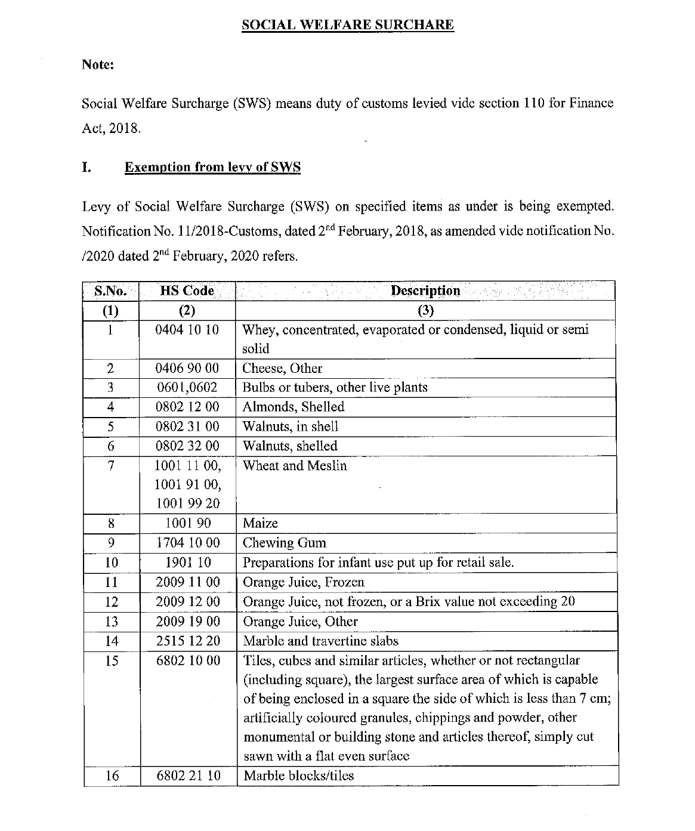

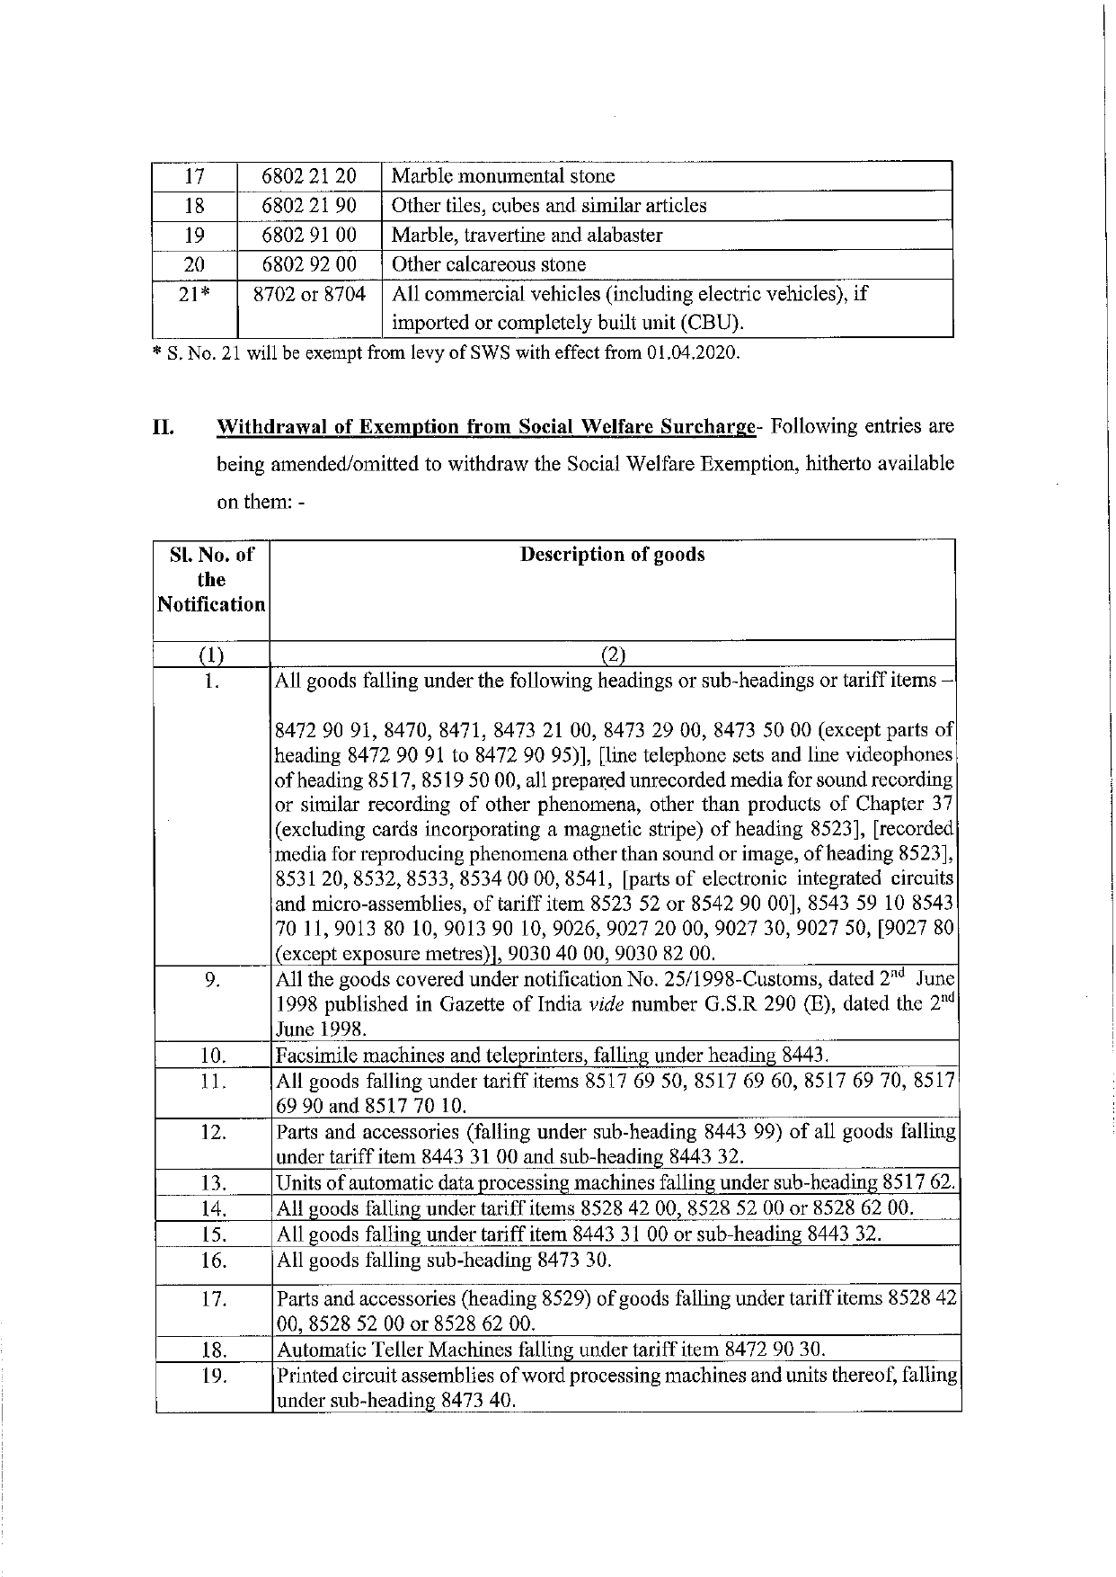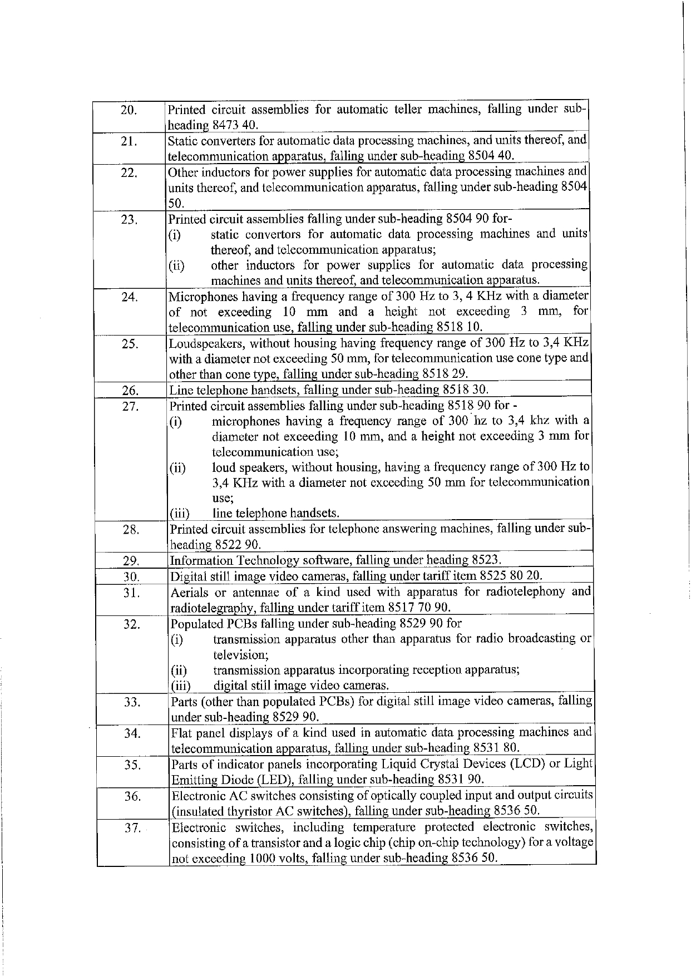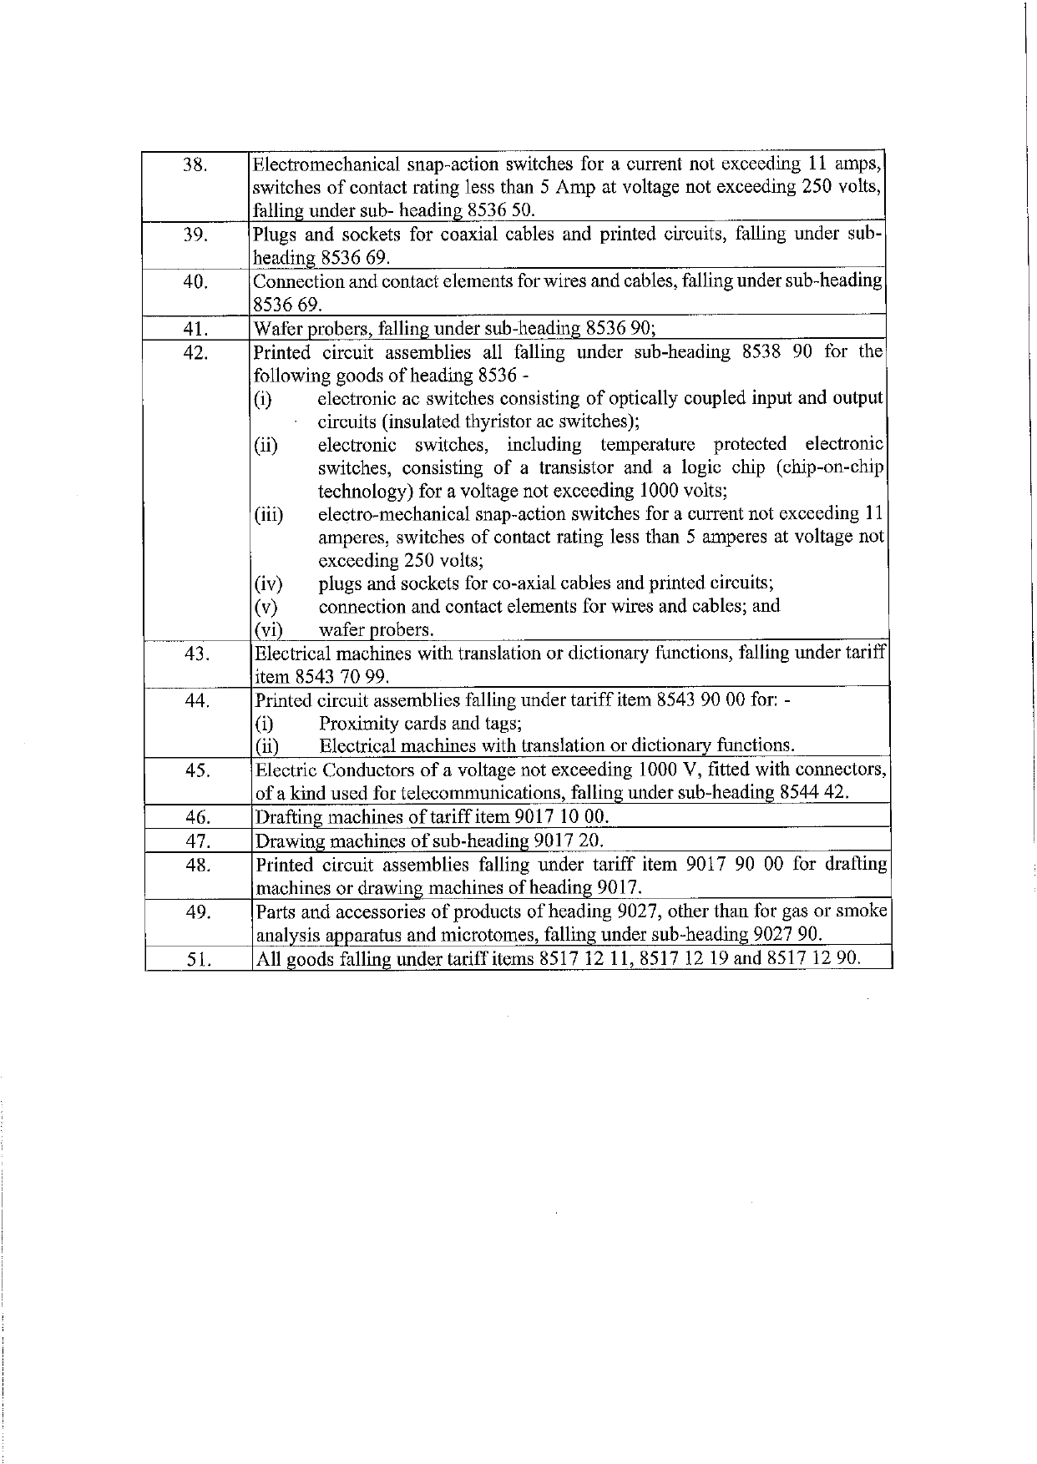

CENTRAL EXCISE
Changes in Central Excise - Budget 2020
Clause 145 of the Finance Bill, 2020 r.w. Fifth Schedule: Levy of National Calamity Contingent Duty (NCCD) is being reviewed on the following items:
Tariff Item | Description of Goods | From | To
(1) | (2) | (3) | (4)
2402 20 10 | Other than filter cigarettes, of length not exceeding 65 millimetres | Rs. 90 per thousand | Rs. 200 per thousand
2402 20 20 | Other than filter cigarettes, of length exceeding 65 millimetres but not exceeding 70 millimetres | Rs. 145 per thousand | Rs. 250 per thousand
2402 20 30 | Filter cigarettes of length (including the length of the filter, the length of filter being 11 millimetres or its actual length, whichever is more) not exceeding 65 millimetres | Rs. 90 per thousand | Rs. 440 per thousand
2402 20 40 | Filter cigarettes of length (including the length of the filter, the length of filter being 11 millimetres or its actual length, whichever is more) exceeding 65 millimetres but not exceeding 70 millimetres | Rs. 90 per thousand | Rs. 440 per thousand
2402 20 50 | Filter cigarettes of length (including the length of the filter, the length of filter being 11 millimetres or its actual length, whichever is more) exceeding 70 millimetres but not exceeding 75 millimetres | Rs. 145 per thousand | Rs. 545 per thousand
2402 20 90 | Other | Rs. 235 per thousand | Rs. 735 per thousand
2402 90 10 | Cigarettes of tobacco substitutes | Rs. 150 per thousand | Rs. 600 per thousand
2403 11 10 | Hookah or gudaku tobacco | 10% | 25%
2403 19 10 | Smoking mixtures for pipes and cigarettes | 45% | 60%
2403 19 90 | Other | 10% | 25%
2403 91 00 | “Homogenised” or “reconstituted” tobacco | 10% | 25%
2403 99 10 | Chewing tobacco | 10% | 25%
2403 99 20 | Preparations containing chewing tobacco | 10% | 25%
2403 99 30 | Jarda scented tobacco | 10% | 25%
2403 99 40 | Snuff | 10% | 25%
2403 99 50 | Preparations containing snuff | 10% | 25%
2403 99 60 | Tobacco extracts and essence | 10% | 25%
2403 99 90 | Other | 10% | 25%

Note: These changes will come into effect immediately [from 00 hours on 02.02.2020] owing to the declaration under the Provisional Collection of Taxes Act, 1931.
(a) "Basic Excise Duty" means the excise duty set forth in the Fourth Schedule to the Central Excise Act, 1944.
(b) NCCD means "National Calamity Contingent Duty" levied under Finance Act, 2001, as a duty of Excise on specified goods at rates specified in the seventh schedule to Finance Act, 2001.

[This space has been intentionally left blank]

From the Authors Desk
Given the environment of slow growth, declining consumption and weak investment, Budget 2020 comes at a very crucial time of the Economy. Undoubtedly, the Finance Minister Nirmala Sitharaman has announced pro-middle class and development-oriented Budget. The FM said the budget is aimed at boosting income and purchasing power of people. Moreover, in this budget the FM broke her own record and delivered the longest Union Budget speech which was 159 minutes long.
FM announced massive state funding to help India’s farm sector in Union Budget 2020-21, aiming to get broader economic growth back up from its lowest in a decade. The fiscal deficit target is revised to 3.8% for the current fiscal year, from an earlier target of 3.3%. She pegged the fiscal deficit target for 2020-21 at 3.5% of the GDP. To give more push to the export sector and achieve higher export credit disbursement, FM proposed a new scheme called Nirvik, which provides for high insurance cover, reduction in premium for small exporters and simplified procedures for claim settlements.
To the limelight of aam aadmi, Income Tax rates for earning up to Rs. 15 lakh per annum have been slashed and no tax will be applied on earnings up to Rs. 5 lakh, if a taxpayer opts for foregoing exemptions and deductions. The FM termed GST as a historic structural reform, while listing out the benefits of the GST regime in reducing the time taken by trucks to transport goods, substantially bringing down the effective tax incidence so that average household saves monthly 4% on account of reduced GST. Around 60 lakh new taxpayers added to tax net and a simplified new return system is being introduced from April 1, 2020. Also, the FM hailed e-invoicing as another innovation wherein critical information shall be captured electronically in a centralized system.
Response of GST is indeed heartening but it remains to be seen as to how smooth these new systems will be put in place. Needless to mention that robust IT network is going to be the heart of new return system and e-invoicing. Unless the system supports these functions without glitches, their utility and efficiency may not be established in desired sense, which we are witnessing in the era of GSTR-1 and GSTR-3B which took its own time to settle and taxpayers still continue to face last day portal glitches leading to staggered extension of due dates – region based. Such ideas may not go well the concept of one nation one tax.
Moreover, the nation was also looking for a roadmap towards rate-rationalisation in GST, which does not seem to be on agenda of this budget. Earlier, former Finance Minister Arun Jaitley had said that the policymakers could merge the 12% and 18% slabs under GST going forward as revenue increases, thereby effectively making it a two-tier tax.

Also, it is time that we strive to maintain stability of provisions and systems under GST, as frequent changes cause disruptions in business operations as well as increasing confusions in trade. Though, Centre and States are quite receptive to resolve GST issues, but certain level of steadiness is also required.
In nutshell, though this budget may be considered as good providing tax benefits to the middlemen, corporates and support to farmers, but the present situation of the economy and taxation system was requiring little more.

[This space has been intentionally left blank]



About us:
A2Z TAXCORP LLP is a boutique Indirect Tax firm having professionals from Multi disciplines which includes Goods and Services Tax (GST), Central Excise, Custom, Service Tax, VAT, DGFT, Foreign Trade Policy, SEZ, EOU, Export – Import Laws, Free Trade Policy etc.

Thanks & Best Regards,
A2Z TAXCORP LLP
Tax and Law Practitioners

Flat No. 34B,
Ground Floor, Pocket – 1,
Mayur Vihar Phase-1
Delhi – 110091 (India)
Tel: +91 11 42427056
Web: www.a2ztaxcorp.com

Bimal Jain
FCA, FCS, LLB, B. Com (Hons)
Author of a book on Goods and Services Tax, titled, "GST Law and Analysis (with conceptual procedures) [5thEdition]
Connect With Us:

DISCLAIMER: The views expressed are strictly of the author and A2Z Taxcorp LLP. The contents of this newsletter are solely for informational purpose. It does not constitute professional advice or recommendation of firm. Neither the author nor firm and its affiliates accepts any liabilities for any loss or damage of any kind arising out of any information in this newsletter nor for any actions taken in reliance thereon.

