SOMETHING YOU NEED TO KNOW ABOUT

MSME

(Micro, Small & Medium Enterprises)

By

CA Arpit N Khetan

B.Com,FCA,DISA

Email:caarpitkhetan@gmail.com , website:www.cakhetan.in

Cell:+91-9922516162 ,91-7972939408

What's MSME

Definitions of Micro, Small & Medium Enterprises In accordance with the provision of Micro, Small & Medium Enterprises Development (MSMED) Act, 2006 the Micro, Small and Medium Enterprises (MSME) are classified in two Classes:

1. Manufacturing Enterprises-The enterprises engaged in the manufacture or production of goods pertaining to any industry specified in the first schedule to the industries (Development and regulation) Act, 1951) or employing plant and machinery in the process of value addition to the final product having a distinct name or character or use. The Manufacturing Enterprise are defined in terms of investment in Plant & Machinery.

2. Service Enterprises:-The enterprises engaged in providing or rendering of services and are defined in terms of investment in equipment

(As per the FM announcement on Atmanirbhar Bharat, differentiation between manufacturing and service MSMEs is being removed.)
MSME as per the Definition New and old:
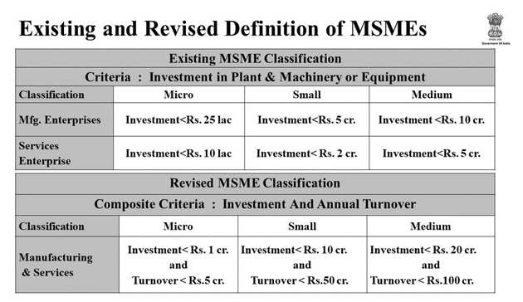

Why Being a MSME is Important or Beneficial
1. Collateral Free loans from banks:
The Credit Guarantee Fund Scheme for Micro and Small Enterprises (CGS) was launched by the GOI to make available collateral-free credit to the micro and small enterprise sector. Both the existing and the new enterprises are eligible to be covered under the scheme. The Ministry of Micro, Small and Medium Enterprises, Government of India and Small Industries Development Bank of India (SIDBI), established a Trust named Credit Guarantee Fund Trust for Micro and Small Enterprises (CGTMSE) to implement the Credit Guarantee Fund Scheme for Micro and Small Enterprises.
2. Eligible for Industrial Promotion subsidy
Enterprises that have MSME Registration are eligible for Industrial Promotion Subsidy as may be prescribed by the government in this behalf.
3. It provides 50% subsidy on Patent registration
Enterprises that have MSME Registration Certificate can avail 50% subsidy for patent registration by making an application to respective ministry.
4. 1% exemption on the interest rate on overdraft
Enterprises that have MSME Registration can avail the benefit of 1% exemption on the interest rate on OD as mentioned in the scheme (this is bank dependent).
5. Protection against delayed payments
The Ministry of Micro, Small and Medium Enterprises gives protection to MSME Registered Business against delay in payments from Buyers and right of interest on delayed payment through conciliation and arbitration and settlement of dispute be done in minimum time. If any micro or small enterprise that has MSME registration, supplies any goods or services, then the buyer is required to make a payment on or before the date agreed upon between the buyer and the micro or small enterprise. In case there is no payment date on the agreement, then the buyer is required to make payment within fifteen days of acceptance of goods or services. Further, in any case, a payment due to a micro or small enterprise cannot exceed forty-five days from the day of acceptance. Then the interest should be paid by the buyer to MSME and the penal interest chargeable for delayed payment to a MSME enterprise is three times of the bank rate notified by the Reserve Bank of India.
6. Reimbursement of ISO Certification charges
Enterprises that have MSME Registration Certificate can claim reimbursement of ISO Certification expenses by making an application to the respective authority.

7. Concession in electricity bills:
Enterprises that have MSME Registration Certificate can avail Concession on electricity bill by making an application to the electricity department along with MSME Registration Certificate.
8. Market assistance from the government and Export Promotion: The Government of India organizes several exchange programs, craft fairs, exhibitions, and trade-related events internationally. Being categorized as a micro, small or medium enterprise gives access to all of these platforms for international cooperation on trade-related aspects with different countries and fosters new business connections. The government also incentivizes the export of goods and services by MSMEs by way of subsidies, tax exemption, and technical support.
9. Technology and quality up-gradation support to MSMEs: In order to enhance the cost-effectiveness and promote clean energy use in manufacturing, the government reimburses project costs towards these goals for MSME sector units and also expenditure incurred for the implementation of clean technology, preparation of audit report and subsidies for licensing products according to national and international standards.
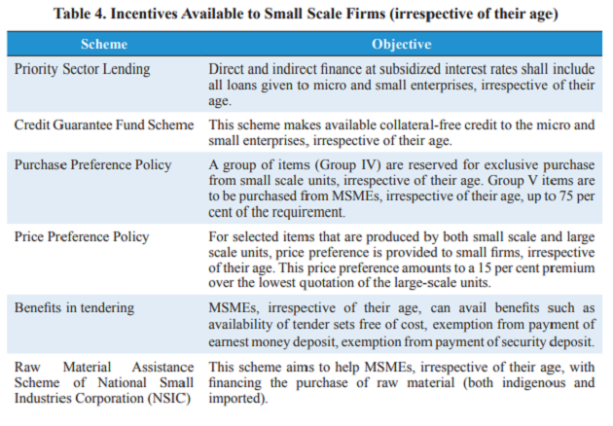
Note: Many other Benefits are available to the Eligible MSME satisfying the eligibility Criteria

Whats in Economic Relief Package for MSME
Here are the six reforms or measures announced by the finance minister.
1. Collateral free automatic loan for SMEs up to 3 lakh crore which means not a single MSME unit needs to pay any collateral or guarantee for the loans availed under this scheme. They will also not be required to pay any principal component of the loan for the first year. The tenure of the loan will be for 4 years. This will benefit 45 lakh units resume business activities and safeguard jobs, said the FM.
2. Rs 20,000 crore subordinated debt for stressed MSMEs facing an equity problem. It will help functioning MSMEs which are either NPA (non performing assets) or are economically stressed. Around Rs 2 lakh MSMEs qualify under this category. The government will provide Rs 4,000 crore partial credit guarantee support to banks and promoters of the MSMEs will be given debt by banks in the form of equity infusion.
3. Fund of fund for the infusion of Rs 50,000 crore as equity into MSMEs. This will benefit MSMEs with potential and viability by providing them greater support in capacity expansion and for the purpose of market-listing. This will cover MSMEs that are performing very well and can use the opportunity to expand.
4. The definition of MSME is being changed to encourage MSMEs to grow bigger without losing on the benefits availed by MSMEs. The investment limit that defined an MSME is being revised upwards along with the addition of turnover as criteria to categorise MSMEs
5. The government procurement tenders up to Rs 200 crore will no longer be open to global tenders/players, allowing MSMEs the chance to compete. The government said it will make necessary amendments to General Financial Rules to enable this provision. Sitharaman said this was a major step towards creating a self-reliant India.
6. Post Covid trade fares will be difficult, therefor e-linkage market is being provided to MSMEs. In addition to this, the government has promised to clear all receivables due to MSMEs in the next 45 days.

Action :
Get Yourself Registered Immediately if not registered till date to get the Benefits of Registration

We hope this article helps all of those who might have had any confusion related to the benefits of MSME registration in India and also to those who are willing to jump into an entrepreneur role or are having a Micro, Small to Medium scale business.

