Tax Planning through creation of Private Family Trust
by : Polad posted: February 19, 2013

Private Family Trust
The creation of family trust makes sense. It is a novel way of tax planning as also planning for dependents marriage, education expenses, etc. After the abolition of Gift Tax Act, a lot of tax planning can be done by creation of such trusts. However, sad to say, many people are yet to appreciate the value of a trust as a powerful financial planning tool and that is understandable, as the layman doesn’t quite understand the concept of the term ‘Trust’ and the tax implications thereof. However, setting up and managing a trust is surprisingly easy, specially, if the trust doesn’t hold any immovable property.
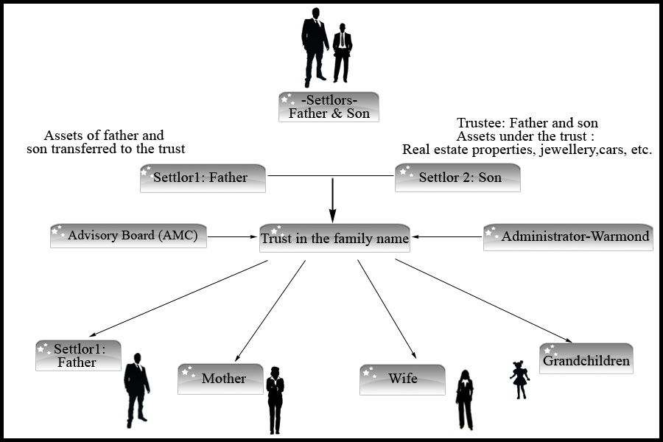

Legal Concept of Trusts
The Indian Trusts Act, 1882 governs the private trusts. This Act doesn’t apply to public trusts and private charitable trusts. The distinction between the private and public trusts is that in private trusts, the beneficiaries are defined and ascertained individuals, but in public trusts, interest may be vested in uncertain and fluctuating body of persons.
A private trust comes into existence when the owner of a particular property (the settlor), while intending to transfer the property to a chosen individual/individuals (the beneficiaries) doesn’t vest the property with the beneficiaries but with other people (the trustees), who are given the responsibility of making over the benefits of the property to the beneficiaries. For example, a father may be settlor of a trust, make himself and his wife as the trustees and his children as beneficiaries.
While creation of such trusts, the following points should be taken care:
(i) The subject matter of the trust should be certain; the person desired to be benefited must be certain, and the period of trust must be defined directly or indirectly.
(ii) Though the Indian Trust Act doesn’t forbid the beneficiary of a trust from being appointed as a trustee, but as a general rule, it is advisable to avoid appointing a beneficiary as a trustee as there may arise a conflict between his interest and his duty. It was held by Orissa High Court in M.C.Mohapatra vs.M.C.Mohapatra that the same person may be a trustee and a beneficiary.
(iii) Typically, a trust deed should provide the day on which the corpus be distributed among the beneficiaries. Normally, the settlor should mention the last date by which the trust should be wound up and leave it to the discretion of the trustee to distribute a part of, or the entire corpus earlier. Under the law, however, the life of such a trust cannot exceed twenty five years. In other words, a private trust should be wound up by a date not later than twenty five years from the date of the creation of the trust. In most cases, however, the corpus is distributed after the children attains majority.
(iv) The investments of trust money are governed by section 20 & section 40 of the Indian Trust Act, 1882. These sections give the details of securities in which investments can be made. However, there is a residuary section 20(f), which says that the trustee may invest money in any security expressly authorized by the instrument of trust. The investment clause in the trust deed should be suitably drafted so that full flexibility remains in the hands of trustees. However, it may be noted that the investment clause is applicable only if the trust has surplus money, which is not immediately required. For fulfilling the objects of the Trust, the investment can be made in any immovable and movable property.

Creation of Private Trusts
A registered document is necessary to set up a trust if immovable property is being transferred to it. However, if only movable property is settled upon the trust, no formal document or agreement in writing is necessary. It is always advisable to prepare a trust deed on a stamp paper, and have it signed by the settlor and the trustees in presence of a witness, to avoid any subsequent disputes.

Types of Private Trusts
A trust may either a discretionary or non-discretionary trust. A trust is non-discretionary if the shares of the beneficiaries are clearly defined by the settlor. In other words, although the trustees have the powers to administer and manage the trust, and its finances, they do not have the discretion to decide the proportion in which the income or the corpus is to be distributed among the beneficiaries. A discretionary trust, on the other hand, only specifies the names of the beneficiaries. The trustees have complete discretion to decide the proportion in which the income or the corpus is to be distributed. Thus, the trustees may distribute the benefits to just a few beneficiaries (and totally exclude the others) or change the proportion each year or even decide not to distribute the income at all in a given year. In effect, so long as the benefits are passed on to one or more of the beneficiaries named by the settlor, the trustees have the discretion to decide who among the beneficiaries will benefit from the trust.

Taxability on Private Trusts
The taxability of the Trust depends upon the type of the trust. In the case of a non-discretionary trust, all income is taxable in the hands of the beneficiaries. But if the beneficiaries are minors, the income is to be clubbed with that of the parent with the higher income. On the other hand, in the case of a discretionary trust, in which the shares of the beneficiaries are unknown and indeterminate, it is taxed in the hands of trust at the maximum marginal rate.

Tax Planning
In the case of non-discretionary trust, no additional tax planning is achieved as the proportionate income or wealth is taxable in the hands of each beneficiaries. However, in case of a discretionary trust, tax planning is possible in the following situations:
(i) By creation of such trust through a Will of a person: If a trust has been created in terms of Will of a person, and if that is the only trust so declared by him, then such trust enjoy taxation as that of an individual. Suppose, the capital of a deceased person is say Rs. 40 lakhs, which has been mostly invested in loans on which interest of Rs. 3.5 lakhs is received each year. On his death, the person wants the capital to be distributed among his wife and one grandson equally.
The wife as well as the parent of the minor are also having income exceeding Rs. 3.5 lakhs each. Suppose if the assets are distributed directly to the wife and grandson, then both the person shall have additional tax liability of Rs. 52500/- each (30% of 175000/-). Thus, the additional income tax liability comes to Rs. 105000/-. Now suppose, if a trust is being created in terms of Will as referred above, and trust invest Rs. 1 lac in 80C instruments, the tax liability on the Trust comes to Rs.15000/- only (at slab rate on Rs. 250000/- after deducting Rs. 100000/- u/s 80C). Thus, there is savings in income tax of Rs. 90000/- annually. In the above example, if the deceased person had jewellery of Rs. 15 lakhs, and both the beneficiaries had taxable wealth, the wealth tax liability of both the beneficiary would have increased by Rs. 7500/- each. However, by creation of such trust, there can be additional wealth tax savings of around 15000/- annually.
(ii) Wealth Tax Planning: Creation of discretionary trust and transfer of taxable wealth tax assets into such trust may give wealth tax benefits. For example, if an individual has jewellery of Rs. 95 lacs, he is liable to pay wealth tax of Rs.65,000/- only. Now, if such individual create two discretionary trusts, then each such discretionary trusts is entitled to a basic wealth tax exemption limit of Rs. 30 lakhs. Thus, if Rs. 30 lakhs worth of jewellery is transferred to each of these two trusts, then the total wealth tax liability is reduced from 65,000/- each year to 5,000/- each year. However, proper care should be taken in selection of beneficiaries in such types of trust.
(iii) Another situation in which creation of such trusts are beneficial is when income of all the beneficiaries are below taxable limit and the beneficiaries are not the beneficiaries of any other trust. In that situation too, the Trust shall be taxable at the slab rates applicable to the individual. After the clubbing provision of minor’s income has been enacted, there is no taxation advantage of minor’s income. Now, a trust may be created in which the minor children may be the beneficiaries, and the parents may be trustees. Thus, the trust shall enjoy the basic exemption limit in both the income and wealth tax act as also the slab rates applicable for individuals. For example, there are two minors and both are having income of Rs. 50000/- each. By virtue of clubbing provisions, the income that will be clubbed in the hands of the parent shall be Rs. 97000/- (100000-1500*2), which may have a tax liability of Rs. 29100/-(97000*30%). However, had the trust been created, there wouldn’t have been any clubbing and a tax savings of Rs. 29100/- could have been made each year.

Conclusion
Tax planning through trusts is to be handled with care, and besides tax planning there should be a legitimate purpose of creation of such trusts. If a trust is created as such, then it can bring smile to both – assessee as well as professional, and of course the beneficiaries.

