Disclaimer:
The information given is to convey the general understanding of TDS and TCS provisions. For detailed information Income Tax Act 1961 shall be consulted. The changes in the Act may be incorporated in the information as and when required.

Overview of TDS
TDS is one of the modes of collection of taxes, by which a certain percentage of amounts are deducted by a person at the time of making/crediting certain specific nature of payment to the other person and deducted amount is remitted to the Government account. It is similar to "pay as you earn" scheme also known as Withholding Tax in many other countries, one of the countries is USA. The concept of TDS envisages the principle of "pay as you earn". It facilitates sharing of responsibility of tax collection between the deductor and the tax administration. It ensures regular inflow of cash resources to the Government. It acts as a powerful instrument to prevent tax evasion as well as expands the tax net.

Who shall deduct tax at source?
Every person responsible for making payment of nature covered by TDS provisions of Income Tax Act shall be responsible to deduct tax.
However in case of payments made under sec. 194A, 194C, 194H, 194I and 194J in respect of individual and HUF, only if the turnover or professional receipt exceeds sum of Rs. 40 lakh or Rs. 10 lakh respectively (the limits will be Rs.60 Lakh or Rs. 15 Lakh respectively w.e.f. 01.07.2010) in previous year, he is required to deduct tax at source.
These persons are mainly:
- Principal Officer of a company for TDS purpose including the employer in case of private employment or an employee making payment on behalf of the employer.
- DDO (Drawing & Disbursing Officer), In case of Govt. Office any officer designated as such.
- In the case of "interest on securities" other than payments made by or on behalf of the Central govt. or the State Government, it is the local authority, corporation or company, including the Principal Officer thereof.
Such person is called Deductor while the person from whom the tax is deducted is called Deductee.
Tax must be deducted at the time of payment in cash or cheque or credit to the payee's account whichever is earlier. Credit to payable account or suspense account is also considered to be credit to payee's account and TDS must be made at the time of such credit.

What a deductor must do?
1. Obtain TAN
Every deductor is required to obtain a unique identification number called TAN (Tax Deduction Account Number) which is a ten digit alpha numeric number e.g.DELH90468K.
This number has to be quoted by the deductor in every correspondence related to Income Tax matters concerning TDS.
2. He/She should obtain PAN of the deductee.
3. He/She should deduct the tax at correct rate.
4. The tax deducted has to be deposited in the designated banks within specified time. (Govt. deductors shall transfer the tax deducted through book entry in Government account).This is detailed below:
▬ By or on behalf of the Government : on the same day,
▬ By or on behalf of any other person : before the 7th of the following month.
However, if the amount is credited in the books on 31st March then the tax should be remitted by 31st May.
Note: w.e.f., 01.04.2008 electronic payment of tax has to be done by all corporate assesses and all persons whose cases are auditable under section 44B.
5. Use challan no. 281 for depositing TDS amount.
6. File statements of tax deduction in the prescribed time.
The due dates for filing of TDS/TCS statement are :
15th of July for Quarter 1,
15th of October for Quarter 2,
15th of January for Quarter 3 and
15th June for last Quarter however for TCS statements the due date is 30th April.
7. Use correct form to file TDS/TCS Returns. They are:
Form 24Q for salaries
Form 26Q for non salaries
Form 27EQ for TCS
Form 27A/27B Control sheet for electronic TDS/TCS
It may be noted that the following persons have to compulsorily file e-TDS /e-TCS statements
- All government offices/Departments
- All companies /corporations
- All persons whose cases are auditable
- All persons whose TDS statements contain more than 50 deductees.

Dos & Dont's for filing TDS Returns
Dos
- Ensure that TDS return is filed with same TAN against which TDS payment has been made & TDS certificate is issued.
- Ensure that correct challan particulars including CIN and amount is mentioned.
- Correct PAN of the deductee is mentioned.
- Correct section is quoted against each deductee record.
- Correct rate is quoted against each deductee record.
- File correction statement as soon as discrepancy is noticed
- Retain the original FVU file to enable future corrections
- Make use of free of charge RPU provided through TIN-NSDL.com
- Download details of challan from challan status enquiry (TAN based view) from TIN-NSDL.com
- Registration for TAN enables you to avail additional facilities from Tax Information System.
- Always verify status of TDS returns from Tin NSDL to ascertain the discrepancy, if any, and/or whether your TDS return stands accepted or rejected by the system.
Dont's
- Don't file late returns as it affects deductee tax credit
- Don't quote incorrect TAN vis-à-vis TDS payments
The process of filing of e-TDS /e-TCS returns is available in detail at following websites www.incometaxindia.gov.in or http://tin-nsdl.com.
8. Issue TDS certificates as per existing procedure and within the time prescribed as stated below:
The certificate should be issued within one month from the end of the month in which the income is credited however for credit entries made on 31st March, due date is 7th June, except in the case of salary where the certificate has to be issued by 30th of April of the following financial year in which the income was credited.
9. File e-TBAF (In case of Govt. DDO's where TDS is credited in Central Govt. account through book adjustments)

Procedure:
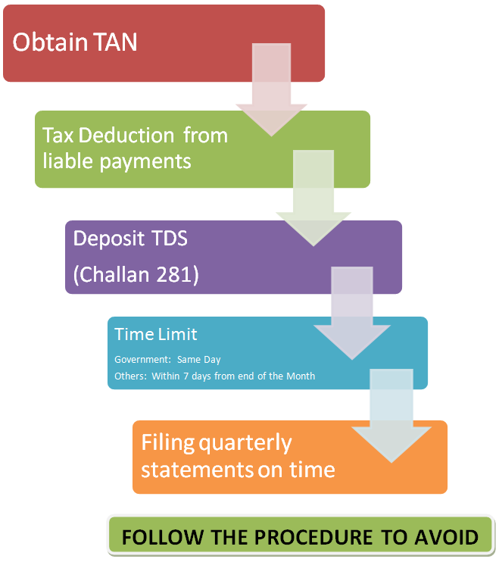

TAN
Every deductor is required to obtain a unique identification number called TAN (Tax Deduction Account Number) which is a ten digit alpha numeric number. This number has to be quoted by the deductor in every correspondence related to TDS.
Format of TAN:
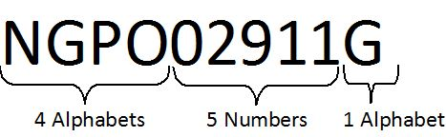

Procedure for getting TAN :
It can be obtained by filing an application in form no. 49B to any of the TIN facilitation Centres (TIN-FC) namely NSDL. Addresses of the TIN-FC as well as the forms can be downloaded from the website www.incometaxindia.gov.in or http://tin-nsdl.com. The fee for processing TAN application is Rs. 60/-. This can be paid by:
▬ Cash at TIN-FC counter
▬ Demand draft or
▬ Cheque or
▬ Credit card
The demand draft/ cheque shall be in favour of 'NSDL-TIN'.
TAN number will be communicated to the deductor by NSDL.

Nature of payments attracting TDS and rates thereon:
Salary
DDOs must calculate the tax payable by an employee for the year and start deducting tax at average rate. The term salary includes wages, any annuity or pension, gratuity, any fees, commission, perquisites or profits in lieu of or in addition to any salary or wages. (These payments are covered under sec. 192 of the Income Tax Act 1961). The income from salaries is required to be computed on estimated basis at the beginning of each financial year, taking into account salaries or remuneration paid or allowed. Income Tax payable on the basis of such estimated salary income should be deducted at the rate applicable to the corresponding slab of income every month in equal instalments subject to adjustments depending upon tax saving investments made by the deductee.
When an employee is working with more than one employer simultaneously or has changed employment from one employer to another during the relevant financial year, the employer will deduct tax on considering the aggregate salary from all sources and tax deducted thereon, if any.

Interest on securities/Dividends/Interest/Insurance commission-
The tax has to be deducted @ 20% for domestic companies and 10% for others with some basic exemption limits, in the case of interest if the amount of interest is up to Rs. 5000/- during a financial year. however, in the case of interest paid by a banking company, Co-operative society engaged in the business of banking and a public company engaged in the financing or construction of residential houses in India, this limit is Rs. 10000/-.
(These payments are covered under sec. 193, 194, 194A& 194D of the Income Tax Act 1961 resp.).

Winning from lottery, puzzle or games of any sort-
The DDO/deductor must deduct tax @ 30% on any payment above Rs. 5000/-.
(However from 1st July 2010,the DDO/deductor must deduct tax @ 30% on any payment above Rs. 10000/-)
(These payments are covered under sec. 194B of the Income Tax Act 1961).

Winning from horse races-
The DDO/deductor must deduct tax @ 30% on any payment above Rs. 2500/-.
(However from 1st July 2010,the DDO/deductor must deduct tax @ 30% on any payment above Rs. 5000/-).
(These payments are covered under sec. 194BB of the Income Tax Act 1961).

Contracts (including work land labour contract) -
The tax has to be deducted @ 2% on contract payments and 1% for subcontract and advertisement contract payments. The tax is required to be deducted if a single payment exceeds Rs. 20000/- or if the aggregate payments exceed Rs. 50000/- per annum.
(However from 1st July 2010, Rate of deduction is @ 2% on all contract payments including subcontract and advertisement contract payments. The tax is required to be deducted if a single payment exceeds Rs. 30000/- or if the aggregate payments exceed Rs. 75000/- per annum).
(These payments are covered under sec. 194C of the Income Tax Act 1961).

Insurance commission-
Any person responsible for paying to a resident any remuneration or reward whether by way of commission or otherwise, for procuring insurance business is required to deduct tax @ 20% for companies and 10% for other person if the amount credited or paid is more than Rs. 5000/- in a financial year.
(However from 1st July 2010, any person responsible for paying to a resident any remuneration or reward whether by way of commission or otherwise, for procuring insurance business is required to deduct tax @ 20% for companies and 10% for other person if the amount credited or paid is more than Rs. 20000/- in a financial year).

Payments to Non residents sportsmen or sport association.-
The tax has to be deducted @10% on making any payment.
(These payments are covered under sec. 194E of the Income Tax Act 1961).

Commission on sale of lottery tickets and on brokerage-.
The tax has to be deducted @10% with some basic exemption.
(These payments are covered under sec. 194G & 194H of the Income Tax Act 1961).

Rent-
Any amount paid as rent above Rs. 120000/- per year will attract TDS provisions @ 10% for Individual & HUF and 20% for others. (TDS will be 2% for the use of any machinery or plant or equipment).
(However from 1st July 2010, any amount paid as rent above Rs. 180000/- per year will attract TDS provisions @ 10% for Individual & HUF and 20% for others).
(These payments are covered under sec. 194I of the Income Tax Act 1961).

Fees for professional or technical services/royalty/Income on units of mutual funds/compensation on acquisition of certain immovable assets-
The tax has to be deducted @10% with some basic exemption limits.
(These payments are covered under sec. 194J, 194K & 194LA of the Income Tax Act 1961).

Payment on Acquisition of certain immovable property-
Any amount above Rs. 100000/- paid as compensation or enhanced compensation on account of compulsory acquisition under any law in force, of any immovable property other than agricultural land will attract TDS provisions @ 10%.

The rates of TDS for representative purpose (in effect till 30.06.2010):
For Salaries:
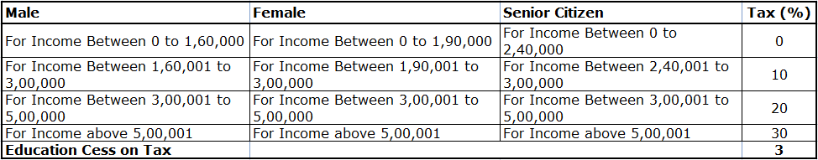
For other payments:
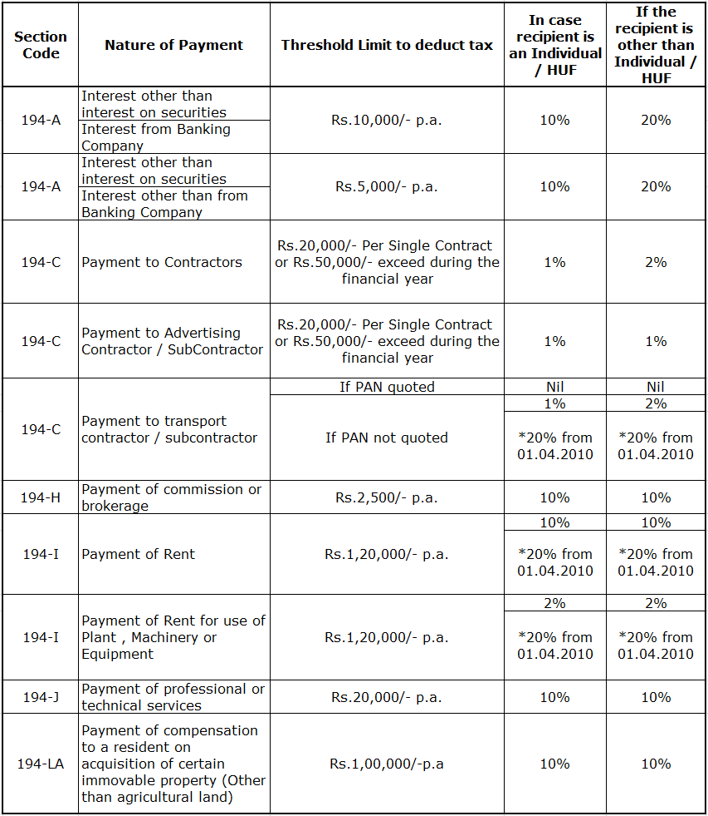

Following changes shall be applicable w.e.f. 01.07.2010 till 31.03.2011:
For Salaries:
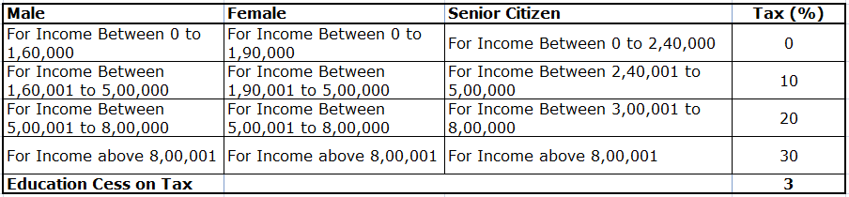

For other payments:

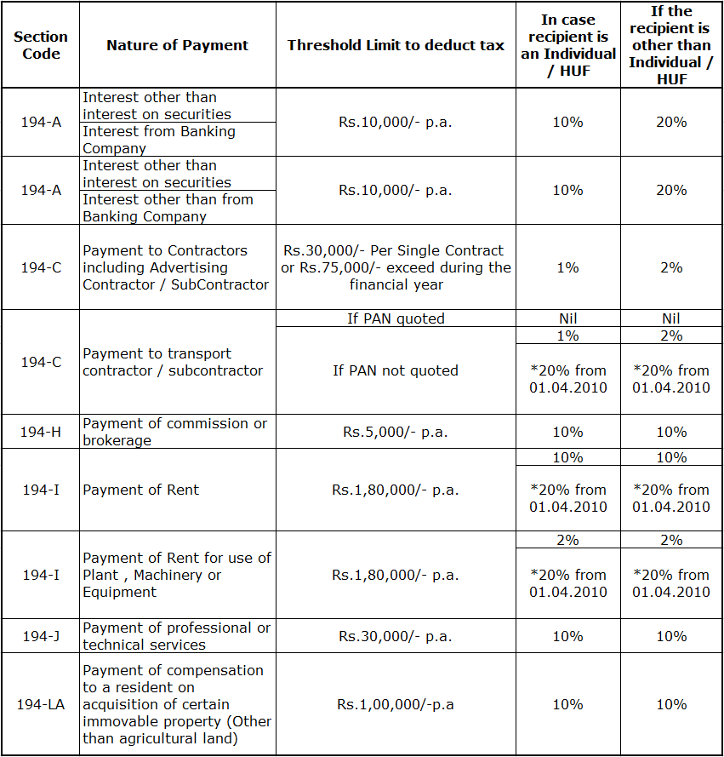

Non deduction or deduction at lower rate in certain situations
No Tax has to be deducted for the payment made to Government, RBI, Corporation whose income is exempt from tax or mutual fund specified u/sec. 10(23D). Also in case where deductee produces a non deduction certificate or lower deduction certificate u/sec. 197 of the Income Tax Act 1961.
Self declaration in Forms 15G and 15H can be filed by the deductee if his income doesn't exceed the amount chargeable to tax. This self declaration can be filed for dividends, interest and mutual fund income only. In these cases no tax has to be deducted. However the tax deductor is required to furnish copies of this self declaration to the concerned CCIT or CIT as per the rules.

Dos and Dont's for Depositing Tax

Dos
- Use challan type 281 for deposit of TDS/TCS amount.
- Deductor should quote correct TAN, full name, address and current A.Y. on each challan.
- Deductor should use separate challan for different nature of payments quoting correct nature of payment code and also for different type of deductee.
- Ensure that the bank has mentioned CIN (Challan Identification Number) on the counter foil. Verify CIN details uploaded by the bank to TIN i.e., 5 digit challan serial no., BSR code of 7 digit and date.
- Insist on computerized receipts from the bank
- E- payment of TDS is recommended.
All details of the payment as uploaded by the banks are available at the NSDL- TIN website www.tin-nsdl.com under the link "challans status enquiry". Deductor should verify the details for ensuring the credit for payments.
Through the TAN Based View details of all challans deposited in the banks for a given TAN during a specified period can be viewed.

TDS defaults
Failure to deduct the whole or part of the Tax at source (non-deduction, short deduction or delay in deduction)
1. Failure to deposit whole or part of the TDS (non-deposit, short deposit or late deposit)
2. Failure to apply for TAN within the prescribed time limit or failure to quote TAN on allotment as required under section 203A.
3. Failure to furnish, in due time, TDS returns or TDS certificates or to deliver or cause to be delivered a copy of declaration in form no. 15H/15G/27C/copy of quarterly statement.
4. Failure to mention the PAN of the deductee in all quarterly statements as well as in all certificates furnished.

Consequences of Defaults
The following chart indicates the nature of default and its consequences which range from penal interest, penalty to prosecution:
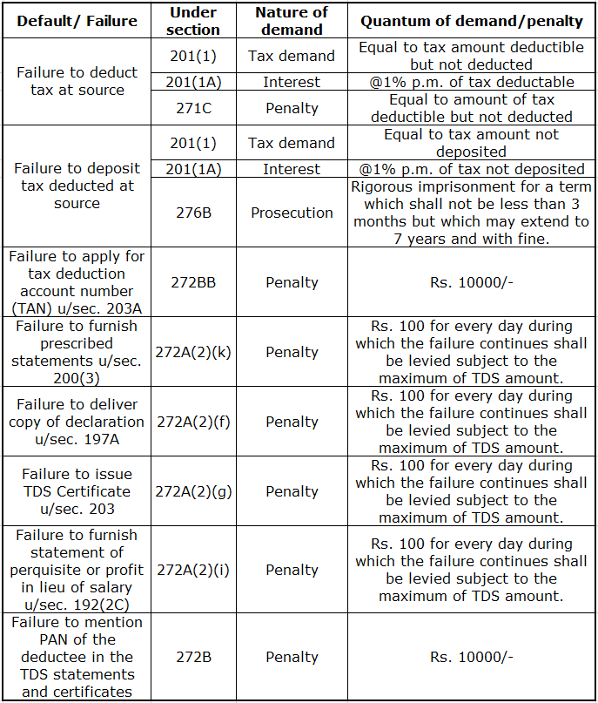
In addition to the above, there are other consequences in certain cases, as enumerated below;
▬ Disallowance of specified expenditure (while computing the income of the deductor) if TDS is not deducted from the payment. (Section 40a(ia)).
▬ Where the tax has not been paid after its deduction it shall be charge on the asset of the defaulter to recover the amount of TDS. (section 201(2)).

TAX COLLECTED AT SOURCE (TCS)

What is TCS?
The seller has to collect tax from the payer who has purchased the following items :
- Alcoholic liquor for human consumption
- Tendu leaves
- Timber obtained under a forest lease
- Timber obtained by any mode other than under a forest lease
- Any other forest produce not being timber or tendu leaves
- Scrap
- Parking lot
- Toll plaza
- Mining and quarrying
The TCS on the above mentioned items vary from 1% to 5%
Deposit of TCS amount- within seven days of the following month.
Issue of TCS certificate- within in one month of collection /debit(form 27D)

The rates of TCS for representative purpose (Financial Year 2010-11):
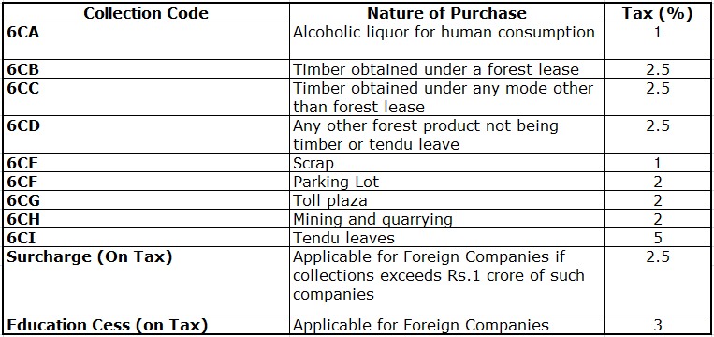

Disclaimer
Please note :
The information given above is to convey the general understanding of TDS and TCS provisions. For detailed information Income Tax Act 1961 shall be consulted. The changes in the Act may be incorporated in the information as and when required.

Various Online Services of Income Tax Department
The Income Tax Department (ITD) as a part of its citizen centric activities is providing a host of online services to the taxpayers services through various websites so that a taxpayer can fulfil his routine tax obligations.
Following services are being provided:
(i) Dissemination of tax related information through websites
(ii) Dissemination of taxpayer specific information
(iii) PAN and TAN related services
(iv) e-filing of returns of income
(v) e-payment of taxes
(vi) e-filing of TDS returns

Dissemination of tax related information

Information about tax laws, procedures etc. is now available on various websites.
- www.incometaxindia.gov.in  - https://incometaxindiaefiling.gov.in.  - www.incometaxindiapr.gov.in  - www.tin-nsdl.com | · These sites contain -  * Acts and Rules  * Procedures  * Circulars & Notifications  * Rates of tax  * Deductions & exemptions  * Jurisdictions  * FAQs  * Downloadable Forms  * Guidelines and Return preparation software for e-filing of income tax returns.  * Facility for filing of e-returns  * Guidelines and Return preparation software for e-filing of TDS returns.  * Facility for direct upload of TDS returns  * Various internet based views for giving feedback to taxpayers
· E-Tutorials available at www.incometaxindiapr.gov.in

