How To Fill Online Income Tax Online E-Return ?

Step 1: Log on to www.incometaxindiaefiling.gov.in and register yourself with your PAN, which acts as the user ID, and log in to your account.
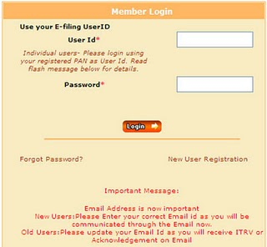

Step 2: From the ‘Downloads’ menu, select the ITR form applicable to you for assessment year (AY) 2010-11 and download the same. For a salaried individual with no other source of income, the relevant one is ITR-1.

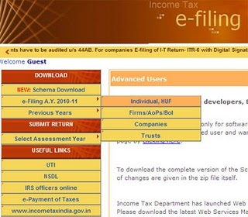

Step 3: Open the downloaded excel utility with ‘macros enabled’. For example, if you are using Office 2003, then go to Tools > Macro > Security, set the security level at ‘medium’ and enable macros while opening the excel utility.

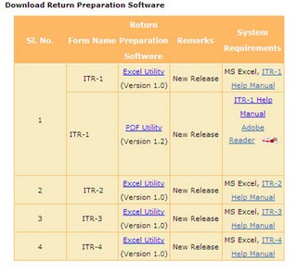

Step 4: Fill in the relevant details with the help of the Form 16 issued by your employer.

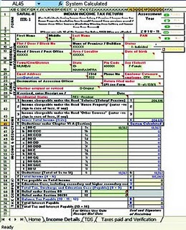

Step 5: Validate all the information by clicking the ‘Validate' key and proceed to generate an XML file. It will be automatically saved in your machine.

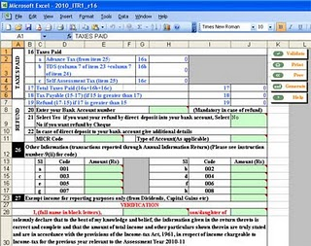

Step 6: Upload this XML file on to the website by going to the drop down menu under the ‘Submit Return’ section; select AY 2010-2011 and the applicable Form. Select ‘No’ for the question ‘Do you want to digitally sign the file?’, unless you have obtained a class II digital signature.

Step 7: If you have followed all steps correctly, a message about successful e-filing will be displayed on the site, along with a note that the ITR-Verification form has been mailed to your e-mail ID.

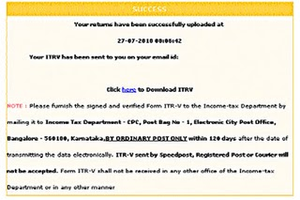

Step 8: Download the ITR-V form, print it out, sign the same and send it by ordinary post to Income Tax Department-CPC, Post Bag No-1, Electronic City Post Office, Bangalore - 560100, Karnataka within 120 days of filing your returns on-line.

A failure to adhere to the deadline will mean going through the process all over again. If you do not have a printer at home, you can simply save the file in a pen drive/CD and carry it to a printing centre.

NOTE : This flow chart has been designed keeping in mind individuals with zero tax liability. For those who are liable to pay taxes or entitled to a refund, the flow chart will entail certain additional steps like entering the details of taxes paid, bank account number, MICR code and the like.

