- Procedure for payment of PTRC & PTEC online:

    - Step 1: Go to www.mahagst.gov.in
    - Step 2: Click on “Menu” button. Click on Menu button on the upper left side of the page, you will be able to see “E-payment” as below.
    - Step 3: Click on “E- Payment – Returns” in E-payment tab.
Note: In case of PTEC Payment, if we want to Paid PTEC in bulk i.e. for 2 years or more select “PTEC OTPT Payment” and then follow the same procedure as below.

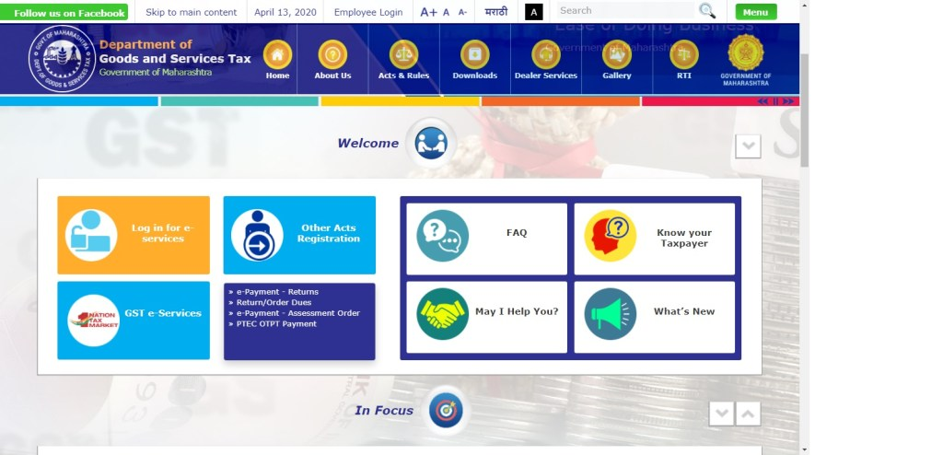

  - Enter the TIN/PAN of the entity enter captcha code and click on next, You will be redirected to payment details:
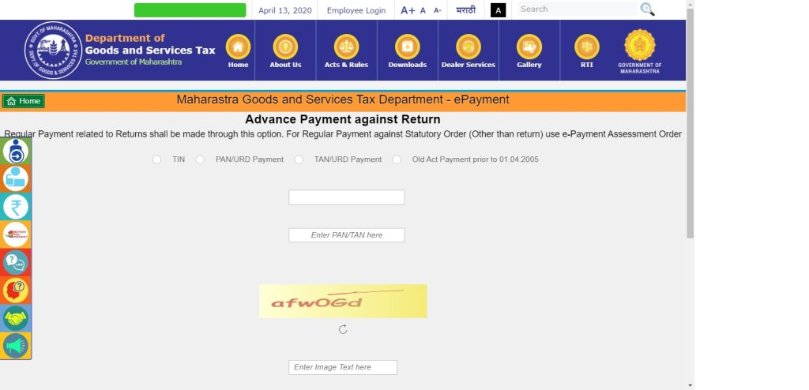

  - Step 4: Enter payment details as below:
- Select act as “PTRC ACT 1975” or “PTEC ACT” the form ID will be automatically selected as “FORM_IIIB” or “FORM _VIII” respectively.
- Financial year as FY 2020-2021/2021-2022.
- Select Period and Enter Amount.
- While making PTRC payment, in period dropdown, select succeeding month of the month to which salary pertains. E.g. select June in the period dropdown to deposit PT deducted from the salary of May.
- Select Location and Enter mobile number.

- And click on “Proceed for Payment” button.
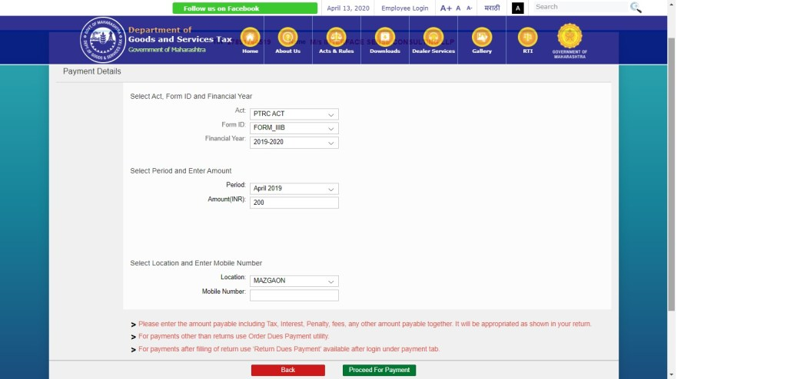

- Step 5: Payment of PTRC fees:
- Click on Agree terms and conditions check box
- Select payment gateway as “Banks supported by GRAS” and click on Proceed.
Note: Payment through “GRAS” is secured and easy. Mostly use “GRAS” for Payment because “GRAS” supported to all banks like SBI, IDBI, Bank of Maharashtra etc. but if we select “SBIePay” it only supported to State bank of India.
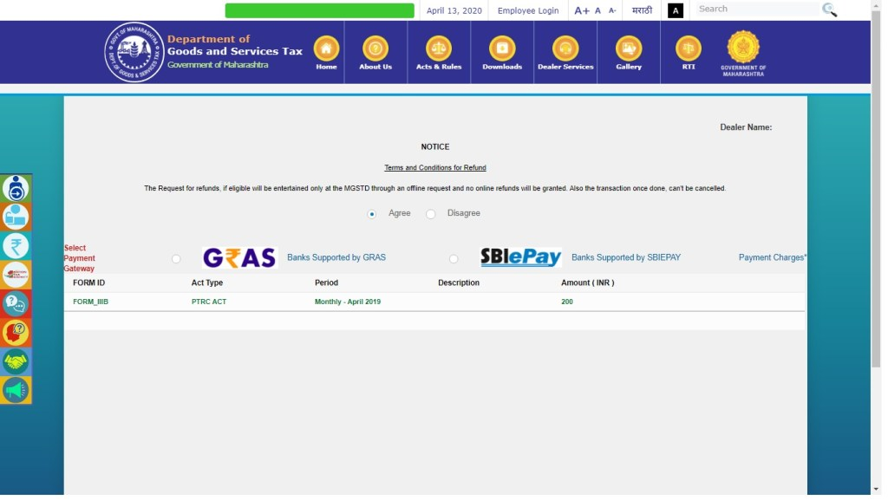
- You will be redirected to “MTR form no 6”.
- Click on “Make payment” button
- You will be directed to select bank and make payment gateway
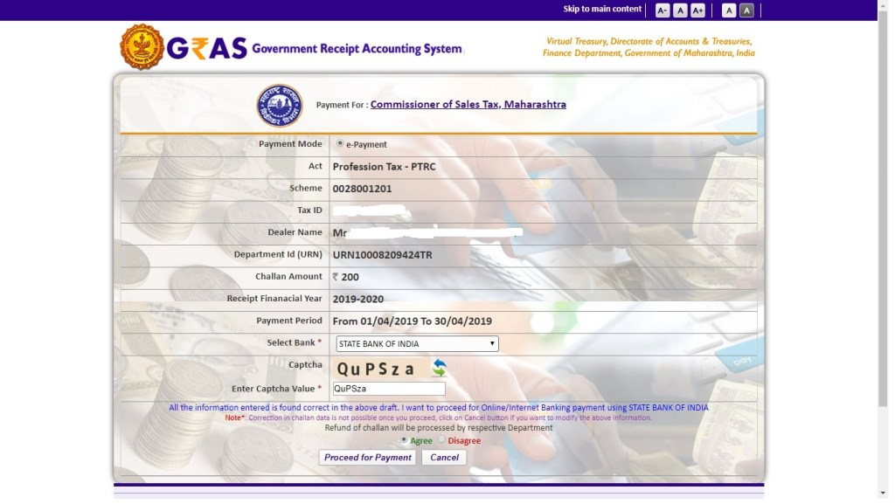

- Step 6: Final Payment of PTRC or PTEC fees.
- “Select the Bank” and Enter captcha code.
- Select and “Agree the terms and conditions” check box.
- Click on “Proceed for Payment” button. You will be redirected to Bank website Enter the credentials and make payment after making the payment save the challan for return and record purpose.

