- Procedure for PTRC returns from FY 2020-21:-
- The Procedure of PTRC return can be summarized in 3 stages:
- Calculation of PTRC liability.
- Payment of PTRC fees via MTR form no 6.
- Preparation of PTRC return and filing online FORM_IIIA.

PTRC FORM_IIIA and details required for preparing PTRC return:
- PTRC return is to be filed in FORM_IIIA. The following is the procedure for downloading the form:
- Step 1: Go to www.mahagst.gov.in.
- Step 2: Click on “Menu” button
Click on “Downloads” tab and select the option “Forms”

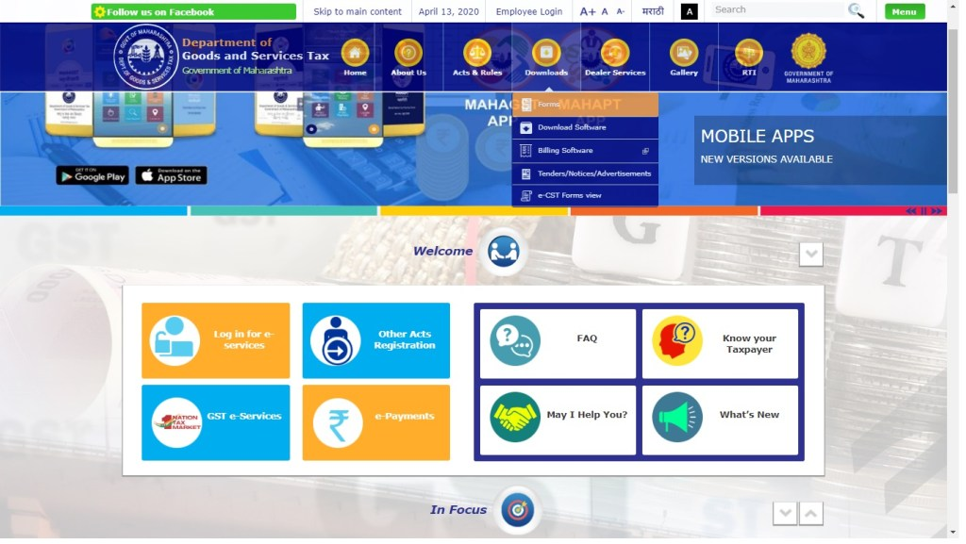

- It will redirect to “Forms list” which shows two specific tabs i.e. “New Manual Forms” and “Electronic Forms”.
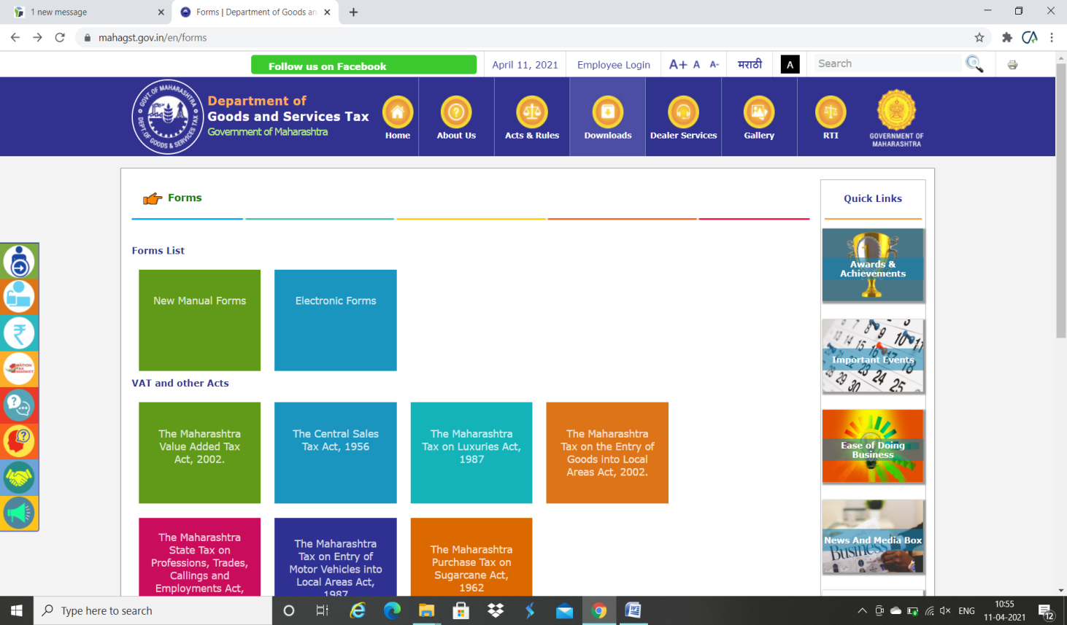
- Now select “Electronic Forms” under the heading “Forms List”
- Select and download “Form III (B) (Version 1.0.001)” under e- returns Forms.
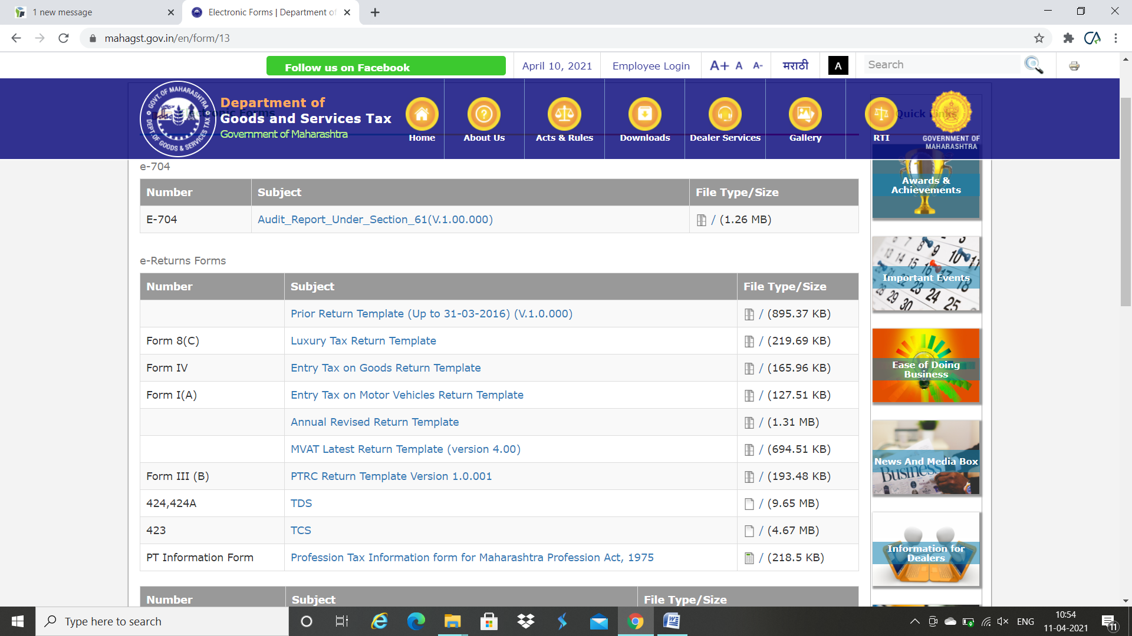
- A zip file will be downloaded. Go to download folder and unzip the file
- A “FORM-IIIB -V-1.0.001.xlsb” file will be generated. Open the file which will be as follows:
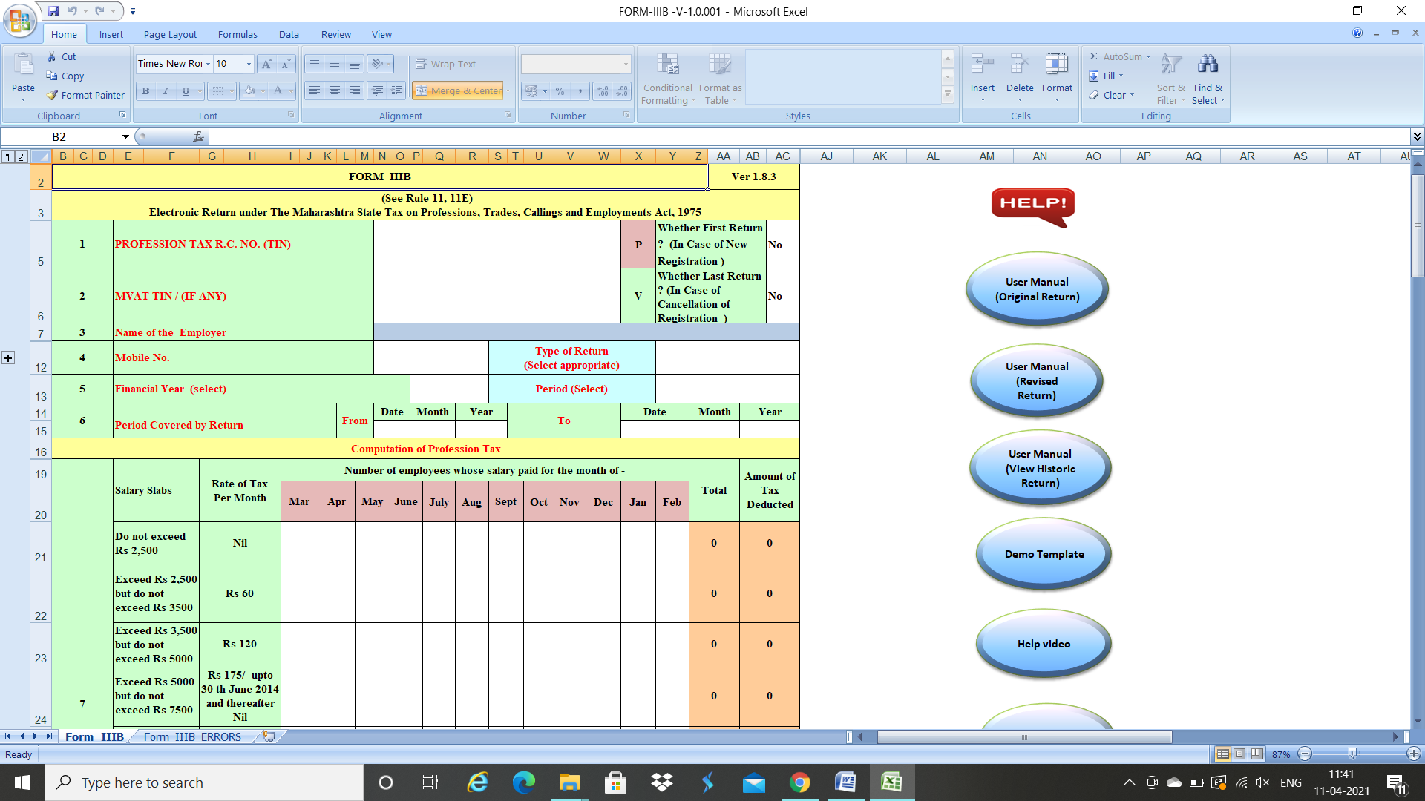
- Click on “enable editing” after which you will be able to edit the file.
- The form will ask the following details:
- PTRC registration number: Enter Valid PTRC number which is belongs to client.
- Select whether first return of the entity? : select “Yes” if there is first return of the entity otherwise “No” in dropdown box. (If entity applies for registration in FY 2020-21 and date of commencement is in FY 2020-21 then entity is filing first return.)
- Whether last return of the entity?: select “Yes” if there is last return otherwise select “No” in dropdown box.
- Mobile no of the authorized person: Enter valid Mobile number.
- Type of return: Select whether “Original return” or “Revised return u/s 6(4) (a)” from dropdown box. Please does not select “Revised return u/s 6(4) (b) (i)” or “Revised return u/s 6(4) (b) (ii)” because this will be only selected when department permitted for revised return second time.
- Financial year for which return is to be filed: Select “2020-2021” from dropdown box if entity wants to file return for FY 2020-21.

- Select the period for which the return is to be filed whether monthly or yearly: If entity wants to file return for first time then select a specific month of return from dropdown and if entity eligible for yearly return select year from dropdown box (refer below image). (Separate sheet has been attached for eligibility criteria of entity as per PTRC Act).
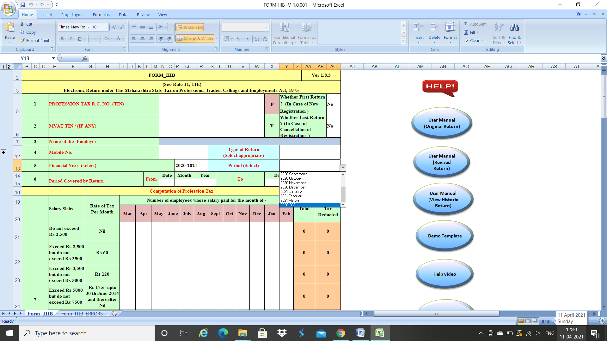
- Enter the no of employees whose salary is paid for each month from March to February: In case of PTRC return period is “March to Feb” for the relevant year. Hence, enter data for each month from “March to Feb”. For e.g. if 5 employees are paid salary is paid for the month of April then no of employees for the month of April shall be 5.(Refer image below)
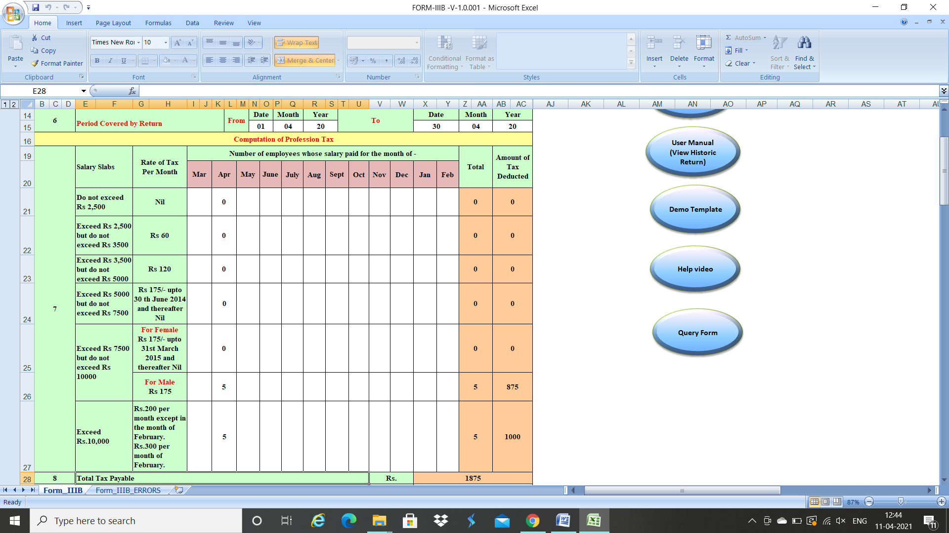
- PTRC Challan details like Challan no, Amount paid through challan, Payment date, Name of the Bank and Branch details. (Refer image below for proper understanding)
- Name of authorized person, Designation and Email Id of the authorized person.
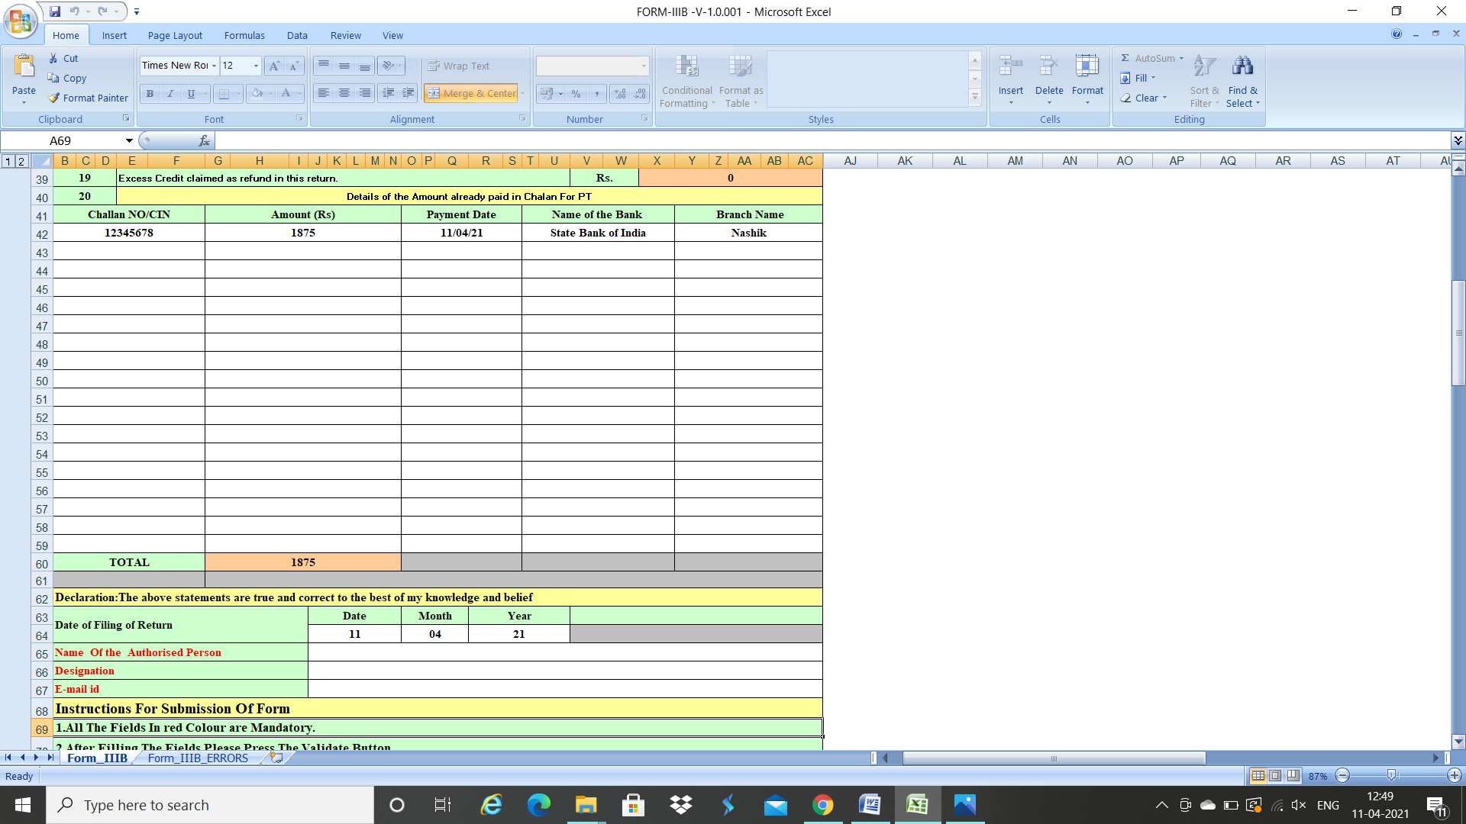

- After all details are entered click on “Press to Validate” button, which will throw the errors made in the Form in the “Form_ IIIB_ ERRORS” sheet. If all the fields are proper then xml will get generated which need to be uploaded on the Mahagst portal (The procedure for which is explained below).

Steps to file PTRC return Form_ IIIB online:
- The following is the steps to file PTRC return online:
- Step 1: Go to www.mahagst.gov.in.
- Step 2: Click on “Menu” button.
Click on Menu button on the upper left side of the page, you will be able to see “Login for e-Services” as above.
- Step 3: Click on ‘’ Log in for VAT & Allied Acts” in Log in for e-Services.
Enter your Login credentials and click on Log on.
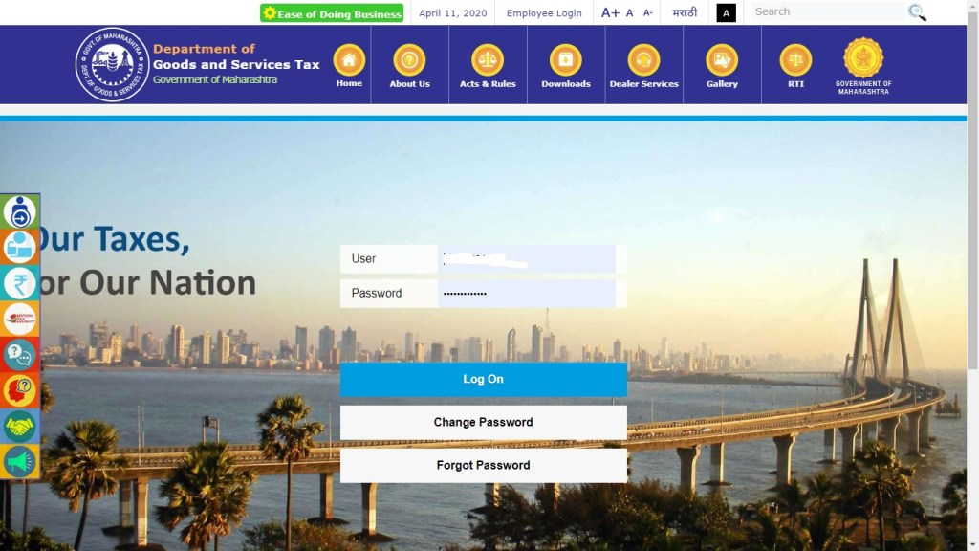
- Step 4: Returns
Now Click on “Returns” from the menu which will redirect you to return filing homepage.
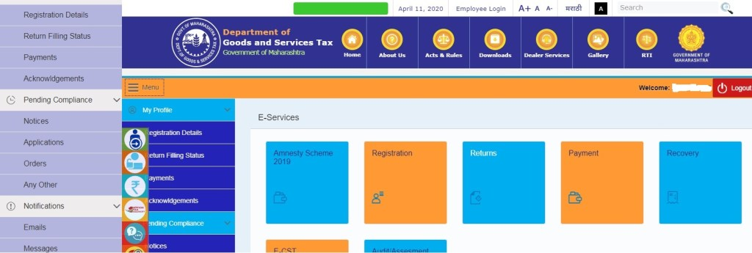
- Step 5: Now click on “Return Submission Other Than VAT/CST (From 1st April 2016)” option. It will redirect you to select the return type.
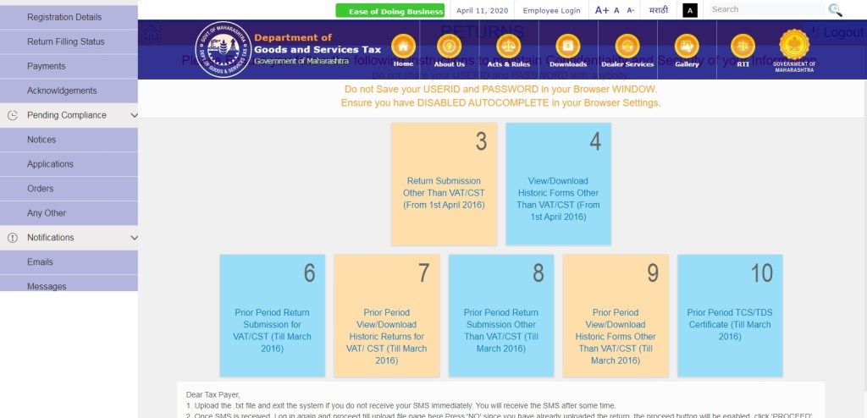
- Step 6: Select “PTRC act” from the drop down. Based on your selection “Form IIIB” will appear by default and click on “NEXT” button in the bottom it will redirect to Type of return statement page.
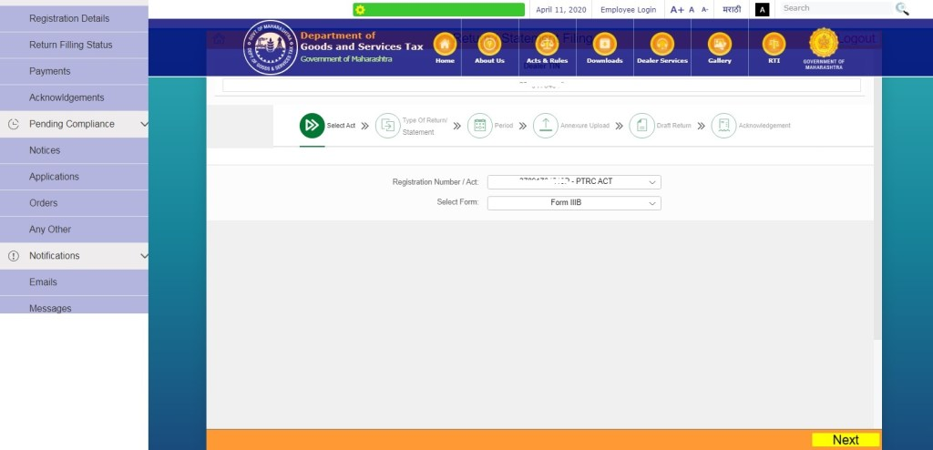

- Step 7: Select Statement Type from Dropdown as “Original” and click on “Next” button it will redirect to “Period of Return” page.
- Step 8: On selecting the return period you will be shown all unfiled periods and Click on “Next”, it will redirect to upload new file. You will be asked to upload New File. Click on ‘’Yes’’ button.
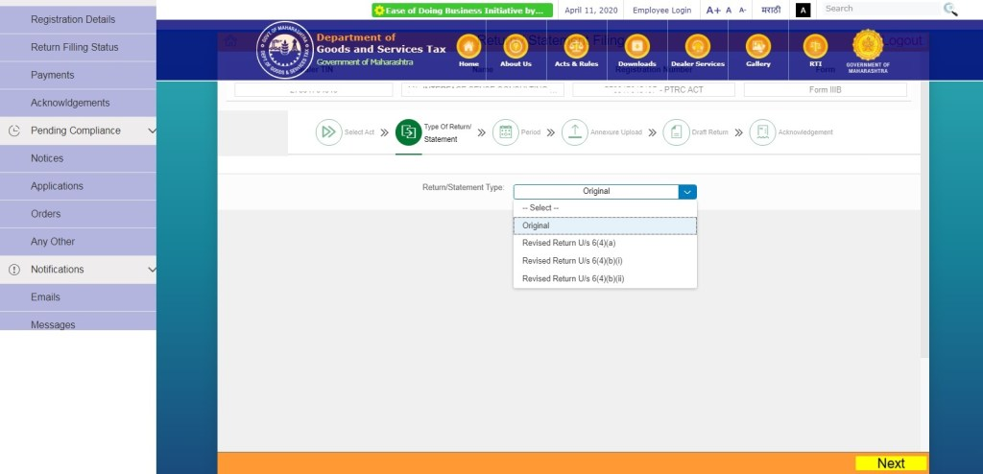
Click on “Yes” to upload new file. It will redirect to file uploading page.
- Step 9: Click on “Browse” and select the .txt file generated on your desktop from the Return template. Uploading “.txt” file name should match with your TIN, Form and Period. Click on “Open” to upload the file. Click on “Upload File”.
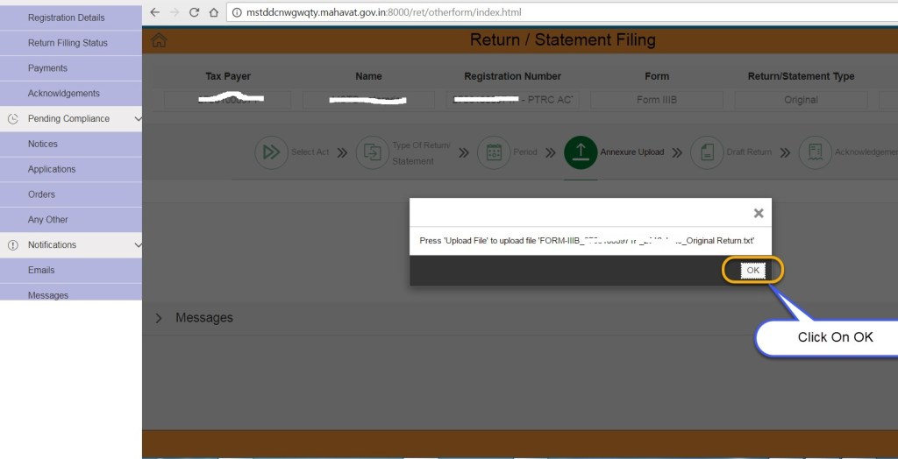
After click on “Upload File”, it will redirect to draft return page. Click on “Yes” to upload a new .txt file OR Click No to continue, it will redirect to “Submit” Screen.
Note: The System will display the Draft Return before submission
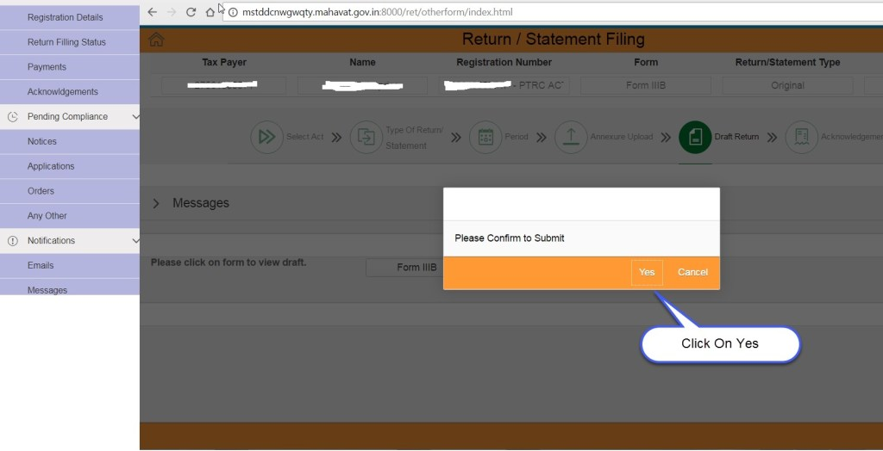
- Before submitting the Return, you can click on, “Form IIIB” to view the Draft Return.
- You can review or download Draft Return.
- Check the input is given by you in Return template and compare with Draft Return then click on “Submit” button.

- Step 10: Click on “Yes”
Click on “Yes” to confirm the submission. You will redirect to acknowledgement message screen.
- Once your Return is submitted successfully, Return Submission Acknowledgement will be displayed on the screen.
- Return PDF and Acknowledgement will be sent to you on your e-mail id provided in Return template.
- SMS will be sent on your mobile number provided in the Return template.

- Step 11: Click on “Download Return” button to view the Return pdf.
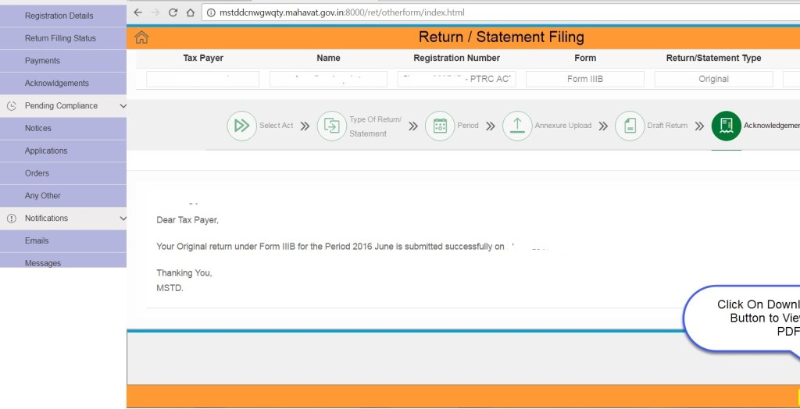

“THANK YOU”

From,
ANIKET V KOTHAWADE
CHARTERED ACCOUNATANT
NASHIK
Contact No: 8087967277
Email-ID: aniketkothawade@gmail.com

