How to file Form 9 in Dvat for the year 2013-2014.
Under Delhi Vat Form-9 refers to e-filing reconciliation in respect to statutory forms received, pending forms and tax paid if any against pending forms for the year 2013-14.It is to be filed by dealer who have made central sale/or stock transfer.
The due date for same is 28.11.2014.
Steps for filling the form online:

Step1:Login to your Dealer account.

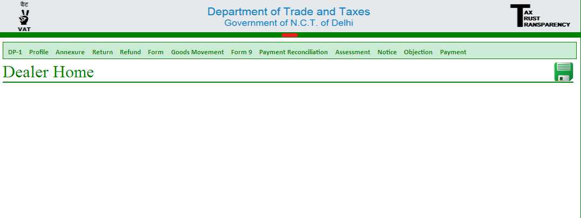

Step2:Click on Form 9 and select Form 9 entry.A screen like below would appear
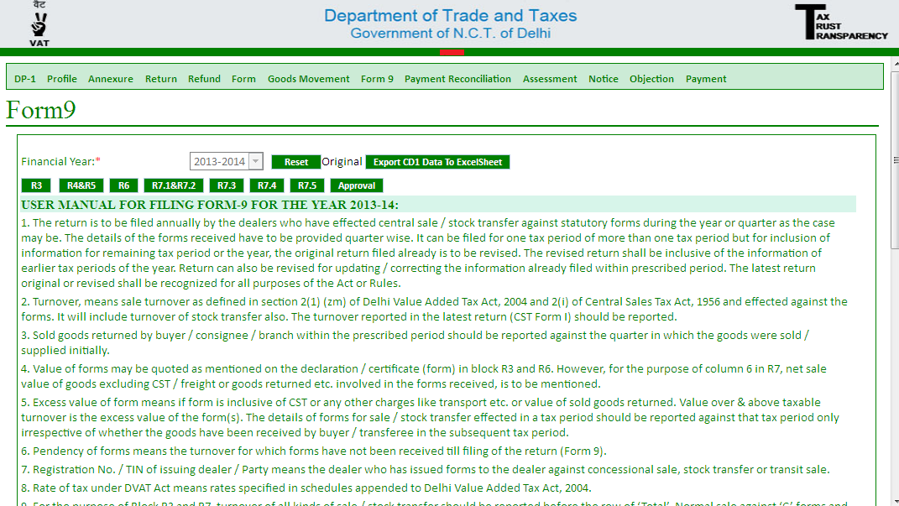

The form has following parts:
1.R3: In R3 a dealer is required to furnish details of Receipt & Pendency of declaration form like Form C or Form F,C+EI,C+EII,H for the year 2013-2014.

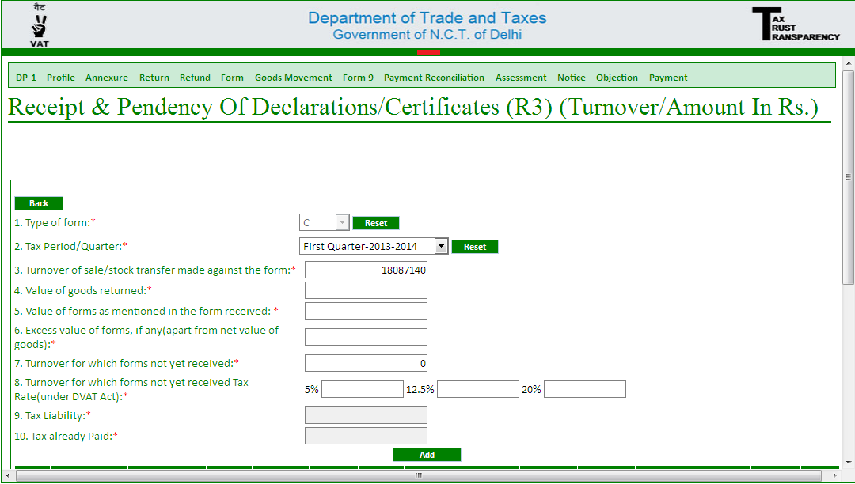
Value as mentioned in all Form C received for the quater.
Excess value means value of forms over and above the taxable turnover
The figure is the value of Central sales made for the Quarter concerned. It should be equal to the value stated in quarterly return
Please note:Pendency of form means –forms not received till filling the form-9.The tax liability for the forms not received in shown is reflected in R4 and R5.

2.R6:In R6 details of forms received for the year 2013-2014 for each quarter have to be entered.details of each C form along with Serial Number and amount has to be filled in.

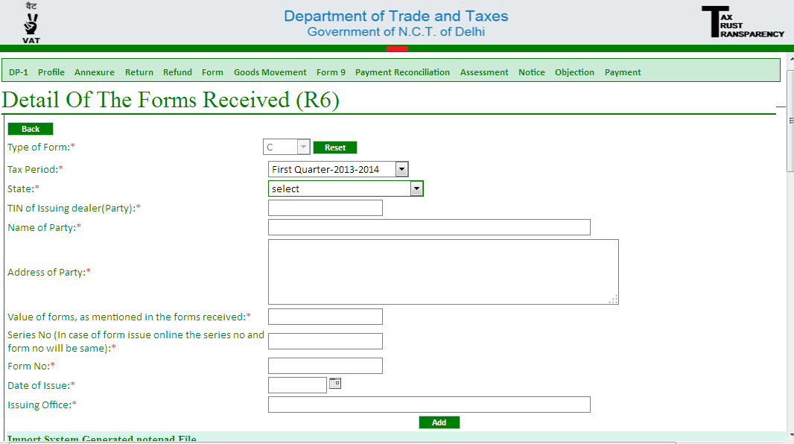
Value as mentioned in the C Form has to be entered here.The value may be inclusive of cst or other charges like freight.Total value mentioned in form is to be considered.
Once you have filled the details for each quarter of 2013-2014.Proceed to the next form:R7.1
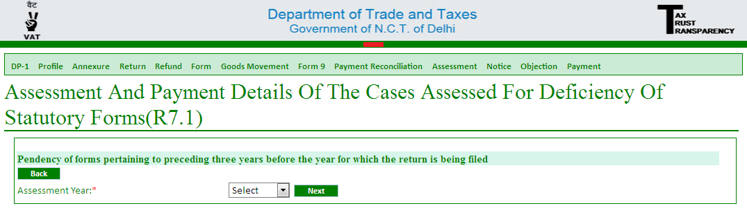
The form shows details of pending forms as assessed in assessment for the preceding three years i.e. for the years 2010-2011,2011-2012 and 2012-2013.If no assessment has been done for the preceding years or assessment done with no forms pending then no need to enter anything in Form R7.1.
3.R7.3-In R7.3 we fill the details of pending forms for the years for which no assessment has been framed.Fill the details for preceding year 2012-2013.
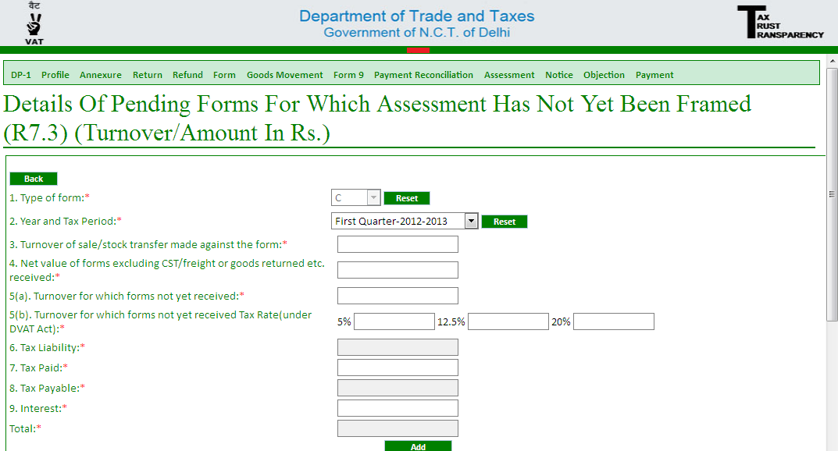
Enter Value of forms less cst less freight less goods returned(if cst,freight or goods returned value is included in taxable value in c form)
Enter the value of central sales as mentioned in the quarterly return

After filling details in Form R7.3 proceed to R7.5.

4.In R7.5 fill the details of C-form of Form F received for every quarter of the year 2012-2013.Detail of each C form received is to be entered in the same manner as we did in R6.The screen for R7.5 is as below:
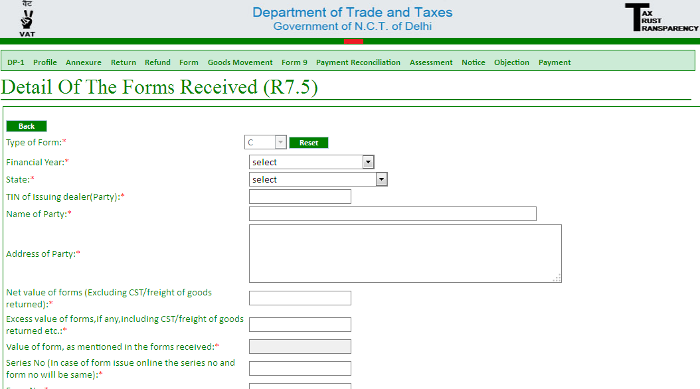

Once have filled all the forms ,the last step is to approve the Form 9 before final submission.Click on Approve and you would be directed to a screen which would appear like this:
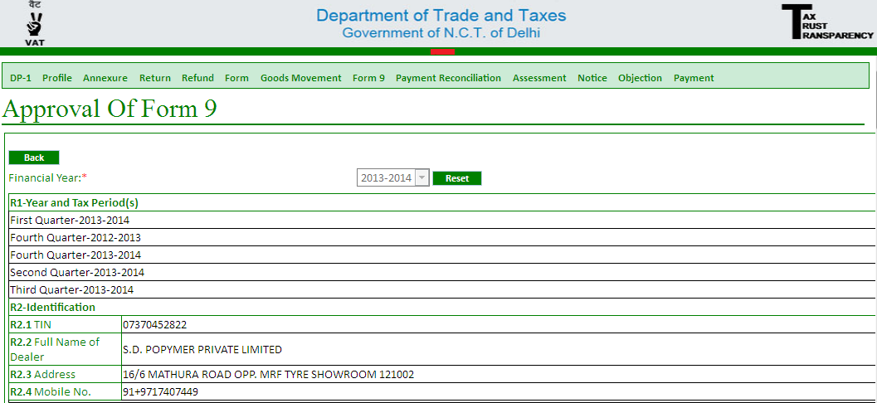

Cross check all the information and submit your Form 9.
Please note for your quick reference ,I have drawn a table below covering almost every detail required to be filed in form9. Table 1-quaterly detail
Type of form | Tax period | Turnover of sales for the tax period(a) | Value of goods returned | Value of Form Received  (b) | Excess Vaue of Form(c )=(b-a) | Turnover for which no form received | Tax rate turnover for which no form received | Tax liability | Tax already paid
C | Qtr-1,13-14 | 10000 | 0 | 12000 | 2000 | 0 | 5% | 0 | 0

Table 2-Details of each C form received
Type of form | Tax period | State | TIN of issuing dealer | Name of party | Address of Party | Net value of form(i.e. taxable value) | Value of Form as mentioned in form received | Excess value of form | Serial No | Form No | Date of issue | Issuing office

Hope the file was of some use.In case of further query write in to annugoyal@gmail.com

