MVAT ACT, 2002

- Who Needs to Register?

 |  |  |  | 
 |  | 
 |  |  |  | 
 |  | 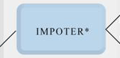
 |  |  |  | 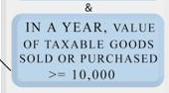

 |  | 
 |  |  |  | 
 |  | 
 |  |  |  | 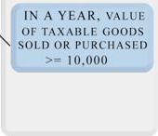

- VOLUNTARY REGISTRATION UNDER MVAT
If dealer wishes to avail the benefits of being a registered dealer, he may apply for voluntary registration by paying a fee of Rs. 5,000/- and Rs.25,000/-as a deposit, which can be used to pay tax payable during the year of registration and subsequent year. If dealer is not in position to utilize the deposit fully even in second year of registration, He can claim refund of the unutilized amount
- REGISTRATION IN CASE OF TAX DEDUCTED AT SOURCE
By notification dated 29th August, 2005, if you have awarded a works contract, whether or not to a registered dealer, and you are making a payment to him of more than Rs.5 lakhs in a year, then you are required to deduct tax at source (TDS) while making the payment. Before making such payment, you must also be registered under this act.
  - If the contractor is a registered dealer, TDS has to be deducted at 2%.
  - And in case the contractor is unregistered, TDS has to be deducted at 4%.

- How to Register?
Application for Registration under section 16 of The Maharashtra Value Added Tax Act, 2002 has to be made in FORM 101, electronically
While making an application for registration, certain documents have to be submitted, list of it given in subsequent part.
Note: Copies of documents must be self attested and the originals should be submitted for verification
- Dealer logon to web-site www.mahavat.gov.in
- Click on e-registration in e-services column on home page.
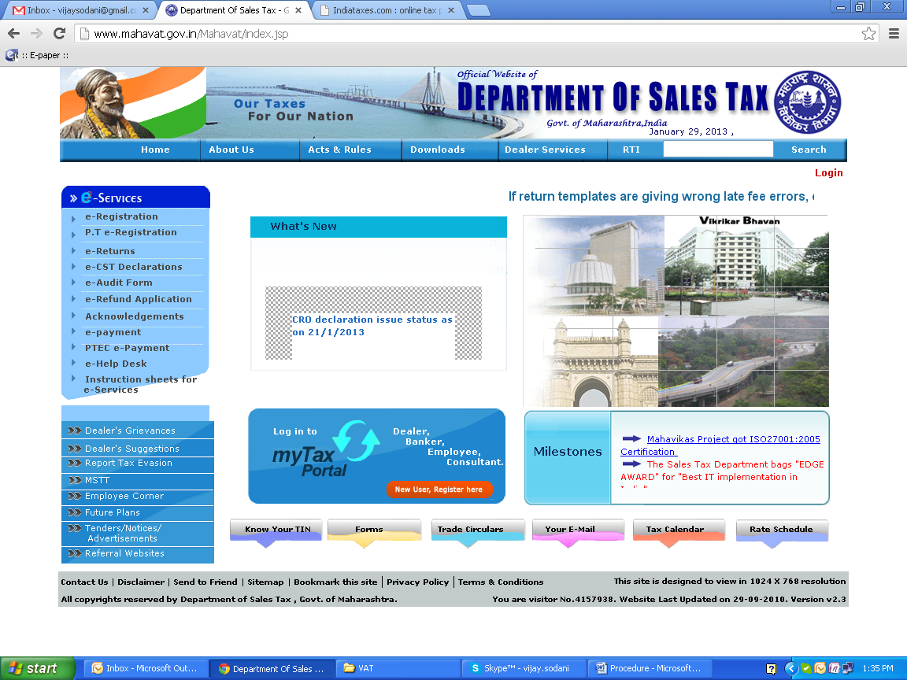
- Instruction sheet – Detailed guidelines regarding application process flow, location details, list of required documents are provided in the instruction sheet. Click “next” and then “e registration information” page will appear.
- e -Registration Information page opens. Read Tool Tips : If net browser IE.6 SP2 or Mozilla Firefox is not available then download Mozilla Firefox by pressing Mozilla Firefox 3.5 button
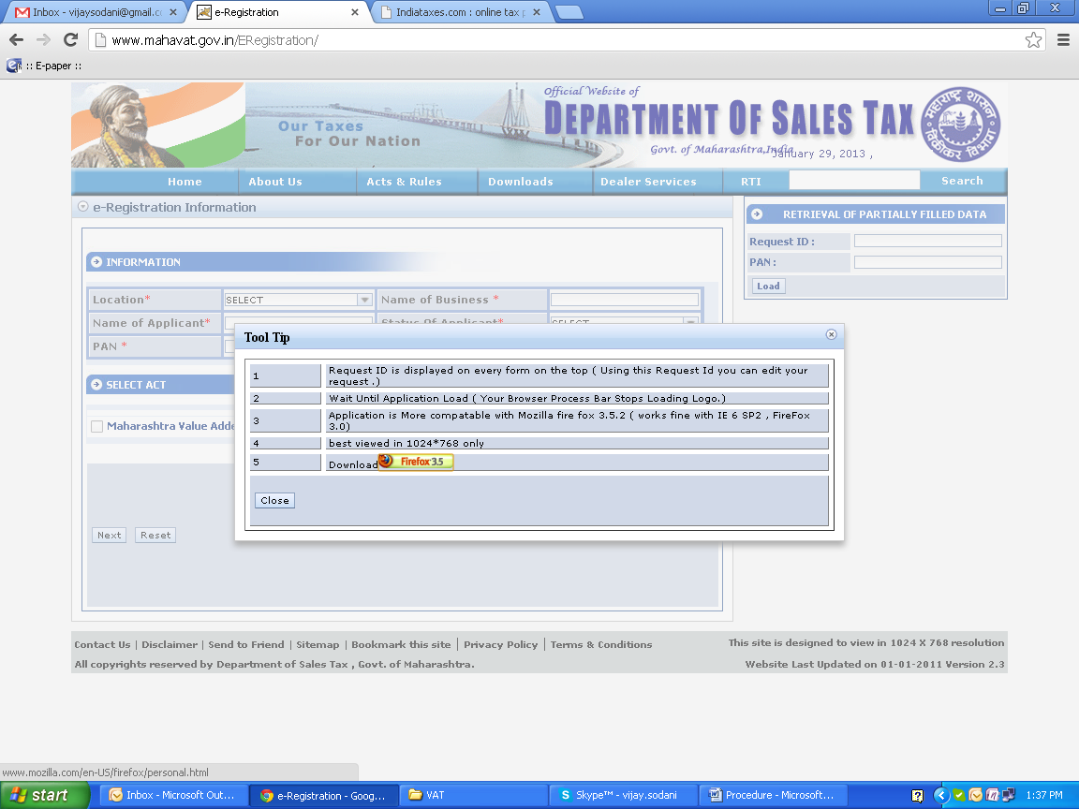
- On the “e Registration Information” page, dealer should enter /select details such as PAN, location, name of business, name of applicant, status of applicant and Act. Applications under MVAT Act and CST Act shall be made electronically. For the time being applications for registration under all other Acts such as Profession Tax Act, Luxury Tax Act, Maharashtra Tax on the Entry of Goods into Local Areas Act and Sugarcane Purchase Tax Act should be submitted manually.
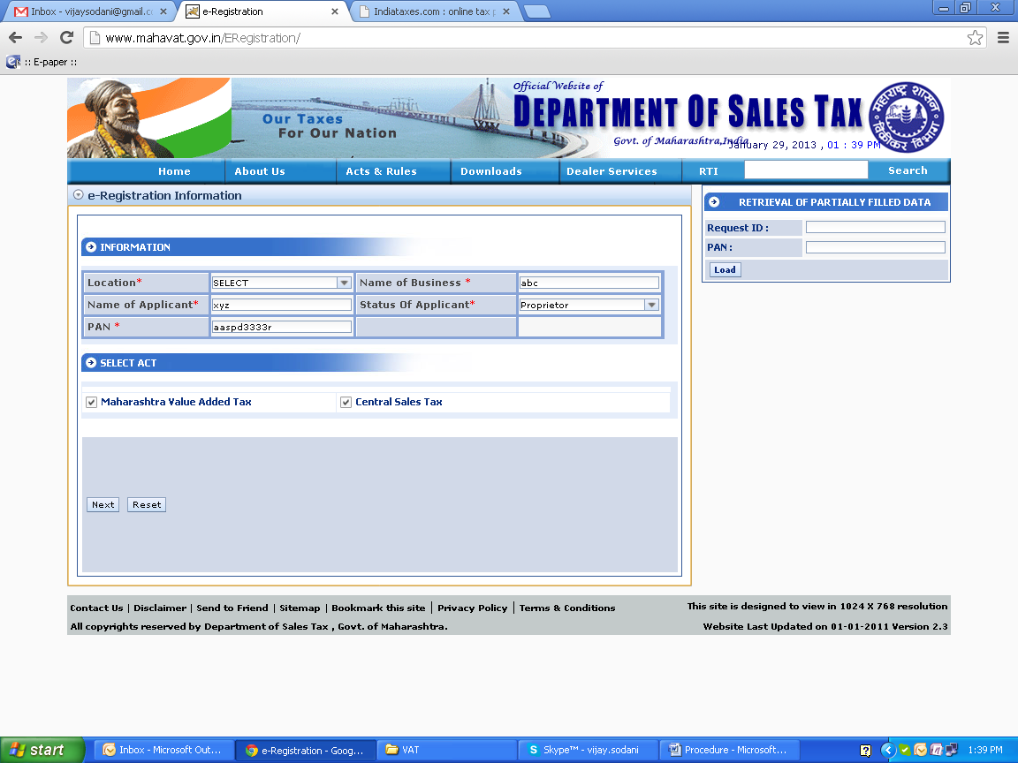
- After the information on the “e Registration Information” page is entered, the dealer should click “next”.
- E-application under MVAT Act will open
- Request id :
Request id of the dealer will appear on upper corner of this left side in red letters. Once Request id is generated, the information entered / selected on ‘e-Registration Information Page’ will not be editable hence dealer has to ensure that information filled on ‘e-Registration Information Page’ is correct before clicking the next option. This request ID and PAN should be noted. If dealer wants to fill e-application in multisession, then dealer should enter this request ID and PAN in “Retrieval of Partially Filled Data” window which appears on e-Registration Information page.
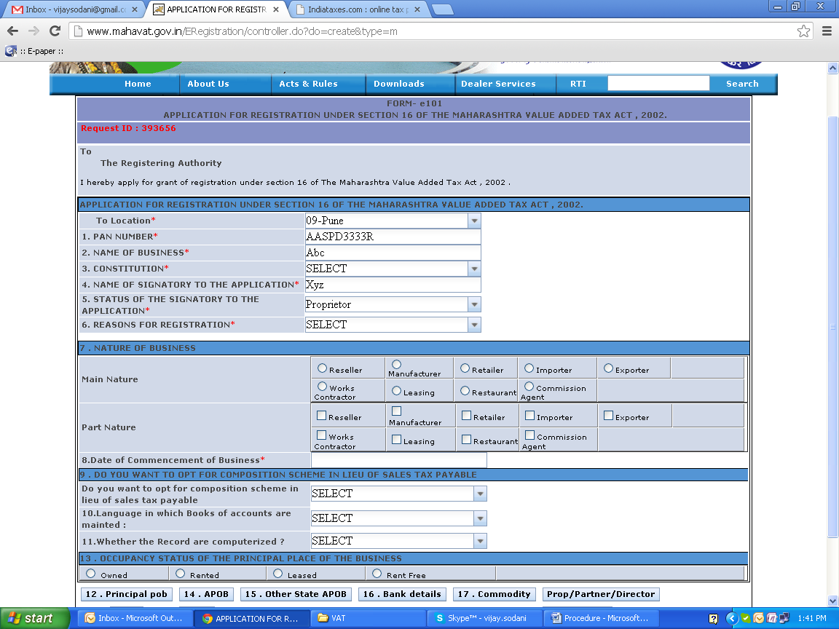
- Information in the form should be completely filled either by entering in the relevant fields or selecting from the given lists and then “submit” button should be clicked... In case a dealer has opted for CST also, then the CST e-application form will open. The data in the field’s common to both VAT and CST shall get populated for the ease of the applicant. Remaining fields are expected to be entered / selected by the applicant.
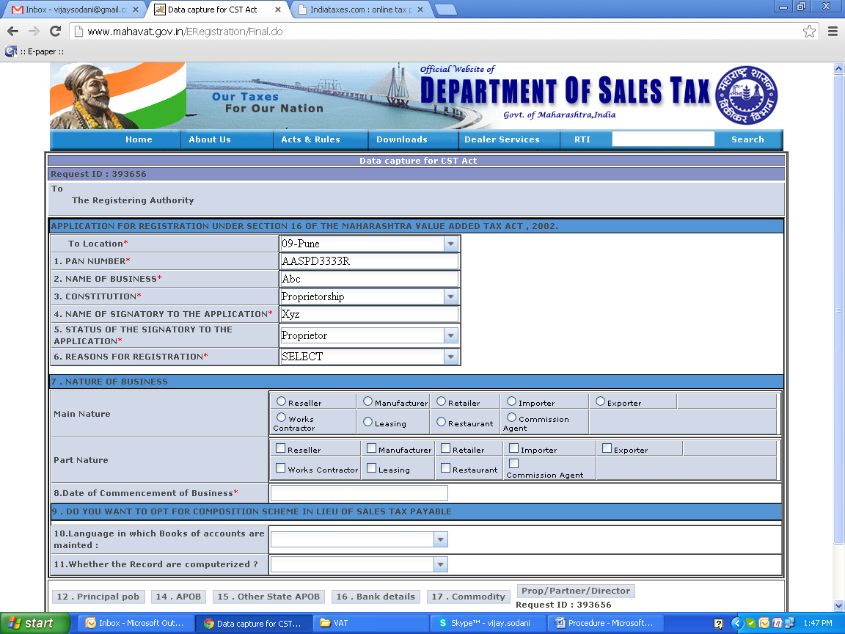
- In case the data in any of the fields is not entered, then the applicant would get error message and would be prompted to enter the said data.
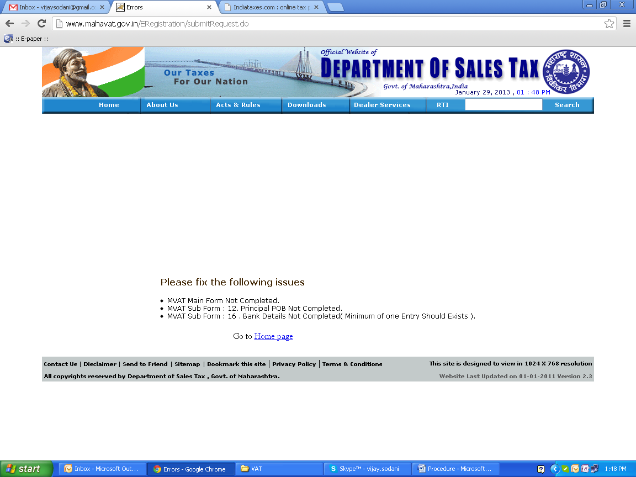
- After the completely filled application form is submitted (uploaded) then the acknowledgment containing date and time for attending before Registering Authority along with code/designation and address of Registering Authority would be generated. This acknowledgment can be saved and should be printed for producing before the registering authority. The dealer should also save the downloadable MVAT and CST e-application form of registration and should take out a print of it.
- The proprietor, partner, Karta, Director, as the case may be are required to sign at relevant place/places on the print out of the application so taken and submit it to the concerned Registration Authority at the time of verification and photo attestation on given date and time along with relevant documents. In case of voluntary registration signature of “introducer” should also be obtained.
- If the application is correct and complete in all respect along with relevant documents then Registering Authority will generate TIN after verification. Registration certificates shall be printed and issued to the dealer on the appointed day. In case the application is eligible for granting registration, then the date of uploading the application shall be considered as the date of application for the purpose of determining the effective date of MVAT RC. In case the dealer has uploaded CST application also, then for the purpose of determining the CST RC effective date, the date of uploading CST application shall be considered as the application date.

- Documents Required?
- In Case of Fresh Registration:-
- Proof of constitution of business (as applicable)
In case of proprietary firm | No proof required
In case of partnership firm | Copy of Partnership Deed (Registered or unregistered)
In case of company | Copy of Memorandum of Association Articles of Association
In case of other constitution | Copy of relevant documents
- Proof of permanent residential address *(Please provide at least 2 documents out of the following documents containing the name and present address). #
  - Copy of passport
  - Copy of driving license
  - Copy of election photo identity card
  - Copy of property card or latest receipt of property tax of Municipal corporation/Council/Grampanchayat as the case may be.
  - Copy of latest paid electricity bill in the name of the applicant.
  - Copy of ration card.
- Proof of place of business
In case of proprietary firm | No proof required
In case of owner | Proof of ownership of premises viz. copy of property card or ownership deed or agreement with the builder or any other relevant documents.
In case of tenant | Proof of tenancy/sub-tenancy like copy of tenancy Sub-tenant agreement or rent receipt or leave and license or consent letter, etc. supported by Documents showing ownership of licensor or person giving consent.
- One latest passport size photograph of the applicant ** (Please do not paste the photo on the printout of application.)
- Copy of Income Tax Assessment Order having PAN or copy of PAN card.

  - Challan in Form No. 210 along with Demand Draft (D.D)/Pay Order (P.O) showing payment of Registration Fee of Rs. 5000/- and Deposit of Rs. 25000/- in case of Voluntary Registration and Rs. 5000/- in other cases. However the dealer may pay Registration Fee of Rs. 5000/- by the way of Court Fee Stamp.
  - For Mumbai location the D.D/ P.O should be drawn in favor of Bank of Maharashtra A/CMVAT and D.D/P.O should be drawn in favor of State Bank of India, A/C MVAT, payable at respective locations.
  - The fees of Rs. 25/- towards CST registration to be paid by affixing the Court Fee Stamp on’ Form- A’.
* In case of partnership firm proof of residence has to be provided for all partners and in case of body corporate, proof of residence of signatory to application should be provided.
# In case of corporate bodies, the details of place of residence and PAN, etc. shall be required to be furnished only for the signatory to the application.
**In case of partnership firm, photograph of only applicant partner needs to be submitted.
Note:
- Copies of documents must be self attested and the originals should be submitted for verification
SUBMISSION OF DOCUMENTS IN THE FOLLOWING SEQUENCE
  - PAN.
  - Bank cancelled cheque leaf.
  - Documents for Place of Business.
  - Documents for Place of Residence.
  - Partnership Deed/ Memorandum & Article of Association ( as applicable)
  - Any other related documents

- In case of Change in Constitution.
- Proof of change in constitution (e.g. if proprietary concern converted to partnership firm then copy of Partnership deed etc.)
- Copy of latest return-cum-challan.
- Registration fee as per Point no 6 of Fresh Registration
- PAN of new firm.
- Proof of permanent residential address as specified at Point no 2 of Fresh Registration

SUBMISSION OF DOCUMENTS IN THE FOLLOWING SEQUENCE
- PAN.
- Bank cancelled cheque leaf.
- Documents for Place of Business.
- Documents for Place of Residence.
- Partnership Deed/ Memorandum & Article of Association ( as applicable)
- Any other related documents

- REGISTRATION IN CASE OF TRANSFER OF BUSINESS

1. All documents from point no 1 to 6 of Fresh Registration
2. Copy of transfer deed.
3. Copy of latest return-cum-challan of the original dealer.
Please attach a leaf of cancelled cheque, as proof of bank account for all types of registration.

- Changes in Business Circumstances.
If, following your registration, there are any amendments to the details you reported when applying for registration, you must, within 60 days of the change, inform the government in writing. Where the amendment involves the following:
- change in the name of the business;
- change in the constitution of the business without dissolution of the firm;
- change in the trustees of a Trust;
- change in the guardianship of a ward;
- change in the Karta of a Hindu Undivided Family;
- conversion of Private limited Company to a Public limited Company;
- change in the place of business;
- addition of new place of business;
- Formation of a partnership with regard to the business.
- an application made by you for insolvency or liquidation of your business;
- an application made against your business for insolvency or liquidation;
- opening or closing of a bank account;
You will not need to make a fresh application for registration. However, the communication to the Registering Authority concerned should be made within sixty days of the change or occurrence of the event.
* NOTE: In case of change in constitution of business (other than in situation as given in ‘b’) and in case of transfer of business, fresh registration has to be made.)

- Cancellation of Registration.

- You will be liable to pay VAT while your registration is effective. If, however, your turnover falls below the threshold, you may choose to apply for cancellation of your registration.
- However, you should continue to collect and pay VAT in the normal way until your registration is formally cancelled. Alternatively, you may allow the registration to continue.
- If you
  - Discontinue your business;
  - Dispose of or sell or transfer your business;
You must inform the Sales Tax Department within 30 days of the event.
- In case of discontinuance of business the registration will be cancelled.
- In case of disposal or sale of business, your successor will need to apply for a fresh registration certificate.
- The Sales Tax Department may cancel your registration in case it comes to know that your business has been discontinued, transferred or place of business has been transferred to another local area, but only after giving you an opportunity of being heard. Unless the Department is satisfied with your plea, you must return the Certificate of Registration.
- The cancellation of your certificate does not affect your liability to pay any tax, interest or penalties in respect of any period prior to the date of cancellation of your registration.
- Form for cancellation of certificate: FORM 103.

- E-Filing Process

For the detailed procedure of getting registered on website of MVAT and the process of filing, press Ctrl and Click Here.

- In Short,
- Get registered on www.mahavat.gov.in
- Download the respective form.
- Duly Fill it.
- Validate it.
- Upload.

