VALUE ADDED TAX (VAT)

- Tax: Tax is compulsory payment to government under any law.
- Why Taxes? Deference, education, health-care, infrastructure, etc.
- Types of Taxes:
- Indirect Tax --- the person who bears the burden of tax does not himself deposit it with the government. E.g. VAT & Service Tax
- Direct Tax --- the person who bears the burden of tax himself deposits it with the government. E.g. Income Tax
- Meaning of VAT: Vat is tax on sales but is not payable again the amount of purchases, on which tax has already been paid.
VAT = Tax collected on sales – Tax paid on purchases
VAT = Output Tax – Input Tax
- Input Tax Credit: Tax is imposed at each stage of sales on the entire sales value and the tax paid at the earlier stage is allowed as set-off. This credit availability is called input tax credit (ITC).
- Vat is a multistage tax levied on value added.
- Entire burden of VAT falls on the final consumer. This is because every seller recovers the amount of tax from the buyer. But final consumer does not sell the goods; therefore he will not be able to recover the amount of tax from any person.
- Presently in India a state government allows credit of only those taxes that have been paid to the same state government.
- As per CAS-4 of ICWA, any taxes paid on purchase of goods, of which credit is not allowed, are included in the cost of goods.
- Manufacturer is liable to pay Excise Duty to central government and VAT to sate government.
- GST: Different taxes on goods and services will be merged in one tax that will be called goods and services tax. Presently GST is only proposed, it is not applicable in India.
- Purchases not eligible for ITC (Exceptions to ITC): ITC shall not be allowed on the purchase of goods ---
- Exempted goods
- Composition Scheme
- Imported Outside India
- Invoice is not available
- Notified by state government
- Personal use
- Unregistered Dealers
- Tax not shown separately
- Vat or CST paid in other State
- CST: Central Sales Tax is collected and kept by the state government from where the movement of goods started. {Present rate of CST is 2%}
- Eligible purchases for availing ITC:
- Sold within the same state
- Interstate sales
- To be used as:
- Containers or packing material
- Raw Material
- Capital Goods (for manufacturing or resale of taxable goods)
- Credit on Capital Goods:

Meaning of Capital Goods | Reasons for allowing credit of taxes on capital goods | Reasons for hesitation to give ITC on capital goods
Goods that are not kept for sale but are used for producing and selling other goods. E.g. machineries, furniture, air conditioners, vehicles, etc. | - Person who sells capital goods deposits VAT on total sale price of such capital goods.  - Person who purchases capital goods allocates its cost in the sale price of goods by way of depreciation. This leads to double taxation*.  - Hence, taxes paid are allowed deduction. | - Govt. do not want to want to loose huge tax revenue.  - Capital goods are normally high value goods. Hence, huge tax revenue.  - Capital goods are not fully used in one or two years. It takes many years to allocate them in the final products.

*Double Taxation on Capital Goods

Raw Material = 100
+Allocated Cost of Machinery = 20
+Expenses = 30
+Profits = 150
Sale Price = 300

- Variants of VAT:
- Gross Product variant --- credit is allowed for taxes on purchases; not for capital goods.
- Consumption variant --- credit is allowed for taxes on purchases (including capital goods)
- Income variant --- credit is allowed for taxes on purchases as well as on capital goods. Credit on capital goods is allowed in installments in 2-3 years (36 months) depending on the state law, but keeping in recommendations of white paper. {Presently this method is being followed in India.}

- Carrying over of tax credit:

*Excess after utilization is when Tax collected on sales < Tax paid on purchases.
**No limit of period of carry forward of credit. No refund of credit is allowed except in the case of exports.

- There is no need for a one-to-one correlation between Input Tax and Output Tax.
- Administrative Procedure under VAT Registration:
- Registration is the process of obtaining certificate of registration from authorities under VAT Acts.
- Eligibility --- Gross Annual Turnover above Rs. 10,00,000 (as per white paper).
- Time Limit --- allowed 30 days from the date of liability to get registered.
- Voluntary Registration ---
  - A dealer who is not eligible may also obtain voluntary registration.
  - Commissioner may impose terms and conditions.
- Cancellation of Registration --- Registration can cancelled on
  - Discontinuance of business; or
  - Selling of business; or
  - Shifting of business to a new location (different state).
- Tax Identification Number (TIN)
- Registration number – 11 digits
- First 2 – state code
- Next 2 – check digits to ensure correctness
- Remaining 7 – unique identification of any dealer
- TIN facilitates cross checking of information.
- Example of a TIN No. ---
- Importance of VAT Invoice:
- Determining credit
- Assurance of invoices
- Assists in audit
- Checks evasion of tax

- Example of Tax Invoice

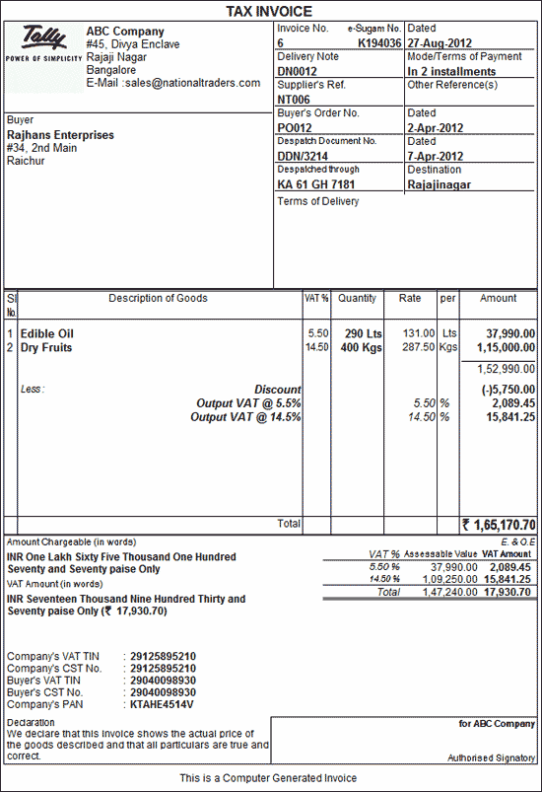

- Small Dealers and Composition Scheme: Dealers with limited turnover – option to pay a lump sum amount – rate as low as 0.25%
- Composition Scheme
- Conditions for Composition Scheme:
  - Turnover --- Rs. 10,00,000 to Rs. 50,00,000
  - Following are not eligible for composition scheme ---
    - Inter-state trade
    - Import or export
    - Transfer of goods to the branch or execution of works contract (i.e. no sales)
- Advantages ---
  - Simplifies calculation
  - Small tax
  - Simple return
  - Simple records
- Disadvantages ---
  - No input tax credit
  - Cannot issue tax invoices
- Stock transfer i.e. transfer to branch does not amount to sale. Therefore, they are not subject to VAT. However tax is paid on:
- Input used in manufacture of finished goods which are stock transferred; or
- Purchases of goods that are stock transferred are available as ITC after retention of 2% of such tax by state govt.
- VAT chain breaks on opting for composition scheme. Loss to seller --- If the composition scheme is availed by a dealer then such dealer cannot avail ITC in respect of input tax paid. Hence the dealer will be loosing the ITC on purchases made by him. He will not be able to pass on the benefit of ITC, which will be added to the cost of the goods. Loss to the purchaser --- The purchaser shall not get any tax credit for the purchases made by him for the dealer operating under the composition scheme.
- Tax Rates under VAT:
- Two basic rates --- 4% and 12.5%
- 1% for gold and silver
- Exempted goods ---
  - 50 commodities of natural and unprocessed products in unorganized sector
  - Items having social implication
- Petrol, diesel, liquor, lottery tickets and other motor spirits are kept outside VAT.
- Facilities given to exporters and SEZ:
- Refund to exporters within 3 months from the end of the period in which transaction for export took place.
- Units of SEZ (Special Economic Zones) and EOU (Export Oriented Units) are granted either exemption from payment of input tax or refund of input tax paid within 3 months. State govt. may reduce the period of 3 months.
- Types of Records: Following records are mandatory under VAT
- Purchase Records
- Sales Records
- VAT Account
- Returns:
- When returns are to be filed ---
  - Monthly or
  - Quarterly or
  - Annually as per the provisions of the State Acts/ Rules
- Required Details ---
  - Output tax
  - Input tax
  - VAT payable
- Scrutiny ---
  - Selected returns shall be scrutinized.
  - If any mistake is detected in scrutiny, the dealer shall be required to pay the deficit.
- Penal Provisions: incorporated by state. Some of them which attract penalties are ---
- Failure to keep records
- Failure to get registered
- Failure to furnish returns
- Failure to deposit tax in time
- Assessment:
- No compulsory assessment
- The liability of tax is himself assessed by the dealer which is called self assessment.
- In selected cases – audit is required. Audit is required due to ---
  - Lack of education
  - Lack of resources
  - Self-assessment
- Internal Audit --- authorized officers of department
External Audit --- CA’s
- Role of CA in VAT:
- Record Keeping
- Tax Planning
- External Audit of VAT Records
- Dealing with departmental officers
- Comparison of Past Sales Tax and VAT:

Basis | Past Sales Tax Law | VAT
Stage of Levy | Single stage | Multi stage
Subsequent Sales | Exempt | Chargeable to tax
Tax Liability | Computation - complex | Computation - easier
Forms | Large number of forms | No forms. Only invoices are required.
Assessment | Done by department | Done by dealers
Penalty | Stricter | Not Strict
- Merits of VAT:
- No tax evasion
- Transparency
- Neutral to production decisions
- Better accounting system
- Better revenue collection
- VAT bring certainty
- Reduces the ultimate sale price
- De-merits of VAT:
- Increase in cost
- Increase in working capital
- Non availability of credit of other taxes
- Demerit of VAT from the view point that it is form of consumption tax --- poor person ends up paying more taxes in the proportion of his income as compared to rich one.
- Methods of VAT
- Addition Method --- Value Addition = Profit + Trading and Manufacturing all other expenses
- Subtraction Method --- Value Addition = Sale Price – Purchase Price
- Invoice Method/ Tax Credit Method/ Voucher Method --- tax paid at earlier stage is allowed as set off on the basis of invoices.

