
AMENDMENTS TO SARFAESI ACT, 2002 : EVERY BANKER WORKING IN CREDIT MUST KNOW
~ Sumat Singhal

The Central Government has notified the provisions of Chapter IVA of Sarfaesi Act, 2020 w.e.f. 24th January 2020 consisting of sections 26B to 26E. This amendment would have major impact on Indian bank’s right over secured creditor.

Implication of such amendment has been explained through this write up as below :

A. The filing of transactions can be done now by all creditors for the purpose of securing due repayment of any financial assistance granted by such creditor to the borrower.
This facility was earlier open only to banks, FIs, Specified NBFCs, ARCs, debenture trustees or any other trustee holding securities on half of banks or FIs – Sec 26B

The effect of amendment is as follows:

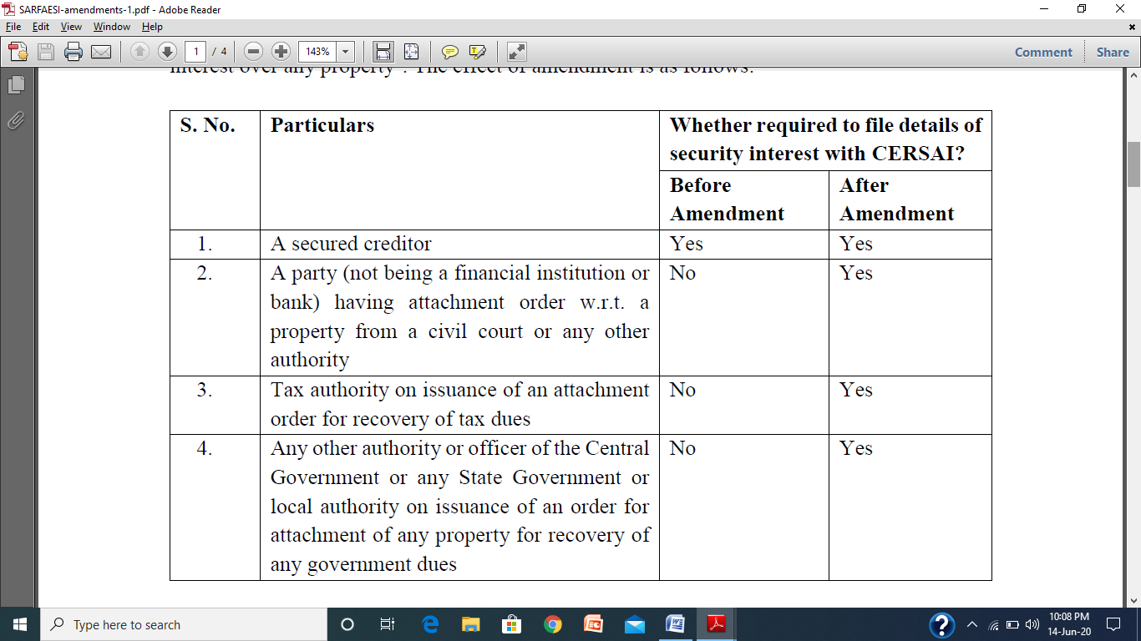
What is the impact of filing or non- filing of Security Interest?
Section 26C(1) of SARAESI Act stipulates that registration of interests, including attachment orders, will serve as a public notification, so that anyone dealing with the property cannot claim to be ignorant about the existence of such interests.
Further, Section 26C (2) provides priority to registered charges, i.e. where there is a registered security interest, any subsequent security interest on the property will be subordinated to a pre-registered interest. In this regard, let us consider the following illustrations: ABC Bank extends loan to P, by creating a security interest on a Property X, Subsequently, B, who is unaware of the loan extended by A, extends loan to P, by creating a security interest in Property X. B then registers its security interest with CERSAI. In this case, who will have priority?
Since security interest of A was not registered, B will have priority.
B. Bar on exercise of SARFAESI powers in case of unregistered security interests:

Section 26D provides that no secured creditor shall be entitled to exercise the rights of enforcement of securities under SARFAESI Act unless the security interest has been registered with CERSAI.
Thus effect of non- registration has been made even more severe. So credit officer fails to create charge at CERSAI, it may adversely impact enforcement of security interest under SERFAESI ACT.
C. Priority to registered security interests over statutory dues:

Section 26E provides that after the registration of security interest, the debts due to any secured creditor shall be paid in priority over all other debts and all revenues, taxes, cesses and other rates payable to the Central Government or State Government or local authority.
This notification also provides a platform where the security interest can be registered by any creditor or government authority who have any security interest or attachment order against any credit given or against any tax dues. This will provide a public notice to all before any subsequent charge is created on the property fraudulently by the borrower or the creditor.

Conclusion:


- Above notification effective from 24th January 2020 is very significant in terms of effect of registration with CERSAI and priority to secured creditors against government and tax dues.

- Main plus point for Banker here is that the registration of security interest with CERSAI would also assure the payment to secured creditors (like Bank) and tax dues or any other government dues would not have any priority over the dues of creditor who have registered his security interest with CERSAI.
**********************************************************************

