NEGOTIABLE INSTRUMENTS ACT, 1881 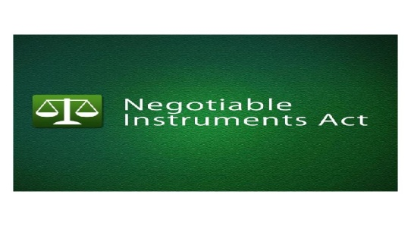
By-Abhiyansh Kumar Dikshit
(M.com, LL.B.( pursuing), CA (final))

INTRODUCTION
The Negotiable Instruments Act was enacted, in India, in 1881. Prior to its enactment, the provision of the English Negotiable Instrument Act were applicable in India, and the present Act is also based on the English Act with certain modifications. It extends to the whole of India except the State of Jammu and Kashmir. The Act operates subject to the provisions of Sections 31 and 32 of the Reserve Bank of India Act, 1934.
MEANING OF NEGOTIABLE INSTRUMENT
The word negotiable means ‘transferable by delivery’, and word instrument means ‘a written document by which a right is created in favour of some person. Thus, the term “negotiable instrument” means “a written document transferable by delivery”.
According to Section 13 (1) of the Negotiable Instruments Act, “A negotiable instrument means a promissory note, bill of exchange, or cheque payable either to order or to bearer”. “A negotiable instrument may be made payable to two or more payees jointly, or it may be made payable in the alternative to one of two, or one or some of several payees” [Section 13(2)].
TYPES OF NEGOTIABLE INSTRUMENTS
There are two types of Negotiable Instruments:
- Instruments Negotiable by Statute:
The Negotiable Instruments Act mentions only three kinds of negotiable instruments (Section 13). These are:
  - Promissory Notes
  - Bills of Exchange, and
  - Cheques
- Instruments Negotiable by Custom or Usage:
There are certain other instruments which have acquired the character of negotiability by the usage or custom of trade. For example: Exchequer bills, Bank notes, Share warrants, Circular notes, Bearer debentures, Dividend warrants, Share certificates with blank transfer deeds, etc.
PROMISSORY NOTES
Section 4 of the Act defines, “A promissory note is an instrument in writing (note being a bank-note or a currency note) containing an unconditional undertaking, signed by the maker, to pay a certain sum of money to or to the order of a certain person, or to the bearer of the instruments.”
The person who makes the promissory note and promises to pay is called the maker. The person to whom the payment is to be made is called the payee.
- Essential Elements of a Promissory Note
- The instrument must be in writing.
- It must be signed by the maker of it. The signature or mark may be placed anywhere on the instrument, not necessarily at the bottoms. It may be at the top or at the back of the instrument.
- It must contain a promise to pay. It must be expressed not implied or inferred.
e.g. “Mr. Sen I.O.U. Rs. 1000”. Here I.O.U. stands for “ I owe you.” This is only an admission of indebtedness and not a promise to pay. So it’s not a promissory note.
- The promise to pay must be unconditional. If it is coupled with a condition , it is not a promissory note.
e.g. “ I promise to pay B Rs.300 on D’s death provided D leaves me enough to pay this sum.”
Promise to pay at a specified time or at a specified place or after the occurrence of an event which is certain to occur or payment after calculating interest at a certain rate.
5. The maker of must be certain and definite.
6. It must be stamped according to the Indian Stamp Act.
7. The sum of money to be paid must be certain.
e.g. “ I promise to pay some money on the occasion of his marriage”
8. The payment must be in the legal tender money of India and certain quantity of goods or foreign money.
9. The money must be payable to a definite person or according to his order i.e. payee is indicated by his official designation.
10. It must be payable on demand or after a certain definite period of time.
11. The Reserve Bank Act prohibits the creation of a promissory note payable on demand to the bearer of the note, except by the Reserve Bank or the Government of India.

SPECIMEN OF PROMISSORY NOTE
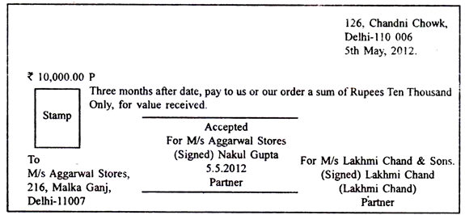
BILL OF EXCHANGE
According to Section 5 of the act, A bill of exchange is “an instrument in writing containing an unconditional order signed by the maker, directing a certain person to pay a certain sum of money only to, or to the order of, a certain person or to the bearer of the instrument”. It is also called a Draft.
Special Benefits of Bill of Exchange:
A bill of exchange is a double secured instrument.
In case of immediate requirement, a Bill may be discounted with a bank.
- Essential Elements of a Bill of Exchange
A Bill of Exchange to be valid must fulfill the following requirements:
- The instrument must be in writing.
- It must be signed by the drawer.
- It must contain an order to pay, which is express and unconditional.
- The drawer, drawee and the payee must be certain and definite individuals.
- The amount of money to be paid must be certain.
- The payment must be in the legal tender money of India.
- The money must be payable to a definite person or according to his order.
- It must be properly stamped.
9. The bill may be payable on demand or after a definite period of time. But no one except the Reserve Bank and the Government of India can draw a bill payable on demand to the bearer of the bill.
If any of the requirements mentioned above is not fulfilled, the document is not a bill of exchange.
e.g. “ Please let the bearer have Rs. 1000 and oblige.”
“ We hereby authorize you to pay on our account to the order of X, Rs 6000.”

SPECIMEN OF BILL OF EXCHANGE
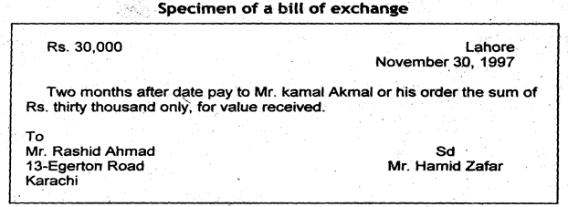
CHEQUE
According to Section 6 of the act, A cheque is “a bill of exchange drawn on a specified banker and not expressed to be payable otherwise than on demand”. A cheque is also, therefore, a bill of exchange with two additional qualification:
It is always drawn on a specified banker.
It is always payable on demand.
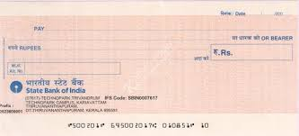

- Types of Cheques
Two Types:
1. Open Cheques: An open cheque is one which is payable in cash across the counter of the bank
2. Crossed Cheques: A crossed cheque is one which has two short parallel lines marked across its face. It can be paid only to another banker.
- The advantage of crossing is that it reduces the danger of unathorised persons getting possession of a cheque and cashing it.
- A crossed cheque can only be cashed through a bank of which the payee of the cheque is a customer.
Modes of Crossing a Cheque
1. General Crossing: The simplest mode of crossing is to put two parallel lines across the face of the cheque.This is called General Crossing. 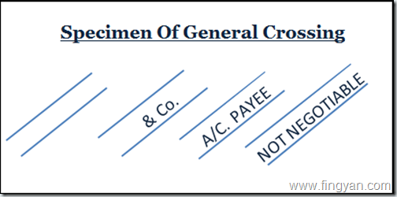
A cheque crossed generally will be paid to any bank through which it is presented.
2. Special Crossing: When the name of bank is written in between the parallel lines, it is called Special Crossing. 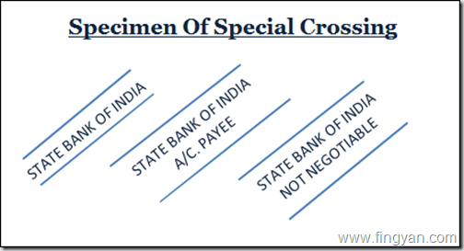
A cheque crossed specially will be paid only when it is presented for collection by the bank named between the parallel lines.
- Essential Features of Cheque
- A cheque must fulfill all the essential requirements of a bill of exchange.
- A cheque may be payable to bearer or to order but in either case it must be payable on demand.
- The banker named must pay it when it is presented for payment to him at his office during the usual office hours, provided the cheque is validly drawn and the drawer has sufficient funds to his credit.
- Bills and notes may be written entirely by hand. There is no legal bar to cheques being handwritten. Usually , banks provide their customers with printed cheque forms which are filled up and signed by drawer.
- The signature must tally with the specimen signature of the drawer kept in the bank.
Parties to Negotiable Instruments
Holder:
The holder of a negotiable instrument means any person entitled in his own name to the possession thereof and to receive or recover the amount due thereon from the parties there to.----Sec.8
In order to be called as a ‘holder’ a person must satisfy the following two conditions:
- He must be entitled to the possession of the instrument in his own name.
- He must be entitled to receive or recover the amount due thereon from the parties liable thereto.
- Parties to Negotiable Instruments
Holder in due course
The holder of a negotiable instrument is called the holder in due course if he satisfies the following conditions.----Sec 9
- He must be a holder.
- He obtained the instrument for valuable consideration i.e. lawful consideration
- He became holder of the instrument before its maturity, i.e. before the amount mentioned in it became payable.
- He had no cause to believe that any defect existed in the title of the person from whom he derived his title
e.g. A post dated cheque does not indicate any defective title and therefore the transferee of such a cheque may be a holder in due course if the other conditions are satisfied.
- Capacities of Parties
“ Every person capable of contracting , according to the law to which he is subject, may bind himself and be bound by making, drawing, acceptance, indorsement, delivery and negotiation of a promissory note, bill of exchange or cheque”------------Sec. 26
- Different Cases of Incapacity
Minor: Sec 26 declares that a minor may draw, indorse, deliver and negotiate a negotiable instrument so as to bind all parties except himself. He does not incur any liability but other adults parties do remain liable. He can be a indorsee or payee.
Insolvent: He is not competent to draw, make, accept or indorse
Corporation: A company cannot incur liability under negotiable instrument unless expressly or impliedly permitted by the Memorandum of Association or Article of Association. But can be a payee or indorsee.
Agent: Every person capable of binding himself or being bound, by a negotiable instrument, may so bind himself or be bound by a duly authorised agent acting in his name.-----Sec 27
Legal Representative (Sec.29): He can deal with the negotiable instruments belonging to the deceased to the same extent as the deceased could have done.If he signs , he must use words to indicate that he is not personally responsible.
Joint Hindu Family: The Karta can bind the joint family by executing negotiable instrument provided its for the benefit of family, other members are not liable personally.
Liability of the Parties
- Maker and Acceptor: The maker of the promissory note and the acceptor of a bill of exchange are primarily responsible for the payment due. ---------Sec 32
- Drawer: The drawer of a bill of exchange or cheque , case of dishonour by the drawee or acceptor thereof, to compensate the holder, provided due notice of dishonour has been given to, or received by the drawer.----------Sec.30
- Drawee of a Cheque: The drawee of a cheque having sufficient funds of the drawer, in his hands, properly applicable to the payment of such cheque must pay the cheque when duly rquired to do so, and, in default of such payment, must compensate the drawer for any loss or damaged caused by such default.----- Sec. 31
- Indorser: He is liable to all subsequent parties in case of dishonour of the instrument provided due notice of dishonour has been given to him.-----------Sec. 35
Nature of liability of Various prior parties.
A bill drawn by P on Q in favour of R is made payable three months after date. It is indorsed by R in favour of X, by X in favour of Y, and by Y in favour of Z. The bill has been accepted by Q, and Z presents it on maturity for payment to Q who duly pays the amount and indorses the fact of payment of the bill. On payment by Q the bill is duly satisfied. But if payment had not been made, Z could sue P, Q, R, X, Y – all or any of them; Y could sue P,Q,R,X; and so on
NEGOTIATION
According to section 14 of the Act, ‘when a promissory note, bill of exchange or cheque is transferred to any person so as to constitute that person the holder thereof, the instrument is said to be negotiated.’ The main purpose and essence of negotiation is to make the transferee of a promissory note, a bill of exchange or a cheque the holder there of.
Negotiation thus requires two conditions to be fulfilled, namely:
- There must be a transfer of the instrument to another person; and
- The transfer must be made in such a manner as to constitute the transferee the holder of the instrument.
MODES OF NEGOTIATION
- Negotiation by delivery (Sec. 47):
Where a promissory note or a bill of exchange or a cheque is payable to a bearer, it may be negotiated by delivery thereof. Example: A the holder of a negotiable instrument payable to bearer, delivers it to B’s agent to keep it for B. The instrument has been negotiated.
- Negotiation by endorsement and delivery (Sec. 48):
A promissory note, a cheque or a bill of exchange payable to order can be negotiated only be endorsement and delivery. Unless the holder signs his endorsement on the instrument and delivers it, the transferee does not become a holder. If there are more payees than one, all must endorse it.
- ENDORSEMENT [SECTION 15]
The word ‘endorsement’ in its literal sense means, writing on the back of an instrument. But under the Negotiable Instruments Act it means, the writing of one’s name on the back of the instrument or any paper attached to it with the intention of transferring the rights therein. Thus, endorsement is signing a negotiable instrument for the purpose of negotiation. The person who effects an endorsement is called an ‘endorser’, and the person to whom negotiable instrument is transferred by endorsement is called the ‘endorsee’.
Who may Endorse / Negotiate [Section 51]:
Every Sole maker, drawer, payee or endorsee, or all of several joint makers, drawers, payees or endorsees of a negotiable instrument may endorse and negotiate the same if the negotiability of such instrument has not been restricted or excluded as mentioned in Section 50.
Essentials of a Valid Endorsement:
- It must be on the back or face of instrument or on a slip of paper annexed thereto.
- It must be signed by the endorser.
- It must be completed by the delivery of the instrument.
- It must be made by the holder of the instrument.

The Negotiable Instruments (Amendment) Bill, 2015

What was the need for the amendment?

This is the third major amendment in recent times to the Negotiable Instruments Act 1881, prompted by dishonour of cheques in lakhs, shaking the credibility of the instrument, confidence of business community and choking courts. The 1988 amendment introduced penalty for issuing cheques which get dishonoured for want of fund in the bank. Since that provision, Section 138, was found insufficient to deal with the menace, the penalty was increased from one to two years imprisonment after a summary trial. Even this has not resolved the problem and at present 1.8 million criminal cases are before magistrates' courts and appellate courts. One of the devices employed by dishonest drawers is to challenge the jurisdiction of the courts, stalling the proceedings. This was tried to be resolved by the Supreme Court in its 2009 judgment in Dashrath Rupsingh case.
What does the present amendment do?

The amendment adopts the basic principles laid down by the Supreme Court in the above case regarding jurisdiction of courts and improves upon it in the light of the representations made by various stakeholders, including industry associations and financial institutions. Complications had arisen because a cheque was issued in one place on one bank, and presented in another place to another bank. The payer company might be in one corner of the country and the payee might be in another. The payee therefore had to chase the accused in distant places and even if he won, appeals would be filed in another court and arguments will continue for years. The Supreme Court found that even high courts had differed on the question of the choice of courts which should try the case. The present amendment removes such legal bottlenecks and speeds up the trial. Now the question of jurisdiction cannot be raised as the law is clear.
What is the procedure laid down by the amendment?

The new provision states that the holder of the cheque can file a criminal complaint before a magistrate where he resides and tendered the cheque. He need not go to the place where the cheque was issued or other courts. After this clarification, there is a single place to file the complaint. Litigation expenses will come down, and the drawers of cheques, including company directors will be more careful while signing such cheques. The government feels that these procedural changes will be fair to both parties.
What happens to cases already pending?

According to the newly introduced Section 142A, all cases which were pending in any court, whether filed before it or transferred to it shall go before the court having jurisdiction under the new procedure.

What is the other important proposed change in the Bill?

The new law also cures a deficiency in the definition of "a cheque in the electronic form". The law as it stood presumed drawing of a physical cheque and signature. With the advance in technology it needed to be updated. Therefore, it is explains that "a cheque in the electronic form" means a cheque drawn in electronic form by using any computer resource and signed in a secure system with digital signature (with or without biometrics signature) and asymmetric crypto system or with electronic signature. The Negotiable Instruments Act borrows definitions of technical expressions from the Information Technology Act 2000.

……………………………………………………………………

