THE INDIAN CONTRACT ACT 1872
The Indian Contract Act, 1872 extends to the whole of India except the State of Jammu and Kashmir; and it came into force on the first day of September, 1872.
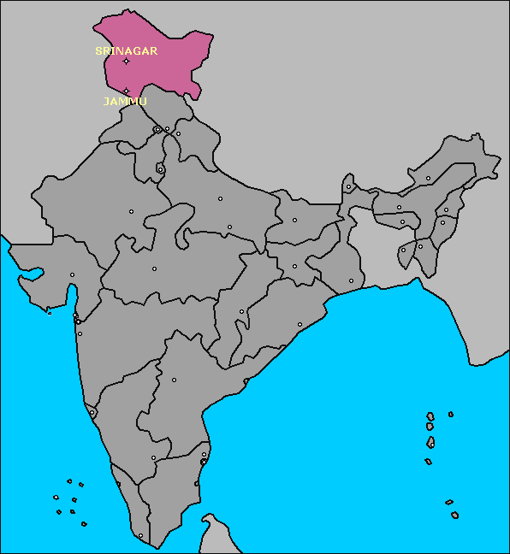
Example:1
Seller’A’---1KgPotatoes @ Rs.20---Buyer’B’ ----------Rs.20----------
Sec (2) BASIC CONCEPTS:
- Proposal
- Promise
- Promisor
- Promisee
- Consideration
- Agreement
- Reciprocal Promises
- Void Contracts
- Contracts
- Voidable Contracts
Section 2(e) Every promise and every set of promises forming the consideration for each other”- Agreement
Section 2 (h) defines a contract as “ Every agreement and promise enforceable at law is a contract”

- Agreement = Offer + Acceptance
- Contract = Agreement+Enforceability at Law
Case Reference:
Balfour v Balfour 1919 2KB 571
- Every contract is an agreement but every agreement is not a contract
Consensus ad Idem (Mutual Agreement)
A had two motor car Maruti Alto and Maruti 800; he intends to sell Maruti 800 to B. But B thought he is selling Maruti Alto agrees to his proposal.
NO consent = NO Contract

Essential Elements of a Valid Contract
(a) Agreement
(b) Lawful consideration
(c) Competent Parties
(d) Free consent
(e) Legal Object
(f) Intended to create legal obligations
(g) Not Void or Illegal
(h) agreement- Certain and Capable
(i) Legal Formalities
Classification Of Contracts:
Based on Enforceability
- Valid Contract: An agreement enforceable by law is a valid contract.
- Void agreement: An agreement not enforceable by law is said to be void.(For Example: An Agreement with Minor)
- Voidable contract: An agreement which is enforceable at the option of one or more parties thereto but not at the option of other or others is a voidable contract. (Example: Contract entered into by threatening)
- Void Contract: A Contract which ceases to be enforceable by law becomes void when it ceases to be so enforceable.
A promises B to sell his horse after one month to B for Rs. 50,000. Before the completion of one month, the horse died. Now, the contract becomes void as the contract cannot be performed.
- Unenforceable contracts: These are the contracts which cannot be enforced in a court of law because of some technical defects. For example a contract may be good, but incapable of enforceable because it is not evidenced by writing as required by statute.
- Illegal agreement: Sale of smuggled goods is illegal so an agreement to sell smuggled goods is an illegal agreement.

Distinction between a void agreement and an illegal agreement:
- An illegal agreement is also void. But a void agreement is not an illegal agreement always.

- When an agreement is illegal, other agreements which are incidental or collateral to it are also void.

Based on method of formation
Formal Contracts
Contract under seal are in writing and signed by the parties to them.
- Contract of Records includes the court judgments and recognizance; obligations in such cases arise out of judgment and not under the contract.
Simple Contracts:
- All contracts other than formal are called simple contracts or parole contracts.

Based on extent of performance
- Executed contracts: An executed contract is one which has been totally completed by both the parties.
- Executory contracts: If one party has performed his part of obligation but the other party has not yet completed his obligation on the contract, the contract still remains executory contract
Based on Obligation
- Unilateral contract: Under this type of contract there is an obligation only on the part of only one party when the contract is concluded
- Bilateral Contract: Here there is an obligation on both the parties to the contract.
- Multilateral Agreements/Contract: When more than three parties are involved in an agreement it is called Multilateral Agreement
- Features of Multi-lateral trade agreements:
    - Reciprocity
    - MFN Treatment
On the basis of mode of creation:
- Express contract: Contracts entered into between the parties by words spoken or written are known as express contracts.
- Implied or inferred contract: Contracts which are made by an act or conduct of the parties and not by words are termed as implied contract.
- E-Contracts: This is a kind of contract formed in the course of E-commerce by interaction of two or more person competent to contract using electronic means, such as e-mail. By growth of e-commerce, there is a rapid advancement in the use of e-contracts.
- Disadvantages: Cyber Frauds, Security issues
- Advantages:
    - Reduce cost
    - Time savings
    - Improved Service Quality

