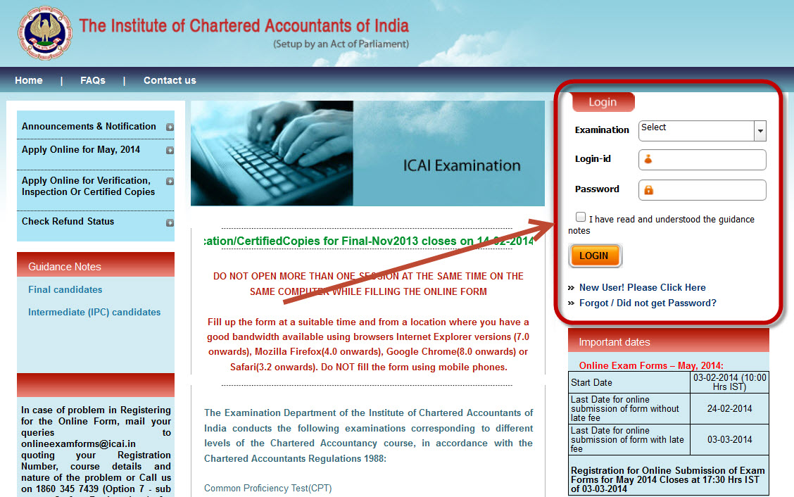

Procedure to Fill IPCC & Final Online Exam Form
ICAI has already declared CA IPCC and Final exam dates / time table for May 2015. CA IPCC and CA Final students who are going to write exams in May 2015 should submit their online exam form. Here we are providing CA IPCC and Final online application procedure, online exam form last date without late fee and with late fee, online form submission address details.
CA IPCC & CA Final May 2015 online exam form filling will be started from 03-02-2015. I have giventhe procedure of filling online CA Final exam form May 2015 & CA IPCC Exam Form May 2015 Last Date of Online Form submission for CA IPCE & Final May 2015 exams & Fees details for exams is given below.

CA IPCC and Final Online Form Submission May 2015
see below CA IPCC online exam form last date and CA Final online exam form last date with out late fee and with late fee for May 2015.
Start Date | 03-02-2015
Last Date for online submission of form without late fee | 24-02-2015
Last Date for online submission of form with late fee | 03-03-2015
Registration for Online Submission of Exam Forms for May 2015 Closes at 17:30 Hrs IST of 03-03-2015

For the benefit of the Students, ICAI has now extended the facility of CA Final & IPCC Exam Form Online. Moreover, to facilitate the use of submission of forms online, ICAI has exempted students submitting the form online from paying the cost of the exam form which is Rs. 500.The facility of physical submission is also available and students desirous of manually submitting the forms can purchase the forms from ICAI on payment of Rs. 500.

Procedure for submitting CA-IPCC, Final Online Exam Form
Check below detail procedure of CA IPCC online form fillup and CA Final online form fillup May 2015.

STEP 1:
Procedure-for-submitting-CA-IPCC-Final-Exam-Form-Online
Just Go to site: http://icaiexam.icai.org/login.php for CA IPCC and Final online application form may 2015

STEP 2 : Create your Account
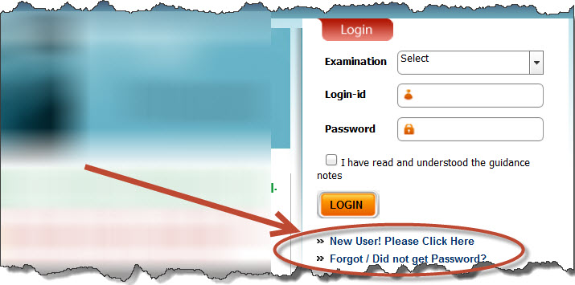
Procedure-for-submitting-CA-IPCC-Final-Exam-Form-Online-
For submitting the CA Final/IPCC Exam Form Online, the 1st step is to register a new account. Creating new account is mandatory for everyone and the users who had created login account for any previous exams also have to create a new account.
So go to: http://icaiexam.icai.org/registration.php or New User! Please Click Here
Your new account will be authenticated with your Student Registration number, your date of birth, your email-id and mobile number. It is advisable to double check your email-id provided by you in the above step, since the login-id and password created by you for filling up the application form would be sent to this email address and mobile only.

STEP 3 : Make Payment
After having successfully created your account, login with your username and the password sent to you by email. Fill up the details in the CA Final/ IPCC Online Exam Form carefully, confirm the particulars displayed in the Confirmation Page and Select the payment method and make payment.
Note: - exam fees is to be remitted Online only using Master/Visa/Maestro Credit/Debit Card. Payment via Net Banking or Mobile Banking are not accepted.
Tip : Candidates are advised to keep a copy of PDF file generated on successful payment, for future reference.
The fees payable for the various examinations are as under:
INTERMEDIATE (IPC)
For Both the Groups / Unit – 9 | Rs/- 1600
For one of the Groups / Unit 1 to 8 | Rs/- 1000
FINAL EXAMINATION
For Both the Groups | Rs/- 2250
For one of the Groups | Rs/- 1250
INSURANCE & RISK MANAGEMENT (IRM) EXAMINATION | Rs/- 1000
The Last Date for Submission of CA Final/ IPCC Exam Form Online is 24-02-2015. However, in case a candidate is unable to submit the CA Final/IPCC Exam Form Online till 24-02-2015, he shall submit the same by 03-03-2015 with a late payment fee of Rs. 500.

STEP 4: Take the Print Out of the PDF Form
After having paid the CA Final/IPCC Exam Fees, you are requested to take the print out on A4 sheet with Portrait Orientation.
Tip : While taking the print, the applicant shall ensure that the Control Number, Payment Particulars and the Bar Codes are appearing correctly in the PDF before taking the Print Out

STEP 5: AFFIX PHOTOGRAPH AND SIGNATURE
Now you will have to send a copy of that printout after affixing photograph and specimen signature and signing the declaration duly countersigned by a member of the Institute /Principal/Gazetted Officer
Tip : Use Black Ink Ball point pen to fill the form

STEP 6: SEND THE PRINT OUTS TO ICAI
After having affixed your photograph and having signed the Examination Form, Send the printout of the form by Speed Post/Registered Post without folding in cloth cover envelope .

CA IPCC and Final online form submission address
see below CA IPCC and Final online form submission address May 2015
To
The Additional Secretary (Exams),
The Institute of Chartered Accountants of India,
ICAI Bhawan,
Indraprastha Marg,
New Delhi 110 002.
- Last Date for Receipt of Printout of Exam Application form (PDF) filled Online Without Late Fee is (Update soon)
- Last Date for Receipt of Printout of Exam Application form (PDF) filled Online With Late Feeis (Update soon)
The Admit Cards for CA IPCC/ CA Final Exams are usually issued by ICAI, 21 days before the start of the Examinations. The Admit Cards can be downloaded online. ICAI doesn’t send physical Admit cards to your home address. see No more CA Physical Admit Cards from ICAI | May 2015
Error in submission of IPCC/ CA Final Exam Form May 2015

ICAI has ensured that the whole process for online submission of Exam Form May 2015 is error-free. However, there may still be minute errors because of slow internet connection, or because of the bank through which the payment is being made or constant refreshing by the student or because of any other error.
In case you face any such problem and are unable to pay the fees online or the fees has been paid online and you have not received the PDF or for any other reason, you should pay the fees online again and the PDF would be generated successfully. You are also required to sent an email to ICAI stating that you’ve again paid the exam fees and the exam fees paid earlier would be refunded. The Exam Fees paid in excess would be automatically refunded on completion of the whole process of the online exam form submission.
In case of problem in Registering for CA Final/IPCC Exam Form Online or on Payment, mail your queries to onlineexamforms@icai.in quoting your Registration Number, course details and nature of the problem or Contact ICAI on 1860 345 0112

Procedure for submitting the CA IPCC and Final Exam Form Physically
The option of submitting the Exam Form for May 2015 Attempt is also available. In case the Student opts for Physical submission of Exam Form, he would first be required to purchase the Exam Form on Payment of Rs. 500 from the authorized centers of ICAI. This Cost of Rs 500 for purchasing the Exam Form is not liable to be paid in case the student submits the Form online.
Students submitting the Exam Form physically would be required to make the payment by Demand Draft of any Scheduled Bank. the Demand Draft shall be drawn in favor of
” The Secretary, Institute of Chartered Accountants of India” payable at New Delhi.
IPCC and CA Final Exam Forms filled physically shall be submitted so as to reach the Additional Secretary (Examinations) New Delhi before the Due Dates. Exam Forms would also be received by hand delivery at the following branches of ICAI – Mumbai, Kolkatta, Chennai, Delhi, Ahmedabad, Hyderabad, Bangalore, Jaipur and Pune.

