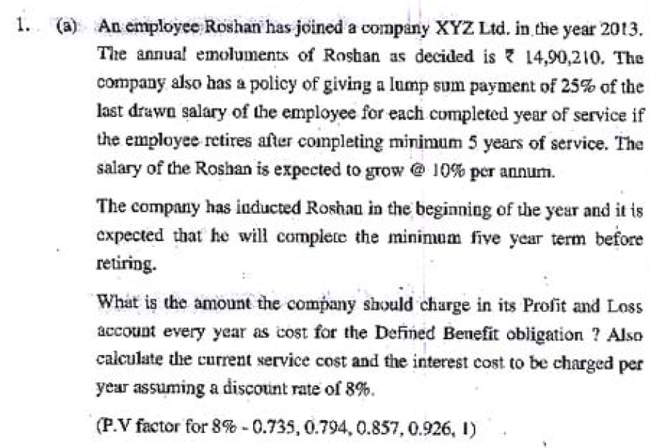
Q1.a. From AS 15

Salary of Roshan expected after 5yrs | 1490210 x (1+0.1)4 | 2,181,816
10% p.a. for 4yrs
(Since the salary of 1st year is given, increment shall be taken for 4yrs only)

Lumpsum payment after 5yrs @ 25% | 2181816 x 25% * 5yrs | 2,727,270
Liability of every year of service | 2181816 x 25% | 545,454

Amount to be charged to P&L as Current Service Cost for 1st yr | 545454 x 0.735 | 400,909
Amount to be charged to P&L as Current Service Cost for 2nd yr | 545454 x 0.794 | 433,090
Amount to be charged to P&L as Current Service Cost for 3rd yr | 545454 x 0.857 | 467,454
Amount to be charged to P&L as Current Service Cost for 4th yr | 545454 x 0.926 | 505,090
Amount to be charged to P&L as Current Service Cost for 5th yr | 545454 x 1 | 545,454

Interest cost to be charged in 1st yr |  | -
(since obligation is credited at the end of the year no interest cost to be charged in yr1)
Interest cost to be charged in 2nd yr | 400909 x 0.08 | 32,073
Interest cost to be charged in 3rd yr | (400909+433090+32073) x 0.08 | 69,286
Interest cost to be charged in 4th yr | (400909+433090+32073+467454+69286) x 0.08 | 112,225
Interest cost to be charged in 5th yr | (400909+433090+32073+467454+69286+505090+112225) x 0.08 | 161,610

Defined Benefit Obligation to be credited in yr1 |  | 400,909
Defined Benefit Obligation to be credited in yr2 | 433090+32073 | 465,163
Defined Benefit Obligation to be credited in yr3 | 467454+69286 | 536,740
Defined Benefit Obligation to be credited in yr4 | 505090+112225 | 617,315
Defined Benefit Obligation to be credited in yr5 | 545454+161610 | 707,064

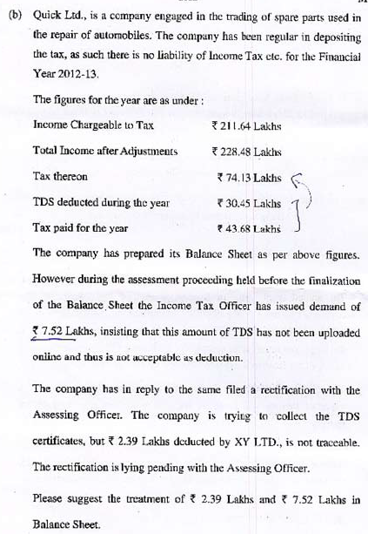
Q1.b. From AS 22
Since out of the amount of Rs.7.52 lakhs demand assessed by Assessing officer, TDS Certificates are traceable for (7.52-2.39)= Rs.5.13 lakhs, no adjustment regarding the same is required to be made in the Balance Sheet since Demand for the same will be reversed as Certificates are available
However TDS Certificates for Rs.2.39 lakhs are not traceable, reason could be not deposited by the party or miscalculation by the company
If the amount is not deposited by the Party liable to deduct TDS, the benefit for the same can be availed by us in the following year, but in the current year we shall be required to pay the tax, hence a Deferred Tax Asset Account shall be created in the Balance Sheet for Rs.2.39 lakhs being Timing Difference benefit to be availed in the following year
If the amount is a miscalculation by the company the same will be required to be paid by the company, reversing the entry of TDS with Income Tax paid along with interest

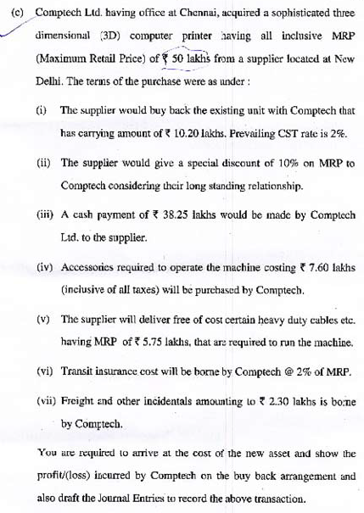
Q1.c.from AS 10
Cost of new Asset in the Books of Comptech Ltd.
Cash Payment | 38,25,000
Exchange of Old Machine (45,00,000-38,25,000) | 6,75,000
Accessories | 7,60,000
Transit Insurance (50,00,000*2%) | 1,00,000
Freight | 2,30,000
TOTAL | 55,90,000

Calculation of old machine exchange price
New Machine Provided @ 10% Discount | 45,00,000
Cash Paid | 38,25,000
Hence Amount received for Old Machine | 6,75,000
This includes CST Payable @ 2%
Hence Amount received after deducting CST  (675000*100/102) | 6,61,765
Loss on Sale (10,20,000-6,61,765) | 3,58,235

Journal Entry
Printer a/c dr. | 55,90,000
To Cash |  | 38,25,000
To Cash (Other Expenses) |  | 10,90,000
To Supplier |  | 6,75,000

Supplier dr. | 6,75,000
P&L dr. | 3,58,235
To Old Fixed Asset |  | 10,20,000
To CST Payable |  | 13,235

